Supporting Information
Achieving a Rapid Na⁺ Migration and Highly Reversible Phase Transition of NASICON for Sodium-Ion Batteries with Suppressed Voltage Hysteresis and Ultralong Lifespan
Qiao Wuª, Yuanzhen Maª, Shengqiang Zhangª, Xin Chenª, Jinbo Bai^{b}, Hui Wang^{a,*} and Xiaojie Liu^{a,*}
ª Key Laboratory of Synthetic and Natural Functional Molecule of the Ministry of Education, College of Chemistry & Materials Science, Northwest University, Xi’an 710127, P. R. China
^{b} Laboratoire Mécanique des Sols, Structures et Matériaux (MSSMat), CNRS UMR 8579, Ecole CentraleSupélec, Université Paris-Saclay, 8-10 rue Joliot-Curie, 91190 Gif-sur-Yvette, France

Corresponding Author:
xiaojie.liu@nwu.edu.cn (X.Liu) and huiwang@nwu.edu.cn (H. Wang)

Experimental Section
Materials preparation:
The N_{1-x}K_{x}VPF/C (x=0, 0.03, 0.08 and 0.13) samples (x is the mole number of the K atom substituting the Na atom in 1 mol NVPF, x =0, 0.03, 0.08 and 0.13) were prepared by sol-gel method. In the synthesis process, the raw materials used are NaF, NH₄VO₃, NH₄H₂PO₄, KF and citric acid, all of which are analytical grade and can be used without further purification. Among them, KF provides K source in the doping process, while citric acid provides C source and provides the function of chelating agent. Stoichiometric ratios of NaF, NH₄VO₃, NH₄H₂PO₄, KF and citric acid were added to distilled water, stirred until being completely dissolved, and the resulting solution was stirred continuously at 80 ℃ for 5 h to form a uniform wet gel, and then dried at 120 ℃ to obtain a gel precursor. After the gel precursor was ground in a mortar and transferred to a tubular furnace, which was pretreated at 300 ℃ in argon atmosphere for 2 h, and then heated at 650 ℃ for 6 h in argon atmosphere, the N_{1-x}K_{x}VPF/C samples were obtained. In the synthesis process, the amount of citric acid was added based on the ratio of n(V): n (citric acid) = 4:5. By controlling the stoichiometric ratio of NaF and KF, N_{1-x}K_{x}VPF/C (x=0, x=0.03, 0.08 and 0.13) with different K contents could be obtained.
Material Characterization:
The crystal structures of the samples were recorded by X-ray diffraction (XRD, Bruker D8 ADVANCE Cu Kα radiation) with a step size of 0.1° s⁻¹ between 10° and 80°. Scanning electron microscope (SEM, Hitachi SU8010) at an accelerating voltage of 30 kV and transmission electron microscope (TEM, FEI Talos F200X, USA) at an accelerating voltage of 200 kV were used to observe the morphology and micro structure of the samples. X-ray photoelectron spectroscopy (XPS, PHI 5000 Versa Probe III) was used to determine the chemical composition of the substance, and then determine whether K was doped into NVPF. The FT-IR analysis of KBr spherules for Tensor 27 in transmission mode was performed. Thermogravimetric analysis (TGA, SDT Q600) was performed to calculate carbon content of materials under an air atmosphere from room temperature to 600 °C at a heating rate of 10 °C min⁻¹. The surface area and porosity were characterized by BET (brunauer-emmettt-teller) and ASAP 2020 Plus 1.03. Electron paramagnetic resonance (EPR) polycrystalline spectra were recorded by Bruker ELEXSYS 500-9.5/12 spectrometer. Elemental content was assessed using Agilent 7900 ICP-MS. UV-Vis diffuse reflectance spectra (UV-DRS) were taken on a UV-3600 plus spectrometer (Shimadazu Co., Ltd) with BaSO₄ as reference. Raman spectra were recorded at a wavelength of 532 nm using dispersive Raman microscope (XPLORA PLUS).
Electrochemical Measurements:
In the measurements of sodium storage performance, CR2025-Type coin cells were assembled in a glove box filled with Ar, with oxygen and water contents less than 0.1 ppm. For half-cell, the free-standing N_{1-x}K_{x}VPF/C membrane electrode (loading mass: 1~2 mg cm⁻²) as the working cathode as well as the Na metal as the counter electrode. The sodium foil glass fiber membrane as the separator was applied between the Na metal and the working cathode, while the electrolyte solution was 1M NaClO₄ dispersed in a mixture of propylene carbonate/ethylene carbonate (1:1) with fluoroethylene carbonate (5wt%) as the additive. Additionally, the galvanostatically charged-discharged tests were performed on the LAND test system (LAND CT 2001A), in which the potential window ranged from 2.5 to 4.3 V at various current densities. The CV curves at different scanning rates were conducted in the CHI 660D electrochemical workstation, and EIS was examined in the frequency range of 0.01 to 105 Hz. All measurements were taken at room temperature (25 ºC).
Computational detail:
DFT calculations were conducted through the open-source code Quantum Espresso software package. Generalized gradient approximation of the Perdew-Burke-Ernzerhof (PBE) functional was used as the exchange-correlation functional. The Brillouin zone was sampled with 2×2×2 K points. The cutoff energy was set as 500 eV, and structure relaxation was performed until the convergence criteria of energy and force reached 1×10⁻⁵eV and 0.02 eV Å⁻¹, respectively. The formation energy of various Na vacancies in Na₃V₂(PO₄)₂F₃ (NVPF) and K-doped Na₃V₂(PO₄)₂F₃ (K-NVPF) was calculated by the following formula:
ΔE_{form}(NVPF-Na_{x}) = E(NVPF- Na_{x}) + xE(Na) - E(NVPF)
ΔE_{form}(KNVPF-Na_{x}) = E(KNVPF- Na_{x}) + xE(Na) - E(KNVPF)
Where the ΔE_{form}(NVPF- Na_{x}) and ΔE_{form}(KNVPF- Na_{x}), E(NVPF- Na_{x}), E(NVPF), E(KNVPF) and E(Na) represent formation energy of NVPF- Na_{x} and KNVPF-Na_{x}, the total energy of NVPF-Na_{x}, KNVPF- Na_{x}, NVPF, KNVPF and Na atoms in bulk metal Na, respectively. The x represents the number of Na atoms.
The migration barrier energies of Na in Na₃V₂(PO4)₂F₃ (NVPF) and K-doped Na₃V₂(PO4)₂F₃ (K-NVPF) are calculated by using the climbing-image under elastic band (CI-NEB) method. The calculations will be finished when the total energy difference is no higher than 1.0×10⁻⁷ eV for per atom and maximum forces on each atom are within 0.03 eV/Å. The value of the migration energy barrier can be obtained by following equation: E_{m} = E_{h}–E_{i} (h>i), in which the E_{m} is the migration energy barrier determined by the maximum value of difference between E_{h} and E_{i}. E_{h} and E_{i} are the relative energies of transition states (h>i) referring to the initial state (seen as reference state with 0 eV in total energy).

Table S1 ICP-MS date of N_{1-x}K_{x}VPF/C(x=0,0.03,0.08 and 0.13) samples.
x | molar ratio
x | Na | K | V | K%
0 | 3.015 | 0.000 | 2.000 | 0
0.03 | 2.914 | 0.092 | 2.000 | 3.06
0.08 | 2.749 | 0.237 | 2.000 | 7.96
0.13 | 2.639 | 0.391 | 2.000 | 12.98

Table S2 The capacity retention rate of N_{1-x}K_{x}VPF/C(x=0, 0.03, 0.08 and 0.13) samples at 10 C.
Samples | Capacity retention ratio(%)
N_{1-x}K_{x}VPF/C | 1000 cycles | 3000 cycles | 5000 cycles
x=0 | 39.1 | 0 | 0
x=0.03 | 76.6 | 60.6 | 56.8
x=0.08 | 82.5 | 65.8 | 60.2
x=0.13 | 80.7 | 57.6 | 52.6

Table S3 Comparison of electrochemical performance of N_{0.92}K_{0.08}VPF/C electrode with those of other NVPF based electrodes.

Cathode | Specific capacity  (mA h g⁻¹) at 10C | Cycle numbers and capacity retention | Ref.
N_{0.92}K_{0.08}VPF/C | 113.3 | 1000,82.5%,5000,60.2% | This work
NVPF@GN | 99 | 1000, 75% | [1]
Na₃V_{1.95}Mg_{0.05}(PO₄)₂F₃/C | 80 | 500, 88% | [2]
NVPF@3Dc | 81 at 5C | 2500, 63.7% | [3]
NVPF@CD | 95 | 1000, 70.4% | [4]
NVPF@ carbon matrix | 107 | 1000, 70% | [5]

Table S4 Kinetic parameters of N_{1-x}K_{x}VPF/C(x=0,0.03,0.08,0.13) samples.
N_{1-x}K_{x}VPF/C | Rs(Ω) | Rct(Ω) | σ(Ωs^{-0.5})
x=0 | 5.548 | 181.3 | 114.11
x=0.03 | 4.661 | 154.3 | 83.69
x=0.08 | 4.769 | 126.9 | 62.57
x=0.13 | 6.672 | 149.2 | 80.97

The diffusion coefficient of the Na ions (D_{Na+}) is calculated according to the following[6]: $D_{{Na}^{+}}=\frac{R^{2}T^{2}}{2A^{2}n^{4}F^{4}C^{2}σ^{2}}$
Z’= R_{s}+R_{ct}+$σ$ω^{-1/2}
in which R means gas constant, T is absolute temperature, A is the area of the active cathode material, n stand for transfer electrons number per molecule, F means Faraday constant, C is the sodium-ions concentration, and$σ$is the Warburg factor which is relative with Z’.

Table S5 Formation energy of NVPF- Na_{x} and KNVPF-Na_{x} and the total energy of NVPF-Na_{x}, KNVPF- Na_{x}, NVPF, KNVPF and Na atoms
Models | E(NVPF)/ eV | xE(Na) / eV | E(NVPF-Nax) / eV | E_{form} / eV
NVPF-first Na⁺ extraction | -499.58 | -1.46 | -497.65 | 0.47
Second Na⁺ extraction | -499.58 | -2.93 | -495.47 | 1.19
25%KNVPF-first Na⁺ extraction | -497.70 | -1.46 | -496.09 | 0.14
Second Na⁺ extraction | -497.70 | -2.93 | -493.88 | 0.89
50%KNVPF-first Na⁺ extraction | -493.98 | -1.46 | -494.18 | -1.66
Second Na⁺ extraction | -493.98 | -2.93 | -492.24 | -1.19

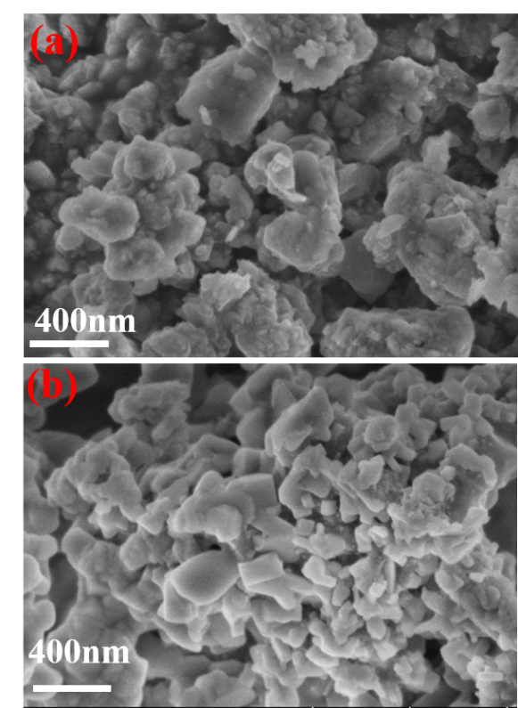
Fig. S1 SEM images of (a) N_{0.97}K_{0.03}VPF/C and (b) N_{0.87}K_{0.13}VPF/C

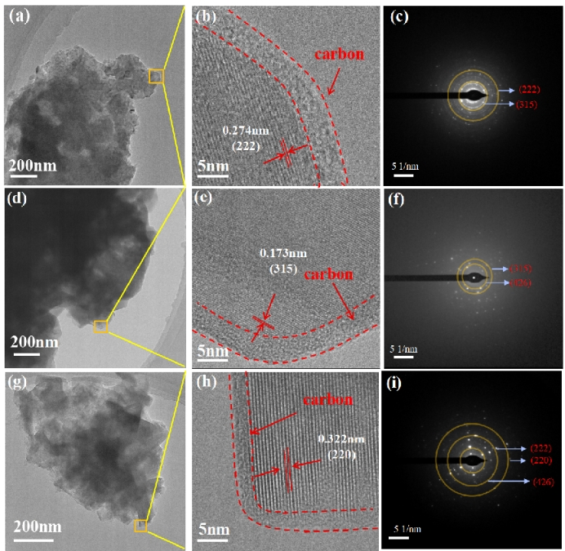
Fig. S2 TEM images of (a-c) NVPF/C, (b-f) N_{0.97}K_{0.03}VPF/C and (g-i) N_{0.87}K_{0.13}VPF/C.

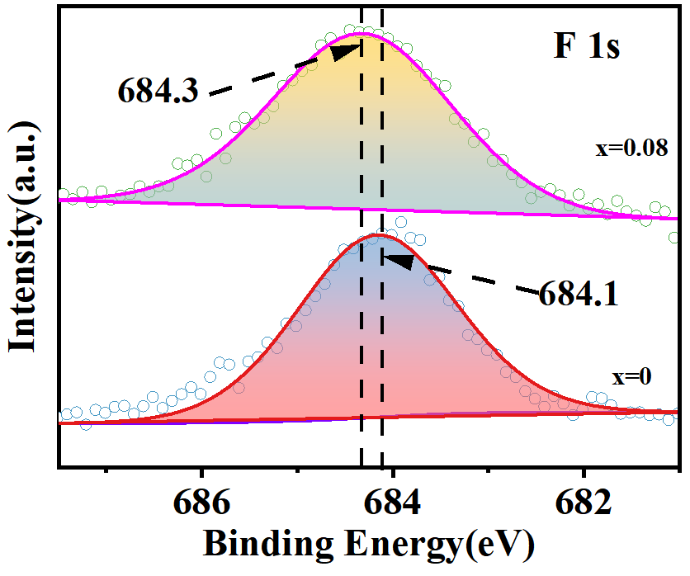
Fig. S3 Narrow scan XPS of F 1s for NVPF/C and N_{0.92}K_{0.08}VPF/C samples.

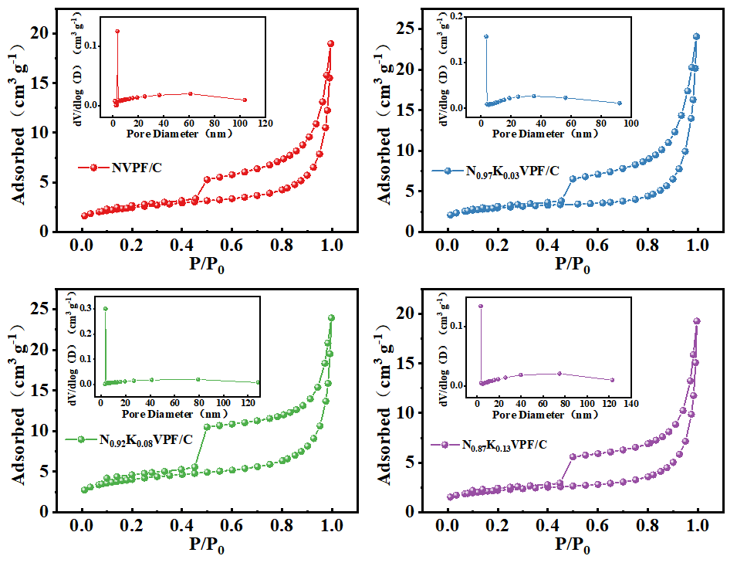
Fig. S4 (a)~(d) Plots of N₂ adsorption/desorption isotherms and inset shows the pore diameter of N_{1-x}K_{x}VPF@C(x=0, 0.03, 0.08 and 0.13) samples.

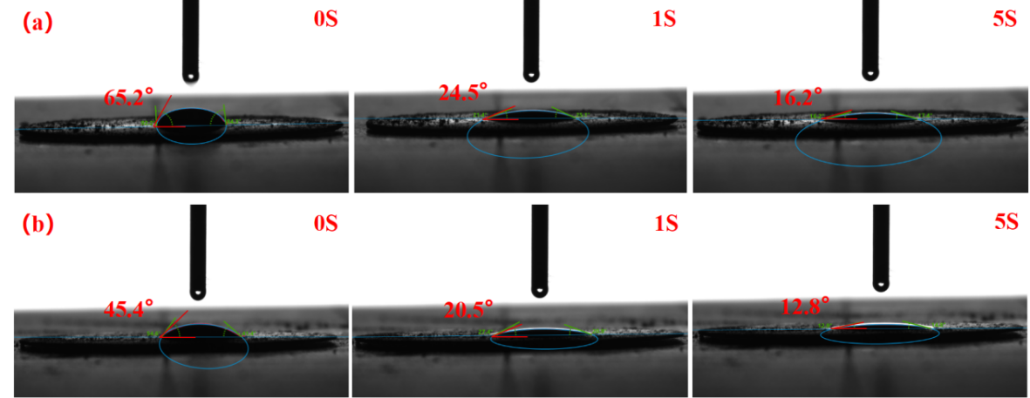
Fig. S5 Surface wet ability of a NaClO₄ droplet on the N_{1-x}K_{x}VPF/C powder (a)x=0 and (b) x=0.08.

Fig. S6 Charge/discharge curves of N_{0.92}K_{0.08}VPF/C sample for 5th, 10th, 20th, 50th, 75th and 100th cycle at 0.2 C.

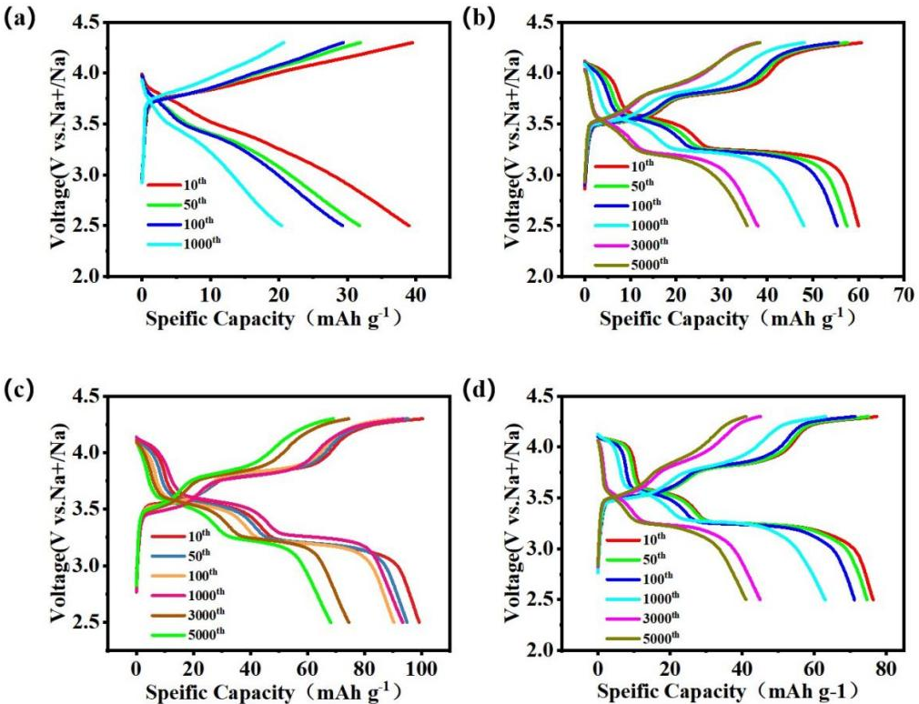
Fig. S7 Charge/discharge curves of N_{1-x}K_{x}VPF/C (x=0, 0.03, 0.08 and 0.13) at a current density of 10 C within the voltage range of 2.5-4.3 V. (a) x=0. (b) x=0.03. (c) x=0.08. (d) x=0.13.

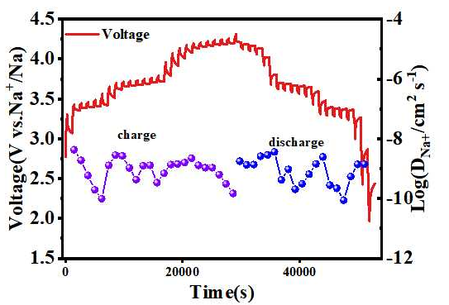
Fig. S8 GITT electrochemical charge/discharge curves of NVPF/C.

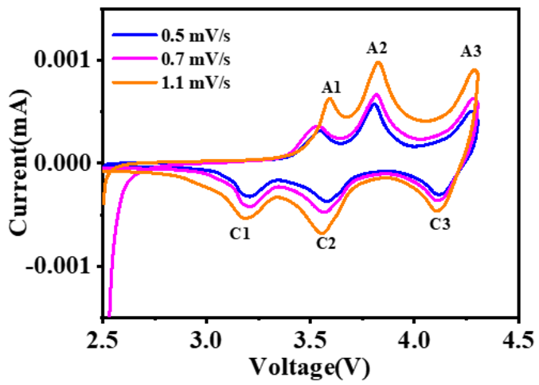
Fig. S9 CV curves of the NVPF/C sample at various scan rates.

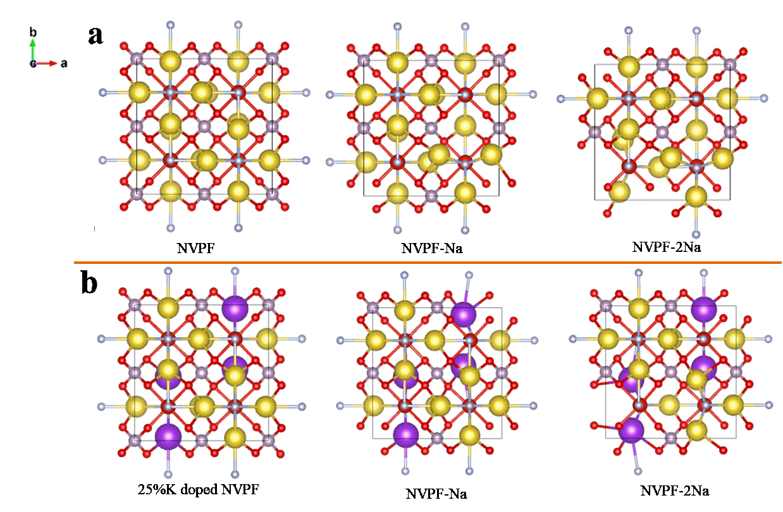
Fig. S10 Crystal structure changes of NVPF (a) and 25% K doped NVPF (b) derived from the extraction of 1 and 2 Na ions.

Fig. S11 SEM image (a), XRD pattern (b), EDS analysis(c-d) and elemental mapping (e-i) of KVPF with K cation fully substituted Na.

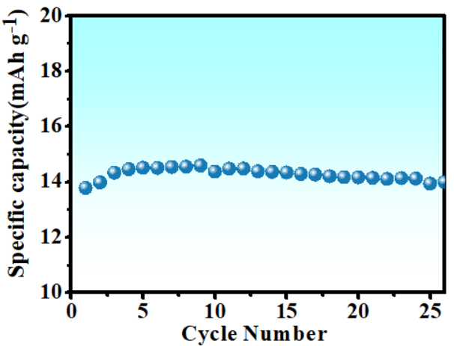
Fig. S12 Cycling performance of KVPF with K cation fully substituted Na.

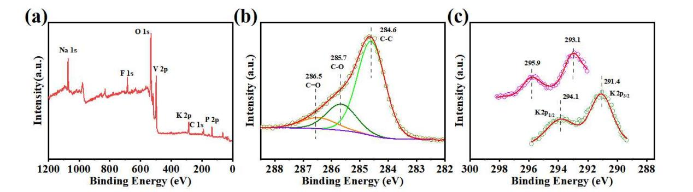
Fig. S13 XPS spectra of N_{0.92}K_{0.08}VPF/C sample after charge to 4.3V at 2 C (a) full spectrum, (b) C 1s fine spectrum and (c) K 2p fine spectrum.

Fig. S14 EDS elemental mappings of Na, V and K of N_{0.92}K_{0.08}VPF/C at 10C after (a) 5 cycles, (b) 20 cycles and (c) 100 cycles.

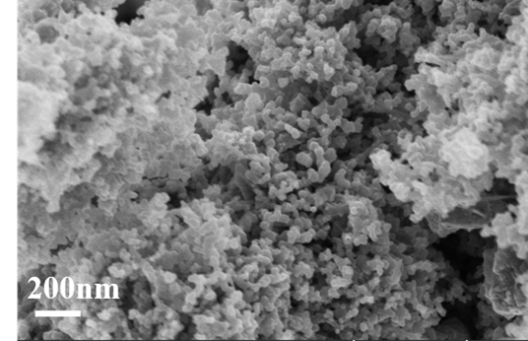
Fig. S15 SEM of N_{0.92}K_{0.08}VPF/C with lower magnification after 2500 cycles at 10C.

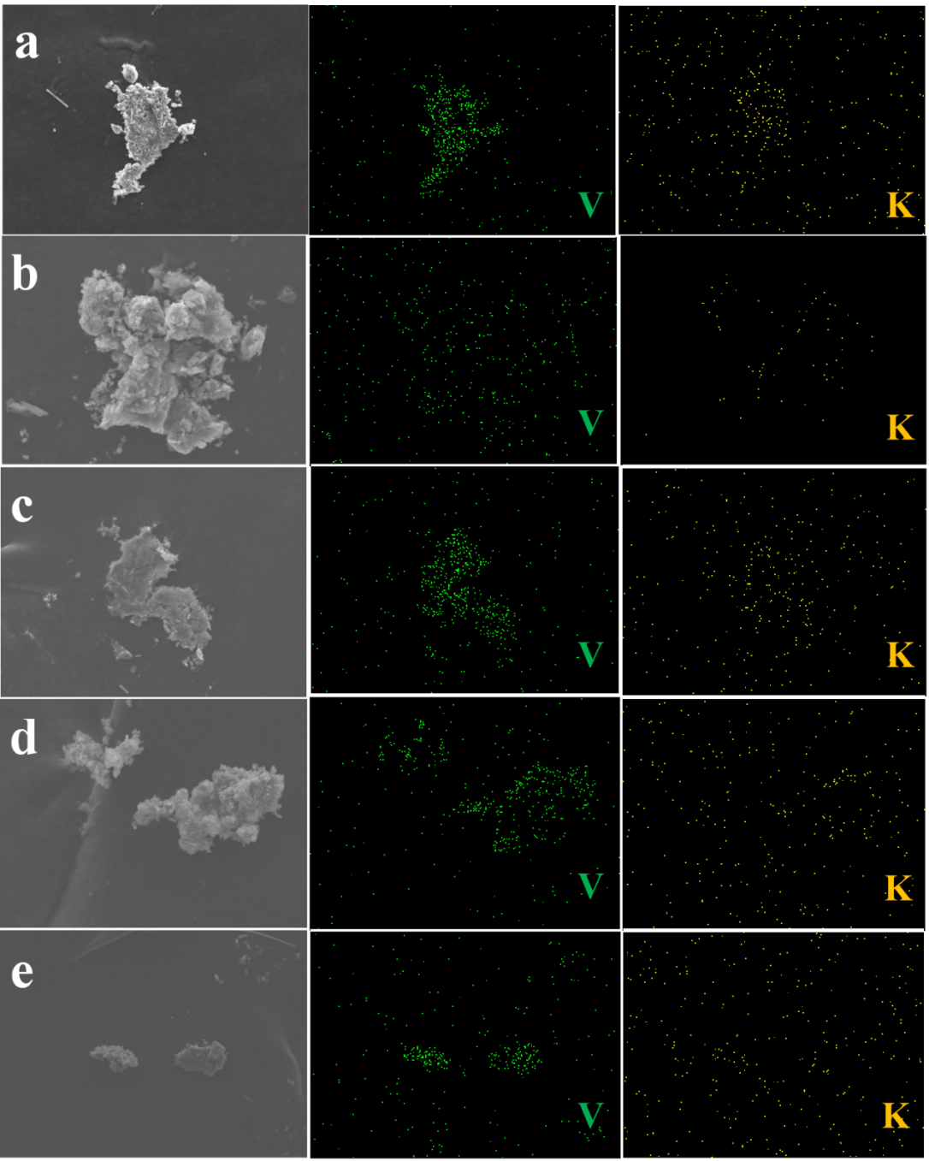
Fig. S16 EDS elemental mappings of Na, V and K of N_{0.92}K_{0.08}VPF/C at 0.5 C charged to (a) 3.45 V, (b) 3.74 V, (c) 4.24 V, (d) 4.3 V and discharged to (e) 2.5 V.

1. Zhu C, Wu C, Chen C-C, Kopold P, van Aken PA, Maier J, Yu Y (2017) A High Power–High Energy Na₃V₂(PO₄)₂F₃ Sodium Cathode: Investigation of Transport Parameters, Rational Design and Realization. Chem Mater 29(12):5207-5215
2. Puspitasari DA, Patra J, Hung IM, Bresser D, Lee T-C, Chang J-K (2021) Optimizing the Mg Doping Concentration of Na₃V_{2–x}Mg_{x}(PO₄)₂F₃/C for Enhanced Sodiation/Desodiation Properties. ACS Sustain Chem Eng 9(20):6962-6971
3. Chen X, Wu Q, Guo P, Liu X (2022) Rational design of two dimensional single crystalline Na₃V₂(PO₄)₂F₃ nanosheets for boosting Na⁺ migration and mitigating grain pulverization. Chem Eng J 439:135533
4. Liu Q, Meng X, Wei Z, Wang D, Gao Y, Wei Y, Du F, Chen G (2016) Core/Double-Shell Structured Na₃V₂(PO₄)₂F₃@C Nanocomposite as the High Power and Long Lifespan Cathode for Sodium-Ion Batteries. ACS Appl Mater Inter 8(46):31709-31715
5. Li L, Xu Y, Sun X, He S, Li L (2018) High capacity-favorable tap density cathode material based on three-dimensional carbonous framework supported Na₃V₂(PO₄)₂F₃ nanoparticles. Chem Eng J 331:712-719
6. Liu W, Yi H, Zheng Q, Li X, Zhang H (2017) Y-Doped Na₃V₂(PO₄)₂F₃ compounds for sodium ion battery cathodes: electrochemical performance and analysis of kinetic properties. J Mater Chem A 5(22):10928-10935
References

