Supplementary information

Characterisation of Defluorination Reaction and Solid Electrolyte Interphase in Fluoride-Shuttle Battery Anode MgF₂

Supplementary Note 1. XRD characterisation of MgF₂ anode
The X-ray diffraction (XRD) pattern obtained from the pristine MgF₂ anode shows the reflection only from Fe particles, as shown in Fig. S1. This is because the reflection in XRD patterns for MgF₂ anode become broader due to the fine particles with below several nanometer sizes. In addition, the high background in the pattern exists due to fluorescence from Fe using the wavelength (CuK_{α1} λ = 0.154059 nm) of the laboratory XRD (Empyrean, PANalytical B.V.).

Fig. S1 XRD characterisation of the MgF₂ anode. The topmost panel is an XRD pattern obtained from the pristine MgF₂ anode. The reference reflection lists of Fe with a space group Im-3m (a = b = c = 0.2886 nm, ICSD number 64795), MgF₂ with a space group of P4₂/mnm (a = b = 0.4621 nm, c = 0.3052, ICSD number 394) and Mg with a space group P6₃/mmc (a = b = 0.32088 nm, c = 0.52099, ICSD number 76259) show below experimental XRD patterns. hkl indices in the reference reflection list show only main reflections.

Supplementary Note 2. SEM and SEM EDS analysis of the MgF₂ anode
Figure S2 shows the backscattered electron scanning electron microscopy (BSE SEM) images of the pristine MgF₂ anode. The contrasts of BSE SEM image increase depending on the square of the atomic number Z, meaning that the contrast of Fe (Z = 26) is brighter than that of Mg (Z = 12) and F (Z = 9). The BSE SEM images of top surfaces of the MgF₂ anode (Figs. S2a and S2b) show that MgF₂ seems to partially cover the surface of the Fe particles.
The cross-sectional EBS SEM image of Fig. S2c shows exposed surfaces of the Fe particles. Then, it can also be confirmed in the magnified cross-sectional image of Fig. S2d that MgF₂ with Fe fine particles covers the Fe particles.

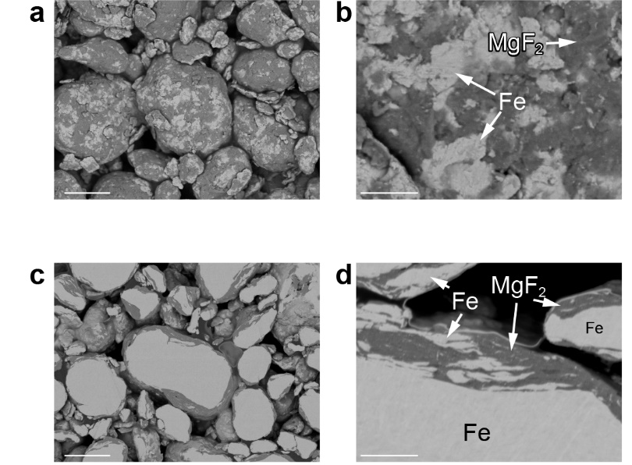

Fig. S2. SEM observation of pristine MgF₂ anode. a BSE SEM image and b magnified image of top view of pristine MgF₂ anode. c BSE SEM image and d magnified image of cross-sectional view of the pristine MgF₂ anode. Scale bars in a and c indicate 1 μm. Scale bars in b and d indicate 500 nm.

Figure S3 shows the results of compositional analysis using SEM EDS for the MgF₂ anode before and after defluorination. The formation of Mg metals in defluorinated MgF₂ anode can be expected, but there is no clear difference between the pristine and defluorinated MgF₂ anodes in the SEM EDS results. This is because the signals of MgF₂ and Mg in the depth direction overlap due to the small region of formed Mg metal. In other words, it is difficult to analyse the difluorinated MgF₂ anode by the SEM EDS method.

Fig S3. SEM EDS analysis of MgF₂ anode before/after defluorination. SEM images and SEM EDS analysis results of Mg-K and F-K in a pristine and b defluorinated MgF₂ anodes. Scale bars, 2 μm.

Supplementary Note 3. Electron diffraction analysis of region of Mg metal formation
Relative plasmon intensity I_{rp} map of Fig. 4d clearly shows the distribution of Mg metal in defluorinated MgF₂ anode. Meanwhile, the reflection from Mg metal is not detected by the electron diffraction pattern of Fig. 2e. This is because the formed Mg metals exist as very fine particles with below several nanometer sizes. It is difficult to detect the reflection of Mg metal in electron diffraction patterns recorded from wide areas. Therefore, we investigated the selected area electron diffraction obtained from the regions with the large volume ratio of Mg metals as shown in Figs. S4a and S4b.
Figure S4c shows the result of the electron diffraction pattern obtained from the region in which the Mg metal is formed. The crystal structure of Mg is hexagonal with a space group P6₃/mmc (a = b = 0.32088 nm, c = 0.52099, ICSD number 76259). The highest intensities in the diffraction pattern of the hexagonal Mg are attributed to 011 reflections as shown in Fig. S1. The Mg 011 reflections are expected to appear in the electron diffraction pattern between the 011 and 111 reflections of MgF₂. In order to improve the visibility of the 011 reflection of the hexagonal Mg, the relevant intensity region was extracted from an electron diffraction pattern as shown in Fig. S4d. The result clearly shows the bright parts derived from the 011 reflection of the hexagonal Mg.

Fig S4. Electron diffraction analysis of Mg metals. a Annular dark-field (ADF) STEM image of the defluorinated MgF₂ anode. b A relative plasmon intensity I_{rp} map from the same region as a. Scale bars, 100 nm. c An electron diffraction pattern obtained from the circled region in a and b. d Extracted intensities from electron diffraction pattern between 011 and 111 reflection of MgF₂ in c. White arrows in d indicate the Mg 011 reflections.

Supplementary Note 4. STEM EDS analysis of MgF₂ anode before/after defluorination
Figure S5 shows the results of compositional analysis of pristine and defluorinated MgF₂ anode using STEM EDS. Compared to the relative plasmon intensity map (main text in Fig. 4), the STEM EDS method cannot clearly distinguish regions of Mg metal formation. This is because the signals of MgF₂ and Mg are overlapped in depth directions. In the defluorinated MgF₂ anode, it can be seen oxygen signals on its surface. An oxide was formed on the surface as a result of electrolyte decomposition.

Fig S5. STEM EDS analysis of MgF₂ anode before/after defluorination. ADF STEM images and EDS map of F-K (yellow), Mg-K (orange), Fe-K (green) and O-K (magenta) of a pristine and b defluorinated MgF₂ anode. Composite images in a and b comprising EDS data of Mg-K (orange), Fe-K (green) and O-K (magenta) to visualize the oxygen on MgF₂ surface. Scale bars, 100 nm.

