Standard Operating Procedure (SOP) for monitoring Black Spot Syndrome in Ocean Surgeonfish

Cheyenna de Wit and Pieter Johnson
Last updated: 25 October 2023

INTRODUCTION
Recently, increasing observations of Black Spot Syndrome (BSS) have been reported to affect important fish grazers, such as surgeonfish and parrotfish, in the Caribbean Sea. Fish grazers play a key role in structuring the benthic community by grazing on macroalgae and preventing overgrowth of algae (Dennis et al. 2019). This syndrome, which manifests as pigmented dermatopathies on the skin, scales, and fins of affected fish, has been linked to an infection by a trematode parasite called Scaphanocephalus expansus (Kohl et al. 2019). Like other trematodes, S. expansus has a complex life cycle involving multiple host species across different trophic levels. The first intermediate host is a marine mollusc, likely a snail, although the specific identity of this host has not yet been established. Free-living stages of the parasite called cercariae emerge from the first intermediate host and swim through the water until they encounter a fish, wherein they encyst as metacercariae. Melanization around the cyst driven, in part, by host immune responses is what causes the appearance of spots on affected fish. These spots may make infected fish more conspicuous to the parasite’s definitive host, which is the fish-eating osprey. Osprey become infected when they consume the fish, and parasites develop into the adult form within the intestine of the bird and reproduce sexually to produce eggs. Eggs are released with the bird’s feces and redeposited in coastal habitats, where they infect the still-undermined first intermediate host. Because relatively little is known about BSS and the factor that drive variation in its severity, it is important to conduct research to measure the phenomenon across time and through space. Non-invasive methods, such as video-based transects, offer an effective technique to do so without capturing or harming affected fish. the number of spots per fish observed by divers or using video correlates positively with the number of encysted metacercariae of S. expansus (Kohl et al. 2019). This approach works most effectively with fish species on which parasite-induced spots are visually conspicuous and unlikely to be confused with natural spots or complex coloration patterns. Ocean surgeonfish (Acanthurus tractus) have proven a good species in which to investigate such questions.

DATA COLLECTION
Equipment
To effectively collect data on BSS infection, the following equipment is essential:
- Complete set of dive equipment: This includes a BCD, regulator, tanks, and other necessary gear for safe underwater diving.
- Underwater slate for communication: An underwater slate allows for clear communication between divers, enabling efficient coordination and data collection during the dives.
- GoPro camera and extendable grip (100 cm): The use of a GoPro camera is recommended, preferably a newer model that offers enhanced video quality. The improved video quality facilitates easier analysis of the recorded footage. The extension grip allows a diver to get closer to individual fish and often at a better angle.

Personnel
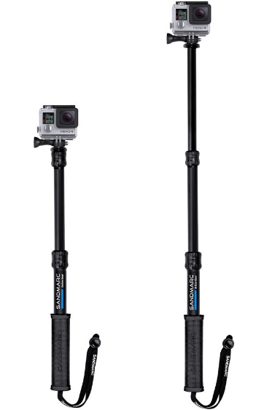
To conduct the surveys for BSS infection, a minimum of two individuals is required. Two people are also recommended for video analysis to minimize the potential for observer bias. Having at least two people involved in the surveys ensures efficient data collection, safe research practices, and enhances accuracy in observations. This allows for cross-validation and verification of findings, reducing the likelihood of individual biases influencing the results.

Optimized GoPro settings
For this research, we recommend a GoPro Hero 9 or later model. The optimum method involved attaching the GoPro to an adjustable grip fully extended (Fig. 1) (100 cm) to get a close shot of each fish. All settings should be on default and the image stabilization mode should be turned on.

Additional settings should be:
Resolution: At least 1080p (1920 x 1080). Higher resolution is possible but this can take up more hard drive space. 1080p is a good option to see the fish clearly in the videos.
Figure 1 GoPro with extendable grip
Frame rate: 60 frames per second. This will capture more detail in fast-moving scenes.
Angle: linear. However, as water scatters and absorbs light the fish should be filmed as close as possible. Wide angle options tend to reduce the size of examined fish and make it harder to count spots.
ISO: 400, should be kept as low as possible to reduce noise and maintain image quality
Sites
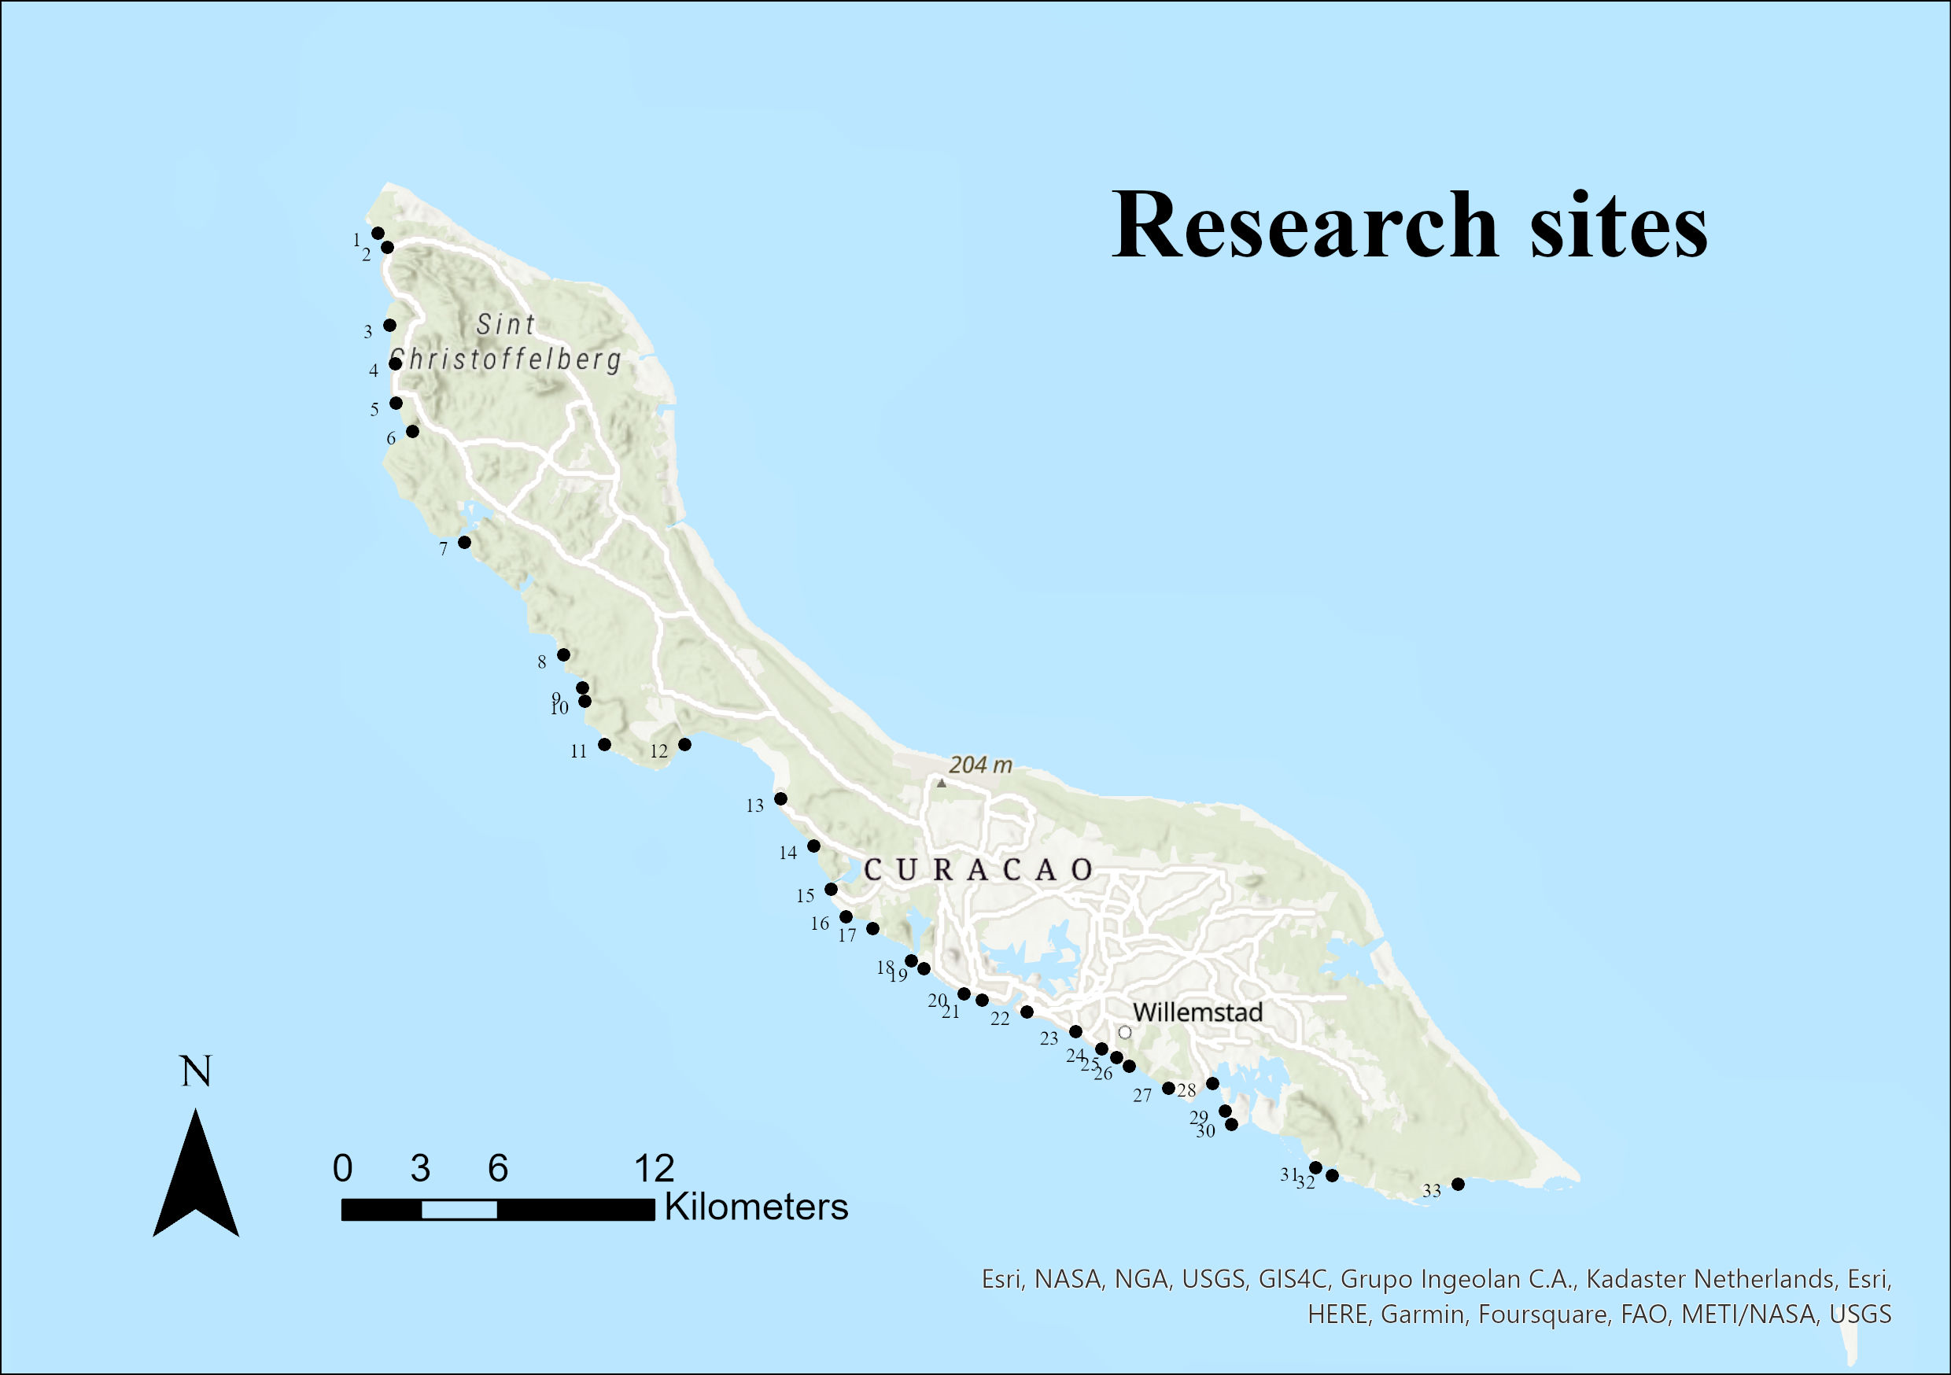
For this research, sites along the leeward coast of Curaçao were selected (Fig. 2) (see Appendix I for a full list of the sites). At each site, surveys were conducted at both 2 and 5 m meters depth. These depths were chosen based on the results of previous research, who found that BSS levels in Bonaire were highest at these depths before decreasing progressively at 12 and 18 meters (Elmer et al. 2019).
Figure 2 Map of Curaçao with all the research sites (Map made with ArcGIS pro)

SURVEY PROCEDURE: SCUBA TRANSECT SURVEYS
- We used a novel, video-based method to assess BSS presence and severity in A. tractus across 33 sites and 2 depths along the coast of Curaçao. The footage was collected at each site while SCUBA diving. Six transects were recorded at each site using a GoPro Hero 9®; three transects at 2 meters and three transects at 5 meters. Two divers both carried a GoPro® with an extendable grip. For optimal results, the GoPro® camera was positioned with the extendable grip fully extended (100 cm), helping to ensure close-up shots of the fish (Fig. 3).
- During the survey, two divers descended to different depths, with one reaching 2 meters and the other reaching 5 meters (i.e., depth of the bottom). They maintained a parallel swim path within visual range but ensured an adequate distance to avoid filming the same fish. To initiate each transect, one diver signaled the other, and simultaneously, both divers pressed the button on top of their GoPro® cameras. The divers pointed the camera to their depth gauge (dive computer) to record the depth of the transect and then briefly on their own face to make a record of who was conducting the transect. Thereafter, the divers focused on ocean surgeonfish encountered during the transect. Note that in some scenarios, divers may simultaneously swim similar depths (for instance, when achieving different depths would require them to be too far apart from one another).
- The divers followed the depth contour, maintaining an approximate speed of 0.5 meters per second. The objective was to locate and record a variable number of A. tractus specimens, typically with a minimum of 20 throughout the transect, chosen haphazardly. It is important to bring the camera close to individual fish (within 0.5 to 1 m) to allow for a detailed examination during subsequent video analysis. Achieving this often requires a slow and gentle approach, which is facilitated by the use of an extendable rod, rather than chasing after fish. Upon reaching an individual fish, the diver carefully moved the camera to obtain adequate footage of one complete side of the target fish. Subsequently, they repositioned the camera to a central transect position before proceeding to the next fish. This method ensured that the individual responsible for processing the data could easily identify and focus on the specific fish being recorded.
- For storing purposes, the recorded videos were generally no longer than 10 to 15 minutes. In the event that 20 to 30 fish were not detected within 10 minutes, the diver stopped and restarted the video recording to create a new file. When both divers were done with the transect at a particular depth, they switched depths with one another and swam another video-transect. This switch was necessary to minimize observer bias (i.e., each depth was surveyed by multiple individuals for each site). The divers switched one more time from depth for the 3rd and final transect. After both of divers recorded three transects, or six in total, the divers could finish the dive.

VIDEO PROCESSING
Once the data were collected from a specific site, the subsequent step involved processing the footage. Initially, the footage was transferred from the GoPro to a designated folder on the hard drive. It is crucial to assign a unique identifying name immediately to each video, incorporating relevant details such as the site name, date, depth, and survey number. This naming convention was implemented to ensure easy retrieval of the videos during subsequent analysis. Following this, the videos were carefully reviewed, and the pertinent information was recorded in an Excel spreadsheet. The spreadsheet contained the following general information about the transect as summary information:

- Surveyor: The name of the person responsible for analyzing the video.
- Date: The date when the footage was captured.
- Site Name: The specific name or identifier of the survey site.
- Dive Number: The unique number assigned to the survey conducted on that particular day.
- Start Time: The time at which the survey was initiated.
- Start Depth: The depth at which the survey began.
- Comments: Any noteworthy information or observations that needed to be remembered for that specific transect

Below this standard information, a few columns should be present for the counting of the black spots. Every fish that will be observed in the video will have its own row:

- File name: the name that the video file has been given
- Date: the date that the footage was analyzed
- Location: the name of the site
- Diver: the person who performed the survey
- Reviewer: the person who analyzed the video
- Time: the time of the video in minutes per seconds where the spots on the fish are counted
- Species: the species of fish that was observed
- Spots: the number of black spots that specific fish had on its body, if possible to count
- Notes: any notes about the individual fish or an explanation for why no spots could be counted (e.g., too far, too dark, bad angle).

VIDEO ANALYSIS
The analysis of the videos was conducted using VLC Media Player, a freely available program equipped with viewing tools that enhanced the efficiency of the analysis process. When a fish exhibiting BSS was observed in the video (Fig. 3), the video was paused for further examination. Specifically, for adult A. tractus fish, all the spots on one side of the fish were carefully counted, and the corresponding spot count was recorded in the "spots" column of the spreadsheet. The exact time in which the fish was observed (minutes and seconds) was also recoded. In some cases, it was necessary to play through different frames for a given fish to identify where spots could be counted most effectively. This counting process was performed in the sequence in which the fish appeared in the video. In instances where multiple fish were visible in same frame, it was necessary to indicate the location of each fish within the shot (e.g., right, left, top, bottom) in the notes section of the spreadsheet. This helped to ensure that a subsequent reviewer was able to identify the appropriate fish. If there were challenges in discerning the spot count due to factors such as distance or low visibility (e.g., the fish being too far away or too dark to observe the spots), the corresponding spot count in the spreadsheet was left blank and the reason no count was made was added to the notes column.
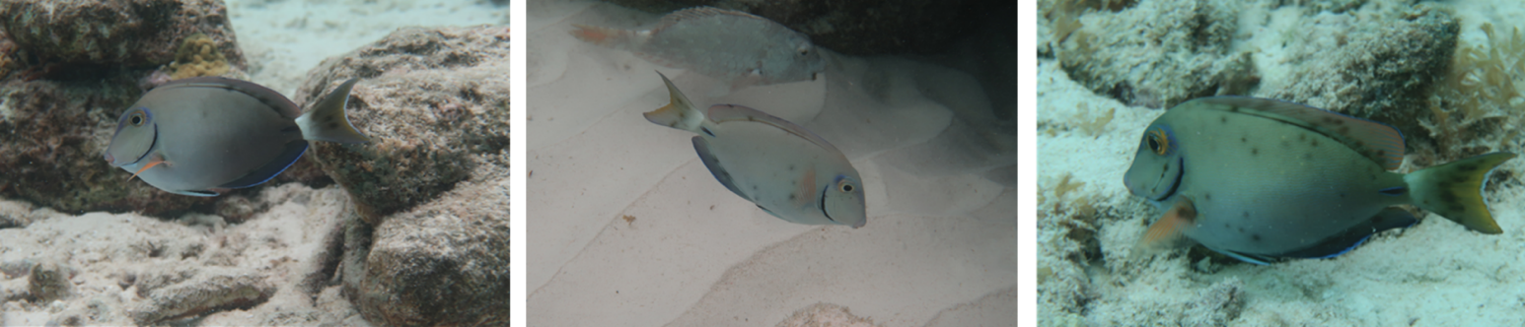
Videos were examined by at least two independent reviewers. The second reviewer was provided with the times recorded by the first reviewer, but not their spot counts. This helped to avoid confusion about the specific frame in which to count spots for each fish while still ensuring that independent assessments of BSS could be performed.
Figure 3 Still images of A. tractus. Severity of BSS infection increasing from left to right (C. de wit)

REFERENCES
Bernal MA, Floeter SR, Gaither MR, Longo GO, Morais R, Ferreira CEL, Vermeij MJ & Rocha LA (2015) High prevalence of dermal parasites among coral reef fishes of Curaçao. Mar Biodivers 46:67–74.
Dennis M, Izquierdo A, Conan A, Johnson K, Giardi S, Frye P, & Freeman M (2019) Scaphanocephalus-associated dermatitis as the basis for black spot disease in Acanthuridae of St. Kitts, West Indies. Dis of Aquat Org, 137:53–63.
Elmer F, Kohl ZF, Johnson PTJ & Peachey RBJ (2019) Black spot syndrome in reef fishes: using archival imagery and field surveys to characterize spatial and temporal distribution in the Caribbean. Coral Reefs, 38(6), 1303–1315.
Kohl ZF, Calhoun DM, Elmer F, Peachey RBJ, Leslie KL, Tkach V, Kinsella JM, & Johnson PTJ (2019) Black-spot syndrome in Caribbean fishes linked to trematode parasite infection (Scaphanocephalus expansus). Coral Reefs, 38(5), 917–930.
APPENDIX I: LIST OF SITES
Site | Dive site name | zone | Lat | Long
1 | Playa kalki | WEST | 12.37511 | -69.1574
2 | Playa Grandi | WEST | 12.36992 | -69.1541
3 | Kleine knip | WEST | 12.34292 | -69.1534
4 | Jeremi | WEST | 12.32932 | -69.1515
5 | Playa Lagun | WEST | 12.31572 | -69.1512
6 | Playa Santa Cruz | WEST | 12.30569 | -69.1454
7 | Santa Martha bay | WEST | 12.26697 | -69.1272
8 | Cas Abou | WEST | 12.22753 | -69.0927
9 | Porto Marie | MIDDLE | 12.21618 | -69.0861
10 | Daaibooibaai | MIDDLE | 12.21153 | -69.0851
11 | Bullenbaai | MIDDLE | 12.17728 | -69.0166
12 | Coral Estate | MIDDLE | 12.19642 | -69.0783
13 | Jan Kok | MIDDLE | 12.19642 | -69.0502
14 | Kokomo | CITY | 12.1608 | -69.0052
15 | Boka Sami | CITY | 12.14582 | -68.999
16 | Snake Bay | CITY | 12.13611 | -68.994
17 | Bluebay | CITY | 12.13193 | -68.9845
18 | Piscadera bay | CITY | 12.12082 | -68.971
19 | Marriot | CITY | 12.1179 | -68.9666
20 | Water factory | CITY | 12.10917 | -68.9527
21 | Double Reef | CITY | 12.10699 | -68.9464
22 | Pietermaai | CITY | 12.10288 | -68.9308
23 | Osprey tree | CITY | 12.09593 | -68.9137
24 | Marie pompoen | CITY | 12.09004 | -68.9045
25 | Mambobeach | CITY | 12.08687 | -68.8994
26 | Seaquarium | CITY | 12.08374 | -68.8949
27 | Jan Thielbaai | CITY | 12.07606 | -68.8811
28 | Caracasbaai | CITY | 12.07776 | -68.8657
29 | Tugboat | CITY | 12.0683 | -68.8614
30 | Directorsbay | CITY | 12.06352 | -68.8591
31 | Boobytrap | EAST | 12.04562 | -68.8241
32 | Newport | EAST | 12.04835 | -68.8297
33 | Eastpoint (Awa Blancu) | EAST | 12.0427 | -68.7799

