Quantifying the impact of severe bushfires on biodiversity to inform conservation
SUPPLEMENTARY INFORMATION

TABLE OF CONTENTS

Supplementary Methods
I. Assessing bushfire extent
II. Rainfall deficits
III. Forest cover dynamics

A. Forest gain, loss and annual cover

B. Protected areas

C. Forest resampling for fire analysis
IV. Flying fox analyses
A. Analyses of grey-headed flying fox foraging habitat
B. Flying fox response to the previous focal fire season (2012-2013)
Supplementary Results
V. Fire season burn metrics from 2012-2020
VI. Impact of resolution on previous focal fire season and anomalous fire season metrics
VII. Forest fragmentation
A. Fragmentation of largest contiguous forest patches
B. Forest fragmentation following fires
VIII. Difference in burned grey-headed flying fox foraging habitat between previous focal and anomalous fire season
IX. Modelling occupancy of grey-headed flying foxes

Supplementary Figures
Figure S1. Difference in generalized burned area after gap incorporation
Figure S2. Overlap in pixels between gain and loss of forest for a given year from 2001 to 2012 for eastern Australia
Figure S3. Protected Areas in eastern Australia and their overlap with forested landscapes
Figure S4. Flying fox roost sites that were included in generalized logistic mixed effects models
Figure S5. Number of unique contiguous burned areas in each fire season from September to March
Figure S6. Comparison of the distribution of 2012-2013 fire sizes at different resolutions
Figure S7. Comparison of the distribution of 2019-2020 fire sizes at different resolutions
Figure S8. Distribution of fire sizes for 2012-2013 and 2019-2020 at 1120m resolution
Figure S9. Fragmentation of one of the largest forest patches in 2012
Figure S10. Reduction in forest patches after fires
Figure S11. Extent of 2012-2013 fire in grey-headed flying fox habitats
Figure S12. Total habitat burned (in hectares) for previous focal fire season and the anomalous fire season
Figure S13. Proportion change of critical winter diet species in all grey-headed flying fox habitat post-fire
Supplementary Tables
Table S1. Longitudinal roost variables
Table S2. Burned area metrics in hectares (ha) from 2012-2020 to show distribution of
fire sizes for 440m resolution
Table S3. Burned area metrics in hectares (ha) from focal years to show distribution of fire sizes and overlap with forest cover for 440m resolution with gaps incorporated (440H)
Table S4. Burned area metrics in hectares (ha) from focal years to show distribution of fire sizes and overlap with forest cover for 1120m resolution
Table S5. Univariate logistic mixed effects regression

SUPPLEMENTARY METHODS

I. Assessing bushfire extent

We retrieved near real-time and archive fire data from NASA’s Fire Information for Resource Management System (FIRMS)¹. VIIRS data has been validated for calculating burned area for long-lasting fires ², and has higher spatial and temporal resolution than other remotely sensed products. These data are available globally. LANDSAT-derived burned area provides a 30m spatial resolution estimate of burned area ³, but are produced only for the conterminous US. FIRMS offers spatial products of fire incidence from Moderate Resolution Infrared Spectroradiometer (MODIS) Terra and Aqua EOS with a resolution of 1km and NPP Visible Infrared Imaging Radiometer Suite (VIIRS) aboard the Suomi-NPP and NOAA-20 satellites with a resolution of approximately 375 meters or 750 meters ¹. The Suomi-NPP satellite instruments provides full global coverage every 12 hours, compared to every 24-48 hours for MODIS Terra and Aqua EOS ^{1, 4}. VIIRS data has been validated across a variety of ecosystems, including extents observed here and found low false positive active fire cases ⁵ and high concordance with LANDSAT imagery ². This remotely sensed data is best suited for higher intensity fires within forests that last multiple days, and these are also the fires that are most important for mapping impacts on wildlife in Australia. It is possible, and likely, that this data overestimates burns in gallery forests and other fire refugia ^{2, 6}. Individual pixels are not subdivided, and microclimate may protect certain habitat patches within a large fire, which we will not be able to detect without higher resolution LANDSAT data or ground surveys.

The fire season in New South Wales generally occurs across spring and can include summer ⁷; we retrieved data from September 1, 2019 to March 1, 2020 on the dates of January 6, 2020, January 15, 2020 and March 16, 2020. We also retrieved archived fire data from September 1, 2012 to March 1, 2013 on January 15, 2020 to compare this previous focal fire season to the anomalous fire season in 2019-2020. Lastly, we retrieved archived fire data from September 1 to March 1 for intervening fire seasons on May 31, 2020 for annual comparison.

We acquired Fire Hotspot data in two different shapefile formats consisting of point data, Near Real-Time (NRT) data and Archive data. Near Real-Time data are VIIRS Active Fire and Thermal Anomalies points that are processed by Land, Atmosphere Near real-time Capability for EOS (LANCE) and FIRMS. These data are readily available but have not been standardized for quality. Archive data contain VIIRS Active Fire and Thermal Anomalies points that have been processed at the University of Maryland with a 3-month lag¹. These standardized data replace the NRT files when available. Both data types contain key metadata such as Latitude, Longitude, Scan pixel size, Track pixel size, Acquisition Date/Time, Confidence, and Fire Radiative power. The archival data contains an additional field from processing which classifies the fire anomaly to one of four classes: presumed vegetation fire, active volcano, other static land source, or offshore detection for detections over water.

VIIRS Active Fire and Thermal Anomaly points are derived from a hybrid thresholding and contextual algorithm ¹. It is based on a dual gain high saturation temperature mid-infrared channel, band M13, and single gain thermal infrared channel, band M15 ⁵. These spectral bands capture data in the range of 4 microns and 11 microns, respectively. Additional I-bands channels are also used for cloud masking, sun glare, and rejection of false positives ¹. This combination algorithm classifies pixels as thermal anomalies or “hotspots”, indicating there is a fire incident occurring in the pixel and places a thermal anomaly point at the center of the cell ¹. Thermal anomalies detected at or near the vertices of pixels results in pixel saturation, where all pixels touching that vertex receive an active fire point.
Due to NPP Suomi Satellite’s multiple collection dates, various passes, and scan angle, each point does not represent a 375-meter by 375-meter pixel or a 750-meter by 750-meter pixel. Rather, each point contains a scan distance and track distance that represent the spatial resolution of that point. The scan represents the spatial resolution in the East-West direction while the track distance represents the North-South spatial resolution ¹. To estimate the total burned area from FIRMS active fire data, we applied the process described below to the 2012-2013 VIIRS FIRMS data and the 2019-2020 FIRMS data. Thermal anomaly points were processed in R version 3.5.3 ⁸ and the resulting polygon vector layers of extrapolated burned area were processed in ArcGIS Pro Version 2.5.0 ⁹.

Shapefiles of thermal anomaly points and all resulting polygon vectors were processed in the WGS84 Australian Albers Equal Conical projection. The FIRMS point data was converted to a raster at 440 meters and 1120 meters resolution to represent the highest and coarsest spatial resolution pixels in the data, respectively. The cell sizes were calculated based on the diagonal distance between points for the highest resolution and coarsest resolution scan and track pixels size for Australia. The resulting rasters were converted to square polygon vectors for subsequent analyses.

The square fire polygon vectors converted from the 440m raster were also used to incorporate small, ‘unburned’ patches to prevent underestimating burnt area missed due to satellite passes. This was done by first filling the gaps completely surrounded by the polygon vector of fire extent using the Eliminate Polygon Part tool in ArcGIS, followed by isolating these gaps with the Symmetrical Difference tool. Gaps with perimeter-to-area ratios greater than 3.5 to were selected for to account for isolated or diagonal gaps which likely reflect the artifact of the satellite path rather than true breaks in burned extent. Gaps with a perimeter-to-area ratio greater than 3.5 represent gaps in the fire extent that are single pixels or entirely diagonal gaps with no shared sides, and are likely not true breaks in the fire front. Gaps with a perimeter-to-area ratio less than 3.5 share at least one common side and are more likely to represent true breaks in the fire extent. Remaining gaps were then assessed for forest cover and those with >20% forest cover were incorporated into the polygon vector layer representing the 440m analysis of fire extent (Figure S1b).
Figure S1. Difference in generalized burned area after gap incorporation. (a) VIIRS thermal anomaly points generalized to burned area at 440m resolution with gaps in fire extent, likely artifact of satellite passes and not true breaks in fire. (b) Generalized burned area at 440m resolution with gaps assessed for perimeter to area ratio >3.5 and >20% forest cover incorporated to prevent underestimation of fire extent, also referred to as 440H.
For each of the three fire layers (440m, 440m with gaps incorporated (440H), and 1120m resolution), several metrics were calculated for the previous focal fire season and the anomalous fire season. These metrics include: total burned area, number of unique fires (the number of unconnected polygons), proportion of area burned by ‘moderately-sized’ fires (>100 ha), proportion of area burned by ‘mega-’ fires (>10,000 ha), and distance from burned areas to unburned areas.

II. Rainfall deficits

Rainfall deficits in the months preceding the focal fire season and anomalous fire season were quantified using Bureau of Meteorological cumulative monthly rainfall at a resolution of 5km ¹⁰. The sum of the average monthly cumulative rainfall from March to November over a 30-year period (1989-2019) was used to calculate the deficits for both 2012 and 2019.

III. Forest cover dynamics

IIIA. Forest gain, loss and annual cover
We used remotely sensed high-resolution (1 arc second, 30 m) global forest cover change data to quantify annual forest cover of eastern Australia ¹¹. This product details the percentage canopy closure for all vegetation taller than 5m in height and loss of forest from 2001- 2018 (data version 1.6). Canopy cover is only available for each pixel in 2000. This forms the base map for all calculations. We used a 20% cutoff (< or = 19% canopy was not considered forest) to develop a binary raster of forest cover for the region of interest (eastern Australian states of Queensland, New South Wales, Australian Capital Territory, and Victoria). Forest gain is only calculated in the original release (v.1.1, 2012) and is a binary variable for forest gain from 2000-2012. We assumed that forest gain was measured in between 2011 and 2012 for purposes of calculations, justified by finding very little overlap in pixels that have both gain and loss from 2009-2012 (Figure S2). To calculate forest cover in 2018, we removed pixels with loss from 2000 to 2011 from the base forest cover map, then added pixels with forest gain, and then removed loss from 2012 to 2018. Finally, pixels with water or roads were removed from the raster layer (see code for step-by-step calculations). The code was adapted to estimate the forest cover for each year.

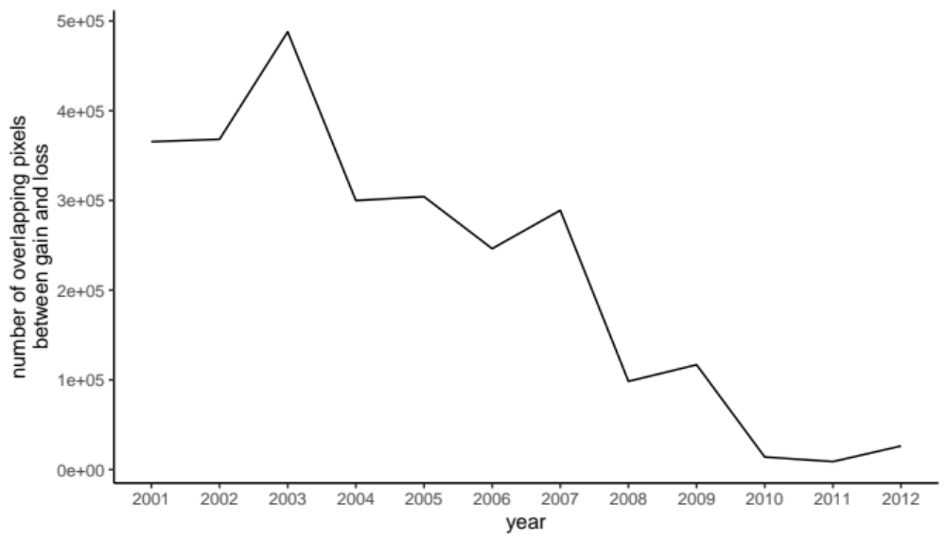

Figure S2. Overlap in pixels between gain and loss of forest for a given year from 2001 to 2012 for eastern Australia. The majority of gain occurs in pixels that are lost early, which makes sense, as the algorithm only detects canopy 5m or greater. There is a slight increase in overlapping pixels in 2009, this overlap is concentrated in Victoria where the Black Saturday Fires lead to significant loss in canopy but some of these areas were able to recover and appear as gained forest by 2012.

Because of the high resolution of the raster data, the eight tiles (10’ x10’) that cover eastern Australia were first clipped to GADM state boundaries (including New South Wales, Queensland, Victoria, and Australian Capital Territory) and analyzed separately. Each of the tiles overlaps with one pixel of adjacent tiles, so they were mosaiced using the maximum value of overlapping pixels (they were all equal). The mosaiced forest cover was then projected into WGS84 Australian Albers Equal Conical projection for identification of forested patches and areas. Forest patches were grouped by forest pixels that shared edges (but not vertices, we used the ‘rook’ method) and the total number of forest patches were calculated.
The remotely sensed forest data doesn’t include any new forest growth from 2012-2018 ¹¹, while this may overestimate forest loss it is unlikely to omit grey-headed flying fox food resources as many species take a minimum of 20-30 years to mature and provide nectar ¹². Additionally, forest gain in Australia is primarily within forestry plantations with limited habitat value for a wide range of biodiversity¹³.

IIIB. Protected areas
Protected areas cover a diversity of habitats in eastern Australia. Protected areas are geographically defined areas that are designated or regulated and managed to achieve conservation objectives. The protected areas used here are from the UN Environment and International Union for Conservation of Nature World Database on Protected Areas ¹⁴. Much of the remaining forest in eastern Australia is within protected areas or adjacent to protected forests (Figure S3).

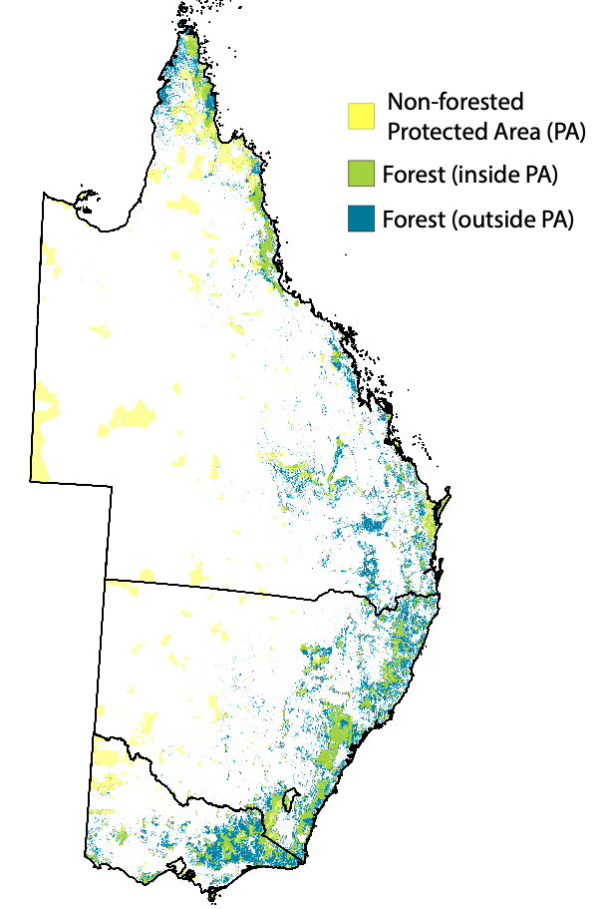

Figure S3. Protected Areas in eastern Australia and overlap with forested landscapes. Protected areas (as defined by IUCN and UNEP) are shown as a transparent yellow layer for eastern Australia. Forest cover (>20% canopy) in 2018 at 30 m resolution is shown in transparent blue. Overlap between protected areas and forests are shown in green. Much of the remaining forests are found in protected areas, particularly in New South Wales.

IIIC. Forest resampled for fire analysis
Because forest cover resolution (30m) was much higher than burned area resolution (440m), we used the Resample tool in ArcGIS to create a 440m resolution raster of forest cover. We used the Maximum Combined Area cell assignment, where the majority of landcover type at the 30m resolution was used to assign the landcover type of that pixel at the 440m resolution forest cover. We used the resampling tool for 2012 and 2018 forest cover, the best approximations for forest cover in the years preceding the previous focal fire season and the anomalous fire season, respectively.

To quantify total burned area of forest cover in each year, we used the Intersect tool on the square fire polygon vectors at the 440m resolution with the 2012 and 2018 resampled forest cover layers. To identify areas of unburned forest cover, we used the Erase tool to removed burned area from the resampled cover layers for the respective years. From the resulting raster, we quantified the number and size of unburned forested patches presented in Figure 3c in the main text. For all other forest data presented in the main text, we used the 30m resolution data (Figure 3a,b).

IV. Flying fox analyses

IVA. Analyses of grey-headed flying fox foraging habitat
Grey-headed flying fox foraging habitat data were made available by the NSW Sharing and Enabling Environmental Data (SEED) Portal. The Department of Planning, Industry, and Environment published these data in 2008. The data contain polygons of productive vegetation communities used by grey-headed flying foxes ¹⁵. These data list diet species and bi-monthly flowering scores of polygons based on productivity, reliability, and abundance of native Myrtaceae diet species in those patches. We updated these data to account for forest loss since 2008, as reflected by the 2012 and 2018 Hansen forest cover data set ¹¹. We created a 50km buffer around all roosts occupied (details below) from 2007-2012 and 2014-2019 to represent their maximum foraging areas. Vegetation communities and total area of habitat within these foraging buffers were evaluated pre-burn and post-burn for each roost. We calculated areas of burned vegetation resources by clipping the square fire polygon vectors at the 440m resolution to the Hansen forest cover layers and intersecting that layer with each roosts’ 50km buffer. We assume that composition of vegetation communities in the grey-headed flying fox habitat used in the case study remained constant since 2008, and only accounted for forest loss that can be detected remotely.

To estimate the extent of winter diet species burned, the immediate foraging area was selected for patches that contained at least one of these five critical winter diet species: Eucalyptus robusta, E. tereticornis, E. siderophloia, Melaleuca quinquenervia, and Banksia integrifolia. Patches containing productive winter species were assessed pre-burn and post-burn using the same method to quantify total burned habitat. The proportion of total area burned was also assessed for each of the five winter diet species by calculating the total extent of the patches containing these species pre-burn and intersecting this with the generalized burned area layers.

IVB. Flying fox response to the previous focal fire season (2012-2013)
Ninety-six roosts were observed at least four times in the year preceding and following the fires in Queensland (Figure S4). We created univariate and multivariate logistic regression mixed effects models with roost and time-specific variables in the 50km foraging radius (Table S1).

Table S1. Longitudinal roost variables.
Category | Predictor variable | Description | Range (before rescaling)
Temporal | Season | meteorological seasons | Categorical (summer (Dec 1-Feb 28/29); autumn (Mar 1- May 29); winter (June 1-Aug 30); spring (Sept 1-Nov 30)
 | Relative fire | Pre- (Dec 2011-Nov 2012) or Post- (Mar 2013-Feb 2014) | binary (0, 1)
Environment | Total habitat burned | Area of burned total habitat within foraging habitat in a 50km radius (0 before fire) | 0 – 25,812 ha
 | Winter habitat burned | Area of burned winter habitat within foraging habitat in a 50km radius (0 before fire) | 0 – 10,214 ha
 | Total remaining habitat | Area of unburned (post fire) foraging habitat in a 50km radius | 14 – 44,1787 ha
 | Total winter remaining | Area of unburned (post fire) winter habitat in a 50km radius | 0 - 18,0750 ha
 | Proportion total burned | Proportion of total foraging habitat that was burned (all pre-fire observations = 0) | 0 – 0.199
 | Proportion winter burned | Proportion of total foraging habitat that was burned (all pre-fire observations = 0) | 0 – 0.231
 | Distance to burned area | distance in meters to closest burned area within the foraging radius (all pre-fire observations set to maximum value of 50000 meters) | 0 – 50,000 m
Ecology | Black Flying Fox occupancy | Black flying foxes present at the same observation | binary (0, 1)

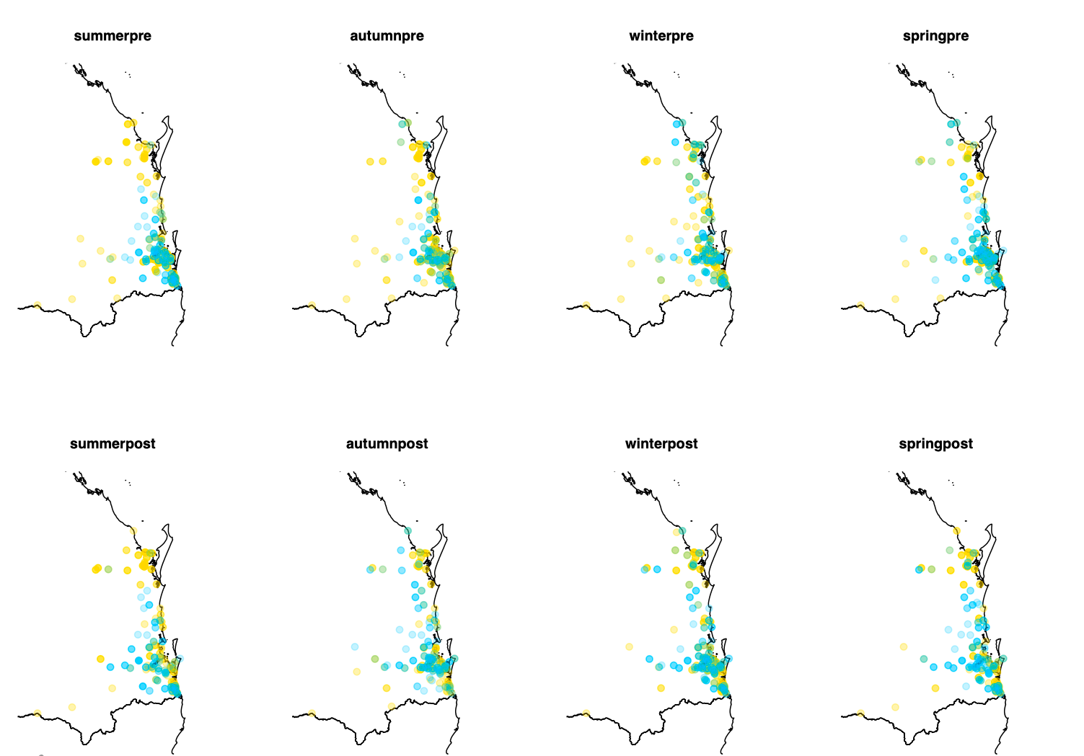
Figure S4. Flying fox roost sites that were included in generalized logistic mixed effects models. The points indicate roosts that were observed in the season indicated on the map subset. Blue indicates presence of grey-headed flying foxes, whereas yellow indicates roosts not occupied by grey-headed flying foxes. Roosts that were observed occupied and unoccupied within a season are colored green. Darker shades indicate more frequent observations in the time period.

SUPPLEMENTARY RESULTS

V. Fire season burn metrics from 2012-2020

The 2019-2020 bushfires had similar numbers of fires to many other years from 2012-2020 (highlighted in gold, Figure S5). Two seasons, both the previous focal fire season 2012-2013 examined in the main text and 2017-2018, had over 60,000 unique fires.

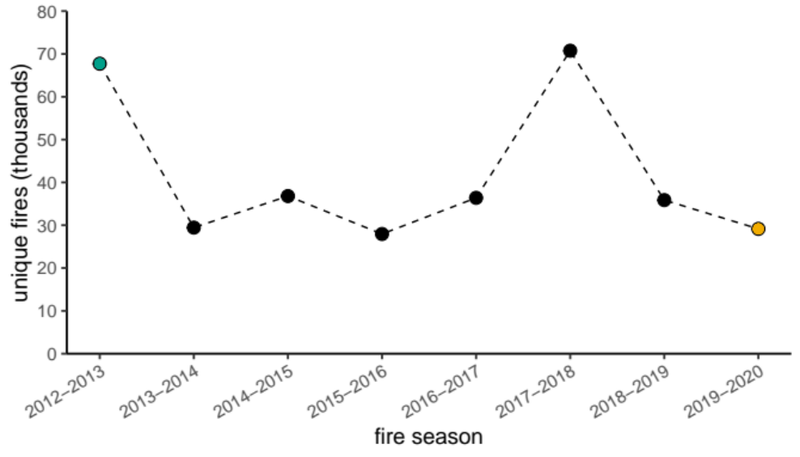
Figure S5. Number of unique contiguous burned areas in each fire season from September to March.

VI. Impact of resolution on previous focal fire season and anomalous fire season metrics

Incorporating gaps into the square fire polygon vector at the 440m resolution connected burned patches and decreased the total number of unique contiguous burned areas for both fire seasons. In the anomalous season, this increased the total area burned by 173,891 ha, which is much greater than the total area burned increase of 39,959 ha during the previous focal fire season. This may be due to the difference in quality between the Archived data used to analyze the previous focal fire season and the Near Real Time data used for the anomalous fire season. The increase in total burned area subsequently increased the proportion of burned area in moderately-sized fires, mega-fires, and burned area of forest cover for both fire seasons. Incorporating gaps with >20% forest cover into the highest resolution fire extent and may more accurately account for fire behavior on the landscape and better represent the total realized burned area.

The coarsest spatial resolution analysis using a pixel size of 1120m for generalized fire extent overestimates total burned area. At this resolution, the number of unique contiguous burned areas declines and the total burned area increases drastically. In the previous focal fire season, the total burned area more than doubles at this resolution. This is likely due to large number of isolated fires smaller than 100 ha that were observed at the 440m resolution. In the anomalous fire seasons, much of the thermal anomaly data is spatially clustered, so expansion of the fire extent to the 1120m resolution connects already burned areas and thus increases the total burned area, though less than it did for the previous focal fire season.

Moderate size fires are defined as contiguous burned areas of 100 ha or greater and mega-fires are contiguous burned areas that are 10,000 ha or greater. At a resolution of 1120m, which is the coarsest resolution of thermal satellite data, the minimum fire size that is possible to detect is greater than 100 ha, so we calculate moderately sized fires as fires greater than the area of one 1120m pixel, or 126 hectares (Table S4).

Table S2. Burned area metrics in hectares (ha) from 2012-2020 to show distribution of fire sizes for 440m resolution. Moderately-sized fires are defined as fires greater than 100 ha. *The proportion of the total area is shown in parentheses.
Fire Season | Number of unique contiguous burned areas | Burned Area of Moderately-sized Fires (ha) | Burned Area of Mega-Fires (ha) | Total Burned Area (ha)
2012-2013 | 67,722 | 6,575,236.80  (0.775) | 1,456,026.88  (0.171) | 8,479,505.76
2013-2014 | 29,440 | 2,853,644.64  (0.776) | 815,714.24  (0.222) | 3,678,032.16
2014-2015 | 36,806 | 2,162,899.20  (0.672) | 255,745.60  (0.079) | 3,217,806.24
2015-2016 | 27,947 | 1,598,961.76  (0.667) | 175,692.00  (0.073) | 2,398,858.88
2016-2017 | 36,389 | 2,041,453.92  (0.663) | 261,282.56  (0.085) | 3,080,601.92
2017-2018 | 70,755 | 2,750,552.64  (0.571) | 294,465.60  (0.061) | 4,815,199.84
2018-2019 | 35,865 | 2,956,291.35  (0.744) | 790,565.60  (0.200) | 3,972,091.20
2019-2020 | 29,148 | 7,226,449.12  (0.900) | 5,018,634.72  (0.625) | 8,025,494.40

Table S3. Burned area metrics in hectares (ha) from focal years to show distribution of fire sizes and overlap with forest cover for 440m resolution with gaps incorporated (440H). *The proportion of the total area is shown in parentheses.
Fire Season | Number of Unique Contiguous Burned Areas | Burned Area of Moderately-sized Fires (ha) | Burned Area of Mega-Fires (ha) | Total Burned Area (ha) | Total Burned Area of Forest Cover (ha)
2012-2013 | 67,692 | 6,615,970.24  (0.777)* | 1,479,568.64  (0.174) | 8,519,464.8 | 1947886.155  (0.229)
2019-2020 | 29,071 | 7,401,947.52  (0.903) | 5,180,968.32  (0.632) | 8,199,385.92 | 5480021.005  (0.668)

Table S4. Burned area metrics in hectares (ha) from focal years to show distribution of fire sizes and overlap with forest cover for 1120m resolution. Moderately-sized fires are defined as fires greater than 126 ha. *The proportion of the total area is shown in parentheses.

Fire Season | Number of unique contiguous burned areas | Burned Area of Moderately-sized Fires (ha) | Burned Area of Large Fires (ha) | Total Burned Area (ha) | Total Burned Area of Forest Cover (ha)
2012-2013 | 13,767 | 19,387,880.96  (1.00) | 11,004,224  (0.568) | 19,387,880.96 | 3,800,550.329  (0.196)
2019-2020 | 7,787 | 13,737,812.48  (1.00) | 9,818,690.56  (0.715) | 13,737,812.48 | 7,322,182.64  (0.533)

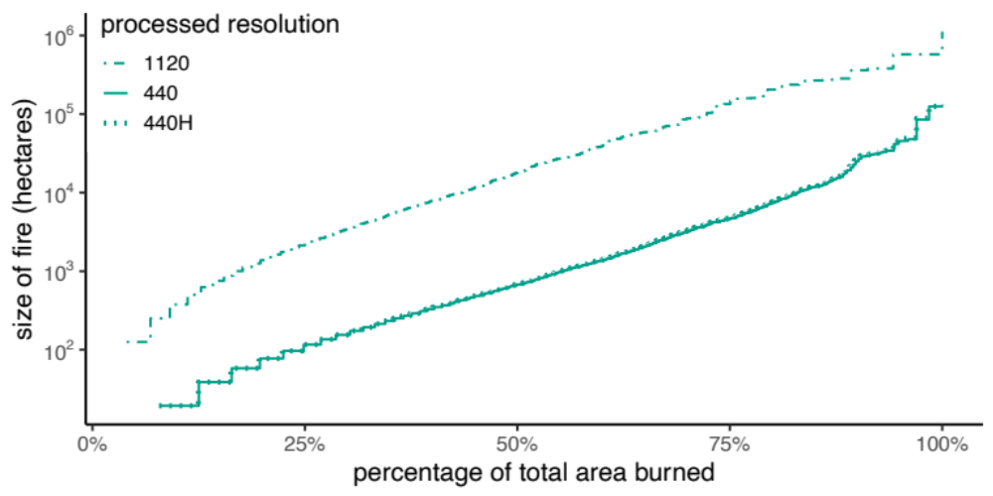

Figure S6. Comparison of the distribution of 2012-2013 fire sizes at different resolutions. The 440m resolution is presented in the main text and is very similar to the 440H (440m with gaps incorporated). There is a very slight difference at the largest fire sizes. Burned area calculated at 1120m resolution is much greater than those at 440 m, and this is the case across all fire sizes. The accumulation is mostly parallel to the 440m resolution, suggesting the smallest fires are responsible for most of the difference.

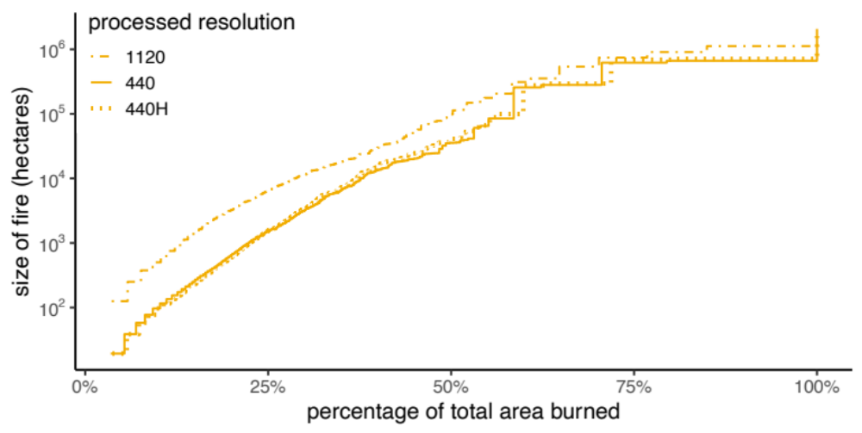

Figure S7. Comparison of the distribution of 2019-2020 fire sizes at different resolutions. The 440m resolution burned area is again very similar to 440H. The 1120 m resolution also showed the greatest difference between the smallest fires, as was observed with the 2012-2013 fires, but the difference was less extreme.

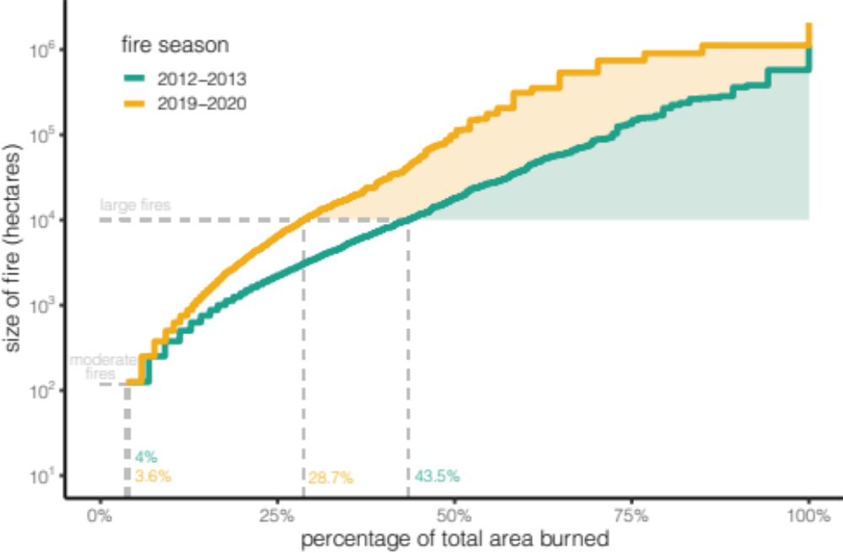

Figure S8. Distribution of fire sizes for 2012-2013 and 2019-2020 at 1120m resolution

VII. Forest fragmentation

VIIA. Fragmentation of largest contiguous forest patches
We focused on contiguous forest patches that are over 100,000 ha to quantify how forests have changed from 2012 to 2018 (closest approximation to 2019). The 28 patches covered the full extent of eastern Australia. All patches declined in the total forest area remaining in continguous patches through deforestation or fragmentation. Most patches also had a reduction in the proportion of forested habitat that can be considered high quality (>100m from forest edge), however a few patches that lost a lot of area through fragmentation increased in the proportion of core forest (Figure S9).

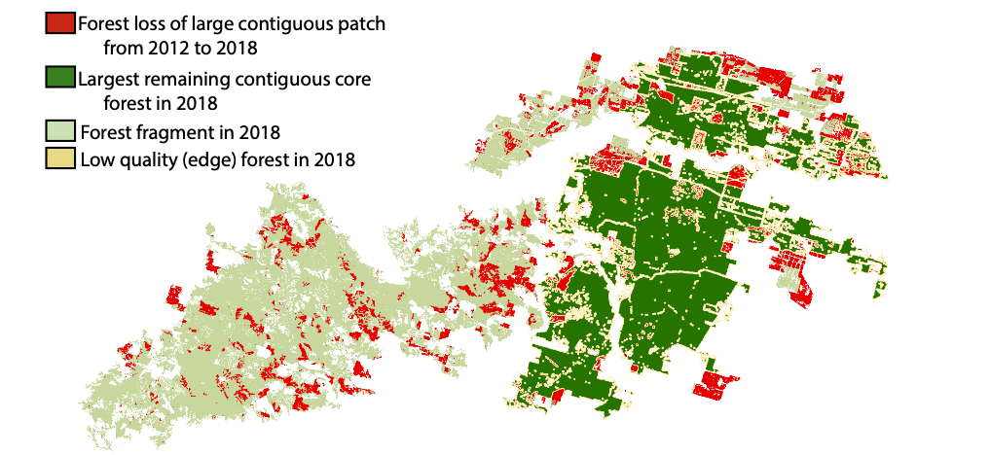

Figure S9. Fragmentation of one of the largest forest patches in 2012. One of the largest contiguous forest patches decreased by over one-half through fragmentation of the forest patch. The proportion of core area in the largest remaining fragment actually increased, because patches with denser edges were fragmented from the largest contiguous patch.

VIIB. Forest fragmentation following fires
Although total area of usable forest habitat declines following fires in both the previous focal and anomalous fire seasons, the extent of burning in forest is greater in the anomalous fires. Both fire seasons reduce the number of patches within the smaller forest size classes. However, the anomalous fires also break up larger forest patches, increasing the total number of forest patches but decreasing their size.

VIII. Difference in burned grey-headed flying fox foraging habitat between previous focal and anomalous fire seasons

We assessed the total area in hectares and the proportion of burned foraging habitat for each roost for the previous focal fire season and the anomalous fire season (Figure 4, Figure S11, S12). The previous focal fire season minimally affected grey-headed flying fox foraging habitat (Figure S11b), and correspondingly, minimally affected winter foraging habitat. The majority of winter habitat at various latitudes remained unburned after the previous focal fire season (Figure S11c-h). A greater extent of habitat burned in the anomalous fire season compared to the previous focal fire season at the roost level (Figure S12) and landscape metrics of the proportion of critical winter diet species burned (Figure S13).
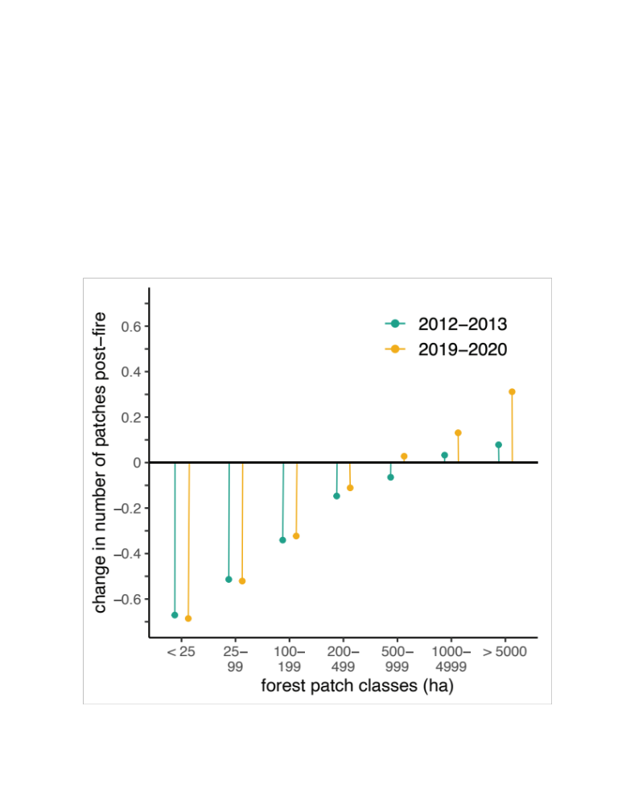
Figure S10. Reduction in forest patches after fires. Proportional change in number of unique forest patches from pre- to post-fire across a range of patch size classes. An increase in the number of forest patches in larger class sizes is due to the very large patches breaking up into smaller patches (but still within the size class). This increase in patch number is greater in the 2019-2020 fires compared with 2012-2013 fires.

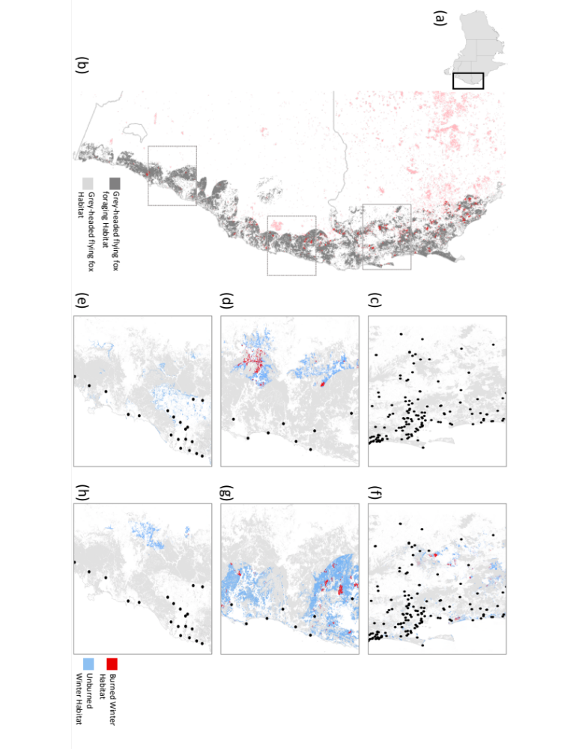

Figure S11. Extent of 2012-2013 fire in grey-headed flying fox habitats. (a) Area of interest, grey-headed flying fox habitat in Queensland and New South Wales is indicated on the map of Australia. (b) Recently occupied roosts before the 2012-2013 fire season show burned flying fox habitat within foraging radii indicated in dark red. Light red indicates burned habitat outside the foraging range of roosts. Areas of interest in boxes are shown in winter habitat in panels c-h. Panels (show roosts in black points and all available winter habitat outside (c-e) and inside (f-h) roost foraging radii. Light grey highlights total habitat.
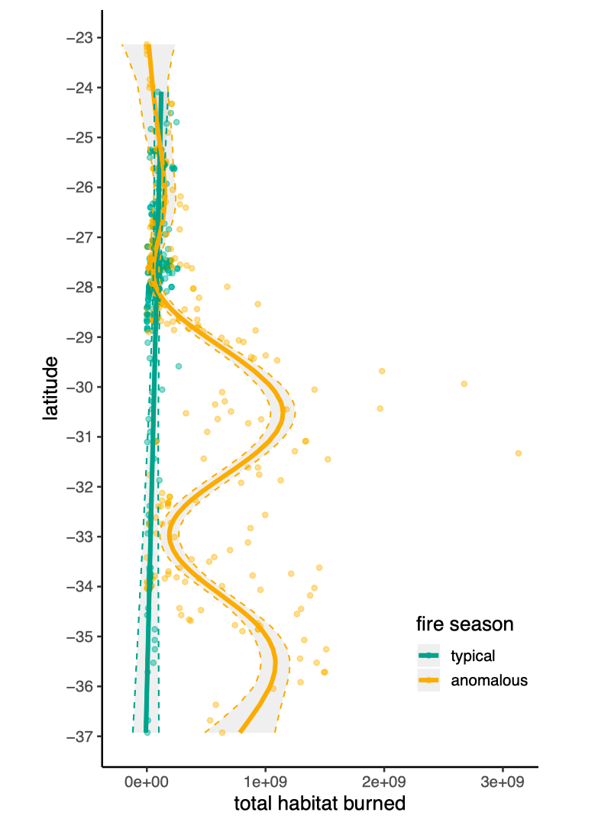
Figure S12. Total habitat burned (in hectares) for previous focal fire season and the anomalous fire season. The lines are generalized additive models fit to year and latitude and explain 32% of variation observed.

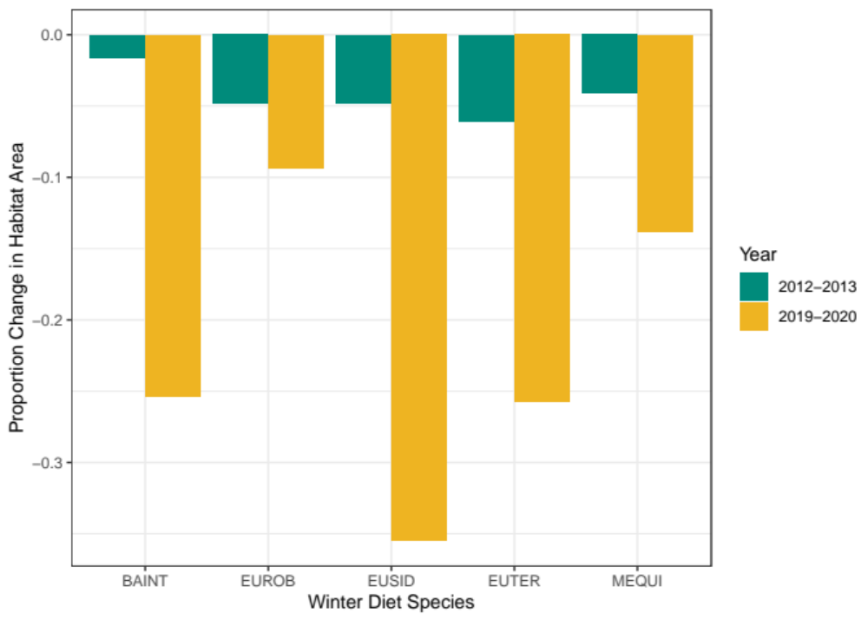
Figure S13. Proportion change of critical winter diet species in all grey-headed flying fox habitat post-fire. Change in the area of habitat containing at least one of the five critical winter diet species burned in the previous focal fire season and the anomalous fire season. Abbreviations of species are BAINT (Banksia integrifolia), EUROB (Eucalyptus robusta), EUSID (E. siderophloia), EUTER (E. tereticornis), and MEQUI (Melaleuca quinquenervia).

IX. Modelling occupancy of grey-headed flying foxes

To predict the location of grey-headed flying foxes in the years surround the 2012-2013 fires and assess if any fire-related environmental characteristics could predict their roost occupancy, we used logistic mixed effects regression models ^{16, 17}. Before running the regression models, we tested for spatial autocorrelation of the data. However, we did not find any evidence of spatial autocorrelation in counts or presence using either a set number of neighboring roosts (K= 1-10) or a geographic distance (no autocorrelation at these ranges: 10km, 50 km, 100km, 200 km). Therefore, only accounting for temporal autocorrelation by including roost ID as a random effect should be sufficient for accounting for repeated observations at roosts.

To build statistical models, we first rescaled all area metrics from 0-1 to improve the ability to fit the wide range of scales (see Table S1 for unscaled ranges). The rescaled areas and other predictor variables were fit to a logistic regression mixed effects model using the ‘bobyqa’ optimizer and roost ID as the random variable. While many of the predictor variables are significant in a univariate regression (Table S5), multivariate models had a much better fit and many of the predictor variables were excluded in a stepwise manner to improve fit and reduce complexity (see Main Text for final multivariate model).

Table S5. Univariate logistic mixed effects regression. Estimates and p-values for univariate logistic mixed effects models for each of the predictors. (*) indicates a p-value <0.05.
category | Predictor variable |  | Estimate | Pr(>|z|)
Temporal | Season | Autumn | - | -
 |  | Spring | 0.724 | *<0.001
 |  | Summer | 0.0267 | 0.871
 |  | Winter | 0.396 | *0.0115
 | Relative fire |  | 0.274 | *0.018
Environment | Total habitat burned |  | 1.121 | *<0.001
 | Winter habitat burned |  | 1.060 | *0.002
 | Total remaining habitat |  | 0.967 | 0.396
 | Total winter remaining |  | 2.707 | *0.024
 | Proportion total burned |  | 9.315 | *<0.001
 | Proportion winter burned |  | 7.843 | *<0.001
 | Distance to burned area |  | -0.313 | *0.015
Ecology | Black Flying Fox occupancy |  | 4.609 | *<0.001

REFERENCES:
1. LANCE FIRMS. NRT VIIRS 375 m Active Fire product VNP14IMGT. (ed (ESDIS) NsESDaIS). NASA (2020).

2. Oliva P, Schroeder W. Assessment of VIIRS 375 m active fire detection product for direct burned area mapping. Remote Sensing of Environment 160, 144-155 (2015).

3. Department of the Interior U.S. Geological Survey. LANDSAT Burned Area (BA) Product Guide.) (2018).

4. LANCE FIRMS. MODIS Collection 6 NRT Hotspot / Active Fire Detections MCD14DL.) (2020).

5. Schroeder W, Oliva P, Giglio L, Csiszar IA. The New VIIRS 375 m active fire detection data product: Algorithm description and initial assessment. Remote Sensing of Environment 143, 85-96 (2014).

6. Collins L, Bennett AF, Leonard SW, Penman TD. Wildfire refugia in forests: Severe fire weather and drought mute the influence of topography and fuel age. Global Change Biology 25, 3829-3843 (2019).

7. Luke RH, McArthur AG. Bushfires in Australia. (ed Organization FaTBCSaIR) (1986).

8. R Core Team. R: A Language and Environment for Statistical Computing.). R Foundation for Statistical Computing, (2019).

9. ESRI. ArcGIS Pro ). Version 2.5.0 edn (2020).

10. Bureau of Meteorology. High resolution monthly and multi-monthly rainfall gridded datasets from 1900 onwards.) (2020).

11. Hansen MC, et al. High-resolution global maps of 21st-century forest cover change. Science 342, 850-853 (2013).

12. Law B, Mackowski C, Schoer L, Tweedie T. Flowering phenology of myrtaceous trees and their relation to climatic, environmental and disturbance variables in northern New South Wales. Austral Ecology 25, 160-178 (2000).

13. Montreal Process Implementation Group for Australia and National Forest Inventory Steering Committee. Australia’s State of the Forests Report 2018.). Commonwaelth of Australia (2018).

14. UNEP-WCMC. User Manual for the World Database on Protected Areas and world database on other effective area-based conservation measures.) (2019).

15. Eby P, Law B. Ranking the feeding habitat of grey-headed flying foxes for conservation management. Department of Environment and Climate Change (NSW), Sydney, (2008).

16. Bates D, Mächler M, Bolker B, Walker S. Fitting linear mixed-effects models using lme4. J Stat Softw 67, 1-48 (2015).

17. Bolker BM, et al. Generalized linear mixed models: a practical guide for ecology and evolution. Trends in ecology & evolution 24, 127-135 (2009).

