Supplementary materials
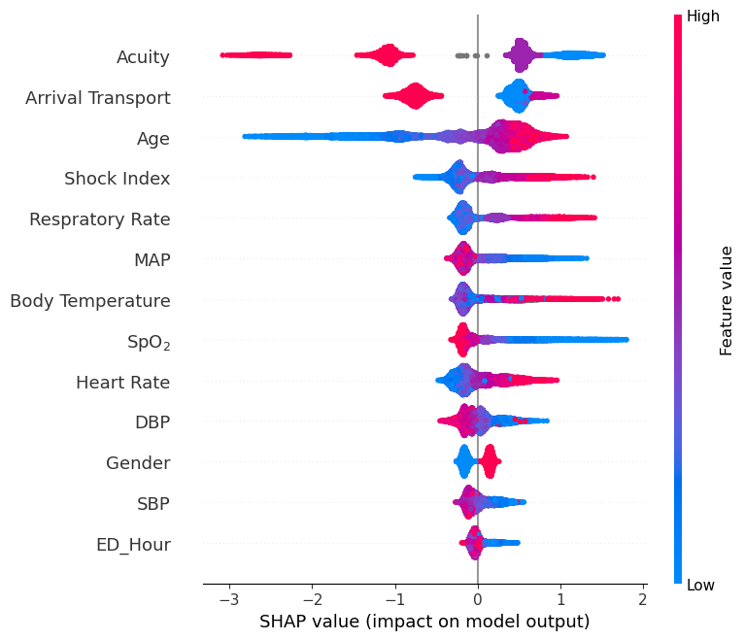
Supplementary Fig. 1: SHAP summary plot
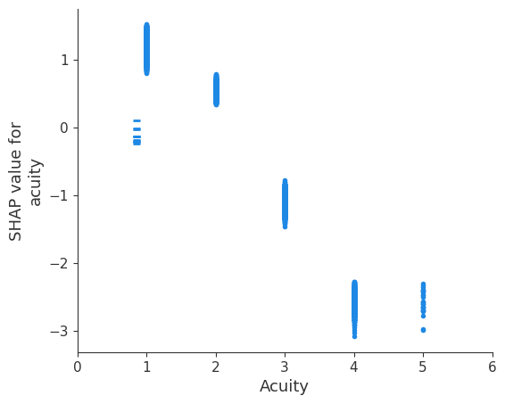
Supplementary Fig. 2: SHAP dependency plot for acuity
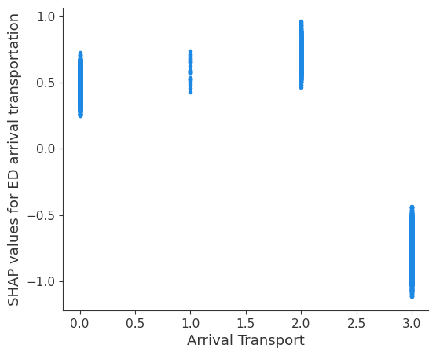
Supplementary Fig. 3: SHAP dependency plot for ED arrival transportation
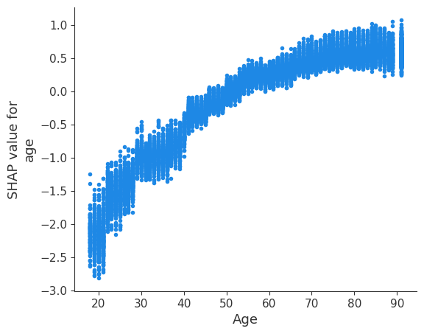
Supplementary Fig. 4: SHAP dependency plot for age
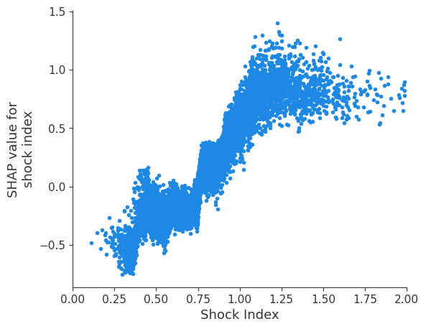
Supplementary Fig. 5: SHAP dependency plot for shock index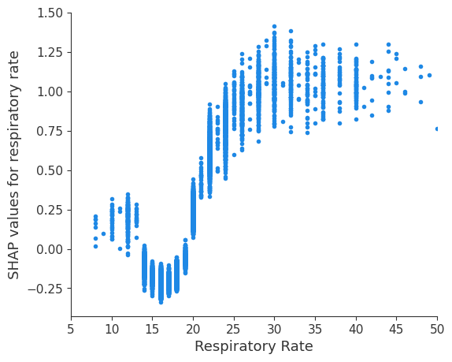
Supplementary Fig. 6: SHAP dependency plot for respiratory rate
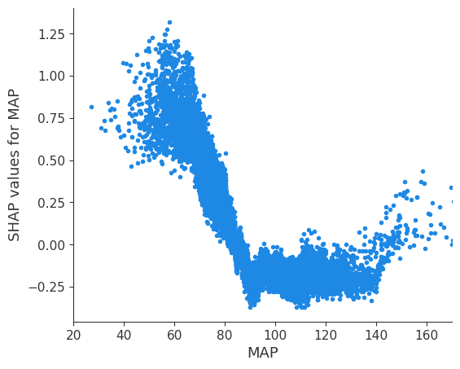
Supplementary Fig. 7: SHAP dependency plot for MAP
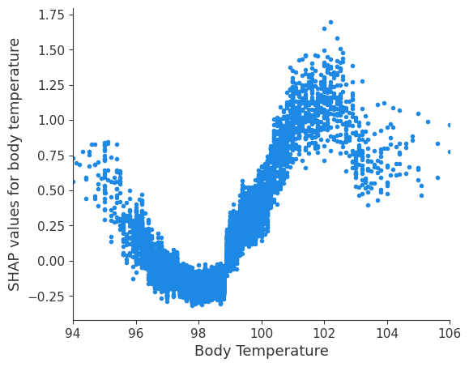
Supplementary Fig. 8: SHAP dependency plot for body temperature
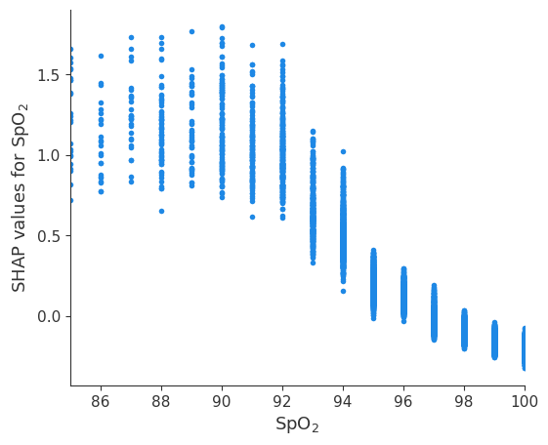
Supplementary Fig. 9: SHAP dependency plot for SpO₂
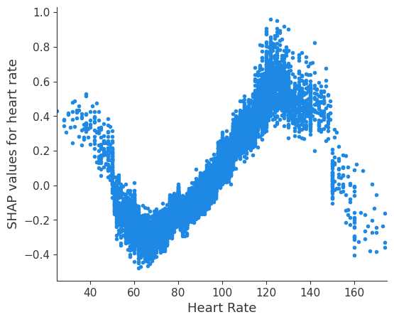
Supplementary Fig. 10: SHAP dependency plot for heart rate
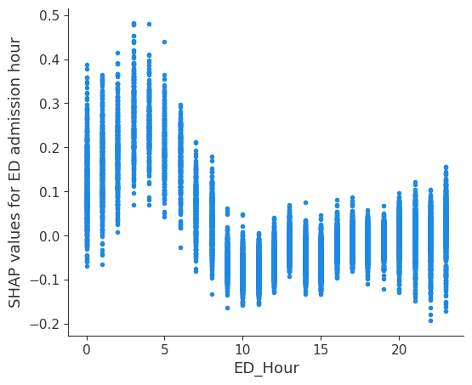
Supplementary Fig. 11: SHAP dependency plot for ED admission hour

