Appendix A: Description of Data Sources
This appendix details the data sources, ranking, and prioritization used to arrive at the final prevalence estimates.

WHO World Mental Health Surveys
The WHO’s WMH Surveys use a multistage cluster household probability sample with case-control design. Respondents were recruited from the General Authority for Statistics 2010 census for Saudi Arabia. Trained interviewers carried out a fully structured diagnostic interview using the WMH-CIDI. In Part 1, a core diagnostic assessment was carried out to quantify the prevalence of mental health conditions of primary interest. Part 2 assessed correlates and disorders that were of secondary interest. Respondents who met criteria for any disorder in Part 1, plus a subsample of 25 percent of respondent controls who did not meet any criteria, were included in Part 2. Post-assessment weighting was applied to adjust survey results for sociodemographic and geographic variables.
When comparing the results of the Saudi WMH Survey to other high-income countries, there are a few notable differences. The lifetime prevalence for mood disorders and drug abuse was higher at 6.8% and 1.4% vs. 5.2% and 0.5% for other high-income countries [68]. The higher prevalence of mood disorders can be attributed to bipolar disorder [69]. Alcohol use disorder was lower than for other high-income countries [70].

WHO Global Health Observatory
The WHO Global Health Observatory Mortality Database uses a combination of health service data, population surveys, civil registration, and vital statistics to produce country estimates of disease prevalence [71]. We used the age-specific crude death rates (5- and 10-year groups) for suicide and applied these rates to the UN Department of Economic and Social Affairs (DESA) Population count estimate “weights” for Saudi Arabia [40] to arrive at the count of age-specific deaths due to suicide for four age groupings (18–34, 35–49, 50–64, and 65+ years).
To assess the prevalence of suicide ideation and/or attempts, we multiplied the age-standardized rates of suicide by 20 [72]. This multiplier coheres with the literature in which most persons with suicidal ideation and or those attempting suicides do not complete.
This dataset is not without its limitations. The lack of registration is exacerbated by the cultural and legal concerns that make suicide as a cause of death a particularly sensitive issue which can result in under-reporting and/or misclassification of deaths [71,73].

World Alzheimer’s Report
The burden of dementia is expected to increase as the population ages and mortality due to communicable diseases decreases. Current dementia estimates for developing countries suggest that the prevalence of dementia is lower than in developed countries [37]. We used the World Alzheimer Group’s regional Middle East and North Africa estimates. The estimates of prevalence were available in six age groups five 5-year age groups from age 60 to 84, plus 85 and older.
Since the risk of dementia increases with age, we used UN population estimates [50] to calculate a standardized rate of dementia for individuals aged 65 and older. High-quality dementia prevalence studies were available in the World Alzheimer’s report, primarily in Western countries. A meta-analysis was conducted to estimate regional prevalence, and in regions where high-quality studies were rare, expert consensus (from the Delphi Consensus and Dementia Working Group) was also included. Few studies estimating dementia have been conducted in low- and middle-income countries [37]. For the Middle East and North Africa, only two empirical studies were considered.

Global Burden of Disease
When estimates of prevalence using the above resources were not available or were not in line with prior workforce estimates, we used estimates from the GBD study. We used the Global Burden of Disease estimates for schizophrenia, child intellectual development disorders, childhood conduct and behavioral disorders, and childhood emotional disorders [38].

Appendix B. Target Coverage and Estimates for Service Coverage, Utilization, and Staffing
As an update to Chisholm Lund, and Saxena (2007), we consulted Dan Chisholm, an expert in health economics for the WHO, for an updated set of inputs for cost and impact of scaling up for mental health. In recent publications, treatment models were separated by basic, moderate, and intensive treatment of depression based on severity of the condition [52]. After reviewing the two publications from 2007 and 2016, we noted that there were substantial changes to the categories of resource usage (for example, inpatient, outpatient, residential care, and day care); estimates for service use inputs (for example, bed-days and visits/sessions), and estimated service coverage. At a minimum, the new inputs would yield workforce estimates that are substantially higher than prior estimates [30], which would not allow for a comparison of current and historical workforce projections. Therefore, we used the estimates, resource utilization, and service coverage from Chisholm, Lund, and Saxena (2007).
Table B1: Target Coverage for Target Populations for Priority Conditions
Condition | Target Coverage Percent
Schizophreniaª | 80
Depressionª | 33
Suicide^{b} | 80
Epilepsy^{c} | 80
Dementia^{d} | 80
Alcohol use disorderª | 25
Other drug use disorders^{e} | 50
Childhood disabilities^{f} | 20
Sources: a. [50]; b. [73]; c. [53]; d. [54]; e. [30]; f. Taken from level attainable in developed countries [51,56]; g. [53] using treatment coverage for anxiety disorders.

Table B2: Target Estimates for Service Coverage and Resource Utilization
Hazardous Alcohol Use | Resource Use per Case^{c} |  | 0 | 0 | 0.1 |  | 0 | 0.2 | 0 | n.a. | 0.8
Hazardous Alcohol Use | Average Rate of Use^{b} |  | 0 | 0 | 5 |  | 0 | 2 | 0 | 1 | 3
Hazardous Alcohol Use | Service Coverage  %ª |  | 0 | 0 | 2 |  | 0 | 10 | 0 | 2—4 | 25
Major Depression | Resource Use per Case^{c} |  | 0 | 0.5 | 0.3 |  | 0.5 | 1.4 | 2.1 | n.a. | 1
Major Depression | Average Rate of Use^{b} |  | 0 | 90 | 14 |  | 50 | 7 | 7 | 1 | 6
Major Depression | Service Coverage  %ª |  | 0 | 0.5 | 2 |  | 1 | 20 | 30 | 7—14 | 20
Bipolar Disorder | Resource Use per Case^{c} |  | 0.9 | 2.7 | 2.8 |  | 3.0 | 4.8 | 1.8 | 0 | 2.4
Bipolar Disorder | Average Rate of Use^{b} |  | 90 | 180 | 28 |  | 100 | 12 | 6 | 0 | 8
Bipolar Disorder | Service Coverage  %ª |  | 1 | 1.5 | 10 |  | 3 | 40 | 30 | 0 | 30
Schizophrenia | Resource Use per Case^{c} |  | 1.8 | 5 | 4.2 |  | 7.5 | 6 | 1.8 | 0 | 2.4
Schizophrenia | Average Rate of Use^{b} |  | 90 | 180 | 28 |  | 100 | 12 | 6 | 0 | 8
Schizophrenia | Service Coverage  %ª |  | 2 | 2.5 | 15 |  | 7.5 | 50 | 30 | 0 | 30
Service |  | Inpatient and residential care^{d} | Mental hospital care (long stay) | Community residential care (long stay) | Community psychiatric unit (acute care) | Outpatient and day care^{e} | Day care services | Hospital outpatient service | Primary health care: treatment | Primary health care: screening^{f} | Psychosocial treatment^{g}

Source: [52]
Note: n.a. = not applicable.
a. Service coverage = percentage of patients in the population expected to use the service or resource over course of 1 year.
b. Average rate of use = mean rate of uptake per year among those expected to use the service or resource.
c. Resource use per “average” patient in the population = percentage of patients expected to use the resource (coverage) multiplied by the average rate of use.
d. Average rate of use in days.
e. Average rate of use in visits.
f. Refers to coverage in the total adult population (before diagnosis).
g. Index therapies used: family therapy (schizophrenia); problem-solving treatment (bipolar disorder); brief psychotherapy (depression); brief physician advice (alcohol use). Sessions last 40 minutes each, except brief interventions for alcohol use, which take 10 minutes.

Table B3: Staffing Proportions by Health Care Setting and Country Income Classification

Occupation | Outpatient |  | Inpatient
Occupation | Day Care | Acute and Primary Care | Acute Care | Long Stay/Residential Care
Low-income countries
Psychiatrists/specialists | 0.00% | 1.67% | 6.25% | 7.69%
Nursing care provider | 66.67% | 20.83% | 62.50% | 61.54%
Psychosocial care provider | 33.33% | 77.50% | 31.25% | 30.77%
TOTAL | 100.00% | 100.00% | 100.00% | 100.00%
Middle-income countries
Psychiatrists/specialists | 0.00% | 3.57% | 10.00% | 6.67%
Nursing care provider | 62.50% | 28.57% | 60.00% | 66.67%
Psychosocial care provider | 37.50% | 67.86% | 30.00% | 26.67%
Total | 100.00% | 100.00% | 100.00% | 100.00%
Source: [52]

Appendix C. Comorbidity Adjustments
Bipolar disorder, depression, and schizophrenia have a high likelihood of comorbidity with alcohol and other drug use disorders [74-76] and suicidality [77]. Co-occurrence of these mental, neurological, and substance use conditions does not necessarily mean that each condition requires a separate dedicated treatment model. Some therapies and treatment models, administered within single visits with health workers, can effectively address two co-occurring conditions [78-80]. In the case of depression comorbid with alcohol or substance use, cognitive behavioral therapy and some medications can, within the same treatment model, address both conditions [78,79]. The same holds for schizophrenia that co-occurs with substance use disorder [80].
Figure C1 illustrates the conditions and the hypothesized temporal sequence of onset of comorbidities. This overview illustrates the possible co-occurrence of conditions. The numeric values represent the proportion of persons who have the comorbidity associated with the respective path that connects two conditions. To walk through an example, 41.7 percent of individuals with schizophrenia have comorbid substance use [75]. This comorbidity is captured in figure C1 via the arrow connecting schizophrenia and other drug use disorders. The value 0.42 (rounded) means that 41.7 percent of individuals with schizophrenia have comorbid substance use.
When two conditions were comorbid with each other, we prioritized the condition with the higher target coverage. In the case of schizophrenia and other drug use disorders, we considered only other drug use disorders within schizophrenia (target coverage 80 percent) and not schizophrenia within other drug use disorders (target coverage 50 percent). After adjusting for comorbidities, we added a screening component to account for potential difficulties in screening for and detecting comorbid conditions within the target population. The primary measure considered was the positive predictive value. The positive predictive value is the likelihood that a standardized screening instrument is able to detect a comorbid condition within the target population.
To continue with the prior example, the detection of substance use in individuals with schizophrenia has a positive predictive value of 45 percent [81]. This means that, if the individuals with schizophrenia in our target population were all screened for substance use, there is a 45 percent chance that those who actually have comorbid substance use would be correctly identified or successfully screened. So, a 0.41 percent age-standardized prevalence of schizophrenia with 80 percent target coverage corresponds to 114,189 target cases within the total population. Within this group, we are assuming that 41.7 percent have comorbid substance use [75] and that 45 percent of this group can be identified for treatment [81]. This leaves us with 21,428 individuals with schizophrenia with detectable other drug use disorders, which means that we can remove 21,428 patients from our “other drug use” treatment model and potentially treat them within the schizophrenia treatment model.
Figure C1: Overview of Comorbidities: Adjustments and Direction of Adjustment
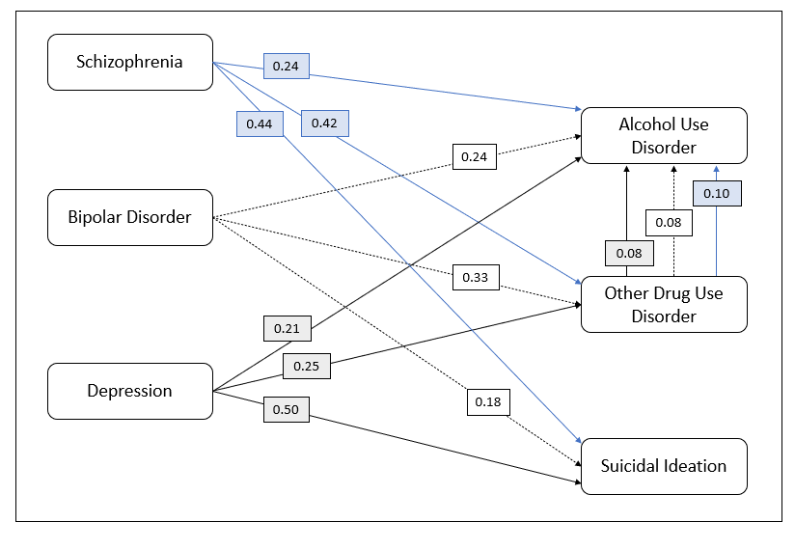
Sources: Schizophrenia and alcohol use disorder [75]; other drug use disorders [75]; suicidal ideation [82].
Bipolar disorder and alcohol use disorder [74]; other drug use disorders [74]; suicidal ideation [83].
Depression and alcohol use disorder [76]; other drug use disorders [76]; suicidal ideation [83].

Positive predictive values for schizophrenia and alcohol use disorder (0.55); other drug use disorders (0.45); suicidal intention (0.79); [81,84,85].
Bipolar disorder and alcohol use disorder (0.35); other drug use disorders (0.35); suicidal intention (0.86): [85,86].
Depression and alcohol use disorder (0.35); other drug use disorders (0.35); suicidal intention (0.86): [85,86].

To address comorbidity of schizophrenia, bipolar disorder, and depression with alcohol and other drug use disorders, we added another level of adjustment for these conditions. For each condition, we identified comorbid other drug and alcohol use [74-76]. In figure C1, the three arrows leading from other drug use disorders to alcohol use disorder depict these comorbidities according to condition. Using the same methodology as before, we assigned the comorbidity to the condition with the larger treatment coverage, which in this case was other drug use disorders (target coverage 50 percent, compared with 25 percent for alcohol use disorder). This means that alcohol use disorder can be treated under the other drug use treatment model. This effectively removes the double count of individuals with schizophrenia who have alcohol use disorder and other drug use disorders and allows us to independently assess alcohol use within schizophrenia.
Figure C2 walks through the example using schizophrenia and comorbid other drug and alcohol use disorder.
Step 1—Review treatment models for comorbidity of other drug use within schizophrenia that can be treated as part of schizophrenia treatment.
- 41.7 percent of individuals with schizophrenia have comorbid other drug use, and if screened, 45 percent of them can be successfully identified for follow-up.
Step 2—Quantify comorbidity of alcohol use disorder that can be treated within other drug use disorders. Remove from alcohol use disorder.
- 10.1 percent of individuals with schizophrenia with comorbid other drug use are likely to have an alcohol use disorder.
Step 3—Remove comorbidity of alcohol use disorder from other drug use disorders (within individuals with schizophrenia).
- This 10.1 percent is removed from the individuals with schizophrenia with comorbid alcohol use population and assigned to individuals with schizophrenia with comorbid other drug use to avoid double count.
Figure C2: Example of Comorbidity Adjustment and Positive Predictive Value for Schizophrenia, Alcohol Use Disorder, and Other Drug Use Disorders
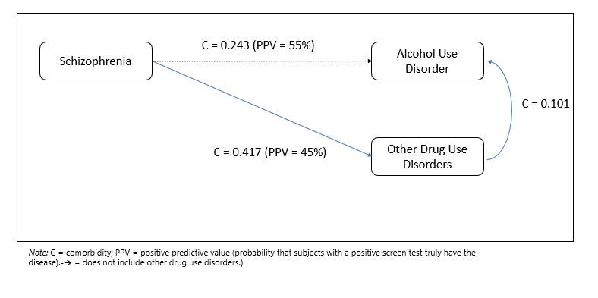
Source: Original figure for this publication.

