Risk of developing hyperkalemia in patients with hypertension treated with combination antihypertensive therapy

Supplemental Table S1-S3
Supplemental Figures S1-S3

Table S1. Name of antihypertensive drugs and their given ATC codes used to define hypertension
ATC codes | Name of drug
C02A | Antiadrenergic agents, centrally acting
C02B | Antiadrenergic agents, ganglion blocking
C02C | Antiadrenergic agents, peripherally acting
C03AA | Thiazides
C03AB | Thiazides and potassium in combination
C03BA | Sulfonamides
C03BB | Sulfonamides and potassium in combination
C03AX | Hydrochlorothiazide
C03C | Loop diuretics
C03DA | Aldosteron antagonists
C03DB | Other potassium sparing agents
C03EA | Low-ceiling diuretics and potassium sparing agents
C03EB | High-ceiling diuretics and potassium sparing agents
C03X | Other diuretics
C07A | Beta-blockers

C07BA | Beta blocking, non-selective, and thiazides
C07BB | Beta blocking, selective, and thiazides
C07BG | Alpha and beta blocking and thiazides
C07FB | Beta-blockers and calcium antagonists
C07E | Beta blocking and calcium antagonist
C07FX | Beta-blockers and other combinations
C08C | Selective calcium antagonists primarily with vascular effect
C08D | Selective calcium antagonists with direct cardiac effect
C08E | Non-selective calcium antagonists
C08G | Calcium antagonists and diuretics
C09AA | Angiotensin converting enzyme inhibitors
C09BA | Angiotensin converting enzyme inhibitors and diuretics
C09BB | Angiotensin converting enzyme inhibitors and calcium antagonists
C09CA | Angiotensin II antagonists
C09DA | Angiotensin II antagonists and diuretics
C09DB | Angiotensin II antagonists and calcium antagonists
C09XA | Renin-inhibitors

Table S2. Definitions of comorbidities, procedures and concomitant medications based on different ICD-10, Nordic Classification of Surgical Procedures (NCSP), and ATC codes identified prior to index date.
Comorbidities and procedures | ICD-10  codes | Time  prior to index  date | NCSP  codes | Time  prior to index  date | ATC  codes | Time  prior to index  date
Ischemic heart disease including myocardial  infarction¹ | I20-25 | 5 years | KFNG,  KFNA-E | 5 years | − | −
Hemodialysis | − | − | BJFD20 | 5 years | − | −
Atrial flutter or fibrillation | I48 | 5 years | − | − | − | −
Ventricular  tachycardia or fibrillation | I47.2, I49 | 5 years | − | − | − | −
Chronic obstructive pulmonary disease | J40-44 | 5 years | − | − | − | −
Diabetes | E10-14 | 5 years | − | − | − | −
Cancer | C00-99 | 5 years | − | − | − | −

Heart failure | I110,  I130,  I132, I42, I50, J81 | 5 years | − | − | − | −
Concomitant  medications | ICD-10  codes | Time  prior to index  date | NCSP  codes | Time  prior to index  date | ATC  codes | Time  prior to index  date
Potassium  supplements | − | − | − | − | A12B  C03AB  C03BB  C03CB | 90 days
Non-steroidal anti inflammatory drugs | − | − | − | − | M01A | 180 days
Macrolides | − | − | − | − | J01FA | 30 days

Table S3. Demographics of patients treated with combination antihypertensive therapy as well as an
available potassium measurements within 90 days from index date and no potassium imbalances up
to 30 days before index date.
 | K+ < 4,6 (n=10359) | K+ > 4,6 (n=793) | Total (n=11152) | p-value
Gender
Female | 4,593 (44.3%) | 327 (41.2%) | 4,920 (44.1%) | 0.098
Age, median (range) | 67( 19, 101) | 71(19, 98) | 67( 19, 101) | < 0.001
Days from hypertension to potassium measurement, median (range) | 25( 0, 90) | 26( 0, 90) | 25( 0, 90) | 0.65
Renal insufficiency | 153 (1.5%) | 55 (6.9%) | 208 (1.9%) | < 0.001
Treatment combinations
BB+CCB | 603 (5.8%) | 39 (4.9%) | 642 (5.8%)
BB+RASi | 2454 (23.7%) | 216 (27.2%) | 2,670 (23.9%)
BB+RASi+MRA | 600 (5.8%) | 87 (11.0%) | 687 (6.2%)
CCB+RASi | 1888 (18.2%) | 115 (14.5%) | 2,003 (18.0%)
CCB+RASi+Thiazid | 554 (5.3%) | 27 (3.4%) | 581 (5.2%)
CCB+Thiazid | 408 (3.9%) | 18 (2.3%) | 426 (3.8%)
RASi+Thiazid | 1941 (18.7%) | 107 (13.5%) | 2,048 (18.4%)
Other combinations | 1911 (18.4%) | 184 (23.2%) | 2,095 (18.8%) | < 0.001
Comorbidities
Heart failure | 1324 (12.8%) | 194 (24.5%) | 1,518 (13.6%) | < 0.001
IHD/MI | 1830 (17.7%) | 207 (26.1%) | 2,037 (18.3%) | < 0.001
Atrial flutter/fibrillation | 1149 (11.1%) | 132 (16.6%) | 1,281 (11.5%) | < 0.001
VT/VF | 323 (3.1%) | 40 (5.0%) | 363 (3.3%) | 0.004
Hemodialysis | 19 (0.2%) | 6 (0.8%) | 25 (0.2%) | 0.004
Diabetes | 1634 (15.8%) | 147 (18.5%) | 1,781 (16.0%) | 0.05
Malignancy | 1481 (14.3%) | 130 (16.4%) | 1,611 (14.4%) | 0.12
NSAIDs | 35 (0.3%) | 8 (1.0%) | 43 (0.4%) | 0.008
Macrolides | 14 (0.1%) | ≤3 (0.1%) | ≤17 (0.1%) | 1.0
Others
Serum sodium, median (range) | 140(113, 161) | 139(119, 150) | 140(113, 161) | 0.008
Potassium supplement | 3551 (34.3%) | 277 (34.9%) | 3,828 (34.3%) | 0.74
Potassiumchloride+antihypertensive | 2457 (23.7%) | 166 (20.9%) | 2,623 (23.5%) | 0.08
Potassiumchloride | 1326 (12.8%) | 132 (16.6%) | 1,458 (13.1%) | 0.002

K⁺<4,6: Normokalemia
K⁺>4,6: Hyperkalemia
BB:Beta blockers
CCB:Calcium channel blockers
RASi:Renin-angiotensin system inhibitors
MRA: Mineralocorticoid-Receptor-Antagonister
IHD/MI: Ischemic heart disease/Myocardial infarction
COPD: Chronic obstructive pulmonary disease
VT/VF: Ventricular tachycardia/ventricular fibrillation
ICD: Implantable cardioverter defibrillator
NSAIDs: Non-steroidal anti-inflammatory drugs
“Potassium supplement” addressed supplementation as a single pill therapy with an
antihypertensive and as an individual pill.

Figure S1. Population flowchart’
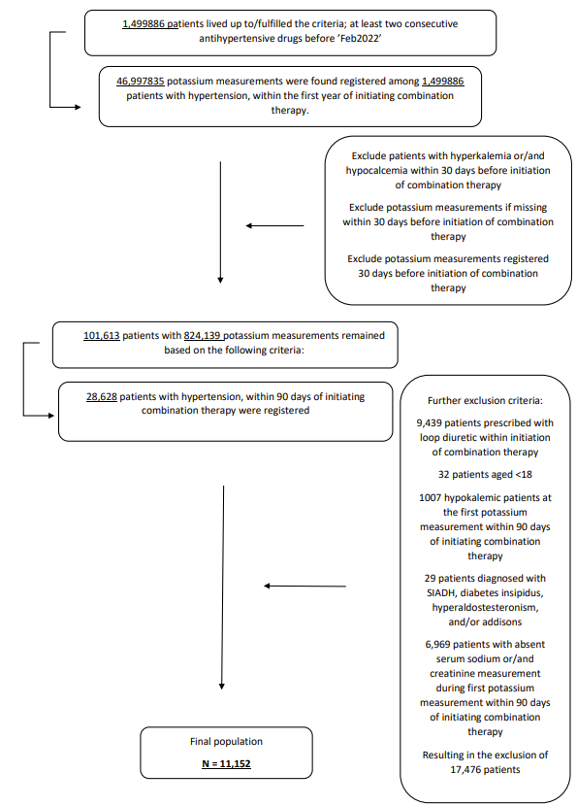

BB: Beta blockers
CCB: Calcium channel blockers
RASi: Renin-angiotensin system inhibitors
MRA: Mineralocorticoid-Receptor-Antagonister
SIADH: Syndrome of inappropriate antidiuretic hormone secretion

Figure S2. Forestplot of univariable conditional logistic regression analysis for development of hyperkalemia. Population matched on age, gender, renal insufficiency and time from combination therapy initiation to serum potassium measurement. The combination of RASi+Thiazides was used as reference.

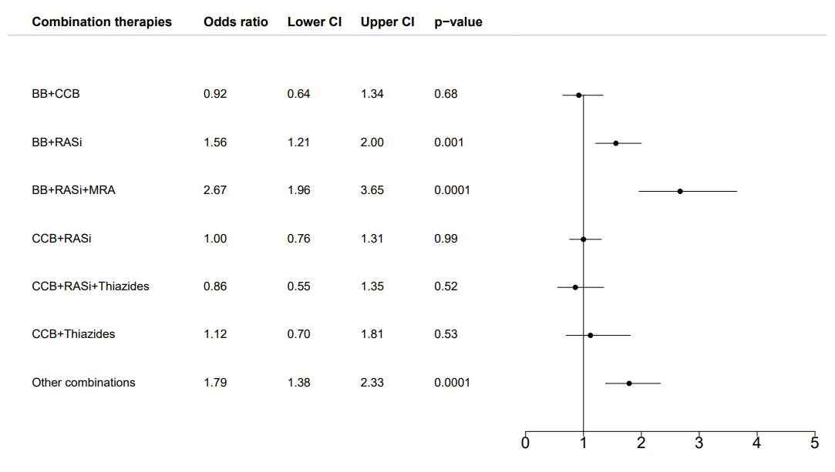

BB:Beta blockers
CCB:Calcium channel blockers
RASi:Renin-angiotensin system inhibitors
MRA: Mineralocorticoid-Receptor-Antagonister

Figure S3. Cumulative incidence proportion curve of hyperkalemia in patients treated with combination antihypertensive therapy. Cumulative incidence proportion of hyperkalemia in patients treated with combination antihypertensive therapy who had available potassium measurements within 90 days from index date and no potassium imbalances up to 30 days before index date (n=11.152).

