Supporting Information

Supplementary Methods
Method S1: Sample Collection for Microbial Fraction Preparation
For the preparation of Rhizospheric MF, the soil of the plants of each variety grown in Net House 1 was sampled. The plant was uprooted and the bulk soil was removed with a trowel. The roots were shaken to remove the loose soil, leaving behind only the tightly adhering soil to the root, the rhizospheric soil. The root and soil were transferred to clean, dry, and labelled polythene (autoclave) bags and carried to laboratory on ice. For Phyllospheric MF, the leaves from each plant were picked and transferred to clean, dry, and labelled polythene (autoclave) bags and carried to laboratory on ice.
Method S2: Quantification of bacterial community in MF samples
The cell pallets collected for each MF were resuspended in 1mL of sterile 1X T.E Buffer and serially diluted (3 times for Rhi.MF samples and 2 times for Phy.MF samples). 0.1mL of each MF was spread on half strength Tryptic Soy Agar (TSA) plates and incubated for 24 hours. The CFUmL-1 for each sample was calculated using the following equation from Tortora 2018 [1]:
$$CFU/mL=\frac{Number of colonies ×Total Dilution Factor}{Volume of inoculant plated}$$

Supplementary Tables
Table S1: Test Group Codes and Microbial Fraction Application details.
Test Group Code |  | Detail
PFV1.RMF | Rhi.RMF | Gossypium hirsutum PFV1 plants to which Microbial Fraction from FDH228 arboreum’s Rhizosphere has been applied
PFV1.RMF | Phy.RMF | Gossypium hirsutum PFV1 plants to which Microbial Fraction from FDH228 arboreum’s Phyllosphere has been applied
PFV1.pRMF | Rhi.pRMF | Gossypium hirsutum PFV1 plants to which Microbial Fraction from PFV1 hirsutum’s Rhizosphere has been applied
PFV1.pRMF | Phy.pRMF | Gossypium hirsutum PFV1 plants to which Microbial Fraction from PFV1 hirsutum’s Phyllosphere has been applied
PFV1.SMF | Rhi.SMF | Gossypium hirsutum PFV1 plants to which Microbial Fraction from PFV2 hirsutum’s Rhizosphere has been applied
PFV1.SMF | Phy.SMF | Gossypium hirsutum PFV1 plants to which Microbial Fraction from PFV2 hirsutum’s Phyllosphere has been applied
PFV1.SA | N/A | Gossypium hirsutum PFV1 plants to which Salicylic Acid has been applied
PFV1.nMF | N/A | Gossypium hirsutum PFV1 plants to which no Microbial Fraction has been applied
PFV2.RMF | Rhi.RMF | Gossypium hirsutum PFV2 plants to which Microbial Fraction from FDH228 arboreum’s Rhizosphere has been applied
PFV2.RMF | Phy.RMF | Gossypium hirsutum PFV2 plants to which Microbial Fraction from FDH228 arboreum’s Phyllosphere has been applied
PFV2.pRMF | Rhi.pRMF | Gossypium hirsutum PFV2 plants to which Microbial Fraction from PFV1 hirsutum’s Rhizosphere has been applied
PFV2.pRMF | Phy.pRMF | Gossypium hirsutum PFV2 plants to which Microbial Fraction from PFV1 hirsutum’s Phyllosphere has been applied
PFV2.SMF | Rhi.SMF | Gossypium hirsutum PFV2 plants to which Microbial Fraction from PFV2 hirsutum’s Rhizosphere has been applied
PFV2.SMF | Phy.SMF | Gossypium hirsutum PFV2 plants to which Microbial Fraction from PFV2 hirsutum’s Phyllosphere has been applied
PFV2.SA | N/A | Gossypium hirsutum PFV2 plants to which Salicylic Acid has been applied
PFV2.nMF | N/A | Gossypium hirsutum PFV2 plants to which no Microbial Fraction has been applied
FDH228.RMF | Rhi.RMF | Gossypium arboreum FDH228 plants to which Microbial Fraction from FDH228 arboreum’s Rhizosphere has been applied
FDH228.RMF | Phy.RMF | Gossypium arboreum FDH228 plants to which Microbial Fraction from FDH228 arboreum’s Phyllosphere has been applied
FDH228.pRMF | Rhi.pRMF | Gossypium arboreum FDH228 plants to which Microbial Fraction from PFV1 hirsutum’s Rhizosphere has been applied
FDH228.pRMF | Phy.pRMF | Gossypium arboreum FDH228 plants to which Microbial Fraction from PFV1 hirsutum’s Phyllosphere has been applied
FDH228.SMF | Rhi.SMF | Gossypium arboreum FDH228 plants to which Microbial Fraction from PFV2 hirsutum’s Rhizosphere has been applied
FDH228.SMF | Phy.SMF | Gossypium arboreum FDH228 plants to which Microbial Fraction from PFV2 hirsutum’s Phyllosphere has been applied
FDH228.SA | N/A | Gossypium arboreum FDH228 plants to which Salicylic Acid has been applied
FDH228.nMF | N/A | Gossypium arboreum FDH228 plants to which no Microbial Fraction has been applied

Table S2: Primers used for Begomovirus DNA amplification
(IUB codes for degenerate bases: M=A/C, R=A/G, W=A/T, S=G/C, Y=C/T. K=G/T,V=A/G/C, H=A/C/T, D=A/G/T, B=G/C/T, N=A/G/C/T
Primer Code | Begomovirus DNA region amplified | Company | Primer sequence (5’-3’)
Beta1(Forward) | β-satellite | Synbio Tech | GGTACCACTACGCTACGCAGCAGCC
Beta2 (Reverse) | β-satellite | Synbio Tech | GGTACCTACCCTCCCAGGGGTACAC

Table S3: Polymerase chain reaction profile for β-satellite amplification (Thermocycler: Nyx Technik, Inc. Model: A4)
Step | Name | Temp/ºC | Time/min
1 | Denaturation | 94 | 4
2 | Denaturation | 94 | 1 | 30 Cycles
3 | Annealing | 68 | 1 | 30 Cycles
4 | Extension | 72 | 1.5 | 30 Cycles
6 | Final Extension | 72 | 10
7 | Cooling | 5 | 5

Supplementary Figures
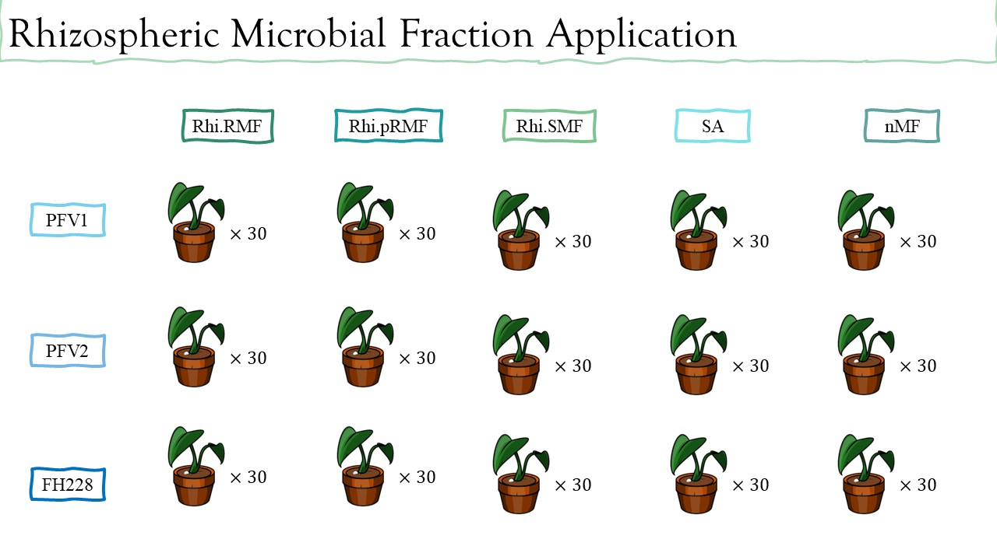
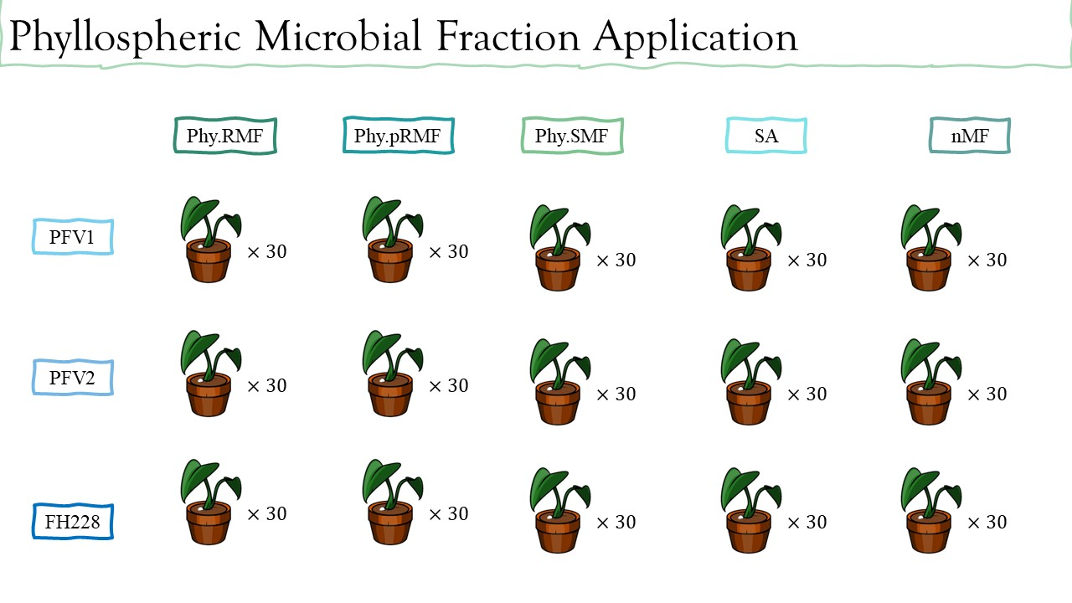
A
B

Figure S1: Microbial Fraction application plan; A: Application test groups for Rhizospheric Microbial Fractions, B: Application test groups for Phyllospheric Microbial Fractions

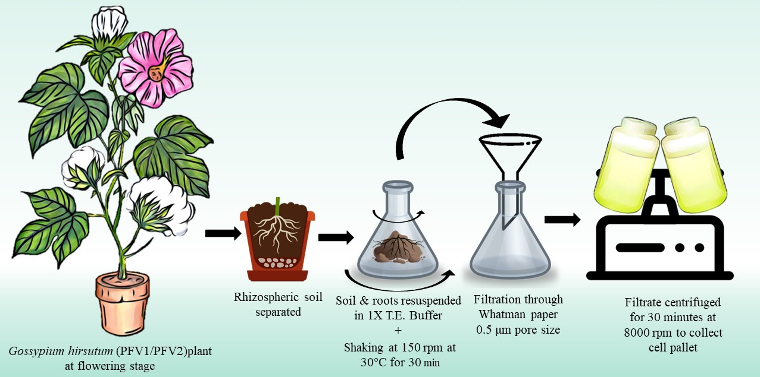
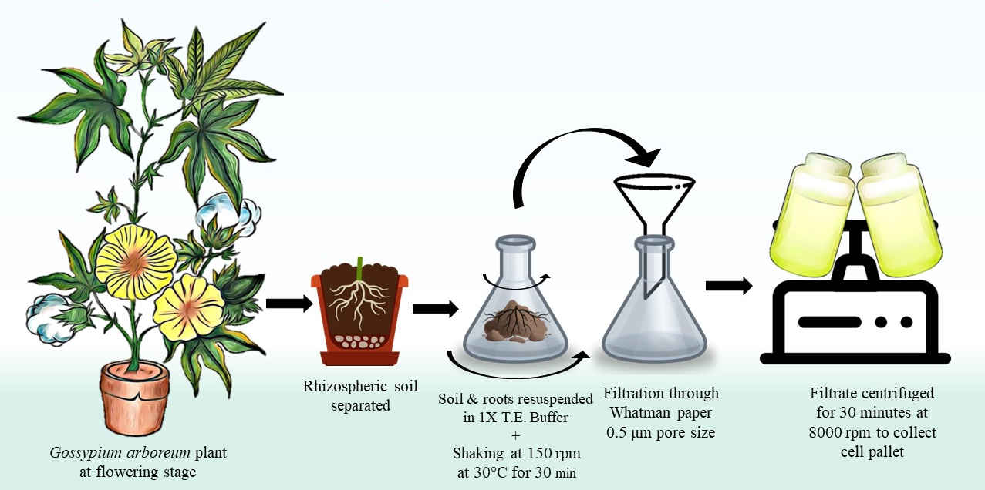
Figure S2: Rhizospheric Microbial Fraction Preparation; A: Rhi.RMF preparation from Gossypium arboreum FDH228 plant rhizospheric soil, B: Rhi.pRMF and Rhi.SMF preparation from Gossypium hirsutum PFV1 and PFV2 plant rhizospheric soil, respectively.
B
A

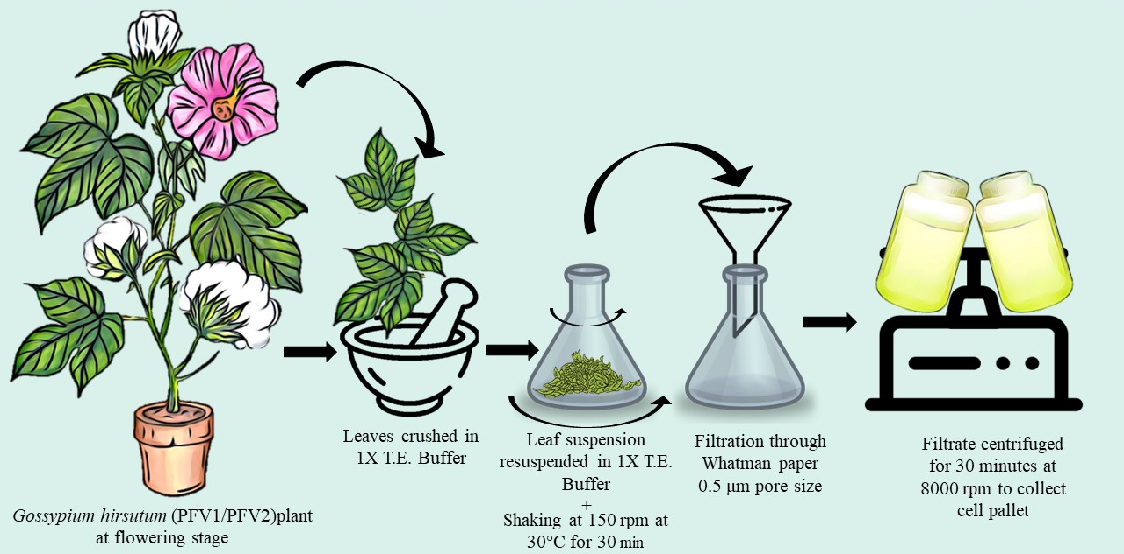
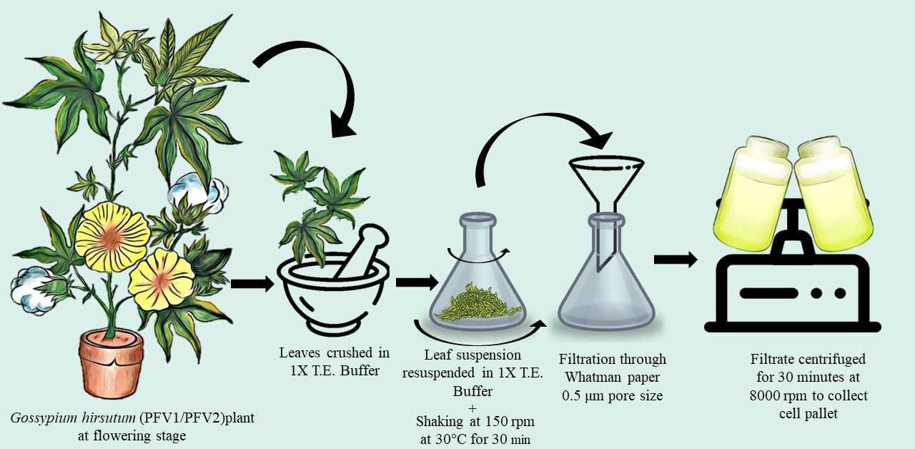
B
A
Figure S3: Phyllospheric Microbial Fraction Preparation; A: Phy.RMF preparation from Gossypium arboreum FDH228 plant phyllosphere, B: Phy.pRMF and Phy.SMF preparation from Gossypium hirsutum PFV1 and PFV2 plant phyllosphere, respectively.

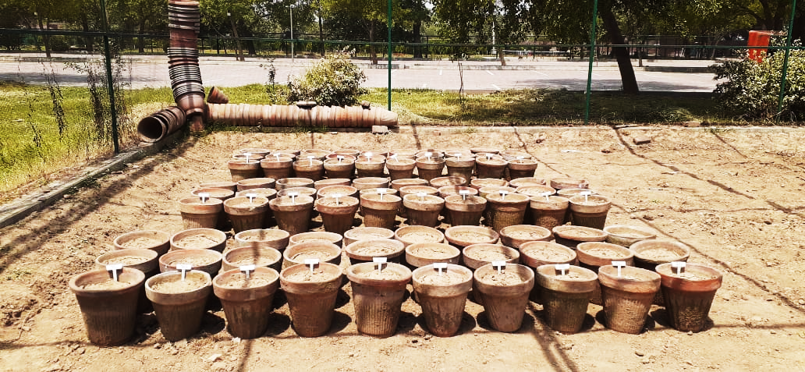
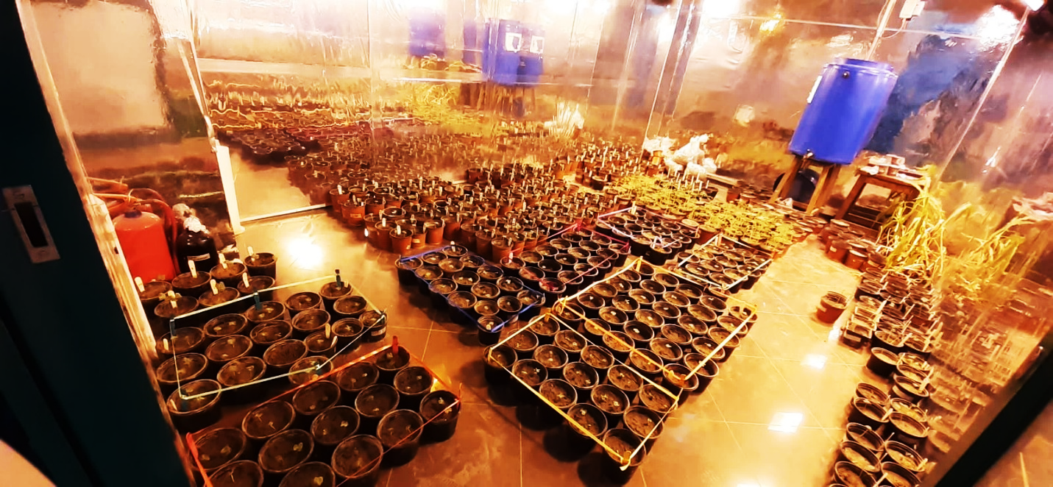
A
B

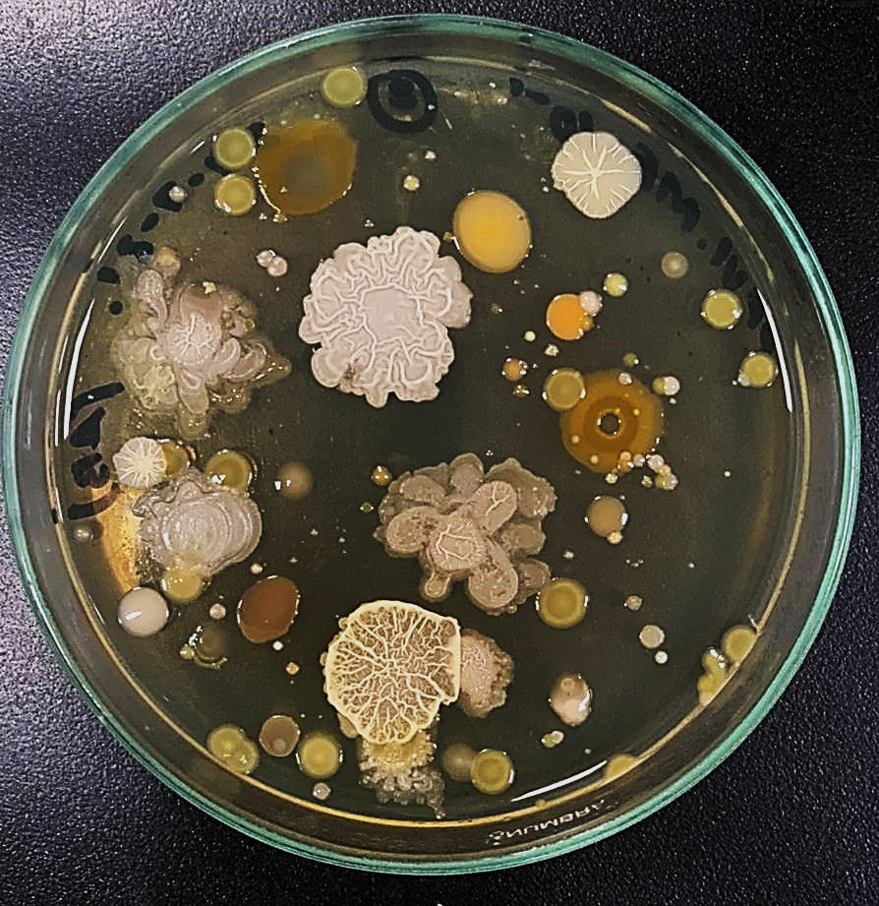
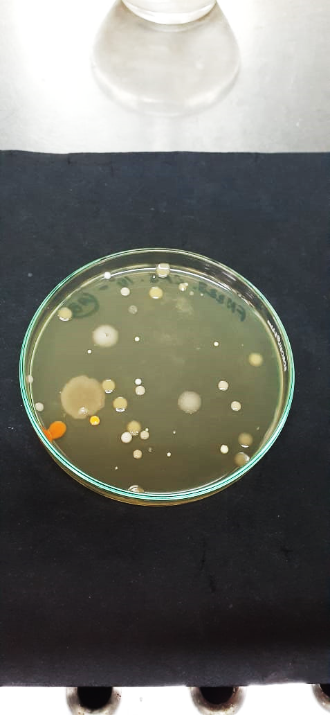
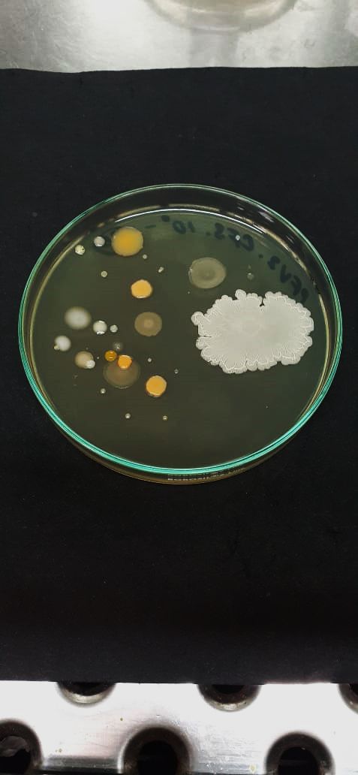
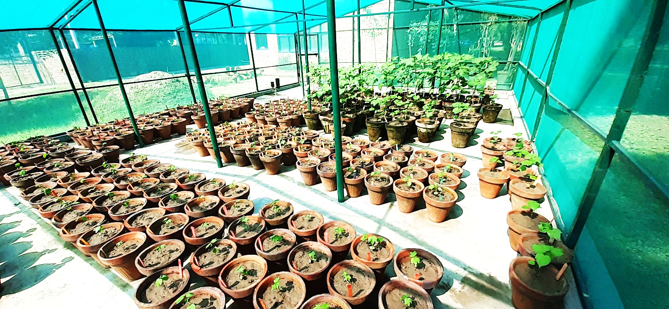
Figure S4: Pot experiment conditions and set up; A: Net house I having uncontrolled conditions and reared viruliferous whitefly with natural photoperiod, reserved for plant batches for MF isolation, B: Climate-controlled room for germination and 4 weeks of pest free environment with an artificially maintained photoperiod of 16 hours of light, 8 hours of dark and 25°C, C: Net house II having uncontrolled conditions and reared viruliferous whitefly with natural photoperiod.
A
B
C
C

Figure S5: Microbial Fraction plated onto half-strength Tryptic Soy Agar; A: 100 µL RMF (Microbial Fraction extracted from FDH228 rhizosphere), B: 100 µL pRMF (Microbial Fraction extracted from PFV1 rhizosphere, C: 100 µL SMF (Microbial Fraction extracted from PFV2 rhizosphere.

**
**
***
***

Figure S6: Culture-based quantification of Microbial Fraction samples in CFU/mL.

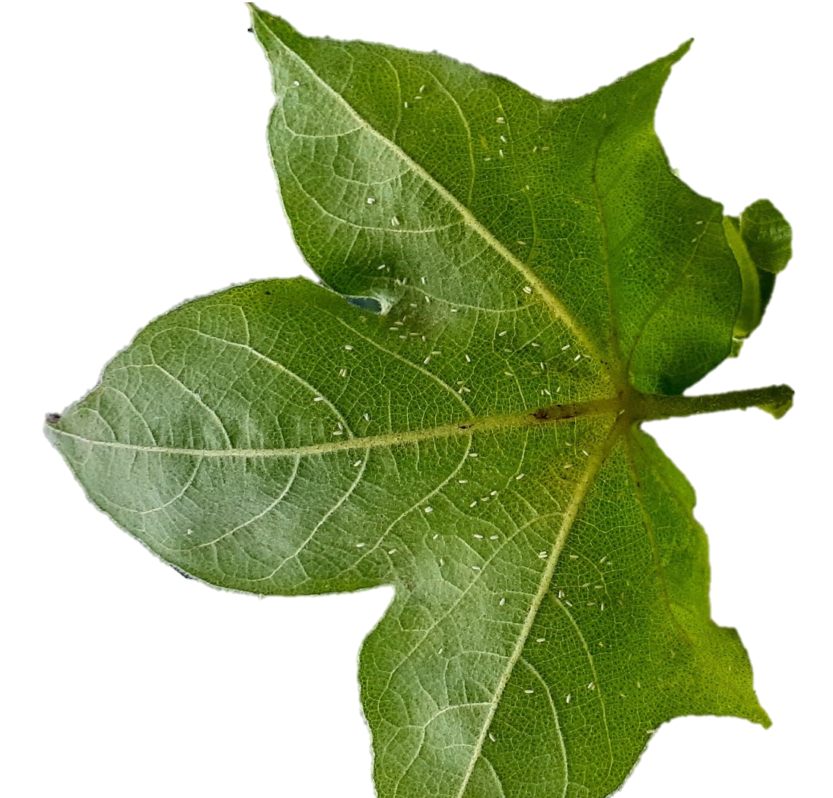
Figure S7: The lower side of Gossypium hirsutum leaf with whitefly attack.

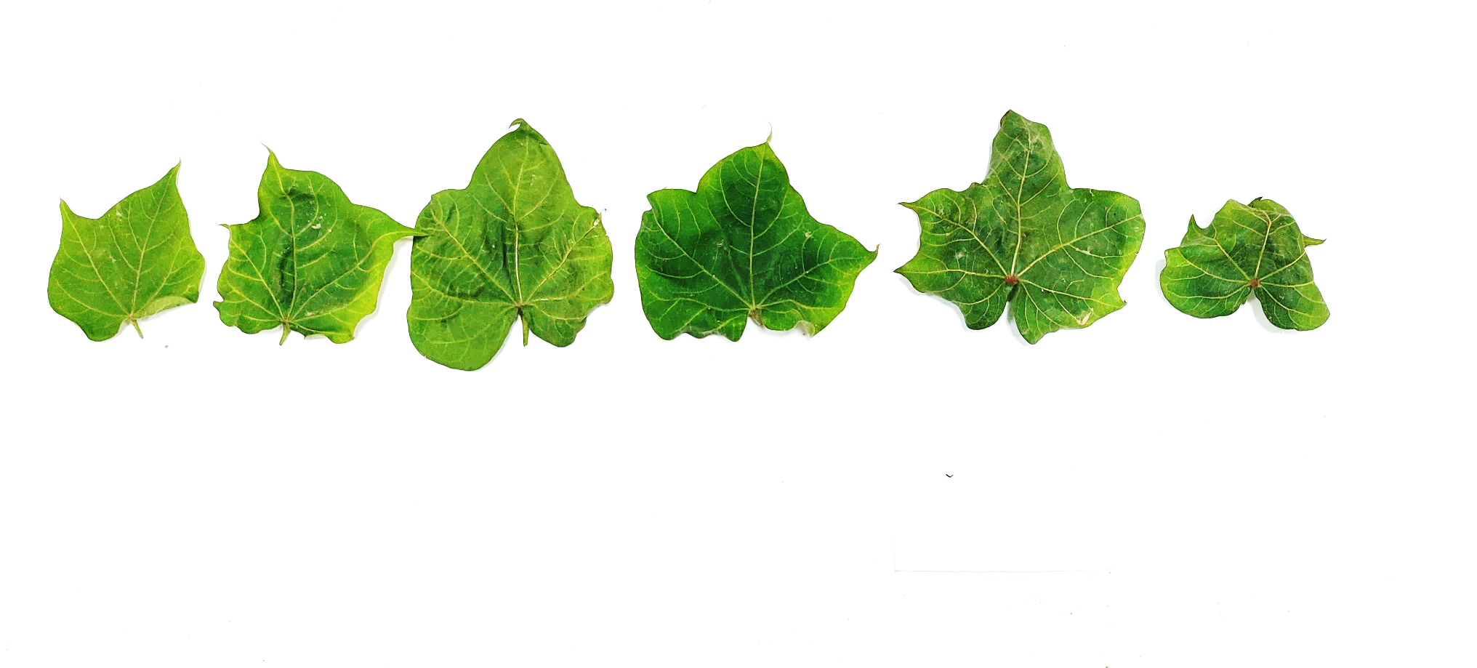
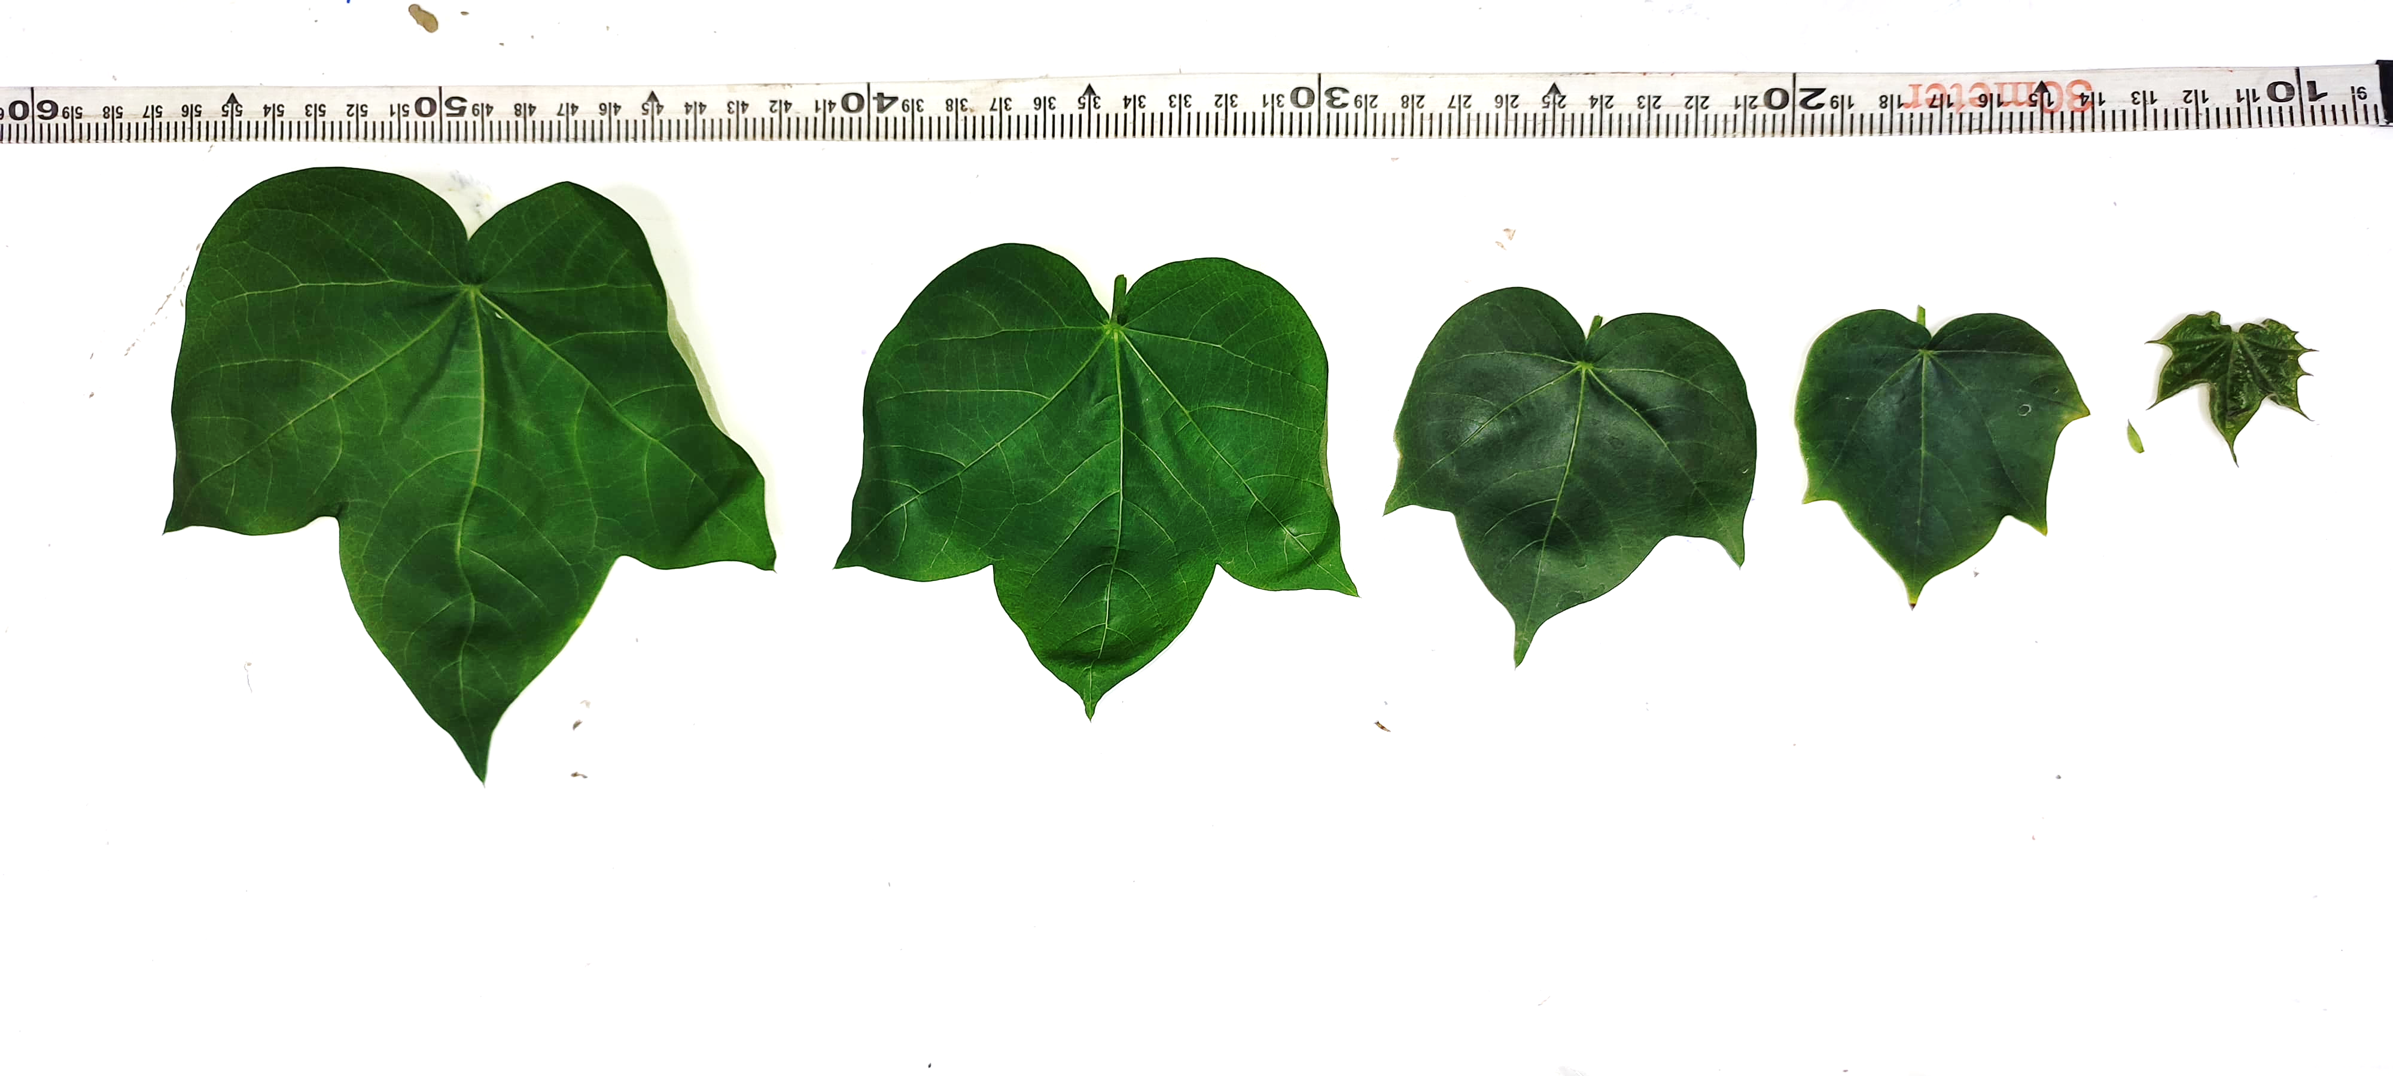
Figure S8: G. hirsutum leaves in the stages of development, A: Leaves from a G. hirsutum plant grown in controlled conditions under 18 hours of light and 6 hours of dark, without viruliferous whitefly attack, B: Leaves from a G. hirsutum plant grown in uncontrolled conditions under natural photoperiod in the hub of viruliferous whitefly, depicting ideal curling symptoms of CLCuD
B
A
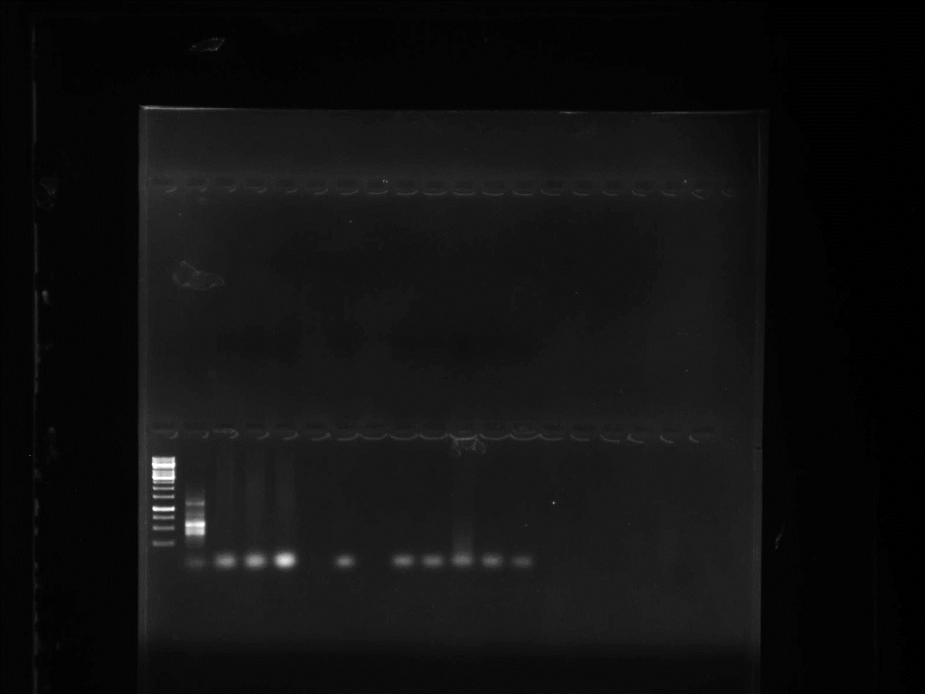
Lane 1
Lane 2
1000 bp
Figure S9: β-satellite amplification for identification of CLCuV infection in G. arboreum and G. hirsutum test plants (Lane 1: 1 kb Gene Ruler, Lane 2: β-satellite complex of Begomovirus

REFERENCES
- Tortora GJ, Funke BR, Case CL. Microbiology: an introduction. Pearson. 2018.

