Supplementary Materials, Table of Contents

Supplementary Figures
Supplementary Figure 1 page 2
Supplementary Figure 2 page 3
Supplementary Figure 3 page 4
Supplementary Figure 4 page 5
Supplementary Figure 5 page 6
Supplementary Figure 6 page 7
Supplementary Figure 7 page 8
Supplementary Figure 8 page 9

Supplementary Table
Supplementary Table 1 page 10

Supplementary Data File Descriptions page 10
List of IMPACC Consortium Members page 11

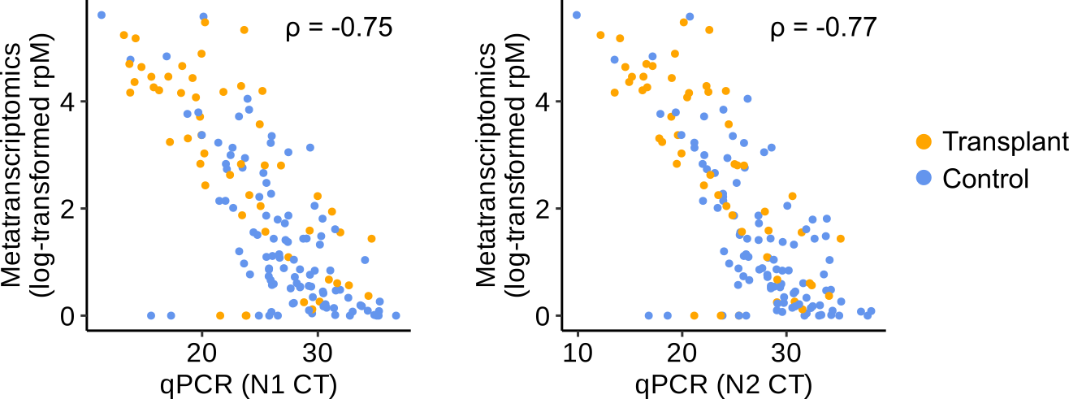
Supplementary Figure 1. SARS-CoV-2 viral abundance measurements by nasal metatranscriptomics and quantitative RT-PCR are highly correlated. Plots showing the relationship between metatranscriptomics viral reads per million (rpM) and cycle threshold (CT) value of N1 (left) and N2 (right) viral genes. Rho indicates the Pearson’s correlation coefficient.

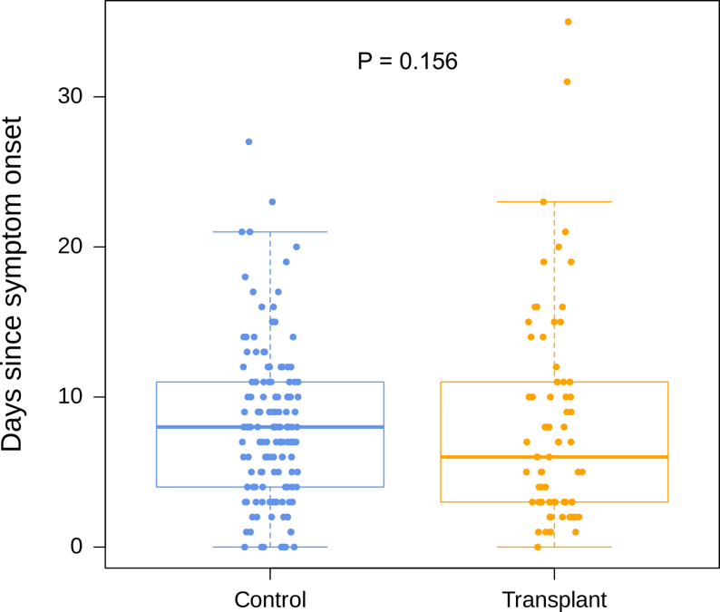
Supplementary Figure 2. Days from symptom onset to hospital admission in SOT recipients and non-SOT controls were similar. SOT recipients (median = 6, IQR = 3-11) versus controls (med = 8, IQR = 4-11).

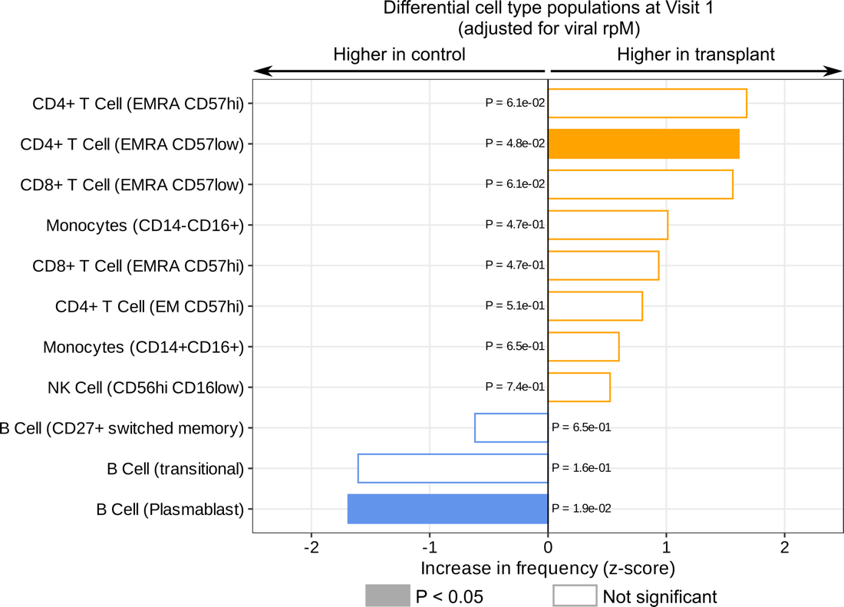
Supplementary Figure 3. Effects of SARS-CoV-2 viral abundance on differential cell type populations at Visit 1. Bar plot showing the cell types that are different between SOT and control groups, after adjusting for SARS-CoV-2 viral rpM. P-values were calculated using linear modelling and Benjamini-Hochberg correction.

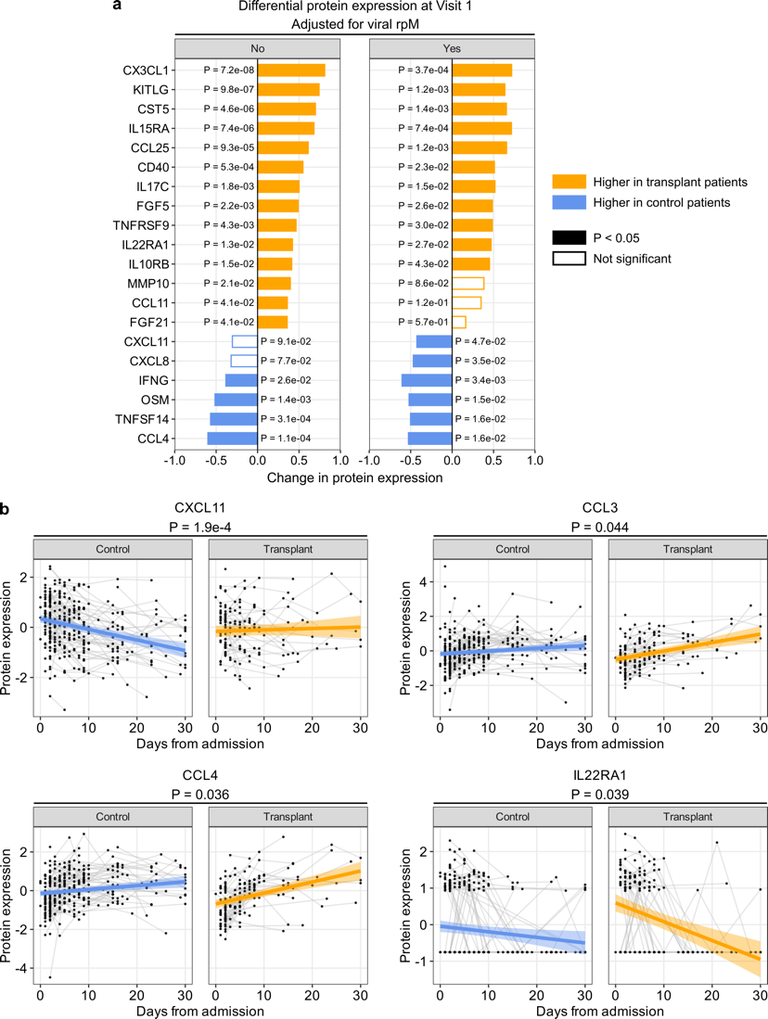
Supplementary Figure 4. Effects of SARS-CoV-2 viral abundance on differential protein expression at Visit 1, and on the dynamics of immune proteins. (a) Bar plots showing serum proteins that are differentially expressed between SOT recipients and non-SOT controls at Visit 1, with (right) and without (left) controlling for SARS-CoV-2 viral rpM. P-values were calculated using a linear modeling and Benjamini-Hochberg correction. (b) Scatter plot showing the dynamics of CXCL11, CCL3, CCL4 and IL22RA1 protein levels after hospital admission (adjusting for SARS-CoV-2 viral rpM). P-values were calculated using a linear mixed effects model and Benjamini-Hochberg correction.
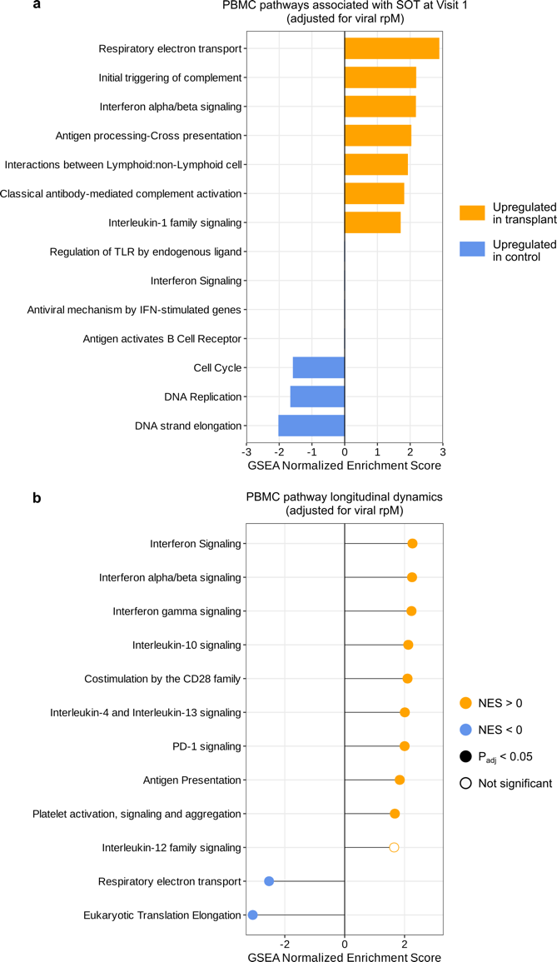
Supplementary Figure 5. Effects of SARS-CoV-2 viral abundance on PBMC transcriptomic pathways. (a) Bar plot highlighting the PBMC pathways differentially enriched in SOT recipients versus controls, with adjustment for SARS-CoV-2 viral rpM. This plot highlights the same pathways as Figure 5b. (b) Differences in the longitudinal dynamics of PBMC signaling pathways, with adjustment for SARS-CoV-2 viral rpM. This plot highlights the same pathways as Figure 5d.
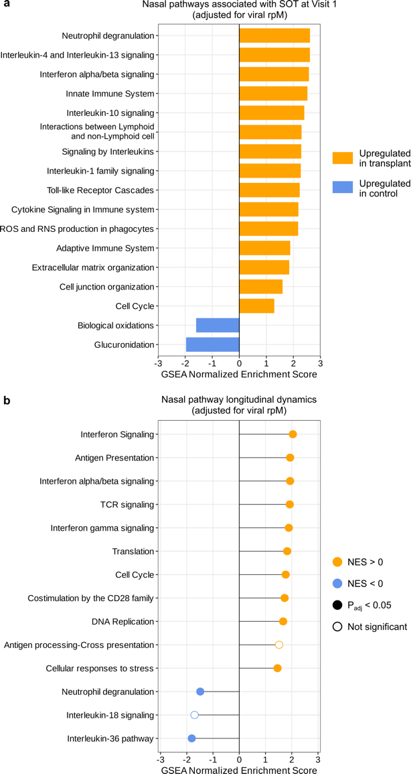
Supplementary Figure 6. Effects of SARS-CoV-2 viral abundance on nasal transcriptomic pathways. (a) Bar plot highlighting the nasal pathways differentially enriched in SOT recipients versus controls, with adjustment for SARS-CoV-2 viral rpM. This plot highlights the same pathways as Figure 6a. (b) Differences in the longitudinal dynamics of nasal signaling pathways, with adjustment for SARS-CoV-2 viral rpM. This plot highlights the same pathways as Figure 6b.
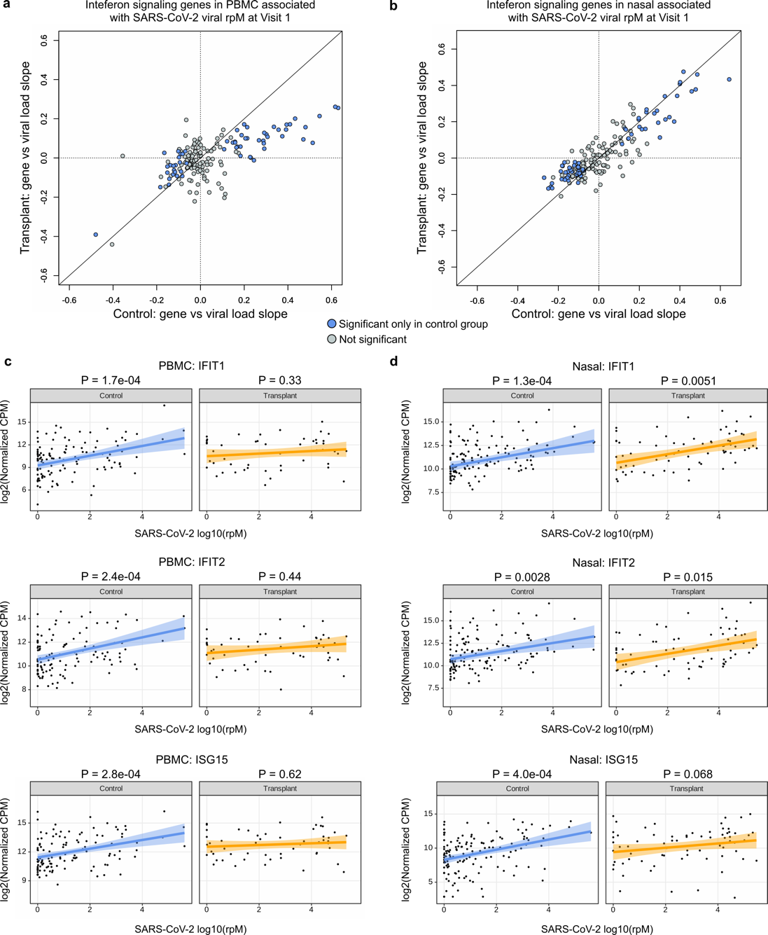
Supplementary Figure 7. Nasal gene expression is more strongly correlated with SARS-CoV-2 viral abundance than PBMC gene expression among SOT patients. (a, b) Plots showing the slopes of (a) PBMC and (b) nasal gene expression against SARS-CoV-2 rpM. The x-axes and y-axes show the slopes in control and SOT groups, respectively. The black diagonal lines indicate y = x. (c, d) Plots showing the relationship of IFIT1, IFIT2 and ISG15 expression and viral rpM in PBMC and nasal samples.
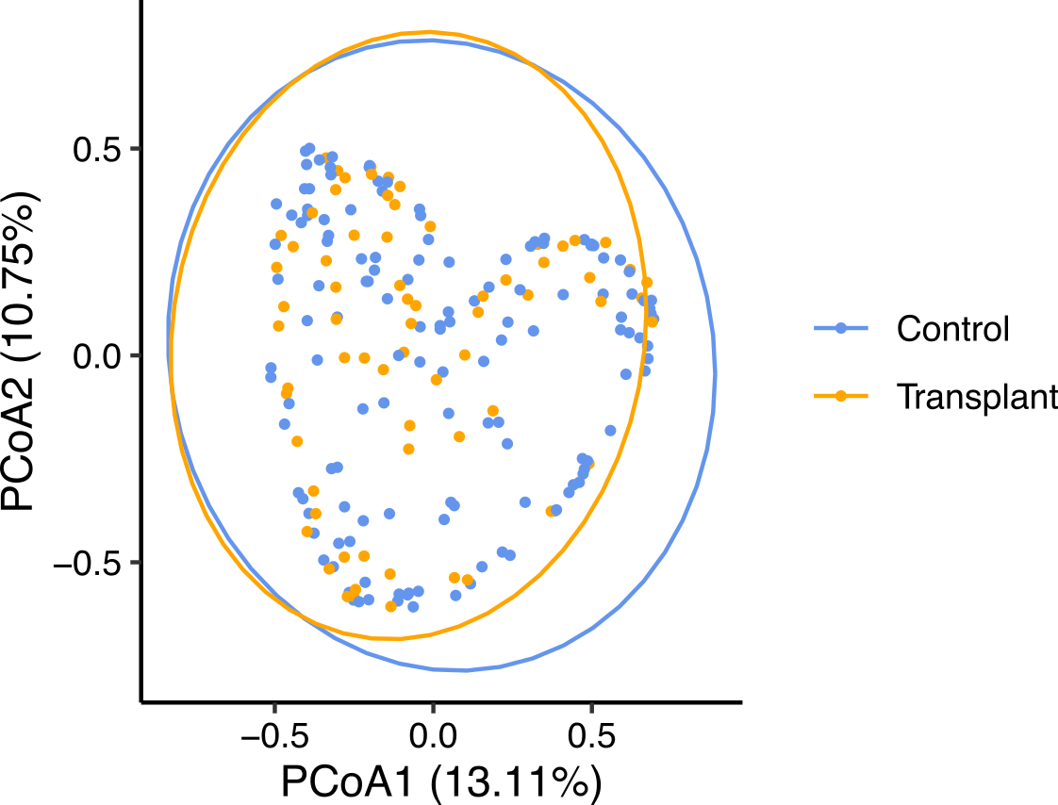
Supplementary Figure 8. Principal coordinate analysis (PCoA) of Bray-Curtis dissimilarity index from nasal metatranscriptomics at Visit 1. Colored by transplant group with 95% confidence intervals denoted by ellipses. Significance tested with Adonis (R² = 0.006, P = 0.186).

Supplementary Table 1. Organ transplant type in SOT recipients.
 | SOT cases
Organ type  Kidney  Lung  Liver  Heart | 45 (52.3%)  17 (19.8%)  14 (16.3%)  10 (11.6%)

Description of Supplementary Data Files:

Supplementary Data 1: Differentially expressed genes (FDR < 0.05) between SOT-recipients and non-SOT controls at Visit 1, based on PBMC transcriptomics.

Supplementary Data 2: Gene set enrichment analysis results based on PBMC differential gene expression (DGE) at Visit 1. NES = Normalized Enrichment Score. vrld = GSEA results based on DGE with adjustment for viral load (SARS-CoV-2 reads per million, rpM).

Supplementary Data 3: Longitudinal gene set enrichment analysis results based on PBMC differential gene expression between SOT-recipients and non-SOT controls. NES = Normalized Enrichment Score. vrld = GSEA results based on DGE with adjustment for SARS-CoV-2 rpM.

Supplementary Data 4: Gene set enrichment analysis results based on nasal differential gene expression at Visit 1. NES = Normalized Enrichment Score. vrld = GSEA results based on DGE with adjustment for SARS-CoV-2 rpM.

Supplementary Data 5: Longitudinal GSEA results based on nasal differential gene expression (DGE) between SOT-recipients and non-SOT controls. NES = Normalized Enrichment Score. vrld = GSEA results based on DGE with adjustment for SARS-CoV-2 rpM.
List of IMPACC Network Consortium Members

#The IMPACC Network
National Institute of Allergy and Infectious Diseases, National Institute of Health, Bethesda, MD 20814, USA: Patrice M. Becker, Alison D. Augustine, Steven M. Holland, Lindsey B. Rosen, Serena Lee, Tatyana Vaysman
Clinical and Data Coordinating Center (CDCC) Precision Vaccines Program, Boston Children’s Hospital, Boston, MA 02115, USA: Al Ozonoff, Joann Diray-Arce, Jing Chen, Alvin Kho, Carly E. Milliren, Annmarie Hoch, Ana C. Chang, Kerry McEnaney, Brenda Barton, Claudia Lentucci, Maimouna Murphy, Mehmet Saluvan, Tanzia Shaheen, Shanshan Liu, Caitlin Syphurs, Marisa Albert, Arash Nemati Hayati, Robert Bryant, James Abraham
Benaroya Research Institute, University of Washington, Seattle, WA 98101, USA: Matthew C. Altman, Naresh Doni Jayavelu, Scott Presnell, Bernard Kohr, Azlann Arnett
La Jolla Institute for Immunology, La Jolla, CA 92037, USA: Bjoern Peters, Randi Vita, Kerstin Westendorf
Knocean Inc. Toronto, ON M6P 2T3, Canada: James A. Overton
Precision Vaccines Program, Boston Children’s Hospital, Harvard Medical School, Boston, MA 02115, USA: Ofer Levy, Hanno Steen, Patrick van Zalm, Benoit Fatou, Kinga Smolen, Arthur Viode, Simon van Haren, Meenakshi Jha
Brigham and Women’s Hospital, Harvard Medical School, Boston, MA 02115, USA: Lindsey R. Baden, Kevin Mendez, Jessica Lasky-Su, Alexandra Tong, Rebecca Rooks
Metabolon Inc, Morrisville, NC 27560, USA: Scott R. Hutton, Greg Michelotti, Kari Wong
Case Western Reserve University and University Hospitals of Cleveland, Cleveland, OH 44106, USA: Rafick-Pierre Sekaly, Slim Fourati, Grace A. McComsey, Paul Harris, Scott Sieg, Susan Pereira Ribeiro
Drexel University, Tower Health Hospital, Philadelphia, PA 19104, USA: Charles B. Cairns, Elias K. Haddad, Michele A. Kutzler, Mariana Bernui, Gina Cusimano, Jennifer Connors, Kyra Woloszczuk, David Joyner, Carolyn Edwards, Edward Lin, Nataliya Melnyk, Debra L. Powell, James N. Kim, I. Michael Goonewardene, Brent Simmons, Cecilia M. Smith, Mark Martens, Brett Croen, Nicholas C. Semenza, Mathew R. Bell, Sara Furukawa, Renee McLin, George P Tegos, Brandon Rogowski, Nathan Mege, Kristen Ulring
MyOwnMed Inc., Bethesda, MD 20817, USA: Vicki Seyfert-Margolis
Emory School of Medicine, Atlanta, GA 30322, USA: Nadine Rouphael, Steven E. Bosinger, Arun K. Boddapati, Greg K. Tharp, Kathryn L. Pellegrini, Brandi Johnson, Bernadine Panganiban, Christopher Huerta, Evan J. Anderson, Hady Samaha, Jonathan E. Sevransky, Laurel Bristow, Elizabeth Beagle, David Cowan, Sydney Hamilton, Thomas Hodder, Aneesh K. Mehta, Laila Hussaini, Kieffer Hellmeister, Andrew Cheng, Christine Spainhour, Erin M. Scherer, Amer Bechnak, Caroline R. Ciric, Lauren Hewitt, Erin Carter, Nina Mcnair, Jacob Usher.

Icahn School of Medicine at Mount Sinai, New York, NY 10029, USA: Ana Fernandez-Sesma, Viviana Simon, Florian Krammer, Harm Van Bakel, Seunghee Kim-schulze, Ana Silvia Gonzalez-Reiche, Jingjing Qi, Brian Lee, Juan Manuel Carreño, Gagandeep Singh, Ariel Raskin, Johnstone Tcheou, Zain Khalil, Adriana van de Guchte, Keith Farrugia, Zenab Khan, Geoffrey Kelly, Komal Srivastava, Lily Eaker, Maria Carolina Bermúdez González, Lubbertus C.F. Mulder, Katherine Beach
Immunai Inc. New York, NY 10016, USA: Adeeb Rahman
Oregon Health Sciences University, Portland, OR 97239, USA: William B. Messer, Catherine L. Hough, Sarah Siegel, Peter Sullivan, Zhengchun Lu
Stanford University School of Medicine, Palo Alto, CA 94305, USA: Holden Maecker, Bali Pulendran, R. Kari C. Nadeau, Yael Rosenberg-Hasson, Michael Leipold, Natalia Sigal, Angela Rogers, Andrea Fernandez, Monali Manohar, Evan Do, Iris Chang
David Geffen School of Medicine at the University of California Los Angeles, Los Angeles CA 90095, USA: Elaine F. Reed, Joanna Schaenman, Ramin Salehi-Rad, Adreanne M. Rivera, Harry C. Pickering, Subha Sen, David Elashoff, Dawn C. Ward
University of California San Francisco, San Francisco, CA 94115, USA: David J. Erle, Carolyn S. Calfee, Carolyn M. Hendrickson, Kirsten N. Kangelaris, Viet Nguyen, Deanna Lee, Suzanna Chak, Rajani Ghale, Ana Gonzalez, Alejandra Jauregui, Carolyn Leroux, Luz Torres Altamirano, Ahmad Sadeed Rashid, Andrew Willmore, Prescott G. Woodruff, Matthew F. Krummel, Sidney Carrillo, Alyssa Ward, Charles R. Langelier, Ravi Patel, Michael Wilson, Ravi Dandekar, Bonny Alvarenga, Jayant Rajan, Walter Eckalbar, Andrew W. Schroeder, Gabriela K. Fragiadakis, Alexandra Tsitsiklis, Eran Mick, Yanedth Sanchez Guerrero, Rajani Ghale, Christina Love, Lenka Maliskova, Michael Adkisson
Yale School of Medicine, New Haven, CT 06510, USA: David A. Hafler, Ruth R. Montgomery, Albert C. Shaw, Steven H. Kleinstein, Jeremy Gygi, Shrikant Pawar, Anna Konstorum, Ernie Chen, Chris Cotsapas, Xiaomei Wang, Leqi Xu, Charles Dela Cruz, Akiko Iwasaki, Subhasis Mohanty, Allison Nelson, Yujiao Zhao, Shelli Farhadian, Hiromitsu Asashima
Yale School of Public Health, New Haven, CT 06510, USA: Denise Esserman, Leying Guan, Anderson Brito, Jessica Rothman, Nathan Grubaugh, Albert I. Ko
Baylor College of Medicine and the Center for Translational Research on Inflammatory Diseases, Houston, TX 77030, USA: David B. Corry, Farrah Kheradmand, Li-Zhen Song, Ebony Nelson
Oklahoma University Health Sciences Center, Oklahoma City, OK 73104, USA: Jordan P. Metcalf, Nelson I Agudelo Higuita, Lauren Sinko, J. Leland Booth
University of Arizona, Tucson AZ 85721, USA: Monica Kraft, Chris Bime, Jarrod Mosier, Heidi Erickson, Ron Schunk, Hiroki Kimura, Michelle Conway
University of Florida, Gainesville, FL 32611, USA: Mark A. Atkinson, Scott C. Brakenridge, Ricardo F. Ungaro, Brittany Roth Manning,
University of Florida, Jacksonville, FL 32218, USA: Jordan Oberhaus, Faheem W. Guirgis,
University of South Florida, Tampa FL 33620, USA: Brittney Borresen, Matthew L. Anderson
University of Texas, Austin, TX 78712, USA: Lauren I. R. Ehrlich, Esther Melamed, Cole Maguire, Justin F. Rousseau, Kerin C. Hurley, Janelle N. Geltman, Nadia Siles, Jacob E. Rogers

