Supplemental Information
Ammonium availability and pH control the contributions of ammonia-oxidizing bacteria and archaea to nitrification
Jennifer Wen¹, Rima Upchurch¹, Donald R. Zak^{1,2}

¹ School for Environment and Sustainability, University of Michigan, Ann Arbor, MI, USA
² Department of Ecology & Evolutionary Biology, University of Michigan, Ann Arbor, MI, USA

*Author for correspondence

Submitted to Microbial Ecology as an Article.

Supplemental Methods
qPCR Protocol
We performed qPCR using an Agilent Mx3000 thermocycler with Agilent Brillant III SYBER Green. We used primers CrenAmoAQ-F/CrenAmoAModR [2] and 1F/2R [3] for AOA and AOB, respectively. Each 20 mlL reaction consisted of 10ul of SYBR mastermix, 0.3ul of Rox standard, 1mlL of template and 0.375 mlL of each primer for AOA and 0.25 mlL of each primer for AOB. The thermal profile for AOA used a modified version of Urakawa et al. [5], which lowered the cycles to 45; we modified Yao et al. [6] thermal profile to increase cycles to 45 and decrease annealing temperature to 53°C.

Table S1. Summary of the stands used in this study, including Stand Number and Ecosystem Types based on Zak & Pregitzer [7], as well as edaphic characteristics (Mean Net N Mineralization, Mean pH, and Nitrification) measured from the collected soil samples in 2019

Stand | Ecosystem Type | Mean Net N Mineralization  (ng N g⁻¹ d⁻¹) | Mean pH | Mean Nitrification (ng NO₃⁻ g⁻¹ d⁻¹)
3 | Black oak-white oak/Vaccinium | 291.16 ± 34.34 | 3.94 ± 0.04 | 0.13 ± 0.86
9 | Black oak-white oak/Vaccinium | 360.07 ± 75.90 | 4.30 ± 0.11 | 139.92 ± 112.78
50 | Black oak-white oak/Vaccinium | 235.16 ± 34.56 | 4.02 ± 0.10 | -0.33 ± 0.88
58 | Black oak-white oak/Vaccinium | 291.59 ± 15.04 | 4.40 ± 0.06 | 24.24 ± 8.87
7 | Sugar maple-red oak/Maianthemum | 410.16 ± 30.17 | 4.26 ± 0.04 | 149.03 ± 40.26
20 | Sugar maple-red oak/Maianthemum | 211.65 ± 40.04 | 4.04 ± 0.06 | -0.49 ± 1.20
31 | Sugar maple-red oak/Maianthemum | 283.8 ± 27.50 | 3.98 ± 0.06 | 0.30 ± 0.79
41 | Sugar maple-red oak/Maianthemum | 578.02 ± 52.93 | 4.12 ± 0.08 | 488.46 ± 81.12
6 | Sugar maple-basswood/Osmorhiza | 414.79 ± 40.65 | 5.03 ± 0.08 | 423.35 ± 51.18
22 | Sugar maple-basswood/Osmorhiza | 827.97 ± 77.70 | 5.93 ± 0.12 | 871.76 ± 78.09
24 | Sugar maple-basswood/Osmorhiza | 617.62 ± 77.24 | 5.12 ± 0.14 | 677.67 ± 98.74
100 | Sugar maple-basswood/Osmorhiza | 734.57 ± 77.41 | 4.73 ± 0.19 | 765.74 ± 71.54

Table S2. Lists of reagents and thermoprofile used for the amplification of amoA for AOA (a) and AOB (b) adapted from [1]
A
Reagent | Volume (μL)
5X Phusion buffer | 5
2mM dNTP | 2.5
(5μM) forward primer | 1
(5μM) reverse primer | 1
(20mg/mL) BSA | 0.5
Phusion Taq | 0.5
Nuclease free H₂O | 13.5
DNA template | 1
Total | 25
Step | Temp (°C) | Time | Cycles
Initial denaturation | 95 | 5 minutes | -
Denaturation | 95 | 20 seconds | 27 cycles
Annealing | 64 | 45 seconds | 27 cycles
Extension | 72 | 45 seconds | 27 cycles
Final extension | 72 | 10 minutes | -

B
Reagent | Volume (μL)
5X Phusion buffer | 5
2mM dNTP | 2.5
(5μM) forward primer | 1
(5μM) reverse primer | 1
(20mg/mL) BSA | 0.5
Phusion Taq | 0.5
Nuclease free H₂O | 13.5
DNA template | 1
Total | 25
Step | Temp (°C) | Time | Cycles
Initial denaturation | 95 | 5 minutes | -
Denaturation | 95 | 20 seconds | 28 cycles
Annealing | 60 | 45 seconds | 28 cycles
Extension | 72 | 25 seconds | 28 cycles
Final extension | 72 | 10 minutes | -

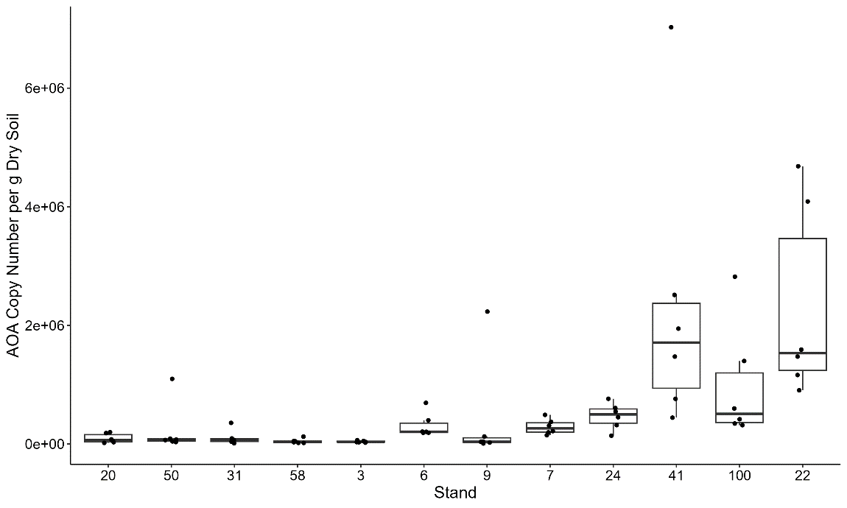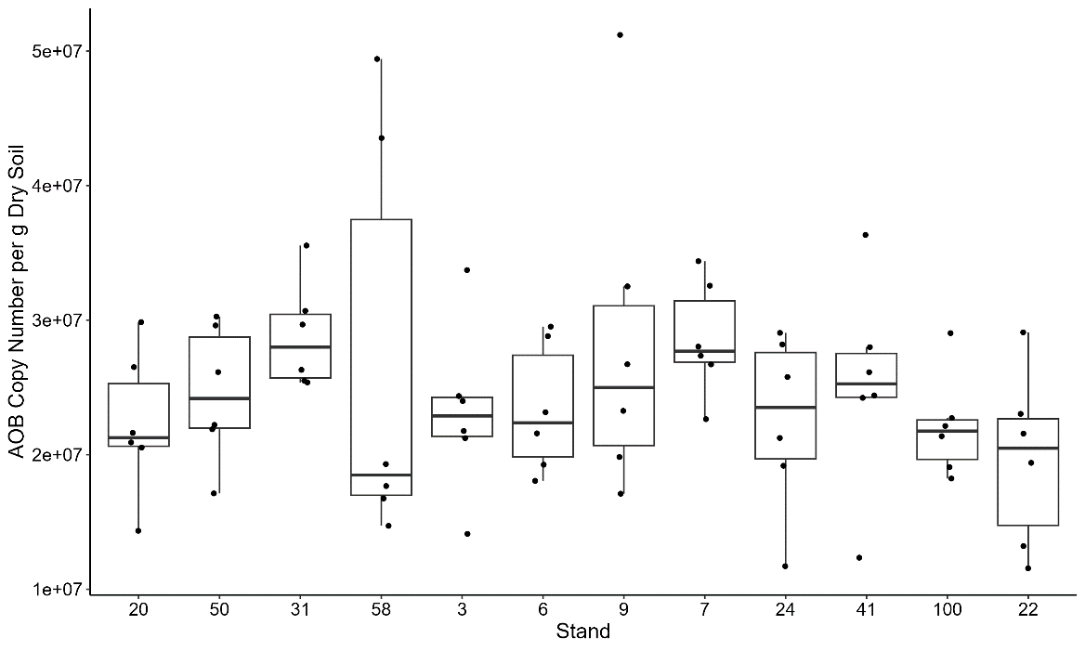
A
B
Figure S1. qPCR copy numbers for AOA (a) and AOB (b) for each stand per copies per gram dry weight soil. Each point on the box plot represents a plot in that stand. Stands are ordered from lowest to highest nitrification rates. Notably, AOB has greater copy numbers than AOA by a factor of 10

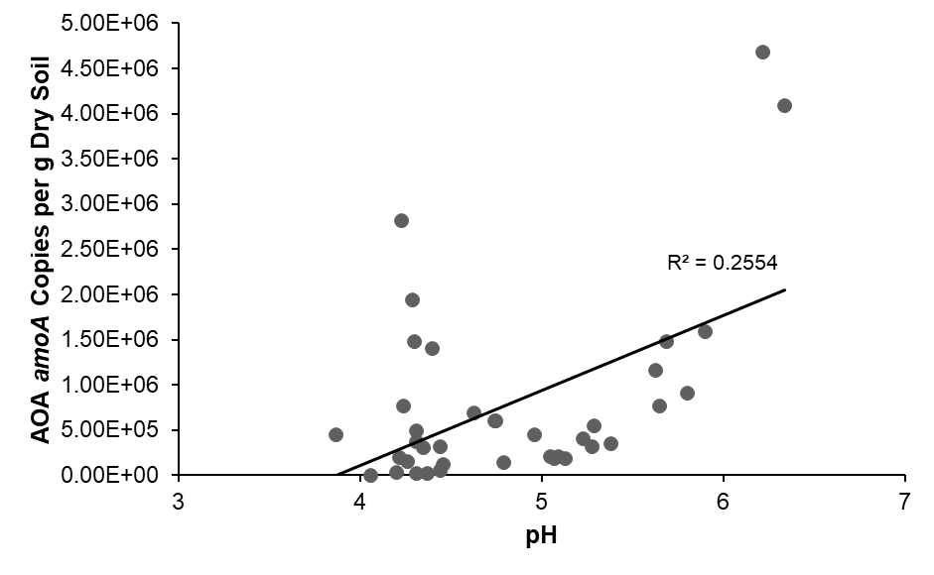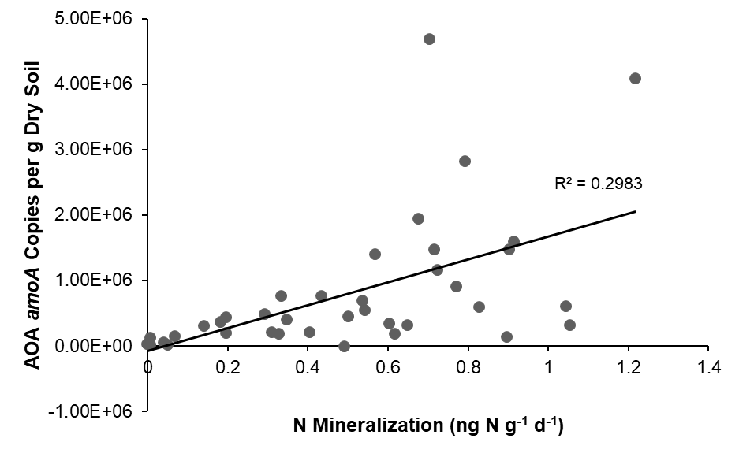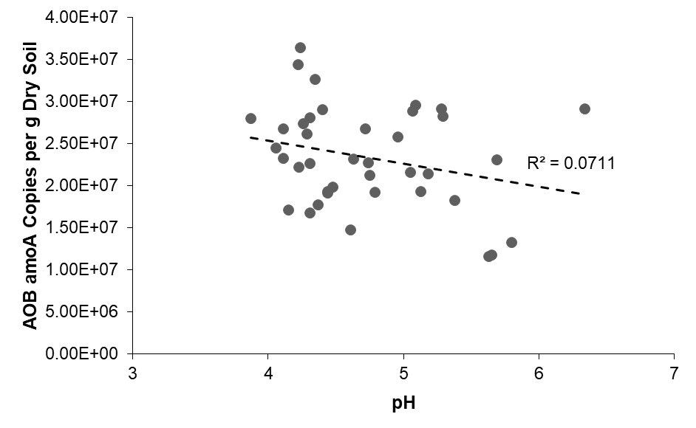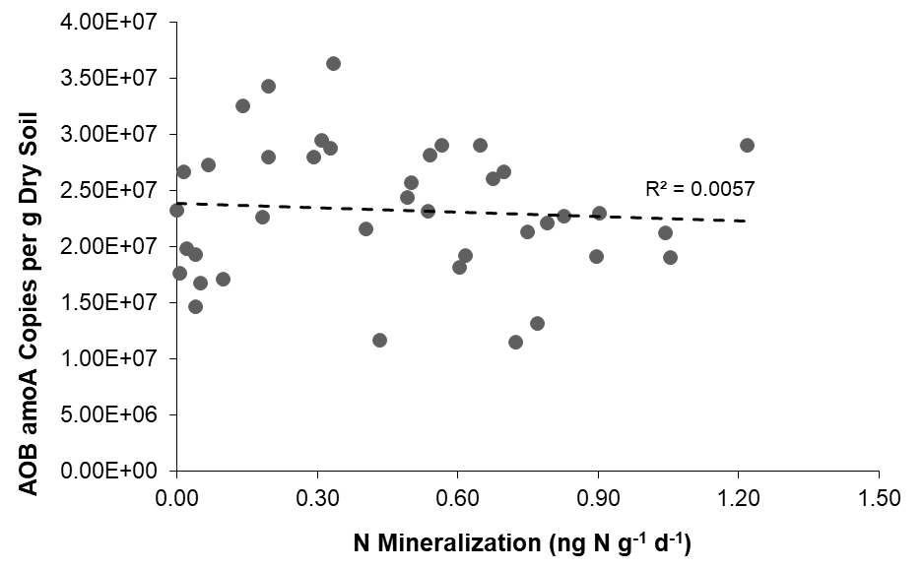
Figure S2. Linear regressions showing the relationships between soil pH or N mineralization rates and amoA qPCR copy numbers for AOA and AOB. Each point represents a plot used in the study. For AOA, plot 50 was removed as an outlier. Dashed lines indicate non-significant regressions. Solid lines indicate significant regressions. The relationships between AOB qPCR copy numbers and N mineralization and pH were non-significant (p = 0.649 and p = 0.101, respectively). The relationships between AOA qPCR copy numbers and N mineralization and pH were significant (p = 0.000422 and p = 0.00189, respectively) – both indicate positive associations

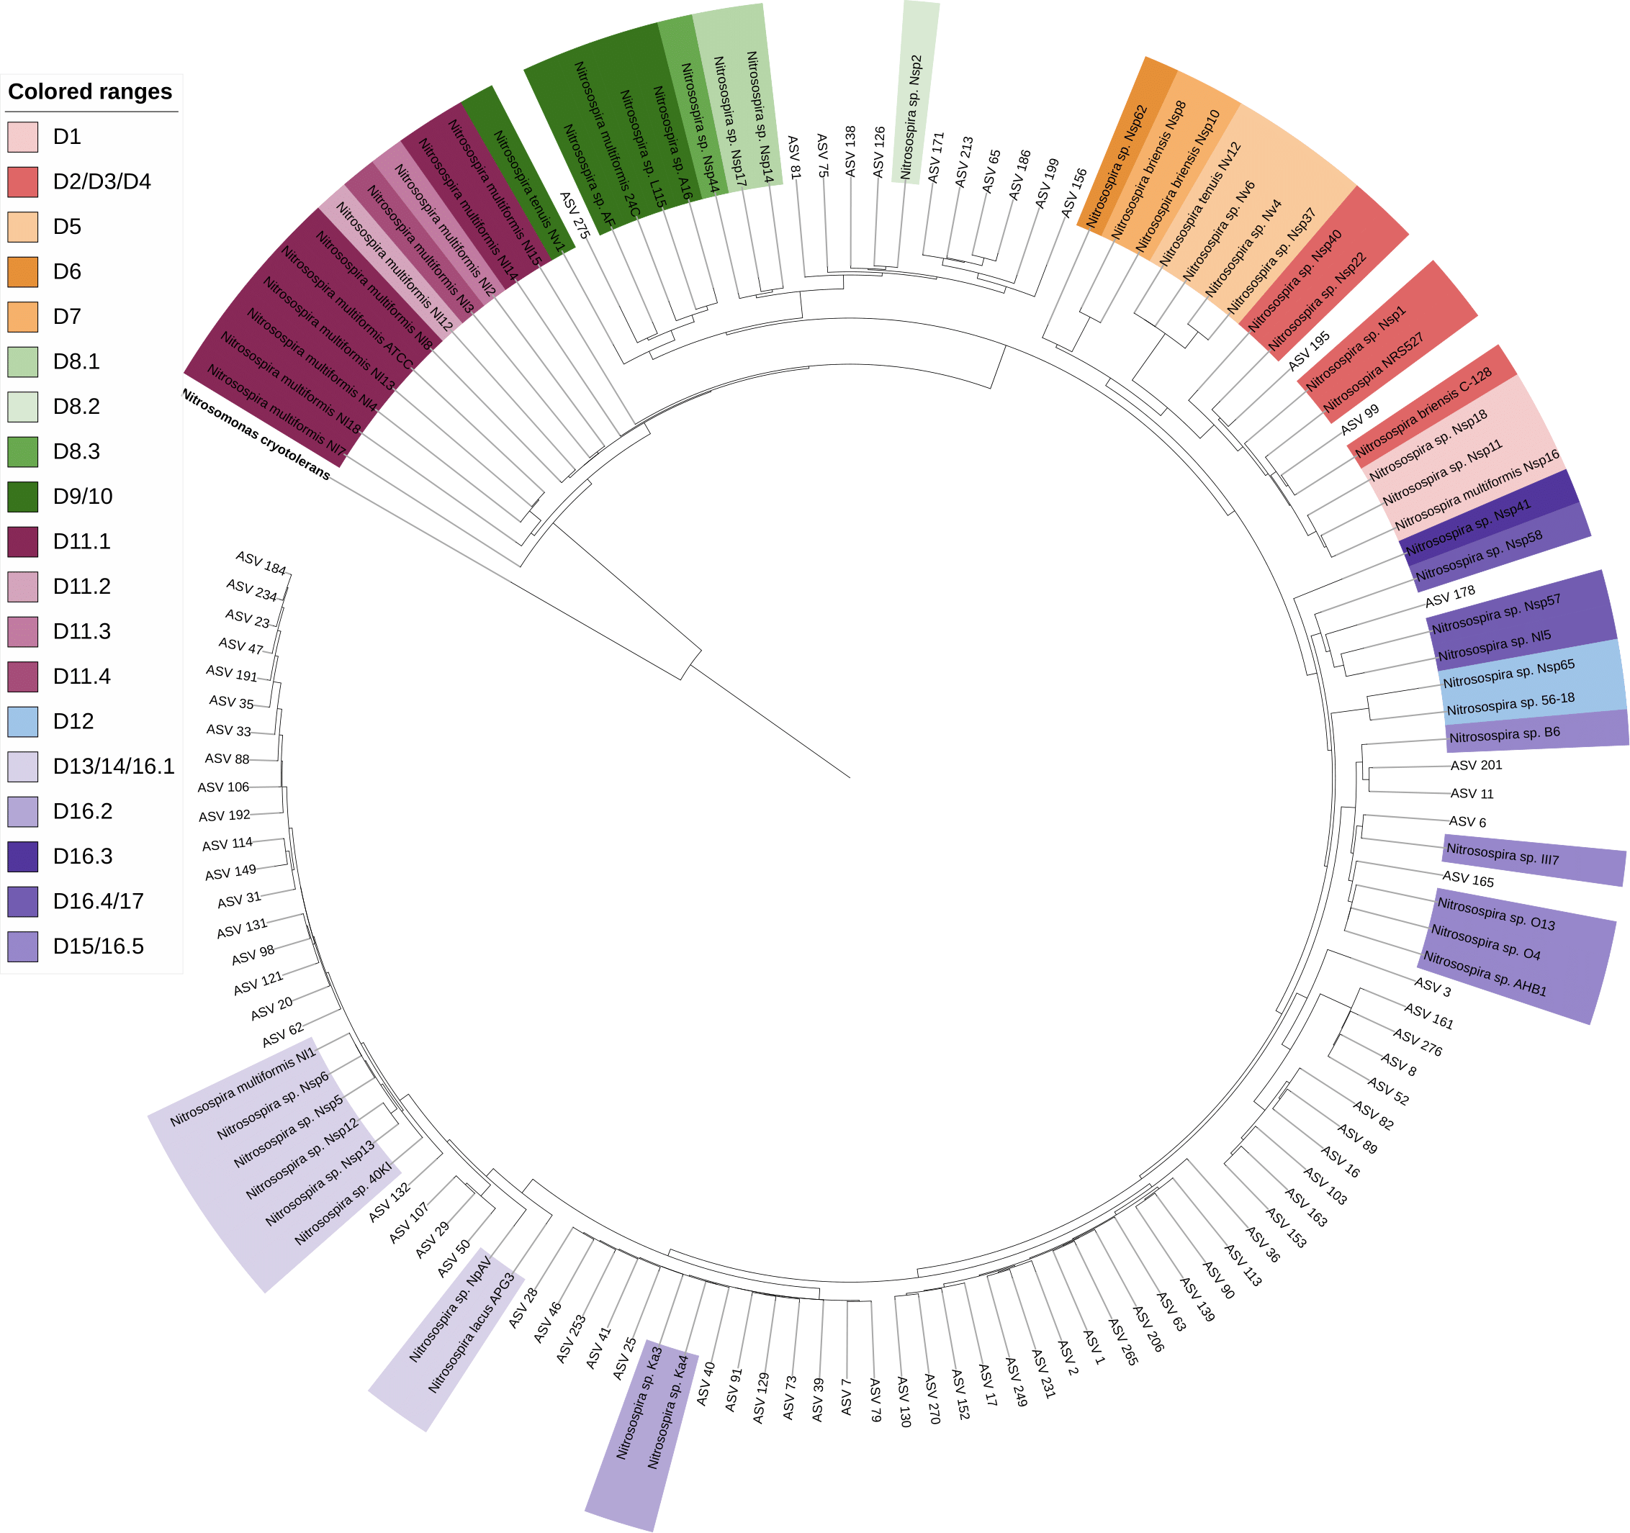

Figure S3. Circular maximum likelihood trees of bacterial amoA ASVs obtained from our samples and the Nitrosospira strains from Aigle et al. (2019). AOB gene lineage designations D1–D17 [1] are indicated by different colors, and our ASVs are indicated without coloration. In contrast to the AOB tree included in the main body of the study, this tree was organized based on the 16s rRNA gene lineages for the same Nitrosospira strains
B.

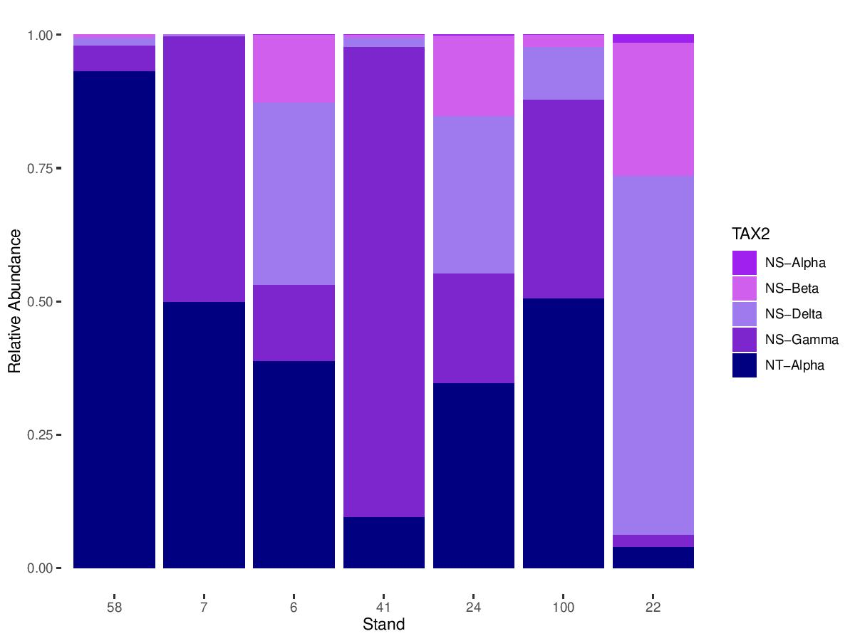
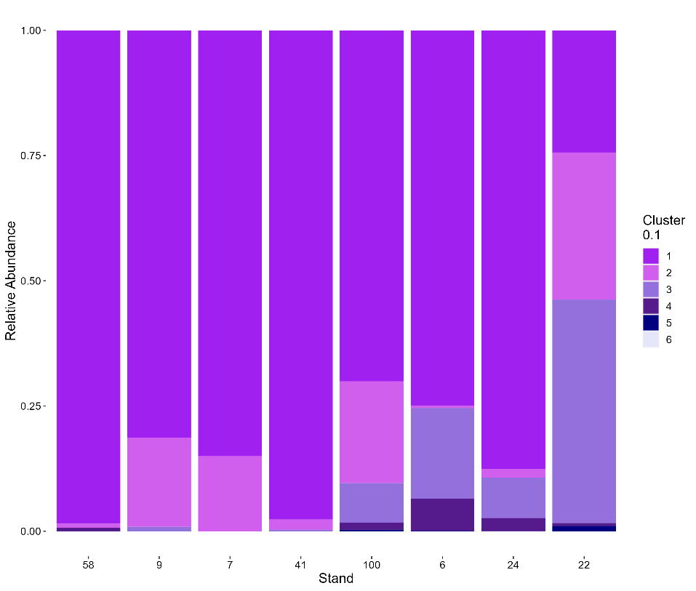
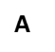
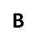
Figure S4. The relative abundance of the primary AOA subclades (a) and AOB Groupings (a) in each stand, differentiated by color. AOA communities primarily comprise NS-Alpha, NS-Beta, NS-Delta, NS-Gamma, and NT-Alpha – representing the Nitrososphaerales (NS) and Ca. Nitrosotaleales (NT) lineages. Clades with relative abundances > 0.05% were omitted from the figure. AOB Groupings are all within Nitrosospira. Groupings were created from ASVs based on a 90% similarity cutoff. Stands are ordered from lowest to highest nitrification rates

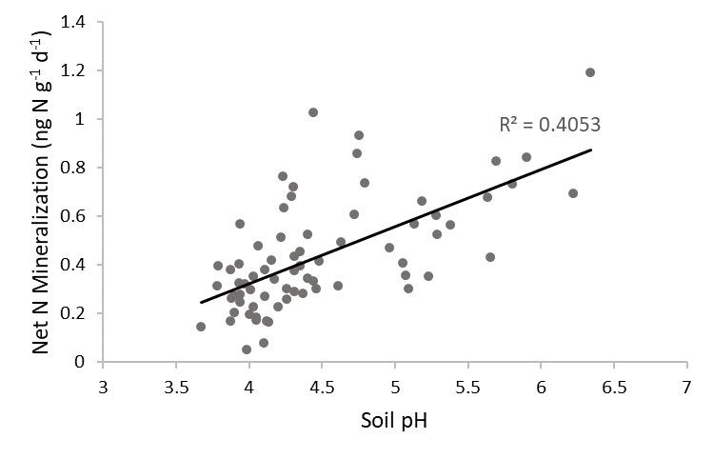
Figure S5. Linear regression showing how soil pH covaries with net N mineralization. Each point represents a plot. The solid line represents a significant positive relationship between soil pH and net N mineralization (p = 1.85e-09).

References
- Aigle A, Prosser JI, Gubry-Rangin C (2019) The application of high-throughput sequencing technology to analysis of amoA phylogeny and environmental niche specialisation of terrestrial bacterial ammonia-oxidisers. Environmental Microbiomes 14(1): 1–10. https://doi.org/10.1186/s40793-019-0342-6
- Mincer TJ, Church MJ, Taylor LT, Preston C, Karl DM, DeLong EF (2007) Quantitative distribution of presumptive archaeal and bacterial nitrifiers in Monterey Bay and the North Pacific Subtropical Gyre. Environ Microbiol 9: 1162-1175. doi: 10.1111/j.1462-2920.2007.01239.x
- Rotthauwe JH, Witzel KP, Liesack W (1997) The ammonia monooxygenase structural gene amoA as a functional marker: molecular fine-scale analysis of natural ammonia-oxidizing populations. Appl Environ Microb 63(12): 4704-4712. doi: 10.1128/aem.63.12.4704-4712.199
- Siljanen HMP, Alves RJE, Ronkainen JG, Lamprecht RE, Bhattarai HR, Bagnoud A, Marushchak ME, Martikainen PJ, Schleper C, Biasi C (2019) Archaeal nitrification is a key driver of high nitrous oxide emissions from arctic peatlands. Soil Biol Biochem 137, 107539. https://doi.org/10.1016/J.SOILBIO.2019.107539
- Urakawa H, Martens-Habbena W, Stahl DA (2010) High Abundance of Ammonia-Oxidizing Archaea in Coastal Waters, Determined Using a Modified DNA Extraction Method. AEM 76: 2129 – 2135. doi: 10.1128/AEM.02692-09
- Yao H, Gao Y, Nicol GW, Campbell CD, Prosser JI, Zhang L, Han W, Singh BK (2011) Links between ammonia oxidizer community structure, abundance, and nitrification potential in acidic soils. Appl Environ Microbiol 77(13): 4618-4625. doi: 10.1128/AEM.00136-11
- Zak DR, Pregitzer KS (1990) Spatial and Temporal Variability of Nitrogen Cycling in Northern Lower Michigan. Forest Sci 36(2): 367–380. https://doi.org/10.1093/forestscience/36.2.367

