Supplementary Material

Cytokines Analysis

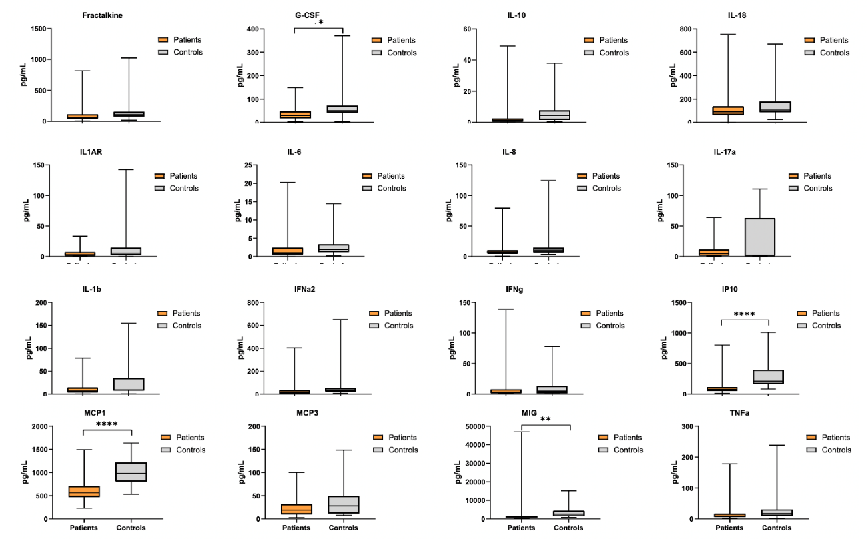
Figure 2: Boxplot of the serum cytokines levels. Indicates *p < 0.05, **p < 0.01, ***p < 0.001, and ****p < 0.0001

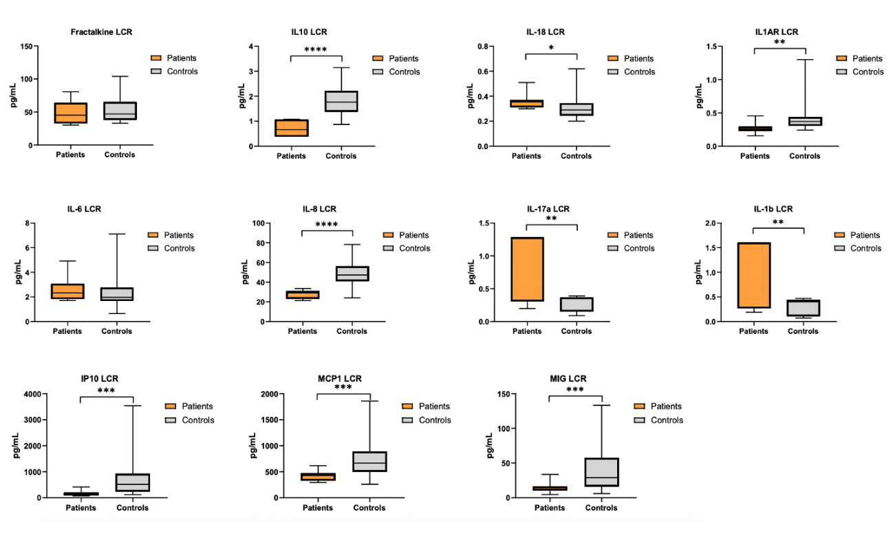
Figure 3: Boxplot of the CSF cytokines levels. Indicates *p < 0.05, **p < 0.01, ***p < 0.001, and ****p < 0.0001

