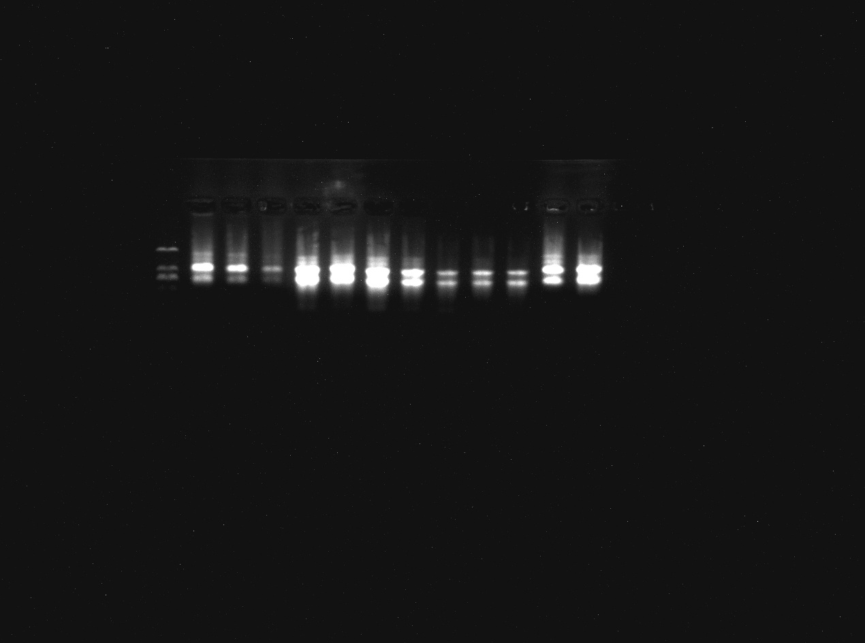
Figure S1-A Agarose gel electrophoresis analysis of total RNA

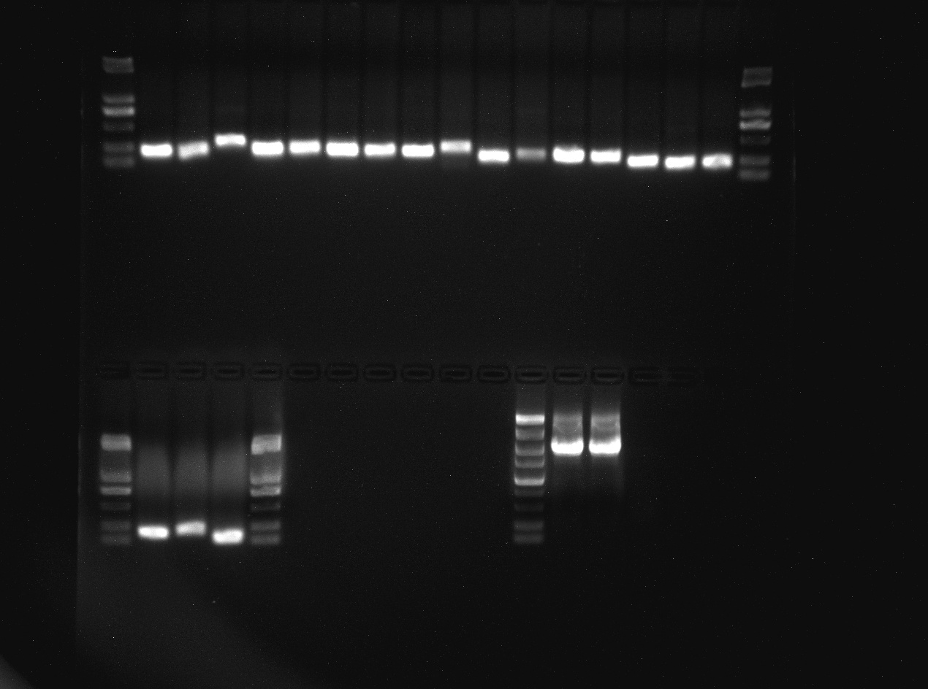
M 1 2 3 4 5 6 7 8 9 10 11 12 13 14 15 16 M
M 17 18 19 M
750
250
750
250

Figure S1-B Agarose gel electrophoresis analysis of candidate gene PCR product
M：Marker 2K；1-19：SsuACT、SsuHis、SsuTUA1、SsuTUA2、SsuUBC1、SsuUBC2、SsuUBCJ2、SsuUBC17、SsuMDH、SsueIF5、SsuGTP、SsuCal7、SsuRIB、SsuMet2、ColGAPDH、SsuTUB、SsuCas、SsuUDP、SsuGAPDH

