Material and Methods
Sample collection
This research was conducted at the Indus Lab Lahore Haripur branch, and at Research Lab of Rehabilitation and Allied Health Sciences, Riphah International University from 2018-2022. The study was approved by Faculty of Rehabilitation and Allied Health Sciences Research and Ethical committee. A total of 1700 urine samples were collected from DHQ Hospital. Samples were transported to the Indus Lab at 4°C. 200 samples were excluded due to contamination.
Physical examination of samples
All the samples were collected in accordance with relevant guidelines and regulations for specific sample collection and culture. Physical examination of all samples and specially urine samples was done by inverting urine bottles. To check out turbidity and cloudiness in samples. Turbidity is the sign of the presence of bacteria, pus cells, proteins, crystals, etc.
Culture media
Blood, HVS, Pus, and wound swab samples were cultured on blood and MacConkey agar under sterile condition at 37°C for 24 hours[1]. Urine samples were cultured on Cysteine Lactose Electrolyte Deficient media (CLED)[2]. Culture plates were incubated at 37°C for 24 hours[3].
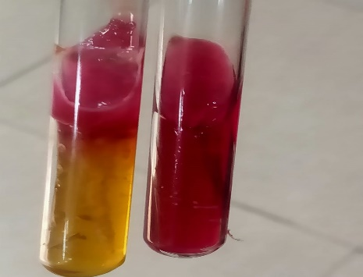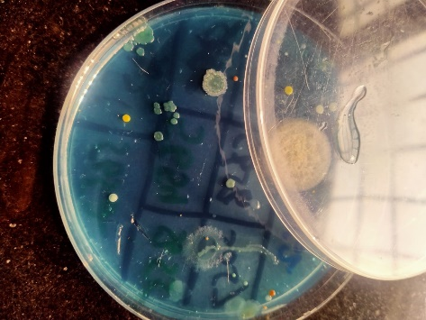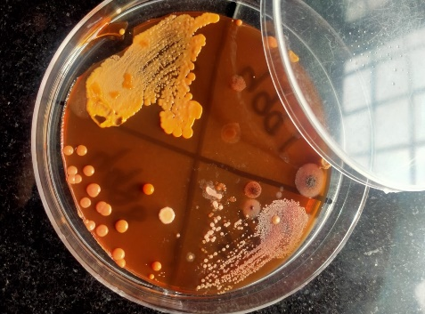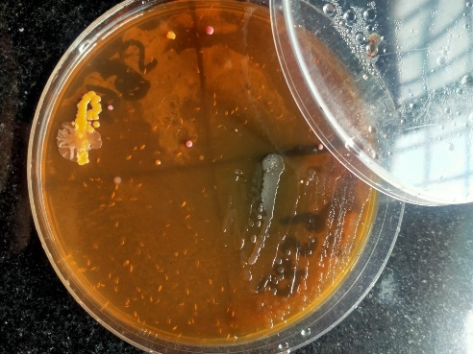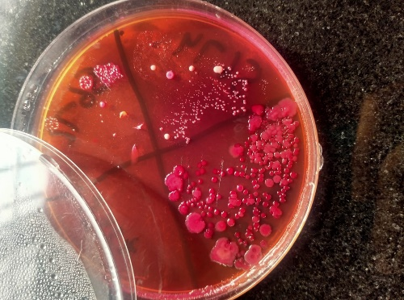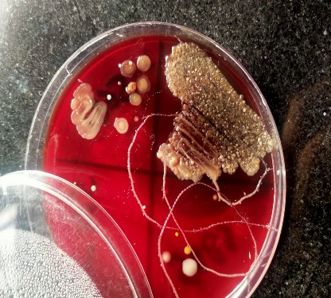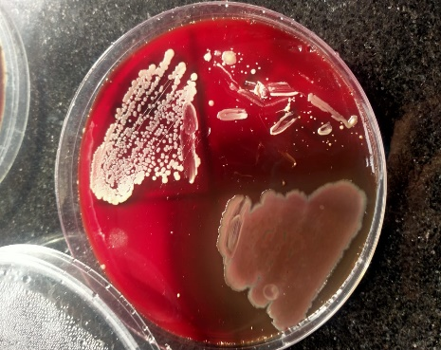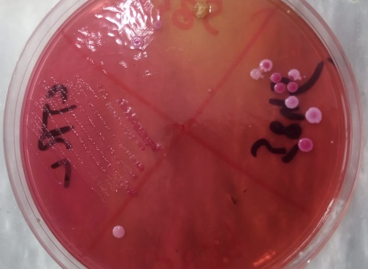
Gram staining
For the morphological differentiation gram staining was done either cocci or rod shapes [4, 5]. For the complete identification of the isolated pathogen different biochemical tests were performed.

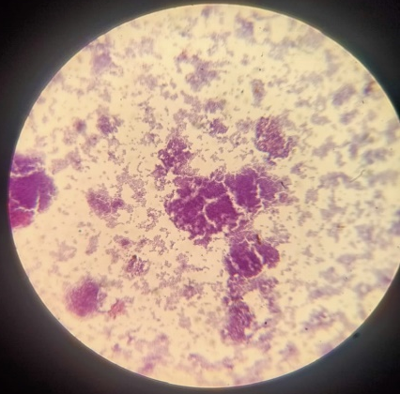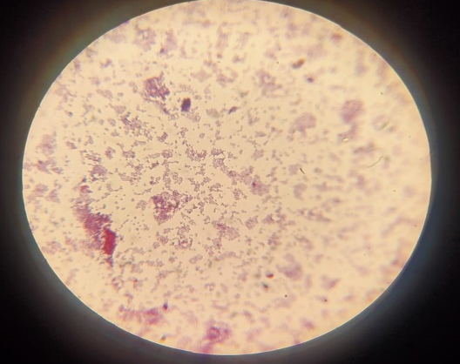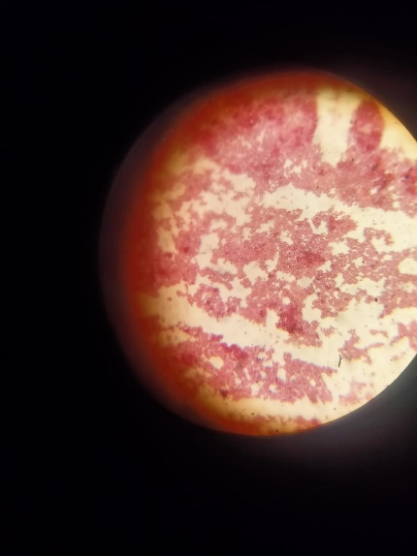
Biochemical analysis
Various biochemical tests were performed to differentiate the bacterial strains. For gram-negative rods (GNRs) triple sugar iron, citrate, sulfide, indole, urease, and oxidase tests were performed. While gram-positive cocci (GPCs) were identified by catalase and coagulase tests[3].
Antibiotic susceptibility testing
The Kirby-Bauer disk diffusion method was used to check out antibiotic resistance following the guidelines of clinical laboratory standard institute (CLSI) [6]. For gram-positive bacteria following antibiotics were used, Ceftriaxone, Gentamicin, Cefuroxime, Ceftazidime, Amoxicillin, Erythromycin, and Cloxacillin, while for gram-negative Ampicillin, Nitrofurantoin, Ceftazidime, Gentamicin, Cefuroxime, Ciprofloxacin, Clavulanate were used.
The isolated bacteria were emulsified in sterile water (water for injection) to make suspension for the disk diffusion method. The turbidity of the suspension was compared with the 0.5% McFarland standard. The Mueller Hinton agar plate was prepared to check antibiotics sensitivity a sterile cotton swab was used to streak the whole surface of the Mueller Hinton agar plate. Different specific antibiotics were applied to specific microorganisms by sterile forceps. Plates were incubated at 37°C for 24 hours. Zone diameter was measured and classified as resistant or sensitive according to CLSI guidelines [7].
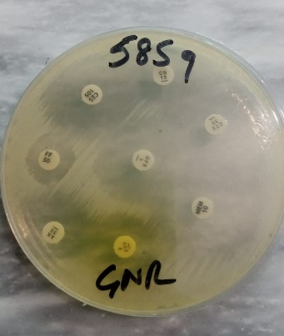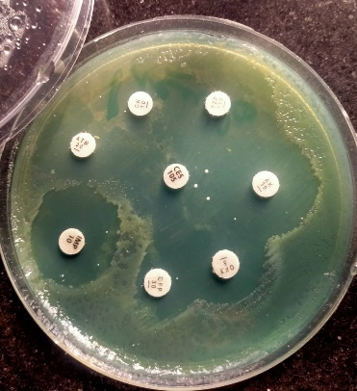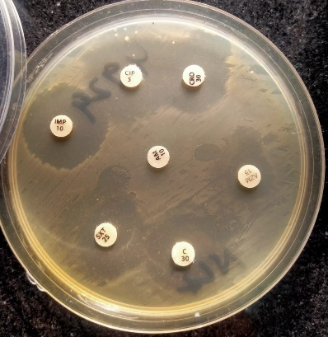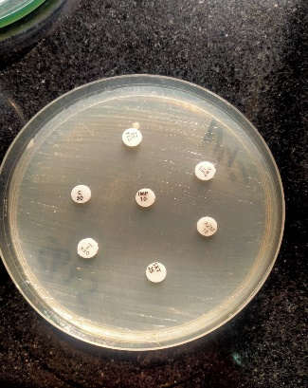

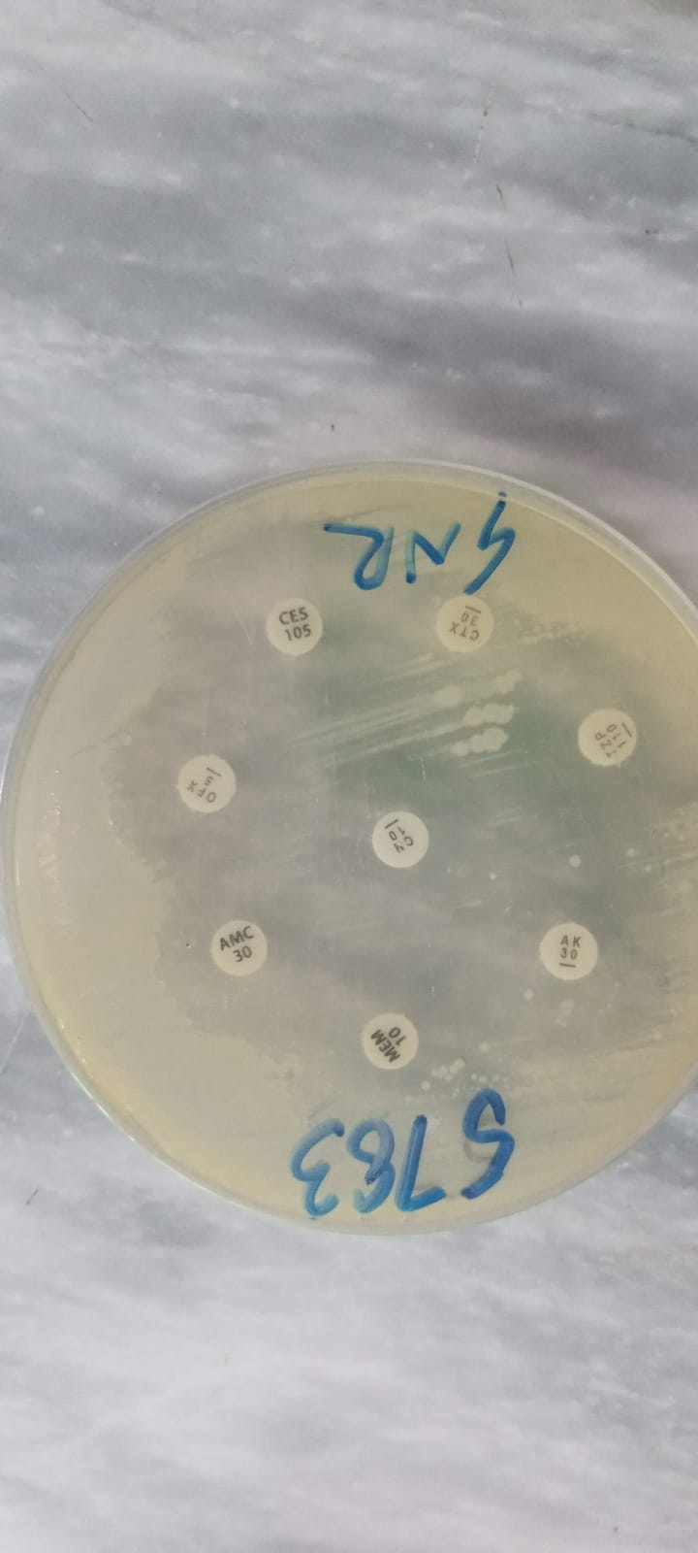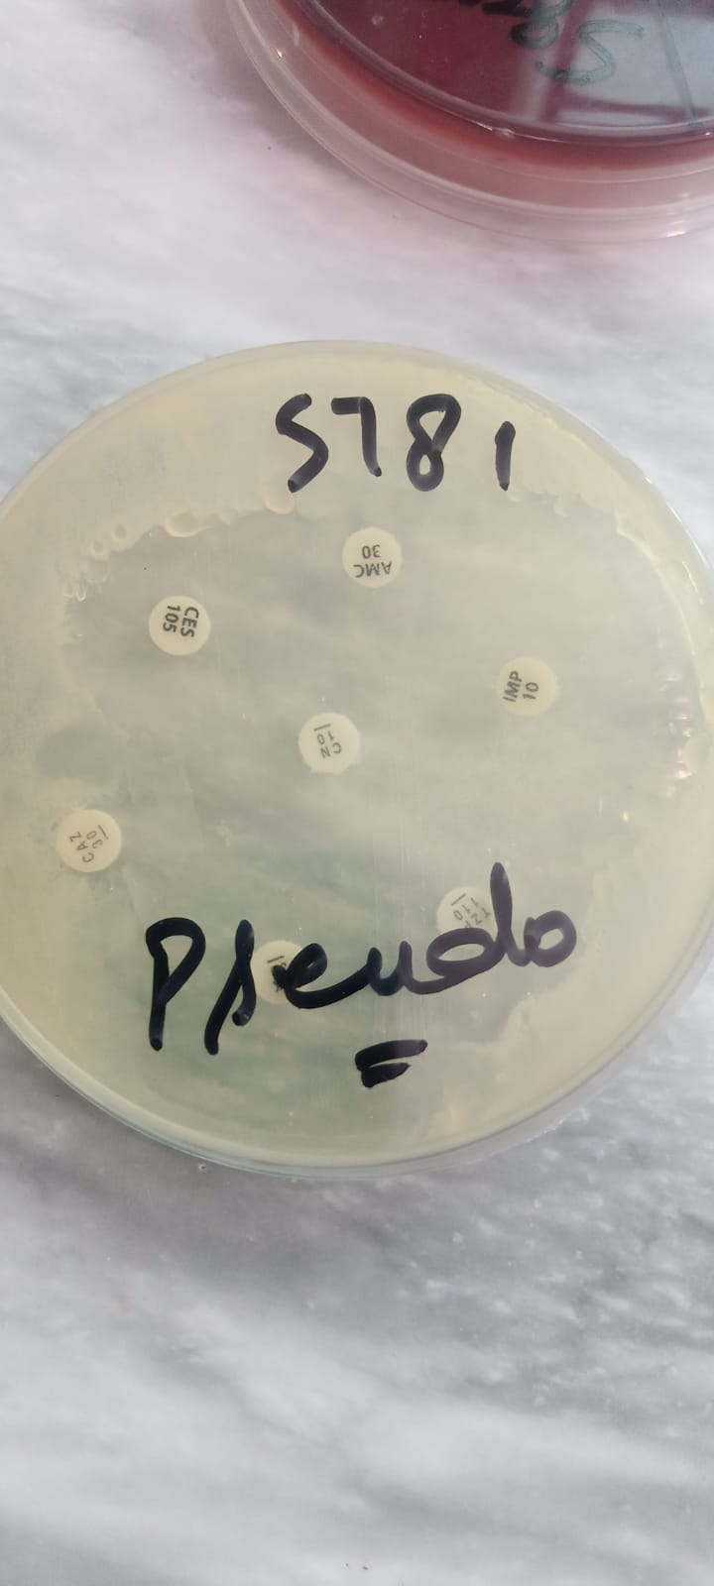
Statistical analysis
Data were entered on Microsoft Excel sheets and then analyzed through R programming version 4.3.0. The percentage of isolates was determined through frequencies. Data visualization was represented through different graphs.

1. EHIAGHE, J., ANTIMICROBIAL SUSCEPTIBILITY PATTERN AND PLASMID DNA PROFILING OF BACTERIA ISOLATED IN SOME SELECTED HOSPITAL IN BENIN CITY, NIGERIA* EHIAGHE, JI, AMENGIALUE, OO, 2 EHIAGHE, FA, 3 IGIEBOR, FA, 2 AND KOYONEN, U. 2.
2. Badini, Z.A., et al., Isolation, Identification, Molecular Characterization and Antibiotic Susceptibility Testing of Uro-Pathogenic E. Coli (UPEC) Isolated From Non-Hospitalized Urinary tract infections (UTI). Pak-Euro Journal of Medical and Life Sciences, 2019. 2(4): p. 69-73.
3. Cheesbrough, M., District laboratory practice in tropical countries, part 2. 2005: Cambridge university press.
4. Johnson, T.N., The problems in scaling adult drug doses to children. Archives of disease in childhood, 2008. 93(3): p. 207-211.
5. Raza, J.A. and A. Movahed, Use of cardiovascular medications in the elderly. International journal of cardiology, 2002. 85(2-3): p. 203-215.
6. Panthi, S., P. Pathak, and J. Sitaula, Knowledge, attitude and practice on antibiotic use and its resistance among medical students in a tertiary care hospital. Journal of Chitwan Medical College, 2020. 10(4): p. 16-19.
7. Wayne, P., National committee for clinical laboratory standards. Performance standards for antimicrobial disc susceptibility testing, 2002. 12: p. 01-53.

