Whole-genome sequencing of reindeer (Rangifer tarandus) populations reveals independent origins of dwarf ecotypes and potential molecular mechanisms underpinning cold adaptation – Torres-Oliva et. al.

Supplementary Figures
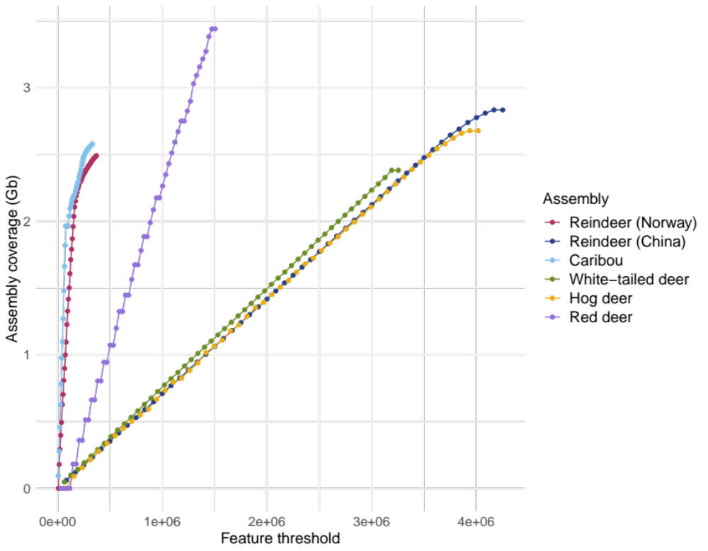
Supplementary Fig. 1: Feature response curves (FRC) of deer assemblies. x-axis represent accumulated errors when mapping Illumina paired-end reads to each respective assembly. Assemblies with fewest errors are Norwegian reindeer (this work) and caribou genome.

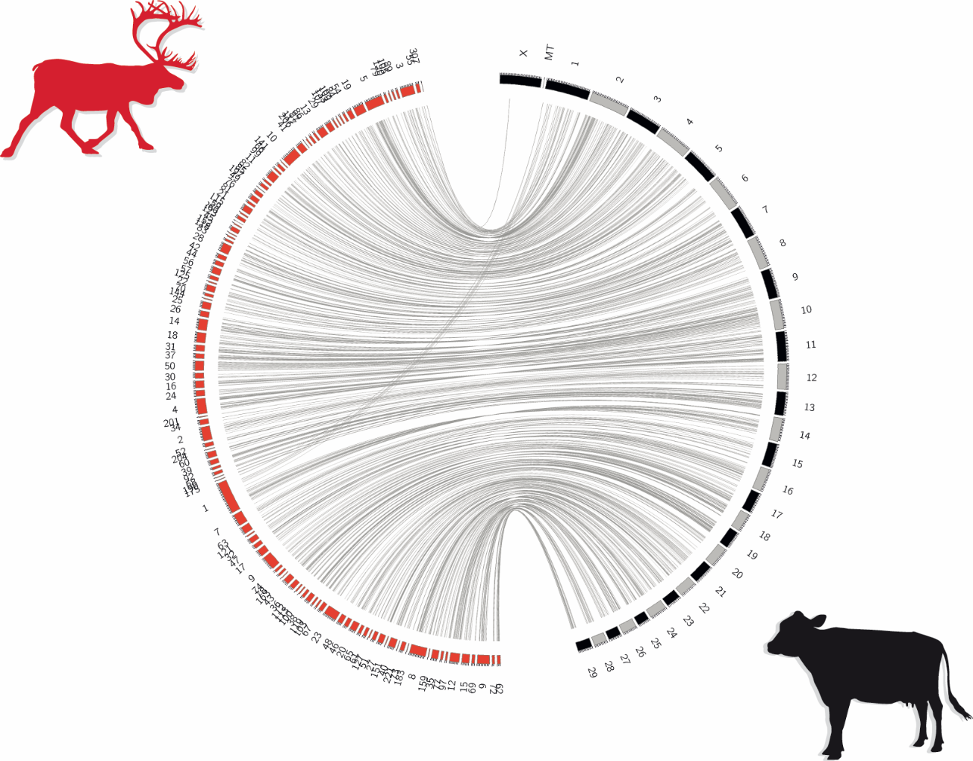
Supplementary Fig. 2: Synteny conservation between Norwegian reindeer and cow (B. taurus) genomes. Red boxes represent scaffolds of the reindeer assembly, black and grey boxes are cow chromosomes. Grey lines indicate aligned regions of > 10 kb, with > 80 % similarity. Lastz [1] was used to align the two assemblies, Circos [2] was used to represent synteny results.

Supplementary Fig. 3: Synteny between reindeer and each cow chromosome. Blue boxes represent scaffolds of the reindeer assembly, red and orange boxes are cow chromosomes. Grey lines indicate aligned regions of > 5 kb, with > 80 % similarity. Lastz [1] was used to align the two assemblies, Circos [2] was used to represent synteny results.

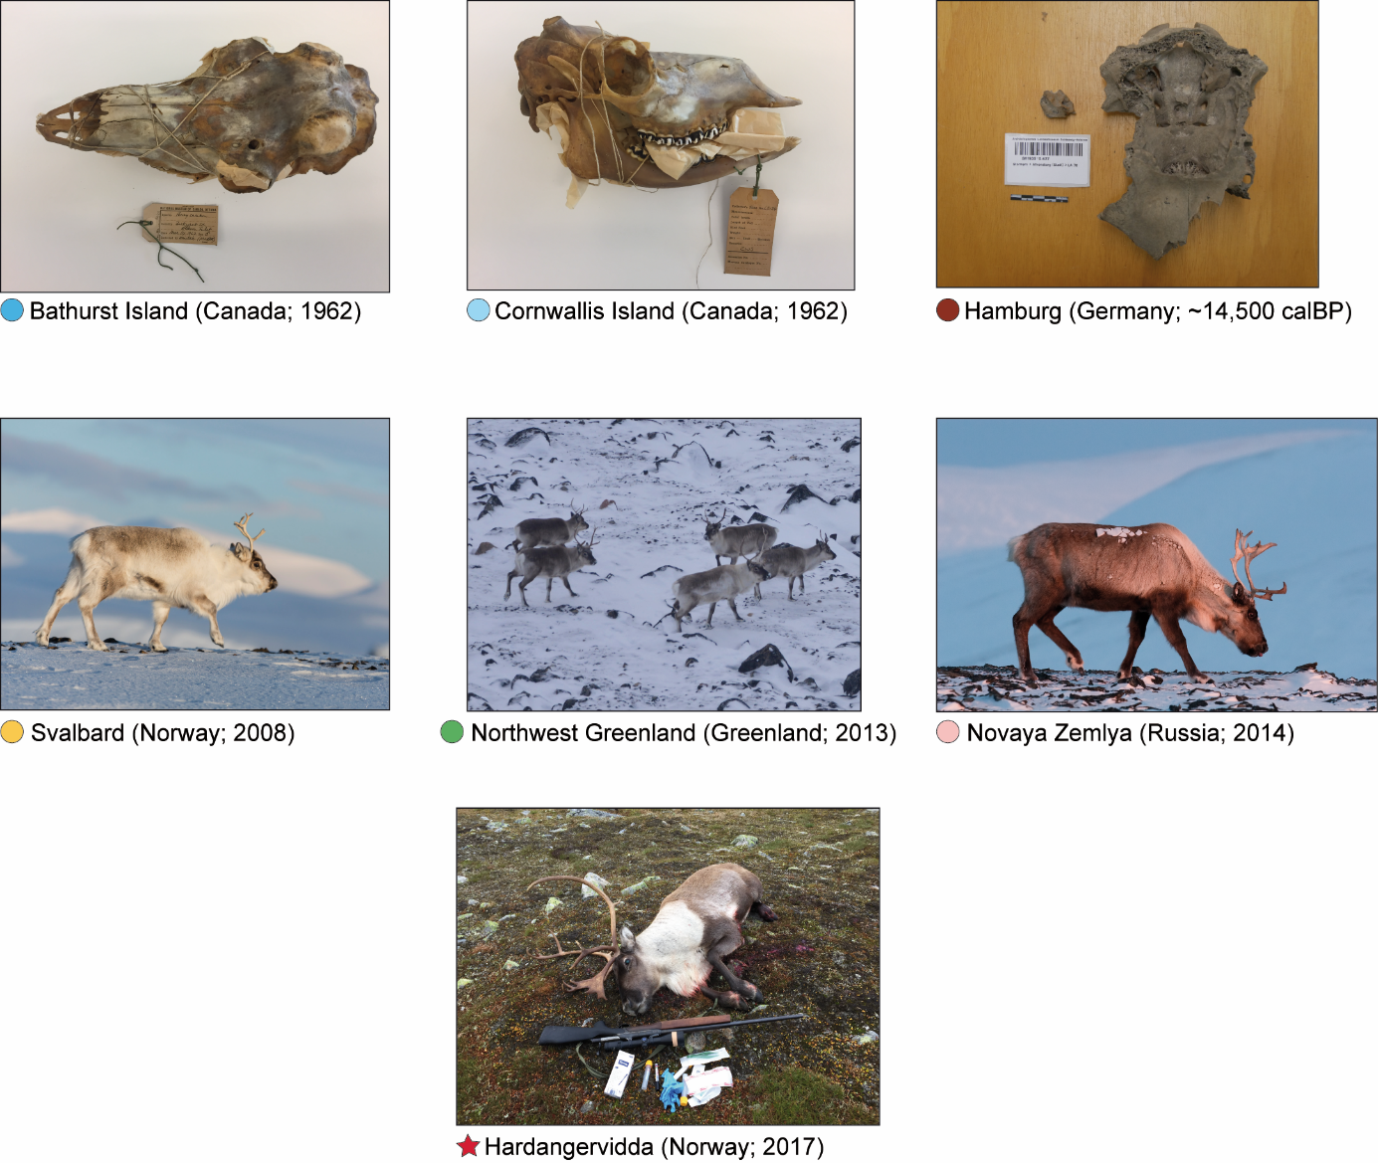
Supplementary Fig. 4: Images of sequenced reindeer. Colored circles correspond to Figure 1c. Photo credits: Karsten Sund (Bathurst Island and Cornwallis Island), Markus Wild (Hamburg), Sophie Cordon (Svalbard), Øystein Wiig (West Greenland), Taras Sipko (Novaya Zemlya), Tom Hemming Karlsen (Hardangervidda).

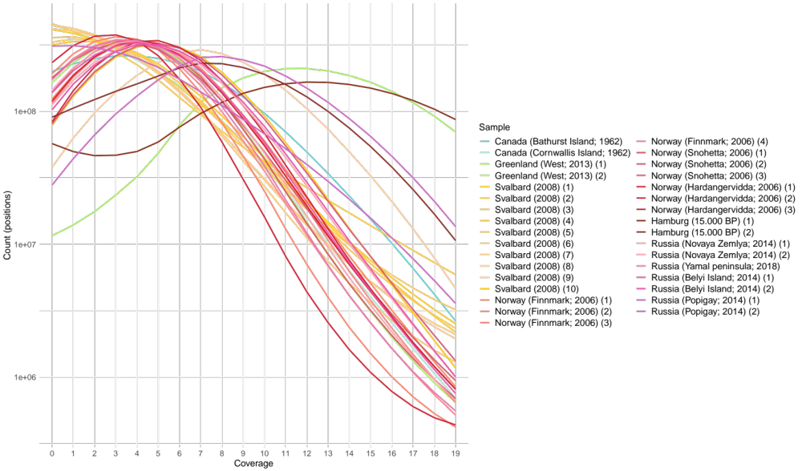
Supplementary Fig. 5: Genome coverage of all WGS samples.

Supplementary Fig. 6: Genome coverage of re-sequenced samples.

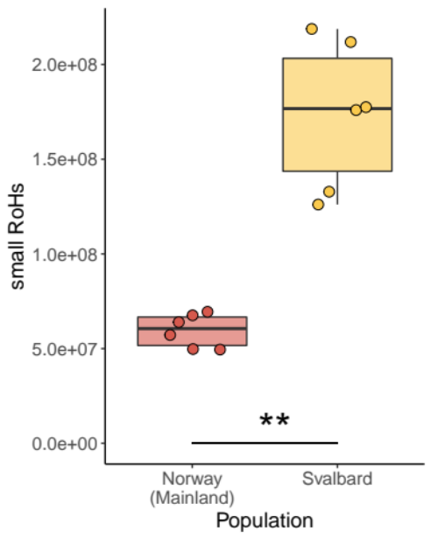
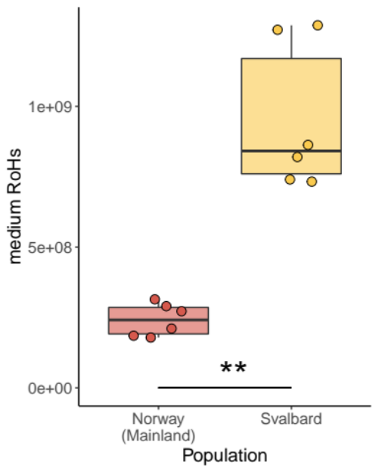
Supplementary Figure 7: Amount of runs of homozygosity (RoHs) in each sample. Medium segments: 0.1 to 1.0 Mb; small segments: < 0.1 Mb. “**”: P < 1×10⁻³.

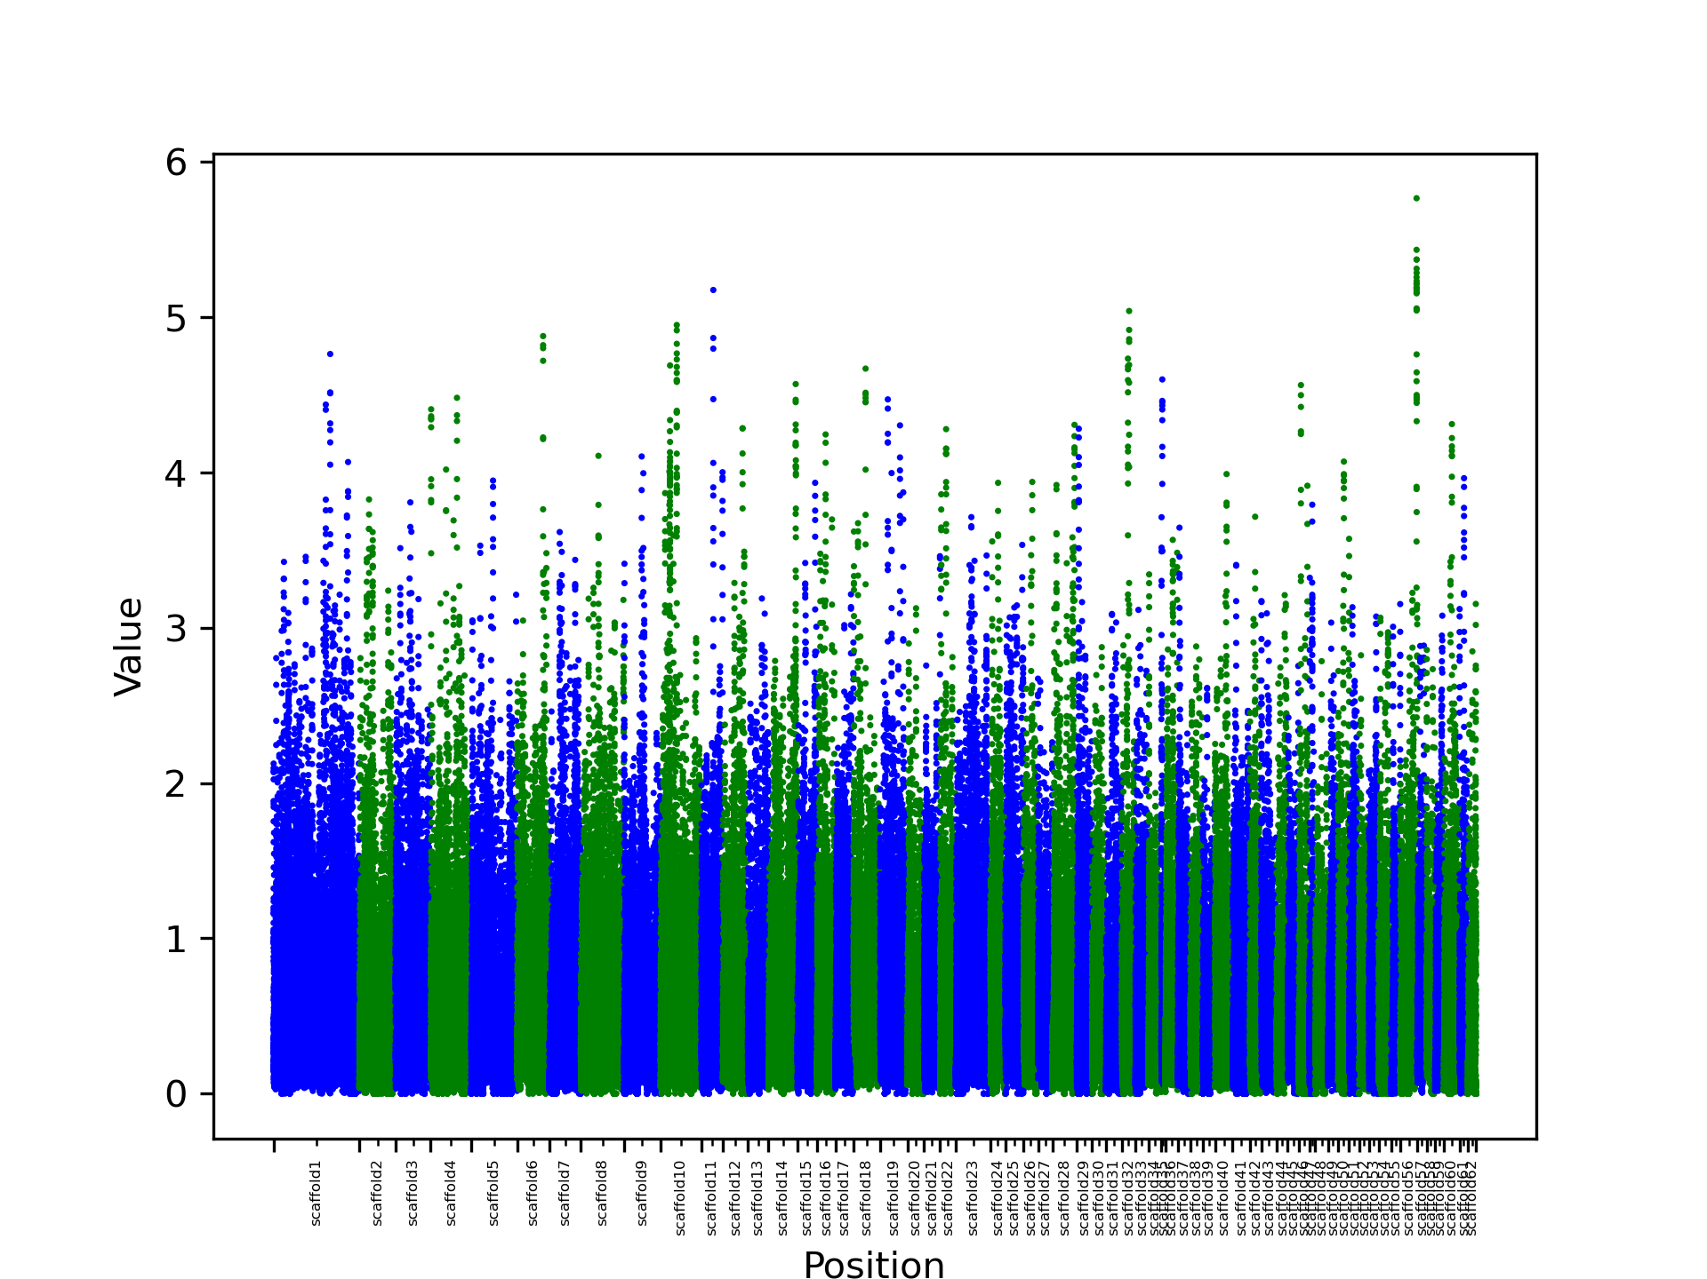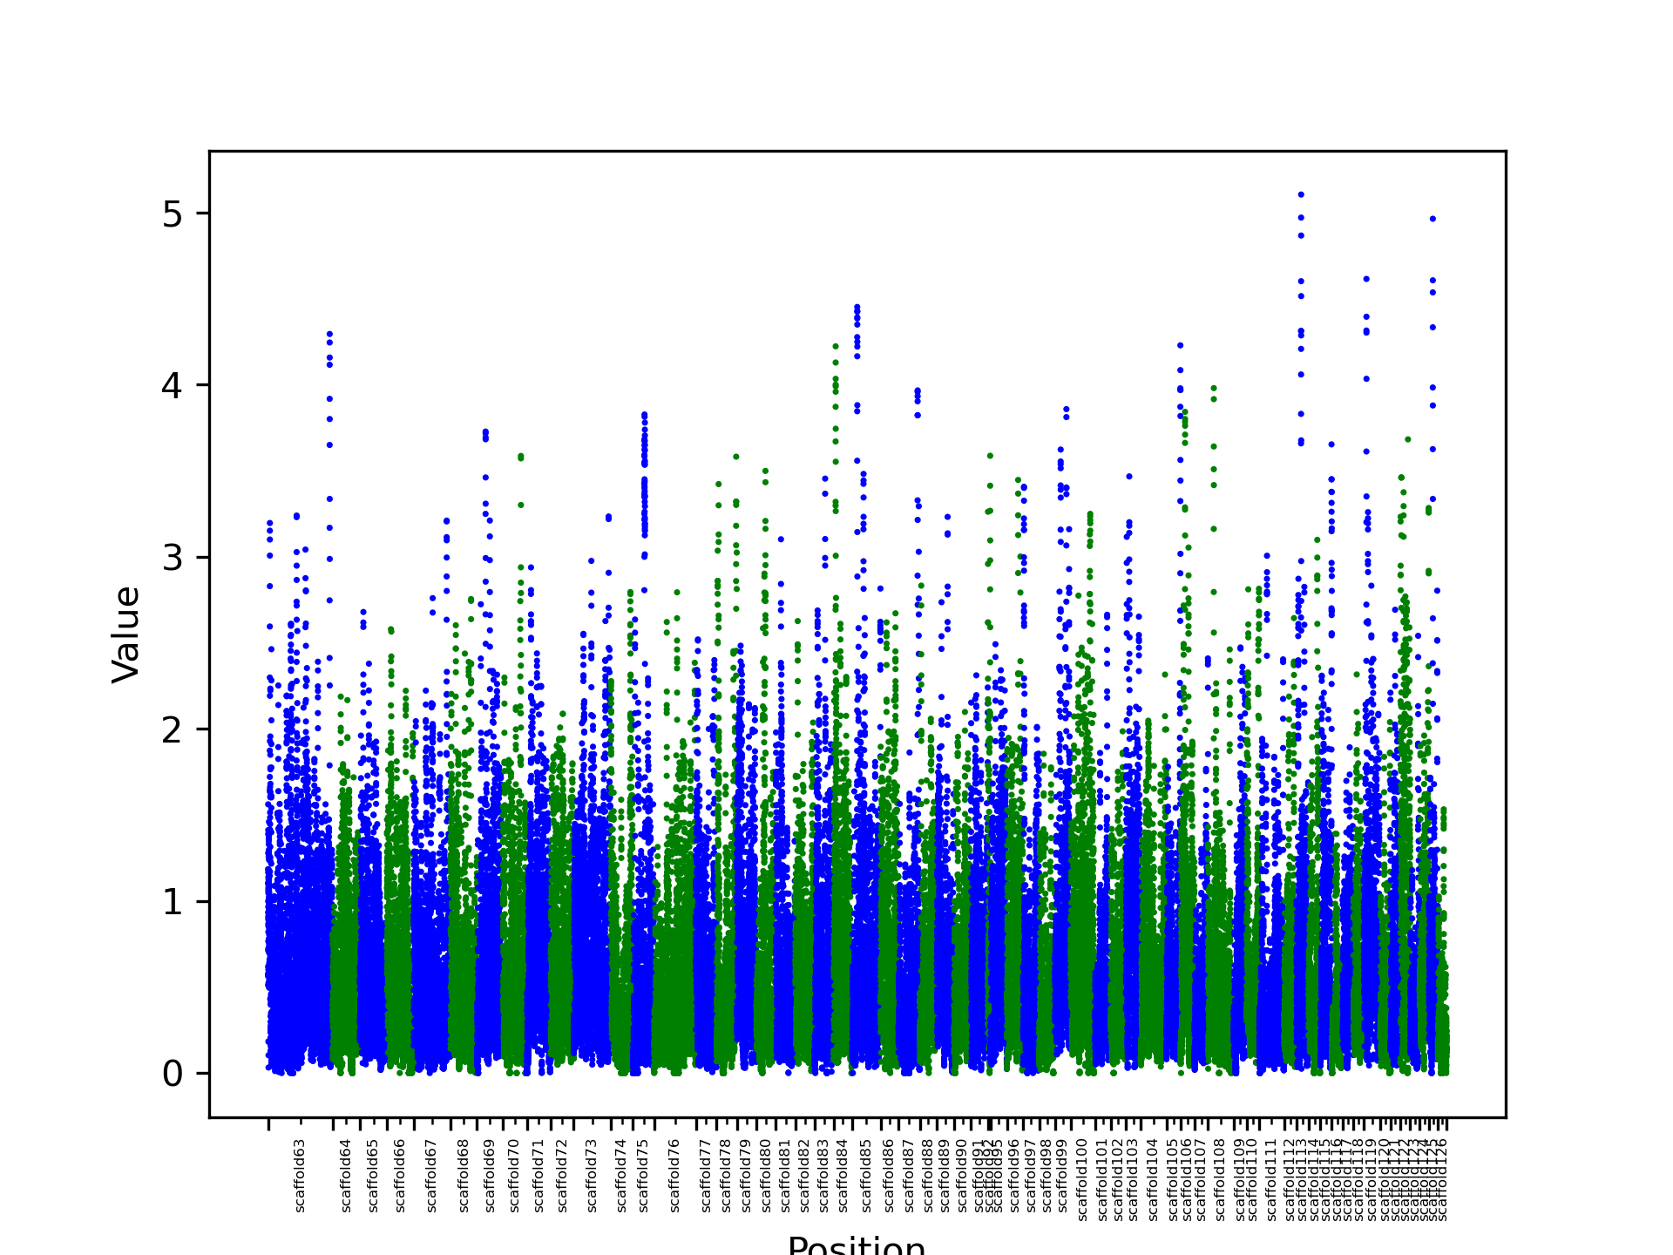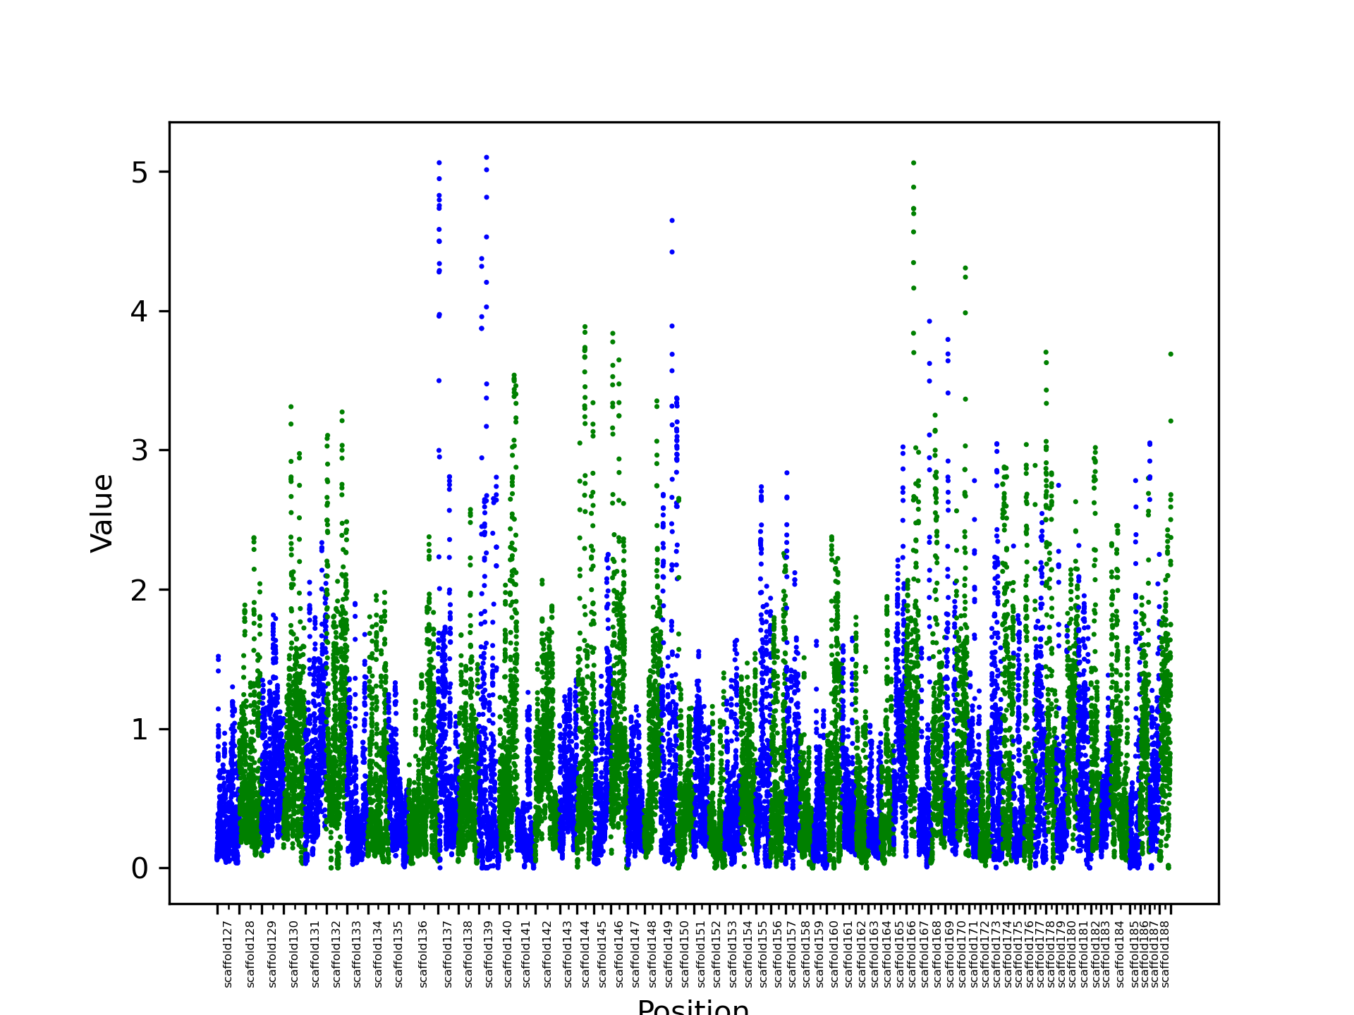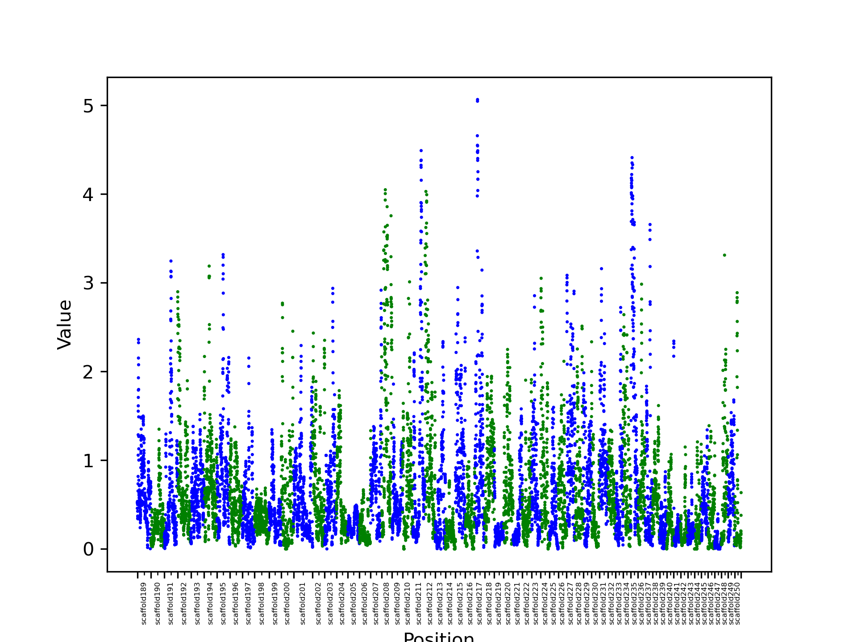
Supplementary Figure 8: Population Branch Statistics (PBS) values across reindeer genome. Y axis correspondent to PBS values calculated using Svalbard as target population, Mainland as reference population and Hamburgian samples (ancient) as outgroup population.

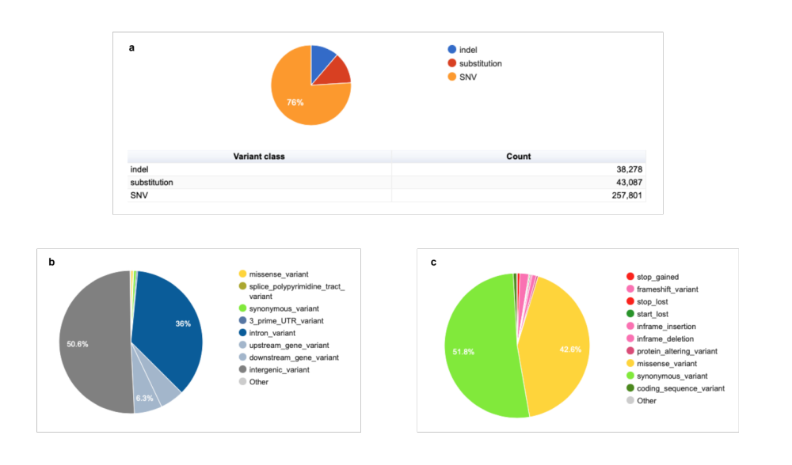
Supplementary Figure 9: Variant Effect Predictor (VEP) [3] results. a) Variant classes. b) Variant consequences. c) Variant coding consequences.

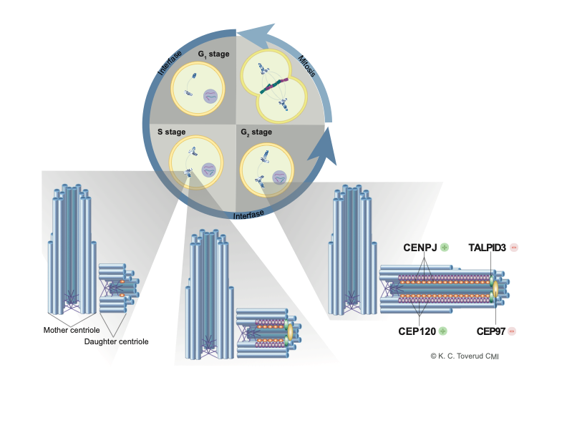
Supplementary Figure 10: Centriole elongation. At the start of the mitotic S phase, the pair of centrioles in the centrosome separate from each other, and from each mother centriole a new daughter centriole grows perpendicularly. The process of centriole elongation is the growth of this daughter centriole by addition of αβ-tubulin units, until it reaches its required length to orchestrate chromosome segregation. 10 of the proteins with non-synonymous variants in Svalbard reindeer control de growth of these centrioles. Four of them are indicated in this figure: CENPJ and CEP120 promote centriole growth, while TALPID3 and CEP97, located at the distal end of the daughter centriole, repress it.
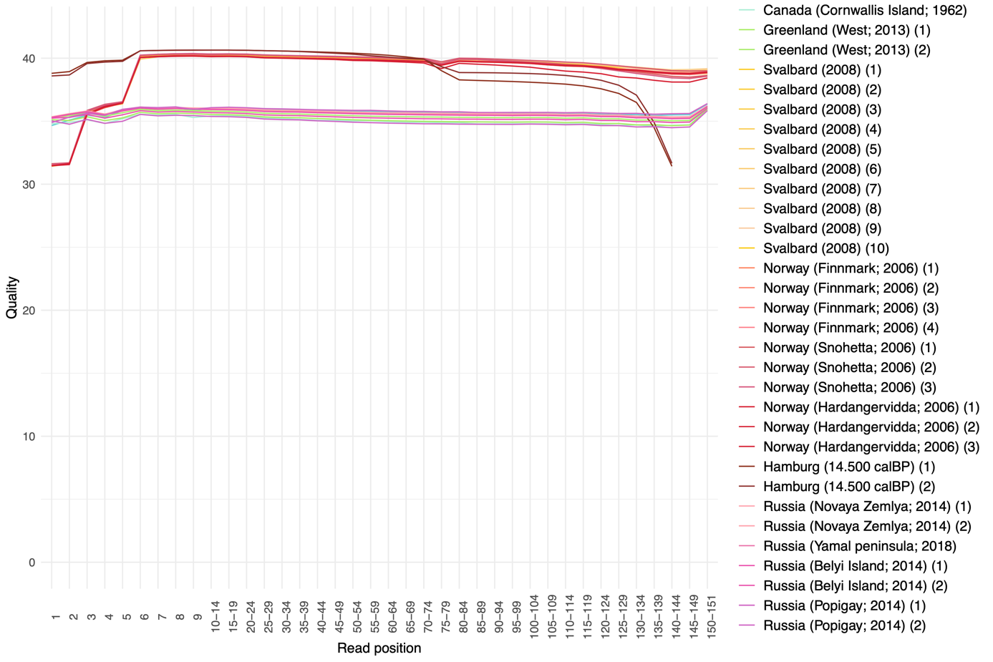
Supplementary Fig. 11: Base quality of trimmed reads.
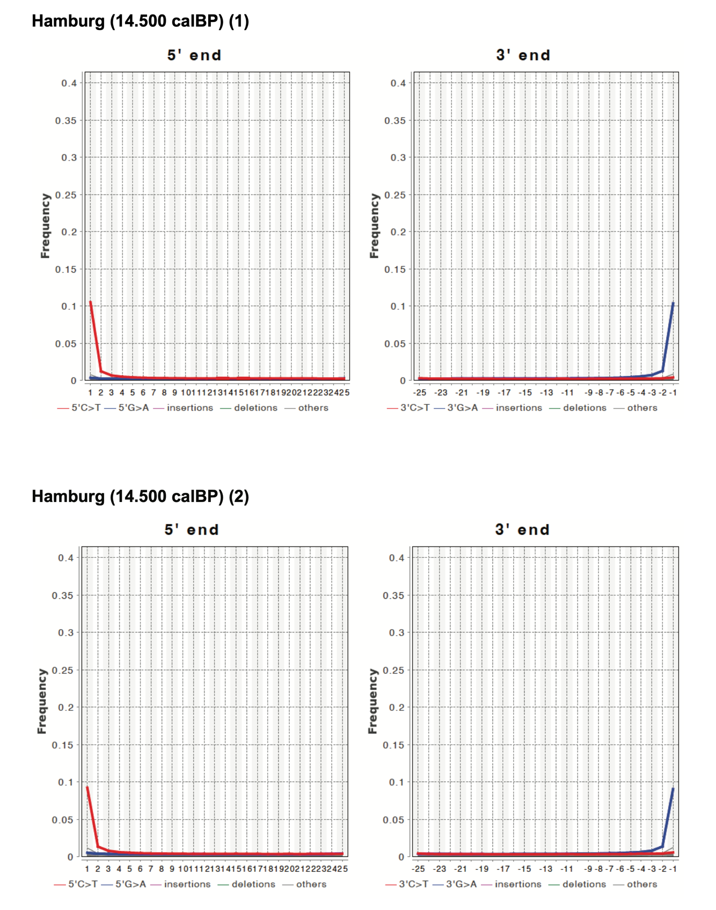
Supplementary Fig. 12: Ancient DNA damage patterns for Hamburgian samples. Both samples show the expected degradation patterns, increased C>T and G>A substitutions at the 5’ and 3’ ends of the reads.

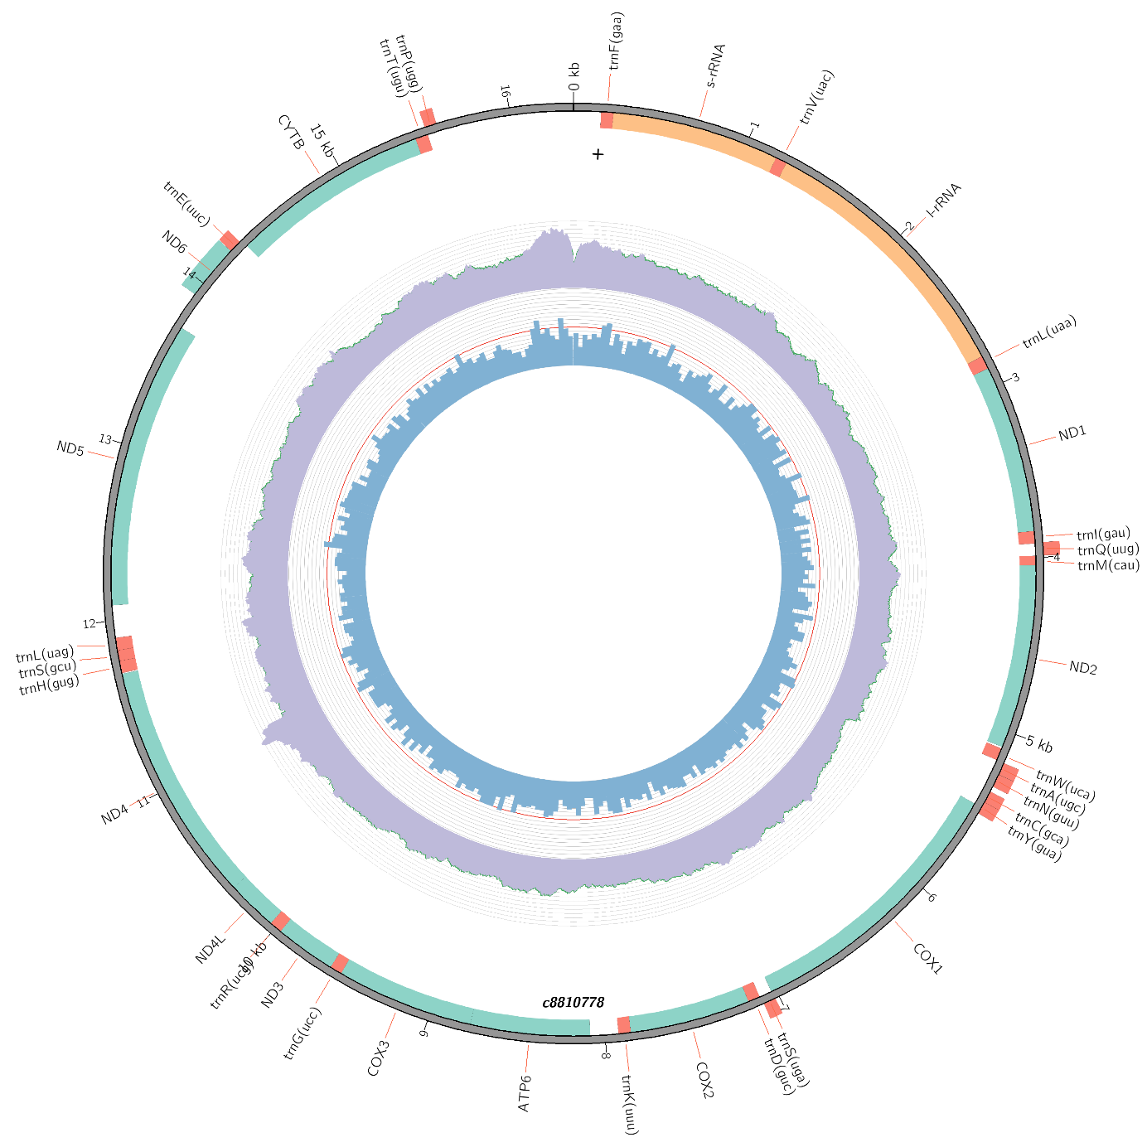
Supplementary Fig. 13: Mitochondrial genome of Hardangervidda reference. Inner circle: GC content; middle circle: read depth; outer circle: genetic features (source: MitoZ [4]).

Supplementary Tables

Supplementary Table 1: Statistics of different deer (and cow) genome assemblies
 | Assembly size (bp) | Scaffold N50 (bp) | Number of scaffolds | Number of Ns | %GC | Publication
Reindeer (Norway) | 2,490,329,208 | 20,747,807 | 2,302 | 42,463,100 | 41.5 | This publication
Reindeer (China) | 2,757,509,296 | 1,018,790 | 11,151 | 98,711,880 | 41.7 | GigaScience (2017) [5]
Caribou | 2,577,115,099 | 54,364,837 | 12,257 | 77,970,599 | 41.5 | BMCGenomics (2023) [6]
White-tailed deer | 2,380,505,687 | 850,721 | 17,026 | 21,568,155 | 41.5 | Submitted to NCBI (2017)
Hog deer | 2,676,163,295 | 20,764,858 | 136,093 | 40,369,753 | 41.6 | Scientific Data (2019) [7]
Red deer | 3,438,623,608 | 107,358,006 | 11,479 | 1,477,834,197 | 41.5 | Molecular Genetics and Genomics (2018) [8]
Bos taurus | 2,664,245,122 | 105,708,250 | 163 | 20,740,234 | 41.8 | Genome Biology (2009) [9] [UMD3.1]

Supplementary Table 2: Percentage of BUSCO mammalian genes in different deer (and cow) genomes
 | Complete | Single copy | Duplicated | Fragmented | Missing | Publication
Reindeer (Norway) | 95.3 | 92.1 | 3.2 | 1.2 | 3.5 | This publication
Reindeer (China) | 92.1 | 88.0 | 4.1 | 2.9 | 5.0 | GigaScience (2017) [5]
Caribou | 93.5 | 89.8 | 3.7 | 2.1 | 4.4 | BMCGenomcis (2023) [6]
White-tailed deer | 92.9 | 90.6 | 2.3 | 2.6 | 4.5 | Submitted to NCBI (2017)
Hog deer | 95.8 | 92.9 | 2.9 | 1.3 | 2.9 | Scientific Data (2019) [7]
Red deer | 79.0 | 78.1 | 0.9 | 7.8 | 13.2 | Molecular Genetics and Genomics (2018) [8]
Cow | 94.0 | 92.3 | 1.7 | 1.9 | 4.1 | Genome Biology (2009) [9] [UMD3.1]

Supplementary Table 3: Origin and description of samples used in this study.
(In “Additional file 1”).

Supplementary Table 4: Read-mapping information
 | % mapped reads | % properly mapped reads | % genome covered | Mean coverage
Canada (Bathurst Island; 1962) | 98,79 | 96,78 | 90,70% | 6,11
Canada (Cornwallis Island; 1962) | 99,13 | 97,59 | 75,65% | 3,98
Greenland (West; 2013) (1) | 99,37 | 97,17 | 97,93% | 14,18
Greenland (West; 2013) (2) | 99,37 | 97,15 | 93,93% | 4,77
Svalbard (2008) (1) | 97,76 | 87,62 | 88,96% | 4,97
Svalbard (2008) (2) | 96,34 | 86,31 | 85,22% | 5,03
Svalbard (2008) (3) | 98,12 | 85,37 | 84,94% | 5,16
Svalbard (2008) (4) | 95,08 | 85,46 | 87,37% | 5,07
Svalbard (2008) (5) | 97,05 | 85,25 | 88,87% | 5,31
Svalbard (2008) (6) | 97,23 | 88,96 | 83,97% | 3,99
Svalbard (2008) (7) | 92,47 | 82,99 | 85,46% | 4,65
Svalbard (2008) (8) | 89,92 | 78,80 | 84,01% | 4,52
Svalbard (2008) (9) | 98,66 | 94,90 | 97,63% | 8,48
Svalbard (2008) (10) | 98,84 | 95,36 | 96,65% | 6,16
Norway (Snohetta; 2006) | 99,03 | 94,71 | 95,12% | 5,06
Norway (Snohetta; 2006) | 99,06 | 94,43 | 93,54% | 5,14
Norway (Snohetta; 2006) | 99,03 | 95,13 | 96,64% | 6,12
Norway (Hardangervidda; 2006) | 99,02 | 95,51 | 95,68% | 5,20
Norway (Hardangervidda; 2006) | 98,95 | 94,98 | 92,67% | 3,91
Norway (Hardangervidda; 2006) | 98,92 | 94,88 | 96,59% | 5,81
Norway (Finnmark; 2006) | 99,00 | 95,92 | 95,48% | 5,21
Norway (Finnmark; 2006) | 99,13 | 95,25 | 93,60% | 4,34
Norway (Finnmark; 2006) | 99,13 | 95,53 | 95,69% | 5,33
Norway (Finnmark; 2006) | 99,04 | 95,84 | 94,06% | 4,50
Hamburg (15.000 BP) (1) | 99,54 | 95,98 | 95,03% | 12,73
Hamburg (15.000 BP) (2) | 99,34 | 95,45 | 93,82% | 7,74
Russia (Novaya Zemlya; 2014) (1) | 98,66 | 96,47 | 94,70% | 4,83
Russia (Novaya Zemlya; 2014) (2) | 99,30 | 97,27 | 95,58% | 4,87
Russia (Yamal peninsula; 2018) | 99,18 | 96,27 | 93,76% | 5,48
Russia (Belyi Island; 2014) (1) | 99,26 | 97,21 | 95,89% | 5,46
Russia (Belyi Island; 2014) (2) | 96,93 | 95,01 | 94,75% | 9,69
Russia (Popigay; 2014) (1) | 98,06 | 91,6 | 88,97% | 5,60
Russia (Popigay; 2014) (2) | 99,34 | 97,35 | 97,81% | 5,11

Supplementary Table 5: Complete list of GO terms enriched in genes with non-synonymous changes.
(In “Additional file 1”).

Supplementary Table 6: TopGO results.
(In “Additional file 1”).

Supplementary Table 7: list of odorant receptors with non-synonymous variants in Svalbard reindeer.
(In “Additional file 1”).

Supplementary Table 8: list of genes with non-synonymous variants in Svalbard reindeer and GO term related to “cilium”.
(In “Additional file 1”).

Supplementary Table 9: Human phenotypes and diseases associated with the cilium-related genes containing non-synonymous variants in Svalbard reindeer genomes^{80,81}.
Gene | Human phenotypes related to body size and morphology | Human and mouse diseases | Missense variants in Svalbard reindeer | Functional prediction of Svalbard variants
CEP162 | BMI-adjusted waist-hip circumference | Seckel Syndrome³, Orofaciodigital Syndrome⁴ | 341G>D | Benign
CEP162 | BMI-adjusted waist-hip circumference | Seckel Syndrome³, Orofaciodigital Syndrome⁴ | 1034S>N | Benign
CEP162 | BMI-adjusted waist-hip circumference | Seckel Syndrome³, Orofaciodigital Syndrome⁴ | 1060V>I | Benign
CEP162 | BMI-adjusted waist-hip circumference | Seckel Syndrome³, Orofaciodigital Syndrome⁴ | 1157V>G | Benign
CEP162 | BMI-adjusted waist-hip circumference | Seckel Syndrome³, Orofaciodigital Syndrome⁴ | 1186V>I | Benign
CEP162 | BMI-adjusted waist-hip circumference | Seckel Syndrome³, Orofaciodigital Syndrome⁴ | 1296V>I | Benign
TALPID3 | Abnormality of body height | Joubert Syndrome⁵, Short-Rib Thoracic Dysplasia⁶ | 1103I>V | Benign
TALPID3 | Abnormality of body height | Joubert Syndrome⁵, Short-Rib Thoracic Dysplasia⁶ | 1274L>V | Probably damaging
INTU | Abnormality of body height, facial morphology measurement | Short-Rib Thoracic Dysplasia, Orofaciodigital Syndrome | 859E>K | Benign
CEP97 |  | Joubert Syndrome | 497H>R | Benign
CEP97 |  | Joubert Syndrome | 552H>N | Benign
CEP97 |  | Joubert Syndrome | 650S>L | Probably damaging
MNR | Abnormality of body height | Joubert Syndrome, Orofaciodigital Syndrome, Short-Rib Thoracic Dysplasia, Asphyxiating Thoracic Dystrophy⁷ | 848R>H | Probably damaging
CENPJ | Abnormality of body height | Microcephaly⁸, Seckel Syndrome | 644P>L | Benign
CENPJ | Abnormality of body height | Microcephaly⁸, Seckel Syndrome | 1325T>A | Benign
DYNC2I1 | Abnormality of body height | Short-Rib Thoracic Dysplasia, Asphyxiating Thoracic Dystrophy | 647Q>P | Benign
DYNC2I1 | Abnormality of body height |  | 681T>A | Benign
CROCC | Body height, BMI-adjusted waist circumference | Alstrom Syndrome⁹, Joubert Syndrome, Seckel Syndrome, Microcephaly | 75A>T | Benign
CEP120 | Abnormality of body height | Short-Rib Thoracic Dysplasia, Joubert Syndrome | 472L>V | Benign
SPAG17 | BMI-adjusted waist-hip circumference, body height | Cranioectodermal Dysplasia¹, Ciliary Dyskinesia² | 1181Q>K | Benign
SPAG17 | BMI-adjusted waist-hip circumference, body height | Cranioectodermal Dysplasia¹, Ciliary Dyskinesia² | 1512T>A | Benign
GAS2L2 |  | Ciliary Dyskinesia | 101E>K | Benign
GAS2L2 |  | Ciliary Dyskinesia | 559Q>K | Benign
DNAH11 |  | Ciliary Dyskinesia | 49Q>L | Benign
DNAH11 |  | Ciliary Dyskinesia | 626T>A | Benign
DNAH11 |  | Ciliary Dyskinesia | 1061P>T | Benign
DNAH11 |  | Ciliary Dyskinesia | 1062R>H | Benign
DNAH5 |  | Ciliary Dyskinesia | 1702R>C | Benign
CFAP221 | Lower face morphology measurement, chronic obstructive pulmonary disease, chronic bronchitis. | Ciliary Dyskinesia | 208Q>P | Benign
CFAP221 |  | Ciliary Dyskinesia | 328T>A | Benign
CFAP221 |  | Ciliary Dyskinesia | 740E>A | Probably damaging
CFAP221 |  | Ciliary Dyskinesia | 772A>T | Benign
¹Cranioectodermal dysplasia: ciliopathy; skeletal abnormalities, including craniosynostosis, narrow rib cage, short limbs, and brachydactyly, and ectodermal defects (OMIM [10]).
²Ciliary Dyskinesia: recurrent respiratory infections leading to chronic inflammation and bronchiectasis caused by defects in the respiratory motile cilia (OMIM [10]).
³Seckel Syndrome: postnatal dwarfism, growth retardation, very small head and dysmorphic face (GARD [11]).
⁴Orofaciodigital Syndrome: affected development of oral cavity and digits and face malformations (GARD [11]).
⁵Joubert Syndrome: brain abnormalities (molar tooth sign), with sometimes weak muscle tone, abnormal breathing patterns, abnormal eye movements, ataxia, distinctive facial features and intellectual disability (GARD [11]).
⁶Short-Rib Thoracic Dysplasia: ciliopathy; constricted thoracic cage, short ribs and shortened tubular bones (OMIM [10]).
⁷Asphyxiating Thoracic Dystrophy: ciliopathy; disorder of bone growth causing narrow chest, short ribs, shortened bones in the arms and legs, short stature and extra fingers and toes. Related to short-rib thoracic dysplasia (OMIM [10]).
⁸Microcephaly: a person’s head is significantly smaller than the expected by standardized charts (GARD [11]).
⁹Alstrom Syndrome: loss of vision and hearing, heart disease, obesity, type 2 diabetes and short stature (GARD [11]).

1. Harris RS. Improved pairwise alignment of genomic DNA. PhD Thesis The Pennsylvania State University. 2007;
2. Krzywinski M, Schein J, Birol I, Connors J, Gascoyne R, Horsman D, et al. Circos: An information aesthetic for comparative genomics. Genome Res. 2009;19(9):1639–45.
3. McLaren W, Gil L, Hunt SE, Riat HS, Ritchie GRS, Thormann A, et al. The Ensembl Variant Effect Predictor. Genome Biol [Internet]. 2016;17(1):122. Available from: https://doi.org/10.1186/s13059-016-0974-4
4. Meng G, Li Y, Yang C, Liu S. MitoZ: a toolkit for animal mitochondrial genome assembly, annotation and visualization. Nucleic Acids Res. 2019;47(11):e63.
5. Li Z, Lin Z, Ba H, Chen L, Yang Y, Wang K, et al. Draft genome of the Reindeer (Rangifer tarandus). Gigascience. 2017;6(November):1–5.
6. Poisson W, Prunier J, Carrier A, Gilbert I, Mastromonaco G, Albert V, et al. Chromosome-level assembly of the Rangifer tarandus genome and validation of cervid and bovid evolution insights. BMC Genomics [Internet]. 2023;24(1):142. Available from: https://doi.org/10.1186/s12864-023-09189-5
7. Wang W, Yan HJ, Chen SY, Li ZZ, Yi J, Niu LL, et al. Data descriptor: The sequence and de novo assembly of hog deer genome. Sci Data. 2019;6:4–11.
8. Bana NA, Nyiri A, Nagy J, Frank K, Nagy T, Steger V, et al. The Red Deer Cervus elaphus Genome CerEla1.0: Sequencing, Annotating, Genes, Chromosomes. Hereditary Genetics. 2018;07(01):1000191.
9. Zimin A V, Delcher AL, Florea L, Kelley DR, Schatz MC, Puiu D, et al. A whole-genome assembly of the domestic cow, Bos taurus. Genome Biol. 2009;10(4):R42.
10. Amberger JS, Bocchini CA, Scott AF, Hamosh A. OMIM.org: leveraging knowledge across phenotype–gene relationships. Nucleic Acids Res [Internet]. 2019 Jan 8;47(D1):D1038–43. Available from: https://doi.org/10.1093/nar/gky1151
11. Hoskins A. Genetic and Rare Diseases Information Center (GARD). Med Ref Serv Q [Internet]. 2022 Oct 2;41(4):389–94. Available from: https://doi.org/10.1080/02763869.2022.2131143

