Supplementary Material:

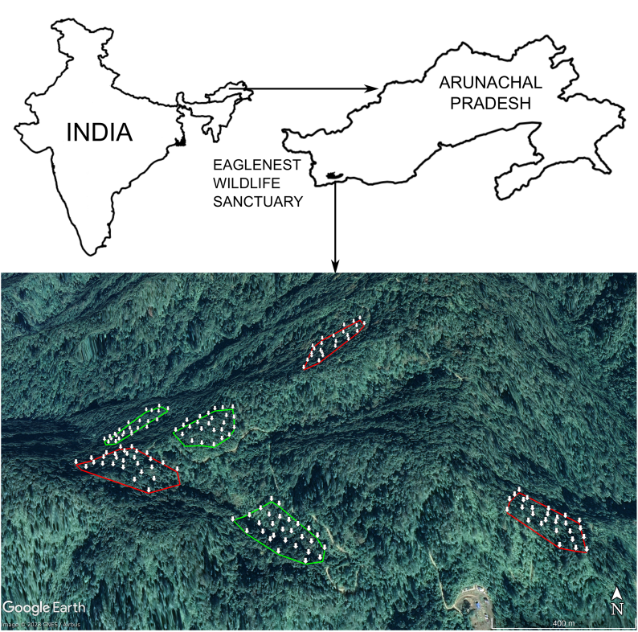
Figure S1: A map of the study area in Eaglenest Wildlife Sanctuary, Arunachal Pradesh, India. Sampling plots in primary forest are outlined in green and plots in logged forest are outlined in red. White arrows show the locations of mist nets along with their corresponding temperature-humidity loggers.
Table S1: The common names, scientific names (Billerman et al., 2022), habitat, microclimatic niche sizes and number of captures each year for all the species analysed. All chosen species are breeders at our study site and had sufficient data for the modelling of survival trends and their microclimatic niches.

Common Name | Scientific Name | Habitat | Microclimatic Sample Size | Number of captures in each year
 |  |  |  | 2011 | 2012 | 2013 | 2014 | 2015 | 2016 | 2017 | 2018 | 2019 | 2021
Black-throated Parrotbill | Suthora nipalensis | logged | 45 | 62 | 22 | 22 | 10 | 43 | 36 | 66 | 42 | 27 | 71
Black-throated Parrotbill | Suthora nipalensis | primary | 50 | 56 | 76 | 21 | 13 | 12 | 27 | 17 | 14 | 18 | 59
Rufous-capped babbler | Cyanoderma ruficeps | logged | 47 | 57 | 60 | 27 | 31 | 62 | 57 | 47 | 45 | 31 | 62
Rufous-capped babbler | Cyanoderma ruficeps | primary | 35 | 33 | 34 | 25 | 13 | 11 | 23 | 29 | 16 | 13 | 48
Yellow-throated Fulvetta | Schoeniparus cinerea | logged | 84 | 73 | 49 | 48 | 24 | 50 | 31 | 50 | 40 | 19 | 124
Yellow-throated Fulvetta | Schoeniparus cinerea | primary | 82 | 51 | 94 | 57 | 18 | 35 | 39 | 31 | 37 | 21 | 107
Rufous-winged Fulvetta | Schoeniparus castaneceps | logged | 51 | 71 | 48 | 23 | 21 | 33 | 43 | 48 | 49 | 35 | 63
Rufous-winged Fulvetta | Schoeniparus castaneceps | primary | 37 | 32 | 59 | 25 | 24 | 20 | 31 | 23 | 33 | 17 | 59
Golden-breasted Fulvetta | Lioparus chrysotis | logged | 85 | 52 | 66 | 24 | 38 | 57 | 50 | 62 | 42 | 43 | 113
Golden-breasted Fulvetta | Lioparus chrysotis | primary | 50 | 30 | 31 | 23 | 8 | 16 | 33 | 31 | 21 | 14 | 64
Snowy-browed Flycatcher | Ficedula hyperythra | logged | 15 | 34 | 23 | 10 | 9 | 20 | 12 | 16 | 26 | 9 | 16
Snowy-browed Flycatcher | Ficedula hyperythra | primary | 25 | 31 | 18 | 17 | 16 | 16 | 20 | 14 | 17 | 12 | 38
White-gorgetted Flycatcher | Anthipes monileger | logged | 16 | 1 | 0 | 1 | 5 | 11 | 3 | 8 | 4 | 3 | 19
White-gorgetted Flycatcher | Anthipes monileger | primary | 8 | 3 | 3 | 9 | 5 | 5 | 6 | 7 | 2 | 6 | 13
Grey-cheeked Warbler | Phylloscopus poliogenys | logged | 18 | 17 | 17 | 7 | 13 | 10 | 15 | 14 | 14 | 6 | 28
Grey-cheeked Warbler | Phylloscopus poliogenys | primary | 28 | 25 | 20 | 13 | 9 | 6 | 14 | 18 | 8 | 13 | 44
Rusty-fronted Barwing | Actinodura egertoni | logged | 10 | 2 | 11 | 8 | 8 | 9 | 16 | 12 | 18 | 6 | 14
Rusty-fronted Barwing | Actinodura egertoni | primary | 10 | 8 | 14 | 19 | 7 | 8 | 4 | 8 | 5 | 4 | 12
Golden Babbler | Cyanoderma chrysaeum | logged | 24 | 24 | 26 | 11 | 18 | 23 | 27 | 27 | 22 | 17 | 34
Golden Babbler | Cyanoderma chrysaeum | primary | 30 | 19 | 24 | 15 | 8 | 8 | 23 | 14 | 20 | 4 | 36
White-spectacled Warbler | Phylloscopus intermedius | logged | 14 | 14 | 11 | 3 | 9 | 13 | 9 | 10 | 8 | 4 | 19
White-spectacled Warbler | Phylloscopus intermedius | primary | 20 | 18 | 12 | 14 | 3 | 7 | 15 | 11 | 13 | 11 | 29
Blyth’s Leaf Warbler | Phylloscopus reguloides | logged | 8 | 9 | 15 | 5 | 13 | 0 | 14 | 16 | 13 | 5 | 14
Blyth’s Leaf Warbler | Phylloscopus reguloides | primary | 29 | 14 | 12 | 8 | 8 | 4 | 2 | 11 | 5 | 3 | 30
Chestnut-crowned Laughingthrush | Trochalopteron erythrocephalum | logged | 11 | 5 | 7 | 4 | 8 | 2 | 9 | 7 | 12 | 9 | 15
Chestnut-crowned Laughingthrush | Trochalopteron erythrocephalum | primary | 10 | 6 | 10 | 8 | 2 | 2 | 7 | 3 | 7 | 6 | 11
Black-faced Warbler | Abroscopus schisticeps | logged | 5 | 6 | 6 | 0 | 8 | 2 | 9 | 9 | 7 | 3 | 5
Black-faced Warbler | Abroscopus schisticeps | primary | 6 | 4 | 12 | 7 | 13 | 3 | 3 | 8 | 1 | 3 | 8
Large Niltava | Niltava grandis | logged | 7 | 10 | 11 | 9 | 4 | 5 | 6 | 9 | 9 | 3 | 11
Large Niltava | Niltava grandis | primary | 16 | 12 | 13 | 11 | 5 | 7 | 6 | 6 | 12 | 7 | 22
White-tailed Robin | Myiomela leucura | logged | 7 | 6 | 5 | 4 | 6 | 8 | 12 | 15 | 17 | 17 | 10
White-tailed Robin | Myiomela leucura | primary | 13 | 11 | 5 | 6 | 2 | 8 | 9 | 8 | 6 | 9 | 16

Table S2 (a): Model parameters for the estimate and 95% confidence intervals around the estimate for the linear model to study the relationship between body mass, time, habitat and niche overlap.

Model: | Z-score ~ Year * Habitat * Niche_Overlap
Parameter | Estimate | Lower CI bound | Upper CI bound
(Intercept) | 0.34 | 0.01 | 0.66
Year | -0.04 | -0.08 | 0.01
Niche_Overlap | -0.33 | -0.68 | 0.03
Habitat_primary | -0.53 | -0.98 | -0.09
Year:Niche_Overlap | 0.03 | -0.01 | 0.08
Year:Habitat_primary | 0.04 | -0.02 | 0.1
Niche_overlap:Habitat_primary | 0.52 | 0.04 | 1
Year:Niche_Overlap:Habitat_primary | -0.04 | -0.11 | 0.03

(b) Results of a Type III Anova test

Model: | Z-score ~ Year * Habitat * Niche_Overlap
Parameter | p-value
Year | 0.08
Niche_Overlap | 0.07
Habitat | 0.02
Year:Niche_Overlap | 0.17
Year:Habitat | 0.21
Niche_Overlap:Habitat | 0.03
Year:Niche_Overlap:Habitat | 0.24

Table S3: Model parameters for the estimate and 95% confidence intervals around the estimate for the CJS model to study the relationship between survival, time, habitat and niche overlap.

Model: | Phi(~Year * Habitat * Niche_Overlap)  p(~1)
Parameter | Estimate | Lower CI bound | Upper CI bound
Phi:(Intercept) | 0.57 | -0.46 | 1.59
Phi:Year | -0.19 | -0.41 | 0.02
Phi:Niche_Overlap | -0.87 | -1.99 | 0.24
Phi:Habitat_primary | -1.98 | -3.41 | -0.55
Phi:Year:Niche_Overlap | 0.24 | 0 | 0.47
Phi:Year:Habitat_primary | 0.36 | 0.05 | 0.67
Phi:Niche_Overlap:Habitat_primary | 2.27 | 0.71 | 3.83
Phi:Year:Niche_Overlap:Habitat_primary | -0.37 | -0.71 | -0.04
p:(Intercept) | -0.47 | -0.61 | -0.33

