Supplementary Information
Application of Machine Learning Algorithms for Accurate Determination of Bilirubin Level on Medically Relevant Tissue Phantom Images
Yijia Yuan^{1, 2}, Jiayao Huang¹, Jiachen Yu^{1, 3}, Justin Kok Soon Tan^{1, 2}, Kevin Ziyang Chng⁴, Jiun Lee⁵, Sangho Kim^{1, 2,} *
¹Department of Biomedical Engineering, National University of Singapore (NUS), 119276, Singapore
²N.1 Institute for Health, National University of Singapore (NUS), 119276, Singapore
³College of Biomedical Engineering and Instrument, Zhejiang University (ZJU), 310027, China
⁴AI Singapore, 117602, Singapore
⁵Department of Neonatology, National University Children's Medical Institute, National University Hospital, 119228, Singapore
*Corresponding author
Sangho Kim, PhD
Department of Biomedical Engineering, National University of Singapore
9 Engineering Drive 1, Singapore 117575, Block E2 #03-20
Singapore 117583
Phone: 65-6516 6713
Fax: 65-6872 3069
Email: bieks@nus.edu.sg

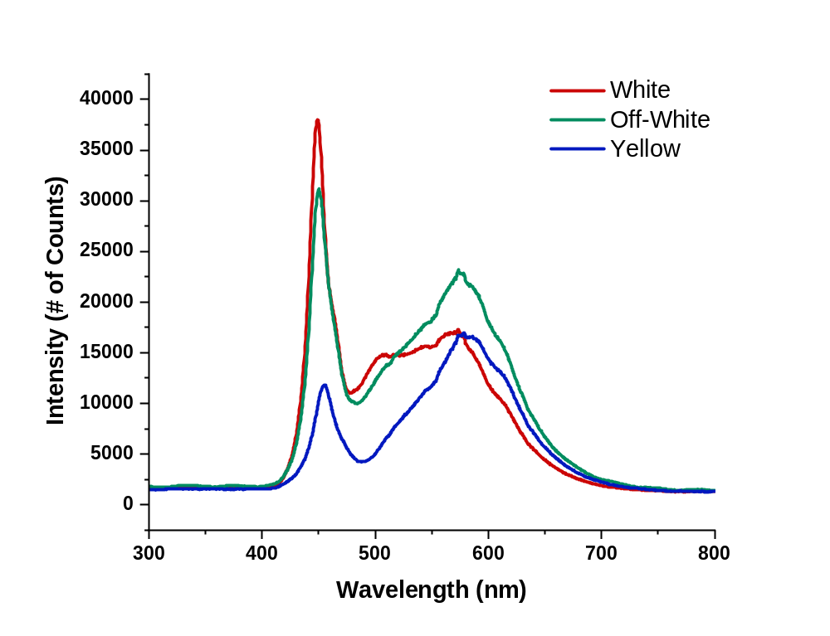
Supplementary Figure 1: Spectral Characterization of Different Illumination Tones. Different illumination tones (white, off-white and yellow) were tested, white illumination has demonstrated the highest peak at 449nm, while the off-white illumination and yellow illumination peak at 451nm and 457nm respectively.

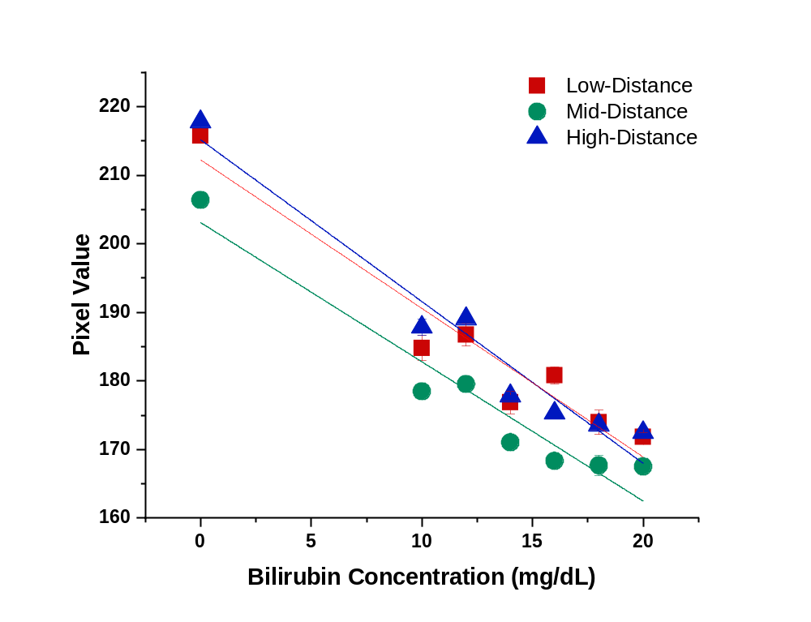
Supplementary Figure 2: Scatter plot of the pixel value of bilirubin concentrations in PDMS-TiO₂ tissue phantom samples with different image capture distances. No statistically significant difference was observed in images with varying capture distances (P > 0.05).

