Supporting Information
Upcycling acrylonitrile-butadiene-styrene Vitrimer ‘in melt’ using a dynamic crosslinker
Siddhesh Sadashiv Rege#, Indranil Dey#, Ria Sen Gupta, Muhammed Ajnas N, Riya Jose, Ashok Misra, Kunal Manna*, Ketaki Samanta*, Suryasarathi Bose*
Department of Materials Engineering, Indian Institute of Science, Bangalore
Corresponding Author email: kunalchemi17@gmail.com; ketakisamanta123@gmail.com; sbose@iisc.ac.in

Synthesis of Castor oil derivatives:
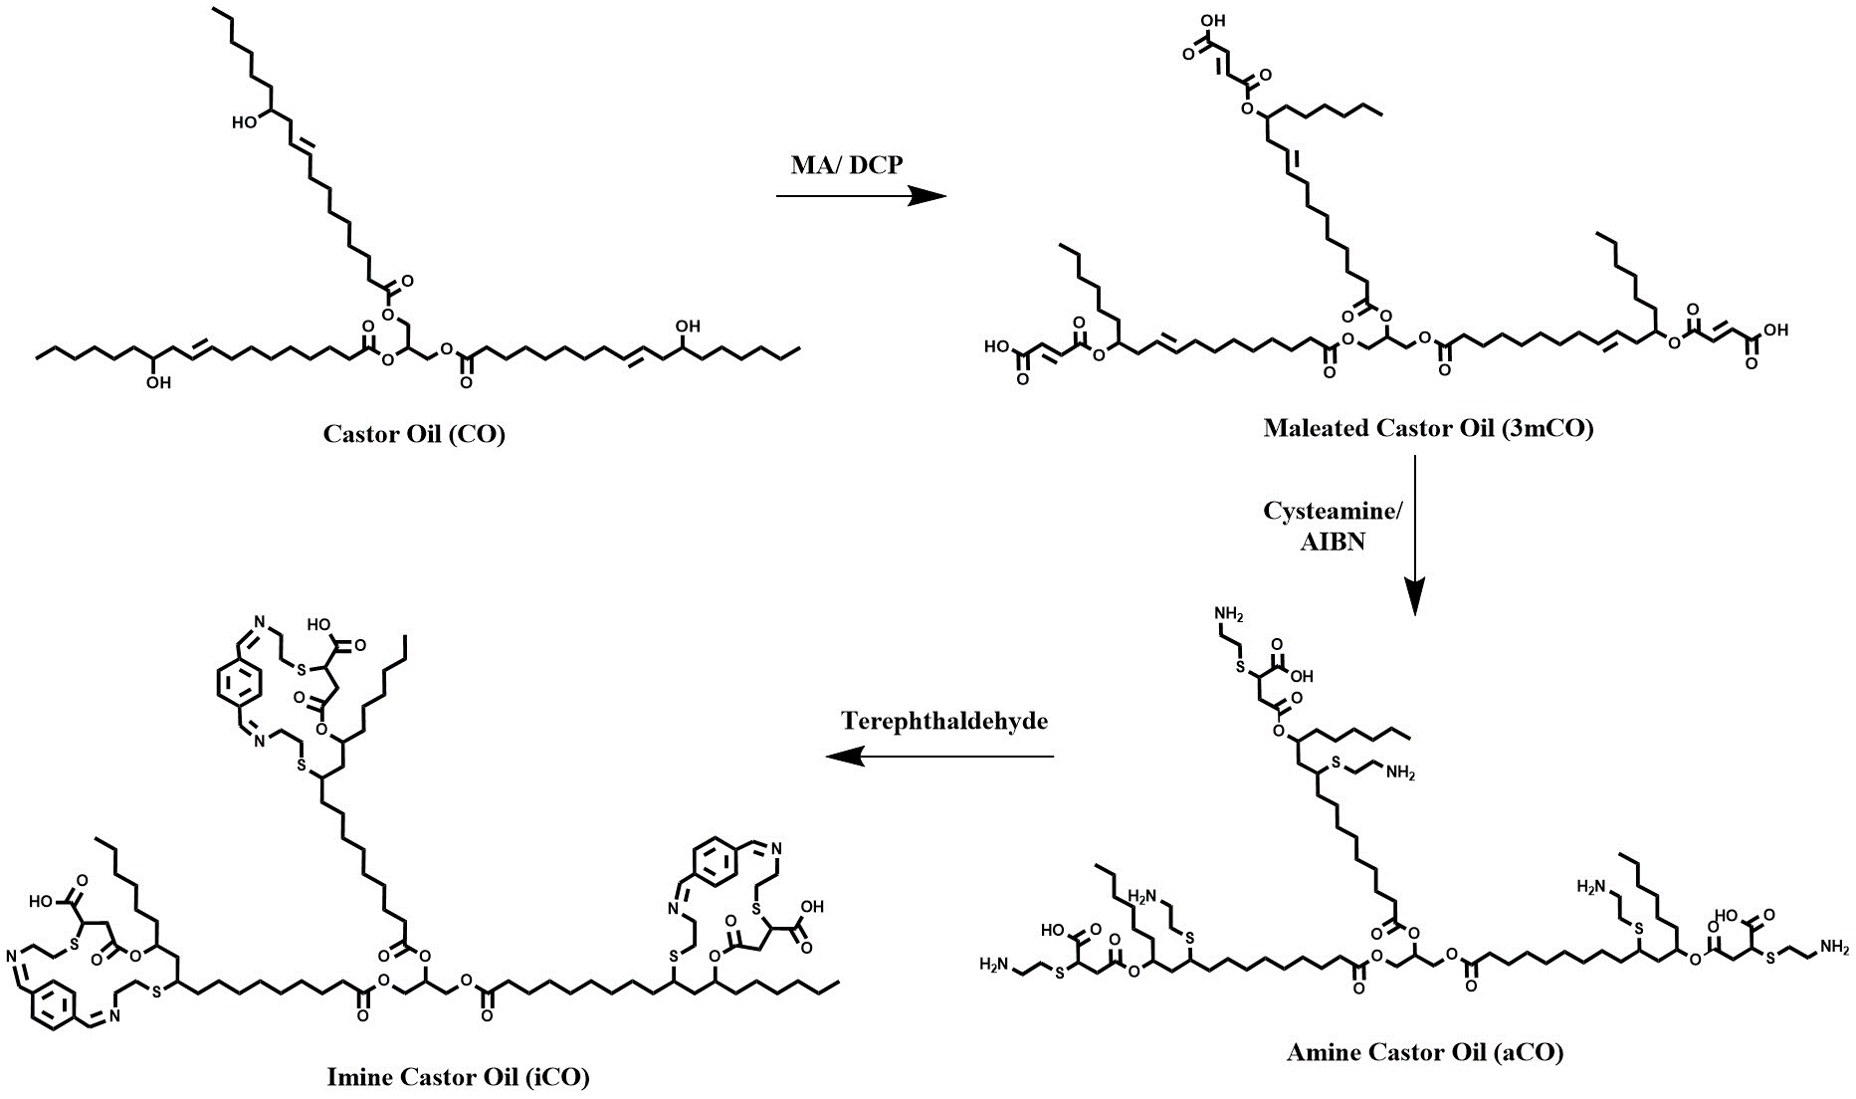
Figure S1: Reaction Schematic for the synthesis of imine castor oil (iCO)

NMR Spectra Analysis for synthesized oil derivatives:
The formation of the intermediate castor oil derivative for the formation of final product iCO was further confirmed through ¹H NMR.
(b)
(a)
Figure S2: ¹H NMR spectra for (a) 3mCO, (b) aCO and (c) iCO.
(c)

¹H NMR of 3mCO (CDCl₃, 500 MHz): 0.88 (9H, t, –CH₃), 1.23–1.28 (54H, m, –CH₂), 1.6–1.61 (6H, m, –CH₂), 1.96–2.01 (9H, m, –CH₂, –CH), 2.30–2.39 (12H, m, –CH₂), 4.1–4.34 (4H, m, –CH₂), 5.0–5.3 (2H, m, –CH), 5.4–5.5 (1H, m, –CH), 6.17–6.46 (2H, m, –CH).

¹H NMR of aCO (D₂O, 500 MHz): 0.88 (9H, t, –CH₃), 1.01–1.3 (54H, m, –CH₂), 1.36–1.46 (18H, m, –CH₂), 1.71–1.73 (6H, m, –CH₂), 2.07–2.15 (6H, broad, –NH₂), 2.66–2.69 (9H, m, – CH₂, –CH), 2.81–3.26 (18H, m, –CH₂), 3.47–3.51 (4H, m, –CH₂), 3.59–3.61 (15H, m, –CH₂, –CH), 5.70–5.73 (1H, m, –CH).

¹H NMR of iCO (D₂O, 500 MHz): 0.88 (9H, t, –CH₃), 1.2–1.4 (54H, m, –CH₂), 1.5–1.7 (18H, m, –CH₂), 1.7–2.5 (6H, m, –CH₂), 2.7–2.9 (9H, m, –CH₂, –CH), 2.9–3.4 (18H, m, –CH₂), 3.5–3.7 (15H, m, –CH₂, –CH), 3.7–3.9 (7H, m, –CH₂, –CH), 5.96 (1H, m, –CH), 7.77–8.13 (18H, m, –CH), 9.94–10.07 (3H, m, –COOH).

(a)
(b)
(c)

Figure S3: Comparative XPS study for PCR ABS and PCR ABS-Ox to confirm oxazoline formation. (a) whole range of XPS spectra; zoomed region for (b) C1s and (c) N1s.

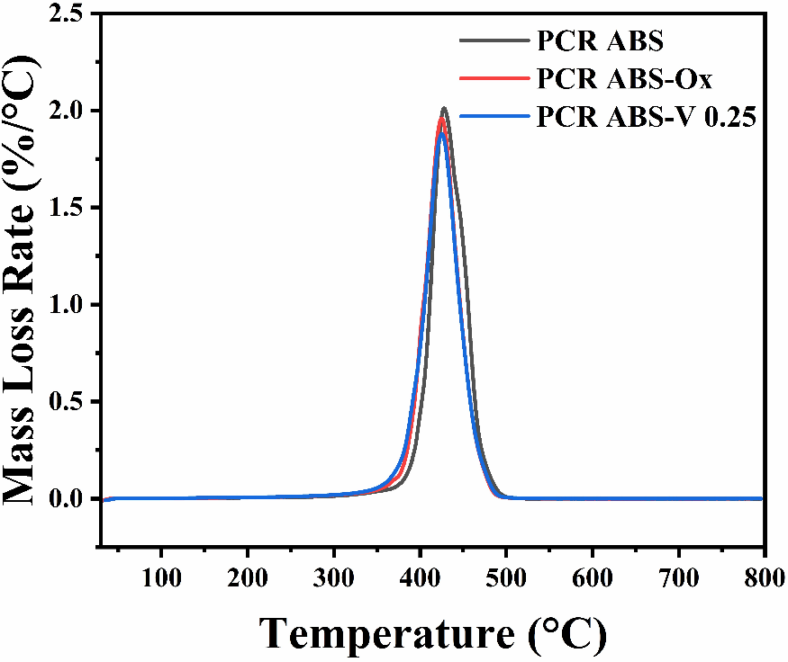

Figure S4: DTGA thermogram for PCR ABS, PCR ABS-Ox and PCR ABS-V 0.25.
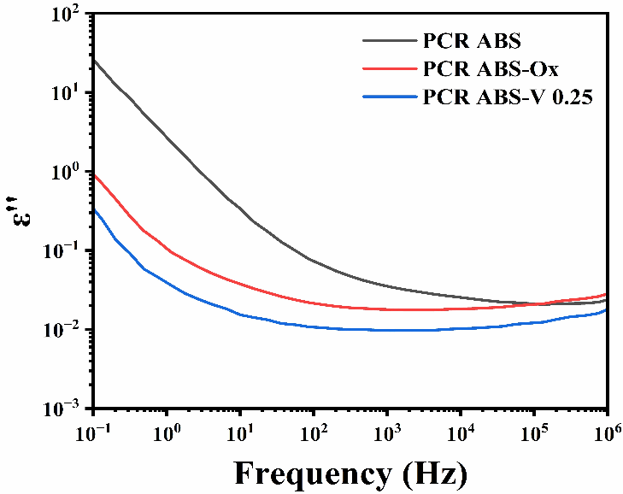

Figure S5. Dielectric loss spectra of PCR ABS, PCR ABS-Ox and PCR ABS-V 0.25.
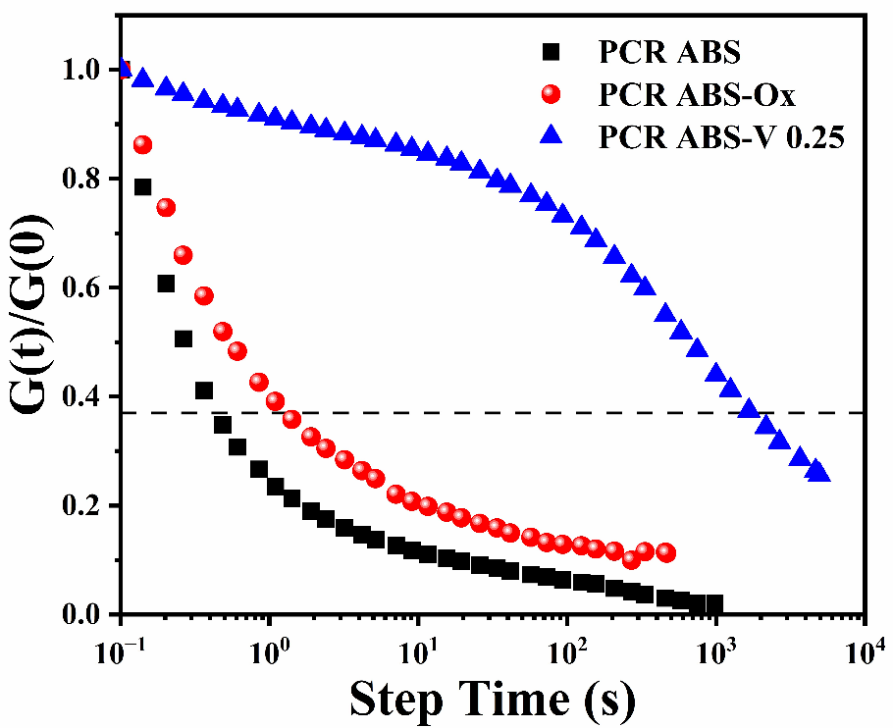

Figure S6: Stress Relaxation curves for PCR ABS, PCR ABS-Ox and PCR ABS-V 0.25 at 250 ℃.

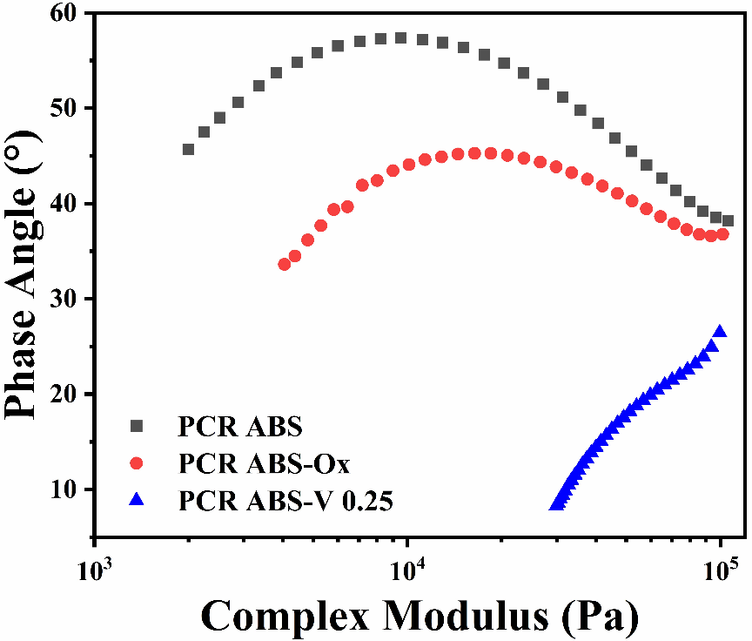

Figure S7: Van Gurp–Palmen plot for PCR ABS, PCR ABS-Ox and PCR ABS-V 0.25 at 220 ℃.

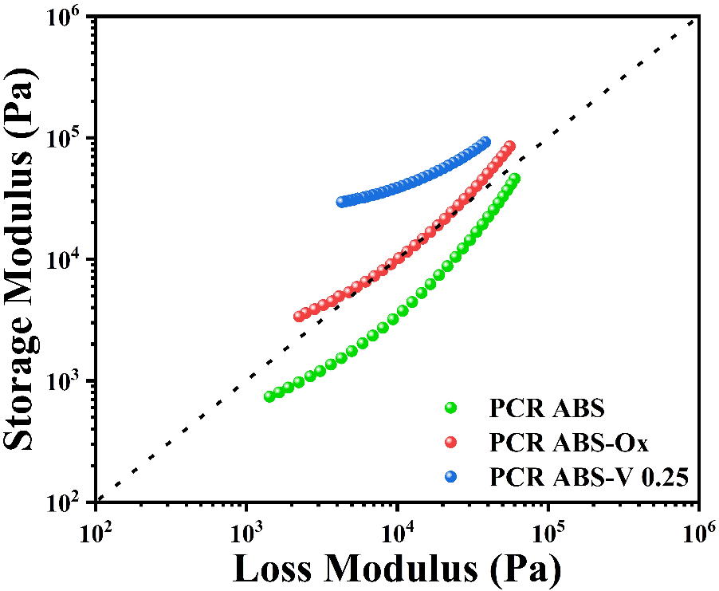

Figure S8: Modified Cole-Cole plots plot for PCR ABS, PCR ABS-Ox and PCR ABS-V 0.25 at 220 ℃.

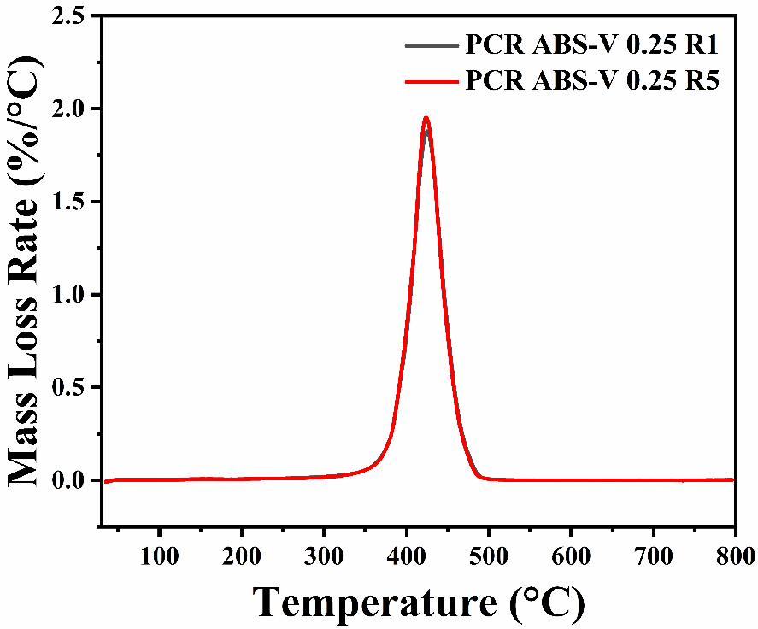

Figure S9: DTGA thermograms for R1 and R5 for PCR ABS V- 0.25.

