Supporting information for

MXene-supported MIL-88A(Fe) as persulfate activator for removal of tetracycline

Junxia Chen ª, Zhenzhen Yang ª, Weigang Li ª, Yuying Yang ª, Feng Zhu ^{b}, Zongli Huo ^{b}, *, Qing Zhou ª, *.

a State Key Laboratory of Pollution Control and Resource Reuse, School of Environ-ment, Nanjing University, Nanjing210023, China.
b Jiangsu Provincial Center for Disease Control and Prevention, Nanjing 210009, China.

*Corresponding author: zhouqing@nju.edu.cn
huozong123@163.com

Page S3 Text S1
Page S4 Text S2
Page S5 Text S3
Page S6 Figure S1
Page S7 Figure S2
Page S8 Figure S3
Page S9 Figure S4
Page S10 Figure S5
Page S11 Figure S6
Page S12 Figure S7
Page S13 Figure S8
Page S14 Figure S9
Page S15 Figure S10

Text S1 Characterization of materials
The surface morphology and chemical composition of as-prepared samples were visualized via scanning electron microscope (SEM) (FEI Quanta 250 FEG, USA) with Energy-dispersive X-ray spectroscopy (EDS) (Oxford Aztec X-MaxN80, UK), whereas X-ray photoelectron spectra (XPS) (Thermo K-Alpha, USA) were investigated to observe the chemical states of elements. X-ray diffractometer (Bruker D8 Advance, GER) was applied for identifying the crystalline structures, and the surface functional groups were determined by Fourier transform infrared spectrometer (FT-IR) (Thermo Nicolet iS 10, USA). The Brunauer-Emmett-Teller (BET) surface area and pore sizes distribution of as-tested samples were recorded with nitrogen adsorption–desorption method at 80 K on a BET-surface area analyzer (Micromeritics ASAP 2460, USA).
Text S2 TC degradation intermediates analysis
The concentration of residual TC was measured using HPLC analyzer with a UV detector (Shimadzu, Japan) at 358 nm and a C18 column (150 × 4.6 mm, 5 μm, Agilent, USA). The flow rate was maintained at 1 mL/min, while the mobile phase consisted of a solution of methanol and 0.01 M oxalic acid aqueous solution (47:53, vol./vol.). The column temperature was controlled at 30 °C.
The TC degradation intermediates were analyzed using LC-MS (Agilent1260 and AB Sciex Triple TOF 5600, USA) equipped with a C18 column (100 × 2.7 mm, 1.8 μm, Agilent, USA). The MS detector was operated using electrospray ionization (ESI) in the positive ion mode, scanning from m/z 50 to 500. The mobile phase composed of acetone (A) and water (0.1% formic acid) (B). The flow rate of mobile phase was 1 mL/min and the injection volume was 10uL. The gradient elution procedure was started for 0.5 min at 5% B, then linearly increased to 20% B within 1 min, further the percentage of B was increased to 60% at 2 min and increased to 95% at 3 min, kept constant for 2 min, finally decreased to 5% B for 1 min before the next injection. The total running time was 7.5 min, including the injection time.
The generated active substances were detected by electron paramagnetic resonance (EPR) (Bruker Magnettech ESR5000, GER) with DMPO as the spin trapping agent.
Text S3 Experimental procedure
Unless otherwise specified, all batch experiments were conducted in a 150 mL glass beaker containing 100 mL TC aqueous solution (20 mg/L) with a continuous magnetic stirring rate of 600 rpm at room temperature (25 °C). Briefly, 30 mg catalyst and 1mM PS were added into the suspension to initiate the degradation reaction. At predetermined time intervals, 0.65 mL TC aqueous solution was withdrawn using a 1-mL pipette, filtrated through a 0.22-μm PTFE syringe filter into a 2-mL HPLC vial and immediately quenched with 0.65 mL methanol.

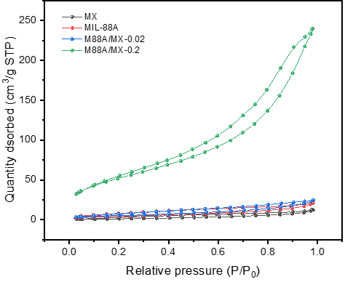
Figure S1. N₂ adsorption/desorption isotherms of as-synthesized catalysts.
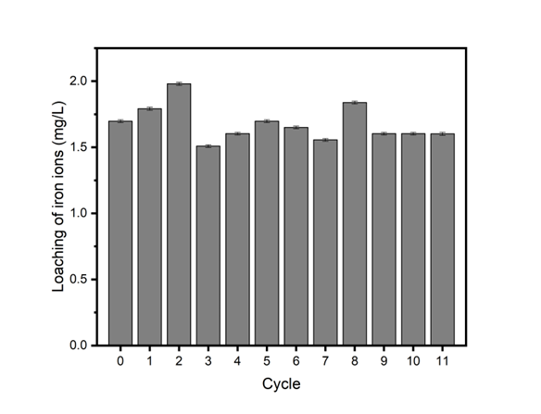
Figure S2 the leaching rate of Fe.

Figure S3. ESR spectra of PS activation by different catalysts with TEMP in deionized water.
Figure S4. MS spectrum for TC.

Figure S5. MS spectrum for P1 and P4.

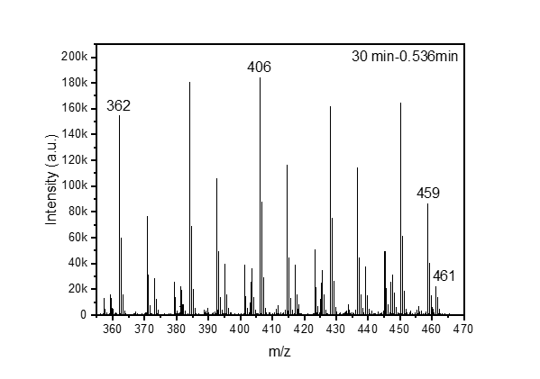
Figure S6. MS spectrum for P2, P4, P5 and P6.

Figure S7. MS spectrum for TC, P2 and P3.

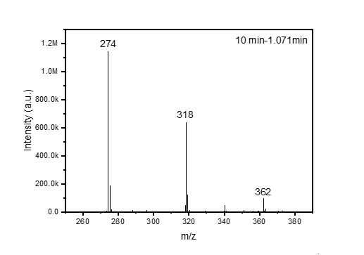
Figure S8. MS spectrum for P7, P8 and P9.

Figure S9. MS spectrum for P10 and P11.

Figure S10. MS spectrum for P12.

