Tables
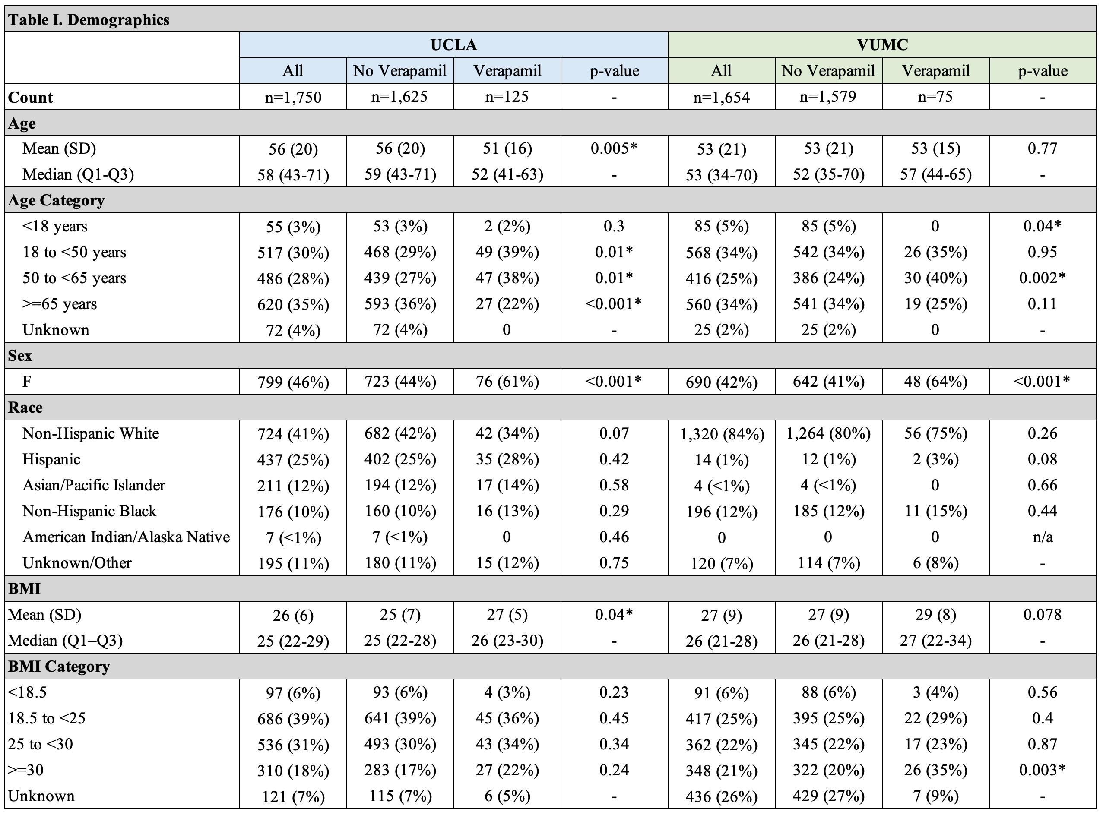
Table I. Basic demographics for the entire study cohort, the subset of patients not receiving verapamil, and the subset of patients receiving verapamil at each institution. An “*” indicates a statistically significant difference as defined by p<0.05.

