Online Supplemental Content

eTable 1. Factors associated with pre-ECMO occult hypoxemia rates in multivariable logistic regression analysis.

eFigure 1. Bland-Altman plots for (A) White, (B) Black, (C) Hispanic, and (D) Asian patients. The solid horizontal line indicates the estimated bias (median difference) and the dashed red lines indicate the 95% limits of agreement at the 2.5th and 97.5th percentiles.

eTable 2. Factors associated with the difference between on-ECMO SpO₂ and SaO₂ as a continuous variable in multivariable linear regression analysis.

eFigure 2. Receiver-operating characteristic curves for SpO₂ predicting SaO₂ at three pre-defined SaO₂ thresholds of (A) 88%, (B) 92%, and (C) 95% to denote hypoxemia.

eTable 1. Factors associated with pre-ECMO occult hypoxemia rates in multivariable logistic regression analysis.

 | OR | 95% CI | P value
Age | 1.00 | 0.99-1.00 | 0.206
Female sex | 0.91 | 0.73-1.12 | 0.374
Race/ethnicity
White | Reference
Black | 1.55 | 1.18-2.02 | 0.001
Asian | 0.87 | 0.62-1.23 | 0.433
Hispanic | 1.07 | 0.81-1.42 | 0.619
Pre-ECMO support
Pre-ECMO tMCS | 0.60 | 0.26-1.40 | 0.239
Pre-ECMO inotrope infusions | 0.93 | 0.61-1.43 | 0.755
Pre-ECMO vasopressor infusions | 0.90 | 0.74-1.11 | 0.338

Abbreviations: CI, confidence interval; ECMO, extracorporeal membrane oxygenation; OR, odds ratio; tMCS, temporary mechanical circulatory support.

Pre-ECMO tMCS consisted of intra-aortic balloon pump, Impella, and left ventricular assist devices. Pre-ECMO inotropic infusions consisted of dobutamine, enoximone, levosimendan, milrinone, nicardipine, nitroglycerin, nitroprusside, tolazoline. Pre-ECMO vasopressor infusions included dopamine, epinephrine, norepinephrine, phenylephrine, and vasopressin.

eFigure 1. Bland-Altman plots for (A) White, (B) Black, (C) Hispanic, and (D) Asian patients. The solid horizontal line indicates the estimated bias (median difference) and the dashed red lines indicate the 95% limits of agreement at the 2.5th and 97.5th percentiles.

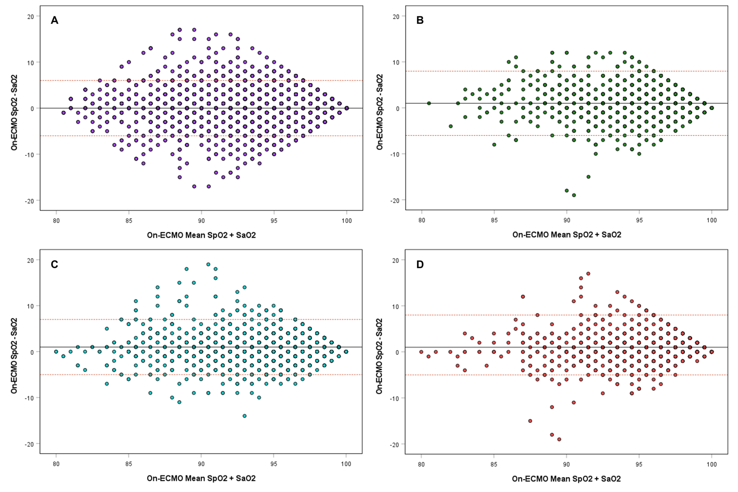

eTable 2. Factors associated with the difference between on-ECMO SpO₂ and SaO₂ as a continuous variable in multivariable linear regression analysis.

 | Unstandardized B | 95% CI for B | Standardized Beta | P value
Age | -0.004 | -0.009 – 0.001 | -0.017 | 0.133
Female sex | -0.118 | -0.259 – 0.024 | -0.018 | 0.103
Pre-ECMO support
Pre-ECMO tMCS | -0.349 | -0.825 – 0.128 | -0.017 | 0.151
Pre-ECMO inotrope infusions | -0.250 | -0.530 – 0.029 | -0.020 | 0.080
Pre-ECMO conventional ventilation | -0.241 | -0.589 – 0.088 | -0.016 | 0.151
ECMO physiology
Double-lumen cannula (one-site) | 0.212 | 0.054 – 0.371 | 0.030 | 0.009
Hemolysis | 0.285 | -0.010 – 0.580 | 0.021 | 0.058
Duration of ECMO, days | 0.0002 | -0.003 – 0.003 | 0.001 | 0.901
On-ECMO lactate | -0.014 | -0.038 – 0.010 | -0.013 | 0.255
Race/ethnicity *
White | Reference
Asian | 0.556 | 0.356 – 0.757 | 0.063 | <0.001
Black | 0.817 | 0.608 – 1.025 | 0.089 | <0.001
Hispanic | 0.346 | 0.152 – 0.541 | 0.041 | <0.001

Abbreviations: CI, confidence interval; ECMO, extracorporeal membrane oxygenation; tMCS, temporary mechanical circulatory support.

Pre-ECMO tMCS consisted of intra-aortic balloon pump, Impella, and left ventricular assist devices. Pre-ECMO inotropic infusions consisted of dobutamine, enoximone, levosimendan, milrinone, nicardipine, nitroglycerin, nitroprusside, tolazoline. Hemolysis was defined as a peak plasma hemoglobin of at least 50 mg/dL occurring at least once during the ECMO run and sustained for at least 2 consecutive days.

* Race/ethnicity was entered into the model as a second level and was associated with a significant r² change of 0.01 for the model (P < 0.001).
eFigure 2. Receiver-operating characteristic curves for SpO₂ predicting SaO₂ at three pre-defined SaO₂ thresholds of (A) 88%, (B) 92%, and (C) 95% to denote hypoxemia.
