Supplementary Notes

Proteomics data QC
In brief, 3,132 participants and 6,907 aptamers passed proteomics QC. 7,548 aptamers were measured before proteomics QC using the SOMAscan 7k platform. Plasma proteomics data from all genetic ancestries were QCed with the seven steps below:

1 Limit of detection, scale factor difference, and coefficient of variation
Limit of Detection (LOD), Scale factor difference (SF), and Coefficient of Variation (CV) are calculated using the protein levels (RFU values provided by Somalogic post-internal normalization) before log10-based transformation (i.e., not the log10-based values).
1.1 Limit of Detection
The limit of detection for an analyte is calculated using the mean and SD of the analyte expression level in buffer [negative controls] non-sample such that:
$$LOD = Mean expression+ 2×Standard Deviation$$
If the average analyte expression value in a sample is higher than the LOD level, this sample is considered a pass sample. The total number of samples that pass for each analyte is calculated.
For an analyte, if the total number of pass samples is > = 85% of total samples, that analyte is considered to pass the LOD filter but if it is < 85%, that analyte is removed.
1.2 Scale factor
Scale factor difference is calculated as the maximum absolute difference between the analyte scale factor and median scale factor of each plate. If the absolute value of the maximum difference is more than 0.5, the analyte is removed.
Mathematically,
Median Plate scale factor for plate P_{n}= median (scale factor of all 7,548 aptamers in Plate P_{n})
where, n = 1 to K

Now, each analyte has K scale factors corresponding to each plate.
So, the scale factor for our QC: $max⁡(\left|analyte scale factor in Plate Pn – Median Plate scale factor for plate Pn\right|)$
where, n = 1 to K
In summary, if an analyte has a scale factor more than 0.5 points away from the median scale factor in any of the plates [on either end of the distribution since the absolute value is considered], it fails QC.
1.3 Coefficient of Variation
The coefficient of variation for each analyte, within each plate, is calculated as the quotient of the standard deviation divided by the mean of the protein expression level in calibrators. If the median coefficient of variation for a given analyte is less than 0.15, that analyte is kept.
Each plate has either 4 or 5 Calibrator samples. The coefficient of variation for an analyte in Plate P_{n} is calculated as:
$$\frac{SD (Expression level of the analytes in Calibrator non samples in Plate Pk)}{mean (Expression level of analytes in Calibrator non samples in Plate Pk)}$$

where, n = 1 to K.

Since we have K plates, we will have K CV values for each analyte. We then take the median value of these CVs to assign the analyte’s CV i.e.,

CV for an analyte for QC:

Median (CV for analyte in Plate₁, Plate₂….Plate_{k})
If CV > 0.15, that analyte is considered to have failed QC and is removed.

2 IQR-based outlier expression level detections
Outliers were defined as any analyte with expression level outside:
$Q1-1.5 ×IQR \sim Q3+1.5×IQR$
where, Q3: Third Quantile, Q1: First Quantile and IQR: Inter Quartile Range
All analytes expression levels were log 10 transformed before IQR and quantiles calculation. Any values that were detected as outliers were replaced by NAs thereby introducing missingness into the expression matrix. No analytes or samples were removed at this step.

3 Remove Analytes and Samples with <65% call rate
The call rate was calculated for each analyte [row-wise] and each sample [column-wise]. Any analyte or sample with a call rate <65% was removed at this step. We first removed analytes and samples with <65% call rate given the protein matrix with 7,161 analytes. At the analyte level, none of the 7,161 analytes had a call rate lower than 65%, so no analytes were removed at this step (Figure S1A). At the sample level, 16 samples had a call rate < 65% and were thus removed (Figure S1B).

4 Re-calculate call rate for analytes and remove analytes with call rate <85%
Once the analytes and samples from Step 3 were removed, the call rate for analytes was recalculated. A more stringent criterion, compared to the earlier step, was used to filter out analytes.

5 Re-calculate missing rate for subjects and remove subjects with < 85% call rate cut-off
The call rate for each sample was calculated using the matrix obtained following the removal of analytes filtered at the 85% call rate cut-off. Based on the new call rate of 85%, six analytes were marked as outliers (Figure S1C), thus 7,155 proteins remained in the matrix. At the sample level, 81 samples with a call rate < 85% were identified as outliers (Figure S1D).

6 Back transformation into raw values
The expression levels, which were $\log{10}$ transformed during the IQR step, were back transformed. The missing data points have not been imputed at this point and will need to be decided based on the nature of downstream analysis on a case-by-case basis. The call rate for the analytes and samples was re-calculated to visualize the overall missing rate at this step.

7 Removal of Non-Human and analytes without protein targets and Final Matrix
After all QC steps, remove analytes with labels as “Non-Human” proteins and as non-biotin type and Spuriomers, which are random nucleic acid sequences that have a similar composition to SOMAmer reagents but have no known specific molecular target.

Metabolomics data QC
Briefly, 3,169 participants and 1,508 metabolites passed metabolomics QC. 1,718 metabolites were measured before QC with Metabolon HD4 platform. Plasma metabolomics data from all genetic ancestries were QCed with 11 steps below:

1 Volume Normalization
Normally, 100 ml sample aliquots are used for metabolite measurements. However, for certain samples volume <100 ml may have been used. In such circumstances, volume normalization of the batch-normalized metabolite expression level is required. For volume normalization, each data point is multiplied by a normalization factor and divided by its median i.e.,
$$Volume Normalization = {Data point×Normalization Factor}/{Median metabolite level}$$
where, $Normalization Factor=$ ${100}/{The volume of samples extracted}$
Note: Volume normalized metabolite levels are also provided by Metabolon, but these files are imputed and thus are not suitable for our QC purpose.

2 Sample Missingness
Sample with more than 50% missingness were removed.

3 Metabolite Missingness
Metabolites with more than 80% missing rate are flagged. This criterion is not applied to metabolites under the Xenobiotics super pathway as these are expected to be missing under normal circumstances because they are not naturally produced within an organism [e.g., environmental chemicals, drugs, etc.]. Unidentified metabolites are grouped with regular metabolites and subjected to the 80% missing rate filter.

4 Fischer’s Exact Test and Differential Expression Check
Missingness in metabolites can be attributed to disease conditions and may not always be due to random technical issues. To confirm whether the high missingness detected in Step 3 of the QC process is true missingness or if the missingness pattern has some association with disease status, we perform Fischer’s Test. For those metabolites that pass FDR corrected p-value in Fischer’s Test, thus showing a higher frequency of missingness associated with either the cases or controls, differential expression is then performed. If the metabolite passes the nominal p-value threshold for differential expression and has the same direction of effect size in both Fischer’s Exact Test and differential expression, these metabolites are retained even if they have high missingness.

5 Minimum Value Imputation
Missing values can weaken the statistical power of any analysis. In metabolomics, these missing points may be a result of falling below the limit of detection and not missing at random due to processing errors. Thus, instead of treating them as non-informative blanks, Metabolon recommends imputing these data points and including them in downstream analysis. However, as mentioned earlier Xenobiotics are indeed expected to be missing, and imputing their values could skew the results. So, imputation is performed only for the non-xenobiotic group of metabolites.
The minimum observed value (following batch and volume normalization) for each metabolite was used for imputation based on the recommendation by Metabolon. This imputation method was recommended based on their internal simulation studies comparing this to other methods.

6 Remove non-informative metabolites
Following, minimum value imputation, metabolite levels are log 10 transformed, and non-informative metabolites are removed. Noninformative metabolites are defined as those showing little variation across samples. Two criteria are used for defining the non-informative analytes: IQR = 0; Variance <= 0.001.
The cutoff for variance was based on a study by Schlosser et al.,¹ where the authors used variance < 0.01 for their log2 transformed data. Since we use the log10 transformation, the cutoff becomes 0.001 when adjusted.
Mathematically,
$$\log_{10}{x}=\log_{2}{x}×\log_{10}{2}=\log_{2}{x}×0.301$$
So, an adjusted variance would be,
$$({\log_{10}{x)}}^{2}={(\log_{2}{x)}}^{2}×{0.301}^{2}$$
$$Variance in log10 scale = 0.01×0.09062=0.0009061 ≅ 0.001$$

7 IQR-based outlier detection
The next QC step included flagging outlier data points using an IQR-based approach and replacing those values with NA. Any values outside the 1.5 times the first and third quantiles were flagged as outlier data points. IQR-based outlier detection was applied to all metabolites, including Xenobiotics.

8 Metabolites with <50 data points
Following IQR-based outlier detection, any metabolite that had a reading for less than 50 samples was removed. These metabolites do not have enough statistical power to give meaningful results in downstream analysis and so need to be removed.

9 Sample Outlier removal based on PCA
Subjects outside 5 standard deviations of PC1 and PC2 were flagged as outliers. 5SD cutoff was used to remain consistent with what was used for other metabolomics data. To calculate PCs, missing values were replaced with 0. This substitution was for PC calculation only.

10 Batch effects of metabolomics data
Post QC, two different batches were identified. The batch effect was found to be by sample draw year such that samples drawn from 1998-2006 clustered together whereas those from other years were clustered into separate groups. But after adjusting the metabolite-PC1 and PC2, the batch effects can be corrected. Based on the model test, it was decided that PC1 and PC2 would be used as covariates in downstream analyses.

11 Final Matrix and Back transformation of metabolite levels
The log10 transformed metabolite levels [following minimum value imputation] were back-transformed to raw values at the end of QC.

More details on genotype data QC steps prior to imputation
These steps along with the downstream imputation were performed within each array-type.
Section01) Pre-QC:
We used the standard PLINK-v1 binary (BED/BIM/FAM) files are used as input. We performed some initial sample-level checks, e.g. sex code, sample ID duplications, etc. We performed variant-level check, e.g. variants with both alleles missing, chromosome/position missing, etc. We retained the multiallelic variants.
Section02) QC:
We used two different thresholds are used to filter the missingness of variant- and sample-level: 20% and followed by >2%. We next performed the sex check using PLINK1.9 on X chromosome alone after pruning. After removing the sex mismatch samples, we checked the Hardy-Weinberg Equilibrium (HWE) and filter out variants with a P-value <10⁻⁶ using autosomal variants. Finally, we checked for duplicated variants by chr, pos, and alleles to take care of the same position warnings in the final merging step, and filtered variants as described in the Pre-QC section.
Section03) Pre-imputation:
We first performed liftover on the variants to hg38 genome build, NOTE: no need of this step if the data is on the hg38 build. We next filtered mitochondrial variants and all Indels, updated the variants strand, position, and reference allele assignment, and changed the variant names to a standard format as “chr:pos:Ref:Alt”. Finally, we split the file into separate chromosomes and sort based on the variant positions, and only uploaded the autosomal chromosomes to the TOPMed server for imputation.

More details on merging differently genotyped cohort subsets
To merge all the individual datasets after QC, we first checked for the allele discrepancy in variant name. We merged new datasets one by one and create and new data merged file this will be later combined with the old data freeze. We next checked the merged file for allele discrepancy in variant name, the quality of the data after each merge with multiple geno and maf filters ranging from 0.01, 0.02, 0.05 to 0.1. This can evaluate how many variants passed QC after all these filters and whether they were in the range of common variants or not. We double checked for the presence of duplicate variants with PLINK1.9 –list-dup-var. In the final merged genotype data, the Ref allele is assigned to A2.

Validations of our PWAS findings
To validate our PWAS findings, we referred to other studies that directly measured protein levels in individuals with and without T2D. Out of the 74 proteins identified from EUR PWAS analysis, 50 were also examined in two external studies. Of those, 18 proteins were reported to have significantly different levels between T2D cases and controls, including ApoM, TBCA, FAM3D, and sE-Selectin. Among the eight proteins per AFR PWAS results, four were tested in the study by Gudmundsdottir et al²., and only FAM3D was reported to have differential expression in T2D.

References

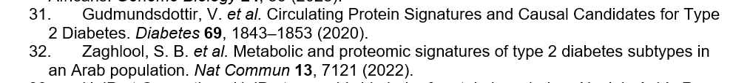

Supplementary Figures
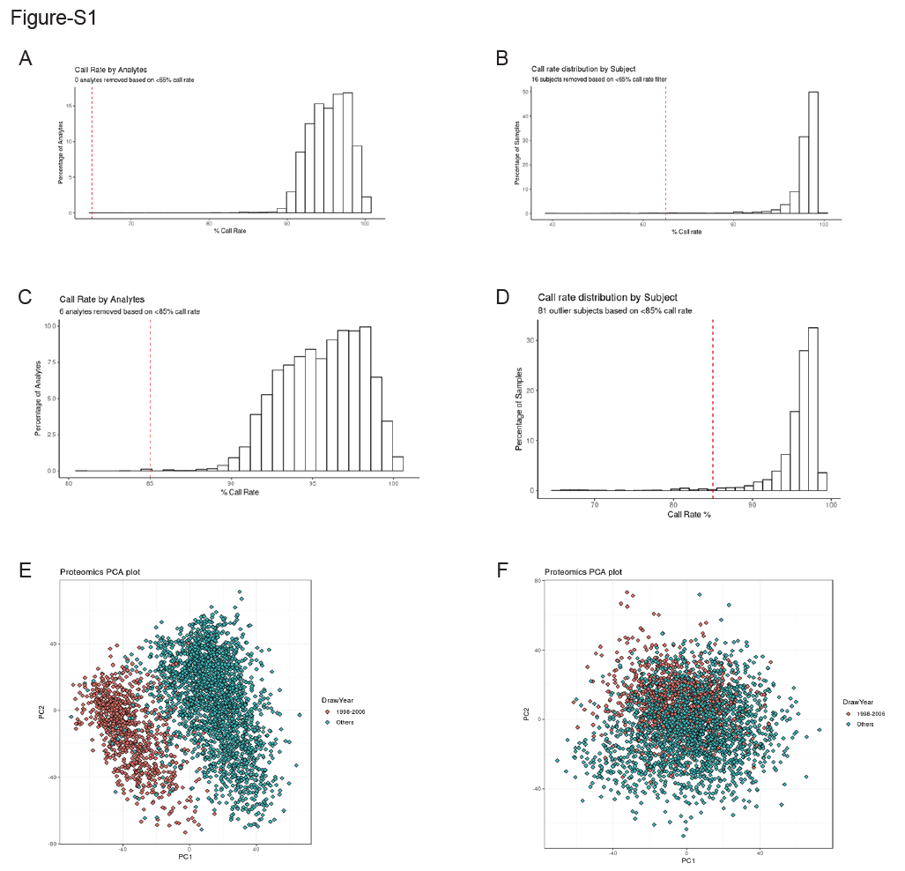

Figure S1 Investigations of multiple proteomics QC steps.
Histograms of call rate distribution on different proteomics QC steps: A) 65% call rate (red vertical line) by proteins, B) 65% call rate (red vertical line) by participants, C) 85% call rate (red vertical line) by proteins, and D) 85% call rate (red vertical line) by participants. scatterplots of proteomic PC1 and PC2 before (E) and after (F) adjusting proteomic PC1 and PC2. The color coded was by “sample draw year” such that samples drawn from 1998-2006 clustered together in red, whereas those from other years were clustered in blue.

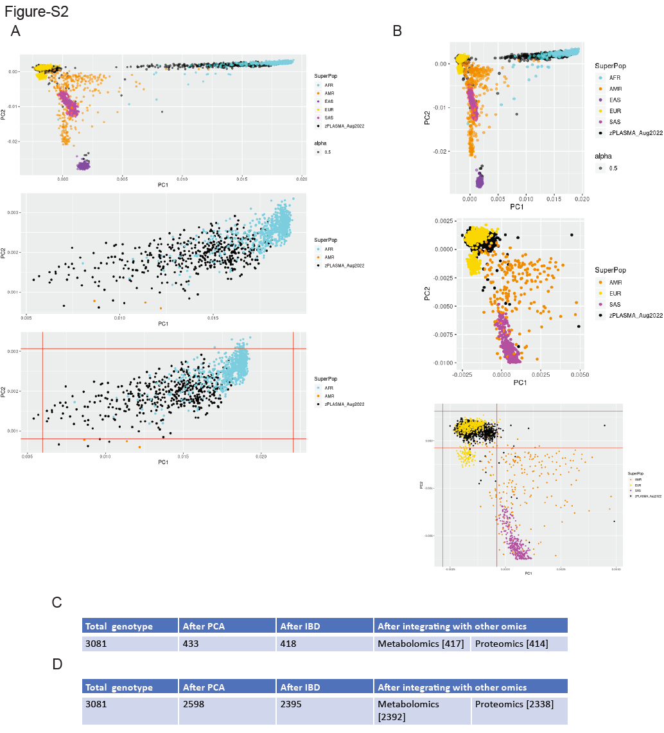

Figure S2 Definition of the AFR and EUR genetic ancestry in this study per genotype PCA.
A) AFR participants were defined within the black window defined per mean +/- 3 times of the standard deviation of PC1 and PC2. (our samples were coded as the black points; AFR samples from 1000 Genome Project were cyan); B) EUR participants were defined within the black window defined per mean +/- 3 times of the standard deviation of PC1 and PC2. (our samples were coded as the black points; EUR samples from 1000 Genome Project were gold); C) Summary of the participants numbers defined as AFR used in downstream multi-omic integration; and D) Summary of the participants numbers defined as EUR used in downstream multi-omic integration.

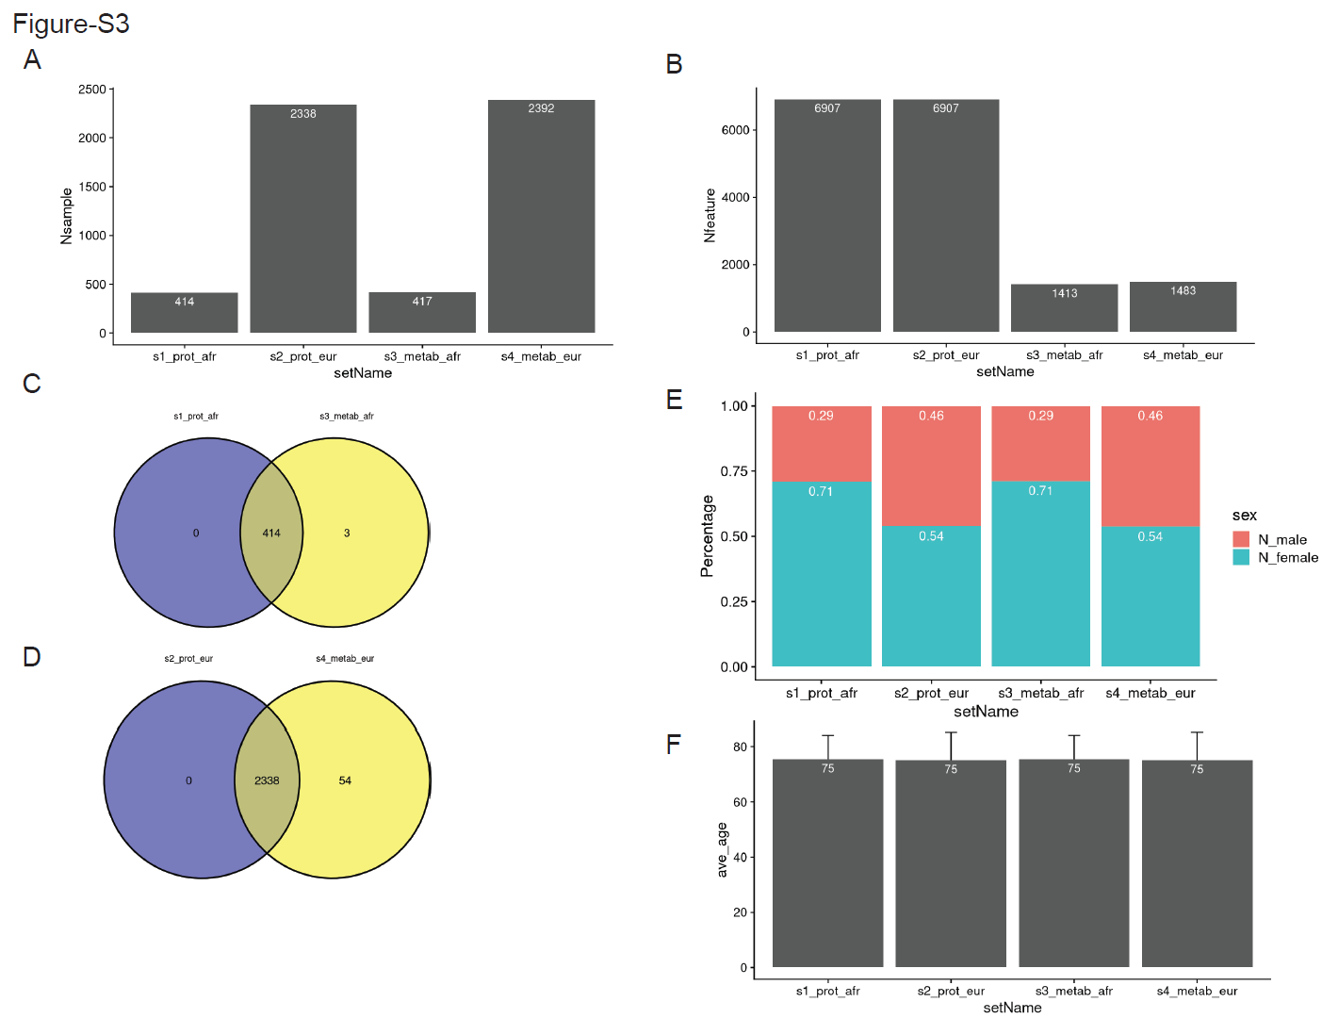

Figure S3 Sample size and demographics of the participants of the plasma proteome and metabolome in participants of African and European ancestry.
A) Bar plot of sample size of each dataset. B) Bar plot of the feature numbers of each dataset. C) Venn diagram of the cross-omics datasets after QC for participants from the African ancestry. D) Venn diagram of the cross-omics datasets after QC for participants from the European ancestry. E) Bar plot of the sex proportions of each dataset. F) Bar plot of the average age distribution of each dataset (error bar is the standard deviation).

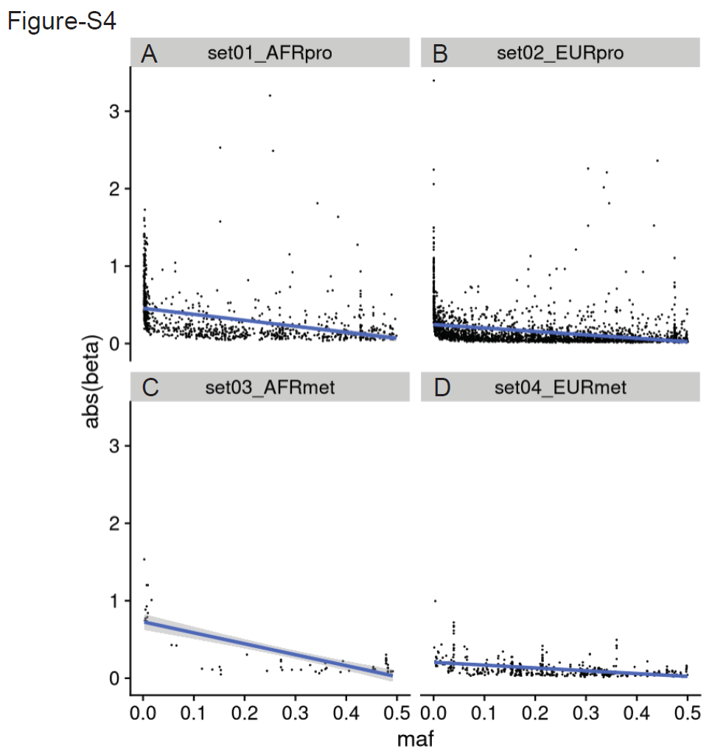

Figure S4 Properties of QTLs [MAF vs abs(beta)].
A) Negative correlation between the absolute value of the effect size of the AFR pQTL and the minor allele frequency of these pQTL in AFR. B) Negative correlation between the absolute value of the effect size of the EUR pQTL and the minor allele frequency of these pQTL in EUR. C) Negative correlation between the absolute value of the effect size of the AFR mQTL and the minor allele frequency of these mQTL in AFR. D) Negative correlation between the absolute value of the effect size of the EUR mQTL and the minor allele frequency of these mQTL in EUR.

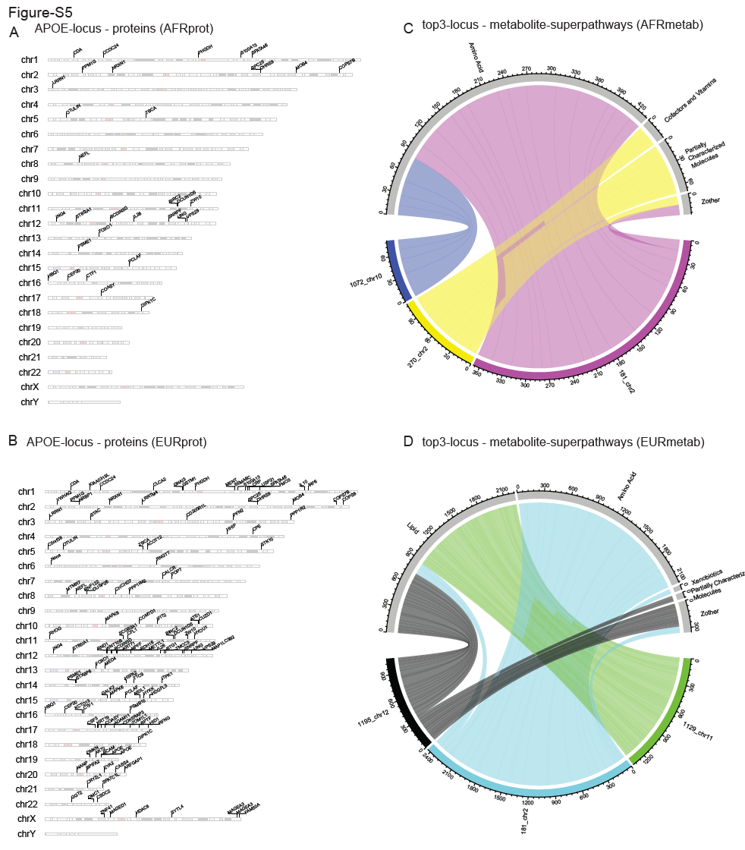

Figure S5 Examples of highly pleiotropic regions from the plasma proteome and metabolome in participants of African and European ancestry.
A) Karyotype ideogram of the APOE-locus as the top AFR pQTL pleiotropic region and its associated proteins. B) Karyotype ideogram of the APOE-locus as the top EUR pQTL pleiotropic region and its associated proteins. C) Chord Diagram of the top-three loci as the AFR mQTL pleiotropic regions and their associated metabolites (grouped by the super pathways). D) Chord Diagram of the top-three loci as the EUR mQTL pleiotropic regions and their associated metabolites (grouped by the super pathways).
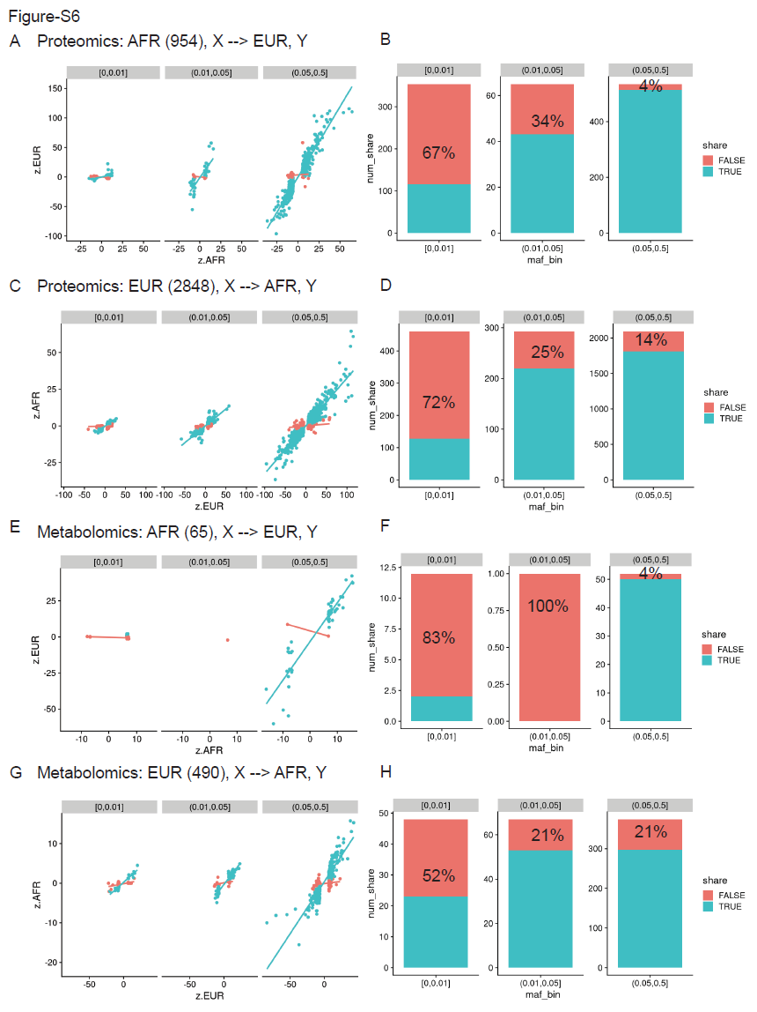

Figure S6 The proportions of ancestry-specific QTLs vary across MAF bins.
A) AFR-specific pQTL vs queried EUR. The scatterplots of the standardized effect sizes between the two ancestries are stratified by three MAF bins (0-0.01; 0.01-0.05; 0.05-0.5) for the shared (green) and AFR-specific (red) pQTLs. The lines are based on linear regression model. B) The bar plots summarizing the numbers of shared and AFR-specific pQTLs within each MAF bin.
C) EUR-specific pQTL vs queried AFR. The scatterplots of the standardized effect sizes between the two ancestries are stratified by the same three MAF bins for the shared (green) and EUR-specific (red) pQTLs. The lines are based on linear regression model. D) The bar plots summarizing the numbers of shared and EUR-specific pQTLs within each MAF bin.
E) AFR-specific mQTL vs queried EUR. The scatterplots of the standardized effect sizes between the two ancestries are stratified by three MAF bins (0-0.01; 0.01-0.05; 0.05-0.5) for the shared (green) and AFR-specific (red) mQTLs. The lines are based on linear regression model. F) The bar plots summarizing the numbers of shared and AFR-specific mQTLs within each MAF bin.
G) EUR-specific mQTL vs queried AFR. The scatterplots of the standardized effect sizes between the two ancestries are stratified by the same three MAF bins for the shared (green) and EUR-specific (red) mQTLs. The lines are based on linear regression model. H) The bar plots summarizing the numbers of shared and EUR-specific mQTLs within each MAF bin.

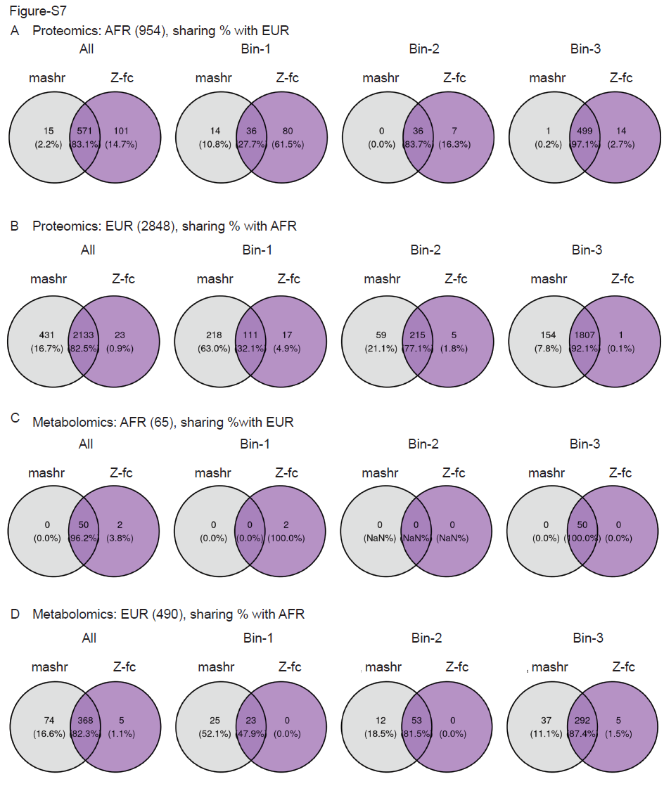Figure S7 Comparisons of mashr and Z-value defined ancestry-shared QTLs.
A) AFR-specific pQTL vs queried EUR. The venn diagram showed 83.1% overlapping using the two strategies (gray circle as mashr output and purple as Z-value output) to classify ancestry-shared pQTLs in the AFR-pQTL set.
B) EUR-specific pQTL vs queried AFR. The venn diagram showed 82.5% overlapping using the two strategies to classify ancestry-shared pQTLs in the EUR-pQTL set.
C) AFR-specific mQTL vs queried EUR. The venn diagram showed 96.2% overlapping using the two strategies to classify ancestry-shared mQTLs in the AFR-mQTL set.
D) EUR-specific mQTL vs queried AFR. The venn diagram showed 82.3% overlapping using the two strategies to classify ancestry-shared mQTLs in the EUR-mQTL set.

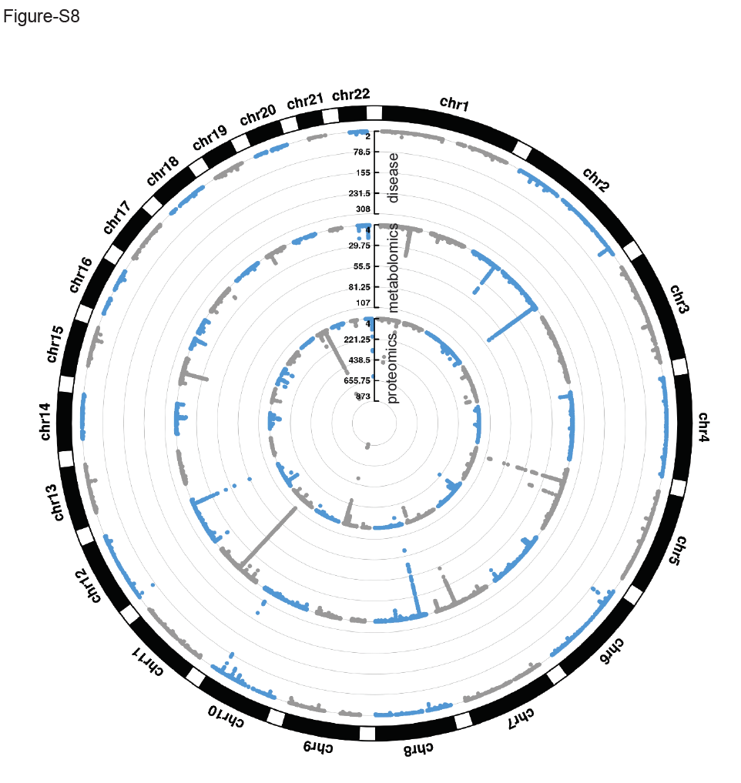Figure S8 Circular Manhattan plot of the genetic associations of EUR proteomics, metabolomics, and T2D risk.
Inner to outer layers are proteomics, metabolomics, and disease GWAS results.

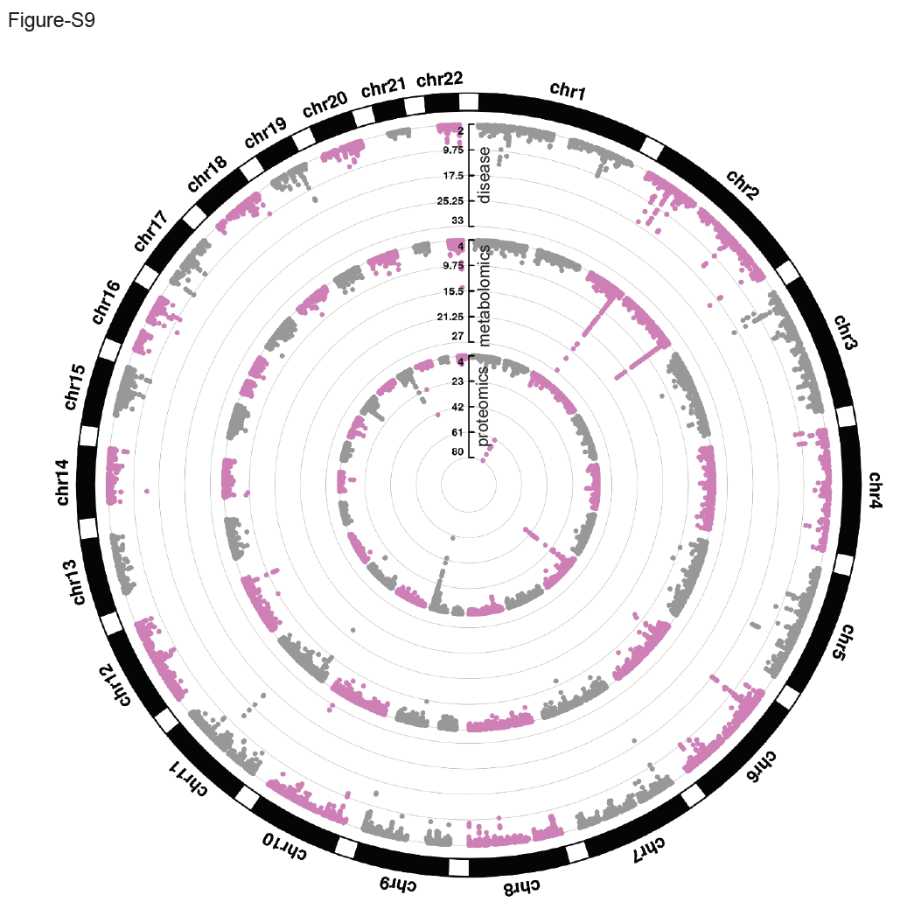Figure S9 Circular Manhattan plot of the genetic associations of AFR proteomics, metabolomics, and T2D risk.
Inner to outer layers are proteomics, metabolomics, and disease GWAS results.

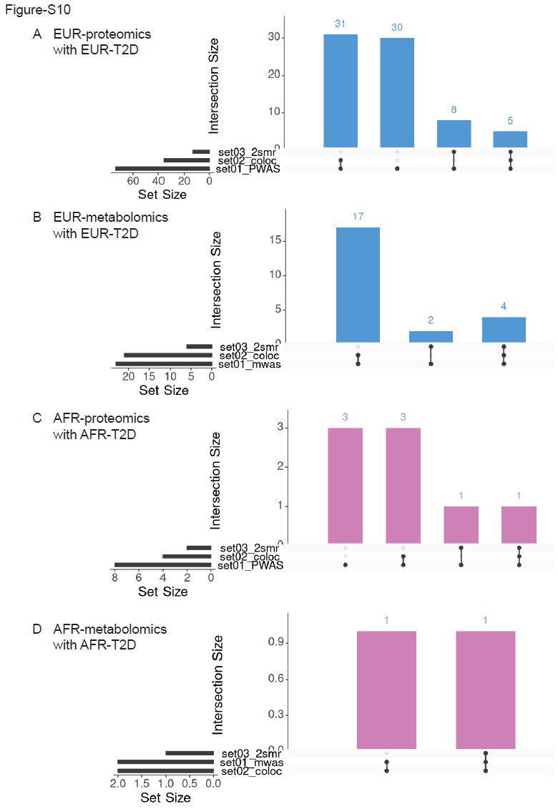

Figure S10 Upset plots of the feature-overlap between each of the three-stage integrative analyses with ancestry-matched T2D risk.
A) EUR proteins, B) AFR proteins, C) EUR metabolites, and D) AFR metabolites.

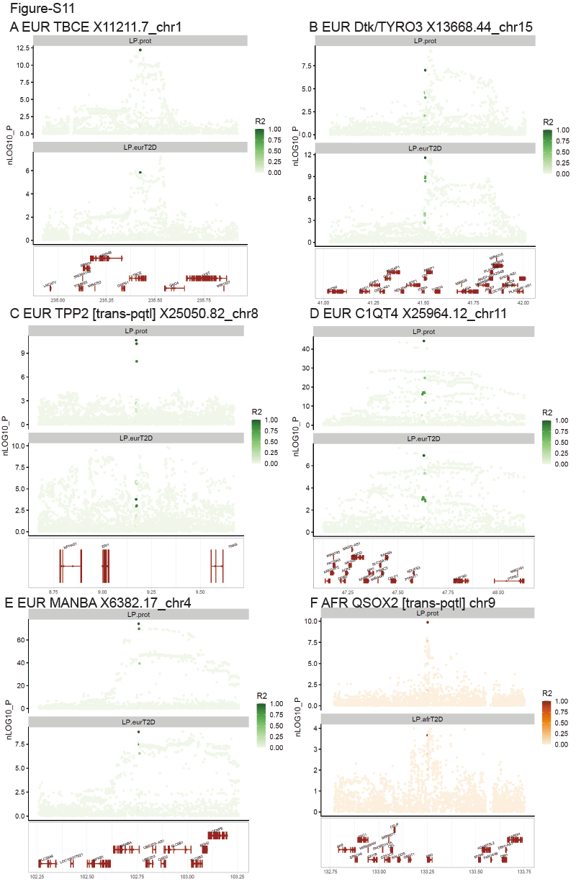

Figure S11 Stacked regional plots of the genetic associations of proteins and ancestry matched T2D risk.
A-E) five EUR proteins on EUR T2D; F) one AFR protein on AFR T2D.

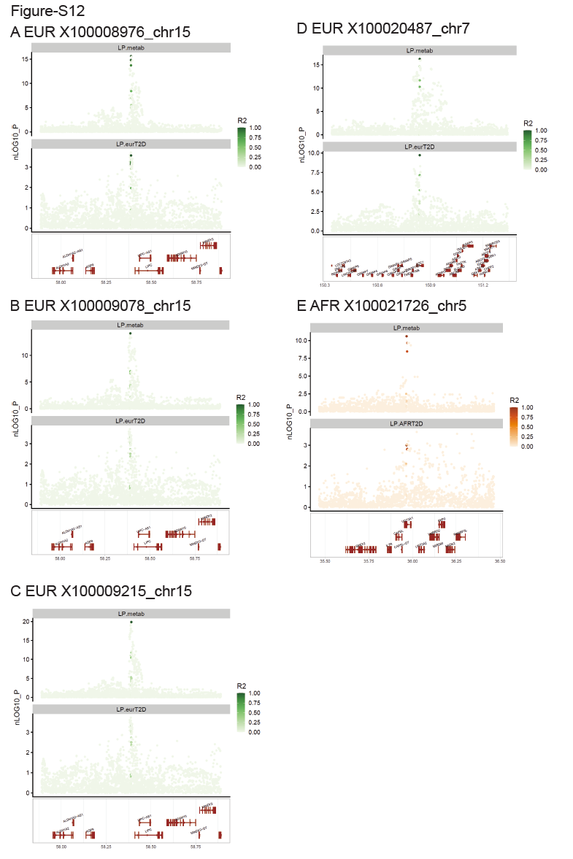

Figure S12 Stacked regional plots of the genetic associations of metabolites and ancestry matched T2D risk.
A-D) four EUR metabolites on EUR T2D; E) one AFR metabolite on AFR T2D.

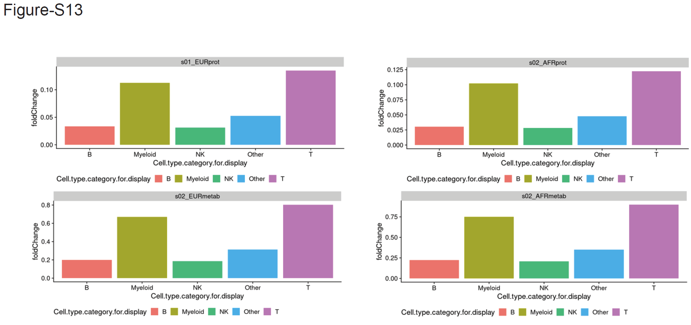Figure S13 Barplots of the fold-change features [per INTACT plus MR result with ancestry-matched T2D risk over all features with a significant QTL] acrss the highest ranked cell-type (five major categories] curated by ImmGen.
The features are from EUR proteins, AFR proteins, EUR metabolites, and AFR metabolites. The cell type was ranked by p-value of the S-LDSC results with the QTL summary statistics per feature.

