Synthesis, Characterization, in vitro and in silico approach of vanillin acetamides
Manikkam Bharathi,^{a,b} S. Shreedevi,^{a,b*} Rajendran Sribalan^{c}
ªPG & Research Department of Chemistry, Arignar Anna Government Arts College,
Cheyyar 604 407, Tamilnadu, India.
^{b}Thiruvalluvar University, Vellore, Tamil Nadu, India
^{c}Biochemie Innovations Lab, Tindivanam-604 001, Tamil Nadu, India
*Corresponding Author: sshreedevi1977@gmail.com
General methods
All the chemicals and reagents are purchased as laboratory reagent grade from sigma-aldrich and used without purifications. Thermo Scientific Nicolet iS50 FT-IR Spectrometer was used for recording FT-IR spectra. ¹H NMR &¹³C NMR spectra were recorded on Bruker 300 & 400 MHz and 100 & 75 MHz instruments in CDCl₃ with TMS as an internal standard or DMSO-D₆ for proton and carbon spectra. Chemical shift values are mentioned in δ (ppm) and coupling constants are given in Hz. LCQ Fleet mass spectrometer, Thermo Fisher Instruments Limited, US was used for recording Mass spectra. Labmann (LMSPUV1200) UV-Vis spectrometer was used for UV absorption (for biological studies). The progress and completion of reactions was checked by TLC on 2 × 5 cm pre-coated silica gel 60 F254 plates of a thickness of 0.25 mm (Merck). The TLCs were visualized under UV 254-366 nm and/or iodine.
Biological studies
Anti-inflammatory activity
BSA denaturation technique
The synthesized compound and standard diclofenac sodium were screened for anti-inflammatory activity by using the inhibition of albumin denaturation technique with minor modification. The standard drug and compound were dissolved in minimum quantity of Dimethyl formamide (DMF) and diluted with phosphate buffer (0.2 M, PH 7.4). The final concentration of DMF in all solution was less than 2.5%. Test Solution (2.5 mL) containing different concentrations of the drug was mixed with 1 mL of 1 mM Bovine serum albumin solution in phosphate buffer and incubated at 37 °C in an incubator for 10 min. Denaturation was induced by keeping the reaction mixture at 70°C in a water bath for 10 min. After cooling, the turbidity was measured at 660 nm. Percentage of Inhibition of denaturation was calculated from control where no drug was added. The percentage inhibition of denaturation was calculated by using the following formula.
% of Inhibition = 100 x[ Ac-At /Ac]
At: Absorbance of test
Ac: Absorbance of control
Antidiabetic activity
α- amylase inhibition technique
The antidiabetic activity of the samples was performed using α-amylase inhibition method. Briefly, Amylase (0.2%) was incubated with and without samples (in 1.5 mL) and standard for 10 min at 25◦C. This experiment was performed in 0.2M phosphate buffer (pH 6.9). After pre incubation, the 1% starch solution (0.5mL) was added and the reaction mixture was incubated for 30 min at 25◦C. In order to stop the enzymatic reaction, DNSA reagent (0.5 mL) was added as the color reagent and then incubated in a boiling water bath for 90 min. After cooling down to the room temperature, 0.5 mL of samples were diluted to 2.5mL of distilled water and the absorbance measured at 540 nm using a UV-Visible spectrophotometer. The measured absorbance was compared with that of the control experiment. The percentage inhibition was calculated from the given formula.
% of Inhibition = 100 x [ Ac -At /Ac]
At: Absorbance of test
Ac: Absorbance of control
Molecular docking study:
Molecular docking of VHAs into the α-amylase, COX-1, COX-2 and BSA enzymes was carried out using the Auto-Dock software (version 4.2). Accelrys discovery studio client 4.1 visualizer was used for the visualizing protein-ligand complex. Three dimensional structures of synthesized derivatives were constructed using ChemBio 3D ultra 13.0 software, then they were energetically minimized by using MMFF94 with 5000 iterations and minimum RMS gradient of 0.10. The crystal structure of α-amylase, COX-1, COX-2 and BSA (1HNY.pdb, 1PGG.pdb, 4COX.pdb and 3V03.pdb) were taken from Protein Data bank. All bound water and ligand were eliminated from the protein and polar hydrogen was added. Moreover all docking a grid box size of 60x60x60 points in X, Y and Z direction. A grid spacing of 0.375 Å and ten runs were generated by using Lamarckian genetic algorithm searches.
Computational calculations
All the computational calculations including representation of HOMO, LUMO, Molecular electrostatic potential (MEP) and Mulliken population analysis (MPA) in the checkpoint files was developed with the Gaussian 09W program using DFT methods. The chemical structure of the VHAs was optimized with B3LYP/6-31G basis set. The ¹H NMR and ¹³C NMR chemical shifts are calculated using GIAO method with the similar basis set as optimization. The Gauss view was used to visualize the computed structures including Frontier Molecular orbitals, MEP, MPA representation.
Fig S1: Optimized structure of VHAs

Fig S2: Molecular orbitals of a) V2PR b)V4PR c)V2PM
Fig S3: Molecular electrostatic potential of a) V2PR b) V4PR c)V2PM
Fig. S4: Mulliken population Analysis of V2PR
Fig. S5: Mulliken population Analysis of V4PR
Fig. S6: Mulliken population Analysis of V2PM

Fig. S7: Molecular docking interactions of V2PR with 1HNY (a), 1-PGG (b), 4-CoX (c) and 3V03 (d).

Fig. S8: Molecular docking interactions of V4PR with 1HNY (a), 1-PGG (b), 4-CoX (c) and 3V03 (d).
Fig. S9: Molecular docking interactions of V2PM with 1HNY (a), 1-PGG (b), 4-CoX (c) and 3V03 (d).

Table S1: Geometrical parameters of VISO
S.No. | ATOM TYPE | BOND LENGTH (Å) | ATOM TYPE | BOND ANGLE (°) | ATOM TYPE | TORSONAL ANGLE (°)
1 | H(39)-C(24) | 1.086 | H(39)-C(24)-C(23) | 120.730 | C(18)-C(24)-C(23)-N(22) | 0.316
2 | H(38)-C(23) | 1.087 | H(39)-C(24)-C(18) | 121.417 | C(18)-C(24)-C(23)-H(38) | -179.983
3 | H(37)-C(21) | 1.086 | C(23)-C(24)-C(18) | 117.853 | H(39)-C(24)-C(23)-N(22) | -179.438
4 | H(36)-C(20) | 1.085 | H(38)-C(23)-C(24) | 121.104 | H(39)-C(24)-C(23)-H(38) | 0.263
5 | H(35)-N(16) | 1.021 | H(38)-C(23)-N(22) | 115.312 | C(23)-C(24)-C(18)-C(20) | -2.076
6 | H(34)-N(15) | 1.019 | C(24)-C(23)-N(22) | 123.583 | C(23)-C(24)-C(18)-C(17) | -179.452
7 | H(33)-C(12) | 1.094 | C(23)-N(22)-C(21) | 117.261 | H(39)-C(24)-C(18)-C(20) | 177.676
8 | H(32)-C(12) | 1.096 | H(37)-C(21)-N(22) | 115.227 | H(39)-C(24)-C(18)-C(17) | 0.300
9 | H(31)-C(11) | 1.095 | H(37)-C(21)-C(20) | 121.164 | C(24)-C(23)-N(22)-C(21) | 1.360
10 | H(30)-C(11) | 1.095 | N(22)-C(21)-C(20) | 123.608 | H(38)-C(23)-N(22)-C(21) | -178.357
11 | H(29)-C(11) | 1.094 | H(36)-C(20)-C(21) | 120.259 | C(23)-N(22)-C(21)-C(20) | -1.326
12 | H(28)-C(7) | 1.102 | H(36)-C(20)-C(18) | 121.963 | C(23)-N(22)-C(21)-H(37) | 178.210
13 | H(27)-C(5) | 1.085 | C(21)-C(20)-C(18) | 117.767 | N(22)-C(21)-C(20)-C(18) | -0.381
14 | H(26)-C(2) | 1.088 | C(17)-C(18)-C(24) | 118.430 | N(22)-C(21)-C(20)-H(36) | 178.390
15 | H(25)-C(1) | 1.089 | C(17)-C(18)-C(20) | 121.634 | H(37)-C(21)-C(20)-C(18) | -179.890
16 | C(24)-C(23) | 1.381 | C(24)-C(18)-C(20) | 119.882 | H(37)-C(21)-C(20)-H(36) | -1.119
17 | C(24)-C(18) | 1.394 | O(19)-C(17)-N(16) | 121.117 | C(21)-C(20)-C(18)-C(24) | 2.105
18 | C(23)-N(22) | 1.351 | O(19)-C(17)-C(18) | 119.423 | C(21)-C(20)-C(18)-C(17) | 179.395
19 | N(22)-C(21) | 1.350 | N(16)-C(17)-C(18) | 119.459 | H(36)-C(20)-C(18)-C(24) | -176.644
20 | C(21)-C(20) | 1.383 | H(35)-N(16)-N(15) | 114.845 | H(36)-C(20)-C(18)-C(17) | 0.646
21 | C(20)-C(18) | 1.394 | H(35)-N(16)-C(17) | 115.619 | C(20)-C(18)-C(17)-N(16) | 37.127
22 | O(19)-C(17) | 1.227 | N(15)-N(16)-C(17) | 122.597 | C(20)-C(18)-C(17)-O(19) | -142.510
23 | C(18)-C(17) | 1.484 | H(34)-N(15)-C(13) | 116.334 | C(24)-C(18)-C(17)-N(16) | -145.545
24 | C(17)-N(16) | 1.380 | H(34)-N(15)-N(16) | 118.509 | C(24)-C(18)-C(17)-O(19) | 34.818
25 | N(16)-N(15) | 1.408 | C(13)-N(15)-N(16) | 117.012 | C(18)-C(17)-N(16)-N(15) | 28.599
26 | N(15)-C(13) | 1.386 | O(14)-C(13)-C(12) | 122.722 | C(18)-C(17)-N(16)-H(35) | 177.887
27 | O(14)-C(13) | 1.231 | O(14)-C(13)-N(15) | 122.989 | O(19)-C(17)-N(16)-N(15) | -151.770
28 | C(13)-C(12) | 1.526 | C(12)-C(13)-N(15) | 114.285 | O(19)-C(17)-N(16)-H(35) | -2.482
29 | C(12)-O(9) | 1.426 | H(32)-C(12)-H(33) | 112.055 | C(17)-N(16)-N(15)-C(13) | 162.619
30 | C(11)-O(10) | 1.422 | H(32)-C(12)-O(9) | 111.425 | C(17)-N(16)-N(15)-H(34) | 15.103
31 | O(10)-C(4) | 1.369 | H(32)-C(12)-C(13) | 106.633 | H(35)-N(16)-N(15)-C(13) | 13.115
32 | O(9)-C(3) | 1.373 | H(33)-C(12)-O(9) | 109.500 | H(35)-N(16)-N(15)-H(34) | -134.400
33 | O(8)-C(7) | 1.225 | H(33)-C(12)-C(13) | 106.437 | N(16)-N(15)-C(13)-C(12) | -170.305
34 | C(7)-C(6) | 1.477 | O(9)-C(12)-C(13) | 110.646 | N(16)-N(15)-C(13)-O(14) | 10.403
35 | C(6)-C(1) | 1.393 | O(10)-C(11)-H(29) | 107.678 | H(34)-N(15)-C(13)-C(12) | -22.081
36 | C(6)-C(5) | 1.400 | O(10)-C(11)-H(30) | 111.186 | H(34)-N(15)-C(13)-O(14) | 158.627
37 | C(5)-C(4) | 1.403 | O(10)-C(11)-H(31) | 111.069 | N(15)-C(13)-C(12)-O(9) | 10.442
38 | C(4)-C(3) | 1.410 | H(29)-C(11)-H(30) | 107.671 | N(15)-C(13)-C(12)-H(33) | 129.328
39 | C(3)-C(2) | 1.402 | H(29)-C(11)-H(31) | 107.729 | N(15)-C(13)-C(12)-H(32) | -110.888
40 | C(2)-C(1) | 1.393 | H(30)-C(11)-H(31) | 111.314 | O(14)-C(13)-C(12)-O(9) | -170.264
41 |  |  | C(4)-O(10)-C(11) | 118.702 | O(14)-C(13)-C(12)-H(33) | -51.378
42 |  |  | C(3)-O(9)-C(12) | 117.438 | O(14)-C(13)-C(12)-H(32) | 68.406
43 |  |  | C(6)-C(7)-O(8) | 122.038 | C(13)-C(12)-O(9)-C(3) | -160.847
44 |  |  | C(6)-C(7)-H(28) | 116.659 | H(33)-C(12)-O(9)-C(3) | 82.140
45 |  |  | O(8)-C(7)-H(28) | 121.304 | H(32)-C(12)-O(9)-C(3) | -42.393
46 |  |  | C(7)-C(6)-C(1) | 119.998 | H(31)-C(11)-O(10)-C(4) | 65.109
47 |  |  | C(7)-C(6)-C(5) | 119.450 | H(30)-C(11)-O(10)-C(4) | -59.438
48 |  |  | C(1)-C(6)-C(5) | 120.549 | H(29)-C(11)-O(10)-C(4) | -177.163
49 |  |  | H(27)-C(5)-C(6) | 118.461 | C(11)-O(10)-C(4)-C(3) | 176.803
50 |  |  | H(27)-C(5)-C(4) | 121.193 | C(11)-O(10)-C(4)-C(5) | -4.943
51 |  |  | C(6)-C(5)-C(4) | 120.342 | C(12)-O(9)-C(3)-C(2) | 155.531
52 |  |  | O(10)-C(4)-C(5) | 123.222 | C(12)-O(9)-C(3)-C(4) | -26.113
53 |  |  | O(10)-C(4)-C(3) | 117.699 | H(28)-C(7)-C(6)-C(5) | -0.245
54 |  |  | C(5)-C(4)-C(3) | 119.057 | H(28)-C(7)-C(6)-C(1) | 179.216
55 |  |  | O(9)-C(3)-C(4) | 127.491 | O(8)-C(7)-C(6)-C(5) | 179.751
56 |  |  | O(9)-C(3)-C(2) | 112.663 | O(8)-C(7)-C(6)-C(1) | -0.788
57 |  |  | C(4)-C(3)-C(2) | 119.827 | C(5)-C(6)-C(1)-C(2) | -0.265
58 |  |  | H(26)-C(2)-C(3) | 120.066 | C(5)-C(6)-C(1)-H(25) | 179.449
59 |  |  | H(26)-C(2)-C(1) | 119.111 | C(7)-C(6)-C(1)-C(2) | -179.719
60 |  |  | C(3)-C(2)-C(1) | 120.823 | C(7)-C(6)-C(1)-H(25) | -0.005
61 |  |  | H(25)-C(1)-C(6) | 120.573 | C(1)-C(6)-C(5)-C(4) | 0.260
62 |  |  | H(25)-C(1)-C(2) | 120.040 | C(1)-C(6)-C(5)-H(27) | -179.029
63 |  |  | C(6)-C(1)-C(2) | 119.386 | C(7)-C(6)-C(5)-C(4) | 179.717
64 |  |  |  |  | C(7)-C(6)-C(5)-H(27) | 0.428
65 |  |  |  |  | C(6)-C(5)-C(4)-C(3) | 0.579
66 |  |  |  |  | C(6)-C(5)-C(4)-O(10) | -177.652
67 |  |  |  |  | H(27)-C(5)-C(4)-C(3) | 179.848
68 |  |  |  |  | H(27)-C(5)-C(4)-O(10) | 1.617
69 |  |  |  |  | C(5)-C(4)-C(3)-C(2) | -1.408
70 |  |  |  |  | C(5)-C(4)-C(3)-O(9) | -179.659
71 |  |  |  |  | O(10)-C(4)-C(3)-C(2) | 176.922
72 |  |  |  |  | O(10)-C(4)-C(3)-O(9) | -1.330
73 |  |  |  |  | C(4)-C(3)-C(2)-C(1) | 1.425
74 |  |  |  |  | C(4)-C(3)-C(2)-H(26) | -178.770
75 |  |  |  |  | O(9)-C(3)-C(2)-C(1) | 179.921
76 |  |  |  |  | O(9)-C(3)-C(2)-H(26) | -0.274
77 |  |  |  |  | C(3)-C(2)-C(1)-C(6) | -0.581
78 |  |  |  |  | C(3)-C(2)-C(1)-H(25) | 179.704
79 |  |  |  |  | H(26)-C(2)-C(1)-C(6) | 179.613
80 |  |  |  |  | H(26)-C(2)-C(1)-H(25) | -0.103

Table S2: Geometrical parameters of V2PR
S.No. | ATOM TYPE | BOND LENGTH (Å) | ATOM TYPE | BOND ANGLE (°) | ATOM TYPE | TORSONAL ANGLE (°)
1 | H(35)-C(21) | 1.084 | H(35)-C(21)-C(16) | 121.458 | C(20)-C(21)-C(16)-N(17) | 0.004
2 | H(34)-C(20) | 1.086 | H(35)-C(21)-C(20) | 119.317 | C(20)-C(21)-C(16)-N(14) | 179.999
3 | H(33)-C(19) | 1.084 | C(16)-C(21)-C(20) | 119.225 | H(35)-C(21)-C(16)-N(17) | 180.000
4 | H(32)-C(18) | 1.086 | H(34)-C(20)-C(21) | 120.435 | H(35)-C(21)-C(16)-N(14) | -0.005
5 | H(31)-N(14) | 1.008 | H(34)-C(20)-C(19) | 120.352 | C(16)-C(21)-C(20)-C(19) | -0.003
6 | H(30)-C(12) | 1.097 | C(21)-C(20)-C(19) | 119.213 | C(16)-C(21)-C(20)-H(34) | -179.999
7 | H(29)-C(12) | 1.097 | H(33)-C(19)-C(20) | 121.408 | H(35)-C(21)-C(20)-C(19) | -179.999
8 | H(28)-C(10) | 1.095 | H(33)-C(19)-C(18) | 120.743 | H(35)-C(21)-C(20)-H(34) | 0.005
9 | H(27)-C(10) | 1.095 | C(20)-C(19)-C(18) | 117.849 | C(21)-C(20)-C(19)-C(18) | 0.003
10 | H(26)-C(10) | 1.094 | H(32)-C(18)-C(19) | 121.312 | C(21)-C(20)-C(19)-H(33) | 179.999
11 | H(25)-C(7) | 1.103 | H(32)-C(18)-N(17) | 114.946 | H(34)-C(20)-C(19)-C(18) | 179.999
12 | H(24)-C(5) | 1.085 | C(19)-C(18)-N(17) | 123.742 | H(34)-C(20)-C(19)-H(33) | -0.005
13 | H(23)-C(2) | 1.089 | C(18)-N(17)-C(16) | 118.173 | C(20)-C(19)-C(18)-N(17) | -0.003
14 | H(22)-C(1) | 1.088 | N(14)-C(16)-C(21) | 117.200 | C(20)-C(19)-C(18)-H(32) | -179.996
15 | C(21)-C(16) | 1.393 | N(14)-C(16)-N(17) | 121.002 | H(33)-C(19)-C(18)-N(17) | 180.000
16 | C(21)-C(20) | 1.394 | C(21)-C(16)-N(17) | 121.798 | H(33)-C(19)-C(18)-H(32) | 0.008
17 | C(20)-C(19) | 1.387 | H(31)-N(14)-C(13) | 117.824 | C(19)-C(18)-N(17)-C(16) | 0.004
18 | C(19)-C(18) | 1.382 | H(31)-N(14)-C(16) | 116.512 | H(32)-C(18)-N(17)-C(16) | 179.997
19 | C(18)-N(17) | 1.350 | C(13)-N(14)-C(16) | 125.664 | C(18)-N(17)-C(16)-C(21) | -0.004
20 | N(17)-C(16) | 1.342 | O(15)-C(13)-C(12) | 122.307 | C(18)-N(17)-C(16)-N(14) | -180.000
21 | C(16)-N(14) | 1.401 | O(15)-C(13)-N(14) | 126.957 | N(17)-C(16)-N(14)-C(13) | -0.004
22 | O(15)-C(13) | 1.226 | C(12)-C(13)-N(14) | 110.736 | N(17)-C(16)-N(14)-H(31) | -179.998
23 | N(14)-C(13) | 1.390 | H(29)-C(12)-H(30) | 111.680 | C(21)-C(16)-N(14)-C(13) | -180.000
24 | C(13)-C(12) | 1.536 | H(29)-C(12)-O(11) | 109.929 | C(21)-C(16)-N(14)-H(31) | 0.006
25 | C(12)-O(11) | 1.415 | H(29)-C(12)-C(13) | 106.447 | C(16)-N(14)-C(13)-C(12) | -179.999
26 | O(11)-C(3) | 1.370 | H(30)-C(12)-O(11) | 109.930 | C(16)-N(14)-C(13)-O(15) | 0.005
27 | C(10)-O(9) | 1.422 | H(30)-C(12)-C(13) | 106.441 | H(31)-N(14)-C(13)-C(12) | -0.005
28 | O(9)-C(4) | 1.370 | O(11)-C(12)-C(13) | 112.348 | H(31)-N(14)-C(13)-O(15) | 179.999
29 | O(8)-C(7) | 1.224 | C(3)-O(11)-C(12) | 119.290 | N(14)-C(13)-C(12)-O(11) | -179.997
30 | C(7)-C(6) | 1.477 | O(9)-C(10)-H(26) | 107.690 | N(14)-C(13)-C(12)-H(30) | -59.627
31 | C(6)-C(1) | 1.391 | O(9)-C(10)-H(27) | 111.135 | N(14)-C(13)-C(12)-H(29) | 59.630
32 | C(6)-C(5) | 1.400 | O(9)-C(10)-H(28) | 111.127 | O(15)-C(13)-C(12)-O(11) | -0.000
33 | C(5)-C(4) | 1.405 | H(26)-C(10)-H(27) | 107.642 | O(15)-C(13)-C(12)-H(30) | 120.370
34 | C(4)-C(3) | 1.410 | H(26)-C(10)-H(28) | 107.642 | O(15)-C(13)-C(12)-H(29) | -120.373
35 | C(3)-C(2) | 1.404 | H(27)-C(10)-H(28) | 111.404 | C(13)-C(12)-O(11)-C(3) | 179.995
36 | C(2)-C(1) | 1.392 | C(4)-O(9)-C(10) | 118.586 | H(30)-C(12)-O(11)-C(3) | 61.663
37 |  |  | C(6)-C(7)-O(8) | 122.278 | H(29)-C(12)-O(11)-C(3) | -61.667
38 |  |  | C(6)-C(7)-H(25) | 116.540 | C(12)-O(11)-C(3)-C(2) | -179.998
39 |  |  | O(8)-C(7)-H(25) | 121.182 | C(12)-O(11)-C(3)-C(4) | 0.008
40 |  |  | C(7)-C(6)-C(1) | 120.069 | H(28)-C(10)-O(9)-C(4) | 62.339
41 |  |  | C(7)-C(6)-C(5) | 119.365 | H(27)-C(10)-O(9)-C(4) | -62.330
42 |  |  | C(1)-C(6)-C(5) | 120.566 | H(26)-C(10)-O(9)-C(4) | -179.998
43 |  |  | H(24)-C(5)-C(6) | 118.257 | C(10)-O(9)-C(4)-C(3) | 179.997
44 |  |  | H(24)-C(5)-C(4) | 121.140 | C(10)-O(9)-C(4)-C(5) | -0.012
45 |  |  | C(6)-C(5)-C(4) | 120.602 | H(25)-C(7)-C(6)-C(5) | -0.005
46 |  |  | O(9)-C(4)-C(5) | 122.843 | H(25)-C(7)-C(6)-C(1) | 179.997
47 |  |  | O(9)-C(4)-C(3) | 118.298 | O(8)-C(7)-C(6)-C(5) | -179.994
48 |  |  | C(5)-C(4)-C(3) | 118.859 | O(8)-C(7)-C(6)-C(1) | 0.008
49 |  |  | O(11)-C(3)-C(4) | 128.715 | C(5)-C(6)-C(1)-C(2) | 0.004
50 |  |  | O(11)-C(3)-C(2) | 111.684 | C(5)-C(6)-C(1)-H(22) | 179.996
51 |  |  | C(4)-C(3)-C(2) | 119.601 | C(7)-C(6)-C(1)-C(2) | -179.999
52 |  |  | H(23)-C(2)-C(3) | 119.416 | C(7)-C(6)-C(1)-H(22) | -0.006
53 |  |  | H(23)-C(2)-C(1) | 119.363 | C(1)-C(6)-C(5)-C(4) | 0.001
54 |  |  | C(3)-C(2)-C(1) | 121.220 | C(1)-C(6)-C(5)-H(24) | -179.999
55 |  |  | H(22)-C(1)-C(6) | 120.816 | C(7)-C(6)-C(5)-C(4) | -179.996
56 |  |  | H(22)-C(1)-C(2) | 120.032 | C(7)-C(6)-C(5)-H(24) | 0.003
57 |  |  | C(6)-C(1)-C(2) | 119.152 | C(6)-C(5)-C(4)-C(3) | -0.006
58 |  |  |  |  | C(6)-C(5)-C(4)-O(9) | -179.997
59 |  |  |  |  | H(24)-C(5)-C(4)-C(3) | 179.995
60 |  |  |  |  | H(24)-C(5)-C(4)-O(9) | 0.004
61 |  |  |  |  | C(5)-C(4)-C(3)-C(2) | 0.005
62 |  |  |  |  | C(5)-C(4)-C(3)-O(11) | 179.999
63 |  |  |  |  | O(9)-C(4)-C(3)-C(2) | 179.997
64 |  |  |  |  | O(9)-C(4)-C(3)-O(11) | -0.009
65 |  |  |  |  | C(4)-C(3)-C(2)-C(1) | -0.000
66 |  |  |  |  | C(4)-C(3)-C(2)-H(23) | 179.996
67 |  |  |  |  | O(11)-C(3)-C(2)-C(1) | -179.995
68 |  |  |  |  | O(11)-C(3)-C(2)-H(23) | 0.002
69 |  |  |  |  | C(3)-C(2)-C(1)-C(6) | -0.004
70 |  |  |  |  | C(3)-C(2)-C(1)-H(22) | -179.997
71 |  |  |  |  | H(23)-C(2)-C(1)-C(6) | 179.999
72 |  |  |  |  | H(23)-C(2)-C(1)-H(22) | 0.007

Table S3: Geometrical parameters of V4PR
S.No. | ATOM TYPE | BOND LENGTH (Å) | ATOM TYPE | BOND ANGLE (°) | ATOM TYPE | TORSONAL ANGLE (°)
1 | H(35)-C(21) | 1.084 | H(35)-C(21)-C(16) | 122.068 | C(20)-C(21)-C(16)-C(17) | -0.244
2 | H(34)-C(20) | 1.086 | H(35)-C(21)-C(20) | 119.242 | C(20)-C(21)-C(16)-N(14) | -179.724
3 | H(33)-C(18) | 1.086 | C(16)-C(21)-C(20) | 118.689 | H(35)-C(21)-C(16)-C(17) | -179.913
4 | H(32)-C(17) | 1.083 | H(34)-C(20)-C(21) | 121.067 | H(35)-C(21)-C(16)-N(14) | 0.607
5 | H(31)-N(14) | 1.012 | H(34)-C(20)-N(19) | 115.177 | C(16)-C(21)-C(20)-N(19) | 0.297
6 | H(30)-C(12) | 1.096 | C(21)-C(20)-N(19) | 123.755 | C(16)-C(21)-C(20)-H(34) | -179.674
7 | H(29)-C(12) | 1.096 | C(20)-N(19)-C(18) | 116.495 | H(35)-C(21)-C(20)-N(19) | 179.976
8 | H(28)-C(10) | 1.094 | H(33)-C(18)-N(19) | 115.285 | H(35)-C(21)-C(20)-H(34) | 0.004
9 | H(27)-C(10) | 1.095 | H(33)-C(18)-C(17) | 120.716 | C(21)-C(20)-N(19)-C(18) | -0.162
10 | H(26)-C(10) | 1.094 | N(19)-C(18)-C(17) | 123.999 | H(34)-C(20)-N(19)-C(18) | 179.811
11 | H(25)-C(7) | 1.103 | H(32)-C(17)-C(18) | 118.496 | C(20)-N(19)-C(18)-C(17) | -0.019
12 | H(24)-C(5) | 1.085 | H(32)-C(17)-C(16) | 123.016 | C(20)-N(19)-C(18)-H(33) | 179.886
13 | H(23)-C(2) | 1.089 | C(18)-C(17)-C(16) | 118.487 | N(19)-C(18)-C(17)-C(16) | 0.056
14 | H(22)-C(1) | 1.088 | N(14)-C(16)-C(21) | 117.333 | N(19)-C(18)-C(17)-H(32) | 179.640
15 | C(21)-C(16) | 1.396 | N(14)-C(16)-C(17) | 124.092 | H(33)-C(18)-C(17)-C(16) | -179.844
16 | C(21)-C(20) | 1.386 | C(21)-C(16)-C(17) | 118.573 | H(33)-C(18)-C(17)-H(32) | -0.260
17 | C(20)-N(19) | 1.347 | H(31)-N(14)-C(13) | 116.778 | C(18)-C(17)-C(16)-C(21) | 0.080
18 | N(19)-C(18) | 1.350 | H(31)-N(14)-C(16) | 115.943 | C(18)-C(17)-C(16)-N(14) | 179.522
19 | C(18)-C(17) | 1.386 | C(13)-N(14)-C(16) | 127.244 | H(32)-C(17)-C(16)-C(21) | -179.484
20 | C(17)-C(16) | 1.391 | O(15)-C(13)-C(12) | 122.499 | H(32)-C(17)-C(16)-N(14) | -0.042
21 | C(16)-N(14) | 1.412 | O(15)-C(13)-N(14) | 125.578 | C(17)-C(16)-N(14)-C(13) | 4.386
22 | O(15)-C(13) | 1.227 | C(12)-C(13)-N(14) | 111.918 | C(17)-C(16)-N(14)-H(31) | -177.864
23 | N(14)-C(13) | 1.392 | H(29)-C(12)-H(30) | 111.677 | C(21)-C(16)-N(14)-C(13) | -176.166
24 | C(13)-C(12) | 1.535 | H(29)-C(12)-O(11) | 110.729 | C(21)-C(16)-N(14)-H(31) | 1.584
25 | C(12)-O(11) | 1.416 | H(29)-C(12)-C(13) | 105.835 | C(16)-N(14)-C(13)-C(12) | -177.341
26 | O(11)-C(3) | 1.369 | H(30)-C(12)-O(11) | 109.567 | C(16)-N(14)-C(13)-O(15) | 1.810
27 | C(10)-O(9) | 1.423 | H(30)-C(12)-C(13) | 108.046 | H(31)-N(14)-C(13)-C(12) | 4.925
28 | O(9)-C(4) | 1.371 | O(11)-C(12)-C(13) | 110.910 | H(31)-N(14)-C(13)-O(15) | -175.923
29 | O(8)-C(7) | 1.224 | C(3)-O(11)-C(12) | 119.448 | N(14)-C(13)-C(12)-O(11) | -160.718
30 | C(7)-C(6) | 1.477 | O(9)-C(10)-H(26) | 107.678 | N(14)-C(13)-C(12)-H(30) | -40.615
31 | C(6)-C(1) | 1.391 | O(9)-C(10)-H(27) | 111.356 | N(14)-C(13)-C(12)-H(29) | 79.136
32 | C(6)-C(5) | 1.400 | O(9)-C(10)-H(28) | 110.888 | O(15)-C(13)-C(12)-O(11) | 20.100
33 | C(5)-C(4) | 1.405 | H(26)-C(10)-H(27) | 107.674 | O(15)-C(13)-C(12)-H(30) | 140.203
34 | C(4)-C(3) | 1.409 | H(26)-C(10)-H(28) | 107.644 | O(15)-C(13)-C(12)-H(29) | -100.046
35 | C(3)-C(2) | 1.404 | H(27)-C(10)-H(28) | 111.403 | C(13)-C(12)-O(11)-C(3) | -174.128
36 | C(2)-C(1) | 1.392 | C(4)-O(9)-C(10) | 118.172 | H(30)-C(12)-O(11)-C(3) | 66.679
37 |  |  | C(6)-C(7)-O(8) | 122.244 | H(29)-C(12)-O(11)-C(3) | -56.940
38 |  |  | C(6)-C(7)-H(25) | 116.553 | C(12)-O(11)-C(3)-C(2) | 176.413
39 |  |  | O(8)-C(7)-H(25) | 121.203 | C(12)-O(11)-C(3)-C(4) | -3.472
40 |  |  | C(7)-C(6)-C(1) | 120.096 | H(28)-C(10)-O(9)-C(4) | 69.521
41 |  |  | C(7)-C(6)-C(5) | 119.358 | H(27)-C(10)-O(9)-C(4) | -55.132
42 |  |  | C(1)-C(6)-C(5) | 120.546 | H(26)-C(10)-O(9)-C(4) | -172.955
43 |  |  | H(24)-C(5)-C(6) | 118.315 | C(10)-O(9)-C(4)-C(3) | 169.124
44 |  |  | H(24)-C(5)-C(4) | 121.111 | C(10)-O(9)-C(4)-C(5) | -12.161
45 |  |  | C(6)-C(5)-C(4) | 120.571 | H(25)-C(7)-C(6)-C(5) | 0.401
46 |  |  | O(9)-C(4)-C(5) | 122.719 | H(25)-C(7)-C(6)-C(1) | -179.777
47 |  |  | O(9)-C(4)-C(3) | 118.356 | O(8)-C(7)-C(6)-C(5) | -179.639
48 |  |  | C(5)-C(4)-C(3) | 118.914 | O(8)-C(7)-C(6)-C(1) | 0.183
49 |  |  | O(11)-C(3)-C(4) | 128.734 | C(5)-C(6)-C(1)-C(2) | -0.096
50 |  |  | O(11)-C(3)-C(2) | 111.696 | C(5)-C(6)-C(1)-H(22) | 179.869
51 |  |  | C(4)-C(3)-C(2) | 119.570 | C(7)-C(6)-C(1)-C(2) | -179.915
52 |  |  | H(23)-C(2)-C(3) | 119.422 | C(7)-C(6)-C(1)-H(22) | 0.049
53 |  |  | H(23)-C(2)-C(1) | 119.350 | C(1)-C(6)-C(5)-C(4) | 0.339
54 |  |  | C(3)-C(2)-C(1) | 121.227 | C(1)-C(6)-C(5)-H(24) | -179.097
55 |  |  | H(22)-C(1)-C(6) | 120.810 | C(7)-C(6)-C(5)-C(4) | -179.840
56 |  |  | H(22)-C(1)-C(2) | 120.019 | C(7)-C(6)-C(5)-H(24) | 0.724
57 |  |  | C(6)-C(1)-C(2) | 119.171 | C(6)-C(5)-C(4)-C(3) | -0.303
58 |  |  |  |  | C(6)-C(5)-C(4)-O(9) | -179.011
59 |  |  |  |  | H(24)-C(5)-C(4)-C(3) | 179.118
60 |  |  |  |  | H(24)-C(5)-C(4)-O(9) | 0.409
61 |  |  |  |  | C(5)-C(4)-C(3)-C(2) | 0.032
62 |  |  |  |  | C(5)-C(4)-C(3)-O(11) | 179.909
63 |  |  |  |  | O(9)-C(4)-C(3)-C(2) | 178.797
64 |  |  |  |  | O(9)-C(4)-C(3)-O(11) | -1.326
65 |  |  |  |  | C(4)-C(3)-C(2)-C(1) | 0.210
66 |  |  |  |  | C(4)-C(3)-C(2)-H(23) | -179.972
67 |  |  |  |  | O(11)-C(3)-C(2)-C(1) | -179.686
68 |  |  |  |  | O(11)-C(3)-C(2)-H(23) | 0.131
69 |  |  |  |  | C(3)-C(2)-C(1)-C(6) | -0.179
70 |  |  |  |  | C(3)-C(2)-C(1)-H(22) | 179.856
71 |  |  |  |  | H(23)-C(2)-C(1)-C(6) | -179.996
72 |  |  |  |  | H(23)-C(2)-C(1)-H(22) | 0.039

Table S4: Geometrical parameters of V2PM
S.No. | ATOM TYPE | BOND LENGTH (Å) | ATOM TYPE | BOND ANGLE (°) | ATOM TYPE | TORSONAL ANGLE (°)
1 | H(34)-C(20) | 1.086 | C(20)-N(21)-C(16) | 117.099 | C(16)-N(21)-C(20)-C(19) | -0.002
2 | H(33)-C(19) | 1.081 | H(34)-C(20)-N(21) | 115.093 | C(16)-N(21)-C(20)-H(34) | 179.996
3 | H(32)-C(18) | 1.086 | H(34)-C(20)-C(19) | 121.536 | C(20)-N(21)-C(16)-N(17) | 0.003
4 | H(31)-N(14) | 1.007 | N(21)-C(20)-C(19) | 123.371 | C(20)-N(21)-C(16)-N(14) | 179.996
5 | H(30)-C(12) | 1.097 | H(33)-C(19)-C(20) | 122.284 | N(21)-C(20)-C(19)-C(18) | 0.003
6 | H(29)-C(12) | 1.096 | H(33)-C(19)-C(18) | 122.517 | N(21)-C(20)-C(19)-H(33) | 179.997
7 | H(28)-C(10) | 1.095 | C(20)-C(19)-C(18) | 115.199 | H(34)-C(20)-C(19)-C(18) | -179.994
8 | H(27)-C(10) | 1.095 | H(32)-C(18)-C(19) | 121.073 | H(34)-C(20)-C(19)-H(33) | 0.000
9 | H(26)-C(10) | 1.094 | H(32)-C(18)-N(17) | 115.344 | C(20)-C(19)-C(18)-N(17) | -0.007
10 | H(25)-C(7) | 1.103 | C(19)-C(18)-N(17) | 123.584 | C(20)-C(19)-C(18)-H(32) | 179.997
11 | H(24)-C(5) | 1.084 | C(18)-N(17)-C(16) | 116.500 | H(33)-C(19)-C(18)-N(17) | 179.999
12 | H(23)-C(2) | 1.089 | N(14)-C(16)-N(21) | 122.003 | H(33)-C(19)-C(18)-H(32) | 0.003
13 | H(22)-C(1) | 1.088 | N(14)-C(16)-N(17) | 113.750 | C(19)-C(18)-N(17)-C(16) | 0.008
14 | N(21)-C(20) | 1.344 | N(21)-C(16)-N(17) | 124.247 | H(32)-C(18)-N(17)-C(16) | -179.995
15 | N(21)-C(16) | 1.335 | H(31)-N(14)-C(13) | 120.892 | C(18)-N(17)-C(16)-N(21) | -0.006
16 | C(20)-C(19) | 1.372 | H(31)-N(14)-C(16) | 112.694 | C(18)-N(17)-C(16)-N(14) | -179.999
17 | C(19)-C(18) | 1.373 | C(13)-N(14)-C(16) | 126.414 | N(17)-C(16)-N(14)-C(13) | 179.998
18 | C(18)-N(17) | 1.348 | O(15)-C(13)-C(12) | 122.507 | N(17)-C(16)-N(14)-H(31) | -0.010
19 | N(17)-C(16) | 1.344 | O(15)-C(13)-N(14) | 126.401 | N(21)-C(16)-N(14)-C(13) | 0.005
20 | C(16)-N(14) | 1.385 | C(12)-C(13)-N(14) | 111.092 | N(21)-C(16)-N(14)-H(31) | 179.996
21 | O(15)-C(13) | 1.226 | H(29)-C(12)-H(30) | 111.759 | C(16)-N(14)-C(13)-C(12) | 179.997
22 | N(14)-C(13) | 1.379 | H(29)-C(12)-O(11) | 110.069 | C(16)-N(14)-C(13)-O(15) | -0.002
23 | C(13)-C(12) | 1.534 | H(29)-C(12)-C(13) | 106.630 | H(31)-N(14)-C(13)-C(12) | 0.007
24 | C(12)-O(11) | 1.416 | H(30)-C(12)-O(11) | 110.066 | H(31)-N(14)-C(13)-O(15) | -179.992
25 | O(11)-C(3) | 1.369 | H(30)-C(12)-C(13) | 106.632 | N(14)-C(13)-C(12)-O(11) | -179.999
26 | C(10)-O(9) | 1.422 | O(11)-C(12)-C(13) | 111.607 | N(14)-C(13)-C(12)-H(30) | -59.770
27 | O(9)-C(4) | 1.370 | C(3)-O(11)-C(12) | 119.559 | N(14)-C(13)-C(12)-H(29) | 59.769
28 | O(8)-C(7) | 1.224 | O(9)-C(10)-H(26) | 107.679 | O(15)-C(13)-C(12)-O(11) | 0.000
29 | C(7)-C(6) | 1.478 | O(9)-C(10)-H(27) | 111.093 | O(15)-C(13)-C(12)-H(30) | 120.229
30 | C(6)-C(1) | 1.391 | O(9)-C(10)-H(28) | 111.100 | O(15)-C(13)-C(12)-H(29) | -120.232
31 | C(6)-C(5) | 1.400 | H(26)-C(10)-H(27) | 107.658 | C(13)-C(12)-O(11)-C(3) | 179.999
32 | C(5)-C(4) | 1.405 | H(26)-C(10)-H(28) | 107.660 | H(30)-C(12)-O(11)-C(3) | 61.807
33 | C(4)-C(3) | 1.409 | H(27)-C(10)-H(28) | 111.451 | H(29)-C(12)-O(11)-C(3) | -61.810
34 | C(3)-C(2) | 1.404 | C(4)-O(9)-C(10) | 118.570 | C(12)-O(11)-C(3)-C(2) | -180.000
35 | C(2)-C(1) | 1.393 | C(6)-C(7)-O(8) | 122.329 | C(12)-O(11)-C(3)-C(4) | 0.001
36 |  |  | C(6)-C(7)-H(25) | 116.557 | H(28)-C(10)-O(9)-C(4) | 62.334
37 |  |  | O(8)-C(7)-H(25) | 121.113 | H(27)-C(10)-O(9)-C(4) | -62.345
38 |  |  | C(7)-C(6)-C(1) | 120.111 | H(26)-C(10)-O(9)-C(4) | 179.998
39 |  |  | C(7)-C(6)-C(5) | 119.382 | C(10)-O(9)-C(4)-C(3) | -180.000
40 |  |  | C(1)-C(6)-C(5) | 120.508 | C(10)-O(9)-C(4)-C(5) | 0.000
41 |  |  | H(24)-C(5)-C(6) | 118.248 | H(25)-C(7)-C(6)-C(5) | -0.008
42 |  |  | H(24)-C(5)-C(4) | 121.147 | H(25)-C(7)-C(6)-C(1) | 179.996
43 |  |  | C(6)-C(5)-C(4) | 120.605 | O(8)-C(7)-C(6)-C(5) | -179.996
44 |  |  | O(9)-C(4)-C(5) | 122.925 | O(8)-C(7)-C(6)-C(1) | 0.009
45 |  |  | O(9)-C(4)-C(3) | 118.178 | C(5)-C(6)-C(1)-C(2) | 0.001
46 |  |  | C(5)-C(4)-C(3) | 118.897 | C(5)-C(6)-C(1)-H(22) | 179.997
47 |  |  | O(11)-C(3)-C(4) | 128.785 | C(7)-C(6)-C(1)-C(2) | 179.996
48 |  |  | O(11)-C(3)-C(2) | 111.637 | C(7)-C(6)-C(1)-H(22) | -0.008
49 |  |  | C(4)-C(3)-C(2) | 119.577 | C(1)-C(6)-C(5)-C(4) | -0.000
50 |  |  | H(23)-C(2)-C(3) | 119.344 | C(1)-C(6)-C(5)-H(24) | 179.993
51 |  |  | H(23)-C(2)-C(1) | 119.414 | C(7)-C(6)-C(5)-C(4) | -179.995
52 |  |  | C(3)-C(2)-C(1) | 121.242 | C(7)-C(6)-C(5)-H(24) | -0.002
53 |  |  | H(22)-C(1)-C(6) | 120.864 | C(6)-C(5)-C(4)-C(3) | -0.001
54 |  |  | H(22)-C(1)-C(2) | 119.965 | C(6)-C(5)-C(4)-O(9) | 179.999
55 |  |  | C(6)-C(1)-C(2) | 119.172 | H(24)-C(5)-C(4)-C(3) | -179.995
56 |  |  |  |  | H(24)-C(5)-C(4)-O(9) | 0.005
57 |  |  |  |  | C(5)-C(4)-C(3)-C(2) | 0.003
58 |  |  |  |  | C(5)-C(4)-C(3)-O(11) | -179.997
59 |  |  |  |  | O(9)-C(4)-C(3)-C(2) | -179.997
60 |  |  |  |  | O(9)-C(4)-C(3)-O(11) | 0.002
61 |  |  |  |  | C(4)-C(3)-C(2)-C(1) | -0.003
62 |  |  |  |  | C(4)-C(3)-C(2)-H(23) | -179.994
63 |  |  |  |  | O(11)-C(3)-C(2)-C(1) | 179.998
64 |  |  |  |  | O(11)-C(3)-C(2)-H(23) | 0.006
65 |  |  |  |  | C(3)-C(2)-C(1)-C(6) | 0.001
66 |  |  |  |  | C(3)-C(2)-C(1)-H(22) | -179.996
67 |  |  |  |  | H(23)-C(2)-C(1)-C(6) | 179.992
68 |  |  |  |  | H(23)-C(2)-C(1)-H(22) | -0.005

Table S5: Observed and calculated ¹H NMR and ¹³C NMR chemical shifts of V2PR
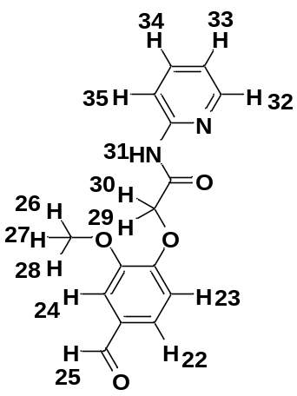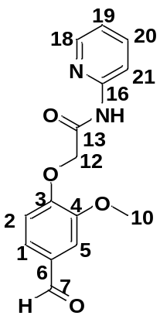

S.No. | V2PR (¹H NMR) |  |  | V2PR (¹³C NMR)
S.No. | Proton | Observed | Calculated | Carbon | Observed | Calculated
1. | 25-H | 9.85 | 10.29 | 7C | 191.85 | 194.31
2. | 32-H | 8.35 | 8.67 | 13C | 167.02 | 162.75
3. | 22-H |  | 7.81 | 3C | 153.08 | 154.90
4. | 34-H |  | 7.25 | 16C | 149.71 | 153.71
5. | 23-H |  | 7.23 | 18C | 148.61 | 152.15
6. | 33-H | 7.80 | 6.81 | 4C | 151.72 | 150.39
7. | 24-H |  | 6.29 | 20C |  | 135.81
8. | 35-H | 8.04 | 6.05 | 6C | 130.75 | 132.54
9. | 31-H | 10.53 | 5.37 | 1C | 126.06 | 124.86
10. | 29-H | 4.95 | 5.08 | 2C |  | 124.78
11. | 30-H | 4.95 | 5.08 | 19C | 113.97 | 120.02
12. | 26-H | 3.88 | 3.69 | 5C | 113.17 | 119.97
13. | 28-H | 3.88 | 3.69 | 21C |  | 110.62
14. | 27-H | 3.88 | 3.69 | 12C | 67.66 | 76.66
 |  |  |  | 10C | 56.14 | 59.43
 | ¹H NMR RMSD:0.773 |  |  | ¹³C NMR RMSD: 4.446

Table S6: Observed and calculated ¹H NMR and ¹³C NMR chemical shifts of V4PR
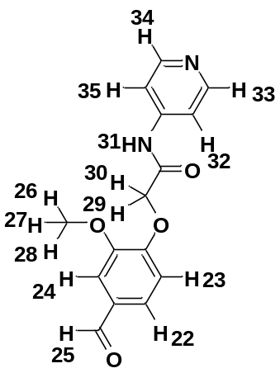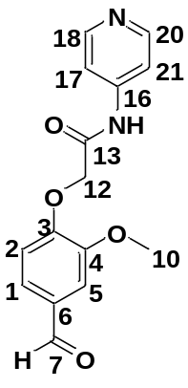

S.No. | V4PR (¹H NMR) |  |  | V4PR (¹³C NMR)
S.No. | Proton | Observed | Calculated | Carbon | Observed | Calculated
1. | 25-H | 9.90 | 10.039 | 7C | 190.76 | 189.30
2. | 33-H | 8.55 | 8.34 | 13C | 166.76 | 165.19
3. | 32-H | 7.59 | 7.17 | 4C | 150.29 | 151.44
4. | 34-H | 8.55 | 8.34 | 18C | 150.29 | 147.92
5. | 22-H |  | 7.40 | 3C | 151.82 | 148.61
6. | 31-H | 9.00 | 7.29 | 20C | 150.29 | 147.92
7. | 23-H |  | 6.77 | 16C | 150.38 | 140.33
8. | 24-H |  | 6.08 | 6C | 132.31 | 132.83
9. | 35-H | 7.59 | 7.17 | 2C |  | 123.87
10. | 30-H | 4.73 | 4.31 | 1C | 126.43 | 119.85
11. | 26-H | 4.02 | 3.44 | 5C |  | 115.96
12. | 29-H | 4.73 | 4.31 | 17C |  | 111.67
13. | 27-H | 4.02 | 3.44 | 21C |  | 111.67
14. | 28-H | 4.02 | 3.44 | 12C | 56.35 | 71.99
15. |  |  |  | 10C | 69.29 | 56.06
 | ¹H NMR RMSD:0.427 |  |  | ¹³C NMR RMSD:4.372

Table S7: Observed and calculated ¹H NMR and ¹³C NMR chemical shifts of V2PM
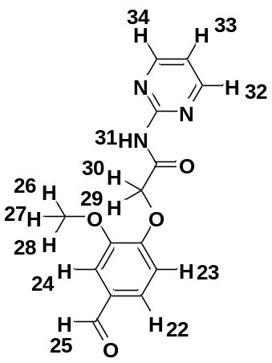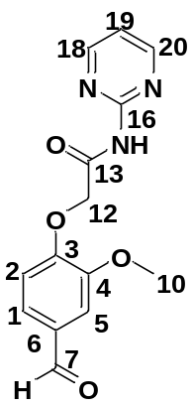

S.No. | V2PM(¹H NMR) |  |  | V2PM(¹³C NMR)
S.No. | Proton | Observed | Calculated | Carbon | Observed | Calculated
1. | 25H | 9.84 | 10.30 | 7C | 191.87 | 194.39
2. | 34H |  | 8.64 | 13C | 170.07 | 164.39
3. | 32H |  | 8.64 | 16C |  | 161.81
4. | 22H |  | 7.81 | 20C |  | 158.33
5. | 23H |  | 7.21 | 18C |  | 158.33
6. | 33H | 7.53 | 6.82 | 3C | 153.01 | 154.80
7. | 31H | 13.42 | 6.37 | 4C | 149.63 | 150.49
8. | 24H |  | 6.30 | 6C | 130.52 | 132.63
9. | 29H | 4.82 | 5.19 | 1C | 126.07 | 124.78
10. | 30H | 4.82 | 5.19 | 2C |  | 124.60
11. | 26H | 3.85 | 3.71 | 5C | 112.78 | 120.01
12. | 27H | 3.85 | 3.71 | 19C | 110.11 | 118.82
13. | 28H | 3.85 | 3.71 | 12C | 65.29 | 77.01
14. |  |  |  | 10C | 56.07 | 59.47
 | ¹H NMR RMSD:0.387 |  |  | ¹³C NMR RMSD: 5.707

Table S8: Calculated and observed frequencies of VISO
S.No. | observed | calculated | scaled | Vibrational assignment with PED (%)
1 |  | 3588 | 3449.140812 | sNH(67%)
2 | 3312 | 3586 | 3447.218214 | sNH(32%)
3 | 3228 | 3245 | 3119.415255 | sCH(99%)
4 |  | 3239 | 3113.647461 | sCH(96%)
5 |  | 3233 | 3107.879667 | sCH(96%)
6 |  | 3229 | 3104.034471 | sCH(99%)
7 |  | 3219 | 3094.421481 | sCH(98%)
8 | 3090 | 3213 | 3088.653687 | sCH(93%)
9 |  | 3208 | 3083.847192 | sCH(89%)
10 |  | 3192 | 3068.466408 | sCH(89%)
11 |  | 3161 | 3038.666139 | sCH(14%)
12 |  | 3122 | 3001.175478 | sCH(99%)
13 |  | 3077 | 2957.917023 | sCH(86%)
14 |  | 3045 | 2927.155455 | sCH(100%)
15 |  | 2961 | 2846.406339 | sCH(99%)
16 |  | 1720 | 1653.43428 | sOC(76%)
17 | 1705 | 1708 | 1641.898692 | sOC(72%)
18 | 1659 | 1695 | 1629.401805 | sOC(67%),bHNC(15%)
19 |  | 1655 | 1590.949845 | sCC(14%),sCC(19%), sCC(19%),sCC(12%),bHCC(11%)
20 |  | 1643 | 1579.414257 | sCC(12%)
21 |  | 1626 | 1563.072174 | sCC(10%), sCC(35%), bCC(11%),bCC(10%)
22 | 1586 | 1595 | 1533.271905 | sCC(30%), bCC(10%), bCC(11%)
23 |  | 1569 | 1508.278131 | sNC(16%), bHNN(54%)
24 |  | 1558 | 1497.703842 | bHCC(30%)
25 |  | 1541 | 1481.361759 | bHCH(18%), bHCH(52%), tHCOC(10%)
26 |  | 1534 | 1474.632666 | bHCH(41%), bHCC(12%), bHCN(23%), bHCN(25%), bHCH(31%)
27 | 1506 | 1529 | 1469.826171 | bHCH(84%)
28 |  | 1505 | 1446.754995 | bHCH(73%)
29 | 1475 | 1485 | 1427.529015 | sOC(15%), bHNC(70%)
30 | 1463 | 1468 | 1411.186932 | sCC(10%), bHCC(10%), bHCO(29%)
31 | 1413 | 1457 | 1400.612643 | sCC(12%), Scc(13%), bHCN(27%), bHCN(20%)
32 | 1400 | 1431 | 1375.618869 | sCC(13%), sCC(15%), bHCO(47%)
33 |  | 1403 | 1348.702497 | sNC(33%), sNN(10%), sCC(14%)
34 |  | 1392 | 1338.128208 | sCC(10%), tHCOC(26%)
35 |  | 1391 | 1337.166909 | bHCC(27%), bHCN(13%), bHCN(13%), bHCC(15%)
36 | 1363 | 1376 | 1322.747424 | sCC(39%)
37 |  | 1330 | 1278.52767 | bHCC(51%)
38 |  | 1310 | 1259.30169 | sNC(10%), bHCC(11%)
39 |  | 1307 | 1256.417793 | sNC(12%)
40 | 1289 | 1292 | 1241.998308 | sCC(16%) sCC(18%), sCC(19%), sNC(34%)
41 | 1268 | 1266 | 1217.004534 | bHCN(20%) bHCN(17%), bHCC(15%)
42 | 1254 | 1257 | 1208.352843 | sCC(10%) sOC(24%), bHCC(10%), bHCC(20%)
43 | 1240 | 1236 | 1188.165564 | bHCO(61%)
44 |  | 1222 | 1174.707378 | sNN(31%) sCC(17%)
45 | 1221 | 1213 | 1166.055687 | tHCOC(13%), tHCOC(21%)
46 |  | 1195 | 1148.752305 | sCC(12%), bHCC(16%), tHCOC(13%), tHCOC(13%)
47 | 1166 | 1165 | 1119.913335 | bHCH(13%), bHCH(12%), tHCoC(38%), tHCOC(17%), tHCOC(20%)
48 |  | 1154 | 1109.339046 | sCC(11%), bHCC(25%)
49 | 1139 | 1141 | 1096.842159 | sCC(10%), sNN(10%), bHCC(17%),
50 |  | 1131 | 1087.229169 | sCC(19%), HCC(19%)
51 |  | 1111 | 1068.003189 | bCCN(26%), bHCC(12%), bCC(17%), bCN(12%)
52 |  | 1050 | 1009.36395 | bHCO(15%), tHCCN(24%), tHCNC(13%), tHCOC(19%) ,oOCNC(10%)
53 |  | 1043 | 1002.634857 | bHCO(12%),tHCCN(24%) ,tHCNC(18%) ,tHCOC(17%)
54 | 1029 | 1041 | 1000.712259 | tHCCC(64%)
55 | 1027 | 1036 | 995.905764 | sOC(45%) ,bCCC(11%) ,bCCC(12%)
56 |  | 1021 | 981.486279 | tHCNC(77%)
57 |  | 1013 | 973.795887 | sOC(48%)
58 | 992 | 1005 | 966.105495 | sNC(24%),bCCN(11%),bCNC(10%) ,tHCCC(31%),tHCCC(31%) ,tCCCC(14%)
59 | 942 | 956 | 919.001844 | sNC(20%),sCC(10%),sOC(16%),bOCN(13%) ,bCNN(14%)
60 | 919 | 942 | 905.543658 | sCC(16%) ,sCC(14%) ,sOC(10%) ,sOC(24%)
61 | 912 | 936 | 899.775864 | tHCCN(27%),tHCNC(36%),tHCNC(10%) ,tHCNC23%)
62 | 868 | 898 | 863.246502 | tHCCC(81%)
63 | 856 | 885 | 850.749615 | tHCNC(13%),tHCNC(23%) ,tHCNC(17%),oONCC(12%) ,oCCCC(19%)
64 | 819 | 878 | 844.020522 | tHCCC(76%)
65 | 809 | 824 | 792.110376 | sOC(12%) ,bOCC(13%)
66 |  | 792 | 761.348808 | tHCNC(16%) ,tCCNC(14%) ,tCCNC(10%) ,tCCCN(26%), ,oONCC(14%)
67 | 769 | 791 | 760.387509 | sCC(19%) ,bOCC(23%) ,bCCC(11%) ,bCCC(10%)
68 | 745 | 784 | 753.658416 | sCC(11%) ,bCNC(18%)
69 | 741 | 744 | 715.206456 | tCCCC(10%), ,oOCCC(10%)
70 |  | 738 | 709.438662 | tCCNC(10%) ,tCCCN(21%), ,oONCC(32%)
71 |  | 734 | 705.593466 | bCNC(10%)
72 | 695 | 717 | 689.251383 | tHNCC(88%)
73 |  | 693 | 666.180207 | bCCN(24%), bCCN(32%), ,bCCC(16%)
74 | 645 | 674 | 647.915526 | bOCC(21%) ,bCCC(12%) ,bCCC(12%)
75 | 638 | 642 | 617.153958 | bNCC(13%) ,oOCNC(11%)
76 |  | 612 | 588.314988 | ,oOCCC(19%) ,tOCNC(11%), ,oCCCC(16%), oOCCC(19%)
77 |  | 601 | 577.740699 | oOCNC(45%)
78 | 571 | 586 | 563.321214 | tHNCC(13%), ,tHNCC(52%)
79 | 546 | 573 | 550.824327 | bOCN(12%), ,tHNCC(13%)
80 | 547 | 551 | 529.675749 | bCCO(10%),bOCC(18%),bCOC(18%),bOCC(11%)
81 | 509 | 544 | 522.946656 | sOC(12%) ,bCCC(12%)
82 |  | 493 | 473.920407 | tHCCC(11%) ,tCCCC(21%),oOCCC(20%)
83 |  | 476 | 457.578324 | bNNC(16%)
84 |  | 444 | 426.816756 | sCC(16%) ,bOCC(13%) ,bCCC(12%) ,bCOC(16%)
85 |  | 410 | 394.13259 | bCCN(14%)
86 |  | 401 | 385.480899 | tHCNC(11%) ,tCCNC(30%),tCCNC(21%)
87 |  | 375 | 360.487125 | sCC(11%) ,bOCN(11%) ,tCCCO(13%)
88 |  | 342 | 328.764258 | tCCCO(15%)
89 |  | 323 | 310.499577 | bCCO(21%) ,bCOC(20%)
90 |  | 306 | 294.157494 | bOCN(19%) ,bCNN(38%) ,tNNCC(10%)
91 |  | 284 | 273.008916 | tHCOC(15%) ,tOCCC(26%) ,tCCCC(14%) ,oCCCC(20%) ,oOCCC(14%)
92 |  | 274 | 263.395926 | bNCC(14%) ,bNNC(20%)
93 |  | 240 | 230.71176 | bOCC(20%) ,bCOC(13%)
94 |  | 225 | 216.292275 | tHCOC(17%) ,tHCOC(17%) ,tHCOC(14%) ,tOCCC(17%)
95 |  | 199 | 191.298501 | bCCC(37%) ,oONCC(10%)
96 |  | 193 | 185.530707 | bCCC(12%) ,tCCCC(11%)
97 |  | 171 | 164.382129 | ,bOCC(15%) ,bOCC(15%) ,bCOC(11%)
98 |  | 150 | 144.19485 | tCCNN(18%)
99 |  | 128 | 123.046272 | tOCCC(14%) ,oCCCC(14%)
100 |  | 126 | 121.123674 | tCCOC(22%) ,tOCCN(19%) ,oCCCC(10%)
101 |  | 114 | 109.588086 | bOCC(13%) ,tOCCC(20%)
102 |  | 94 | 90.362106 | tCNNC(29%) ,tCOCC(24%)
103 |  | 90 | 86.51691 | tCNNC(17%) ,tCOCC(46%)
104 |  | 77 | 74.020023 | tNCCC(55%)
105 |  | 50 | 48.06495 | tCCCO(11%) ,tCCOC(11%) ,tNCCC(13%) ,tNNCC(31%)
106 |  | 44 | 42.297156 | tCNNC(16%) ,tCCNN(12%)
107 |  | 32 | 30.761568 | bCOC(12%) ,tCCCO(10%),tNNCC(16%)
108 |  | 12 | 11.535588 | tCCOC(20%) ,tOCCN(52%)
109 |  | 7 | 3449.140812 | tCOCC(68%) ,tCCNN(10%)
s:stretching, b: bending, t;torsional, o:out of plane bending
Table S9: Calculated and observed frequencies of V2PR
S.NO | Observed | calculated | scaled | Vibrational assignment with PED (%)
1 | 3388 | 3601 | 3461.638 | sNH(100%)
2 |  | 3248 | 3122.299152 | sCH(99%)
3 |  | 3239 | 3113.647461 | sCH(99%)
4 |  | 3231 | 3105.957069 | sCH(100%)
5 |  | 3220 | 3095.38278 | sCH(99%)
6 |  | 3217 | 3092.498883 | sCH(95%)
7 |  | 3208 | 3083.847192 | sCH(98%)
8 |  | 3192 | 3068.466408 | sCH(98%)
9 |  | 3181 | 3057.892119 | sCH(89%)
10 |  | 3114 | 2993.485086 | sCH(94%)
11 |  | 3113 | 2992.523787 | sCH(94%)
12 |  | 3063 | 2944.458837 | sCH(100%)
13 |  | 3039 | 2921.387661 | sCH(100%)
14 | 2858 | 2947 | 2832.948153 | sCH(99%)
15 | 1707 | 1770 | 1701.49923 | sOC(76%)
16 | 1674 | 1703 | 1637.092197 | sOC(70%),bHCO(10%)
17 |  | 1658 | 1593.833742 | sCC(16%),sCC(23%),sCC(16%),sCC(12%),  bHCC(11%)
18 |  | 1647 | 1583.259453 | sNC(21%),sCC(17%),bHNC(25%)
19 |  | 1638 | 1574.607762 | sCC(69%)
20 |  | 1618 | 1555.381782 | sCC(10%),sCC(34%),bCCC(11%),bCCC(10%)
21 |  | 1573 | 1512.123327 | sCC(15%),bHNC(35%)
22 |  | 1563 | 1502.510337 | bHCC(32%)
23 |  | 1545 | 1485.206955 | bHCH(76%)
24 |  | 1533 | 1473.671367 | bHCH(38%),bHCH(38%),tHCOC(16%)
25 | 1506 | 1525 | 1465.980975 | bHCH(73%),tHCOC(11%)
26 | 1437 | 1518 | 1459.251882 | sNC(13%),bHCN(23%),bHCC(13%),sNC(19%)
27 |  | 1505 | 1446.754995 | bHCH(77%)
28 | 1434 | 1474 | 1416.954726 | bHCN(17%),bHCC(28%),bHCC(22%)
29 | 1432 | 1470 | 1413.10953 | bHCC(10%),bHCO(21%),sCC(16%)
30 | 1413 | 1437 | 1381.386663 | bHCO(50%),sCC(13%),sCC(13%)
31 |  | 1399 | 1344.857301 | bHCH(13%),tHCOC(23%),tHCOC(32%)
32 |  | 1380 | 1326.59262 | bHCO(10%),sCC(19%),sCC(23%)
33 | 1363 | 1367 | 1314.095733 | bHCN(26%),sNC(11%),sNC(25%)
34 |  | 1336 | 1284.295464 | bHCN(10%),bHCC(16%),sCC(11%),sNC(31%)
35 |  | 1335 | 1283.334165 | bHCC(38%)
36 | 1312 | 1317 | 1266.030783 | bHCC(15%),sCC(19%),bHCC(23%)
37 | 1289 | 1296 | 1245.843504 | sNC(38%)
38 | 1264 | 1275 | 1225.656225 | bHCC(12%),bCCC(10%),sCC(10%),sCC(19%),  sOC(12%)
39 | 1252 | 1255 | 1206.430245 | bHCO(81%),tHCOC(12%)
40 |  | 1218 | 1170.862182 | bHCC(69%)
41 |  | 1216 | 1168.939584 | tHCOC(36%)
42 |  | 1202 | 1155.481398 | tHCOC(18%),tHCOC(18%),bHCC(13%)
43 |  | 1183 | 1137.216717 | sNC(40%),sCC(11%)
44 | 1166 | 1166 | 1120.874634 | bHCH(12%),tHCOC(38%),tHCOC(18%),  tHCOC(18%),bHCH(12%)
45 | 1153 | 1158 | 1113.184242 | bHCC(28%)
46 | 1136 | 1149 | 1104.532551 | bHCC(10%),sCC(13%),sCC(16%),bHCC(33%)
47 |  | 1081 | 1039.164219 | sCC(49%)
48 |  | 1061 | 1019.938239 | sOC(52%)
49 | 1030 | 1039 | 998.789661 | tHCCC(65%)
50 | 1029 | 1037 | 996.867063 | bCCC(12%),sOC(51%)
51 |  | 1027 | 987.254073 | tHCNC(10%),tHCCC(18%),tHCOC(12%),  tCCCN(11%),tCOCC(10%),bHCO(18%)
52 |  | 1010 | 970.91199 | tHCCC(80%)
53 | 979 | 1007 | 968.028093 | bCCN(17%),bCCC(15%),bCOC(38%)
54 | 964 | 997 | 958.415103 | tHCNC(52%),tHCCC(22%)
55 | 955 | 957 | 919.963143 | bCNC(10%),sOC(10%),sNC(10%),sCC(30%)
56 |  | 944 | 907.466256 | sCC(17%),sCC(12%),sOC(11%),sOC(22%)
57 |  | 905 | 869.975595 | tHCCC(78%)
58 | 880 | 893 | 858.440007 | tHCCC(78%)
59 | 866 | 883 | 848.827017 | sNC(10%),sNC(17%),bCCN(10%),bCCC(19%)
60 | 831 | 876 | 842.097924 | tHCCC(84%)
61 | 794 | 820 | 788.26518 | tHCNC(12%),tHCCC(22%),tHCCC(21%),  oNCNC(26%)
62 |  | 817 | 785.381283 | bOCC(18%),sOC(10%),bCCC(10%)
63 | 774 | 789 | 758.464911 | bCCC(11%),sCC(19%),bOCC(22%),bCCC(11%)
64 | 745 | 759 | 729.625941 | tHCCC(20%),tHCCC(25%),tCCNC(30%),  tCCCN11%)
65 | 738 | 742 | 713.283858 | sCC(11%),bOCN(13%),bCCC(12%),bCCC(11%)
66 | 682 | 725 | 696.941775 | tCCCC(91%)
67 | 651 | 674 | 647.915526 | bOCC(57%)
68 | 645 | 653 | 627.728247 | bCCC(15%),bCCN(33%),bCNC(20%)
69 | 616 | 641 | 616.192659 | tHNCC(73%)
70 |  | 615 | 591.198885 | bCNC(19%),bCCC(13%),bCCN(11%)
71 |  | 600 | 576.7794 | tCCCC(15%),oCCCC(17%),oOCCC(27%)
72 | 584 | 594 | 571.011606 | oOCNC(53%),tHNCC(13%)
73 | 558 | 563 | 541.211337 | sOC(14%),bCCC(17%),bCCO(21%)
74 | 511 | 528 | 507.565872 | tCCCC(15%),oOCNC(12%),oNCNC(42%)
75 | 509 | 512 | 492.185088 | bOCC(15%),bCOC(25%)
76 |  | 483 | 464.307417 | tCCCC(18%),tCCCC(26%),oOCCC(23%),  tHCCC(11%)
77 |  | 433 | 416.242467 | sCC(20%)
78 |  | 425 | 408.552075 | tHCCC(10%),tCCNC(30%),tCCCC(26%),  tCCCN(10%),tHCNC(11%),tHCCC(10%)
79 |  | 373 | 358.564527 | bCOC(12%),bCCN(15%),bCOC(20%)
80 |  | 354 | 340.299846 | bOCN(25%),bCNC(13%),bCNC(10%),  bNCN(23%)
81 |  | 347 | 333.570753 | tCCCO(33%),tCCCC(11%),tCCCC(12%),  oCCCC(23%)
82 |  | 294 | 282.621906 | bOCC(10%),bCCN(15%),bCOC(17%)
83 |  | 291 | 279.738009 | oCCCC(15%),oOCCC(13%),tHCOC(20%)
84 |  | 237 | 227.827863 | tCCCC(11%),tHCOC(11%),tHCOC(13%),  tHCOC(13%),tOCCC(19%)
85 |  | 229 | 220.137471 | tCCCC(18%),tCCCN(47%),tCCNC(14%)
86 |  | 225 | 216.292275 | bCCO(10%),bCNC(10%),bNCN(11%),bCCC(13%),  bOCC(11%),bOCC(14%)
87 |  | 197 | 189.375903 | bOCC(16%),bCOC(11%)
88 |  | 152 | 146.117448 | tCCCC(28%),tOCCC(18%),tCCCO(17%)
89 |  | 151 | 145.156149 | bCCC(33%),bOCC(10%)
90 |  | 126 | 121.123674 | bCOC(16%),bCCO(16%),bCNC(30%),bNCN(18%)
91 |  | 103 | 99.013797 | oCCCC(15%),tOCCC(33%),tCCCO(10%)
92 |  | 79 | 75.942621 | tCOCC(68%),tHCOC(11%)
93 |  | 70 | 67.29093 | tCCNC(38%),tOCCN(12%),tCNCC(10%)
94 |  | 65 | 62.484435 | tOCCN(31%),tCCOC(16%)
95 |  | 40 | 38.45196 | bCOC(29%),bCNC(12%),bCCN(18%),bOCC(27%)
96 |  | 28 | 26.916372 | tCCOC(24%),tCOCC(34%),tCCNC(13%)
97 |  | 20 | 19.22598 | tCCNC(61%)
98 |  | 11 | 10.574289 | tCCOC(35%)
s:stretching, b: bending, t;torsional, o:out of plane bending

Table S10: Calculated and observed frequencies of V4PR
S.NO | Observed | calculated | scaled | Vibrational assignment with PED (%)
1 |  | 3844 | 3695.233356 | sNH(100%)
2 |  | 3467 | 3332.823633 | sCH(98%)
3 |  | 3414 | 3281.874786 | sCH(99%)
4 |  | 3403 | 3271.300497 | sCH(98%)
5 |  | 3396 | 3264.571404 | sCH(100%)
6 |  | 3395 | 3263.610105 | sCH(96%)
7 |  | 3386 | 3254.958414 | sCH(99%)
8 |  | 3370 | 3239.57763 | sCH(100%)
9 |  | 3352 | 3222.274248 | sCH(89%)
10 | 3334 | 3340 | 3210.73866 | sCH(99%)
11 |  | 3287 | 3159.789813 | sCH(100%)
12 | 2933 | 3255 | 3129.028245 | sCH(99%)
13 | 2815 | 3212 | 3087.692388 | sCH(86%)
14 | 2092 | 3211 | 3086.731089 | sCH(90%)
15 |  | 1896 | 1822.622904 | sOC(79%)
16 |  | 1870 | 1797.62913 | bHNC(15%),sOC(62%)
17 |  | 1812 | 1741.873788 | sCC(14%),sCC(22%),bHCC(10%)
18 |  | 1804 | 1734.183396 | sCC(19%),bHNC(19%),sCC(15%)
19 |  | 1789 | 1719.763911 | bCCC(17%),sNC(20%),sCC(13%)
20 |  | 1783 | 1713.996117 | sCC(33%),bCCC(11%),bCCC(10%),sCC(12%)
21 |  | 1718 | 1651.511682 | sCC(13%),sNC(11%),bHNC(17%),sNC(15%)
22 | 1674 | 1700 | 1634.2083 | bHCC(35%)
23 |  | 1676 | 1611.137124 | bHCN(19%),bHCN(20%),bHCC(18%)
24 |  | 1666 | 1601.524134 | bHCH(26%),bHCH(54%),tHCOC(12%)
25 | 1634 | 1660 | 1595.75634 | bHCH(41%),bHCH(26%),tHCOC(14%)
26 | 1600 | 1651 | 1587.104649 | bHCH(84%)
27 | 1596 | 1633 | 1569.801267 | bHCH(78%)
28 |  | 1590 | 1528.46541 | bHCC(12%),bHCO(25%),sCC(11%)
29 |  | 1575 | 1514.045925 | bHCC(11%),bHCN(17%),bHCN(19%),sCC(11%),  sCC(12%)
30 |  | 1541 | 1481.361759 | bHCO(46%),tHCOC(10%),tHCOC(13%)
31 |  | 1530 | 1470.78747 | bHCO(16%),tHCOC(18%),tHCOC(28%)
32 | 1464 | 1508 | 1449.638892 | bHCC(18%),bHCN(28%),bHCN(19%),bHCC(11%)
33 |  | 1453 | 1396.767447 | bHNC(13%)
34 |  | 1448 | 1391.960952 | bHCC(15%),sOC(11%)
35 | 1411 | 1434 | 1378.502766 | bHCC(34%),sCC(21%),sOC(11%)
36 |  | 1387 | 1333.321713 | sNC(16%),sOC(10%)
37 |  | 1375 | 1321.786125 | bHCO(62%),tHCOC(18%)
38 |  | 1373 | 1319.863527 | sOC(10%)
39 | 1340 | 1362 | 1309.289238 | bHCC(13%),bHCN(18%),bHCN(20%),  bHCC(15%),sNC(12%)
40 | 1329 | 1357 | 1304.482743 | sCC(35%)
41 | 1291 | 1319 | 1267.953381 | bHCH(11%),tHCOC(30%),tHCOC(24%)
42 |  | 1289 | 1239.114411 | sCC(13%),sCC(17%),sNC(31%),sCC(20%)
43 | 1265 | 1283 | 1233.346617 | sCC(16%),sCC(12%),bHCC(12%)
44 | 1260 | 1275 | 1225.656225 | bHCH(13%),bHCH(12%),tHCOC(37%),  tHCOC(17%),tHCOC(18%)
45 |  | 1251 | 1202.585049 | sCC(16%),bHCC(30%)
46 |  | 1232 | 1184.320368 | sCC(18%),sCC(17%),bHCC(18%),bHCC(19%)
47 | 1174 | 1193 | 1146.829707 | bNCC(18%),bCNC(10%),bCCN(24%),  bHCC(10%),bHCC(10%)
48 |  | 1171 | 1125.681129 | tHCCN(26%),tHCNC(48%),tHCNC(12%)
49 | 1154 | 1167 | 1121.835933 | tHCCC(26%),tHCCC(14%),tHCCC(23%),  tCCCC(15%),tCCCC(10%)
50 |  | 1153 | 1108.377747 | tHCOC(32%),oOCNC(19%),bHCO(27%)
51 |  | 1142 | 1097.803458 | tHCCC(18%),sOC(17%),sOC(16%)
52 | 1138 | 1140 | 1095.88086 | tHCCC(15%),sOC(33%)
53 |  | 1137 | 1092.996963 | tHCNC(47%),tHCCN(18%),tCCNC(13%)
54 |  | 1134 | 1090.113066 | tHCCC(12%),sOC(43%)
55 |  | 1097 | 1054.545003 | bCNC(11%),sNC(19%),sNC(21%),bCCN(16%)
56 |  | 1057 | 1016.093043 | sNC(19%),sCC(21%)
57 | 1027 | 1033 | 993.021867 | tHCCC(69%)
58 |  | 1016 | 976.679784 | tHCCN(14%),tHCNC(21%),tHCCN(10%),  sCC(10%),sOC(12%)
59 | 979 | 989 | 950.724711 | tHCCC(74%)
60 | 944 | 982 | 943.995618 | tHCNC(19%),tHCCN(31%),oNCCC(22%)
61 | 942 | 952 | 915.156648 | sCC(17%),sNC(12%),bCNC(12%)
62 |  | 889 | 854.594811 | sOC(15%),bCCC(13%)
63 | 856 | 866 | 832.484934 | tHNCC(64%),tHCNC(15%)
64 | 813 | 850 | 817.10415 | sCC(21%),bOCC(22%),bCCC(12%),bCCC(10%)
65 | 794 | 837 | 804.607263 | tCCNC(13%),tCNCC(13%),tCCCN(44%)
66 | 782 | 830 | 797.87817 | tHCCC(11%),tCCCC(16%),tCCCC(19%),  tCCCC(11%),oOCCC(12%)
67 | 732 | 761 | 731.548539 | bOCN(12%),bCNC(23%)
68 | 733 | 751 | 721.935549 | bCCN(22%),bNCC(42%),bCCC(11%)
69 | 695 | 721 | 693.096579 | bOCC(22%),bCCC(11%),bCCC(12%)
70 |  | 676 | 649.838124 | tCCCC(11%),tCCCC(10%),oCCCC(20%),  oOCCC(20%)
71 | 645 | 666 | 640.225134 | oOCNC(50%)
72 | 608 | 613 | 589.276287 | oNCCC(13%),bCCO(13%)
73 |  | 604 | 580.624596 | oNCCC(17%)
74 | 558 | 596 | 572.934204 | bOCC(15%),bCOC(12%)
75 | 521 | 576 | 553.708224 | bCCC(11%)
76 | 509 | 530 | 509.48847 | tHCOC(18%),tHCOC(28%),tCCCC(23%),  oOCCC(16%)
77 |  | 480 | 461.42352 | sCC(14%),bOCC(13%),bCOC(16%)
78 |  | 459 | 441.236241 | tHCCN(11%),tCCNC(35%),tCNCC(28%),  tHCCN(11%)
79 |  | 433 | 416.242467 | tCCCO(22%),oCCCC(14%)
80 |  | 393 | 377.790507 | bNCC(60%)
81 |  | 353 | 339.338547 | bCCO(20%),bCOC(16%)
82 |  | 297 | 285.505803 | tCNCC(12%),tCCCCN(10%)
83 |  | 295 | 283.583205 | tCNCC(19%),tCCCN(15%),tCCNC(12%),  tCCNC(10%)
84 |  | 261 | 250.899039 | bOCC(11%),bOCC(16%),bCCC(17%),bCOC(14%)
85 |  | 230 | 221.09877 | tHCOC(16%),tHCOC(13%),tHCOC(12%),  tOCCC(10%)
86 |  | 213 | 204.756687 | tCCCC(17%),bCCC(15%)
87 |  | 203 | 195.143697 | bCNC(21%),bNCC(18%),bOCC(11%)
88 |  | 164 | 157.653036 | bOCC(17%),bCCC(20%),bCOC(10%)
89 |  | 144 | 138.427056 | tOCCN(23%),tCCOC(32%)
90 |  | 132 | 126.891468 | tOCCC(41%)
91 |  | 93 | 89.400807 | tOCCN(13%),tOCCC(13%),tCNCC(10%)
92 |  | 92 | 88.439508 | oNCCC(10%),tCCNC(24%)
93 |  | 78 | 74.981322 | tCOCC(71%)
94 |  | 64 | 61.523136 | tCCOC(11%),tCNCC(33%)
95 |  | 38 | 36.529362 | bCOC(22%),bOCC(12%),tCCCO(18%),  tCNCC(11%),tOCCN(13%)
96 |  | 26 | 24.993774 | tCCOC(25%),tCNCC(11%),tOCCN(29%)
97 |  | 9 | 8.651691 | tCCOC(12%),tCOCC(71%)
s:stretching, b: bending, t;torsional, o:out of plane bending
Table S11: Calculated and observed frequencies of V2PM
S.NO | Observed | calculated | scaled | Vibrational assignment with PED (%)
1 | 3324 | 3594 | 3454.908606 | sNH(100%)
2 |  | 3251 | 3125.183049 | sCH(86%)
3 |  | 3248 | 3122.299152 | sCH(99%)
4 |  | 3232 | 3106.918368 | sCH(99%)
5 |  | 3220 | 3095.38278 | sCH(99%)
6 |  | 3218 | 3093.460182 | sCH(97%)
7 |  | 3213 | 3088.653687 | sCH(92%)
8 |  | 3182 | 3058.853418 | sCH(89%)
9 |  | 3117 | 2996.368983 | sCH(99%)
10 | 2953 | 3113 | 2992.523787 | sCH(100%)
11 | 2827 | 3066 | 2947.342734 | sCH(100%)
12 | 2733 | 3039 | 2921.387661 | sCH(100%)
13 | 2110 | 2948 | 2833.909452 | sCH(99%)
14 |  | 1767 | 1698.615333 | sOC(67%)
15 | 1676 | 1703 | 1637.092197 | bHCO(10%),sOC(70%)
16 |  | 1658 | 1593.833742 | sCC(16%),sCC(12%),sHCC(11%),sCC(16%),  sCC(23%)
17 |  | 1620 | 1557.30438 | sNC(17%),bCCN(10%),bHNC(19%),sNC(15%)
18 |  | 1618 | 1555.381782 | sCC(31%),bCCC(10%)
19 | 1585 | 1603 | 1540.962297 | bHNC(10%),bHNC(13%),sNC(17%),sCC(32%)
20 |  | 1565 | 1504.432935 | bHCC(28%)
21 |  | 1557 | 1496.742543 | bHNC(25%),sCC(12%)
22 |  | 1545 | 1485.206955 | bHCH(76%)
23 |  | 1534 | 1474.632666 | bHCH(38%),bHCH(38%),tHCOC(15%)
24 | 1509 | 1523 | 1464.058377 | bHCH(74%),tHCOC(11%)
25 |  | 1505 | 1446.754995 | bHCH(77%)
26 |  | 1495 | 1437.142005 | bHCC(15%),bHCN(21%),bNCN(18%),sNC(22%)
27 | 1463 | 1470 | 1413.10953 | bHCO(22%),sCC(15%),
28 |  | 1456 | 1399.651344 | bHCN(46%),bHCC(10%),sNC(13%),sNC(11%)
29 | 1412 | 1437 | 1381.386663 | bHCO(49%),sCC(12%),sCC(14%)
30 |  | 1401 | 1346.779899 | bHCH(13%),tHCOC(21%),tHCOC(30%)
31 |  | 1393 | 1339.089507
32 |  | 1380 | 1326.59262 | bHCO(10%),sCC(19%),sCC(24%)
33 | 1325 | 1335 | 1283.334165 | bHCC(16%),bHCC(29%),sCC(10%)
34 |  | 1317 | 1266.030783 | bHCC(17%),sCC(18%),sOC(23%)
35 | 1289 | 1293 | 1242.959607 | bHCN(20%),bHCN(10%),sNC(24%),sNC(15%)
36 | 1264 | 1274 | 1224.694926 | bHCC(12%),sCC(12%),sOC(12%),bCCC(10%)
37 |  | 1256 | 1207.391544 | bHCO(80%),tHCOC(12%)
38 | 1252 | 1252 | 1203.546348 | sNC(60%)
39 | 1215 | 1216 | 1168.939584 | tHCOC(19%),tHCOC(19%),bHCC(10%)
40 | 1188 | 1202 | 1155.481398 | tHCOC(17%),tHCOC(17%),bHCC(13%)
41 |  | 1184 | 1138.178016 | sNC(37%),bHNC(12%)
42 |  | 1166 | 1120.874634 | bHCH(12%),tHCOC(38%),tHCOC(18%),  tHCOC(18%),bHCH(12%)
43 |  | 1158 | 1113.184242 | bHCC(28%)
44 | 1136 | 1140 | 1095.88086 | sCC(14%),bCCN(11%),bHCC(40%)
45 |  | 1100 | 1057.4289 | bCNC(20%),bCNC(18%),sCC(12%),bCCN(12%)
46 |  | 1065 | 1023.783435 | sOC(52%)
47 |  | 1039 | 998.789661 | tHCCC(66%)
48 |  | 1037 | 996.867063 | bCCC(12%),sOC(51%)
49 | 1026 | 1028 | 988.215372 | tHCOC(34%),tHCOC(10%),tCOCC(11%),  oOCNC(24%),bHCO(19%)
50 |  | 1022 | 982.447578 | tHCNC(15%),tHCCN(29%),tHCNC(33%),  tCCNC(22%)
51 |  | 1009 | 969.950691 | tHCCC(34%),tHCCC(32%),tHCNC(53%),  tHCNC(33%),tCCCC(15%)
52 | 967 | 1001 | 962.260299 | bCNC(10%),sNC(16%),bCNC(11%),bCCN(35%),  bCNC(11%)
53 | 940 | 966 | 928.614834 | sOC(10%),sCC(28%)
54 | 918 | 945 | 908.427555 | sCC(17%),sCC(12%),sOC(11%),sOC(23%)
55 |  | 893 | 858.440007 | tHCCC(78%),sNC(26%),sNC(15%),sNC(16%)
56 |  | 875 | 841.136625 | tHCCC(84%)
57 | 856 | 856 | 822.871944 | tHNCN(14%),tCNCN(13%),tCCNC(21%),  oONNC(27%)
58 | 813 | 824 | 792.110376 | tHCCN(59%),tCNCN(13%),tCCNC(10%)
59 | 794 | 820 | 788.26518 | bOCC(19%),sOC(10%)
60 | 783 | 790 | 759.42621 | sCC(19%),bOCC(23%),bCCC(11%),bCCC(11%)
61 | 745 | 749 | 720.012951 | sCC(12%),bOCN(13%),bCCC(12%)
62 | 730 | 733 | 704.632167 | tHNCN(74%)
63 | 682 | 725 | 696.941775 | tCCCC(29%),tCCCC(14%),tCCCC(23%),  oOCCC(11%)
64 | 645 | 676 | 649.838124 | bCCC(12%),bOCC(20%),bCCC(11%),bCCC(13%)
65 | 643 | 656 | 630.612144 | bCNC(32%),bCNC(31%)
66 | 621 | 635 | 610.424865 | bCNC(12%),bNCN(14%),bCCN(10%)
67 |  | 601 | 577.740699 | oOCNC(38%)
68 | 584 | 599 | 575.818101 | tCCCC(11%),oOCNC(19%),oCCCC(12%),  oOCCC(20%)
69 | 546 | 564 | 542.172636 | sOC(13%),bCCC(17%),bCCO(22%)
70 | 520 | 532 | 511.411068 | tCNCN(11%),tCNCN(17%),oNNNC(36%)
71 | 509 | 515 | 495.068985 | bOCC(16%),bCOC(25%)
72 |  | 483 | 464.307417 | tCCCC(18%),tCCCC(26%),oOCCC(23%),  tHCCC(11%)
73 |  | 434 | 417.203766 | sCC(20%),bOCC(10%)
74 |  | 423 | 406.629477 | tCNCN(41%),tNCNC(24%),tHCNC(15%),  tHCNC(16%)
75 |  | 375 | 360.487125 | bNCN(16%),bCOC(11%),bCCN(14%),bCOC(16%)
76 |  | 364 | 349.912836 | sNC(12%),bOCN(24%),bNCN(20%)
77 |  | 347 | 333.570753 | tCCCO(32%),tCCCC(11%),tCCCC(12%),  oCCCC(23%)
78 |  | 294 | 282.621906 | bOCC(11%),bCCN(15%),bCOC(18%)
79 |  | 291 | 279.738009 | tCCCC(10%),oOCCC(15%),oOCCC(14%),  tHCOC(20%)
80 |  | 238 | 228.789162 | tHCOC(11%),tHCOC(14%),tHCOC(14%),  tCCCC(11%)
81 |  | 225 | 216.292275 | bCCO(10%),bNCN(10%),bCNC(10%),bCCC(13%),  bOCC(11%),bOCC(15%)
82 |  | 197 | 189.375903 | bOCC(16%),bCOC(11%)
83 |  | 153 | 147.078747 | tCCCC(29%),tOCCC(18%),tCCCO(17%)
84 |  | 151 | 145.156149 | bCCC(32%),bOCC(10%)
85 |  | 127 | 122.084973 | bCCO(16%),bNCN(17%),bCNC(31%),bCOC(16%)
86 |  | 104 | 99.975096 | oCCCC15%),tOCCC(33%)
87 |  | 79 | 75.942621 | tCOCC(68%),tHCOC(11%)
88 |  | 75 | 72.097425 | tCCNC(27%),tOCCN(10%),tCNCN(23%)
89 |  | 56 | 53.832744 | tOCCN(19%),tCCCO(12%),tCCOC(18%),  tCOCC(33%)
90 |  | 49 | 47.103651 | tCNCN(55%),tCOCC(16%)
91 |  | 40 | 38.45196 | bCNC(12%),bCCN(19%),bCOC(29%),bOCC(27%)
92 |  | 24 | 23.071176 | tCCOC10%)%),tCOCC(16%),tCCNC(26%),  tOCCN(24%)
93 |  | 11 | 10.574289 | tCCOC(50%)

s:stretching, b: bending, t;torsional, o:out of plane bending
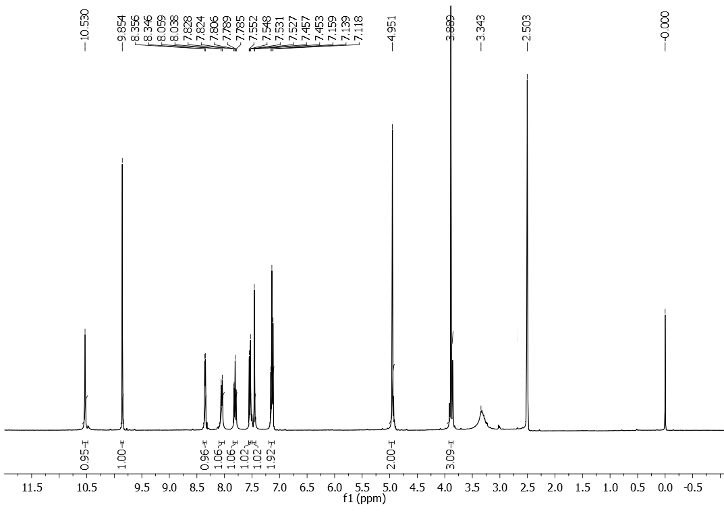
¹H NMR (400MHz, DMSO-D₆) spectrum of V2PR

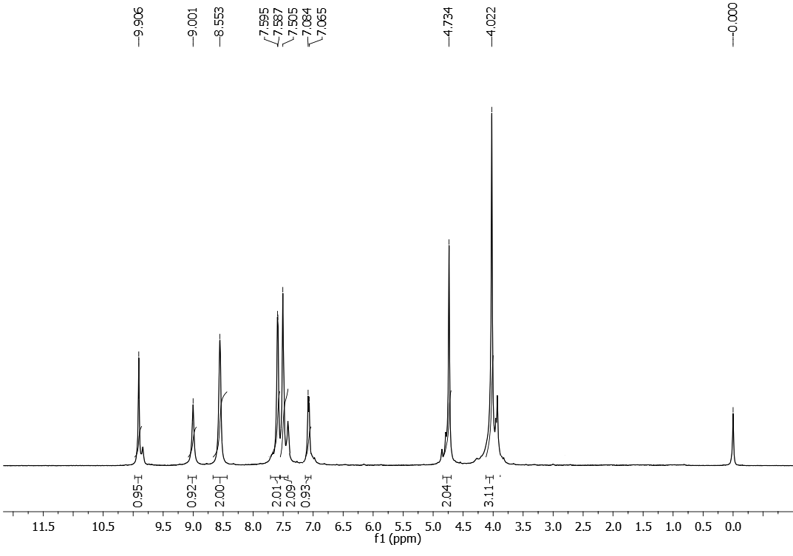
¹H NMR (400MHz, CDCl₃) spectrum of V4PR
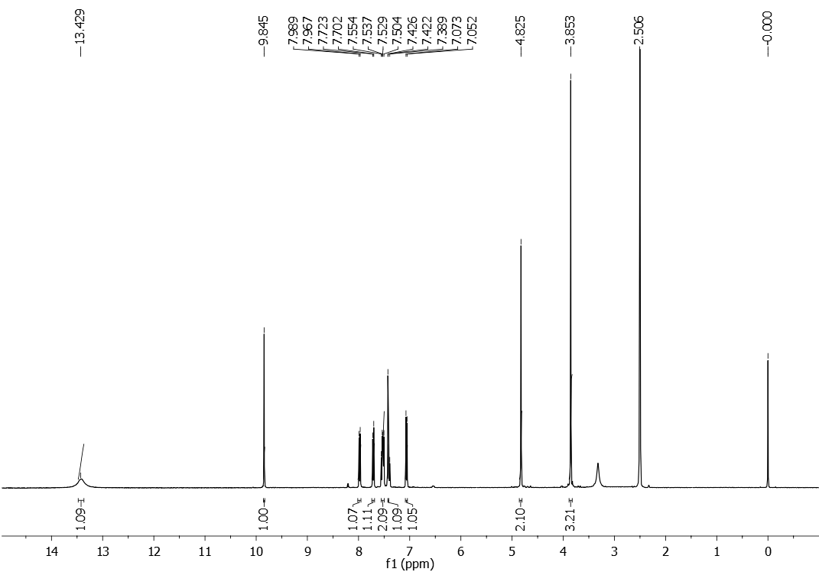

¹H NMR (400MHz, DMSO-d₆) spectrum of V2PM

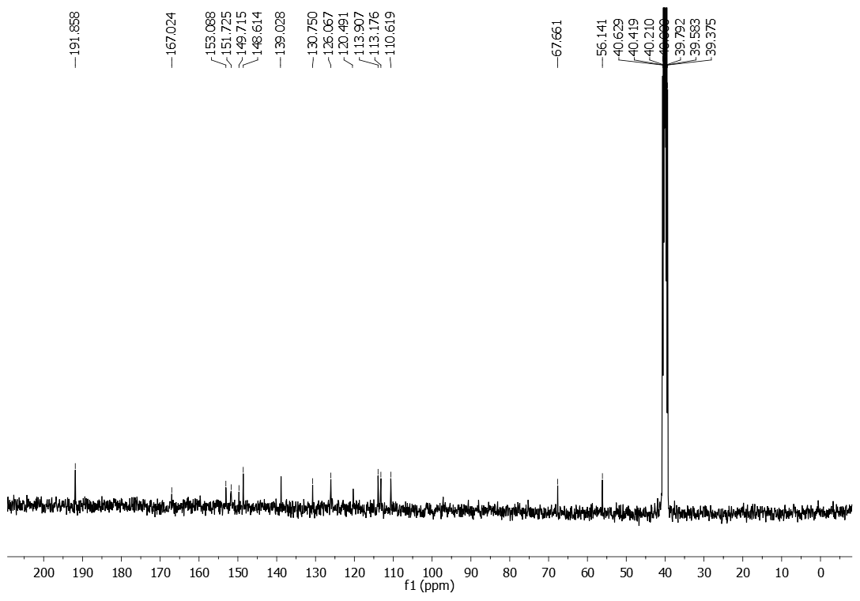
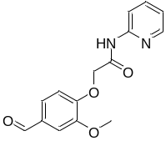
¹³C NMR (100MHz, DMSO-D₆) spectrum of V2PR

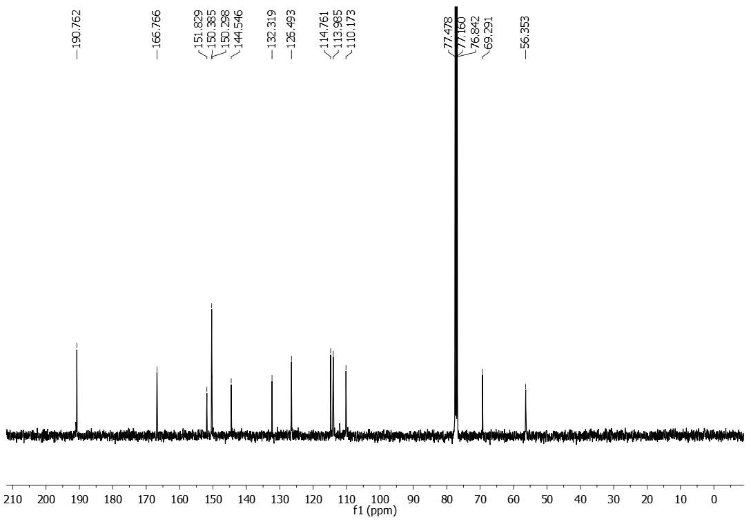
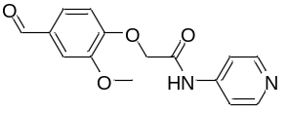
¹³C NMR (100MHz, CDCl₃) spectrum of V4PR

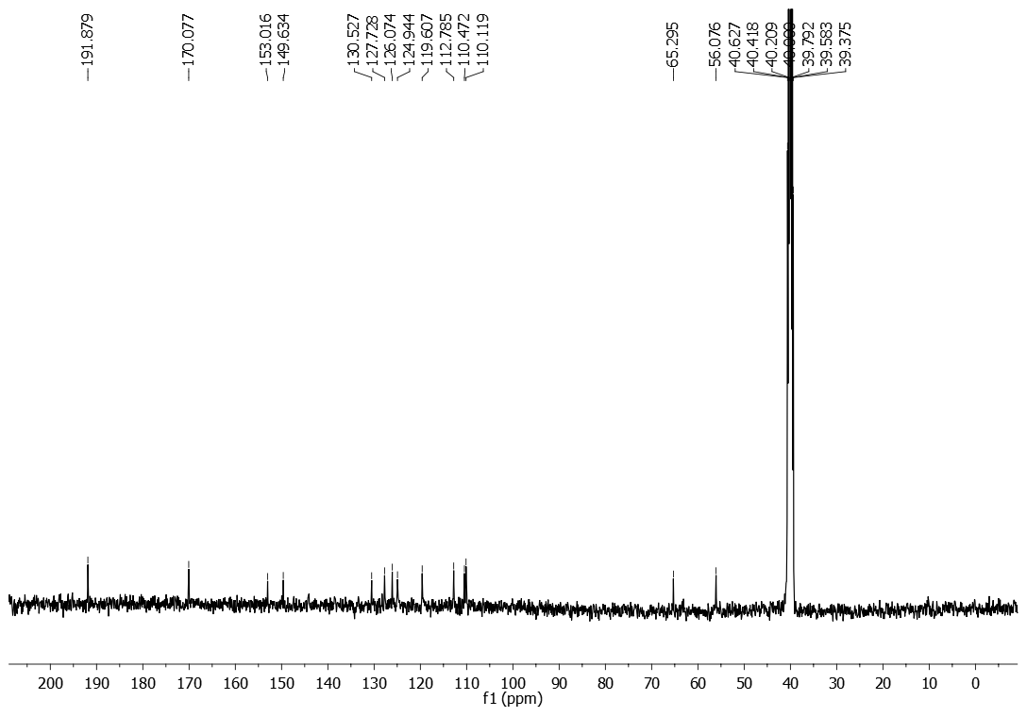
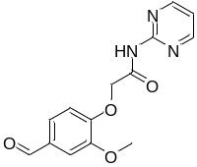
¹³C NMR (100MHz, DMSO-D₆) spectrum of V2PM
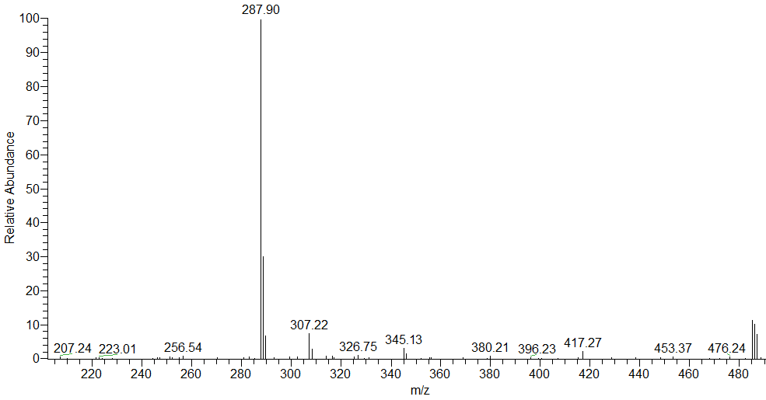
ESI-Mass spectrum of V2PR

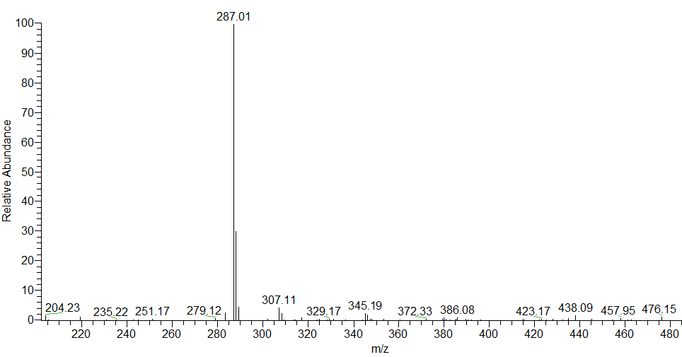
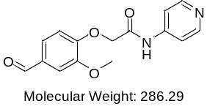
ESI-Mass spectrum of compound V4PR

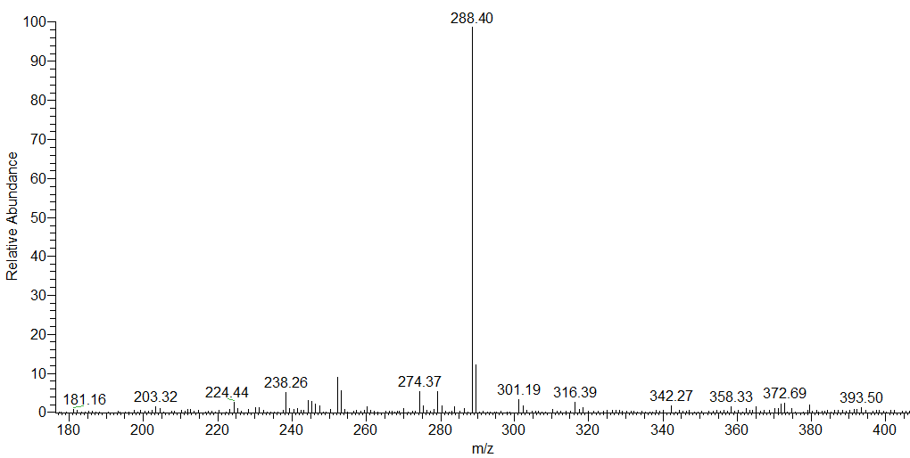
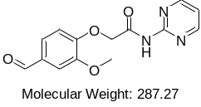
ESI-Mass spectrum of V2PM

