Supplementary materials
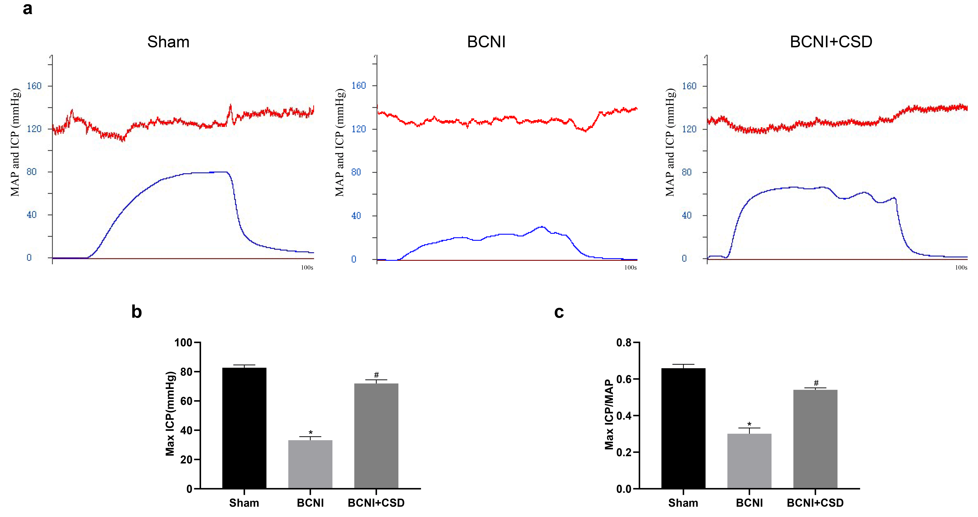
Fig. S1 Erectile function testing. The max ICP and max ICP/MAP ratio were used to assess erection in various groups. a Representative traces of MAP (above) and ICP (below) in various group. b, c Statistical analysis of the max ICP and max ICP/MAP values among groups. Bars graphs delegate the mean ± SD (n=5/group). *P<0.05 vs Sham group, #P<0.05 vs BCNI group.
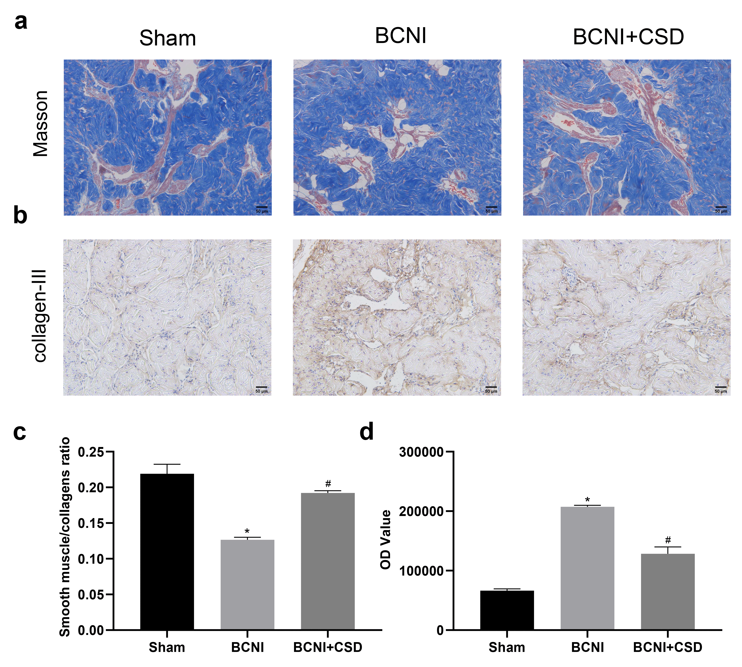
Fig. S2 Masson’s trichrome staining and collagen content determination in the corpus cavernosum. a Representative photos of Masson staining show smooth muscle (red) and collagen (blue) in different groups (×200). b Representative images of immunochemistry staining for collagen-III as brown areas in various groups (×200). c Statistical analysis of the smooth muscle/collagen ratios among groups. d Statistical analysis of the immunochemistry results among groups. Bars graphs delegate the mean ± SD (n=3/group). *P<0.05 vs Sham group, #P<0.05 vs BCNI group.
Calculation of sample size：
The sample size calculation was based on the Max ICP/MAP ratio from our preliminary experimental results as follows: The max ICP/MAP ratio, a well-established indicator of erectile function, was 0.617 ± 0.040, 0.297 ± 0.070 and 0.542 ± 0.011 in rats in Sham, BCNI and BCNI+CSD groups respectively. Subsequently, the sample size was calculated by using PASS software. A total of 3 rats per group were considered necessary. Considering the possibility of animal death during the experiment, we assigned 5 rats to each group.
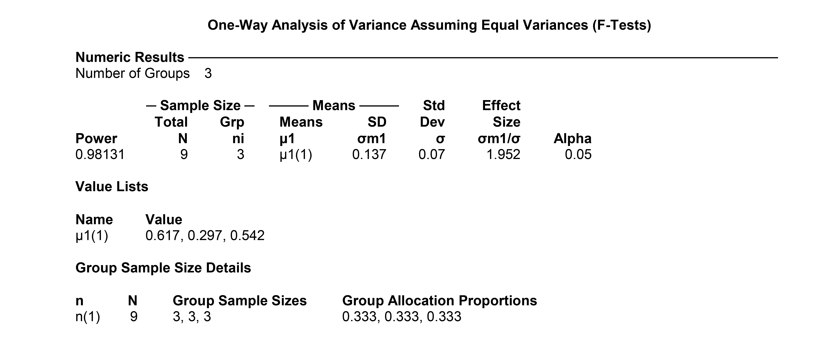
Inclusion and exclusion criteria:
We used apomorphine to select rats with normal erectile function for the experiment, and exclusion criteria were erectile dysfunction or severe infection or death after surgery. During the whole experiment, there is no case that needs to be excluded.
Randomisation:
A total of 15 rats were divided into 3 different groups (5 rats in each group). Within each group, a random number was assigned to each animal through a random number table. These rats were randomly assigned to three groups (Sham, BCNI or BCNC+CSD). Intracavernosal pressure test time was between 08.30 am. to 21:00 pm and testing order was randomized daily.
Blinding:
For each animal, four different investigators were involved as follows: a first investigator performed the surgical procedure based on a random number table, and he was the only one who knew the detailed group information. A second investigator was responsible for the delivery of therapeutic agent. A third investigator (also unaware of treatment) was responsible for the evaluation of erectile function, and a fourth investigator analyzed the data.

