Supporting Information
Conductive Ni₃(HITP)₂ Nano-film with Asymmetrical Morphology Prepared by Gas-liquid Interface Self-assembly for Glucose Sensing
Lin-an Cao¹*, Min Wei¹, Xin Guo¹, Dailian Wang¹, Lu Chen¹, Jing Guo¹
1 School of Chemistry and Chemical Engineering, NingXia Normal University, Guyuan 756000, People’s Republic of China
1 Ningxia Hui Autonomous Region Key Laboratory of Green Catalytic Materials and Technology
Address correspondence to E-mail: caolinan136@163.com

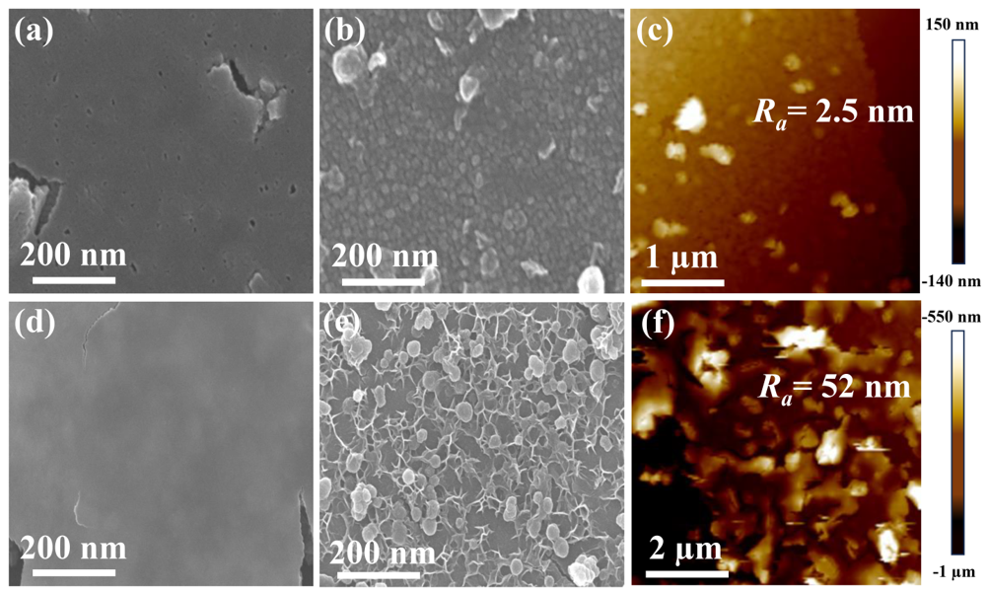
Fig. S1 SEM images of (a) up-side surface and (b) down-side surface for Ni₃(HITP)₂ film-1min, SEM images of (d) up-side surface and (e) down-side surface for Ni₃(HITP)₂ film-5 min, AFM images for (c) Ni₃(HITP)₂ film-1min and (f) Ni₃(HITP)₂ film-5 min.

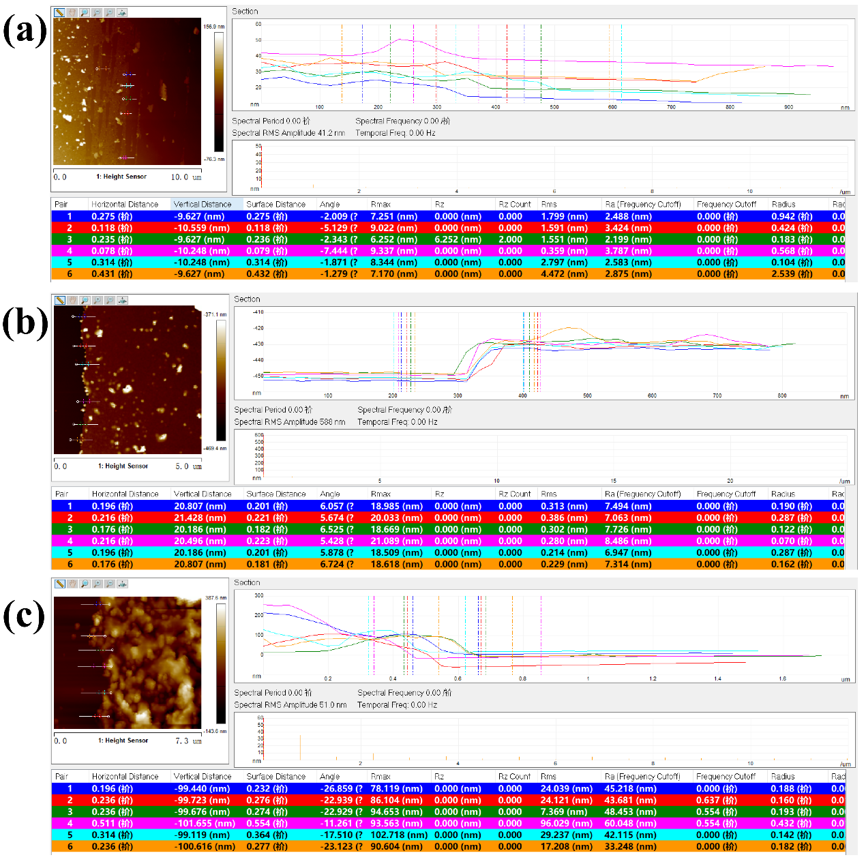
Fig. S2 AFM images and height profiles of up-side surface for (a) Ni₃(HITP)₂ film-1 min, (b) Ni₃(HITP)₂ film-3 min and (c) Ni₃(HITP)₂ film-5 min.

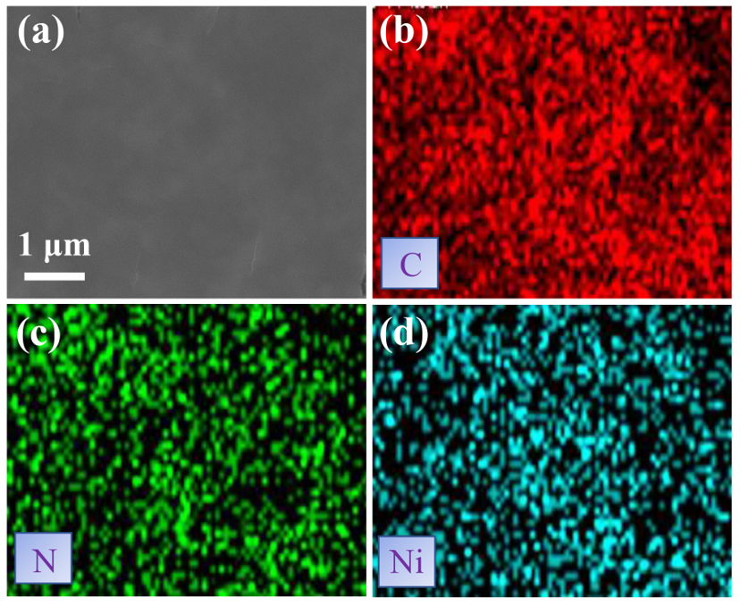
Fig. S3 (a) SEM image for Ni₃(HITP)₂ film, EDS elemental mapping images of (b) C, (c) N and (d) Ni elements.

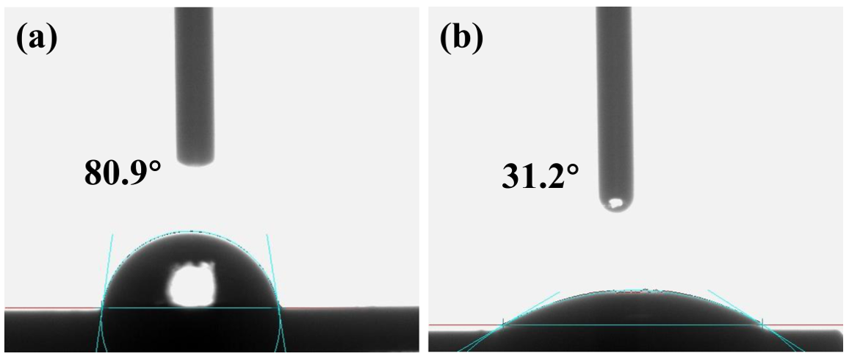
Fig. S4 Contact angle of (a) up-side surface and (b) down-side surface of Ni₃(HITP)₂ film-3 min.

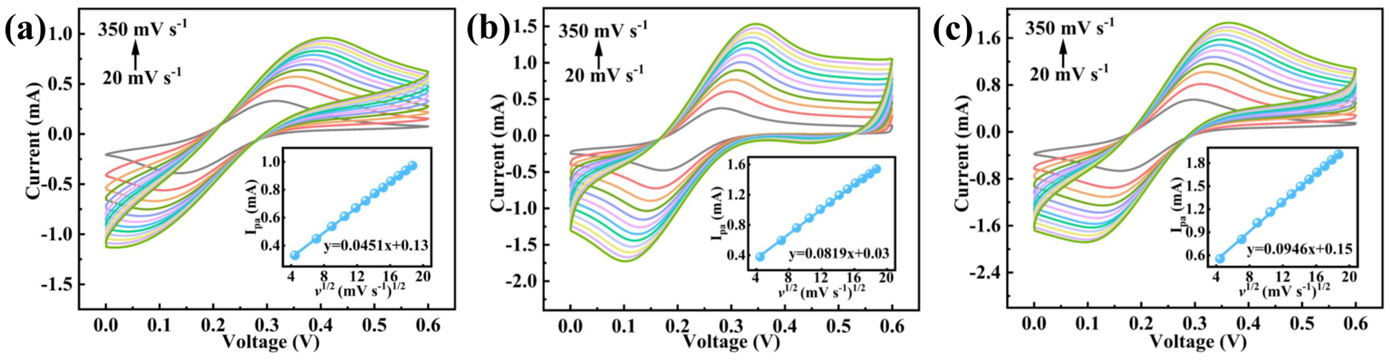
Fig. S5 CV curves of (a) bare ITO, (b) US-Ni-HITP film-3 min/ITO and (c) DS-Ni-HITP film-3 min/ITO at different scan rate (20, 50, 80, 110, 140, 170, 200, 230, 260, 290, 320 and 350 mV s⁻¹) with an aqueous solution of 5.0 mM K₃[Fe(CN)₆] containing 0.1 M KCl (inset: corresponding calibration plots between the oxidation peaks current and the square root of scan rates).

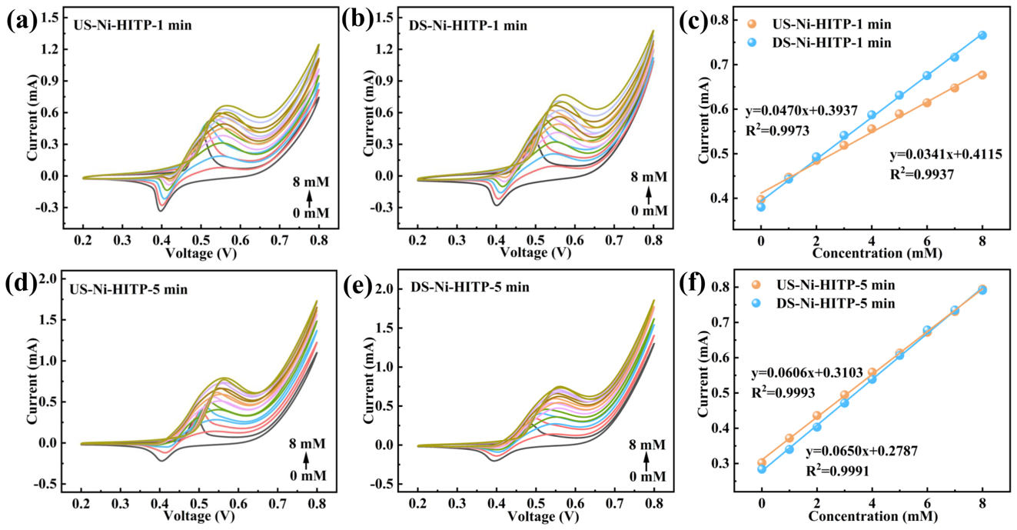
Fig. S6 CV curves of (a) US-Ni-HITP-1 min/ITO and (b) DS-Ni-HITP-1 min/ITO in different concentration of glucose, (c) Calibration plots of oxidation peaks current versus glucose concentration for US-Ni-HITP-1 min and DS-Ni-HITP-1 min, CV curves of (d) US-Ni-HITP-5 and (e) DS-Ni-HITP-5 min/ITO in different concentration of glucose, (f) Calibration plots of oxidation peaks current versus glucose concentration for US-Ni-HITP-5 min and DS-Ni-HITP-5 min.
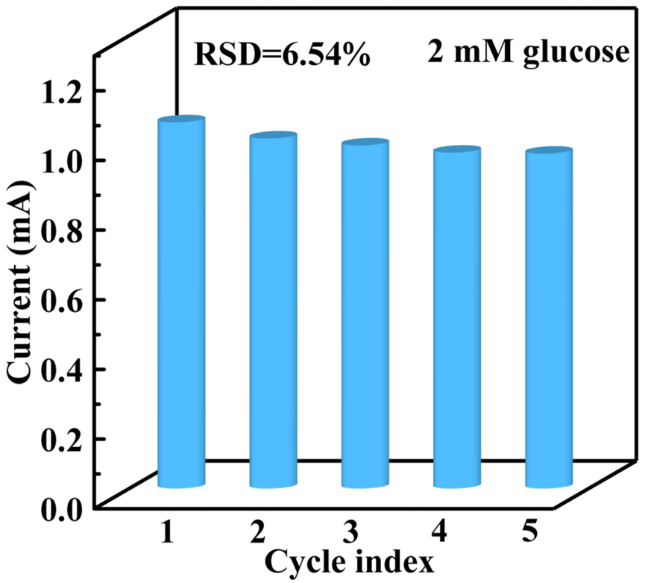
Fig. S7 Response current density of DS-Ni-HITP film-3 min/ITO electrode toward 2 mM glucose for five continuous tests.
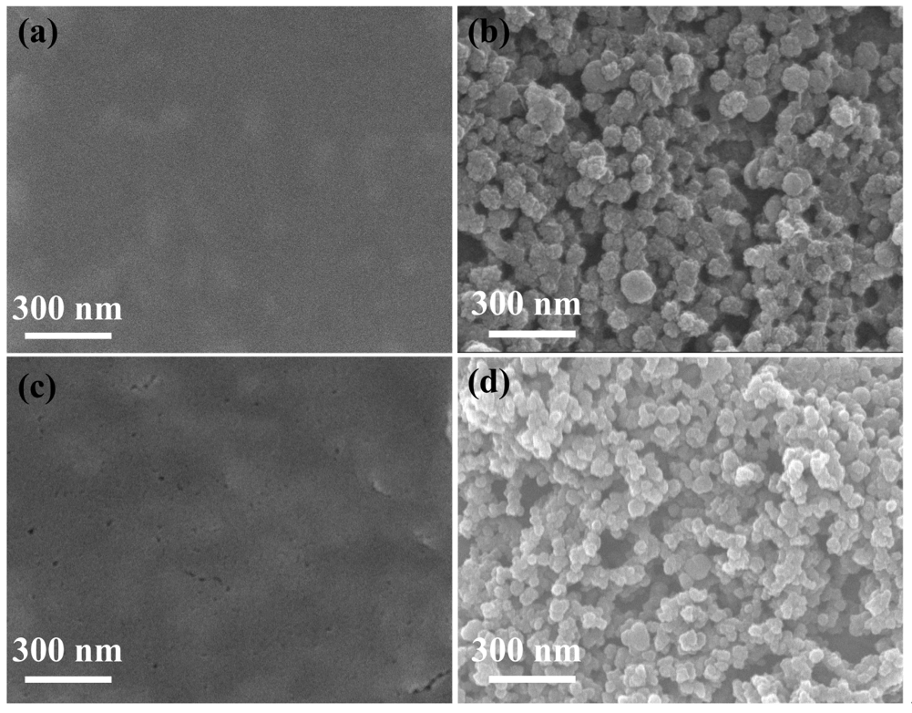
Fig. S8 SEM images of (a) US-Ni-HITP film-3 min and (b) DS-Ni-HITP film-3 min before glucose detection, SEM images of the (c) US-Ni-HITP film-3 min and (d) DS-Ni-HITP film-3 min after glucose detection.

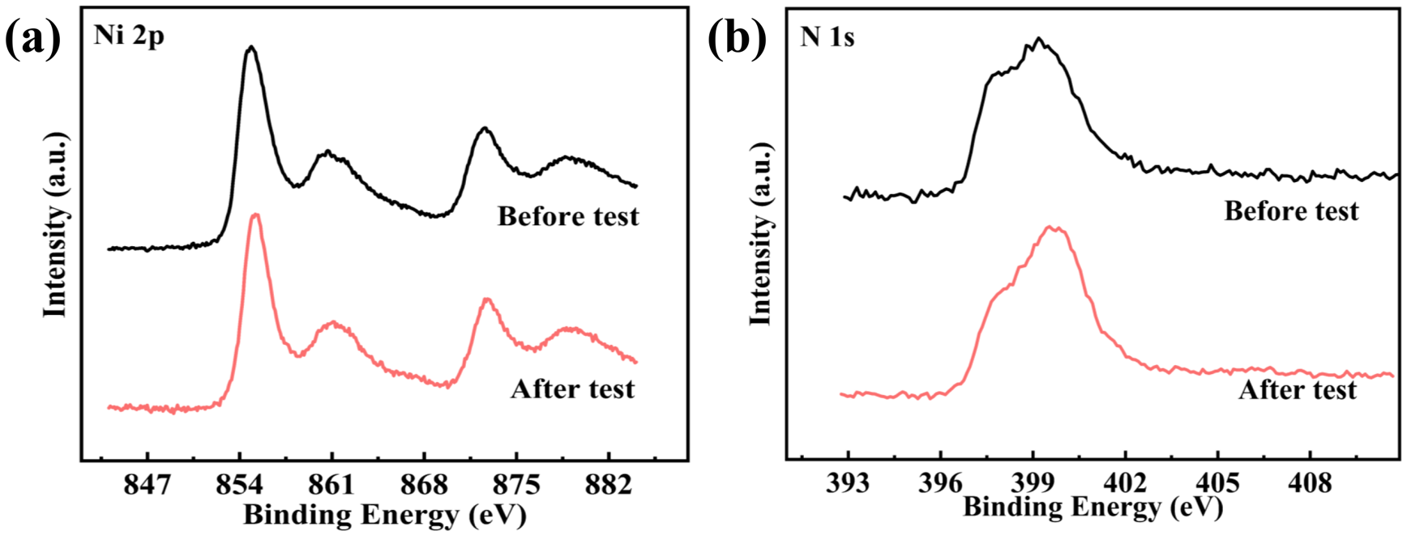
Fig. S9 XPS spectra of DS-Ni-HITP film before and after glucose detection: (a) Ni 2p, (b) N 1s spectrum.

Fig S10. Response current of DS-Ni-HITP film at the first, 15th and 48th days, respectively.

Table. S1 Comparison of analytical performances with other materials modified electrodes for detection of Glucose.
Sensor | Electrochemical method | Detection limit (μM) | Linear range (mM) | Sensitivity (μA cm⁻² Mm⁻¹) | Ref.
Ni-BDC-NH₂/GCE | CV | 3.82 | 0.01-1.4 | 308 | ^{[1]}
Ni₃(HITP)₂/GCE | CV | - | 0-10 | - | ^{[2]}
Ni₃(HHTP)₂/Nafion/CP | i-t | 0.66 | 0.001-8 | 21744 | ^{[3]}
Ni-Cu LDH@Cu(OH)₂ NWs/CuF | i-t | 1.3 | 6×10⁻⁶-1.6×10⁻³ | 7.08 | ^{[4]}
Cu NWs/GCE | i-t | 2.3 | 0-25 | 1001.8 | ^{[5]}
CuO NWs/CW | CV | 2.86 | 0.555-8.555 | 446.7 | ^{[6]}
Co-Ni hydroxide | CV | 0.127 | 1-5 | 1911.5 | ^{[7]}
Ni-MOF/CNTs/GCE | i-t | 0.82 | 0.001-6 | 13.85 | ^{[8]}
PtAg/MWCNTs/GCE | DPV | 600 | 1-25 | 115.8 | ^{[9]}
3D porous Ni networks | CV | 0.07 | 0.0005-4 | 2900 | ^{[10]}
Ni(TPA)-SWCNT/GCE | i-t | 4.6 | 0.02-4.4 | 2.44 | ^{[11]}
Laser-treated Ni foam | i-t | 1.9 | 0-0.05 | 13822 | ^{[12]}
NiMo-MOF | i-t | 22.23 | 0-5 | 184.4 | ^{[13]}
CoMo-MOF | i-t | 26.17 | 0~15 | 246.7 | ^{[13]}
US-Ni-HITP film/ITO | CV | 0.26 | 0-8 | 64.7 | This work
BS-Ni-HITP film/ITO | CV | 0.09 | 0-6 | 183.5 | This work

1. Daud AD, Lim HN, Ibrahim I, Endot NA, Gowthaman NSK, Jiang ZT, Cordova KE (2022) An effective metal-organic framework-based electrochemical non-enzymatic glucose sensor. J Electroanal Chem 921(39):116676.
2. Chen Y, Tian Y, Zhu P, Du L, Chen W, Wu C (2020) Electrochemically Activated Conductive Ni-Based MOFs for Non-enzymatic Sensors Toward Long-Term Glucose Monitoring. Front Chem 8: 602752.
3. Qiao Y, Liu Q, Lu S, Chen G, Gao S, Lu W, Sun X (2020) High-performance non-enzymatic glucose detection: using a conductive Ni-MOF as an electrocatalyst. J Mater Chem B 8(25): 5411-5415.
4. Zhao Z, Huang Y, Huang Z, Mei H, Xie Y, Long D, Zhu F, Gong W (2022) Nonenzymetic glucose sensitive device based on morchella shaped nickel-copper layered double hydroxide. Appl Surf Sci 597(12):153658.
5. Liu X, Yang C, Yang W, Lin J, Liang C, Zhao X (2021) One-pot synthesis of uniform Cu nanowires and their enhanced non-enzymatic glucose sensor performance. J Mater Sci 56(37): 5520-5531.
6. He G, Wang L (2018) One-step preparation of ultra-thin copper oxide nanowire arrays/copper wire electrode for non-enzymatic glucose sensor. Ionics 24(10): 3167-3175.
7. Li H, Zhang L, Mao Y, Wen C, Zhao P (2019) A Simple Electrochemical Route to Access Amorphous Co-Ni Hydroxide for Non-enzymatic Glucose Sensing. Nanoscale Res Lett 14(1): 135.
8. Zhang X, Xu Y, Ye B (2018) An efficient electrochemical glucose sensor based on porous nickel-based metal organic framework/carbon nanotubes composite (Ni-MOF/CNTs). J Alloys Compd 767: 651-656.
9. Lin K-C, Yang C-Y, Chen S-M (2015) Fabrication of a Nonenzymatic Glucose Sensor Based on Multi-Walled Carbon Nanotubes Decorated with Platinum and Silver Hybrid Composite. Int J Electrochem Sci 10(5): 3726-3737.
10. Niu X, Lan M, Zhao H, Chen C (2013) Highly sensitive and selective nonenzymatic detection of glucose using three-dimensional porous nickel nanostructures. Anal Chem 85(7): 3561-3569.
11. Wang F, Chen X, Chen L, Yang J, Wang Q (2019) High-performance non-enzymatic glucose sensor by hierarchical flower-like nickel(II)-based MOF/carbon nanotubes composite. Mater Sci Eng C Mater Biol Appl 96: 41-50.
12. Gao X, Feng W, Zhu Z, Wu Z, Li S, Kan S, Qiu X, Guo A, Chen W, Yin K (2021) Rapid Fabrication of Superhydrophilic Micro/Nanostructured Nickel Foam Toward High‐Performance Glucose Sensor. Adv Mater Interfaces 8(7):2002133.
13. Liang X, Sun Q, Liu Z, Pu H, Yin M, Yu J, Yan W, Fa H, Yin W (2023) Performance comparison of non-enzymatic electrochemical glucose sensor with bimetallic NiMo-MOF and CoMo-MOF. Ionics 29(8): 3393-3405.

