Supplementary Tables
Table S1. Table reporting statistical data of the DAS.
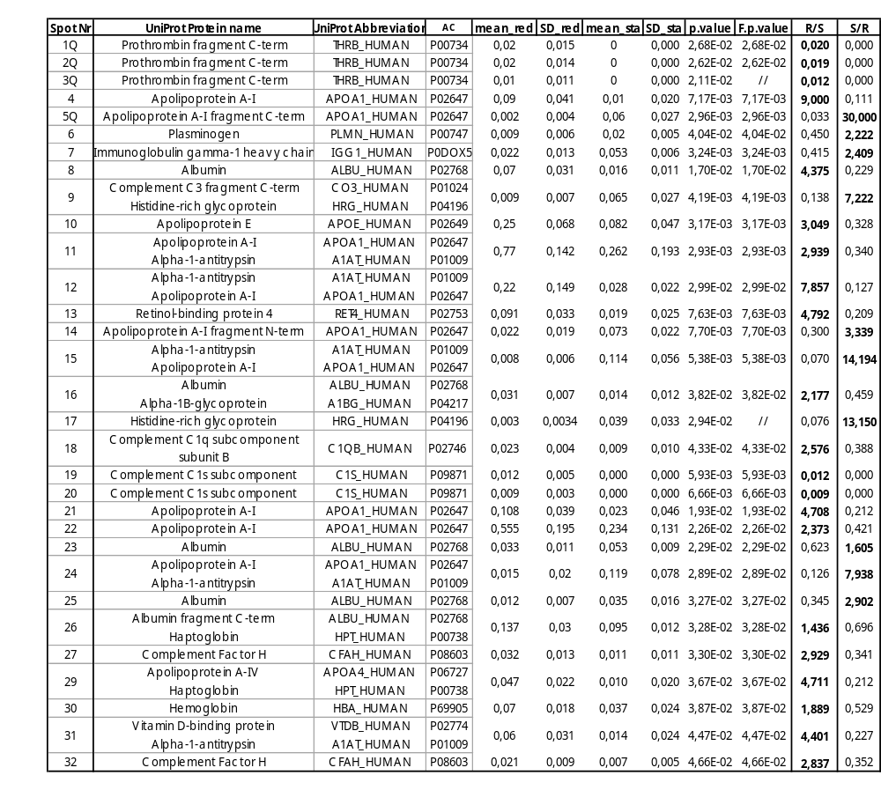

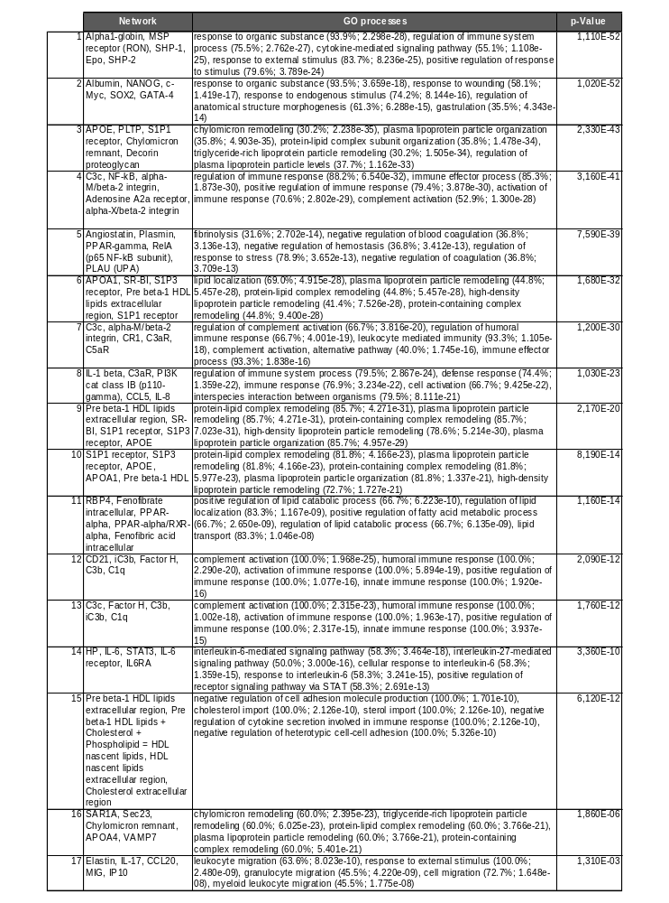
Table S2. Table reporting canonical pathways and relative GO processes by MetaCore

Table S3. Table of Process network results by MetaCore
Processes | p-value | FDR | Network Objects from Active Data
high-density lipoprotein particle remodeling | 6,051E-21 | 1,006E-17 | HDL, Pre beta-1 HDL, HDL proteins, APOE, Albumin, APOA1, Large apoE-rich HDL, APOA4, Nascent HDL
very-low-density lipoprotein particle remodeling | 3,141E-19 | 1,564E-16 | HDL, Pre beta-1 HDL, HDL proteins, APOE, APOA1, Large apoE-rich HDL, APOA4, Nascent HDL
protein-lipid complex remodeling | 3,763E-19 | 1,564E-16 | HDL, Pre beta-1 HDL, HDL proteins, APOE, Albumin, APOA1, Large apoE-rich HDL, APOA4, Nascent HDL
plasma lipoprotein particle remodeling | 3,763E-19 | 1,564E-16 | HDL, Pre beta-1 HDL, HDL proteins, APOE, Albumin, APOA1, Large apoE-rich HDL, APOA4, Nascent HDL
protein-containing complex remodeling | 5,394E-19 | 1,680E-16 | HDL, Pre beta-1 HDL, HDL proteins, APOE, Albumin, APOA1, Large apoE-rich HDL, APOA4, Nascent HDL
positive regulation of cholesterol esterification | 6,067E-19 | 1,680E-16 | HDL, Pre beta-1 HDL, HDL proteins, APOE, APOA1, Large apoE-rich HDL, APOA4, Nascent HDL
platelet degranulation | 8,656E-19 | 2,055E-16 | Glycoprotein Ib-alpha, HDL, Pre beta-1 HDL, HDL proteins, Plasminogen, Albumin, APOA1, Large apoE-rich HDL, HPRG, Nascent HDL, Alpha 1-antitrypsin
phospholipid efflux | 1,114E-18 | 2,057E-16 | HDL, Pre beta-1 HDL, HDL proteins, APOE, APOA1, Large apoE-rich HDL, APOA4, Nascent HDL
peripheral nervous system axon regeneration | 1,114E-18 | 2,057E-16 | HDL, Pre beta-1 HDL, HDL proteins, APOE, APOA1, Large apoE-rich HDL, APOA4, Nascent HDL
chylomicron remodeling | 1,484E-18 | 2,243E-16 | HDL, Pre beta-1 HDL, HDL proteins, APOE, APOA1, Large apoE-rich HDL, APOA4, Nascent HDL
high-density lipoprotein particle assembly | 1,484E-18 | 2,243E-16 | HDL, Pre beta-1 HDL, HDL proteins, APOE, APOA1, Large apoE-rich HDL, APOA4, Nascent HDL
regulation of cholesterol esterification | 1,958E-18 | 2,712E-16 | HDL, Pre beta-1 HDL, HDL proteins, APOE, APOA1, Large apoE-rich HDL, APOA4, Nascent HDL
triglyceride-rich lipoprotein particle remodeling | 3,316E-18 | 3,936E-16 | HDL, Pre beta-1 HDL, HDL proteins, APOE, APOA1, Large apoE-rich HDL, APOA4, Nascent HDL
chylomicron assembly | 3,316E-18 | 3,936E-16 | HDL, Pre beta-1 HDL, HDL proteins, APOE, APOA1, Large apoE-rich HDL, APOA4, Nascent HDL
reverse cholesterol transport | 5,433E-18 | 6,020E-16 | HDL, Pre beta-1 HDL, HDL proteins, APOE, APOA1, Large apoE-rich HDL, APOA4, Nascent HDL
response to wounding | 6,751E-18 | 7,012E-16 | Factor H, C3, HDL, HP/HB complex, Thrombin, Pre beta-1 HDL, HDL proteins, Plasminogen, Adult hemoglobin, APOE, APOA1, Large apoE-rich HDL, HPRG, APOA4, Nascent HDL, Alpha 1-antitrypsin
plasma lipoprotein particle organization | 1,353E-17 | 1,323E-15 | HDL, Pre beta-1 HDL, HDL proteins, APOE, Albumin, APOA1, Large apoE-rich HDL, APOA4, Nascent HDL
cellular oxidant detoxification | 1,971E-17 | 1,819E-15 | HDL, HP/HB complex, HDL proteins, Adult hemoglobin, APOE, HP, Albumin, Large apoE-rich HDL, Alpha1-globin, APOA4
protein-lipid complex subunit organization | 2,184E-17 | 1,910E-15 | HDL, Pre beta-1 HDL, HDL proteins, APOE, Albumin, APOA1, Large apoE-rich HDL, APOA4, Nascent HDL
regulation of intestinal cholesterol absorption | 2,545E-17 | 1,923E-15 | HDL, Pre beta-1 HDL, HDL proteins, APOA1, Large apoE-rich HDL, APOA4, Nascent HDL
regulation of phospholipid efflux | 2,545E-17 | 1,923E-15 | HDL, Pre beta-1 HDL, HDL proteins, APOE, APOA1, Large apoE-rich HDL, Nascent HDL
positive regulation of phospholipid efflux | 2,545E-17 | 1,923E-15 | HDL, Pre beta-1 HDL, HDL proteins, APOE, APOA1, Large apoE-rich HDL, Nascent HDL
regulation of intestinal lipid absorption | 3,730E-17 | 2,696E-15 | HDL, Pre beta-1 HDL, HDL proteins, APOA1, Large apoE-rich HDL, APOA4, Nascent HDL
cholesterol efflux | 5,279E-17 | 3,656E-15 | HDL, Pre beta-1 HDL, HDL proteins, APOE, APOA1, Large apoE-rich HDL, APOA4, Nascent HDL
cellular detoxification | 5,765E-17 | 3,832E-15 | HDL, HP/HB complex, HDL proteins, Adult hemoglobin, APOE, HP, Albumin, Large apoE-rich HDL, Alpha1-globin, APOA4
regulation of Cdc42 protein signal transduction | 1,050E-16 | 6,710E-15 | HDL, Pre beta-1 HDL, HDL proteins, APOE, APOA1, Large apoE-rich HDL, Nascent HDL
regulated exocytosis | 1,166E-16 | 7,180E-15 | Glycoprotein Ib-alpha, C3, HDL, HP/HB complex, Pre beta-1 HDL, HDL proteins, Plasminogen, Adult hemoglobin, HP, Albumin, APOA1, Large apoE-rich HDL, HPRG, Nascent HDL, Alpha 1-antitrypsin
regulation of triglyceride metabolic process | 1,897E-16 | 1,126E-14 | C3, HDL, Pre beta-1 HDL, HDL proteins, APOE, APOA1, Large apoE-rich HDL, APOA4, Nascent HDL
plasma lipoprotein particle assembly | 1,979E-16 | 1,134E-14 | HDL, Pre beta-1 HDL, HDL proteins, APOE, APOA1, Large apoE-rich HDL, APOA4, Nascent HDL
regulation of intestinal absorption | 2,581E-16 | 1,384E-14 | HDL, Pre beta-1 HDL, HDL proteins, APOA1, Large apoE-rich HDL, APOA4, Nascent HDL
high-density lipoprotein particle clearance | 2,581E-16 | 1,384E-14 | HDL, Pre beta-1 HDL, HDL proteins, APOE, APOA1, Large apoE-rich HDL, Nascent HDL
protein-lipid complex assembly | 3,556E-16 | 1,847E-14 | HDL, Pre beta-1 HDL, HDL proteins, APOE, APOA1, Large apoE-rich HDL, APOA4, Nascent HDL
receptor-mediated endocytosis | 4,407E-16 | 2,219E-14 | HDL, HP/HB complex, Pre beta-1 HDL, HDL proteins, Adult hemoglobin, APOE, HP, Albumin, APOA1, Large apoE-rich HDL, Alpha1-globin, Nascent HDL
vitamin transport | 4,694E-16 | 2,295E-14 | RBP4, VDB, HDL, Pre beta-1 HDL, HDL proteins, APOA1, Large apoE-rich HDL, Nascent HDL
regulation of plasma lipoprotein particle levels | 5,335E-16 | 2,533E-14 | HDL, Pre beta-1 HDL, HDL proteins, APOE, Albumin, APOA1, Large apoE-rich HDL, APOA4, Nascent HDL
detoxification | 5,998E-16 | 2,769E-14 | HDL, HP/HB complex, HDL proteins, Adult hemoglobin, APOE, HP, Albumin, Large apoE-rich HDL, Alpha1-globin, APOA4
exocytosis | 6,899E-16 | 3,099E-14 | Glycoprotein Ib-alpha, C3, HDL, HP/HB complex, Pre beta-1 HDL, HDL proteins, Plasminogen, Adult hemoglobin, HP, Albumin, APOA1, Large apoE-rich HDL, HPRG, Nascent HDL, Alpha 1-antitrypsin
positive regulation of lipoprotein lipase activity | 7,321E-16 | 3,202E-14 | HDL, Pre beta-1 HDL, HDL proteins, APOA1, Large apoE-rich HDL, APOA4, Nascent HDL
positive regulation of triglyceride lipase activity | 9,286E-16 | 3,957E-14 | HDL, Pre beta-1 HDL, HDL proteins, APOA1, Large apoE-rich HDL, APOA4, Nascent HDL
negative regulation of cell adhesion molecule production | 9,577E-16 | 3,979E-14 | HDL, Pre beta-1 HDL, HDL proteins, APOA1, Large apoE-rich HDL, Nascent HDL
regulation of phospholipid transport | 1,169E-15 | 4,625E-14 | HDL, Pre beta-1 HDL, HDL proteins, APOE, APOA1, Large apoE-rich HDL, Nascent HDL
positive regulation of phospholipid transport | 1,169E-15 | 4,625E-14 | HDL, Pre beta-1 HDL, HDL proteins, APOE, APOA1, Large apoE-rich HDL, Nascent HDL
positive regulation of triglyceride catabolic process | 1,460E-15 | 5,552E-14 | HDL, Pre beta-1 HDL, HDL proteins, APOA1, Large apoE-rich HDL, APOA4, Nascent HDL
intermembrane lipid transfer | 1,470E-15 | 5,552E-14 | HDL, Pre beta-1 HDL, HDL proteins, APOE, APOA1, Large apoE-rich HDL, APOA4, Nascent HDL
sterol import | 1,595E-15 | 5,641E-14 | HDL, Pre beta-1 HDL, HDL proteins, APOA1, Large apoE-rich HDL, Nascent HDL
cholesterol import | 1,595E-15 | 5,641E-14 | HDL, Pre beta-1 HDL, HDL proteins, APOA1, Large apoE-rich HDL, Nascent HDL
negative regulation of cytokine secretion involved in immune response | 1,595E-15 | 5,641E-14 | HDL, Pre beta-1 HDL, HDL proteins, APOA1, Large apoE-rich HDL, Nascent HDL
positive regulation of steroid metabolic process | 1,653E-15 | 5,723E-14 | HDL, Pre beta-1 HDL, HDL proteins, APOE, APOA1, Large apoE-rich HDL, APOA4, Nascent HDL
triglyceride homeostasis | 2,898E-15 | 9,633E-14 | HDL, Pre beta-1 HDL, HDL proteins, APOE, APOA1, Large apoE-rich HDL, APOA4, Nascent HDL
acylglycerol homeostasis | 2,898E-15 | 9,633E-14 | HDL, Pre beta-1 HDL, HDL proteins, APOE, APOA1, Large apoE-rich HDL, APOA4, Nascent HDL

Supplementary Figures
Figure S1. Figure reporting (A) highly abundant and (B) lowly abundant proteins in Reduced FT3

