Identification of potential 3CLpro inhibitors-modulators for human norovirus infections: An advanced virtual screening approach

Supplementary data

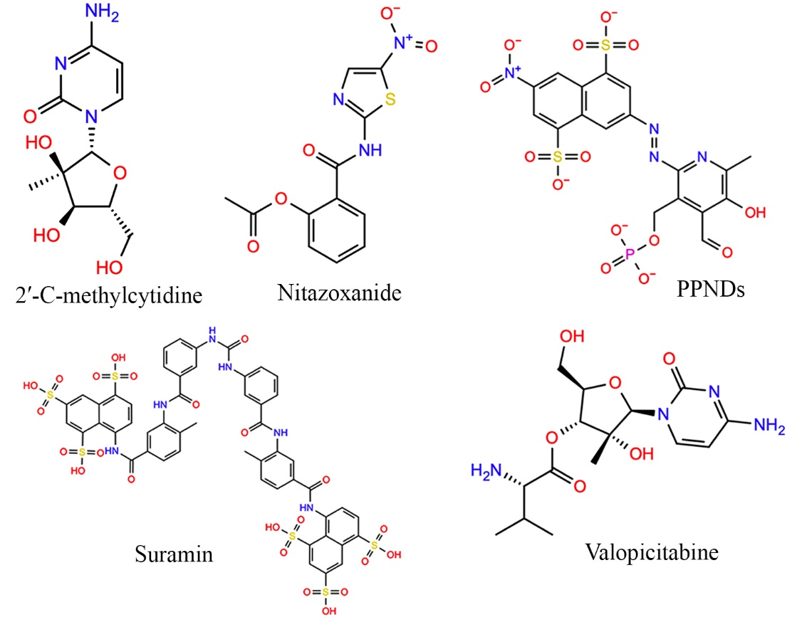
Figure S1. Two-dimensional representation of standard query molecules

Table S1. Binding energy from Vina-scorch and PLANTS docking tools
ChEMBL ID | Binding energy (kcal/mol) |  | ChEMBL ID | Binding energy (kcal/mol) |  | ChEMBL ID | Binding energy (kcal/mol)
ChEMBL ID | Vina-Scorch | PLANTS | ChEMBL ID | Vina-Scorch | PLANTS | ChEMBL ID | Vina-Scorch | PLANTS
CHEMBL413180 | -8.301 | -81.725 | CHEMBL260004 | -6.412 | -65.597 | CHEMBL4209992 | -5.233 | -60.903
CHEMBL4096803 | -8.535 | -80.017 | CHEMBL4114490 | -5.279 | -64.940 | CHEMBL223482 | -5.405 | -60.142
CHEMBL1256476 | -7.906 | -79.433 | CHEMBL1082352 | -5.996 | -64.917 | CHEMBL192254 | -5.562 | -59.928
CHEMBL2106499 | -6.309 | -75.986 | CHEMBL1940641 | -6.338 | -64.810 | CHEMBL1622540 | -7.916 | -55.430
CHEMBL131091 | -8.256 | -75.598 | CHEMBL4111741 | -5.652 | -64.800 | CHEMBL4303027 | -7.067 | -44.937
CHEMBL1779947 | -7.545 | -73.968 | CHEMBL4093378 | -5.394 | -64.703 | CHEMBL1206126 | -8.768 | -42.669
CHEMBL393820 | -9.413 | -80.926 | CHEMBL3984618 | -6.367 | -64.360 | CHEMBL1207473 | -8.694 | -42.112
CHEMBL1256743 | -7.211 | -73.213 | CHEMBL386997 | -5.558 | -64.162 | CHEMBL2028556 | -9.342 | -82.330
CHEMBL1940767 | -6.737 | -72.765 | CHEMBL98778 | -5.401 | -64.136 | CHEMBL1207462 | -8.690 | -41.209
CHEMBL4098888 | -6.478 | -71.961 | CHEMBL1637 | -5.697 | -64.092 | CHEMBL3747799 | -10.005 | -80.839
CHEMBL409304 | -6.950 | -71.130 | CHEMBL3121482 | -6.308 | -63.817 | CHEMBL2007804 | -9.430 | -38.736
CHEMBL2205540 | -6.173 | -71.024 | CHEMBL99131 | -5.583 | -63.765 | CHEMBL1207505 | -7.421 | -38.707
CHEMBL1631364 | -5.962 | -70.970 | CHEMBL3951539 | -7.022 | -63.731 | CHEMBL1207280 | -9.037 | -38.060
CHEMBL259794 | -6.091 | -70.247 | CHEMBL4067892 | -5.766 | -63.433 | CHEMBL1207524 | -8.067 | -36.215
CHEMBL4061654 | -6.470 | -70.149 | CHEMBL438605 | -5.338 | -63.432 | CHEMBL1206388 | -8.232 | -35.483
CHEMBL405500 | -7.482 | -69.875 | CHEMBL413145 | -8.579 | -63.415 | CHEMBL265502 | -9.050 | -35.419
CHEMBL1545 | -6.288 | -69.838 | CHEMBL1276303 | -5.400 | -63.097 | CHEMBL3990952 | -9.051 | -32.861
CHEMBL1277806 | -6.331 | -69.609 | CHEMBL4110895 | -5.872 | -63.055 | CHEMBL1092751 | -8.485 | -32.777
CHEMBL1801519 | -6.030 | -69.347 | CHEMBL3121481 | -5.828 | -62.962 | CHEMBL1206359 | -8.198 | -31.639
CHEMBL214424 | -6.023 | -68.620 | CHEMBL266646 | -7.525 | -62.924 | CHEMBL1207514 | -9.316 | -30.712
CHEMBL1490919 | -6.734 | -68.509 | CHEMBL2311204 | -5.590 | -62.917 | CHEMBL3558720 | -8.756 | -30.644
CHEMBL4097372 | -7.266 | -68.410 | CHEMBL3121390 | -5.911 | -62.889 | CHEMBL2028216 | -8.492 | -30.566
CHEMBL3746109 | -7.760 | -67.953 | CHEMBL497390 | -5.377 | -62.871 | CHEMBL1207542 | -8.299 | -29.747
CHEMBL1241360 | -5.939 | -67.624 | CHEMBL2031681 | -5.221 | -62.814 | CHEMBL1206368 | -10.009 | -28.968
CHEMBL2205534 | -6.761 | -67.420 | CHEMBL1240570 | -5.842 | -62.726 | CHEMBL1208520 | -8.584 | -24.759
CHEMBL1911635 | -6.151 | -67.229 | CHEMBL4111873 | -5.906 | -62.663 | CHEMBL1207502 | -8.852 | -21.229
CHEMBL2205532 | -6.916 | -66.371 | CHEMBL413376 | -8.084 | -62.111 | CHEMBL1207516 | -8.380 | -18.105
CHEMBL413246 | -9.387 | -66.298 | CHEMBL1473612 | -6.264 | -62.075 | CHEMBL1092448 | -8.486 | -13.969
CHEMBL276295 | -9.747 | -66.168 | CHEMBL413910 | -8.252 | -62.058 | CHEMBL1207525 | -7.270 | -30.634
CHEMBL1549213 | -6.143 | -66.062 | CHEMBL1241244 | -6.195 | -61.988 | CHEMBL1615557 | -8.932 | -20.177
CHEMBL1401 | -6.572 | -65.993 | CHEMBL3121391 | -5.734 | -61.745 | CHEMBL1207434 | -9.662 | -27.117
CHEMBL1673141 | -5.548 | -65.708 | CHEMBL888 | -5.462 | -61.411
CHEMBL1242578 | -6.633 | -65.693 | CHEMBL4110694 | -5.731 | -61.355

