Formulation of traditional Chinese medicine and its application on intestinal flora of constipated rats
Sihan Li^{1,2,†}, Youcheng He^{1,†}, Haiou Zhang¹, Rong Zheng¹, Ruoying Xu¹, Qihong Liu¹, Shuihua Tang¹, Xiao Ke^{1,*} and Minghan Huang^{1,*}
¹Department of Gastroenterology, the second people's Hospital affiliated to Fujian University of traditional Chinese Medicine, Fuzhou 353003, China
²School of Basic Medical Sciences, Guangzhou University of Chinese Medicine, Guangzhou, China
†These two authors contributed equally to this work;
*Corresponding author:
Prof. Minghan Huang,
Email: huangminghan2010@163.com
Prof. Xiao Ke,
Email: drkxkx@163.com

Supplementary Figure captions:
Fig. 1S. Multy samples rarefaction curves for each group.
Fig. 2S. Number of samples sequenced for each group.
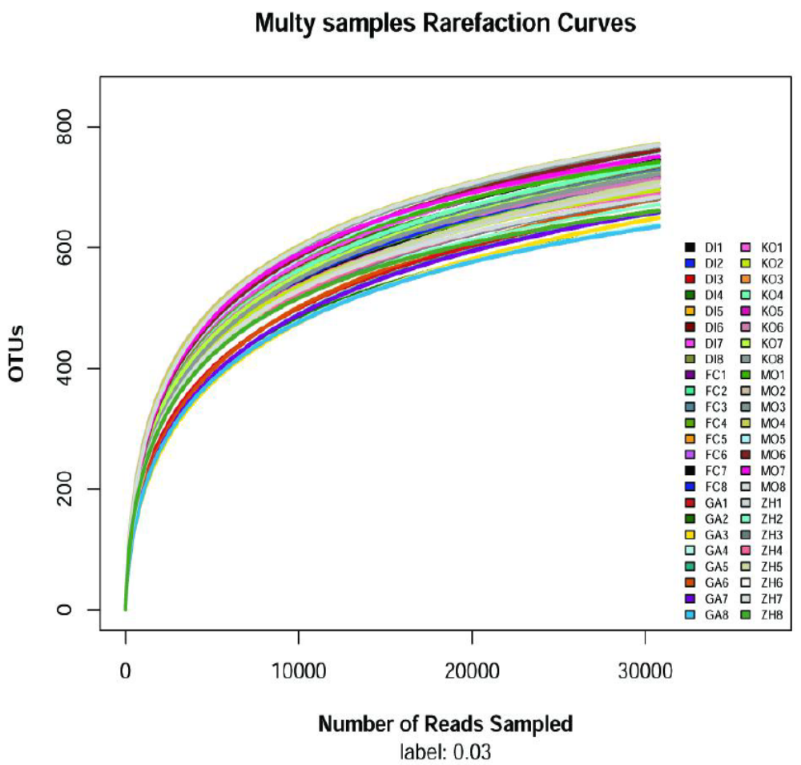

Fig. 1S.
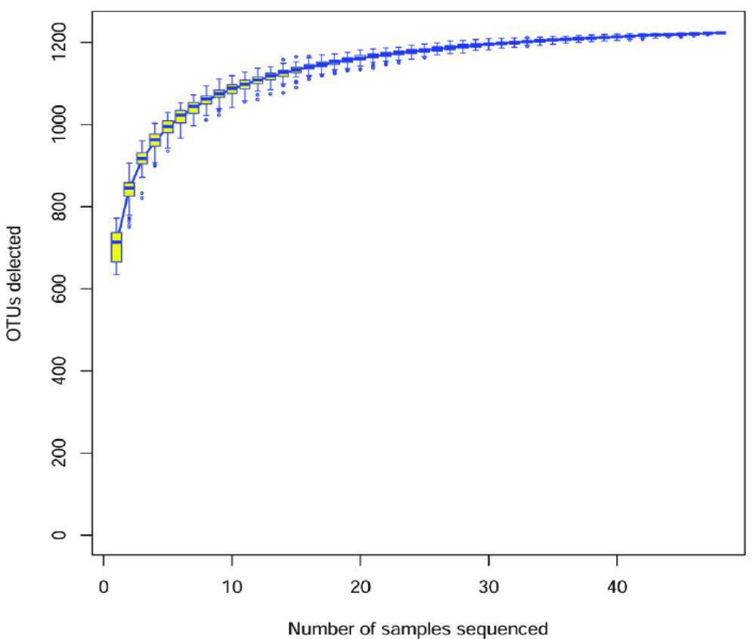
Fig. 2S.

