Supplementary Information

Processing Rusty Metals into Versatile Prussian Blue for Sustainable Energy Storage

J.P., et.al
Experimental Section
Preparation of R-PB: Firstly, 10 rust flat head nails (Paslode, QTY570, 65*2.8 mm) were washed with deionized water (DI-water) for several times and immersed into 200 ml of DI-water containing 1 M of HCl. Afterward, the solution was collected by vacuum filter after reaction for 20 mins. The obtained solution was diluted by 200 ml DI-water with 20 g trisodium citrate and marked as A. 50 mmol Na₄Fe(CN)₆ was dispersed into 200 ml DI-water as solution B. The solution B was add into solution A dropwise by peristaltic pump under continuous stirring for 6 h and aged for 24 h at room temperature. Finally, the precipitate was dried at 120 °C in vacuum oven overnight. The obtained sample was marked as R-PB (R represents “rusty”, PB is the abbreviation of Prussian blue).
Materials Characterization: A neutron diffraction investigation was conducted at the Australian Synchrotron with λ = 1.622 Å to determine the structure of R-PB. The diffraction pattern was first indexed and then refined by the Rietveld method with GSAS software. The morphology was characterized with a field emission scanning electron microscope (JEOL, KSM-7500FA) and a 200 kV scanning transmission electron microscope (STEM) with a double aberration-corrector (JEM-ARM 200F). The elemental energy dispersive spectroscopy (EDS) mapping images were obtained through STEM. The thermogravimetry tests were carried out on a Netzsch STA 449 F3 analyzer in N₂ from room temperature to 500 °C. Raman spectroscopy was conducted on a LabRAM HR800 (Horiba JobinYvon) with a wavelength of 532 nm. Fourier transform infrared spectroscopy (FT-IR) was carried out to examine the vibration states of existing functional groups of the samples on a Thermo Nicolet Nexus 670 FT-IR spectrometer. X-ray photoelectron spectroscopy (XPS) with an Al Kα source was applied to collect the surface information through an ESCALAB 250Xi (Thermo Fisher) spectrometer.
Electrochemical Measurement: The cathode electrode slurry for 2032 coin cell testing was prepared by mixing 70 wt% active materials (PBAs), 20 wt% carbon black (Super P), and 10 wt% carboxymethyl cellulose (CMC) in water. The mixed slurry was pasted on Al foil and then dried at 120 °C in a vacuum oven overnight. Sodium metal and glass fiber (Whatman, GF/A) were used as the counter electrode and the separator, respectively. 1 M NaClO₄ in ethylene carbonate and diethyl carbonate (v/v = 1:1) with 4 % fluoroethylene carbonate additive served as the electrolyte. The batteries were assembled in an argon-filled glove box with H₂O and O₂ concentrations less than 0.1 ppm. The cycling and rate performance were examined on a Neware battery cycler (CT-4008-5V10mA-164, Shenzhen, China) with a voltage window of 2.0-4.2 V. Cyclic voltammetry (CV) was performed using a Biologic VMP-3 electrochemical workstation at a scan rate of 0.1 mV s⁻¹ from 2.0 to 4.2 V.
DFT calculations:
Density Functional Theory (DFT) calculations with the Hubbard U correction were implemented in the code VASP (version 5.4.4)^{1, 2}, and the value of U was set according to previous research.³ The interaction between core ion and valence electron are described by the projector augmented wave method (PAW).⁴ The spin-polarized generalized gradient approximations (GGA) in the scheme of Perdew, Burke, Ernzerhof (PBE) were used to describe rhe exchange correlation.^{5, 6} An energy cutoff of 600 eV was used with Monkhorst k-points⁷ sampling scheme 2×2×2 for geometry optimization. Conjugated gradient method was used to the geometry optimization and all the atomic coordinates were fully relaxed until the maximal force on each atom was less than 0.01 eV/Å, and the convergence condition for energy is 10⁻⁴ eV. The activation barriers for Na-ion diffusion were calculated using the climbing image nudged elastic band (CI-NEB) method.

Table S1 Detailed structural information on the R-PB sample after Rietveld refinement based on neutron diffraction.
R-PB. Cubic, space group Fm-3m, a=b=c=10.3354 Å, V=1104.032406 Å³
Atom | x | y | z | Occupation | U | Site
Na | 0.25 | 0.25 | 0.25 | 0.784 | 0.036 | 8c
Fe | 0 | 0 | 0 | 1 | 0.077 | 4a
Fe | 0 | 0 | 0.5 | 0.836 | 0.014 | 4b
C | 0 | 0 | 0.18197 | 0.836 | 0 | 24e
N | 0 | 0 | 0.29346 | 0.836 | 0.035 | 24e

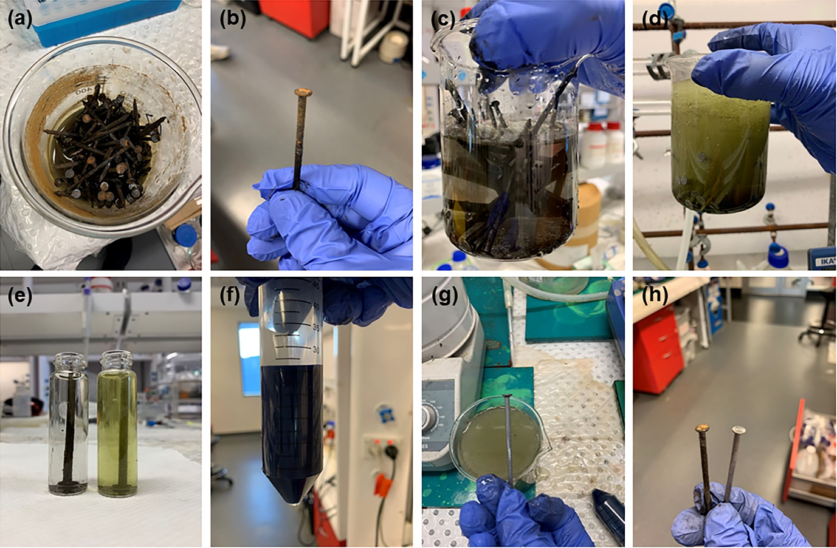
Figure S1. Digital images during the synthesis of the R-PB.

Figure S2. XRD pattern of R-PB.

Figure S3. Raman spectra of the R-PB.

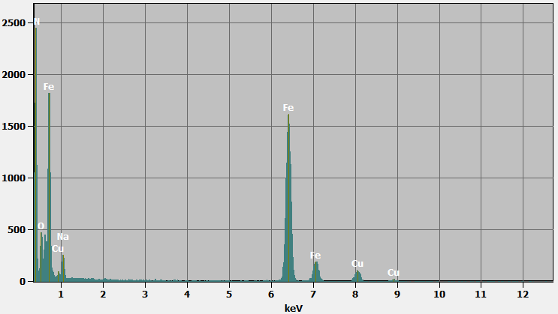
Figure S4. Scanning transmission electron microscopy energy-dispersive X-ray spectroscopy line analysis.

Figure S5. Charge and discharge curves of the R-PB at different cycles at the current density of 150 mA g⁻¹.

Figure S6. Charge and discharge curves of the R-PB at different cycles at the current density of 750 mA g⁻¹.

Figure S7. Charge and discharge curves of the R-PB at different current density from 30-1500 mA g⁻¹.

Figure S8. Middle point potential of the R-PB at different cycles at the current density of 150 mA g⁻¹.

Figure S9. Middle point potential of the R-PB at different cycles at the current density of 750 mA g⁻¹.

Reference:
1. Kresse G, Hafner J. Ab initio molecular-dynamics simulation of the liquid-metal–amorphous-semiconductor transition in germanium. Phys Rev B 49, 14251 (1994).
2. Kresse G, Furthmüller J. Efficient iterative schemes for ab initio total-energy calculations using a plane-wave basis set. Phys Rev B 54, 11169 (1996).
3. Li W, et al. Stress distortion restraint to boost the sodium ion storage performance of a novel binary hexacyanoferrate. 10, 1903006 (2020).
4. Blöchl PEJPrB. Projector augmented-wave method. 50, 17953 (1994).
5. Perdew JP, Burke K, Ernzerhof M. Generalized gradient approximation made simple. Phys Rev Lett 77, 3865 (1996).
6. Kohn W, Sham LJ. Self-consistent equations including exchange and correlation effects. Physical review 140, A1133 (1965).
7. Monkhorst HJ, Pack JDJPrB. Special points for Brillouin-zone integrations. 13, 5188 (1976).

