Supporting Information

Dissipation of pesticides and responses of bacterial, fungal and protist communities in a multi-contaminated vineyard soil

Gwenaël Imfeld^{1,*}, Fatima Meite¹, Lucas Ehrhart², Bertrand Fournier^{2,3}, Thierry J. Heger²

- Earth & Environment Strasbourg, Université de Strasbourg/EOST/ENGEES, CNRS UMR 7063, 5 rue Descartes, Strasbourg F-67084, France
- Soil Science and Environment Group, CHANGINS, University of Applied Sciences and Arts Western Switzerland, Route de Duillier 50, 1260 Nyon, Switzerland
- Institute of Environmental Science and Geography, University of Potsdam, Karl-Liebknecht-Str. 24-25, 14476, Potsdam, Germany

*Corresponding author phone: + 333 6885 0474; e-mail: imfeld@unistra.fr

Manuscript for Environmental Science and Pollution Research

Figure S1. Experimental set-up (on the left) and experimental design (table on the right) for each sampling event. A total of five scheduled samplings were carried out at Days 1, 10, 50, 100, and 200. The experiments were augmented with the pesticide mixture to achieve a final concentration of each individual pesticide at 5 µg g⁻¹ of soil (dry weight).

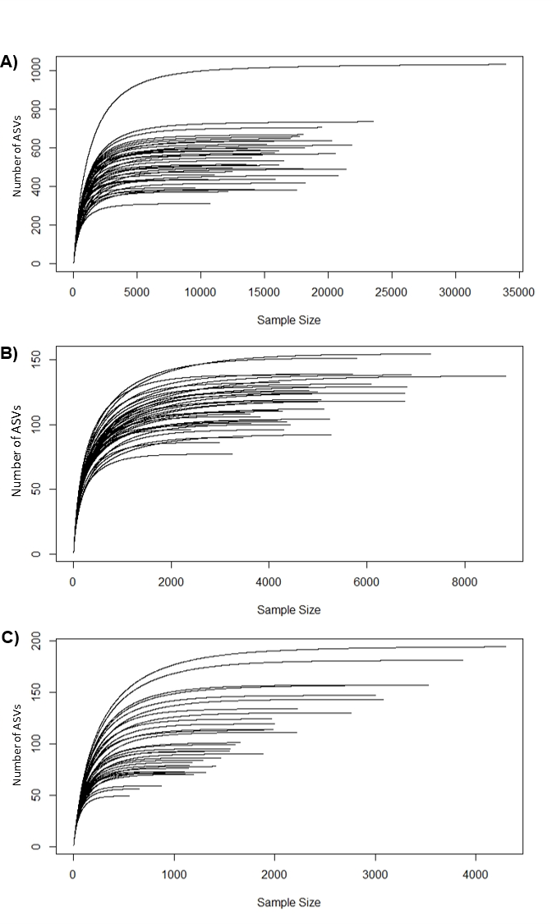
Figure S2. Rarefaction curves for bacteria (A), fungi (B) and protists (C) based on the number of sequences (sample size). Each line represents one sample.

Table S1. Physicochemical properties and half-lives of selected pesticides, ordered according to pesticide solubility in water (20°C). Data are from the Pesticide Properties DataBase. I: Insecticide, H: herbicide, F: fungicide.
Compound | Formula | Family | Type | Solubility | K_{oc} | Theoretical
 |  |  |  | [mg L⁻¹] | [mL g⁻¹] | DT₅₀ [d]
Flufenoxuron | C₂₁H₁₁ClF₆N₂O₃ | Benzoylurea | I | 0.0043 | 157643 | 42
Pyraflufen-ethyl | C₁₃H₉Cl₂F₃N₂O₄ | Phenylpyrazole | H | 0.1 | 1949 | 0.3
Pendimethalin | C₁₃H₁₉N₃O₄ | Anilinopyrimidine | H | 0.3 | 15744 | 90
Oryzalin | C₁₂H₁₈N₄O₆S | Dinitroaniline | H | 1.1 | 897 | 45
Isoxaben | C₁₈H₂₄N₂O₄ | Benzamide | H | 0.9 | 351 | 105
Kresoxim-methyl | C₁₈H₁₉NO₄ | Strobilurin | F | 2 | 437 | 16
Simazine | C₇H₁₂ClN₅ | Triazine | H | 5 | 340 | 60
Terbuthylazine | C₉H₁₆ClN₅ | Triazine | H | 6.6 | 219 | 75
Azoxystrobin | C₂₂H₁₇N₃O₅ | Strobilurin | F | 6.7 | 581 | 78
Carbendazim | C₉H₉N₃O₂ | Benzimidazole | F | 8 | 223 | 40
Cyprodinil | C₁₄H₁₅N₃ | Anilinopyrimidine | F | 13 | 1470 | 37
Dimethomorph | C₂₁H₂₂ClNO₄ | Morpholine | F | 29 | 1360 | 57
Atrazine | C₈H₁₄ClN₅ | Triazine | H | 35 | 93 | 75
Diuron | C₉H₁₀C_{l2}N₂₀ | Phenylurea | H | 35.6 | 499 | 76
Isoproturon | C₁₂H₁₈N₂O | Phenylurea | H | 70 | 122 | 12
Pyrimethanil | C₁₂H₁₃N₃ | Anilinopyrimidine | F | 121 | 301 | 55
Tetraconazole | C₁₃H₁₁Cl₂F₄N₃O | Triazole | F | 157 | 4680 | 61
S-Metolachlor | C₁₅H₂₂ClNO₂ | Chloroacetamide | H | 480 | 185 | 15
Cymoxanil | C₇H₁₉N₄O₃ | Cyanoacetamide oxide | F | 780 | 44 | 0.7
Metalaxyl | C₁₅H₂₁NO₄ | Phenylamide | F | 7100 | 163 | 42

Table S2. Physico-chemical properties of the crop and the vineyard soils. Analytical uncertainty is 5 % for the major elements.
Parameter | Unit | Vineyard soil
Bulk density ($ρ_{b})$ | [g.cm⁻³] | 1.1
Clay | [%] | 69
Silt | [%] | 23
Sand | [%] | 8
OM Loss on ignition | [%] | 1.7
OC Black & Walkley | [%] | 0.8
Al₂O₃ | [%] | 7.5
CaCO₃ | [%] | 27.1
Fe₂O₃ | [%] | 3.9
MnO | [%] | 0.1
pH | [-] | 8.1

Soils were sieved at 2 mm prior to analysis. The particle size distribution was measured by laser granulometry using a Beckmann Coulter LS230. pH, organic matter content and carbonate content were respectively determined on the soils sieved at 2 mm by electrometry in a soil–solvent suspension (1:2.5) (NF EN 12176), pyrolysis at 375 °C for 16 h after pre-drying at 150 °C (NF EN 12875) and measure of the volume of lost gas during the dissolution of carbonates by HCl (volumetric calcimetry, NF ISO 10693).
Table S3. Extraction recoveries of pesticides quantified with GC-MS. Results for pesticides with a recovery <20% and/or an analytical error >20% were not reported in this study.

Compound | Recovery [%] | Analytical errorª [%]
Simazine | 23 | 2
Dimethomorph | 51 | 14
Atrazine | 61 | 1
Pyrimethanil | 55 | 6
S-Metolachlor | 23 | 9
Metalaxyl | 67 | 3
ª Standard deviation of mean recovery values from n ≥3 measurements.

Atrazine, dimethomorph, metalaxyl, pyrimethanil, simazine and S-metolachlor were quantified by gas chromatography (Trace 1300, Thermo Fisher Scientific) coupled to a mass spectrometer (ISQ, Thermo Fisher Scientific) (GC-MS), equipped with a TG-5MS column (30 m × 0.25 mm ID, 0.25 μm film thickness), with helium as carrier gas with a flow rate of 1.5 mL min⁻¹. The GC oven was held at 50 °C for 1 min, ramped to 160 °C at 30 °C min⁻¹, then to 220 °C at 4 °C min⁻¹ and finally to 300 °C for 1 min at 30 °C min⁻¹. The samples (1.5 μL volume) were injected into a split/splitless injector operated in split mode with a split flow at 6.0 mL min⁻¹ and held at 280 °C. The MS transfer line and source were heated at 320 °C.

Table S4. Extraction recoveries of pesticides quantified with LC-MS. Results for pesticides with a recovery <20% and/or an analytical error >20% were not reported in this study.
Compound | Parent mass | Transition 1 | Transition 2 | Recovery [%] | LOD [µg g⁻¹] | LOQ [µg g⁻¹]
Isoxaben | 333 | 165 | 107 | 23 | 0.17 | 0.5
Carbendazim | 192 | 160 | 132 | 23 | 0.17 | 0.5
Isoproturon | 207 | 72 | 165 | 105 | 0.17 | 0.5

Carbendazim, isoproturon and isoxaben were quantified using LC-MS (TSQ Quantum Access Max, Thermo Scientific, Waltham, Massachusetts, USA). The mobile phase (0.3 ml min⁻¹) consisted of a gradient of acetonitrile (30 to 95 %) and water (70 to 5 %) in a positive mode at 4500 V. This last step was hold during 3 min and then was returned to initial conditions during 6 min. Each time, 20 µL of each sample was injected into an EC 150/3 Nucleodur C18 Pyramid 3 µm column with isoproturon d6 as an internal standard.

Table S5. Dissipation rate constants (k) of pesticides in the vineyard soil.
Compound | Formula | k [d⁻¹]
Compound | Formula | Biotic |  |  |  | Abiotic
Compound | Formula | 20 °C |  | 30 °C |  | 20 °C |  | 30 °C
Compound | Formula | 20 % water | 40 % water | 20 % water | 40 % water | 20 % water | 40 % water | 20 % water | 40 % water
Isoxaben | C₁₈H₂₄N₂O₄ | n.a. | n.a. | 0.009 | n.a. | 0.007 | n.a. | 0.013 | n.a.
Simazine | C₇H₁₂ClN₅ | n.a. | 0.012 | 0.009 | n.a. | 0.007 | n.a. | 0.007 | n.a.
Carbendazim | C₉H₉N₃O₂ | n.a. | 0.008 | 0.015 | n.a. | 0.009 | 0.010 | 0.021 | 0.011
Dimethomorph | C₂₁H₂₂ClNO₄ | 0.008 | n.a. | 0.011 | n.a. | n.a. | n.a. | 0.005 | n.a.
Atrazine | C₈H₁₄ClN₅ | 0.015 | 0.013 | 0.020 | n.a. | 0.007 | 0.007 | 0.011 | 0.009
Isoproturon | C₁₂H₁₈N₂O | n.a. | 0.006 | 0.017 | 0.011 | 0.010 | 0.008 | 0.021 | 0.006
Pyrimethanil | C₁₂H₁₃N₃ | 0.018 | 0.004 | 0.019 | 0.006 | 0.003 | 0.003 | 0.009 | 0.002
S-Metolachlor | C₁₅H₂₂ClNO₂ | 0.024 | 0.015 | 0.025 | n.a. | 0.007 | n.a. | 0.010 | 0.006
Metalaxyl | C₁₅H₂₁NO₄ | 0.010 | 0.007 | 0.013 | 0.008 | 0.003 | 0.003 | 0.002 | n.a.
n.a.: denotes the absence of value due insignificant correlations.

Table S6. Biodegradation extent (B, %) of pesticides over time (day). Standard errors are provided in parentheses.
Compound | Formula | Ageing [d] | 20 °C |  | 30 °C
Compound | Formula | Ageing [d] | 20 % water | 40 % water | 20 % water | 40 % water
Isoxaben | C₁₈H₂₄N₂O₄ | 50 | n.a. | n.a. | n.a. | 21 (5)
Isoxaben | C₁₈H₂₄N₂O₄ | 100 | n.a. | 8 (4) | 0 | 4 (1)
Isoxaben | C₁₈H₂₄N₂O₄ | 200 | n.a. | 0 | 2 (1) | 5 (1)
Simazine | C₇H₁₂ClN₅ | 50 | 33 (11) | 0 | 57 (17) | 27 (10)
Simazine | C₇H₁₂ClN₅ | 100 | 51 (23) | 62 (37) | 20 (8) | 34 (25)
Simazine | C₇H₁₂ClN₅ | 200 | 24 (8) | 22 (5) | 5 (1) | 21 (5)
Carbendazim | C₉H₉N₃O₂ | 50 | n.a. | n.a. | n.a. | 88 (23)
Carbendazim | C₉H₉N₃O₂ | 100 | n.a. | 10 (5) | 0 | -6 (2)
Carbendazim | C₉H₉N₃O₂ | 200 | n.a. | 0 | 0 | 17 (5)
Dimethomorph | C₂₁H₂₂ClNO₄ | 50 | 0 | 57 (20) | n.a. | 50 (50)
Dimethomorph | C₂₁H₂₂ClNO₄ | 100 | 0 | 22 (12) | 4 (0) | 23 (44)
Dimethomorph | C₂₁H₂₂ClNO₄ | 200 | 15 (0) | 18 (4) | 53 (1) | 29 (8)
Atrazine | C₈H₁₄ClN₅ | 50 | 32 (0) | 4 (0) | 38 (0) | 28 (0)
Atrazine | C₈H₁₄ClN₅ | 100 | 50 (0) | 46 (1) | 24 (0) | 28 (1)
Atrazine | C₈H₁₄ClN₅ | 200 | 18 (0) | 21 (0) | 9 (0) | 19 (1)
Isoproturon | C₁₂H₁₈N₂O | 50 | n.a. | n.a. | 30 (15) | n.a.
Isoproturon | C₁₂H₁₈N₂O | 100 | n.a. | 28 (15) | 9 (77) | 0
Isoproturon | C₁₂H₁₈N₂O | 200 | n.a. | 0 | 0 | 66 (23)
Pyrimethanil | C₁₂H₁₃N₃ | 50 | 47 (0) | 6 (0) | 70 (1) | 49 (1)
Pyrimethanil | C₁₂H₁₃N₃ | 100 | 84 (2) | 60 (1) | 79 (1) | 78 (1)
Pyrimethanil | C₁₂H₁₃N₃ | 200 | 44 (2) | 10 (0) | 12 (0) | 71 (1)
S-Metolachlor | C₁₅H₂₂ClNO₂ | 50 | 47 (0) | 53 (1) | 49 (1) | 56 (1)
S-Metolachlor | C₁₅H₂₂ClNO₂ | 100 | 57 (2) | 34 (1) | 22 (0) | 37 (1)
S-Metolachlor | C₁₅H₂₂ClNO₂ | 200 | 21 (1) | 27 (1) | 12 (0) | 38 (4)
Metalaxyl | C₁₅H₂₁NO₄ | 50 | 53 (0) | 35 (0) | 99 (1) | 62 (1)
Metalaxyl | C₁₅H₂₁NO₄ | 100 | 95 (1) | 74 (1) | 78 (1) | 80 (1)
Metalaxyl | C₁₅H₂₁NO₄ | 200 | 39 (0) | 51 (1) | 55 (1) | 79 (2)

Table S7. Effect of exposure to nine pesticides, as well as variations in water content and incubation time, on three microbial groups assessed through envfit analysis.

 | Bacteria |  |  |  |  | Fungi |  |  |  |  | Protists
 | NMDS1 | NMDS2 | R² | Pr(>r) |  | NMDS1 | NMDS2 | R² | Pr(>r) |  | NMDS1 | NMDS2 | R² | Pr(>r)
Treatment | -0.22940 | -0.97333 | 0.0010 | 0.980 |  | 0.41676 | -0.90901 | 0.0188 | 0.733 |  | -0.21056 | -0.97758 | 0.0121 | 0.823
Temperature | 0.49493 | -0.86894 | 0.0311 | 0.563 |  | -0.23911 | -0.97099 | 0.0001 | 0.999 |  | 0.54068 | 0.84123 | 0.1397 | 0.106
Water content | 0.77617 | -0.63052 | 0.6177 | 0.001*** |  | 0.99670 | -0.08117 | 0.3839 | 0.001*** |  | -0.38815 | -0.92160 | 0.3492 | 0.003**
Incubation time | 0.20877 | 0.97796 | 0.5883 | 0.001*** |  | 0.51307 | -0.85835 | 0.2033 | 0.017* |  | -0.22308 | 0.97480 | 0.2469 | 0.015*
Simazine | -0.16967 | -0.98550 | 0.0762 | 0.223 |  | -0.65672 | -0.75414 | 0.0272 | 0.646 |  | 0.16151 | -0.98687 | 0.1743 | 0.044*
Atrazine | -0.23992 | -0.97079 | 0.1087 | 0.118 |  | -0.98518 | -0.17155 | 0.0384 | 0.506 |  | 0.13371 | -0.99102 | 0.1464 | 0.095
Pyremethanil | -0.02976 | -0.99956 | 0.0614 | 0.289 |  | 0.81691 | 0.57677 | 0.0021 | 0.968 |  | -0.06757 | -0.99771 | 0.1241 | 0.132
Metalaxyl | -0.23037 | -0.97310 | 0.0792 | 0.206 |  | -0.98800 | -0.15443 | 0.0148 | 0.772 |  | 0.08586 | -0.99631 | 0.1076 | 0.161
S-metolachlor | -0.20742 | -0.97825 | 0.1071 | 0.121 |  | -0.90872 | -0.41740 | 0.0374 | 0.514 |  | 0.18522 | -0.98270 | 0.1640 | 0.075
Dimethomorph | -0.03565 | -0.99936 | 0.0471 | 0.412 |  | 0.95273 | 0.30383 | 0.0006 | 0.986 |  | 0.13740 | -0.99052 | 0.1265 | 0.126
Carbendazim | 0.03873 | -0.99925 | 0.0649 | 0.302 |  | 0.90374 | 0.42809 | 0.0051 | 0.918 |  | 0.06702 | -0.99775 | 0.1369 | 0.088
Isoproturon | 0.06040 | -0.99817 | 0.0800 | 0.212 |  | 0.79281 | 0.60947 | 0.0140 | 0.802 |  | -0.02690 | -0.99964 | 0.1414 | 0.085
Isoxaben | -0.13085 | -0.99140 | 0.0674 | 0.276 |  | -0.35210 | -0.93596 | 0.0492 | 0.400 |  | 0.21032 | -0.97763 | 0.2109 | 0.017*

