The potential of cyanobacterium Nostoc sp. as the primary producer in the life-support system on Mars

Tong Ye^{1,2,3}, Peifan Gu^{2,3}, Xianyuan Zhang^{2,3}, & Gaohong Wang^{2,3,4*}

¹ State Key Laboratory of Herbage Improvement and Grassland Agro-ecosystems, and College of Ecology, Lanzhou University, Lanzhou, 730000, China.
² Key Laboratory of Algal Biology, Institute of Hydrobiology, Chinese Academy of Sciences, Wuhan, 430072, China
³ University of Chinese Academy of Sciences, Beijing, 100049, China
⁴ Huaian Research Center of Hydrobiology, Huaian, 223001, Jiangsu, China

*Author for correspondence:
Gaohong Wang
Tel: +86-27-68780036
Fax: +86-27-68780123
E-mail: space@ihb.ac.cn

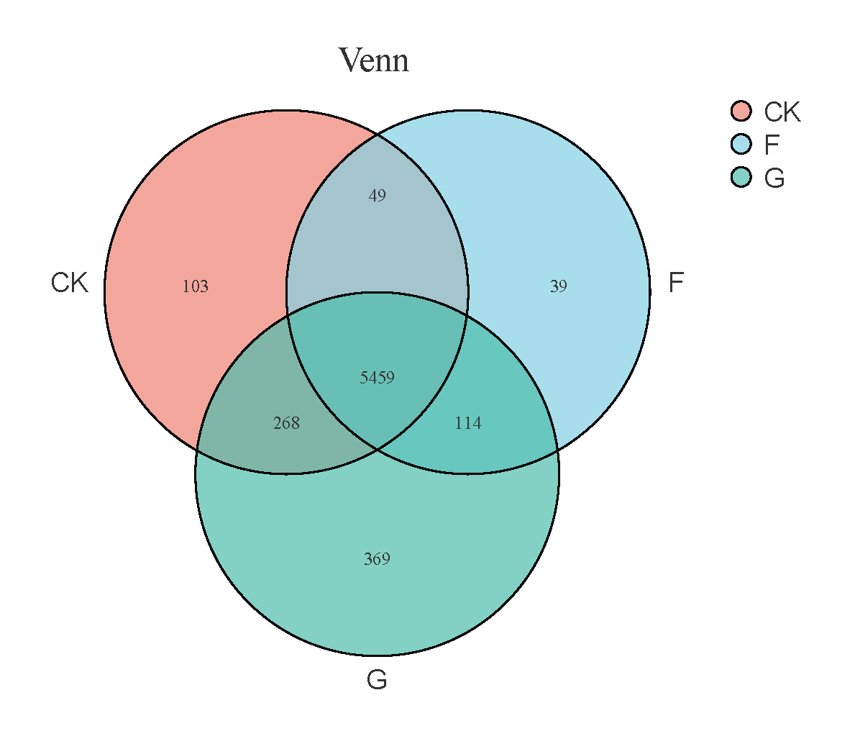

Figure S1. Venn diagram of gene sets of different groups

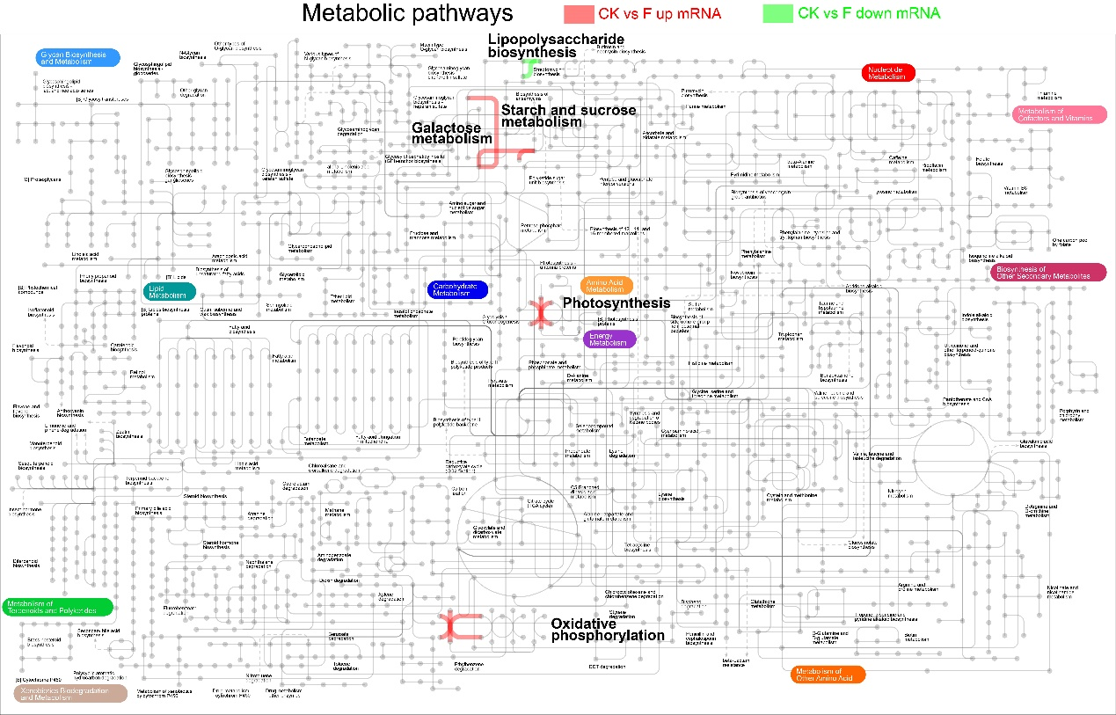
Figure S2. Related metabolic pathway maps of DEGs between laboratory control group and flight group. Pathways in red were the up-regulated genes located; Pathways in green were the downregulated genes located.

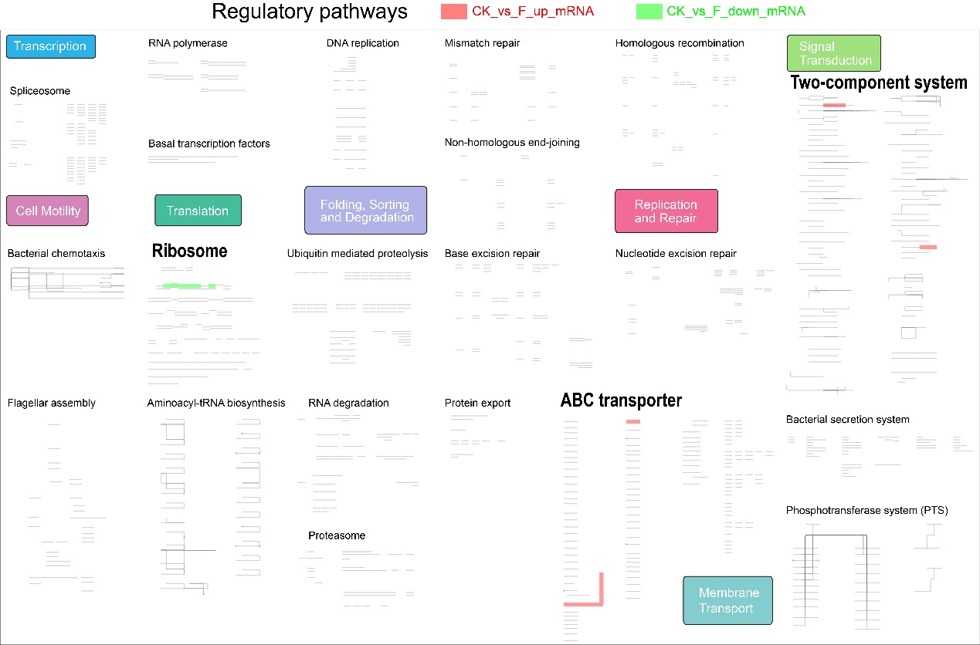
Figure S3. Related regulatory pathway maps of DEGs between laboratory control group and flight group. Pathways in red were the up-regulated genes located; Pathways in green were the downregulated genes located.

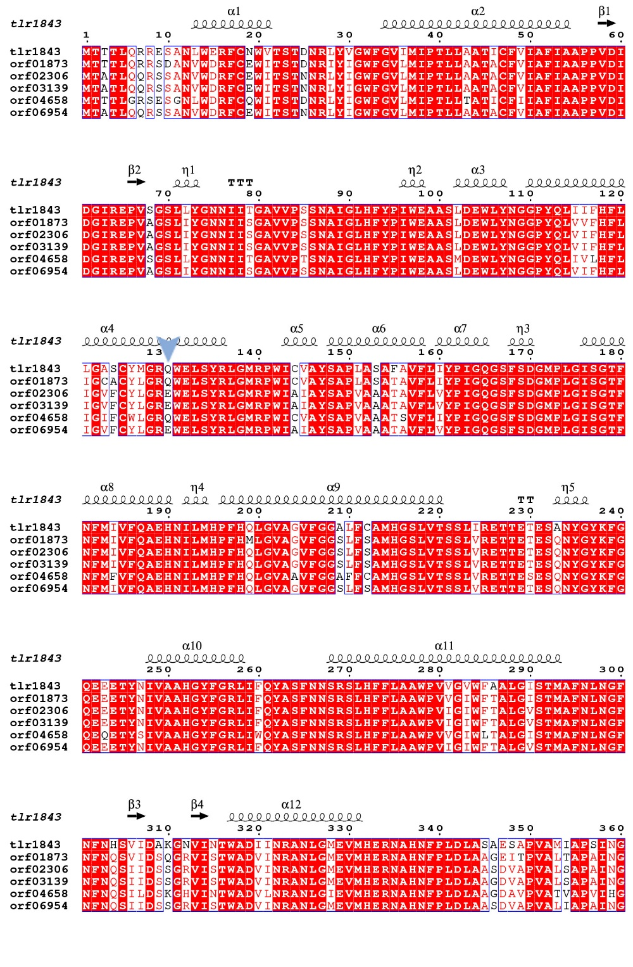
Figure S4. Multiple sequence alignment of psbA protein; Mutation position is highlighted with a blue triangle.

