Figure S1: An illustration of depth uncertainty test to determine error bounds on the inverted crustal thickness. Other details are same as Figure 6. The synthetic RFs and dispersion fitting (cyan line) along with the error bounds (black dashed line) for varying Moho depth by ±1 (left panel) and ±2 km (right panel). Any change of Moho >±2 km does-not fit the RF and dispersion data well (outside the error bounds) suggesting ±2 km be the error in Moho estimation.

Figure S2: An illustration of uncertainty test to determine uncertainties in shear velocity (Vs). Other details are same as Figure 6. The synthetic RFs and dispersion fitting (cyan line) along with the error bounds (black dashed line) for varying Vs by ±1% (left panel) and ±2% (right panel). The model with 1% Vs change gets a good fit to both RF and dispersion curve, while the 2% Vs change has the RF fit well and the dispersion curve crossing the error bounds. For >±2% Vs change the computed RF and dispersion curve does not match with the observed and fits exceed the error bounds.

Figure S3: Joint-inversion results for station WEIJ for clusters in different backazimuths and epicentral distances (all the details are as in Figure 6).

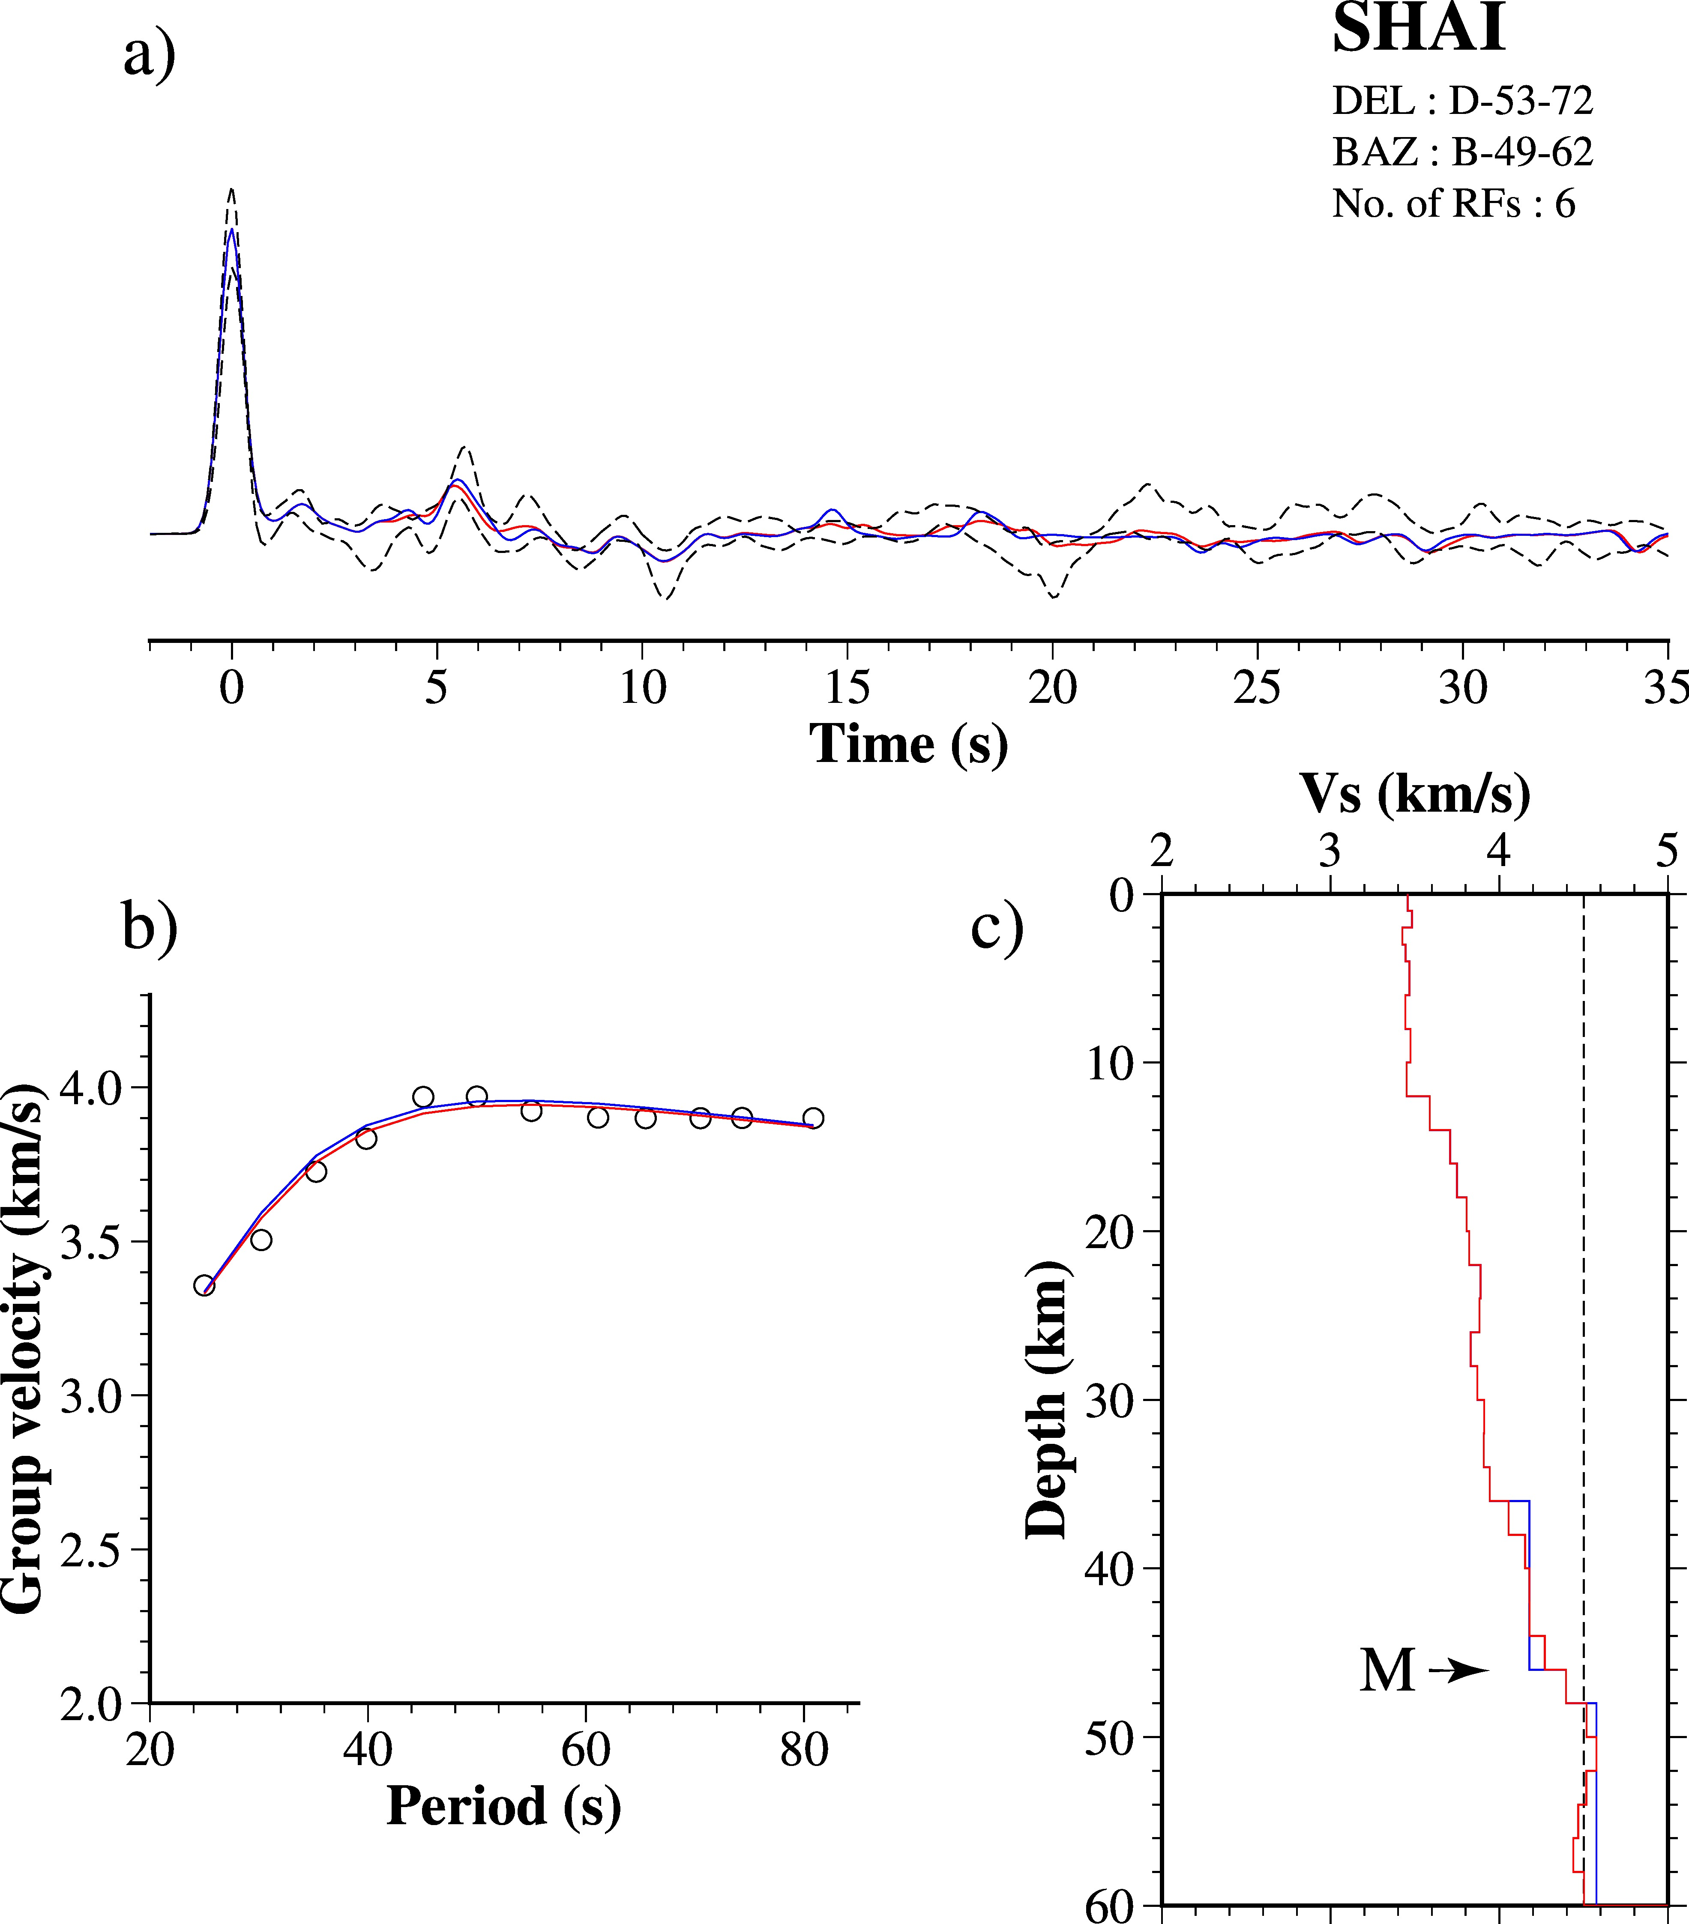

Figure S4: Joint-inversion results for station SHAI for clusters in different backazimuths and epicentral distances (all the details are as in Figure 6).

Figure S5: Joint-inversion results for station KLEF for clusters in different backazimuths and epicentral distances (all the details are as in Figure 6).

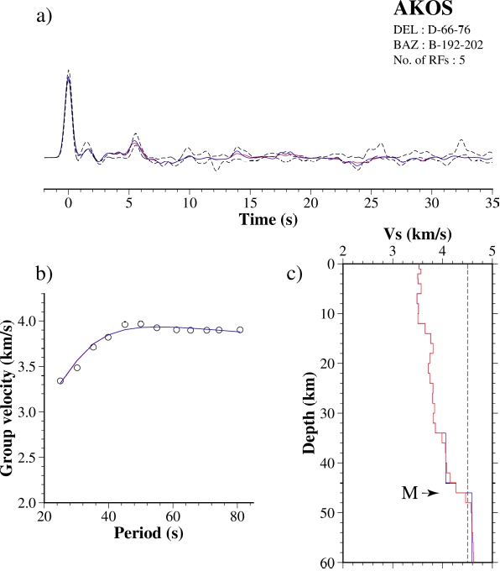

Figure S6: Joint-inversion results for station AKOS for clusters in different backazimuths and epicentral distances (all the details are as in Figure 6).

Figure S7: Joint-inversion results for station KUKU for clusters in different backazimuths and epicentral distances (all the details are as in Figure 6).

Figure S7 (cont.): Joint-inversion results for station KUKU for different clusters (continued.......).
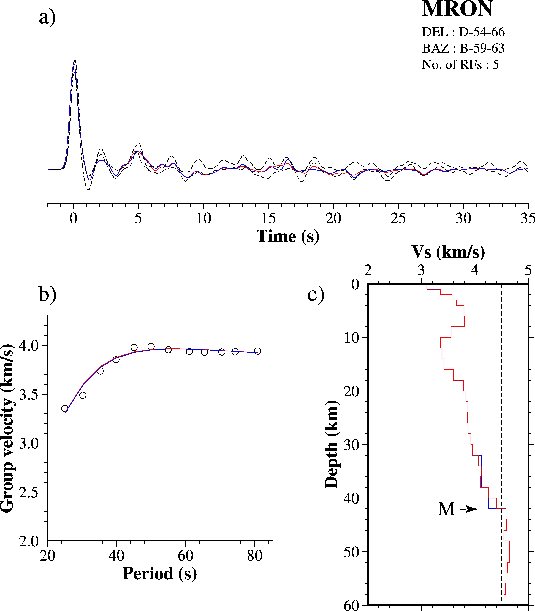
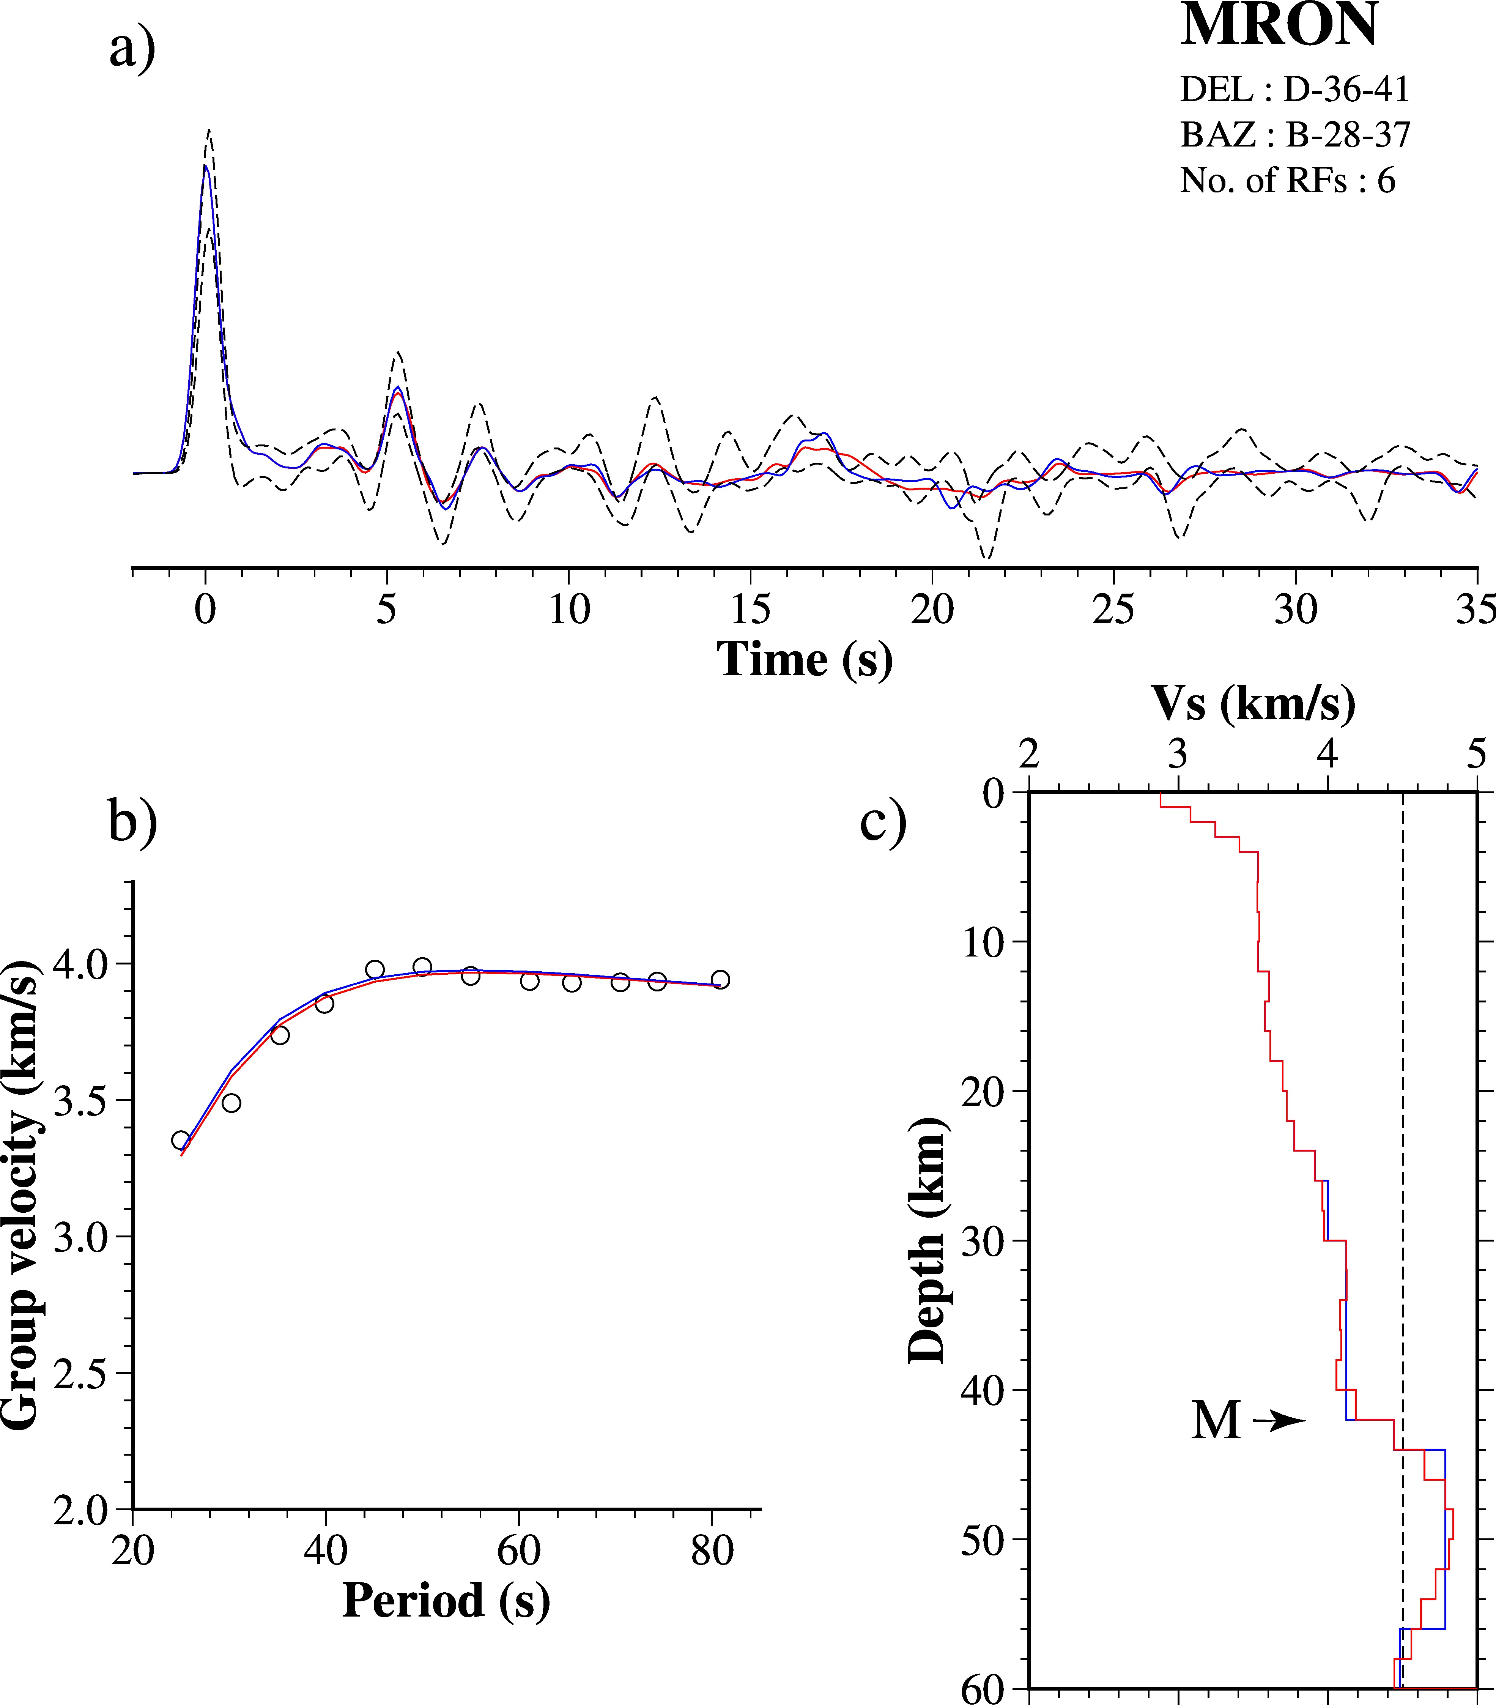
Figure S8: Joint-inversion results for station MRON for clusters in different backazimuths and epicentral distances (all the details are as in Figure 6).
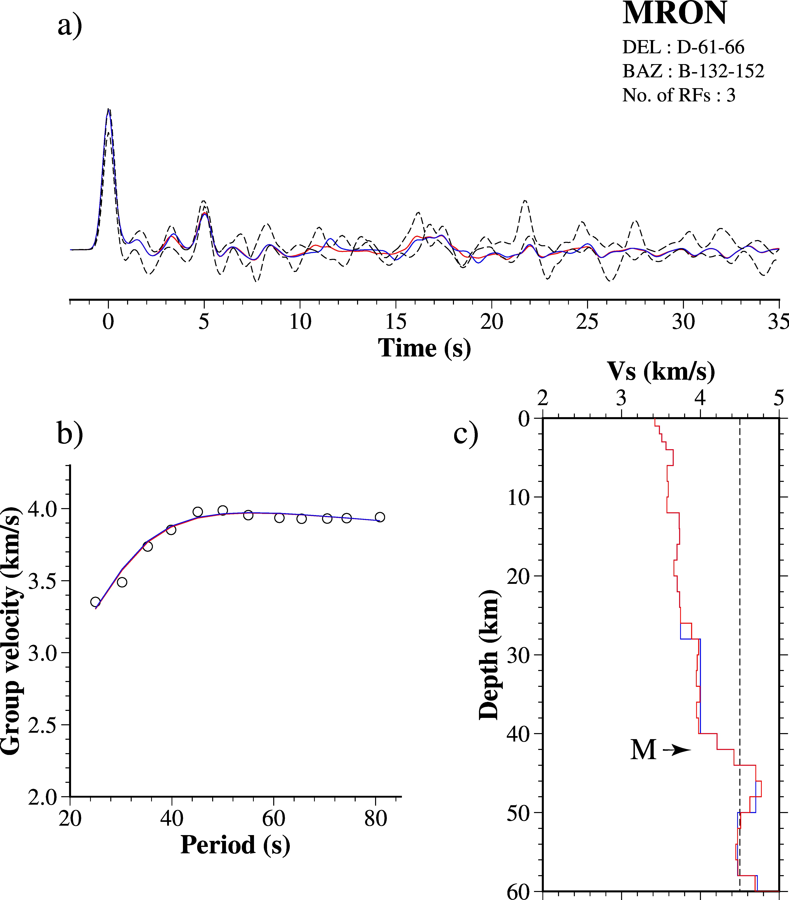
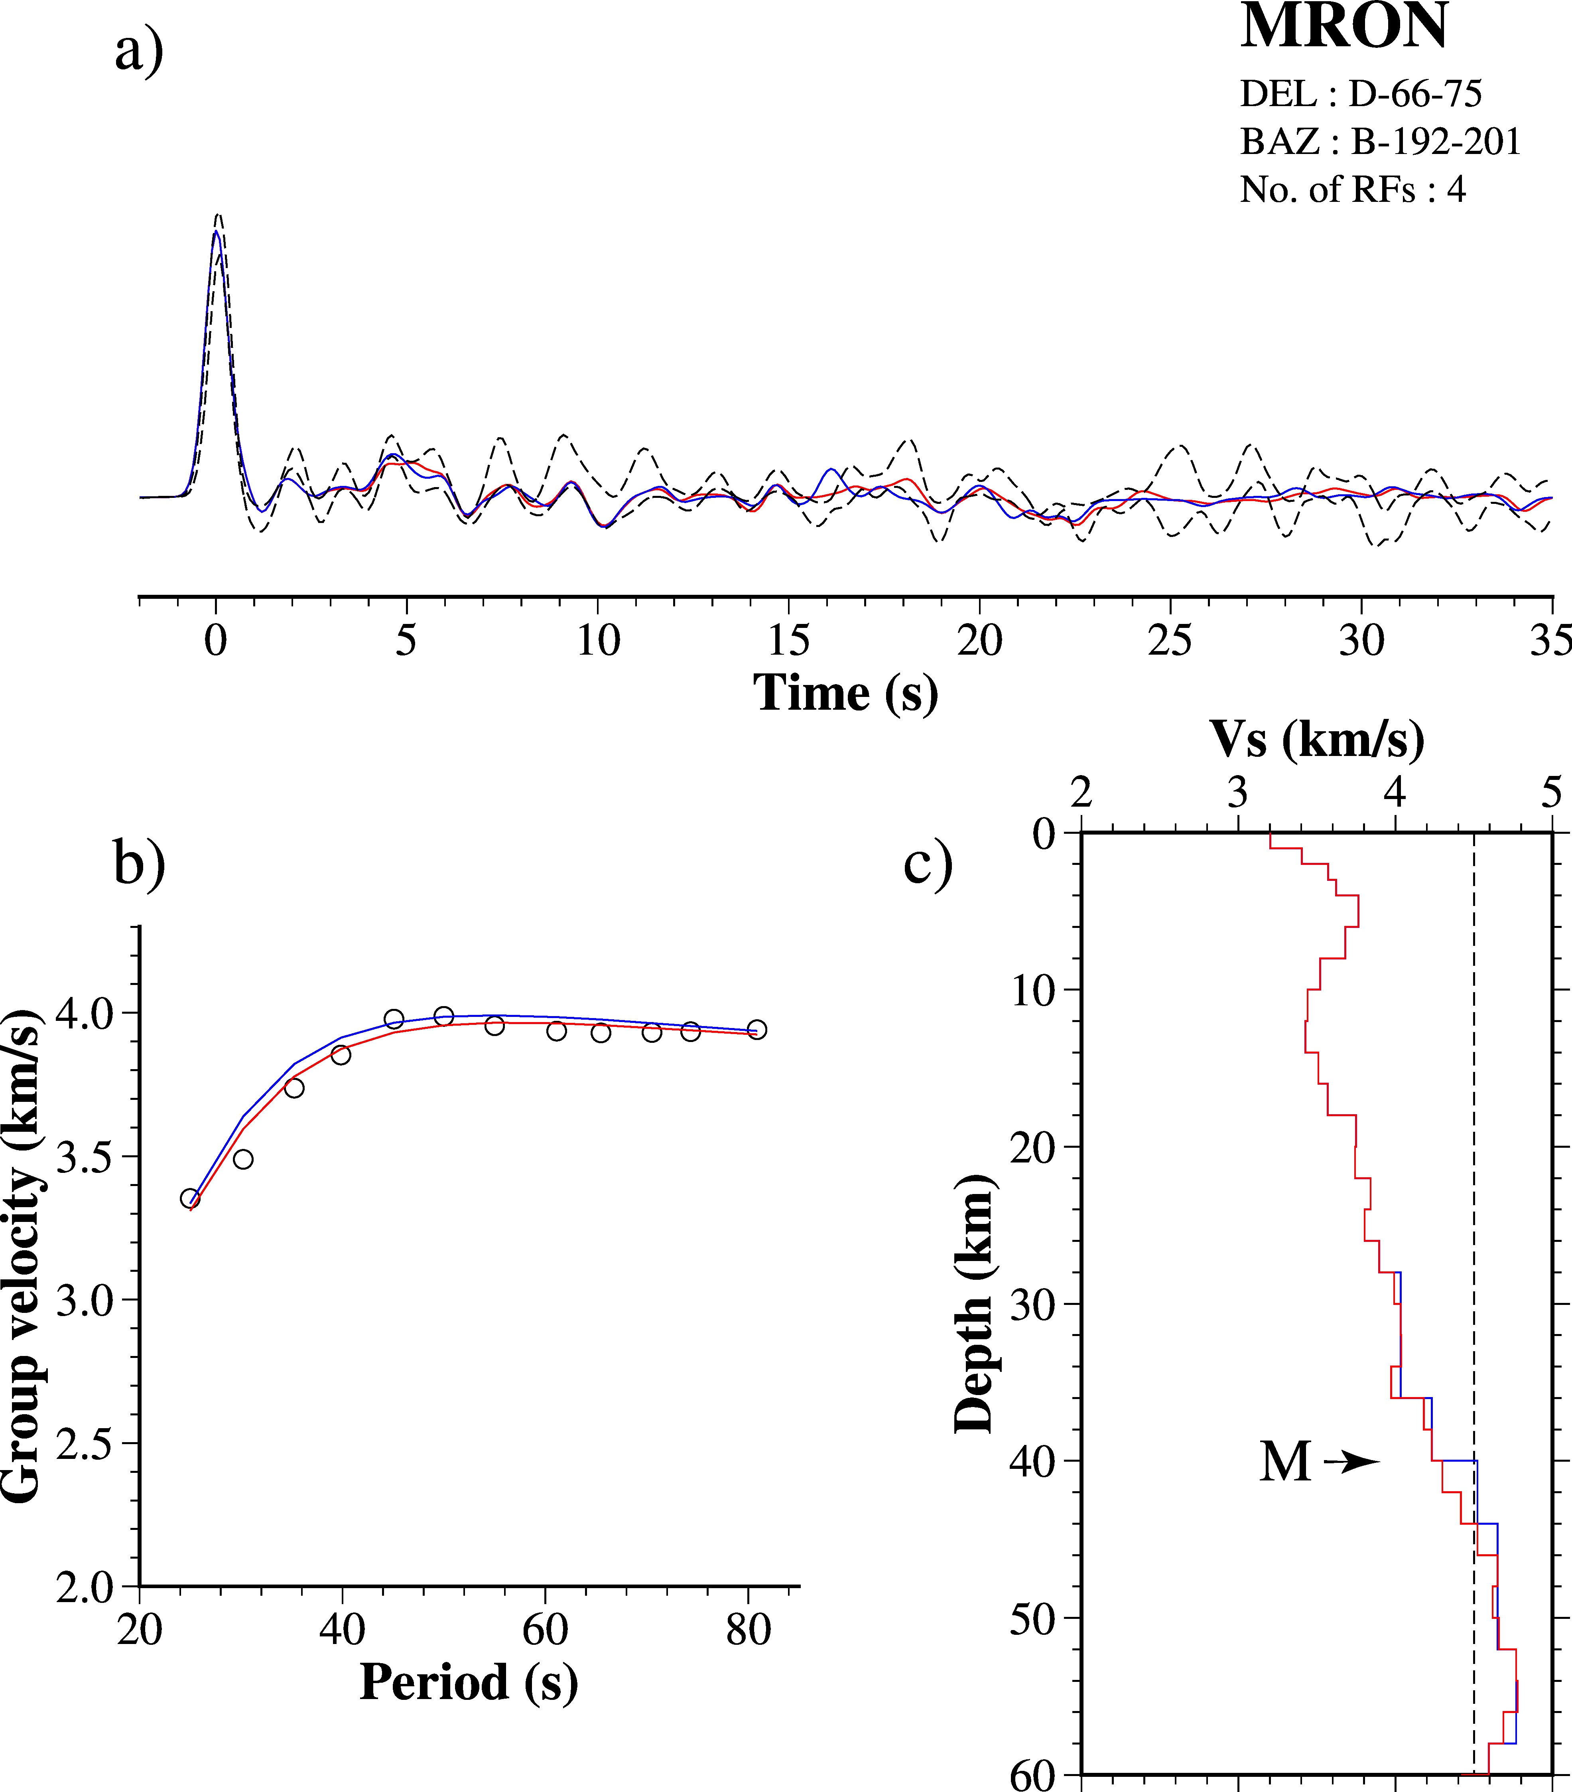

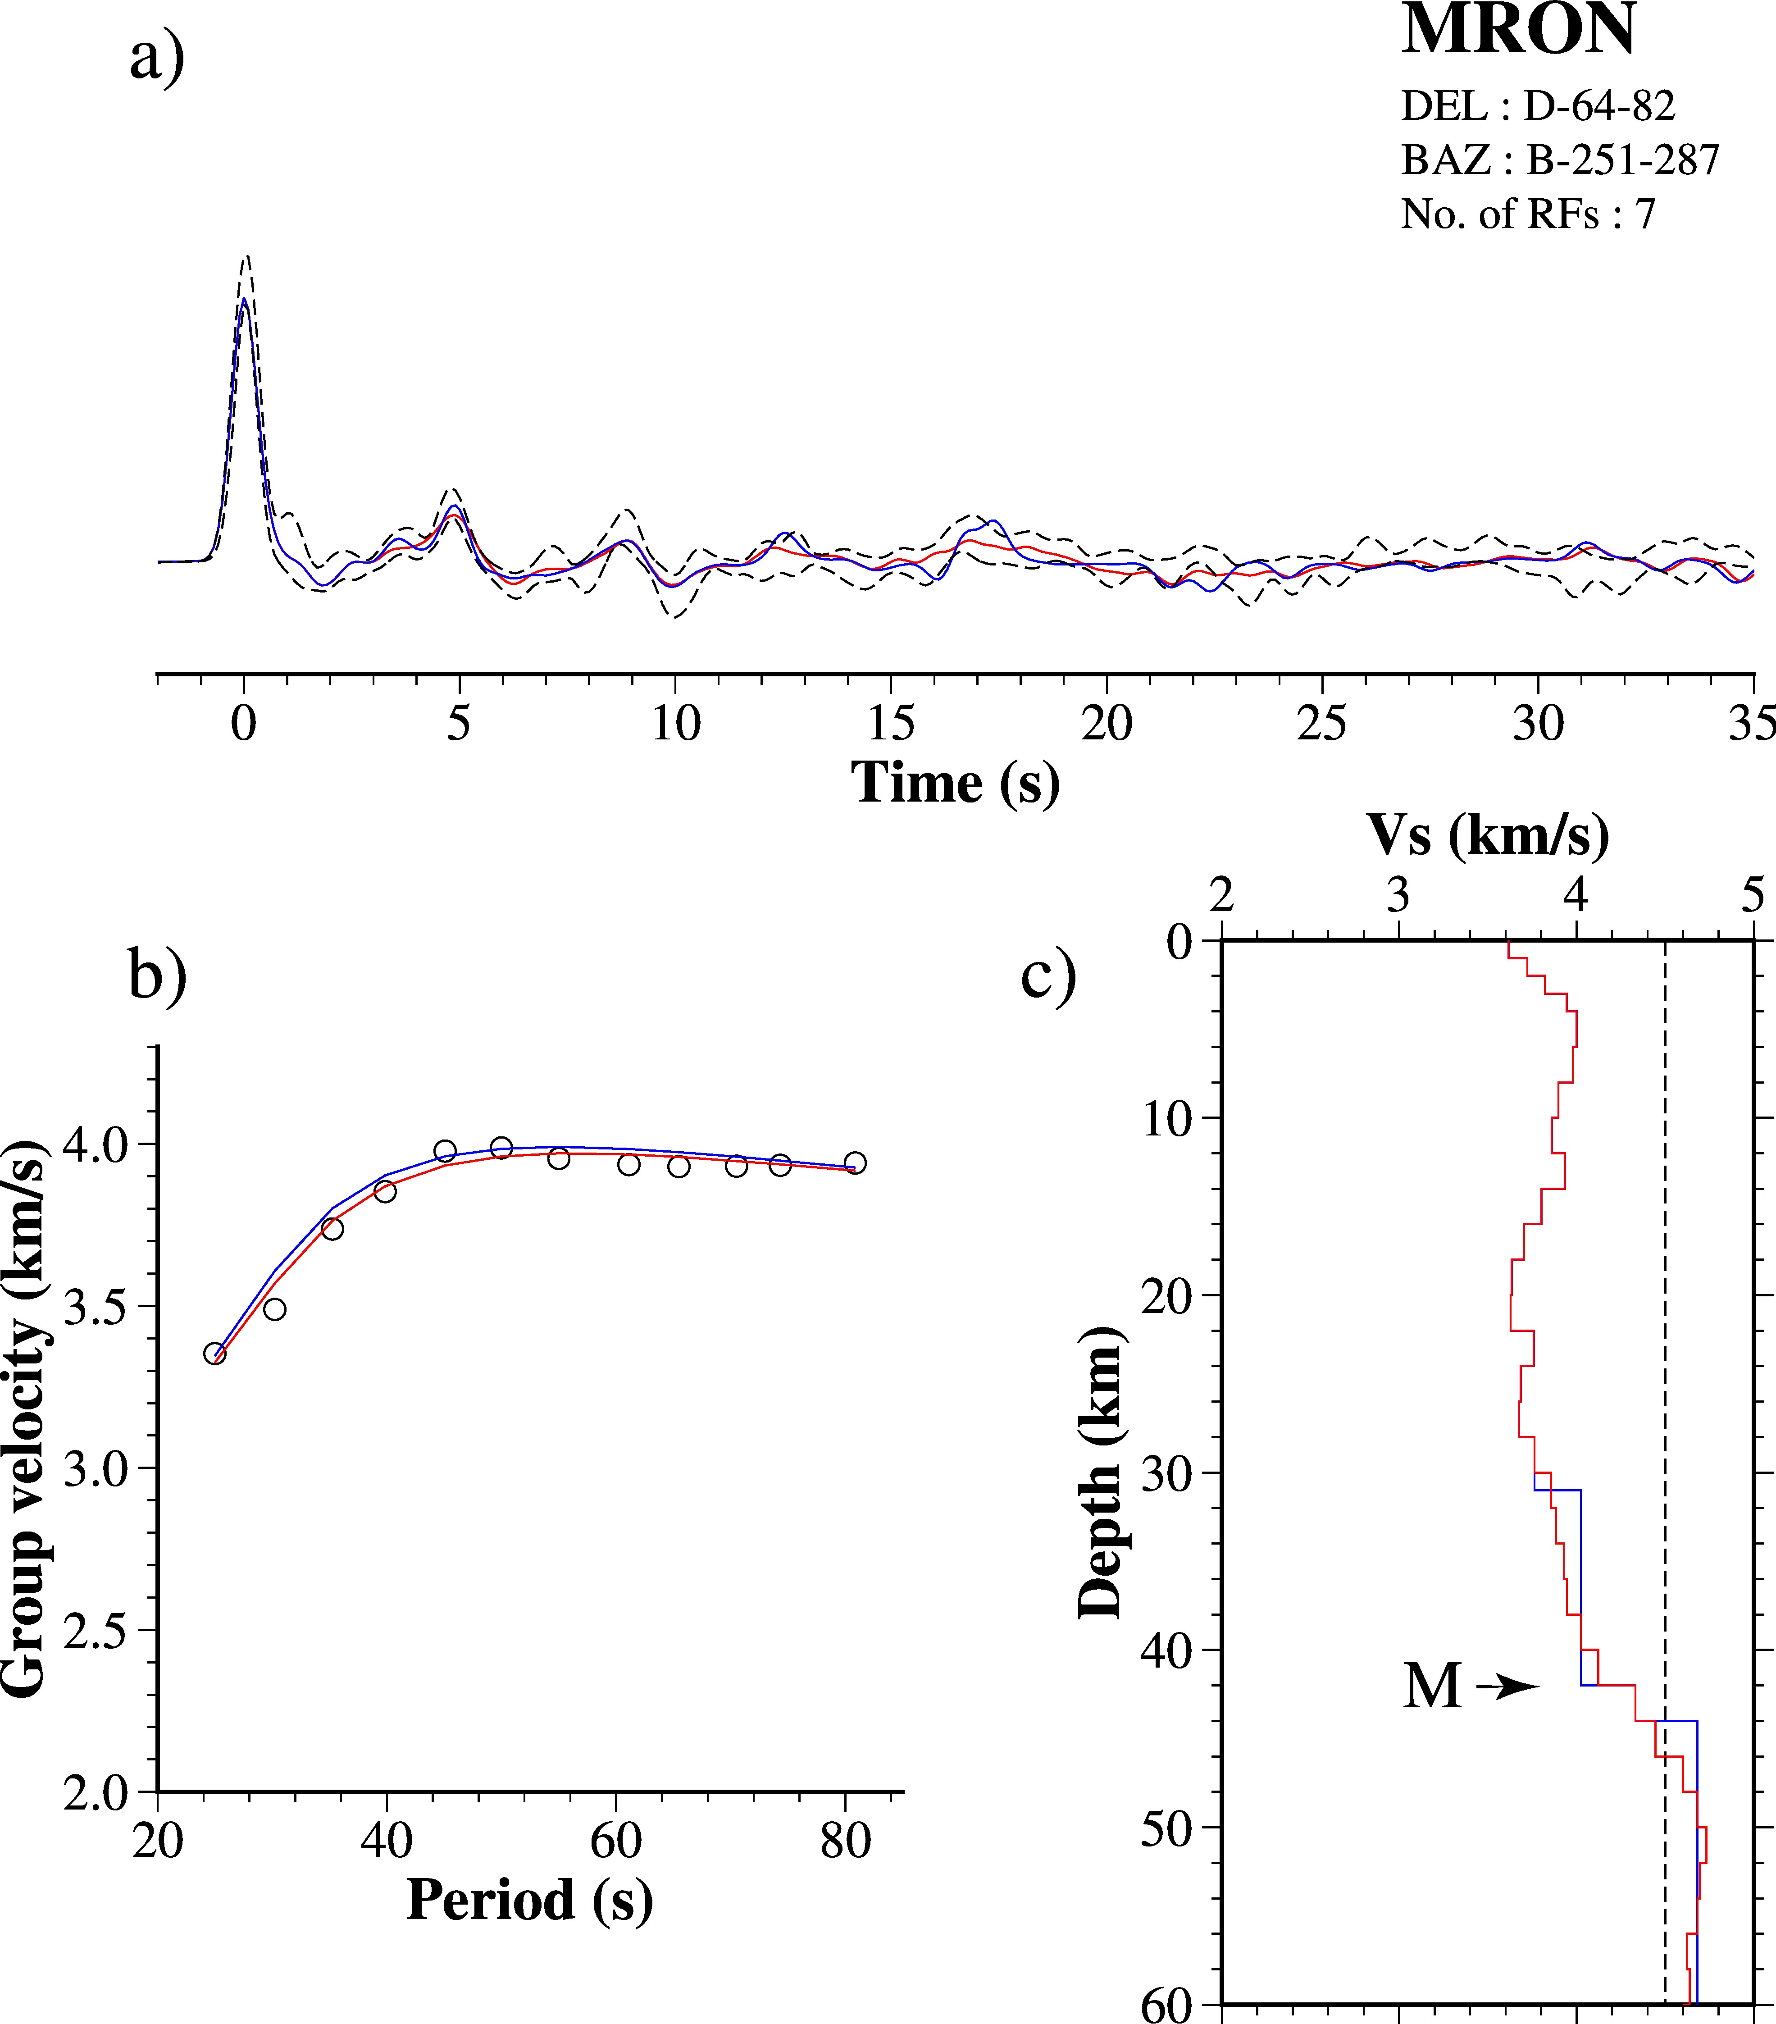

Figure S8 (cont.): Joint-inversion results for station MRON for different clusters (continued.......).

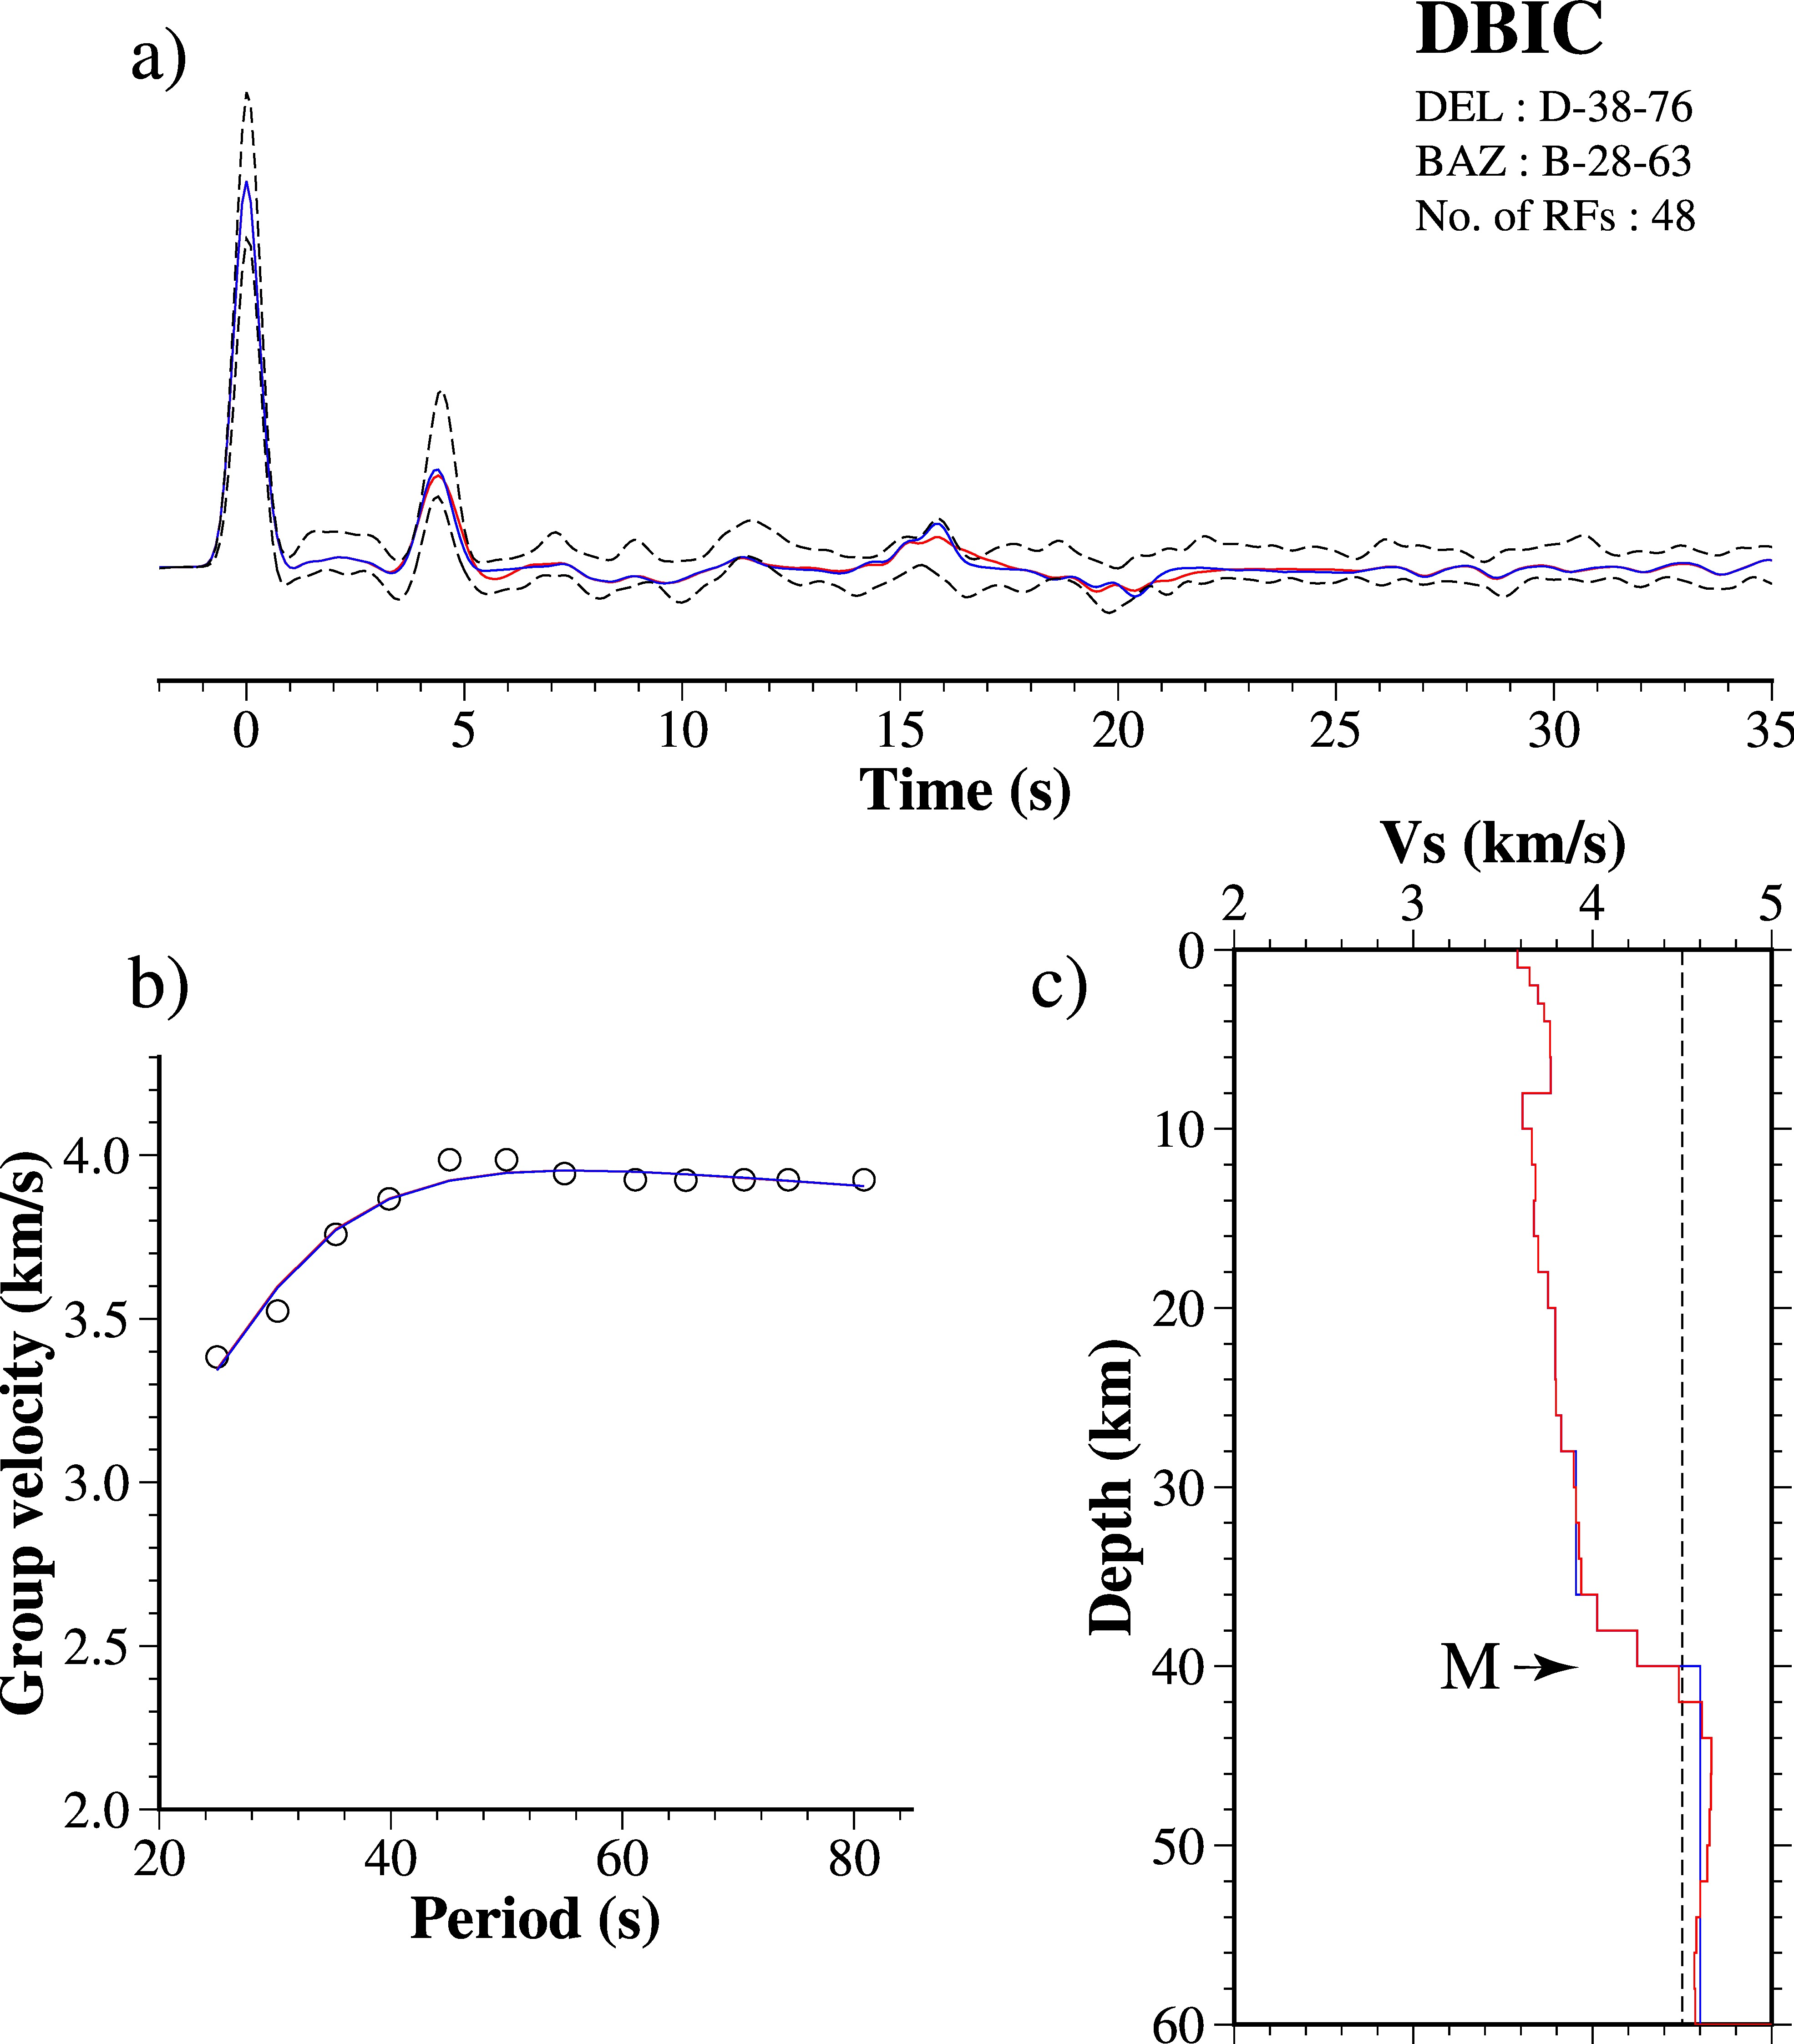
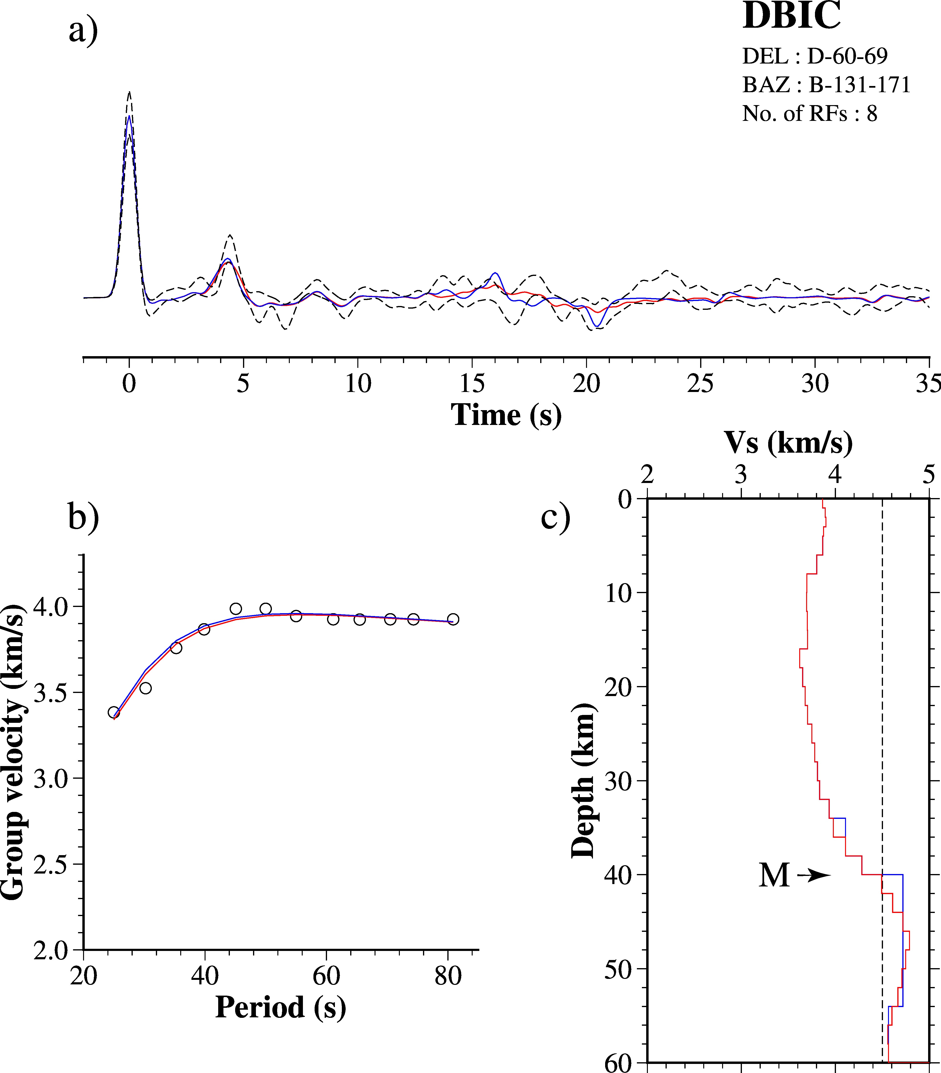

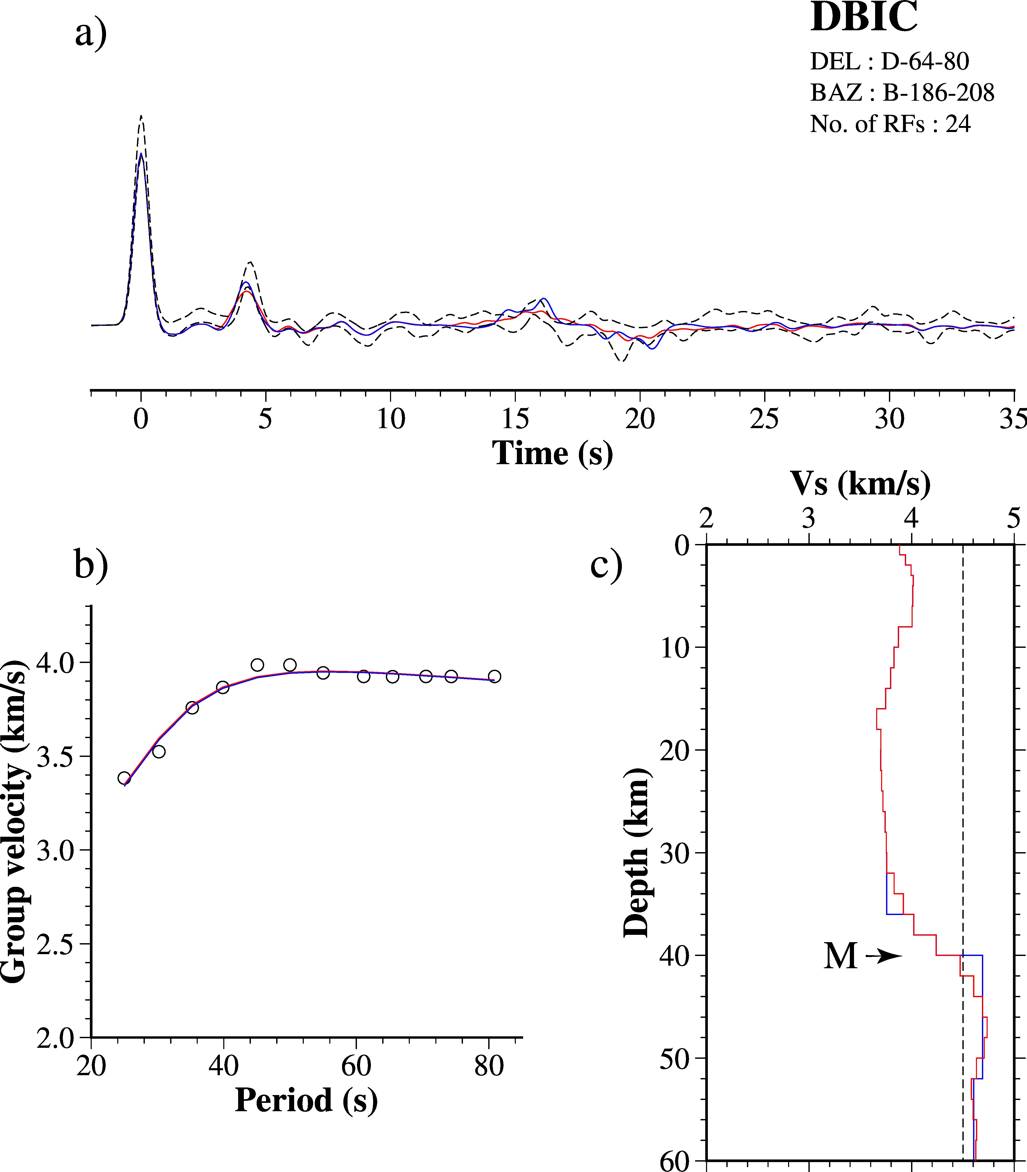
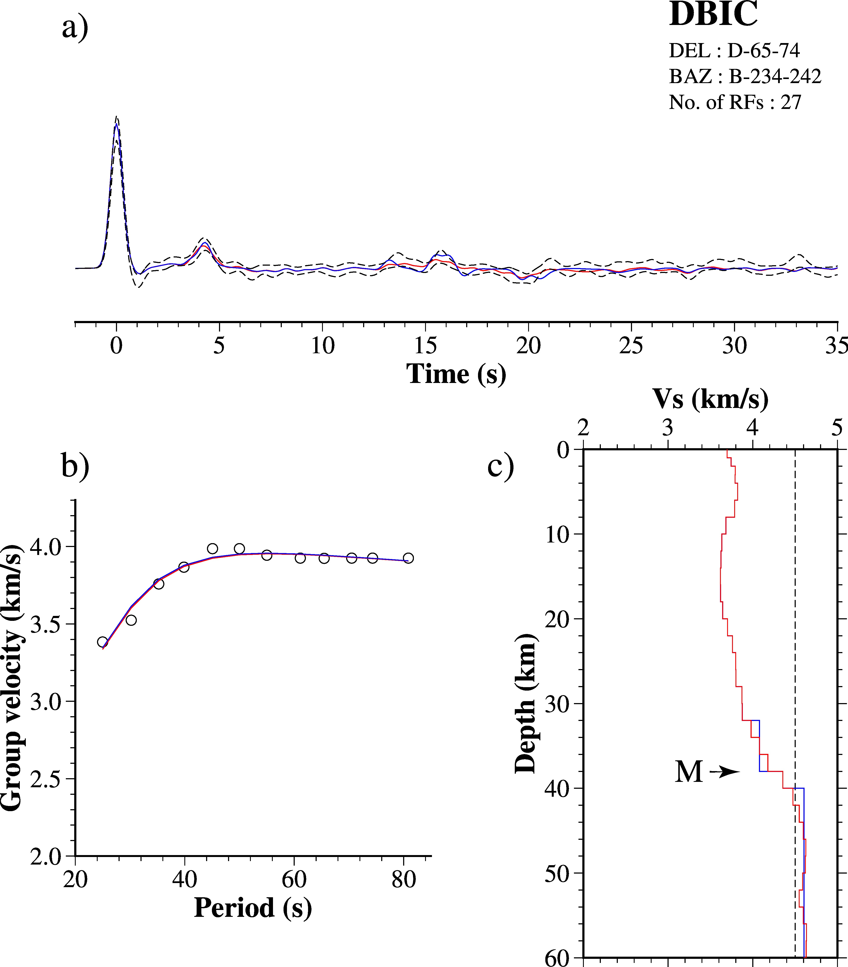

Figure S9: Joint-inversion results for station DBIC for clusters in different backazimuths and epicentral distances (all the details are as in Figure 6).

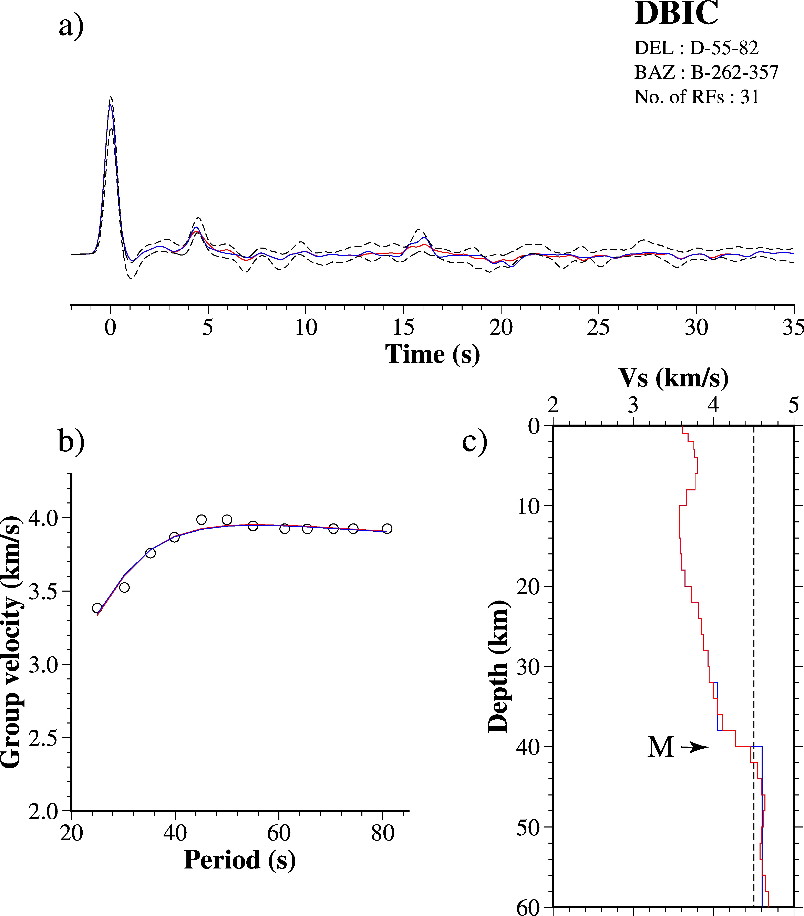

Figure S9 (cont.): Joint-inversion results for station DBIC for different clusters (continued.......).

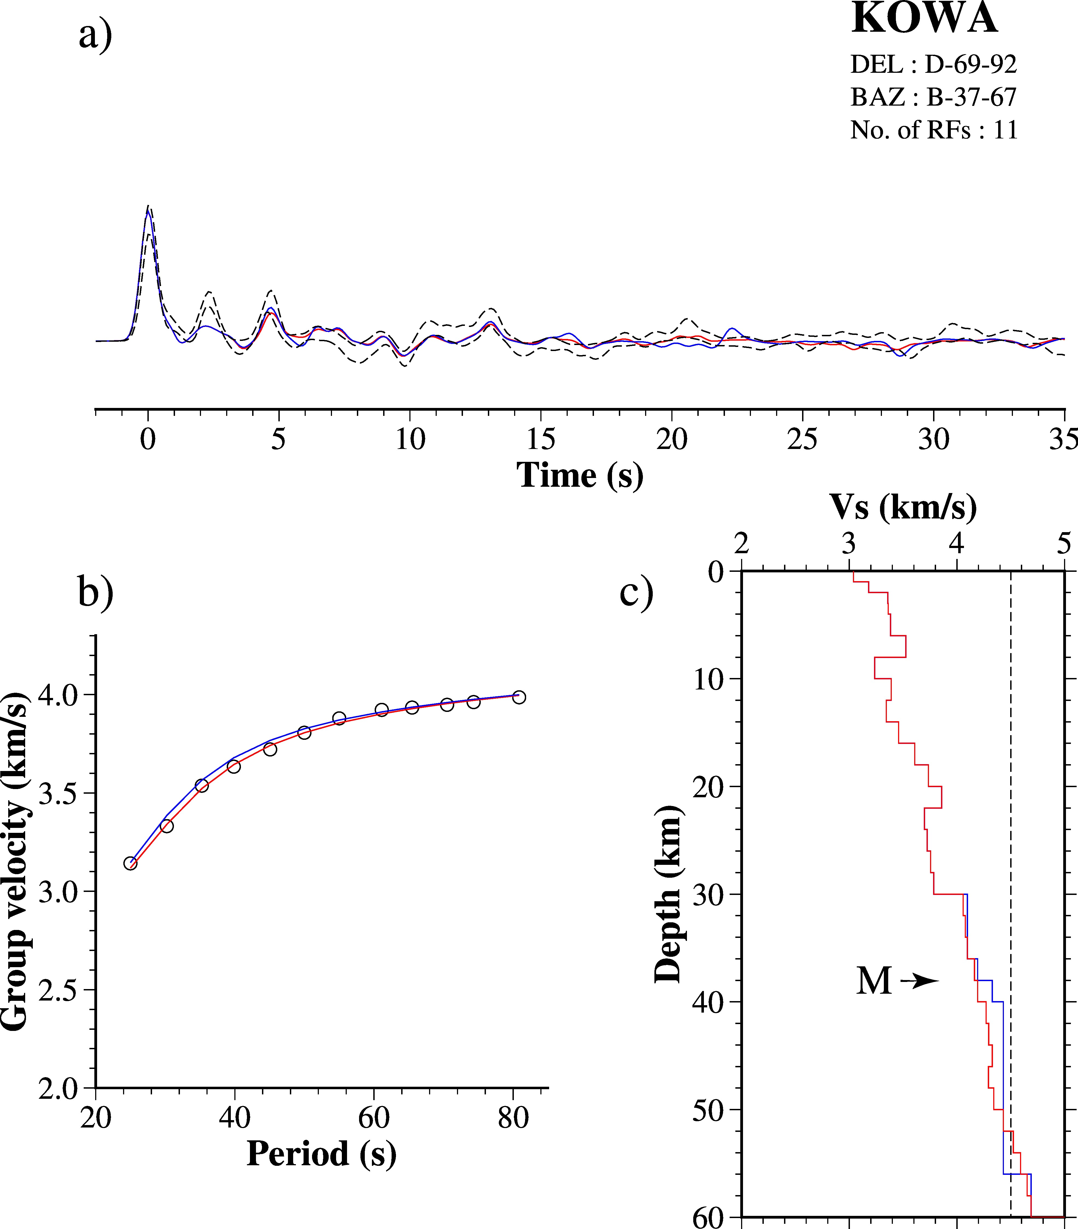

Figure S10: Joint-inversion results for station KOWA for clusters in different backazimuths and epicentral distances (all the details are as in Figure 6).

Figure S10 (cont.): Joint-inversion results for station KOWA for different clusters (continued.......).

