Fig. S1 MAUVE alignment of Phaseoleae species chloroplast genomes. The M. pruriens genome is shown as the reference genome. Within each of the alignments, local collinear blocks are represented by blocks of the same color connected by lines.

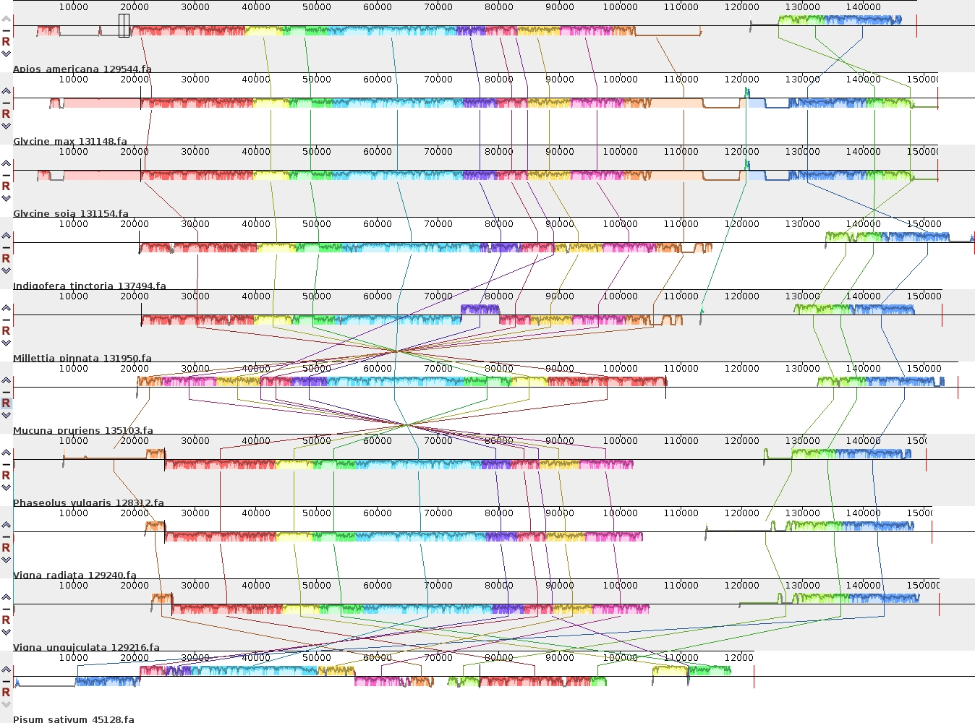

Fig. S2 MAUVE alignment of Phaseoleae species mitochondrial genomes. The M. pruriens genome is shown as the reference genome. Within each of the alignments, local collinear blocks are represented by blocks of the same color connected by lines.

