Supplementary Information

3D Plasmonic Multilayered Gold Nanoarchitecture for Multiple Cancer Diagnosis Using SERS and Machine Learning-Assisted Liquid-Phase Human Urine Sensing

Muhammad Shalahuddin Al Ja’farawy^{1,2,†}, Vo Thi Nhat Linh^{1,†}, Jun-Yeong Yang¹, Chaewon Mun¹, Seunghun Lee¹, Sung-Gyu Park¹, In Woong Han³, Samjin Choi^{4,*}, Min-Young Lee^{1,**}, Dong-Ho Kim^{1,2,***}, and Ho Sang Jung^{1,2,5,****}

¹Department of Nano-Bio Convergence, Korea Institute of Materials Science (KIMS), Changwon, 51508, South Korea
²Advanced Materials Engineering, University of Science and Technology (UST), Daejeon, 34113, South Korea
³Division of Hepatobiliary-Pancreatic Surgery, Department of Surgery, Samsung Medical Center, Sungkyunkwan University School of Medicine, Seoul, 06351, South Korea
⁴Department of Biomedical Engineering, College of Medicine, Kyung Hee University, Seoul, 02447, South Korea
⁵School of Convergence Science and Technology, Medical Science and Engineering, Pohang University of Science and Technology (POSTECH), Pohang, 37673, South Korea
†These authors contributed equally

*Corresponding author
**Corresponding author
***Corresponding author
****Corresponding author
E-mail: jhs0626@kims.re.kr (Dr. Ho Sang Jung), dhkim2@kims.re.kr (Dr. Dong-Ho Kim), myay0615@kims.re.kr (Dr. Min-Young Lee), medchoi@khu.ac.kr (Prof. Samjin Choi).
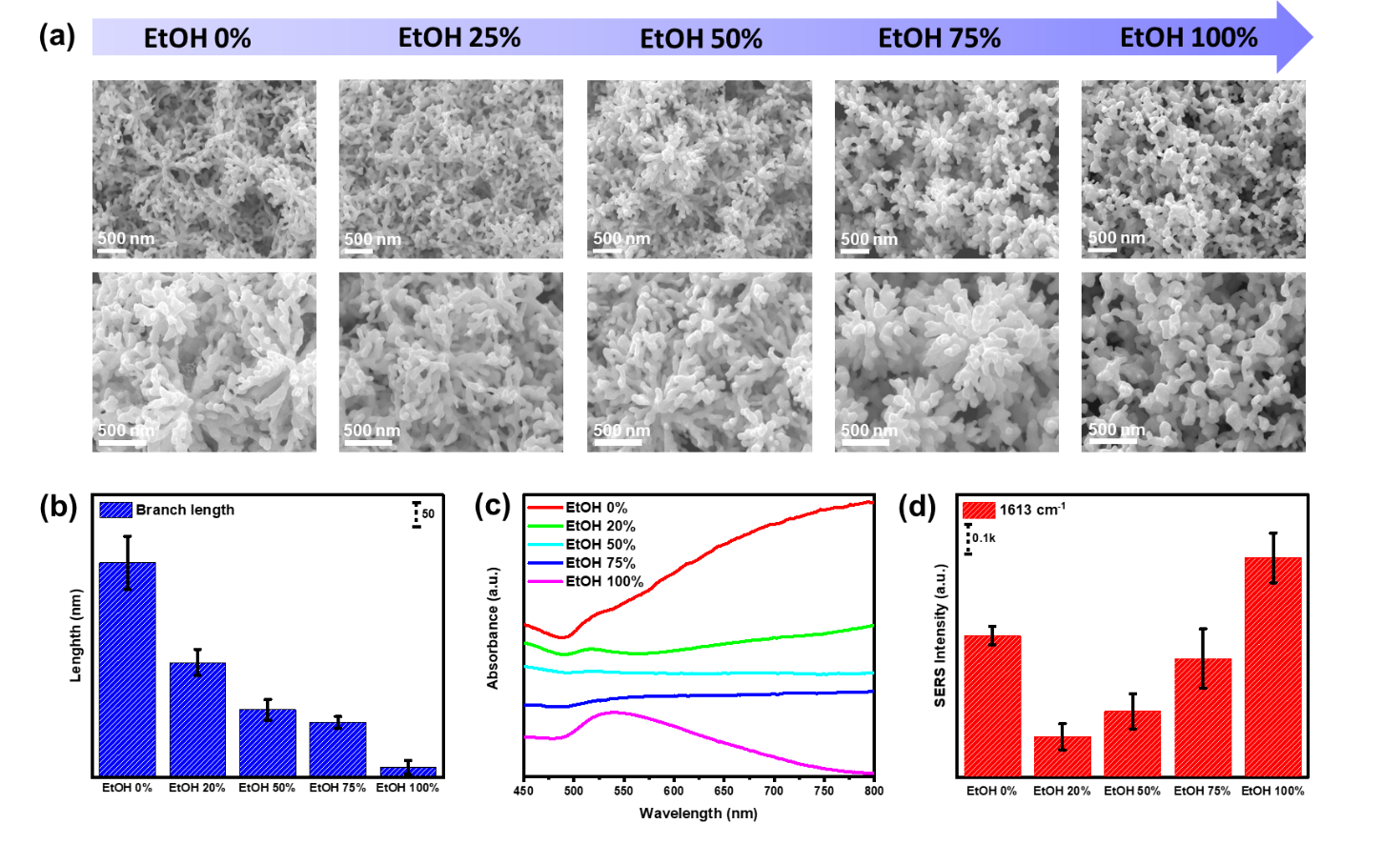
Figure S1. Study of Au nanostructure development at various CH₃-rich environment. a SEM images, b branch length, c UV–vis absorbance, and d SERS performance of Au nanostructure formed at different EtOH concentrations.
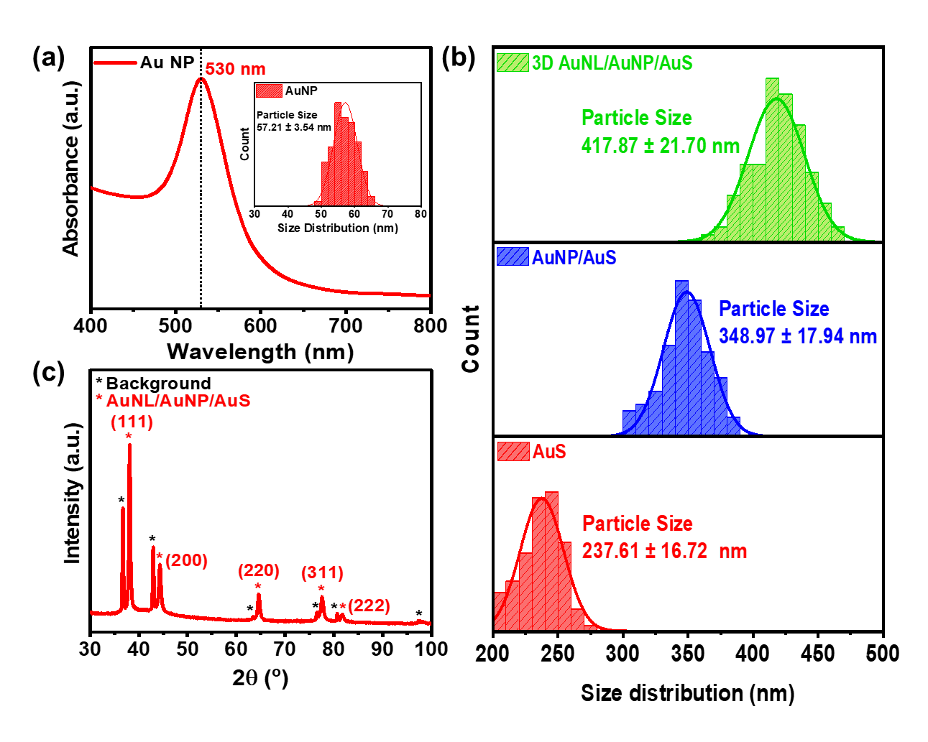
Figure S2. Material characterization of 3D AuNL/AuNP/AuS. a UV–vis absorbance and particle size distribution of AuNP (inset figure), b particle size distribution of AuS, AuNP/AuS, and 3D AuNL/AuNP/AuS, and c XRD measurement of 3D AuNL/AuNP/AuS well plate.
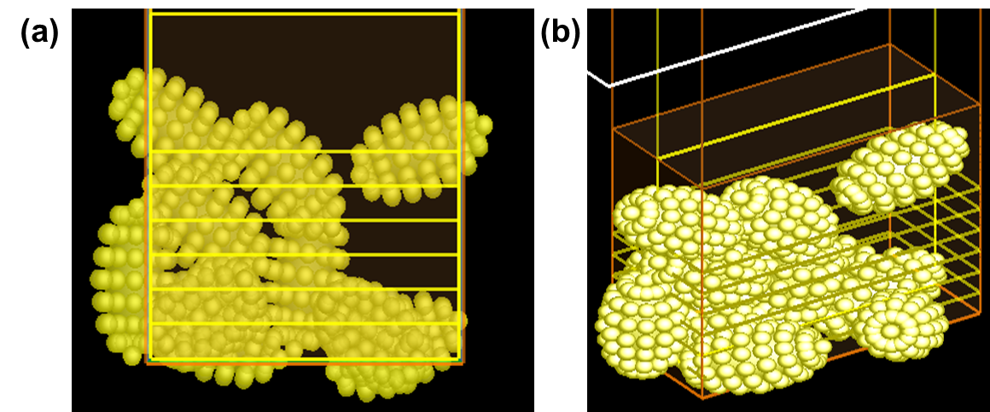
Figure S3. The model for FDTD simulation in a XZ and b 3D views.
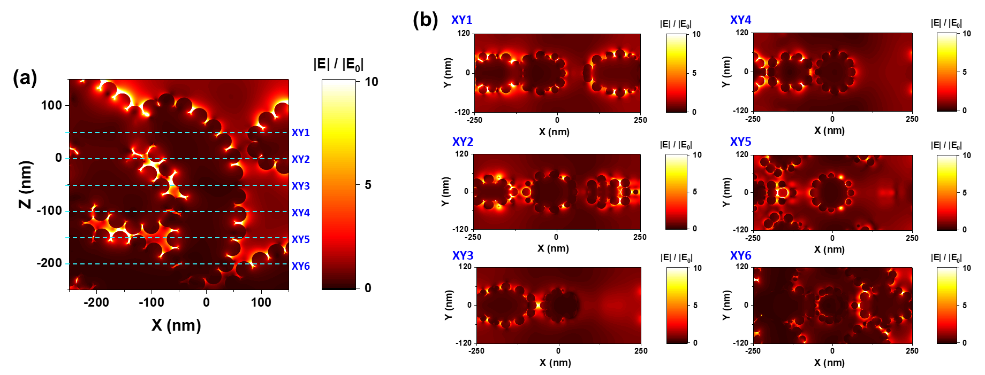
Figure S4. E-field distribution of 3D AuNL/AuNP/AuS obtained by FDTD simulation at a XZ cross-section view and b in various z axis positions.
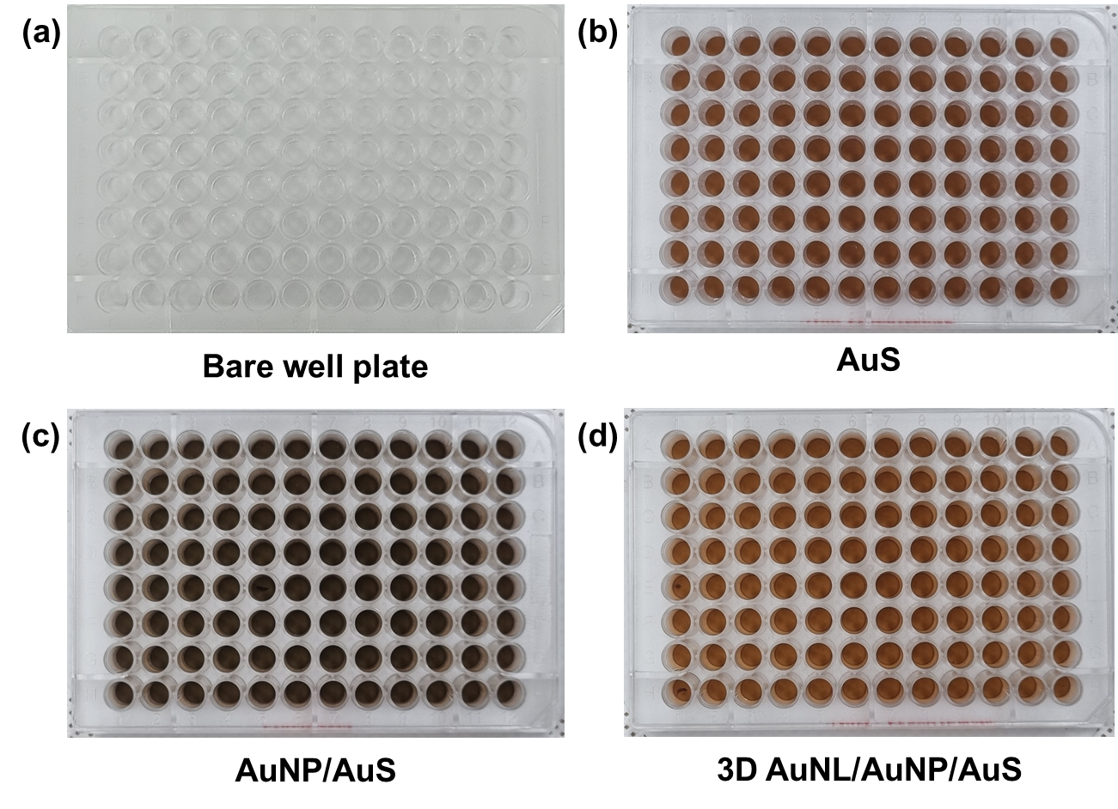
Figure S5. Photograph images of a bare well plate, b AuS, c AuNP/AuS, and d 3D AuNL/AuNP/AuS.
Figure S6. SERS performance of 3D AuNL/AuNP/AuS in the dry- and liquid-state measurements of MG (1 µM).
Figure S7. SERS analysis of 3D AuNL/AuNP/AuS for human urine sensing in dry- and liquid-state measurements.
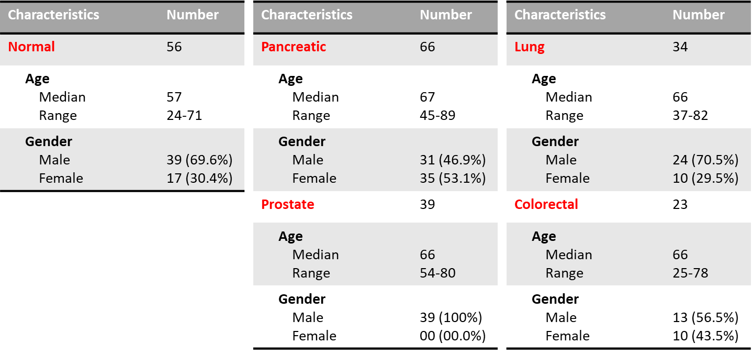
Figure S8. Normal and cancer patient information used for multicancer detection.
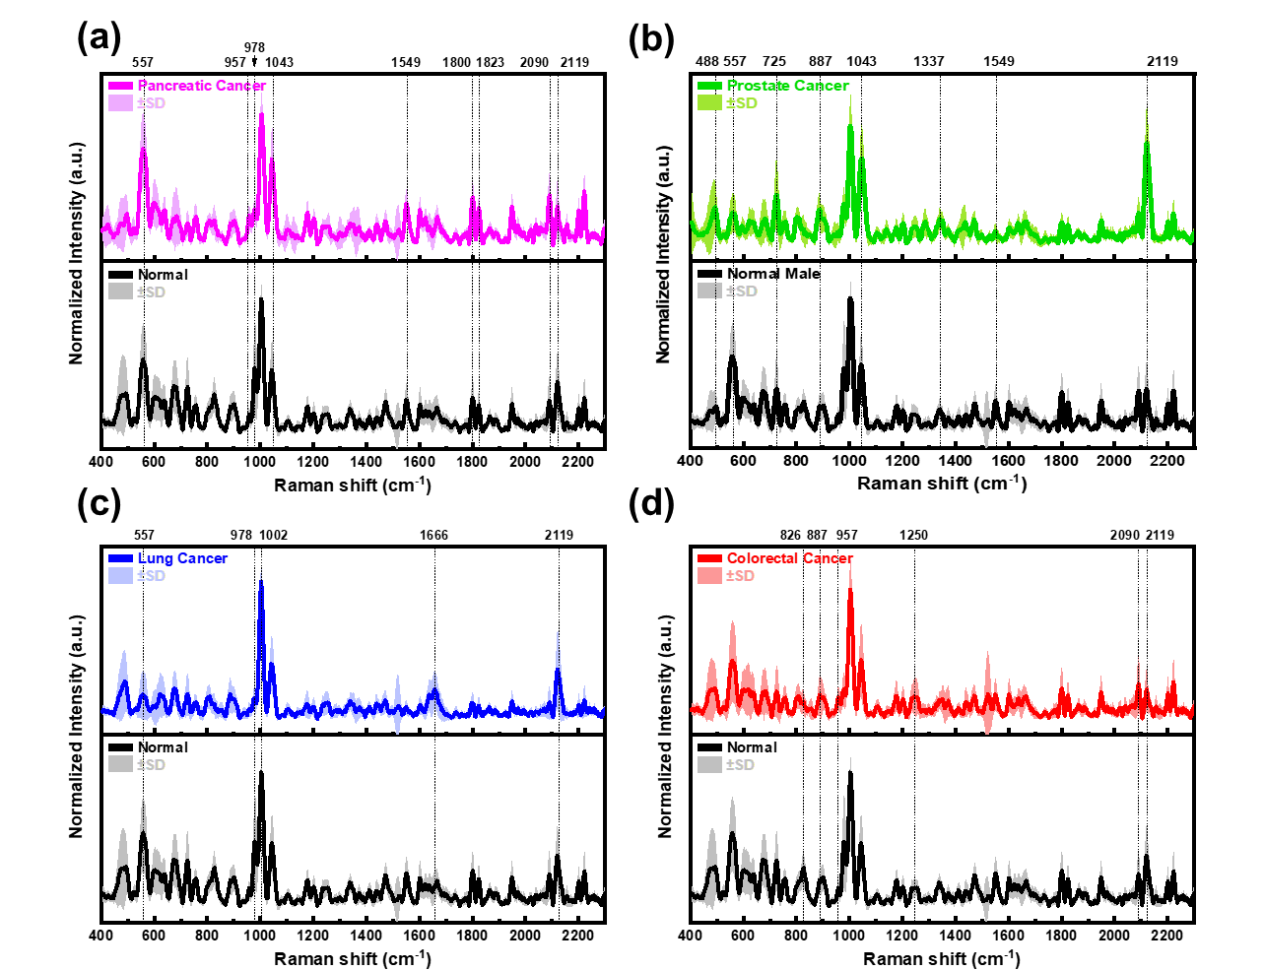
Figure S9. Raman spectra comparison of normal and patients with a pancreatic, b prostate, c lung, and d colorectal cancers.
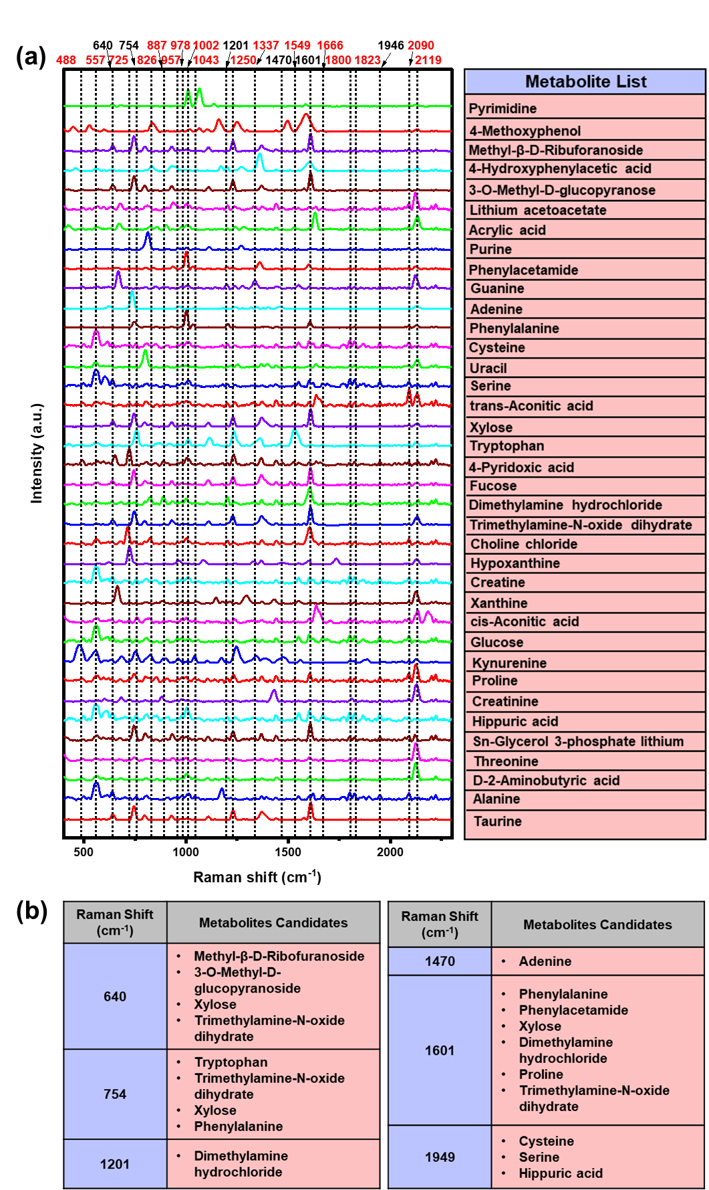
Figure S10. a SERS spectra of each metabolite candidate at a concentration of 10 mM obtained on 3D AuNL/AuNP/AuS (numbers marked on the top indicate the Raman shift positions observed from urine spectra, numbers in red are for the selective positions in Figure 4b and b Raman peak assignment of metabolite candidates for peak positions marked in black color in Figure S10a.
Figure S11. Accuracy and loss graph of CNN deep learning–based model for the training dataset.

