Supplementary Information:
Supplementary Table 1. Programme participants and sites
Participants (n=26) | n (%)
Grade of practice
Senior House Officer | 5 (19)
Registrar | 1 (4)
Specialist Registrar | 19 (73)
Physician Associate | 1 (4)
Hospitals (n=15)
Model 4 | 8 (53)
Model 3 | 7 (47)

Supplementary Figure 1. Programme Run Chart
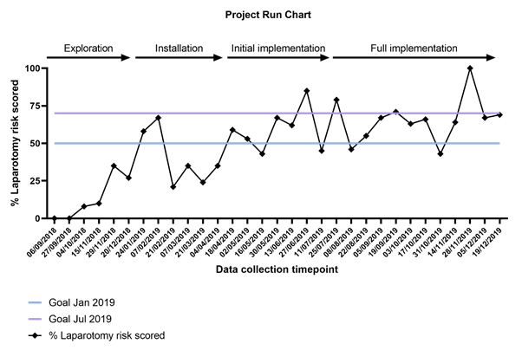
Supplementary Figure 2. Impact of post rotation on data collection and risk scoring. (A) Proportion of available data collection time-points with data contributed before and after July 2019 and (B) Proportion of laparotomies risk scored before and after July 2019

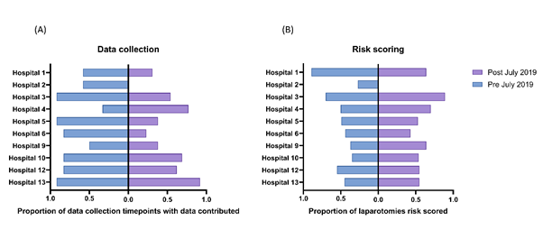

Supplementary Figure 3. Volume of “WhatsApp” messages sent by local leads before and after July 2019
