The development of the adult nervous system in the annelid Owenia fusiformis

Allan M. Carrillo-Baltodano^{1*}, Rory D. Donnellan¹, Elizabeth A. Williams², Gáspar Jékely^{3,4}, José M. Martín-Durán¹

¹School of Biological and Behavioural Sciences, Queen Mary University of London, London, UK
²Faculty of Health and Life Sciences, University of Exeter, Exeter, UK
³Living Systems Institute, University of Exeter, Exeter, UK
⁴Centre for Organismal Studies (COS), University of Heidelberg, Heidelberg, Germany

*Corresponding author: a.carrillo-baltodano@qmul.ac.uk

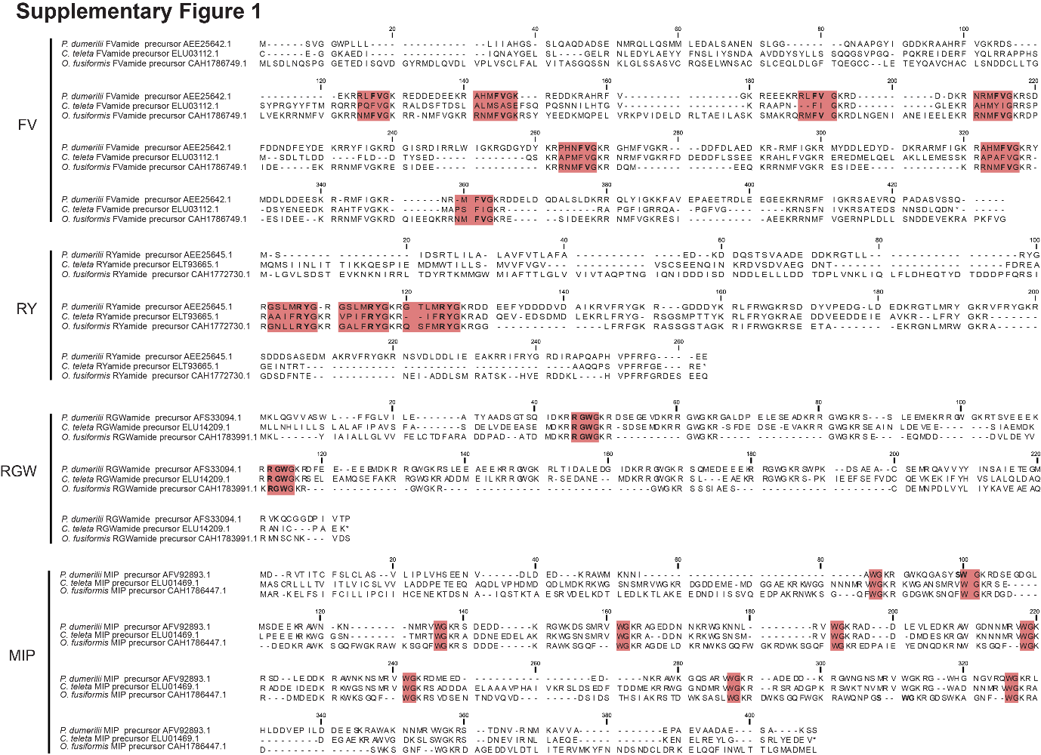
Supplementary Information

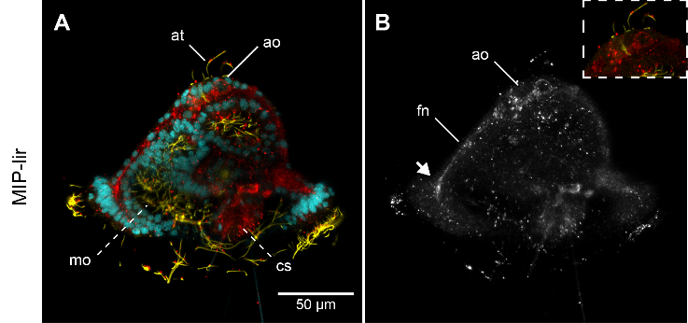
Additional File1: Supplementary Figure 1 Alignment of the neuropeptide precursors P. dumerilii (30-32), C. teleta (62) and Owenia fusiformis (29). Representative mature peptides and conserved dipeptides are highlighted in red and bold, respectively.

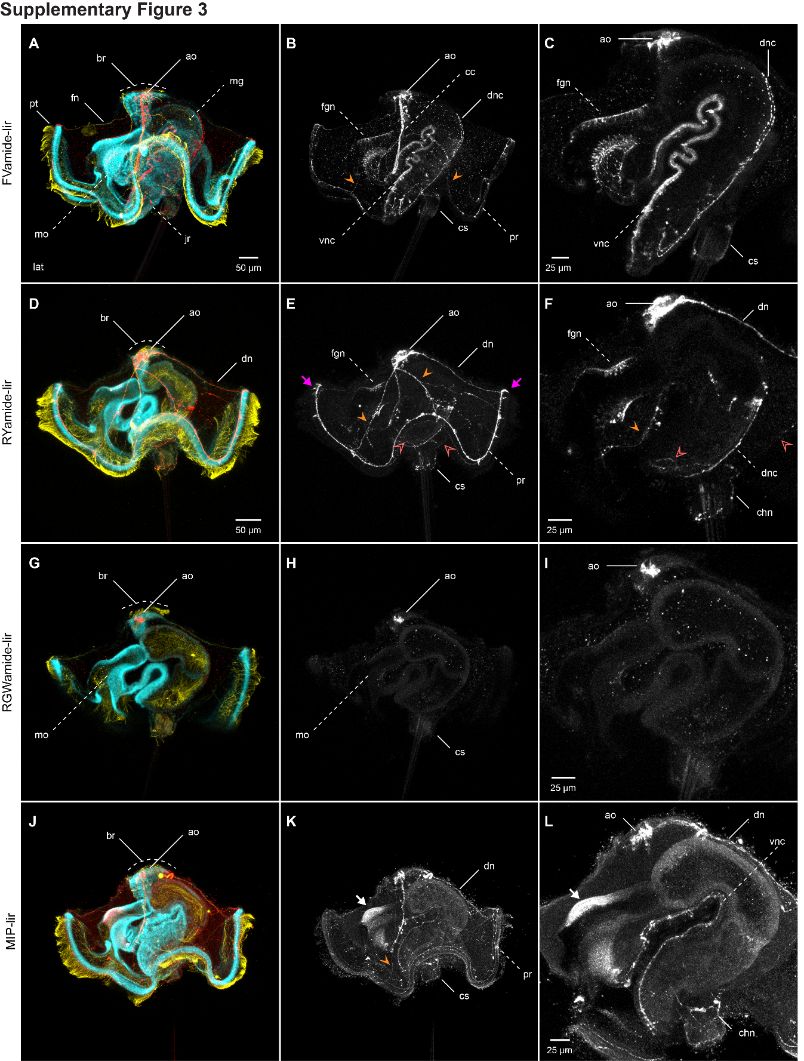
Additional File 2: Supplementary Figure 2 MIP-lir elements in the 24hpf mitraria. MIP-lir cells include several cells as part of the apical organ (ao) and one cell anterior to the foregut (white arrow), including a MIP-lir frontal nerve (fn). Inset in b is a close up of the apical organ (ao) in the same view as the larger image. ao: apical organ; at: apical tuft; cs: chaetal sac; fn: frontal nerve; mo: mouth.

Additional File 3: Supplementary Figure 3. Neuropeptide-lir elements in the competent larvae. CLSM images of DAPI (cyan), acetylated tubulin (yellow) and neuropeptide-lir (red or white) elements in the competent larvae (~ 3 wpf). Lateral views, with anterior to the left. c, f, i, l are close ups of the juvenile rudiment in the same view as the respective larger image in b, e, h, k. a–c FVamide-lir cells and MIP-lir cells in the apical organ connect via FVamide-lir and MIP-lir circumesophageal connectives (cc) to the ventral nerve cord (vnc) of the juvenile trunk rudiment (jr), and via a–b FVamide-lir, d–e RYamide-lir and j–k MIP-lir frontal (fn), dorsal (dn) and peripheral nerves (closed orange arrow heads) to the a–c FVamide-lir, d–f RYamide-lir and j–l MIP-lir prototrochal ring (pr). See also Figure 2. d–f RYamide-lir and j–l MIP-lir peripheral nerves also branch out to the chaetal nerve (chn) (open pink arrowheads). The foregut is innervated by a–c FVamide-lir and d–f RYamide-lir cells and neurites. By this stage the juvenile rudiment has a vnc and a a–c FVamide-lir and d–f RYamide-lir dorsal nerve cord (dnc). g–i RGWamide-lir cells are only present in the apical organ. j–l MIP-lir is present in the anterior part of the foregut (white arrow). an: anus; ao: apical organ; at: apical tuft; br: brain; cc: circumesophageal connectives; chn: chaetal sac nerve; cs: chaetal sac; dn: dorsal nerve; dnc: dorsal nerve cord; fg: foregut; fgn: foregut nerve; fn: frontal nerve; jr: juvenile rudiment; mg: midgut; mo: mouth; pr: prototrochal ring; pt: prototroch; vnc: ventral nerve cord.
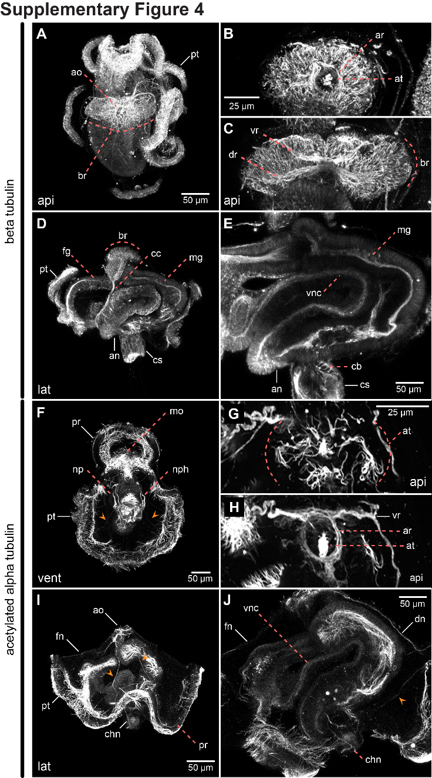

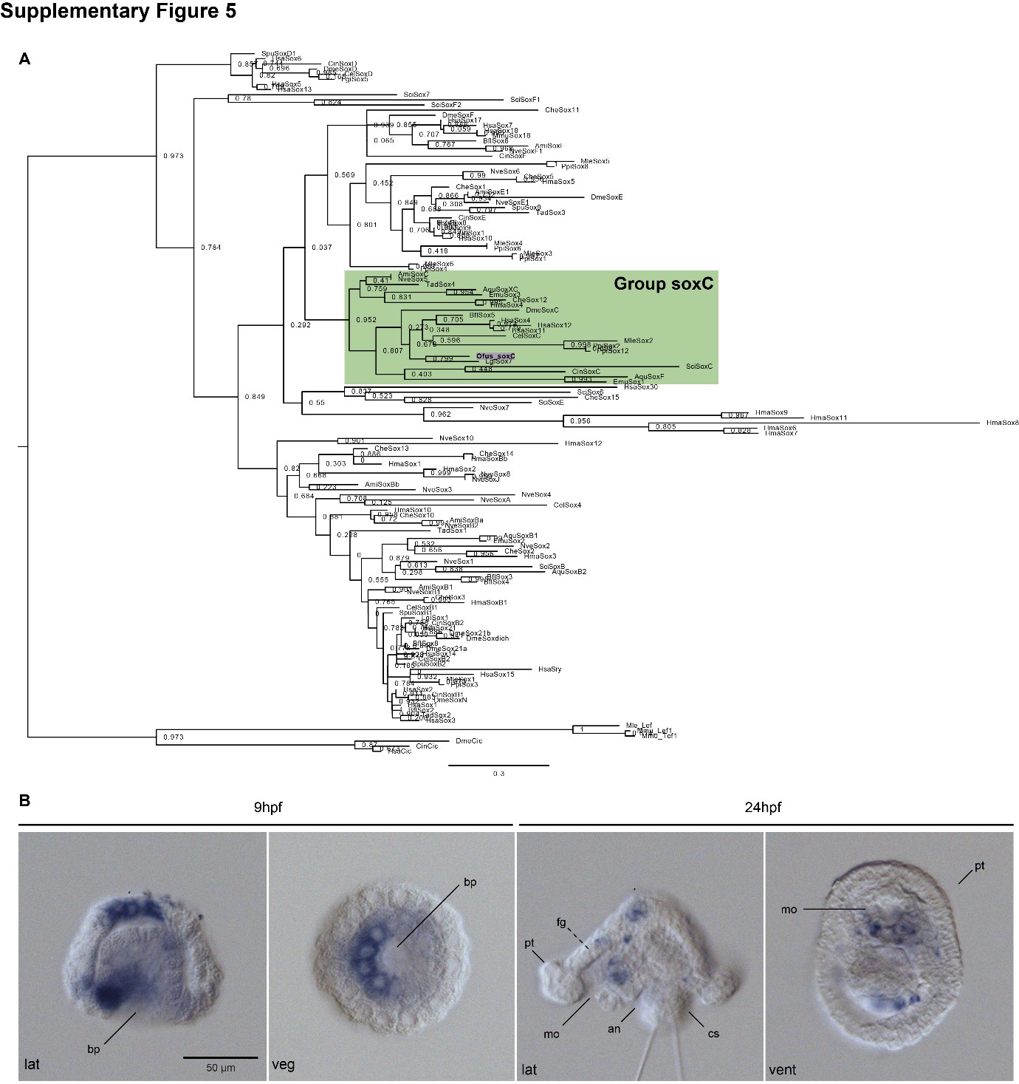
Additional File 4: Supplementary Figure 4 Tubulin⁺ elements in the competent. CLSM images of beta-tubulin (a–e) and alpha-acetylated tubulin (f–j) in the competent larvae (~3 wpf). a–c, g–h apical views; d–e, i–j, lateral views; f ventral view. a–c, g–h the apical organ (ao), associated with an apical tuft (at) and apical nerve ring (ar) is positioned above the brain (br). Ventral (vr) and dorsal (dr) roots c, h make the neuropil of the brain, that connects with the d cirucomesophageal connectives (cc), and ultimately with the ventral nerve cord (vnc) d–e. f, i–j Tubulin⁺ peripheral nerves (fn, dn, and orange arrowheads) connect the apical organ with the prototroch ring (pr). ao: apical organ; an: anus; ar: apical nerve ring; at: apical tuft; br: brain; cb: chaetoblast; cc: circumesophageal connectives; chn: chaetal sac nerve; cs: chaetal sac; dn: dorsal nerve; dnc: dorsal nerve cord; dr: dorsal root; fg: foregut; fgn: foregut nerve; fn: frontal nerve; jr: juvenile rudiment; mg: midgut; mo: mouth; nph: nephridia; pr: prototrochal ring; pt: prototroch; vnc: ventral nerve cord; vr: ventral root.

Additional File 5: Supplementary Figure 5 SoxC orthology and early mRNA expression. a Maximum likelihood orthology assignments of soxC. b DIC images showing expression of soxC during gastrulation (9hpf) and early mitraria (24hpf). Asterisks mark the animal/apical pole an: anus; bp: blastopore; cs: chaetal sac; fg: foregut; mo: mouth; pt: prototroch.
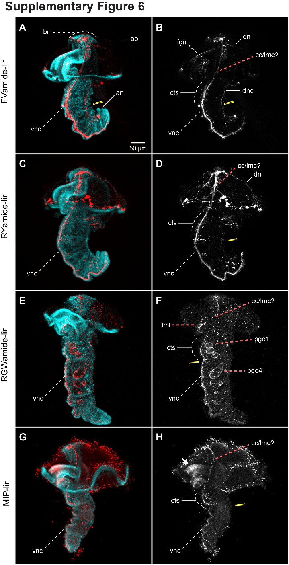

Additional File 6: Supplementary Figure 6 Neuropeptide-lir elements during metamorphosis. CLSM images of DAPI (cyan) and neuropeptide-lir (red or white) elements during metamorphosis (~ 3 4pf). Lateral views, with anterior to the top. a–hThe brain connects with the ventral nerve cord (vnc), via circumesophageal connectives (lateral medullary cords (22) at the trunk thorax, made out of three ciliated thoracis segments (cts). The foregut (fg) has b FVamide-lir, f RYamide-lir and h MIP-lir neurons and cells. e–f RWGamide labels the parapodial glandular organs (pgos), and the lower mouth lip (lml). Double yellow line marks the division between thoracic and abdominal segments. ao: apical organ; an: anus; br: brain; cc: circumesophageal connectives; cts: ciliated thoracic segments; dn: dorsal nerve; dr: dorsal root; fg: foregut; fgn: foregut nerve; lmc: lateral medullary cords; lml: lower mouth lip; np: brain neuropil; pgo: parapodial glandular organ 1–4; pr: prototrochal ring; pt: prototroch; vnc: ventral nerve cord; vr: ventral root.
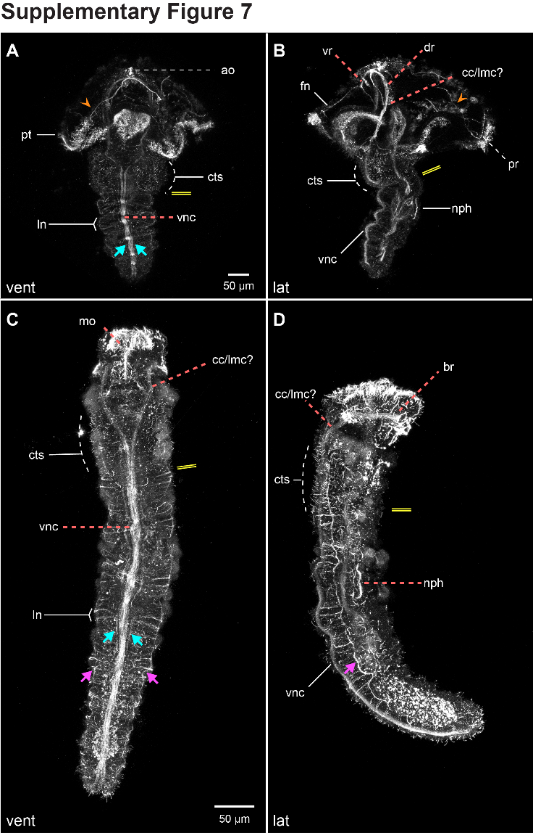

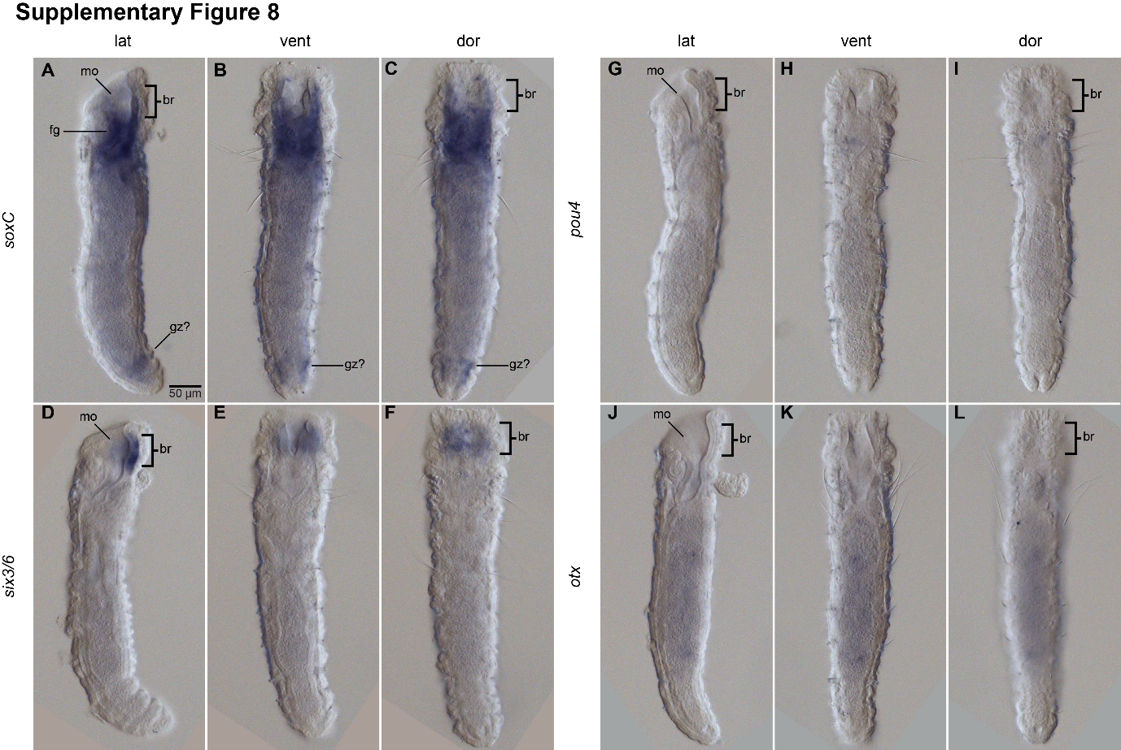
Additional File 7: Supplementary Figure 7 Tubulin⁺ elements during metamorphosis and juvenile. CLSM images of acetylated tubulin. a–b Larvae undergoing metamorphosis. c–d >4 wfp juvenile. a–b Tub⁺ peripheral nerves (orange arrowheads) in the remaining episphere of the larva keep connecting the brain to the prototrochal ring (pr). a–d The brain connects with the ventral nerve cord (vnc), via circumesophageal connectives (lateral medullary cords (22) at the trunk thorax, made out of three ciliated thoracis segments (cts). The vnc is composed of two robust longintudinal tracts, and two more lateral tracts (magenta arrows). On the anterior border of each segment, there is a pair of lateral transverse nerves (ln) that connect to lateral ventral-lateral longitudinal cords (magenta arrows). Double yellow line marks the division between thoracic and abdominal segments. ao: apical organ; br: brain; cc: circumesophageal connectives; cts: ciliated thoracic segments; dr: dorsal root; fn: frontarl nerve; lmc: lateral medullary cords; ln: lateral transverse nerves; nph: nephridia; pr: prototrochal ring; pt: prototroch; vnc: ventral nerve cord; vr: ventral root.

Additional File 8: Supplementary Figure 8 Neural development in juveniles. DIC images showing expression of soxC, pou4, six3/6 and otx. a, d, g, j Lateral views; b, e, h, k ventral views; c, f, i, l dorsal views. a–c soxC and d–f six3/6 are expressed in the brain (br). g–i pou 4 and j–l otx have no longer any neural expression. a–c soxC is expressed in the foregut (fg), and in the putative growth zone (gz). br: brain; fg: foregut; gz: growth zone; mo: mouth.

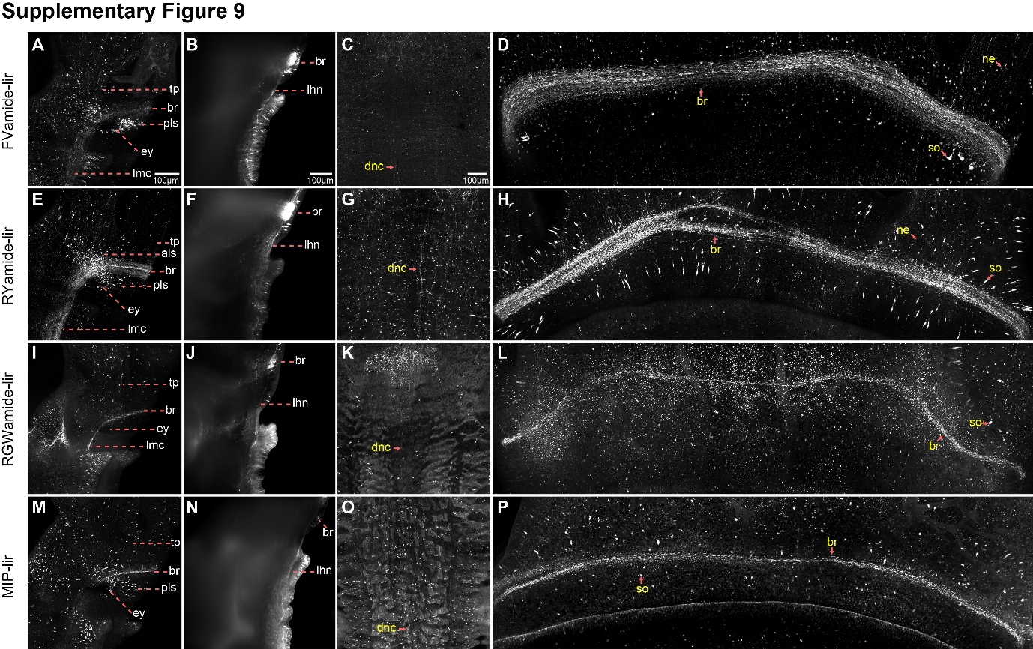
Additional File 9: Supplementary Figure 9 Neuropeptide-lir elements in the adults. CLSM images of neuropeptide-lir close ups of images in Figure 9. a–b, e–f, i–j, m–n ventral views; c–d, g–h, k–l, o–p dorsal views. a, e, i, m Views of the eye showing FVamide-lir, RYamide-lir and MIP-lir, antero-lateral (als) and postero-lateral (pls) somata. b, f, j, n Lateral head neurites (lhn) extend toward the tentacles and the trunk. c, g, k, o Longitudinal dorsal nerve cord (dnc). d, h, l, p Brain ring with associated neurites (ne) and somata (so). als: anterior-lateral somata; br: brain; dnc: dorsal nerve cord; ey: eye; lhn: lateral head neurites; lmc: lateral medullary cord; ne: neurite; pls: posterior-lateral somata; so: somata; tp: tentacle plexus.

