Supplementary Material for
Target screening of plant secondary metabolites in river waters by liquid chromatography coupled to high resolution mass spectrometry (LC-HRMS)
Mulatu Yohannes Nanusha^{1, 2}, Martin Krauss¹, Carina D. Schönsee^{3,4}, Barbara F. Günthardt³, Thomas D. Bucheli³ and Werner Brack^{1, 2}
¹Helmholtz Centre for Environmental Research - UFZ, Department of Effect-Directed Analysis, Permoserstraße 15, 04318 Leipzig, Germany
² Goethe University Frankfurt,Max-von-Laue Str. 13, 60438 Frankfurt (Main), Germany
³Agroscope, Environmental Analytics, Reckenholzstrasse 191, 8046 Zürich, Switzerland
⁴ETH Zürich, Department of Environmental Systems Science, Universitätstrasse 16, 8092 Zürich, Switzerland

Supplementary Tables and Figure
List of Tables
Table S1: Information on river samples and sampling locations………………………………..……….In excel format
Table S2: Plant metabolites selected for target screening of river samples…………..….…...… In excel format
Table S3: Setting for MZmine data processing. 5
Table S4: Internal standards used for the chemical analysis (ESIpos)………………………………… In excel format
Table S5: Mass spectrometry setting for the chemical analysis of water samples. 5
Table S6: Quantifier and confirming ions used in TraceFinder for quantification of detected target compounds. 6
Table S7: The concentration of detected metabolites in river water from Leipzig and Bode catchment. 7

List of Figures
Figure S1: Workflow for screening toxic plant metabolites in river waters. 4
Figure S2: MS/MS spectra (HCD fragmentation at 45 a.u.) of coumarin in a reference standard and water sample (NL: signal intensity at 100% relative abundance). 8
Figure S3: MS/MS spectra (HCD fragmentation at 45 a.u.) of esculetin in a reference standard and water sample (NL: signal intensity at 100% relative abundance). 9
Figure S4: MS/MS spectra (HCD fragmentation at 45 a.u.) of fraxidin in a reference standard and water sample (NL: signal intensity at 100% relative abundance). 10
Figure S5: MS/MS spectra (HCD fragmentation at 45 a.u.) of scopoletin in a reference standard and water sample (NL: signal intensity at 100% relative abundance). 11
Figure S6: MS/MS spectra (HCD fragmentation at 45 a.u.) of bergapten in a reference standard and water sample (NL: signal intensity at 100% relative abundance). 12
Figure S7: MS/MS spectra (HCD fragmentation at 45 a.u.) of psoralen in a reference standard and water sample (NL: signal intensity at 100% relative abundance). 13
Figure S8: MS/MS spectra (HCD fragmentation at 45 a.u.) of lycorine in a reference standard and water sample (NL: signal intensity at 100% relative abundance). 14
Figure S9: MS/MS spectra (HCD fragmentation at 45 a.u.) of narciclasine in a reference standard and water sample (NL: signal intensity at 100% relative abundance). 15
Figure S10: MS/MS spectra (HCD fragmentation at 45 a.u.) of nicotine in a reference standard and water sample (NL: signal intensity at 100% relative abundance). 16
Figure S11: MS/MS spectra (HCD fragmentation at 45 a.u.) of piperine in a reference standard and water sample (NL: signal intensity at 100% relative abundance). 17
Figure S12: MS/MS spectra (HCD fragmentation at 45 a.u.) of formononetin in a reference standard and water sample (NL: signal intensity at 100% relative abundance). 18
Figure S13: MS/MS spectra (HCD fragmentation at 45 a.u.) of coniferyl aldehyde in a reference standard and water sample (NL: signal intensity at 100% relative abundance). 19

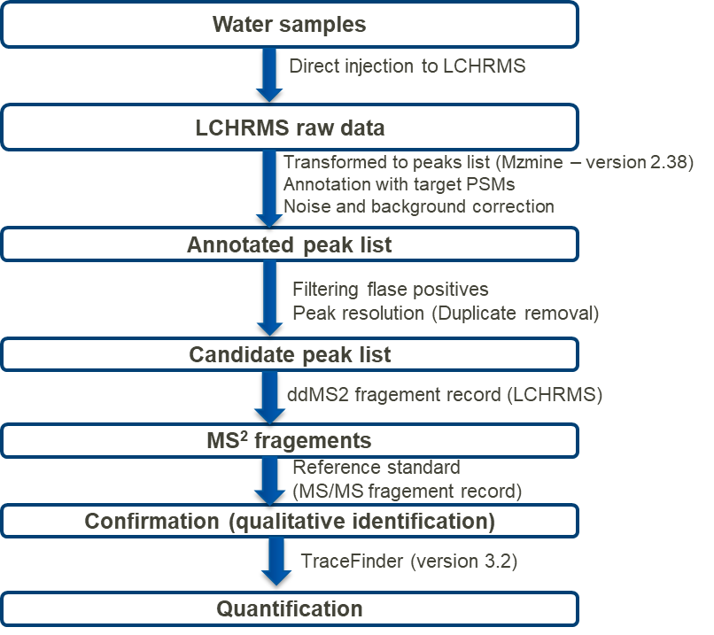
Figure S1: Workflow for screening toxic plant metabolites in river waters.

Table S3: Setting for MZmine data processing.
 | Parameters | Mass detection | Chromatogram building | Chromatogram deconvolution | Join aligner | Gap filling | Target annotation (identification)
Peak detection | Mass detector | Centroid
Peak detection | Noise level | 5.00E+3
Peak detection | MS level | 1.0
Peak detection | Group intensity threshold |  | 1.00E+4
Peak detection | Min height intensity |  | 5.00E+03
Peak detection | m/z tolerance |  | 0.001
Peak detection | Algorithm |  |  | Local minimum search
Peak detection | Chromatographic threshold (%) |  |  | 60.0
Peak detection | Search minimum in retention time range |  |  | 0.1
Peak detection | Minimum relative height (%) |  |  | 30
Peak detection | Minimum absolute height |  |  | 5.0E+4
Peak detection | Min ratio of peak top/edge |  |  | 2.3
Peak detection | Peak duration range (min) |  |  | 0.1-0.5
Peak alignment and identification | m/z tolerance |  |  |  | 0.001 | 0.001 | 0.001
Peak alignment and identification | Weight for m/z tolerance |  |  |  | 70
Peak alignment and identification | Retention time tolerance (absolute, min) |  |  |  | 0.3 | 0.15 | 0.5
Peak alignment and identification | Weight for RT |  |  |  | 30
Peak alignment and identification | Intensity tolerance (%) |  |  |  |  | 30.00
Peak alignment and identification | RT range
Peak alignment and identification | Adducts |  |  |  |  |  | M+H+, M+Na+, M+NH4+,

Table S5: Mass spectrometry setting for the chemical analysis of water samples.
Parameters | Full MS | MS/MS
Polarity | positive | positive
Resolving power (m/z 200) | 70,000 | 35,000
Automated gain control target value | 3e6 | 5e5
Maximum injection time | 200 ms | 110 ms
HCD collision energy |  | 45 a.u

Table S6: Quantifier and confirming ions used in TraceFinder for quantification of detected target compounds.
Compound Name | Chemical formula | CAS | Quantifier MS1 (Precursor) m/z (M+H+) | Adduct | Polarity | Retention time (min) | Confirming ion – 1 (MS2, M+H+) | Confirming ion – 2 (MS2, M+H+)
Coumarin | C₉H₆O₂ | 91-64-5 | 147.0441 | M+H | + | 7.3 | 103.0542 | 91.0542
Esculetin | C₉H₆O₄ | 305-01-1 | 179.0336 | M+H | + | 4.2 | 133.0283 | 123.044
Fraxidin | C₁₁H₁₀O₅ | 525-21-3 | 223.06 | M+H | + | 7.8 | 190.026 | 162.0311
Scopoletin | C₁₀H₈O₄ | 92-61-5 | 193.0496 | M+H | + | 7.1 | 133.0283 | 165.0545
Bergapten | C₁₂H₈O₄ | 484-20-8 | 217.0495 | M+H | + | 10.1 | 202.0259 | 174.031
Psoralen | C₁₁H₆O₃ | 66-97-7 | 187.0388 | M+H | + | 9.1 | 143.049 | 131.049
Lycorine | C₁₆H₁₇NO₄ | 476-28-8 | 288.1225 | M+H | + | 1 | 177.0546 | 119.0491
Narciclasine | C₁₄H₁₃NO₇ | 29477-83-6 | 308.0765 | M+H | + | 5.7 | 248.0553 | 214.0499
Nicotine | C₁₀H₁₄N₂ | 54-11-5 | 163.1228 | M+H | + | 0.9 | 132.0807 | 106.0651
Piperine | C₁₇H₁₉NO₃ | 94-62-2 | 286.1434 | M+H | + | 11.9 | 201.0544 | 135.0439
Formononetin | C₁₆H₁₂O₄ | 485-72-3 | 269.0804 | M+H | + | 10.8 | 237.0544 | 213.0908
Coniferyl aldehyde | C₁₀H₁₀O₃ | 458-36-6 | 179.0701 | M+H | + | 7.6 | 147.044 | 119.0492

Sample ID | Sampling season | Sampling location | Concentration (ng/l) |  |  |  |  |  |  |  |  |  |  |  | Number of SPMs detected per sample | Grand total (all SPMs detected) concentration (ng/l) per sample
Sample ID | Sampling season | Sampling location | Bergapten | Coniferyl aldehyde | Coumarin | Esculetin | Formononetin | Fraxidin | Lycorine | Narciclasine | Nicotine | Piperine | Psoralen | Scopoletin | Number of SPMs detected per sample
ELP19 | Summer | Leipzig | ND | ND | ND | ND | 8 | 546 | ND | ND | ND | 271 | ND | 47 | 4 | 872
ELP23 | Spring | Leipzig | 510 | 46 | ND | ND | ND | 56 | ND | ND | ND | 338 | ND | 31 | 5 | 981
ELP17 | Spring | Leipzig | ND | 13 | ND | ND | ND | 294 | 2331 | 506 | ND | ND | ND | 13 | 5 | 3157
ELP18 | Summer | Leipzig | ND | ND | ND | 1658 | ND | 1144 | 1015 | 3352 | ND | ND | ND | 41 | 5 | 7211
ELP2 | Spring | Leipzig | ND | ND | ND | ND | 12 | 84 | ND | ND | ND | 1 | ND | 18 | 4 | 115
ELP3 | Spring | Leipzig | ND | ND | ND | ND | 23 | 173 | ND | ND | 2 | ND | ND | 9 | 4 | 207
ELP9 | Summer | Leipzig | ND | ND | ND | ND | 33 | 132 | ND | ND | ND | ND | ND | 21 | 3 | 186
ELP10 | Spring | Leipzig | ND | ND | 12 | ND | 35 | 196 | ND | ND | 6 | 1 | ND | 34 | 6 | 284
ELP21 | Spring | Leipzig | ND | ND | ND | 116 | ND | 228 | ND | ND | ND | ND | ND | 20 | 3 | 363
BD2 | Summer | Bode | ND | ND | ND | ND | ND | 52 | ND | ND | 35 | ND | ND | 47 | 3 | 134
BD8 | Summer | Bode | ND | ND | ND | ND | ND | 130 | ND | ND | ND | 294 | ND | 13 | 3 | 436
BD9 | Summer | Bode | ND | ND | ND | ND | ND | 85 | ND | ND | ND | ND | 224 | 13 | 3 | 321
BD10 | Summer | Bode | 541 | ND | 43 | 104 | ND | 106 | ND | ND | ND | ND | 141 | 49 | 6 | 984
BD1 | Summer | Bode | ND | ND | ND | ND | ND | 36 | ND | ND | ND | ND | ND | 8 | 2 | 44
BD3 | Summer | Bode | ND | ND | ND | 113 | 123 | 59 | 11 | ND | ND | ND | ND | 38 | 5 | 343
BD4 | Summer | Bode | ND | ND | ND | ND | ND | 155 | ND | ND | 4 | 4 | ND | 27 | 4 | 190
BD5 | Summer | Bode | ND | ND | ND | ND | ND | 19 | ND | ND | ND | ND | ND | 7 | 2 | 25
BD12 | Spring | Bode | ND | ND | ND | 157 | ND | ND | ND | ND | ND | ND | ND | 23 | 2 | 179
Table S7: The concentration of detected metabolites in river water from Leipzig and Bode catchment.

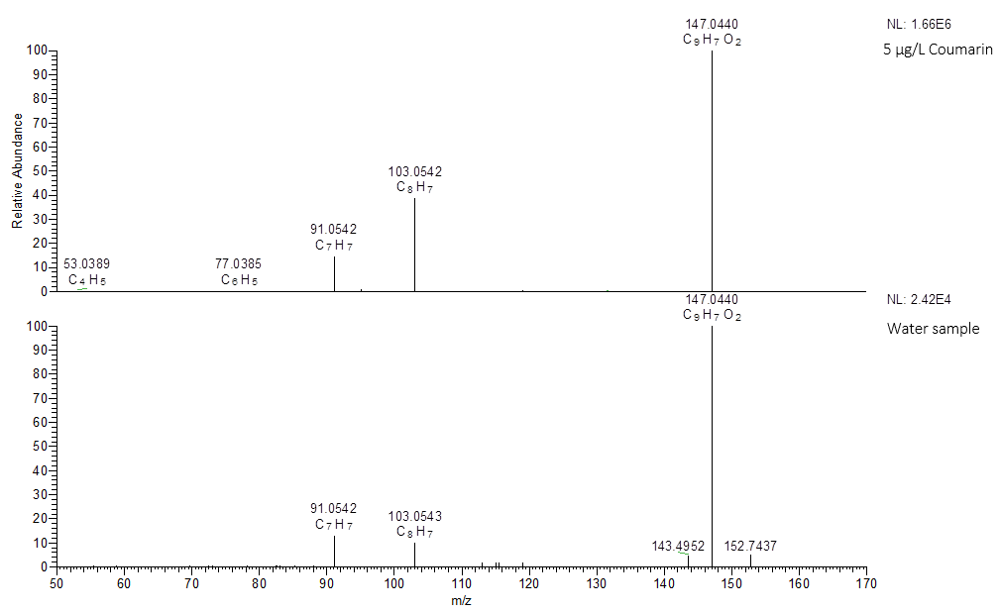
Figure S2: MS/MS spectra (HCD fragmentation at 45 a.u.) of coumarin in a reference standard and water sample (NL: signal intensity at 100% relative abundance).
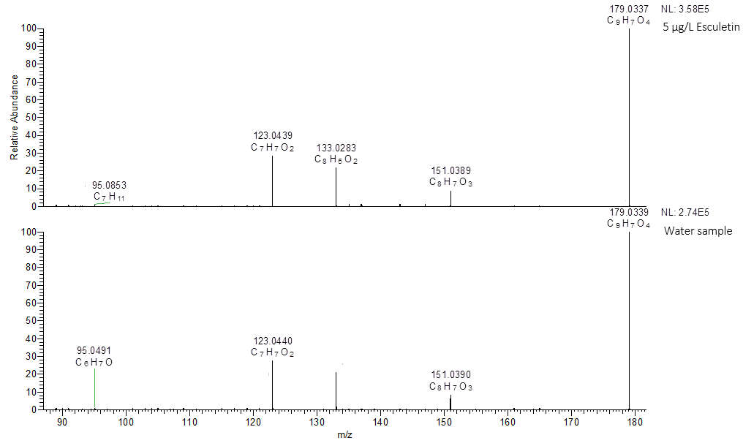
Figure S3: MS/MS spectra (HCD fragmentation at 45 a.u.) of esculetin in a reference standard and water sample (NL: signal intensity at 100% relative abundance).
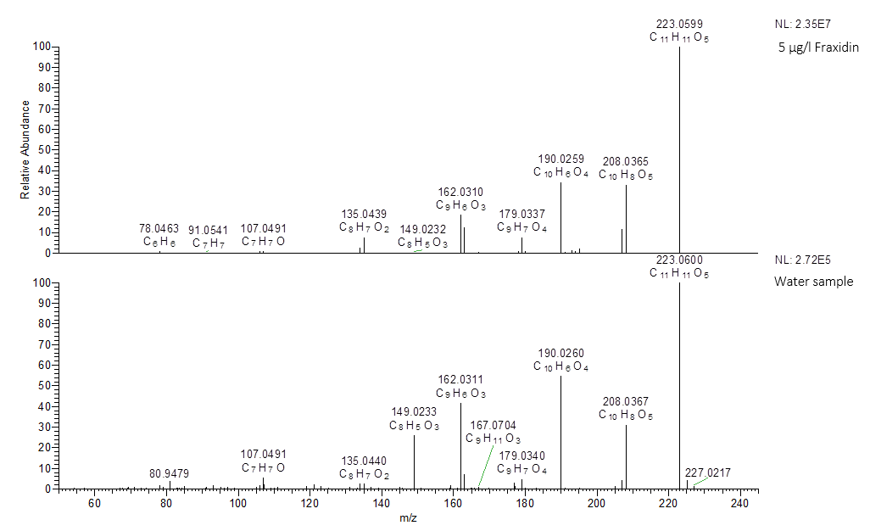
Figure S4: MS/MS spectra (HCD fragmentation at 45 a.u.) of fraxidin in a reference standard and water sample (NL: signal intensity at 100% relative abundance).
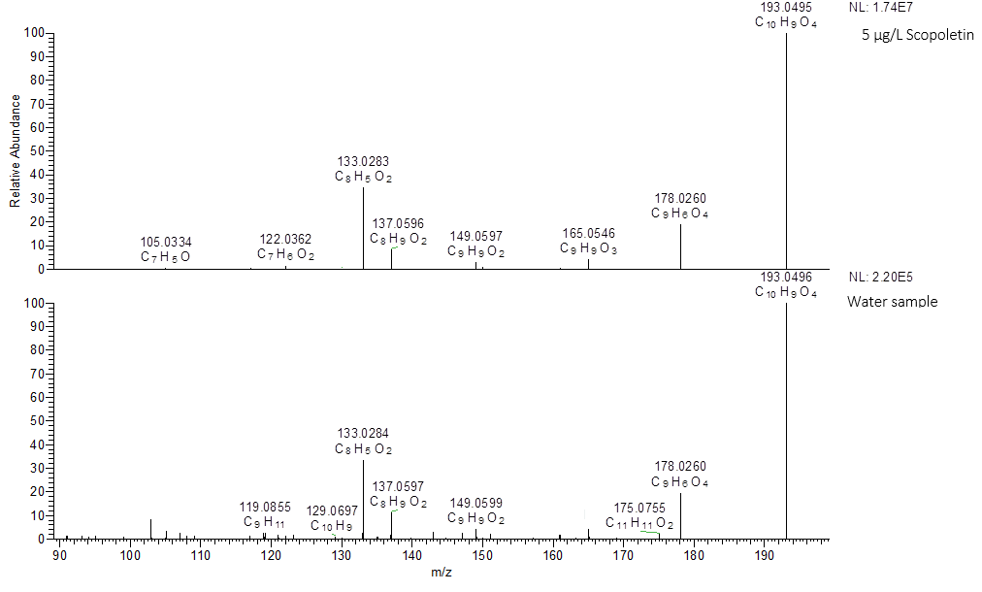
Figure S5: MS/MS spectra (HCD fragmentation at 45 a.u.) of scopoletin in a reference standard and water sample (NL: signal intensity at 100% relative abundance).
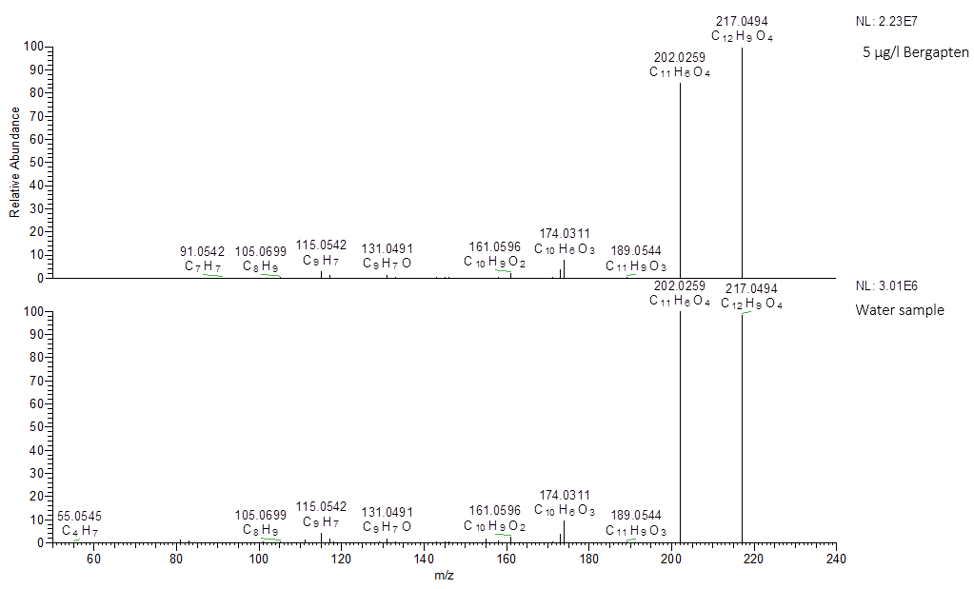
Figure S6: MS/MS spectra (HCD fragmentation at 45 a.u.) of bergapten in a reference standard and water sample (NL: signal intensity at 100% relative abundance).
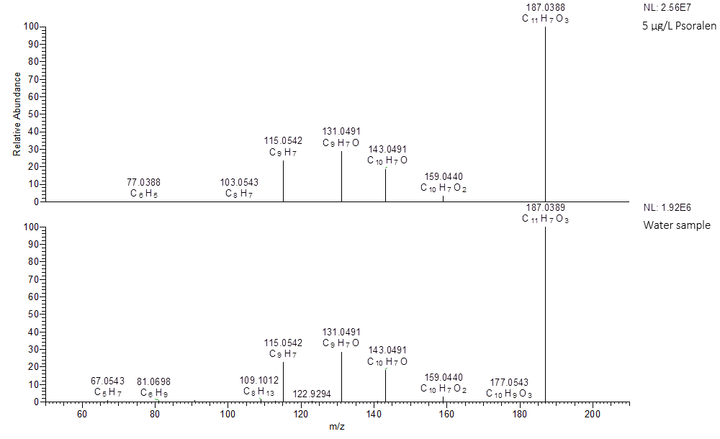
Figure S7: MS/MS spectra (HCD fragmentation at 45 a.u.) of psoralen in a reference standard and water sample (NL: signal intensity at 100% relative abundance).
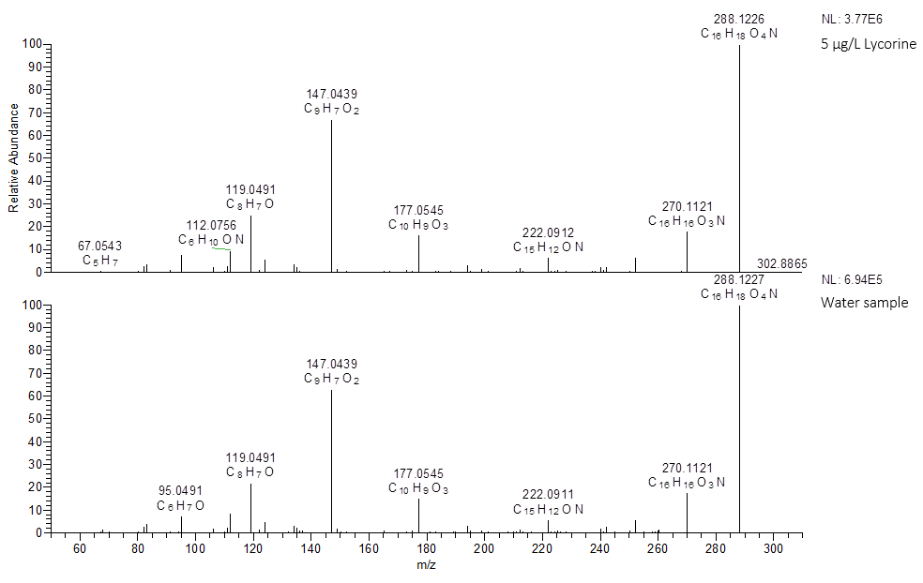
Figure S8: MS/MS spectra (HCD fragmentation at 45 a.u.) of lycorine in a reference standard and water sample (NL: signal intensity at 100% relative abundance).
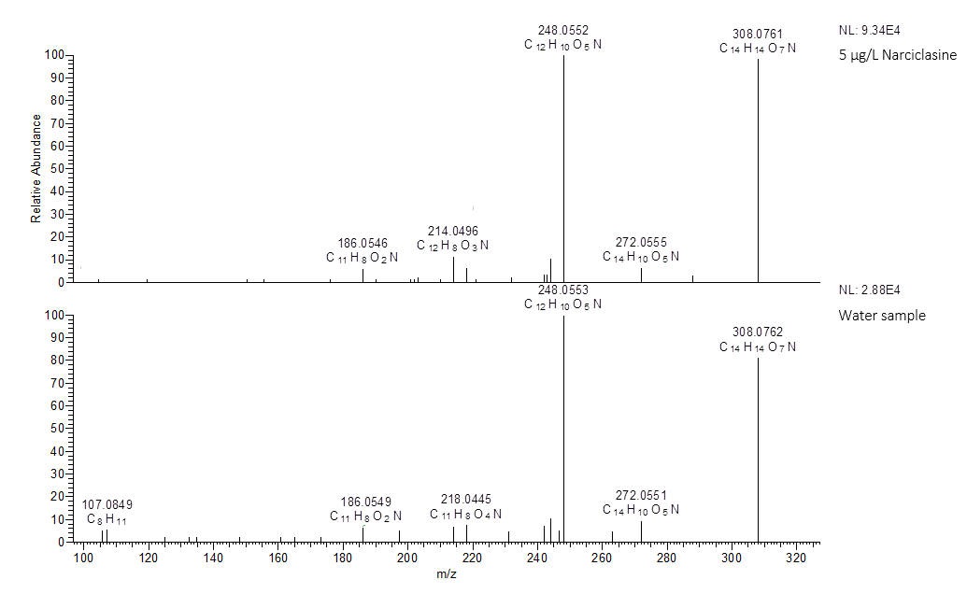
Figure S9: MS/MS spectra (HCD fragmentation at 45 a.u.) of narciclasine in a reference standard and water sample (NL: signal intensity at 100% relative abundance).
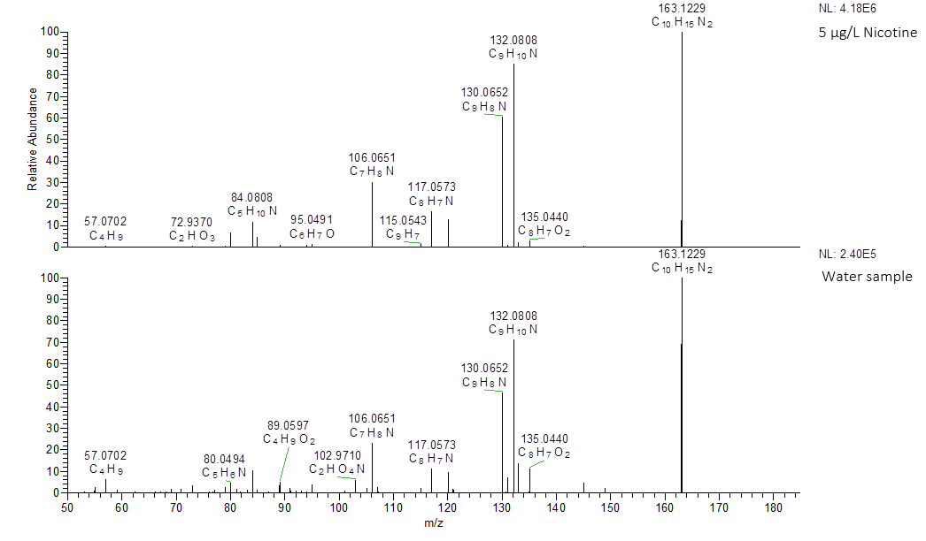
Figure S10: MS/MS spectra (HCD fragmentation at 45 a.u.) of nicotine in a reference standard and water sample (NL: signal intensity at 100% relative abundance).
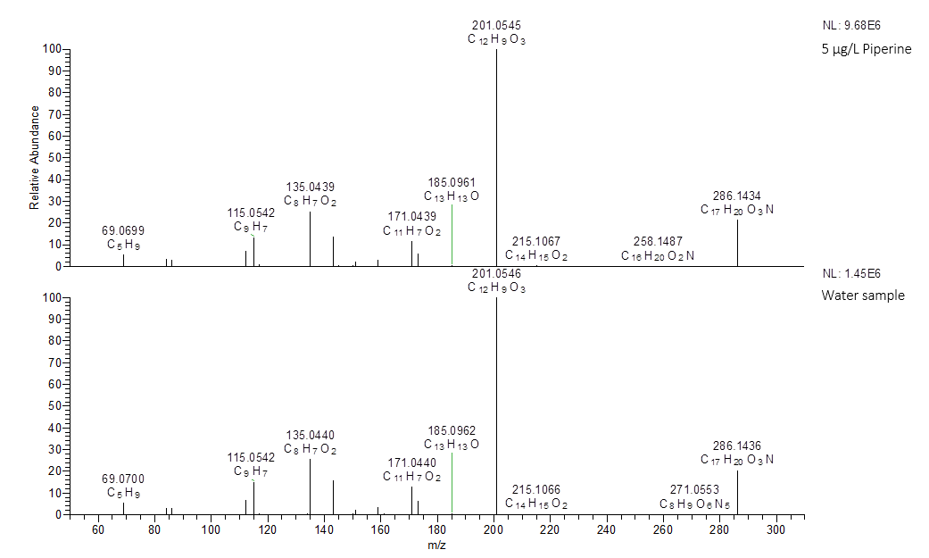
Figure S11: MS/MS spectra (HCD fragmentation at 45 a.u.) of piperine in a reference standard and water sample (NL: signal intensity at 100% relative abundance).
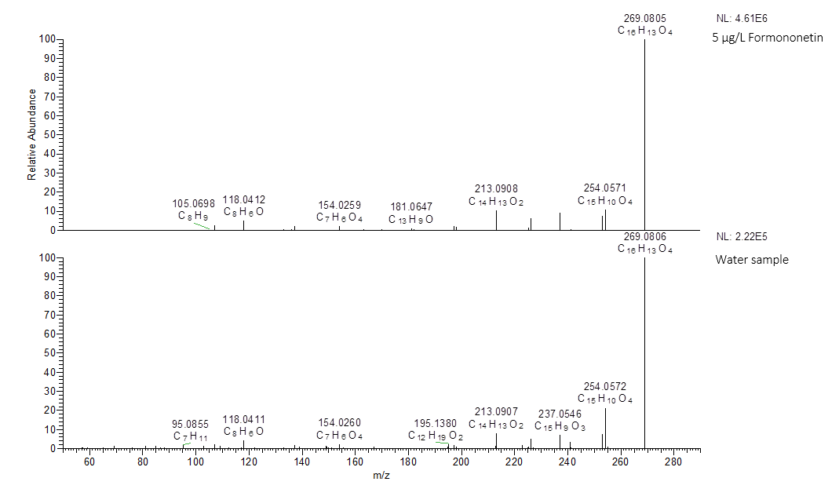
Figure S12: MS/MS spectra (HCD fragmentation at 45 a.u.) of formononetin in a reference standard and water sample (NL: signal intensity at 100% relative abundance).
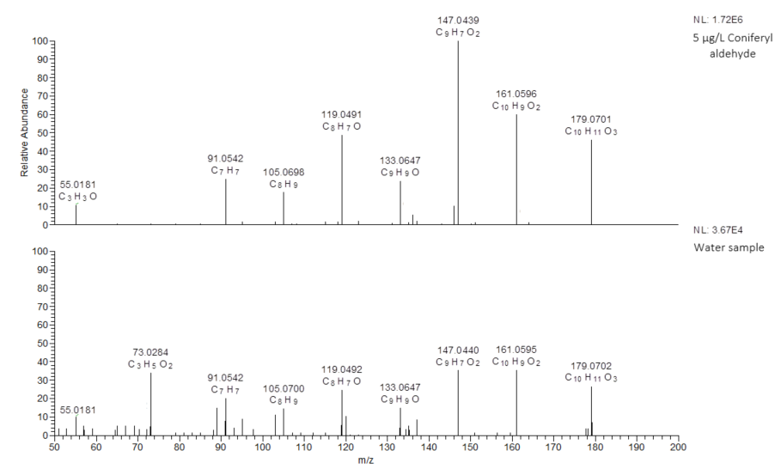
Figure S13: MS/MS spectra (HCD fragmentation at 45 a.u.) of coniferyl aldehyde in a reference standard and water sample (NL: signal intensity at 100% relative abundance).

