Supplemental Online Content
Table 3. Correlation analysis of parameters of controls group and IVM group.
Table 4. Patients with neurodevelopmental delay.
Figure 4. Histogram of the age distribution of fetal MR scans.
Figure 5. Volume of gray matter in occipital gyrus with gestational age.
Figure 6. Volume of white matter in occipital gyrus with gestational age.

Table 3. Correlation analysis of parameters of controls group and IVM group.
Brain regions |  | White mater |  | Gray matter
 |  | r | P | r | P
IVM | OL | 0.56 | <0.01 | 0.72 | <0.01
IVM | SOG | 0.57 | <0.01 | 0.76 | <0.01
IVM | MOG | 0.76 | <0.01 | 0.77 | <0.01
IVM | IOG | 0.77 | <0.01 | 0.74 | <0.01
IVM | CE | 0.63 | <0.01 | 0.41 | <0.01
IVM | LG | 0.56 | <0.01 | 0.78 | <0.01
Control | OL | 0.51 | <0.01 | 0.77 | <0.01
Control | SOG | 0.75 | <0.01 | 0.77 | <0.01
Control | MOG | 0.76 | <0.01 | 0.81 | <0.01
Control | IOG | 0.73 | <0.01 | 0.67 | <0.01
Control | CE | 0.40 | <0.01 | 0.36 | <0.01
Control | LG | 0.69 | <0.01 | 0.86 | <0.01

Table 4. Patients with neurodevelopmental delay.
Patients with neurodevelopmental delay | Fetal MRI  (Ventriculomegaly in mm) | GA at  MRI | Gender  (male/female) | Follow-up Age  (months) | Follow-up findings
IVM group
Patient 07 | 11.5 mm Unilateral left | 27 | F | 18m | fine motor delayed development
Patient 11 | 12.2 mm Unilateral right | 28 | M | 17m | language delayed development
Patient 13 | 10.5 mm Unilateral left | 28 | F |  | gross motor, fine motor, language delayed development
Patient 14 | 10 mm Unilateral left | 29 | M | 3m | gross motor delayed development
Patient 16 | 11 mm Unilateral left | 29 | F | 12m | language delayed development
Patient 19 | 12.1-12.7 mm Bilateral | 30 | M | 12m | adaptability, gross motor, fine motor, language, social personality delayed development
Patient 24 | 10 mm Unilateral left | 31 | M | 20m | fine motor delayed development
Patient 26 | 10 mm Unilateral left | 31 | M | 11m | language delayed development
Patient 28 | 11 mm Unilateral left | 32 | F | 17m | language delayed development
Patient 25 | 12.6 mm Unilateral left | 34 | M | 4m | fine motor, language delayed development
Control group
Control 05 | - | 26 | M | 15m | gross motor delayed development
Control 23 | - | 31 | M | 13m | fine motor delayed development

Figure 4. Histogram of the age distribution of fetal MR scans.

Figure 5. Volume of gray matter in occipital gyrus with gestational age.

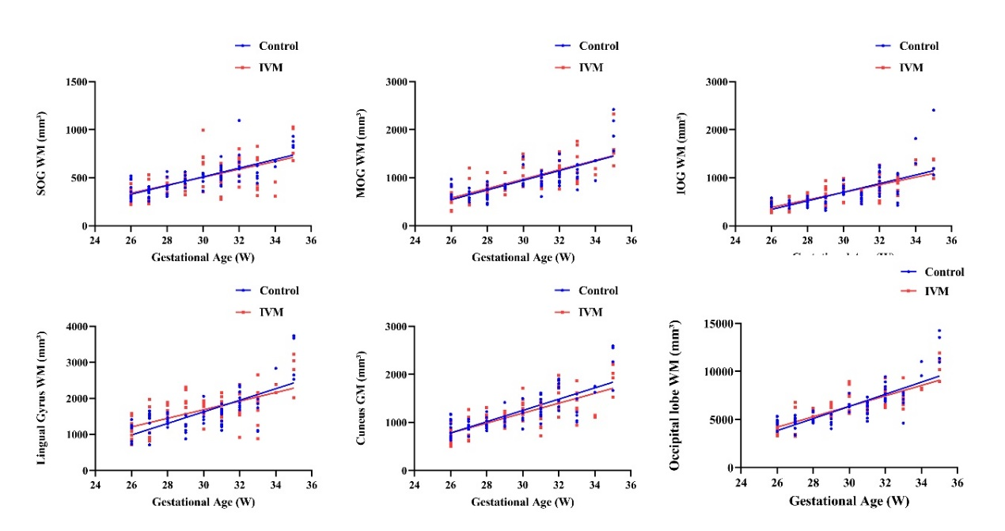
Figure 6. Volume of white matter in occipital gyrus with gestational age.

