Supplementary Materials for

Intramolecular Chalcogen Bonding Activated SuFEx Click Chemistry for Efficient Organic-Inorganic Linking
Minlong Wang¹, Jiaman Hou¹, Chao Wang¹, Xiaohe Zhang¹, Ying Du¹, Qixin Dong¹, Lijun Wang¹, Ke Ni¹, Fazheng Ren¹, Jie An¹*
¹ Key Laboratory of Precision Nutrition and Food Quality, Department of Nutrition and Health, China Agricultural University, Beijing, 100083, China
*Corresponding author. Email: jie_an@cau.edu.cn

Table of Contents
1 General Information 2
2 Development of intramolecular S-activated SuFEx reaction of alkyl sulfonyl fluorides 3
2.1 Synthesis of ethenesulfonyl fluoride (ESF) 3
2.1.1 Synthesis of 2-chloroethanesulfonyl fluoride 3
2.1.2 Synthesis of ESF 3
2.2 Synthesis of 3-(trimethylsilyl)propane-1-thiol 4
2.2.1 Synthesis of S-(2-(trimethylsilyl)ethyl) ethanethioate 4
2.2.2 Synthesis of 3-(trimethylsilyl)propane-1-thiol 4
2.3 General procedure for preparation of alkyl sulfonyl fluorides bearing γ-S 5
2.4 Synthesis of alkyl sulfonyl fluorides for the control experiments 6
2.4.1 Synthesis of 1-hexanesulfonyl fluoride 6
2.4.2 Synthesis of 2-(sulfonyl)ethane-1-sulfonyl fluoride 6
2.5 Reaction optimization 7
2.6 Comparative studies on SuFEx reactions alkyl sulfonyl fluorides with and without γ-S 8
2.6.1 General procedure for the SuFEx reactions between alkyl sulfonyl fluorides and phenols 8
2.6.2 Effect of the thioether additive on the SuFEx reactions of alkylsulfonyl fluorides without γ-S 10
2.6.3 General procedure for the reactions between alkyl sulfonyl fluorides and sodium phenoxide 11
2.7 UV/Vis kinetics experiments 11
3 General procedure for the O-sulfonylation with phenols 12
4 General procedure for the O-sulfonylation with aliphatic alcohols 24
5 General procedure for the N-sulfonylation 28
6 Click platform for efficient organic-inorganic linkages based the S-SuFEx hub 40
6.1 SuFEx reactivity of the S-SuFEx hub 1c 40
6.2 Surface pre-treatment of glass cover slips 45
6.3 General procedure for covalently linking organic units and glasses via 1c. 46
6.4 Assessment of the functionalized glass surface 46
7 Mechanistic investigations 49
7.1 The reaction between 1b and phenol without BTMG 49
7.2 Different amounts of BTMG to sulfonyl fluoride 1b monitored by ¹H NMR 49
7.3 Different amounts of BTMG to phenol 4a monitored by ¹H NMR 50
7.4 Reaction courses 51
8 References 53
9 NMR spectra 54

1 General information
All reactions were performed in a clean, oven-dried glass reaction vessel. Analytical grade solvents and commercially available reagents were purchased from Energy Chemical, InnoChem, Leyan, HEOWNS or TCI and were used directly without further purification. Anhydrous solvents were purchased as ultra-dry solvent from Energy Chemical. Fresh deionized water was used for all aqueous electrolyte solutions and water washings. The room temperature ranged from 15 to 25 °C. Thin layer chromatography (TLC) analyses were performed on Leyan HPTLC Silica Gel 60 GF254 and visualized by UV (254 nm) and KMnO₄ solution. Flash column chromatography was performed with silica gel 60, 35-70 μm. NMR spectra were acquired using a Bruker Avance NEO 500. ¹H NMR, ¹³C NMR, ¹⁹F NMR Spectra were processed using MNOVA software (Mestrelab). Chemical shifts are reported in parts per million (ppm), coupling constants (J) in Hz and are calibrated to residual protonated solvent. Reference values for residual solvent were taken as δ = 7.27 (CDCl₃), δ = 1.94 (MeCN-d₃), δ = 2.50 (DMSO-d₆), for ¹H NMR and δ = 77.16 (CDCl₃), δ = 39.52 (DMSO-d₆) for ¹³C{¹H} NMR. The multiplicities of the ¹H NMR signals are designated by the following abbreviations: singlet (s), doublet (d), triplet (t), quarter (q), multiplet (m), doublet and doublet (dd), doublet and triplet (dt), triplet and doublet (td). High resolution mass spectra (HRMS) were performed at the Thermo Scientific Q Exactive Hybrid Quadrupole-Orbitrap mass spectrometer. Fourier transform infrared (FT-IR) spectra were recorded on Bruker Invenio-S instrument with an attenuated total reflection (ATR) attachment. UV-Vis absorption spectra were recorded on a UNICO UV-2800A spectrophotometer. The ultra-white glass slides were obtained from Shitai. Contact angle measurements was performed using a contact angle goniometer (OCA20, Dataphysics, Germany). Green fluorescence was visualized with a 488-nm laser using a Leica DMi8 fluorescence microscope. Atomic force microscope (AFM) characterization is performed using a Bruker Dimension XR FastScan microscope.

2 Development of intramolecular S-activated SuFEx reaction of alkyl sulfonyl fluorides

2.1 Synthesis of ethenesulfonyl fluoride (ESF)

2.1.1 Synthesis of 2-chloroethanesulfonyl fluoride
2-chloroethanesulfonyl fluoride was synthesized according to published procedures¹. KFHF (93.50 g, 1.2 mol) was added to a round bottom flask containing H₂O (250 mL). The mixture was stirred at room temperature for 20 min. After complete dissolution, 2-chloroethane-1-sulfonyl chloride (85.59 g, 0.525 mol) was poured into the cold saturated KFHF solution, and the mixture was vigorously stirred at room temperature for 3 hours. After the completion of the reaction, the organic phase was collected and washed with brine (50 mL x 1), giving 2-chloroethane-1-sulfonyl fluoride. The rest aqueous KFHF layer was extracted with CH₂Cl₂ (50 mL x 3). The combined organic phases were washed with brine (50 mL x 2) and evaporated in vacuo, and combined with the first batch of product as a light yellow liquid (75.45 g, 98%).
¹H NMR (500 MHz, CDCl₃) δ 3.92 (t, J = 7.0 Hz, 2H), 3.85 – 3.78 (m, 2H). ¹³C NMR (126 MHz, CDCl₃) δ 52.74 (d, J = 17.1 Hz), 35.12.

2.1.2 Synthesis of ESF
ESF was synthesized according to published procedures¹. A 500 mL round bottom flask was charged with 2-chloroethanesulfonyl fluoride (73.28 g, 0.5 mol) and H₂O (200 mL). After cooled down to 0 °C, MgO
(11.08 g; 0.275 mol) was added portion-wise to the vigorously stirred reaction mixture, keeping the reaction temperature below 35 °C. After completion of the addition, the reaction was warmed to 25 ºC and stirred for 3 h. Upon completion, the organic layer of the neat ESF was separated and dried over anhydrous MgSO₄. The residual liquid was extracted with CH₂Cl₂ (50 mL x 3) and dried over anhydrous MgSO₄. The resulting solution was concentrated and combined with the first batch of product to give ESF as a light yellow liquid (42.78 g, 78%).
Caution: All manipulations must be performed in a well-ventilated fume hood. ESF is high eye irritant and should be stored in a plastic bottle.
¹H NMR (500 MHz, CDCl₃) δ 6.80 – 6.57 (m, 2H), 6.39 (dd, J = 9.4, 5.4 Hz, 1H). ¹⁹F NMR (471 MHz, CDCl₃) δ 57.62 (s). ¹³C NMR (126 MHz, CDCl₃) δ 134.76, 129.80 (d, J = 27.5 Hz).

2.2 Synthesis of 3-(trimethylsilyl)propane-1-thiol

2.2.1 Synthesis of S-(2-(trimethylsilyl)ethyl) ethanethioate
S-(2-(trimethylsilyl)ethyl) ethanethioate was synthesized according to published procedures². Tetrahydrofuran (THF, 50 mL) was added to a flask containing thioacetic acid (9.99 g, 87.5 mmol) and allyltrimethylsilane (11.12 g, 146.1 mmol), followed by 2,2'-azobis(2-methylpropionitrile) (AIBN, 0.14 g, 0.875 mmol). The mixture was stirred and refluxed for 16 hours under argon. This mixture was cooled to 0 °C and 10 wt% aqueous NaOH (40 mL) was added while stirring. The solvent was removed under reduced pressure and ethyl acetate (EA, 40 mL) was added. The layers were separated, and the EA layer was extracted with 10 wt% aqueous NaOH (40 mL x 4). The combined aqueous phases were extracted with EA (40 mL x 2). Afterwards, all the organic phases were combined and sequentially washed with deionized water (40 mL x 1) and brine (40 mL x 1), then dried over anhydrous MgSO₄ and evaporated in vacuo to to afford the title compound as the colorless liquid (15.55 g, 97%).
¹H NMR (500 MHz, CDCl₃) δ 2.87 (t, J = 7.4 Hz, 2H), 2.32 (s, 3H), 1.61 – 1.50 (m, 2H), 0.60 – 0.53 (m, 2H), -0.02 (s, 9H). ¹³C NMR (126 MHz, CDCl₃) δ 196.12, 32.73, 30.78, 24.59, 16.46, -1.64.

2.2.2 Synthesis of 3-(trimethylsilyl)propane-1-thiol
3-(trimethylsilyl)propane-1-thiol was synthesized according to published procedures². A solution of S-(2-(trimethylsilyl)ethyl) ethanethioate (7.61 g, 40 mmol) in ethanol (50 mL) was cooled to 0°C. Subsequently, 25 wt% aqueous NaOH (2.4 g, 60 mmol) was added. The reaction mixture was warmed to room temperature and stirred for 12h. After neutralization with 1 M aqueous HCl solution, the mixture was extracted with CH₂Cl₂ (40 mL x 2). The combined organic phases were sequentially washed with deionized water (40 mL x 3), 10 wt% aqueous NaOH (40 mL x 3), deionized water (40 mL x 1) and brine (40 mL x 1). The resulted organic phases were dried with anhydrous MgSO₄ and the solvent was evaporated under vacuum to give the desired substrates as a light yellow liquid (4.37 g, 74%).
¹H NMR (500 MHz, CDCl₃) δ 2.78 – 2.65 (m, 2H), 1.74 – 1.63 (m, 2H), 0.67 – 0.54 (m, 2H), 0.01 (s, 9H). ¹³C NMR (126 MHz, CDCl₃) δ 43.00, 24.12, 16.11, -1.54.

2.3 General procedure for preparation of alkyl sulfonyl fluorides bearing γ-S
Alkyl sulfonyl fluorides bearing γ-S atom (1) were synthesized according to published procedures³. A 50 mL round bottom flask was charged with ethenesulfonyl fluoride (ESF, 2.2 g, 20 mmol), thiols (20 mmol, 1 equiv) in THF (20 mL), then added triethylamine (0.1 g, 1 mmol) dropwise. The reaction mixture was stirred at room temperature for 3 h. After completion of the reaction, the solvent was removed directly under reduced pressure. The crude product was purified by a flash column chromatography eluted with petroleum ether PE/EA to afford the products 2-(thiol)ethane-1-sulfonyl fluorides 1.
2-(Propylthio)ethane-1-sulfonyl fluoride (1a)
Yield: 99%. Yellow liquid. ¹H NMR (500 MHz, CDCl₃) δ 3.61 (ddd, J = 9.8, 8.4, 4.6 Hz, 2H), 3.02 – 2.95 (m, 2H), 2.59 – 2.52 (m, 2H), 1.68 – 1.58 (m, 2H), 1.01 (t, J = 7.4 Hz, 3H). ¹³C NMR (126 MHz, CDCl₃) δ 51.25 (d, J = 15.3 Hz), 34.41, 24.88, 22.70, 13.34. ¹⁹F NMR (471 MHz, CDCl₃) δ 53.78.
2-((3-(Trimethylsilyl)propyl)thio)ethane-1-sulfonyl fluoride (1b)
Yield: 85%. Yellow liquid. ¹H NMR (500 MHz, CDCl₃) δ 3.66 – 3.56 (m, 2H), 3.05 – 2.95 (m, 2H), 2.59 (t, J = 7.4 Hz, 2H), 1.66 – 1.54 (m, 2H), 0.66 – 0.55 (m, 2H), -0.00 (s, 9H). ¹³C NMR (126 MHz, CDCl₃) δ 51.30 (d, J = 15.0 Hz), 36.11, 24.95, 24.25, 16.33, -1.67. ¹⁹F NMR (471 MHz, CDCl₃) δ 53.83. HRMS (ESI) m/z: calculated for C₈H₁₉FO₂S₂Si+Na⁺: 281.0477 [M+Na]⁺, found 281.0482.
2-((3-(Triethoxysilyl)propyl)thio)ethane-1-sulfonyl fluoride (1c)
Yield: 96%. Yellow liquid. ¹H NMR (500 MHz, CDCl₃) δ 3.79 (dd, J = 14.0, 7.0 Hz, 6H), 3.64 – 3.54 (m, 2H), 3.00 – 2.91 (m, 2H), 2.59 (t, J = 7.4 Hz, 2H), 1.70 (dt, J = 15.1, 7.5 Hz, 2H), 1.20 (t, J = 7.0 Hz, 9H), 0.74 – 0.67 (m, 2H). ¹³C NMR (126 MHz, CDCl₃) δ 58.63, 51.38(d, J = 15.2 Hz), 35.23, 24.88, 23.16, 18.45, 9.84. ¹⁹F NMR (471 MHz, CDCl₃) δ 53.71 (s). HRMS (ESI) m/z: calculated for C₁₁H₂₅FO₅S₂Si+Na⁺: 371.0794 [M+Na]⁺; found: 371.0792.

2.4 Synthesis of alkyl sulfonyl fluorides for the control experiments

2.4.1 Synthesis of 1-hexanesulfonyl fluoride
1-hexanesulfonyl fluoride was synthesized according to published procedures⁴. To a suspension of NaF (0.11 g, 2.5 mmol) in anhydrous MeCN (50 mL) was added the sodium 1-hexanesulfonate (0.48 g, 2.5 mmol), followed by stirring under an argon atmosphere. A solution of Xtalfluor-E (1.15 mg, 5 mmol) in anhydrous MeCN (7 mL) was added to the reaction mixture, and the reaction was heated 2 h at 50 ºC. After reaction completion, the mixture was diluted with EA (20 mL) and washed with H₂O (20 mL x 1) and brine (20 mL x 1), dried over anhydrous MgSO₄, concentrated in vacuo and then purified by flash column chromatography on silica gel to give pure product as brown oil.
¹H NMR (500 MHz, CDCl₃) δ 3.43 – 3.31 (m, 2H), 1.95 (tt, J = 7.8, 6.9 Hz, 2H), 1.52 – 1.46 (m, 2H), 1.37 – 1.31 (m, 4H), 0.91 (t, J = 6.9 Hz, 3H). ¹³C NMR (126 MHz, CDCl₃) δ 50.99 (d, J = 15.9 Hz), 31.04, 27.62, 23.46, 22.32, 13.95.

2.4.2 Synthesis of 2-(sulfonyl)ethane-1-sulfonyl fluoride
2-(sulfonyl)ethane-1-sulfonyl fluoride was synthesized according to published procedures⁵. Under ice bath cooling, ruthenium(III) chloride hydrate (6.8 mg, 0.03 mmol) was added to a solution of 2-(thiol)ethane-1-sulfonyl fluorides 1 (6 mmol, 1 equiv.) in MeCN/H₂O (1:1 v/v, 6 mL), followed by NaIO₄ (3.21 g, 15 mmol). The reaction mixture was warmed to room temperature and stirred for 3 h. Upon completion, the reaction was quenched with water (30 mL), extracted with CH₂Cl₂ (30 mL x 2), washed with brine (30 mL x 2), and dried over anhydrous MgSO₄. The solvent was removed in vacuo and the residue was purified by recrystallization from CH₂Cl₂/PE to afford the title products 3.
2-(Propylsulfonyl)ethane-1-sulfonyl fluoride (3a)
Yield: 99%. White solid. ¹H NMR (500 MHz, CDCl₃) δ 3.90 (ddd, J = 8.8, 8.3, 4.6 Hz, 2H), 3.53 – 3.45 (m, 2H), 3.15 – 3.06 (m, 2H), 2.01 – 1.90 (m, 2H), 1.14 (t, J = 7.4 Hz, 3H). ¹³C NMR (126 MHz, CDCl₃) δ 56.08, 46.35, 43.57 (d, J = 21.5 Hz), 16.09, 13.18. HRMS (ESI) m/z: calculated for C₅H₁₁FO₄S₂+Na⁺: 240.9980 [M+Na]⁺; found: 240.9983.
2-((3-(Trimethylsilyl)propyl)sulfonyl)ethane-1-sulfonyl fluoride (3b)
Yield: 99%. White solid. ¹H NMR (500 MHz, CDCl₃) δ 3.95 – 3.84 (m, 2H), 3.54 – 3.43 (m, 2H), 3.18 – 3.08 (m, 2H), 1.95 – 1.83 (m, 2H), 0.70 – 0.59 (m, 2H), 0.05 (s, 9H). ¹³C NMR (126 MHz, CDCl₃) δ 57.60, 46.45, 43.57 (d, J = 21.6 Hz), 17.26, 16.11, -1.73. HRMS (ESI) m/z: calculated for C₈H₁₉FO₄S₂Si+Na⁺: 313.0376 [M+Na]⁺; found: 313.0371.

2.5 Reaction optimization
Entry | Base (equiv) | Solvent | T [h] | Yield [%]
1 | / | MeCN | 2 | 0
2 | BTMG (0.2) | MeCN | 0.5 | 38
3 | BTMG (0.5) | MeCN | 0.5 | 95
4 | BTMG (1.0) | MeCN | 0.5 | 99
5 | BTMG (0.5) | MeCN | 2 | 99
6 | BTMG (0.5) | CH₂Cl₂ | 2 | 99
7 | BTMG (0.5) | THF | 2 | 97
8 | TEA (0.5) | MeCN | 2 | 27
9 | TEA (0.5) | MeCN | 12 | 78
10 | TEA (1.0) | MeCN | 12 | 91
11 | TEA (1.5) | MeCN | 12 | 92
12 | TEA (2.0) | MeCN | 12 | 97
13 | DBU (0.5) | MeCN | 2 | 86
14 | DMAP (0.5) | MeCN | 2 | 18
15 | CsCO₃ (0.5) | MeCN | 2 | 54
A 10 mL round bottom flask was charged with 1b (0.0775 g, 0.3 mmol), triclosan 4z (0.3 mmol, 1 equiv) in solvent (1 mL), then added base (0.06~0.6 mmol, 0.2~2 equiv.). The reaction mixture was stirred at room temperature for T h. After completion of the reaction, the solvent was removed directly under reduced pressure, and the yields was calculated by ¹H-NMR by adding 1,1,2,2- tetrachloroethane as internal standard.
Result: After a series of efforts, optimized conditions were established with 0.5 equiv. readily available 2-tert-butyl-1,1,3,3-tetramethylguanidine (BTMG) as base in a 0.3 M MeCN solution; the corresponding sulfonate product 8z was obtained in 99% yield after 2 h. BTMG could generate phenolate anions to activate phenolic substrates and enable catalytic SuFEx directly with alcohol substrates⁶. In this reaction, BTMG also exhibited the best promotion of the SuFEx process between alkyl sulfonyl fluoride bearing γ-S atom and triclosan, whereas no reaction occurred without the base. The amount of BTMG had a great influence on the reaction. The results demonstrated that decreasing the amount of BTMG to 0.2 equiv. resulted in the significantly lower yield. Notably, other organic bases, such as 1,8-diazabicyclo[5.4.0]undec-7-ene (DBU) and Et₃N also worked very well to deliver the title product. The reactivity order of organic bases typically correlates with their corresponding pK_{b} values. Moreover, the use of inorganic bases afforded the final product, although with moderate yield, due to the lower solubility of such bases in acetonitrile.

2.6 Comparative studies on SuFEx reactions alkyl sulfonyl fluorides with and without γ-S

2.6.1 General procedure for the SuFEx reactions between alkyl sulfonyl fluorides and phenols
A 10 mL round bottom flask was charged with alkyl sulfonyl fluorides (0.3 mmol, 1 equiv), phenols (0.3 mmol, 1 equiv) in MeCN-d₃ (1 mL), then added BTMG (0.0257 g, 0.15 mmol). The reaction mixture was stirred at room temperature for 2 h. The reaction mixture was directly analyzed by ¹H-NMR, and the yields was calculated by ¹H-NMR by adding 1,1,2,2- tetrachloroethane as internal standard. After collating the data, the reaction solutions with excellent yield (>90%) were was condensed and purified by flash column chromatography to afford the pure products.
Phenyl 2-(propylthio)ethane-1-sulfonate (5a)
Yield: 99%. Colorless oil. ¹H NMR (500 MHz, CDCl₃) δ 7.45 – 7.39 (m, 2H), 7.35 – 7.31 (m, 1H), 7.30 – 7.26 (m, 2H), 3.52 – 3.44 (m, 2H), 3.06 – 2.99 (m, 2H), 2.58 – 2.51 (m, 2H), 1.69 – 1.57 (m, 2H), 1.00 (t, J = 7.3 Hz, 3H). ¹³C NMR (126 MHz, CDCl₃) δ 149.13, 130.17, 127.52, 122.06, 50.83, 34.45, 25.17, 22.82, 13.43. HRMS (ESI) m/z: calculated for C₁₁H₁₆O₃S₂+Na⁺: 283.0439 [M+Na]⁺; found: 283.0435.
4-Chloro-2-(2,4-dichlorophenoxy)phenyl 2-(propylthio)ethane-1-sulfonate (5z)
Yield: 99%. Colorless oil. ¹H NMR (500 MHz, CDCl₃) δ 7.49 (dd, J = 17.6, 2.5 Hz, 2H), 7.24 (ddd, J = 12.5, 8.8, 2.5 Hz, 2H), 6.95 (d, J = 8.8 Hz, 1H), 6.77 (d, J = 8.8 Hz, 1H), 3.65 – 3.56 (m, 2H), 3.06 – 2.98 (m, 2H), 2.54 – 2.46 (m, 2H), 1.61 – 1.56 (m, 2H), 0.96 (t, J = 7.3 Hz, 3H). ¹³C NMR (126 MHz, CDCl₃) δ 150.15, 147.13, 139.38, 130.90, 130.68, 129.44, 128.66, 128.51, 126.51, 125.62, 121.26, 119.48, 52.34, 34.40, 25.13, 22.79, 13.43. HRMS (ESI) m/z: calculated for C₁₇H₁₇Cl₃O₄S₂+Na⁺: 476.9532 [M+Na]⁺; found: 476.9526.
Result: As shown in Figure S1, The SuFEx reaction of 1a with phenol performed well in a near quantitative yield to give the desired product 5a using 0.5 equivalent of BTMG (2-tert-butyl-1,1,3,3-tetramethylguanidine). Under identical reaction conditions, 2a without γ-S reacted with phenol slowly, delivering sulfonate 6a in very poor yield (23%). Changing the thiol precursor from 1a to 1b or 1c lead to the same high reactivity. Nor Me₃Si- roup or (EtO)₃Si-group has impact on the reactivity of S-SuFEx reaction and (EtO)₃Si-group was well retained under the reaction conditions. After 1a and 1b oxidized to the corresponding sulfones (3a and 3b), the SuFEx reaction between 3a and 3b with phenol to generate sulfonates 7a and 7b in extremely low yield (about 10%).
Figure S1. Comparative reaction of alkyl sulfonyl fluorides with and without γ-S atom

2.6.2 Effect of the thioether additive on the SuFEx reactions of alkylsulfonyl fluorides without γ-S
A 10 mL round bottom flask was charged with alkyl sulfonyl fluorides (0.3 mmol, 1 equiv), phenol (0.0282 g, 0.3 mmol) in MeCN-d₃ (1 mL), then added dibutyl sulfide (0.0438 g, 0.3 mmol) and BTMG (0.0257 g, 0.15 mmol). The reaction mixture was stirred at room temperature for 2 h. The reaction mixture was directly analyzed by ¹H-NMR, and the yields was calculated by ¹H-NMR by adding 1,1,2,2- tetrachloroethane as internal standard.
Result: The thioether additive did not influence the outcomes of the reactions.

2.6.3 General procedure for the reactions between alkyl sulfonyl fluorides and sodium phenoxide
A 10 mL round bottom flask was charged with alkyl sulfonyl fluorides (0.3 mmol, 1 equiv), sodium phenoxide (0.0348 g, 0.3 mmol) in MeCN-d₃ (1 mL). The reaction mixture was stirred at room temperature for 2 h. The reaction mixture was directly analyzed by ¹H-NMR, and the yields was calculated by ¹H-NMR by adding 1,1,2,2- tetrachloroethane as internal standard.
Result: The direct reaction of 1b with sodium phenoxide delivered 5b in excellent 87% yield, while the reaction between 3b and sodium phenoxide only gave 31% yield. Those results demonstrated that the S-SuFEx reaction was not enhanced by the base used.

2.7 UV/Vis kinetics experiments
The kinetic reactions^{6,7} between 1b, 2b or SO₂F₂ and phenol were individually conducted at room temperature. For 1b and 2b, a 10 mL round bottom flask was charged with 1b (0.0775 g, 0.3 mmol), phenol (0.0282 g, 0.3 mmol) in MeCN (1 mL). As for SO₂F₂, a 10 mL round bottom flask was charged with phenol (0.0282 g, 0.3 mmol) in MeCN (1 mL), and SO₂F₂ was introduced by needle from a balloon filled with the gas. The experiments were initiated by adding BTMG (0.0257 g, 0.15 mmol), and the reaction mixture was stirred at room temperature. At different reaction time intervals, 10 μL of solution was immediately collected into a sample bottle containing 3 mL MeCN. Then 1 mL of the solution was transferred to a cuvette for sample analysis, and the absorbances were recorded at 485 nm (λ_{max} = 485 nm for phenol). The rate of reaction was collected by monitoring the appearance and intensity of absorbance peak of phenol in the spectra over time. A pseudo-first-order kinetic plot was generated from the linear portion of the absorbance plot and fit to obtain rate constants.
Table S1. Kinetic traces for 1b, 2b and SO₂F₂ reacted with phenol
Time / min |  | 0 | 1 | 3 | 5 | 10 | 20 | 30 | 45 | 60 | 90 | 120
A₀/A_{t} | 1b | 1 | 0.4443 | 0.3562 | 0.2959 | 0.1953 | 0.1417 | 0.1065 | 0.0855 | 0.0754 | 0.0578 | 0.0369
A₀/A_{t} | SO₂F₂ | 1 | 0.7982 | 0.6260 | 0.4945 | 0.3540 | 0.3163 | 0.2890 | 0.2735 | 0.2602 | 0.2446 | 0.2402
A₀/A_{t} | 2b | 1 | 0.9638 | 0.9312 | 0.9258 | 0.9191 | 0.9101 | 0.9049 | 0.9017 | 0.9012 | 0.9003 | 0.8996

3 General procedure for the O-sulfonylation with phenols
General procedure 1 (GP1): A 10 mL round bottom flask was charged with 1b (0.3 mmol, 1 equiv.), phenols (0.3 mmol, 1 equiv., by the number of phenolic hydroxyl group) in MeCN (1 mL), then added BTMG (0.0257 g, 0.15 mmol). The reaction mixture was stirred at room temperature for 2 h. When the reaction was completed, the solvent was concentrated in vacuo. The residue was purified via a flash chromatography to afford the pure products 8.
ªGeneral procedure 2 (GP2): A 10 mL round bottom flask was charged with 1b (0.3 mmol, 1 equiv.), phenols (0.3 mmol, 1 equiv.) in MeCN (1 mL), then added BTMG (0.0257 g, 0.15 mmol). The reaction mixture was stirred at room temperature for 0.5 h. When the reaction was completed, the solvent was concentrated in vacuo. The residue was purified via a flash chromatography to afford the pure products 8.
^{b}General procedure 3 (GP3): A 10 mL round bottom flask was charged with 1b (0.3 mmol, 1 equiv.), phenols (0.3 mmol, 1 equiv.) in MeCN (1 mL), then added BTMG (0.0514 g, 0.3 mmol). The reaction mixture was stirred at room temperature for 2 h. When the reaction was completed, the solvent was concentrated in vacuo. The residue was purified via a flash chromatography to afford the pure products 8.
^{d}General procedure 4 (GP4): A 10 mL round bottom flask was charged with 1b (0.3 mmol, 1 equiv.), phenols (0.3 mmol, 1 equiv.) in N,N-dimethylformamide (DMF, 1 mL), then added BTMG (0.0257 g, 0.15 mmol). The reaction mixture was stirred at room temperature for 2 h. When the reaction was completed, the mixture was diluted with EA (10 mL) and washed with H₂O (10 mL x 2) and brine (10 mL x 1). The EA layer was dried with anhydrous MgSO₄, filtered and the solvent was concentrated in vacuo. The residue was purified via a flash chromatography to afford the pure products 8.
Phenyl 2-((3-(trimethylsilyl)propyl)thio)ethane-1-sulfonate (8a)
Following GP1: Yield: 99%. Colorless oil. ¹H NMR (500 MHz, CDCl₃) δ 7.39 (t, J = 7.9 Hz, 2H), 7.32 – 7.25 (m, 3H), 3.53 – 3.42 (m, 2H), 3.06 – 2.97 (m, 2H), 2.61 – 2.52 (m, 2H), 1.65 – 1.54 (m, 2H), 0.63 – 0.54 (m, 2H), 0.01 (s, 9H). ¹³C NMR (126 MHz, CDCl₃) δ 149.01, 129.94, 127.25, 121.87, 50.62, 35.80, 24.96, 24.11, 16.11, -1.78. HRMS (ESI) m/z: calculated for C₁₄H₂₄O₃S₂Si+Na⁺: 355.0834 [M+Na]⁺; found: 355.0837.
3-Tolyl 2-((3-(trimethylsilyl)propyl)thio)ethane-1-sulfonate (8b)
Following GP2: Yield: 98%. Colorless oil. ¹H NMR (500 MHz, CDCl₃) δ 7.30 (t, J = 7.9 Hz, 1H), 7.14 (d, J = 7.6 Hz, 1H), 7.08 (dd, J = 12.7, 4.6 Hz, 2H), 3.51 – 3.44 (m, 2H), 3.07 – 3.01 (m, 2H), 2.62 – 2.55 (m, 2H), 2.39 (s, 3H), 1.65 – 1.57 (m, 2H), 0.64 – 0.56 (m, 2H), 0.01 (s, 9H). ¹³C NMR (126 MHz, CDCl₃) δ 149.08, 140.60, 129.80, 128.29, 122.58, 118.89, 50.81, 36.14, 25.23, 24.35, 21.42, 16.37, -1.62. HRMS (ESI) m/z: calculated for C₁₅H₂₆O₃S₂Si+Na⁺: 369.0990 [M+Na]⁺; found: 369.0997.
2,4-Dimethylphenyl 2-((3-(trimethylsilyl)propyl)thio)ethane-1-sulfonate (8c)
Following GP2: Yield: 96%. Colorless oil. ¹H NMR (500 MHz, CDCl₃) δ 7.14 (d, J = 8.3 Hz, 1H), 7.08 (s, 1H), 7.02 (d, J = 8.3 Hz, 1H), 3.56 – 3.50 (m, 2H), 3.10 – 3.04 (m, 2H), 2.64 – 2.57 (m, 2H), 2.33 (d, J = 2.9 Hz, 6H), 1.62 (ddd, J = 15.0, 7.5, 3.9 Hz, 2H), 0.63 – 0.58 (m, 2H), 0.00 (d, J = 3.2 Hz, 9H). ¹³C NMR (126 MHz, CDCl₃) δ 145.51, 137.25, 132.63, 131.06, 127.90, 121.83, 51.62, 36.18, 25.32, 24.42, 20.95, 16.77, 16.43, -1.60. HRMS (ESI) m/z: calculated for C₁₆H₂₈O₃S₂Si+Na⁺: 383.1147 [M+Na]⁺; found: 383.1148.
4-Fluorophenyl 2-((3-(trimethylsilyl)propyl)thio)ethane-1-sulfonate (8d)
Following GP2: Yield: 99%. Colorless oil. ¹H NMR (500 MHz, CDCl₃) δ 7.28 – 7.23 (m, 2H), 7.13 – 7.08 (m, 2H), 3.52 – 3.45 (m, 2H), 3.07 – 2.99 (m, 2H), 2.58 (t, J = 7.4 Hz, 2H), 1.64 – 1.56 (m, 2H), 1.48 – 1.43 (m, 2H), 0.62 – 0.57 (m, 2H), -0.00 (s, 9H). ¹³C NMR (126 MHz, CDCl₃) δ 161.32 (d, J = 247.5 Hz), 144.67 (d, J = 2.9 Hz), 123.84 (d, J = 8.8 Hz), 116.92 (d, J = 23.8 Hz), 50.88, 36.18, 25.20, 24.36, 16.39, -1.62. HRMS (ESI) m/z: calculated for C₁₄H₂₃FO₃S₂Si+Na⁺: 373.0740 [M+Na]⁺; found: 373.0746.
3-Chlorophenyl 2-((3-(trimethylsilyl)propyl)thio)ethane-1-sulfonate (8e)
Following GP2: Yield: 99%. Colorless oil. ¹H NMR (500 MHz, CDCl₃) δ 7.38 – 7.29 (m, 3H), 7.19 (dd, J = 7.9, 1.5 Hz, 1H), 3.55 – 3.46 (m, 2H), 3.07 – 3.00 (m, 2H), 2.59 (t, J = 7.4 Hz, 2H), 1.63 – 1.57 (m, 2H), 0.63 – 0.58 (m, 2H), -0.00 (s, 9H). ¹³C NMR (126 MHz, CDCl₃) δ 149.20, 135.41, 130.84, 127.84, 122.71, 120.44, 51.17, 36.16, 25.17, 24.32, 16.35, -1.63. HRMS (ESI) m/z: calculated for C₁₄H₂₃ClO₃S₂Si+Na⁺: 389.0444 [M+Na]⁺; found: 389.0444.
2-Nitrophenyl 2-((3-(trimethylsilyl)propyl)thio)ethane-1-sulfonate (8f)
Following GP3: Yield: 78%. Yellow oil. ¹H NMR (500 MHz, CDCl₃) δ 8.06 (dd, J = 8.2, 1.5 Hz, 1H), 7.72 – 7.66 (m, 1H), 7.58 (dd, J = 8.2, 1.0 Hz, 1H), 7.51 – 7.45 (m, 1H), 3.74 – 3.67 (m, 2H), 3.12 – 3.06 (m, 2H), 2.63 (t, J = 7.4 Hz, 2H), 1.66 – 1.61 (m, 2H), 0.67 – 0.59 (m, 2H), 0.01 (s, 9H). ¹³C NMR (126 MHz, CDCl₃) δ 140.98, 134.74, 127.79, 126.33, 125.45, 52.87, 36.11, 29.85, 25.08, 24.40, 16.43, -1.60. HRMS (ESI) m/z: calculated for C₁₄H₂₃NO₅S₂Si+Na⁺: 400.0685 [M+Na]⁺; found: 400.0685.
4-(Tert-butyl)phenyl 2-((3-(trimethylsilyl)propyl)thio)ethane-1-sulfonate (8g)
Following GP2: Yield: 99%. Colorless oil. ¹H NMR (500 MHz, CDCl₃) δ 7.45 – 7.40 (m, 2H), 7.21 – 7.17 (m, 2H), 3.51 – 3.43 (m, 2H), 3.08 – 3.01 (m, 2H), 2.63 – 2.56 (m, 2H), 1.67 – 1.59 (m, 2H), 1.33 (s, 9H), 0.65 – 0.56 (m, 2H), 0.01 (s, 9H). ¹³C NMR (126 MHz, CDCl₃) δ 146.88, 141.08, 127.12, 121.47, 50.73, 36.22, 31.48, 25.30, 24.43, 16.45, 0.14, -1.58. HRMS (ESI) m/z: calculated for C₁₈H₃₂O₃S₂Si+Na⁺: 411.1460 [M+Na]⁺; found: 411.1456.
4-(Methylthio)phenyl 2-((3-(trimethylsilyl)propyl)thio)ethane-1-sulfonate (8h)
Following GP2: Yield: 99%. Colorless oil. ¹H NMR (500 MHz, CDCl₃) δ 7.29 – 7.26 (m, 2H), 7.22 – 7.18 (m, 2H), 3.50 – 3.43 (m, 2H), 3.07 – 2.99 (m, 2H), 2.58 (t, J = 7.4 Hz, 2H), 2.49 (s, 3H), 1.64 – 1.57 (m, 2H), 0.64 – 0.56 (m, 2H), 0.00 (s, 9H). ¹³C NMR (126 MHz, CDCl₃) δ 146.47, 138.35, 127.95, 122.57, 50.81, 36.19, 25.23, 24.38, 16.41, 16.16, -1.60. HRMS (ESI) m/z: calculated for C₁₅H₂₆O₃S₃Si+Na⁺: 401.0711 [M+Na]⁺; found: 401.0714.
4-(Methylsulfonyl)phenyl 2-((3-(trimethylsilyl)propyl)thio)ethane-1-sulfonate (8i)
Following GP1: Yield: 81%. Light yellow oil. ¹H NMR (500 MHz, CDCl₃) δ 8.08 – 7.98 (m, 2H), 7.54 – 7.43 (m, 2H), 3.60 – 3.52 (m, 2H), 3.11 – 3.02 (m, 5H), 2.61 (t, J = 7.4 Hz, 2H), 1.64 – 1.58 (m, 2H), 0.65 – 0.56 (m, 2H), 0.01 (s, 9H). ¹³C NMR (126 MHz, CDCl₃) δ 152.54, 139.56, 129.93, 123.16, 51.77, 44.69, 36.24, 25.18, 24.33, 16.39, -1.61. HRMS (ESI) m/z: calculated for C₁₅H₂₆O₅S₃Si+Na⁺: 433.0609 [M+Na]⁺; found: 433.0612.
4-(Hydroxymethyl)phenyl 2-((3-(trimethylsilyl)propyl)thio)ethane-1-sulfonate (8j)
Following GP2: Yield: 90%. Colorless oil. ¹H NMR (500 MHz, CDCl₃) δ 7.40 (d, J = 8.4 Hz, 2H), 7.27 – 7.22 (m, 2H), 4.69 (s, 2H), 3.51 – 3.43 (m, 2H), 3.06 – 2.99 (m, 2H), 2.62 – 2.54 (m, 2H), 2.08 (s, 1H), 1.65 – 1.55 (m, 2H), 0.64 – 0.56 (m, 2H), -0.00 (s, 9H). ¹³C NMR (126 MHz, CDCl₃) δ 148.27, 140.38, 128.53, 122.13, 64.38, 50.85, 36.13, 25.18, 24.33, 16.37, -1.63. HRMS (ESI) m/z: calculated for C₁₅H₂₆O₄S₂Si+Na⁺: 385.0939 [M+Na]⁺; found: 385.0941.
4-Aminophenyl 2-((3-(trimethylsilyl)propyl)thio)ethane-1-sulfonate (8k)
Following GP1: Yield: 89%. Colorless oil. ¹H NMR (500 MHz, CDCl₃) δ 7.06 – 7.01 (m, 2H), 6.66 – 6.61 (m, 2H), 3.63 (s, 2H), 3.47 – 3.38 (m, 2H), 3.05 – 2.95 (m, 2H), 2.61 – 2.53 (m, 2H), 1.63 – 1.55 (m, 2H), 0.63 – 0.54 (m, 2H), -0.00 (s, 9H). ¹³C NMR (126 MHz, CDCl₃) δ 145.84, 140.91, 122.91, 115.72, 50.19, 36.06, 25.17, 24.31, 16.33, -1.65. HRMS (ESI) m/z: calculated for C₁₄H₂₅NO₃S₂Si+Na⁺: 348.1123 [M+Na]⁺; found: 348.1115.
4-Formylphenyl 2-((3-(trimethylsilyl)propyl)thio)ethane-1-sulfonate (8l)
Following GP1: Yield: 94%. Colorless oil. ¹H NMR (500 MHz, CDCl₃) δ 10.02 (s, 1H), 7.99 – 7.95 (m, 2H), 7.48 – 7.43 (m, 2H), 3.58 – 3.50 (m, 2H), 3.09 – 3.02 (m, 2H), 2.63 – 2.57 (m, 2H), 1.64 – 1.56 (m, 2H), 0.62 – 0.57 (m, 2H), -0.00 (s, 9H). ¹³C NMR (126 MHz, CDCl₃) δ 190.60, 153.19, 135.15, 131.74, 122.74, 51.62, 36.20, 25.19, 24.33, 16.38, -1.63. HRMS (ESI) m/z: calculated for C₁₅H₂₄O₄S₂Si+Na⁺: 383.0783 [M+Na]⁺; found: 383.0784.
2-(4-(((2-((3-(trimethylsilyl)propyl)thio)ethyl)sulfonyl)oxy)phenyl)acetic acid (8m)
Following GP1: Yield: 72%. Colorless oil. ¹H NMR (500 MHz, CDCl₃) δ 7.35 (d, J = 8.6 Hz, 2H), 7.27 – 7.22 (m, 2H), 3.67 (s, 2H), 3.52 – 3.44 (m, 2H), 3.07 – 2.98 (m, 2H), 2.63 – 2.54 (m, 2H), 1.66 – 1.55 (m, 2H), 0.64 – 0.56 (m, 2H), 0.01 (s, 9H). ¹³C NMR (126 MHz, CDCl₃) δ 177.08, 148.32, 132.72, 131.21, 122.30, 50.94, 40.38, 36.19, 25.23, 24.37, 16.40, -1.60. HRMS (ESI) m/z: calculated for C₁₆H₂₆O₅S₂Si+Na⁺: 413.0889 [M+Na]⁺; found: 413.0891.
4-acetamidophenyl 2-((3-(trimethylsilyl)propyl)thio)ethane-1-sulfonate (8n)
Following GP1: Yield: 98%. White solid. ¹H NMR (500 MHz, CDCl₃) δ 7.93 (s, 1H), 7.54 (d, J = 8.9 Hz, 2H), 7.18 (dd, J = 8.8, 1.4 Hz, 2H), 3.53 – 3.44 (m, 2H), 3.08 – 2.98 (m, 2H), 2.58 (t, J = 7.4 Hz, 2H), 2.15 (d, J = 1.3 Hz, 3H), 1.63 – 1.54 (m, 2H), 0.64 – 0.56 (m, 2H), -0.01 (s, 9H). ¹³C NMR (126 MHz, CDCl₃) δ 168.89, 144.66, 137.37, 122.60, 121.27, 50.79, 36.13, 25.17, 24.51, 24.29, 16.34, -1.65. HRMS (ESI) m/z: calculated for C₁₆H₂₇NO₄S₃Si+K⁺: 428.0788 [M+K]⁺; found: 428.0777.
Methyl 3-(((2-((3-(trimethylsilyl)propyl)thio)ethyl)sulfonyl)oxy)benzoate (8o)
Following GP1: Yield: 92%. Colorless oil. ¹H NMR (500 MHz, CDCl₃) δ 8.03 – 7.99 (m, 1H), 7.91 (s, 1H), 7.50 (d, J = 6.6 Hz, 2H), 3.93 (s, 3H), 3.53 – 3.49 (m, 2H), 3.06 – 3.02 (m, 2H), 2.59 (t, J = 7.4 Hz, 2H), 1.63 – 1.56 (m, 2H), 0.61 – 0.57 (m, 2H), -0.01 (s, 9H). ¹³C NMR (126 MHz, CDCl₃) δ 165.63, 148.87, 132.44, 130.20, 128.57, 126.69, 123.14, 52.58, 51.25, 36.16, 25.21, 24.30, 16.34, -1.66. HRMS (ESI) m/z: calculated for C₁₆H₂₆O₅S₂Si+Na⁺: 413.0889 [M+Na]⁺; found: 413.0891.
3-(Dimethylamino)phenyl 2-((3-(trimethylsilyl)propyl)thio)ethane-1-sulfonate (8p)
Following GP2: Yield: 95%. Colorless oil. ¹H NMR (500 MHz, CDCl₃) δ 7.22 (t, J = 8.1 Hz, 1H), 6.66 – 6.61 (m, 1H), 6.58 (dd, J = 8.5, 1.3 Hz, 2H), 3.52 – 3.43 (m, 2H), 3.07 – 3.00 (m, 2H), 2.97 (s, 6H), 2.61 – 2.54 (m, 2H), 1.60 (ddd, J = 19.9, 9.9, 6.6 Hz, 2H), 0.63 – 0.57 (m, 2H), 0.01 (s, 9H). ¹³C NMR (126 MHz, CDCl₃) δ 151.89, 150.46, 130.16, 111.07, 108.66, 105.50, 50.59, 40.39, 36.09, 25.25, 24.34, 16.33, -1.65. HRMS (ESI) m/z: calculated for C₁₆H₂₉NO₃S₂Si+H⁺: 376.1436 [M+H]⁺; found: 376.1428.
4-(Phenylamino)phenyl 2-((3-(trimethylsilyl)propyl)thio)ethane-1-sulfonate (8q)
Following GP1: Yield: 99%. Colorless oil. ¹H NMR (500 MHz, CDCl₃) δ 7.31 (dd, J = 11.6, 4.2 Hz, 2H), 7.15 (dd, J = 8.9, 0.8 Hz, 2H), 7.09 (d, J = 8.5 Hz, 2H), 7.06 – 7.02 (m, 2H), 7.00 (td, J = 7.4, 1.0 Hz, 1H), 5.85 (s, 1H), 3.52 – 3.43 (m, 2H), 3.10 – 3.00 (m, 2H), 2.59 (t, J = 7.4 Hz, 2H), 1.68 – 1.57 (m, 2H), 0.67 – 0.57 (m, 2H), 0.02 (s, 9H). ¹³C NMR (126 MHz, CDCl₃) δ 142.86, 142.29, 142.13, 129.52, 122.99, 121.95, 118.67, 117.90, 50.40, 36.08, 25.17, 24.30, 16.32, -1.65. HRMS (ESI) m/z: calculated for C₂₀H₂₉NO₃S₂Si+H⁺: 424.1436 [M+H]⁺; found: 424.1427.
Benzo[d][1,3]dioxol-5-yl 2-((3-(trimethylsilyl)propyl)thio)ethane-1-sulfonate (8r)
Following GP2: Yield: 99%. Colorless oil. ¹H NMR (500 MHz, CDCl₃) δ 6.82 – 6.76 (m, 2H), 6.73 (dd, J = 8.5, 2.3 Hz, 1H), 6.02 (s, 2H), 3.50 – 3.42 (m, 2H), 3.06 – 2.99 (m, 2H), 2.58 (t, J = 7.4 Hz, 2H), 1.64 – 1.55 (m, 2H), 0.64 – 0.56 (m, 2H), 0.00 (s, 9H). ¹³C NMR (126 MHz, CDCl₃) δ 148.50, 146.84, 143.05, 114.88, 108.28, 104.30, 102.25 (s), 50.56, 36.13, 25.18, 24.35, 16.37, -1.63. HRMS (ESI) m/z: calculated for C₁₅H₂₄O₅S₂Si+Na⁺: 399.0732 [M+Na]⁺; found: 399.0731.
4-(Cyanomethyl)-2-methoxyphenyl 2-((3-(trimethylsilyl)propyl)thio)ethane-1-sulfonate (8s)
Following GP1: Yield: 98%. Light yellow oil. ¹H NMR (500 MHz, CDCl₃) δ 7.29 (d, J = 8.3 Hz, 1H), 6.98 (d, J = 1.7 Hz, 1H), 6.92 (dd, J = 8.3, 1.7 Hz, 1H), 3.92 (s, 3H), 3.76 (s, 2H), 3.56 – 3.48 (m, 2H), 3.12 – 3.03 (m, 2H), 2.59 (t, J = 7.4 Hz, 2H), 1.65 – 1.56 (m, 2H), 0.65 – 0.56 (m, 2H), -0.00 (s, 9H). ¹³C NMR (126 MHz, CDCl₃) δ 151.83, 137.83, 130.36, 125.15, 120.63, 117.39, 112.53, 56.27, 52.02, 36.06, 25.28, 24.35, 23.53, 16.34, -1.67. HRMS (ESI) m/z: calculated for C₁₇H₂₇NO₄S₂Si+Na⁺: 424.1048 [M+Na]⁺; found: 424.1049.
4-Amino-3-nitrophenyl 2-((3-(trimethylsilyl)propyl)thio)ethane-1-sulfonate (8t)
Following GP1: Yield: 94%. Yellow oil. ¹H NMR (500 MHz, CDCl₃) δ 8.00 (d, J = 2.8 Hz, 1H), 7.31 (dd, J = 9.1, 2.8 Hz, 1H), 6.85 (d, J = 9.1 Hz, 1H), 6.24 (s, 2H), 3.56 – 3.48 (m, 2H), 3.07 – 3.00 (m, 2H), 2.60 (t, J = 7.4 Hz, 2H), 1.60 (ddd, J = 19.7, 9.9, 6.4 Hz, 2H), 0.65 – 0.56 (m, 2H), -0.01 (s, 9H). ¹³C NMR (126 MHz, CDCl₃) δ 143.91, 137.93, 130.98, 130.65, 120.14, 119.35, 50.90, 36.15, 25.15, 24.25, 16.30, -1.67. HRMS (ESI) m/z: calculated for C₁₄H₂₄N₂O₅S₂Si+Na⁺: 415.0794 [M+Na]⁺; found: 415.0795.
2-Isopropyl-5-methylphenyl 2-((3-(trimethylsilyl)propyl)thio)ethane-1-sulfonate (8u)
Following GP1: Yield: 96%. Colorless oil. ¹H NMR (500 MHz, CDCl₃) δ 7.24 (d, J = 8.4 Hz, 1H), 7.10 (d, J = 6.5 Hz, 2H), 3.59 – 3.53 (m, 2H), 3.28 (hept, J = 6.8 Hz, 1H), 3.11 – 3.05 (m, 2H), 2.61 (t, J = 7.4 Hz, 2H), 2.34 (s, 3H), 1.66 – 1.59 (m, 2H), 1.24 (d, J = 6.9 Hz, 6H), 0.65 – 0.57 (m, 2H), 0.01 (s, 9H). ¹³C NMR (126 MHz, CDCl₃) δ 146.15, 138.41, 137.28, 128.50, 127.23, 122.42, 51.90, 36.21, 26.89, 25.33, 24.43, 23.41, 21.00, 16.44, -1.59. HRMS (ESI) m/z: calculated for C₁₈H₃₂O₃S₂Si+Na⁺: 411.1460 [M+Na]⁺; found: 411.1466.
4-(3-Oxobutyl)phenyl 2-((3-(trimethylsilyl)propyl)thio)ethane-1-sulfonate (8v)
Following GP1: Yield: 99%. Light yellow oil. ¹H NMR (500 MHz, CDCl₃) δ 7.23 (d, J = 8.6 Hz, 2H), 7.19 – 7.16 (m, 2H), 3.49 – 3.42 (m, 2H), 3.06 – 2.99 (m, 2H), 2.90 (t, J = 7.5 Hz, 2H), 2.76 (t, J = 7.5 Hz, 2H), 2.60 – 2.55 (m, 2H), 2.15 (s, 3H), 1.60 (ddd, J = 19.8, 9.9, 6.3 Hz, 2H), 0.63 – 0.56 (m, 2H), -0.00 (s, 9H). ¹³C NMR (126 MHz, CDCl₃) δ 207.41, 147.35, 140.67, 130.04, 122.07, 50.75, 44.94, 36.15, 30.20, 29.00, 25.21, 24.36, 16.38, -1.62. HRMS (ESI) m/z: calculated for C₁₈H₃₀O₄S₂Si+K⁺: 441.0992 [M+K]⁺; found: 441.0986.
(E)-3-(4-(((2-((3-(trimethylsilyl)propyl)thio)ethyl)sulfonyl)oxy)phenyl)acrylic acid (8w)
Following GP1: Yield: 86%. Colorless oil. ¹H NMR (500 MHz, CDCl₃) δ 7.76 (d, J = 16.0 Hz, 1H), 7.61 (d, J = 8.6 Hz, 2H), 7.33 (d, J = 8.6 Hz, 2H), 6.45 (d, J = 16.0 Hz, 1H), 3.55 – 3.48 (m, 2H), 3.09 – 3.02 (m, 2H), 2.60 (t, J = 7.4 Hz, 2H), 1.63 – 1.59 (m, 2H), 0.65 – 0.56 (m, 2H), 0.01 (s, 9H). ¹³C NMR (126 MHz, CDCl₃) δ 150.42, 145.17, 133.46, 130.08, 122.75, 118.39, 115.52, 51.32, 36.25, 25.26, 24.39, 16.44, -1.59. HRMS (ESI) m/z: calculated for C₁₇H₂₆O₅S₂Si+K⁺: 441.0628 [M+K]⁺; found: 441.0618.
Naphthalen-1-yl 2-((3-(trimethylsilyl)propyl)thio)ethane-1-sulfonate (8x)
Following GP2: Yield: 95%. Colorless oil. ¹H NMR (500 MHz, CDCl₃) δ 8.14 (d, J = 8.0 Hz, 1H), 7.90 (d, J = 8.0 Hz, 1H), 7.82 (d, J = 8.0 Hz, 1H), 7.64 – 7.56 (m, 2H), 7.50 (dt, J = 15.6, 4.4 Hz, 2H), 3.64 – 3.60 (m, 2H), 3.13 – 3.07 (m, 2H), 2.56 (t, J = 7.4 Hz, 2H), 1.61 – 1.55 (m, 2H), 0.61 – 0.55 (m, 2H), 0.00 (s, 9H). ¹³C NMR (126 MHz, CDCl₃) δ 145.15, 135.01, 128.14, 127.51, 127.37, 127.19, 127.14, 125.45, 121.54, 118.30, 51.67, 36.17, 25.38, 24.36, 16.36, -1.61. HRMS (ESI) m/z: calculated for C₁₈H₂₆O₃S₂Si+Na⁺: 405.0990 [M+Na]⁺; found: 405.0995.
4-(2-(4-Hydroxyphenyl)propan-2-yl)phenyl 2-((3-(trimethylsilyl)propyl)thio)ethane-1-sulfonate (8y)
Following GP1: Yield: 88%. Colorless oil. ¹H NMR (500 MHz, CDCl₃) δ 7.29 – 7.24 (m, 2H), 7.17 – 7.13 (m, 2H), 7.10 – 7.06 (m, 2H), 6.77 – 6.73 (m, 2H), 5.07 (s, 1H), 3.52 – 3.45 (m, 2H), 3.07 – 3.01 (m, 2H), 2.59 (t, J = 7.4 Hz, 2H), 1.65 (s, 6H), 1.63 – 1.57 (m, 2H), 0.63 – 0.57 (m, 2H), 0.01 (s, 9H). ¹³C NMR (126 MHz, CDCl₃) δ 153.73, 150.57, 146.82, 142.19, 128.51, 128.03, 121.40, 115.02, 50.74, 42.29, 36.16, 31.04, 25.21, 24.35, 16.38, -1.61. HRMS (ESI) m/z: calculated for C₂₃H₃₄O₄S₂Si+Na⁺: 489.1565 [M+Na]⁺; found: 489.1560.
Propane-2,2-diylbis(4,1-phenylene) bis(2-((3-(trimethylsilyl)propyl)thio)ethane-1-sulfonate) (8z)
Following GP1: Yield: 95%. Colorless oil. ¹H NMR (500 MHz, CDCl₃) δ 7.27 – 7.23 (m, 4H), 7.20 – 7.15 (m, 4H), 3.51 – 3.45 (m, 4H), 3.15 – 2.93 (m, 4H), 2.68 – 2.51 (m, 4H), 1.68 (s, 6H), 1.64 – 1.57 (m, 4H), 0.64 – 0.56 (m, 4H), -0.00 (s, 18H). ¹³C NMR (126 MHz, CDCl₃) δ 149.37, 147.05, 128.49, 121.67, 50.82, 42.78, 36.14, 30.91, 25.20, 24.33, 16.36, -1.62. HRMS (ESI) m/z: calculated for C₃₁H₅₂O₂S₄Si₂+Na⁺: 727.2083 [M+Na]⁺; found: 727.2076.
4-Chloro-2-(2,4-dichlorophenoxy)phenyl 2-((3-(trimethylsilyl)propyl)thio)ethane-1-sulfonate (8aa)
Following GP1: Yield: 99%. Colorless oil. ¹H NMR (500 MHz, CDCl₃) δ 7.49 (dd, J = 17.1, 2.5 Hz, 2H), 7.23 (ddd, J = 13.4, 8.8, 2.5 Hz, 2H), 6.95 (d, J = 8.8 Hz, 1H), 6.77 (d, J = 8.8 Hz, 1H), 3.62 – 3.58 (m, 2H), 3.04 – 3.00 (m, 2H), 2.54 – 2.49 (m, 2H), 1.58 – 1.50 (m, 2H), 0.56 – 0.52 (m, 2H), -0.01 (s, 9H). ¹³C NMR (126 MHz, CDCl₃) δ 150.13, 147.14, 139.38, 130.88, 130.67, 129.40, 128.65, 128.47, 126.52, 125.61, 121.28, 119.43, 52.37, 36.12, 25.23, 24.29, 16.36, -1.64. HRMS (ESI) m/z: calculated for C₂₀H₂₅Cl₃O₄S₂Si+Na⁺: 548.9927 [M+Na]⁺; found: 548.9931.
5,7-Dimethyl-2-(4,8,12-trimethyltridecyl)chroman-6-yl 2-((3-(trimethylsilyl)propyl)thio)ethane-1-sulfonate (8ab)
Following GP1: Yield: 95%. Colorless oil. ¹H NMR (500 MHz, CDCl₃) δ 3.62 – 3.57 (m, 2H), 3.18 – 3.09 (m, 2H), 2.62 (dt, J = 6.2, 5.4 Hz, 4H), 2.25 (s, 3H), 2.22 (s, 3H), 2.12 (s, 3H), 1.89 – 1.74 (m, 2H), 1.70 – 1.60 (m, 3H), 1.60 – 1.37 (m, 7H), 1.35 – 1.23 (m, 10H), 1.19 – 1.06 (m, 6H), 0.88 (dd, J = 11.0, 6.6 Hz, 12H), 0.66 – 0.61 (m, 2H), 0.03 (s, 9H). ¹³C NMR (126 MHz, CDCl₃) δ 150.32, 139.12, 128.72, 127.29, 123.90, 118.13, 75.44, 52.27, 40.12, 40.06, 39.47, 37.49, 36.12, 33.78, 32.86, 32.77, 31.07, 28.08, 25.43, 24.91, 24.54, 24.40, 23.99, 22.84, 22.75, 21.10, 20.79, 19.86, 19.80, 19.73, 16.38, 14.58, 13.76, 12.06, -1.62. HRMS (ESI) m/z: calculated for C₃₅H₆₄O₄S₂Si+Na⁺: 691.4226 [M+Na]⁺; found: 691.4221.
4-Nonylphenyl 2-((3-(trimethylsilyl)propyl)thio)ethane-1-sulfonate (8ac)
Following GP1: Yield: 87%. Colorless oil. ¹H NMR (500 MHz, CDCl₃) δ 7.41 – 7.28 (m, 2H), 7.21 – 7.16 (m, 2H), 3.46 (ddt, J = 8.1, 6.4, 4.0 Hz, 2H), 3.07 – 3.01 (m, 2H), 2.61 – 2.54 (m, 2H), 1.66 – 1.55 (m, 5H), 1.34 – 1.15 (m, 7H), 0.89 (ddd, J = 9.6, 6.9, 3.7 Hz, 2H), 0.84 – 0.63 (m, 6H), 0.63 – 0.55 (m, 3H), 0.03 – -0.02 (m, 9H). ¹³C NMR (126 MHz, CDCl₃) δ 150.27, 146.73, 127.89, 121.17, 51.93, 50.67, 43.52, 41.44, 41.06, 36.17, 33.80, 31.48, 30.76, 27.07, 25.27, 24.39, 22.93, 16.43, -1.60. HRMS (ESI) m/z: calculated for C₂₃H₄₂O₃S₂Si+Na⁺: 481.2242 [M+Na]⁺; found: 481.2242.
(8R,9S,13S,14S)-13-methyl-17-oxo-7,8,9,11,12,13,14,15,16,17-decahydro-6H-cyclopenta[a]phenanthren-3-yl 2-((3-(trimethylsilyl)propyl)thio)ethane-1-sulfonate (8ad)
Following GP2: Yield: 97%. Colorless oil. ¹H NMR (500 MHz, CDCl₃) δ 7.31 (d, J = 8.5 Hz, 1H), 7.05 – 6.98 (m, 2H), 3.49 – 3.42 (m, 2H), 3.06 – 2.99 (m, 2H), 2.93 (dd, J = 8.8, 4.0 Hz, 2H), 2.58 (t, J = 7.4 Hz, 2H), 2.51 (dd, J = 19.0, 8.7 Hz, 1H), 2.44 – 2.37 (m, 1H), 2.28 (dd, J = 14.2, 7.4 Hz, 1H), 2.20 – 2.11 (m, 1H), 2.10 – 2.00 (m, 2H), 1.96 (dd, J = 8.7, 6.3 Hz, 1H), 1.66 – 1.43 (m, 8H), 0.91 (s, 3H), 0.63 – 0.56 (m, 2H), -0.00 (s, 9H). ¹³C NMR (126 MHz, CDCl₃) δ 220.49, 146.99, 139.25, 138.96, 127.02, 122.00, 119.01, 50.74, 50.46, 47.94, 44.19, 37.94, 36.11, 35.88, 31.59, 29.47, 26.25, 25.79, 25.21, 24.33, 21.64, 16.35, 13.88, -1.64. HRMS (ESI) m/z: calculated for C₂₆H₄₀O₄S₂Si+H⁺: 509.2216 [M+H]⁺; found: 509.2206.
3'-Hydroxy-3-oxo-3H-spiro[isobenzofuran-1,9'-xanthen]-6'-yl 2-((3-(trimethylsilyl)propyl)thio)ethane-1-sulfonate (8ae)
Following GP4: Yield: 81%. Light yellow oil. ¹H NMR (500 MHz, CDCl₃) δ 8.05 (d, J = 7.6 Hz, 1H), 7.68 (dtd, J = 26.2, 7.4, 0.9 Hz, 2H), 7.25 – 7.23 (m, 1H), 7.17 (d, J = 7.6 Hz, 1H), 6.95 (dd, J = 8.7, 2.2 Hz, 1H), 6.84 (d, J = 8.7 Hz, 1H), 6.75 (d, J = 2.3 Hz, 1H), 6.65 – 6.60 (m, 1H), 6.57 (dd, J = 8.6, 2.3 Hz, 1H), 3.59 – 3.50 (m, 2H), 3.09 – 3.01 (m, 2H), 2.60 (t, J = 7.4 Hz, 2H), 1.64 – 1.57 (m, 2H), 0.63 – 0.57 (m, 2H), -0.00 (s, 9H). ¹³C NMR (126 MHz, CDCl₃) δ 170.00, 158.43, 152.90, 152.19, 152.10, 149.83, 135.63, 130.27, 129.88, 129.35, 126.39, 125.40, 124.15, 118.44, 117.54, 113.08, 111.05, 103.33, 51.30, 36.21, 25.18, 24.33, 16.39, -1.60. HRMS (ESI) m/z: calculated for C₂₈H₃₀O₇S₂Si+H⁺: 571.1280 [M+H]⁺; found: 571.1274.
5,5'-Diallyl-2'-hydroxy-[1,1'-biphenyl]-2-yl 2-((3-(trimethylsilyl)propyl)thio)ethane-1-sulfonate (8af)
Following GP1: Yield: 76%. Colorless oil. ¹H NMR (500 MHz, CDCl₃) δ 7.42 (dd, J = 8.4, 0.8 Hz, 1H), 7.28 (dd, J = 7.7, 1.1 Hz, 1H), 7.23 (d, J = 2.2 Hz, 1H), 7.15 (d, J = 8.3 Hz, 1H), 7.02 (d, J = 2.2 Hz, 1H), 6.95 (dd, J = 8.3, 1.7 Hz, 1H), 5.97 (ddtd, J = 16.9, 10.2, 6.8, 4.8 Hz, 2H), 5.17 – 5.04 (m, 4H), 3.44 (d, J = 6.8 Hz, 2H), 3.37 (d, J = 6.7 Hz, 2H), 3.06 – 2.97 (m, 2H), 2.55 – 2.47 (m, 2H), 2.44 – 2.36 (m, 2H), 1.55 – 1.47 (m, 2H), 0.61 – 0.51 (m, 2H), 0.00 (s, 9H). ¹³C NMR (126 MHz, CDCl₃) δ 151.43, 145.03, 140.19, 137.57, 136.44, 132.55, 132.36, 131.16, 130.54, 130.32, 130.06, 123.74, 123.59, 116.97, 116.59, 116.05, 51.70, 39.63, 39.41, 35.94, 24.67, 24.27, 16.42, -1.60. HRMS (ESI) m/z: calculated for C₂₆H₃₆O₄S₂Si+Na⁺: 527.1718 [M+Na]⁺; found: 527.1722.
5,5'-Diallyl-[1,1'-biphenyl]-2,2'-diyl bis(2-((3-(trimethylsilyl)propyl)thio)ethane-1-sulfonate) (8ag)
Following GP1: Yield: 90%. Colorless oil. ¹H NMR (500 MHz, CDCl₃) δ 7.41 (d, J = 8.4 Hz, 2H), 7.29 (dd, J = 8.4, 2.2 Hz, 2H), 7.24 (d, J = 2.1 Hz, 2H), 5.98 (ddt, J = 16.9, 10.1, 6.8 Hz, 2H), 5.20 – 5.11 (m, 4H), 3.45 (d, J = 6.7 Hz, 4H), 3.07 (s, 4H), 2.58 – 2.47 (m, 4H), 2.41 (t, J = 7.4 Hz, 4H), 1.59 – 1.45 (m, 4H), 0.62 – 0.51 (m, 4H), -0.00 (s, 18H). ¹³C NMR (126 MHz, CDCl₃) δ 144.70, 139.57, 136.43, 132.20, 130.10, 130.02, 122.84, 117.05, 51.99, 39.60, 36.02, 24.81, 24.32, 16.41, -1.59. HRMS (ESI) m/z: calculated for C₃₄H₅₄O₆S₄Si₂+Na⁺: 765.2239 [M+Na]⁺; found: 765.2234.

4 General procedure for the O-sulfonylation with aliphatic alcohols
General procedure 5 (GP5): A 10 mL round bottom flask was charged with 1b (0.3 mmol, 1 equiv.), aliphatic alcohols (0.3 mmol, 1 equiv.) in MeCN (1 mL), then added BTMG (0.0257 g, 0.15 mmol). The reaction mixture was stirred at room temperature for 6 h. When the reaction was completed, the mixture was diluted with EA (10 mL) and washed with H₂O (10 mL x 1) and brine (10 mL x 1). The EA layer was dried with anhydrous MgSO₄, filtered and the solvent was concentrated in vacuo. The residue was purified via a flash chromatography to afford the pure products 10.
ªGeneral procedure 6 (GP6): A 10 mL round bottom flask was charged with 1b (0.3 mmol, 1 equiv.), aliphatic alcohols (0.3 mmol, 1 equiv.) in MeCN (1 mL), then added BTMG (0.0257 g, 0.15 mmol). The reaction mixture was stirred at room temperature for 2 h. When the reaction was completed, the mixture was diluted with EA (10 mL) and washed with H₂O (10 mL x 1) and brine (10 mL x 1). The EA layer was dried with anhydrous MgSO₄, filtered and the solvent was concentrated in vacuo. The residue was purified via a flash chromatography to afford the pure products 10.
2,2,2-Trifluoroethyl 2-((3-(trimethylsilyl)propyl)thio)ethane-1-sulfonate (10a)
Following GP5: Yield: 97%. Colorless oil. ¹H NMR (500 MHz, CDCl₃) δ 4.53 (q, J = 8.0 Hz, 2H), 3.46 (dd, J = 7.3, 4.2 Hz, 2H), 2.99 – 2.90 (m, 2H), 2.57 (t, J = 7.4 Hz, 2H), 1.63 – 1.55 (m, 2H), 0.64 – 0.53 (m, 2H), -0.00 (s, 9H). ¹³C NMR (126 MHz, CDCl₃) δ 122.11 (q, J = 277.7 Hz), 64.02 (q, J = 37.8 Hz), 51.92, 36.05, 25.00, 24.27, 16.36, -1.69. HRMS (ESI) m/z: calculated for C₁₀H₂₁F₃O₃S₂Si+Na⁺: 361.0551 [M+Na]⁺; found: 361.0547.
2-Aminoethyl 2-((3-(trimethylsilyl)propyl)thio)ethane-1-sulfonate (10b)
Following GP5: Yield: 72%. Colorless oil. ¹H NMR (500 MHz, CDCl₃) δ 3.44 – 3.34 (m, 2H), 3.06 – 2.98 (m, 2H), 2.59 (t, J = 7.4 Hz, 2H), 2.40 (s, 4H), 1.65 – 1.57 (m, 2H), 0.65 – 0.57 (m, 2H), 0.01 (s, 9H). ¹³C NMR (126 MHz, CDCl₃) δ 77.41, 52.88, 36.12, 27.06, 25.05, 24.40, 16.45, -1.58. HRMS (ESI) m/z: calculated for C₁₀H₂₅NO₃S₂Si+Na⁺: 322.0943 [M+Na]⁺; found: 322.0935.
2-Methylallyl 2-((3-(trimethylsilyl)propyl)thio)ethane-1-sulfonate (10c)
Following GP5: Yield: 76%. Colorless oil. ¹H NMR (500 MHz, CDCl₃) δ 5.11 (d, J = 28.3 Hz, 2H), 4.64 (s, 2H), 3.38 – 3.31 (m, 2H), 2.98 – 2.91 (m, 2H), 2.60 – 2.54 (m, 2H), 1.83 (s, 3H), 1.60 (ddd, J = 14.9, 7.4, 3.8 Hz, 2H), 0.63 – 0.57 (m, 2H), 0.01 (s, 9H). ¹³C NMR (126 MHz, CDCl₃) δ 138.26 (s), 116.45 (s), 73.49 (s), 51.42 (s), 36.15 (s), 25.27 (s), 24.39 (s), 19.36 (s), 16.44 (s), -1.60 (s). HRMS (ESI) m/z: calculated for C₁₂H₂₆O₃S₂Si+Na⁺: 333.0990 [M+Na]⁺; found: 333.0983.
2-Methylallyl 2-((3-(trimethylsilyl)propyl)thio)ethane-1-sulfonate (10d)
Following GP5: Yield: 83%. Colorless oil. ¹H NMR (500 MHz, CDCl₃) δ 3.88 (s, 2H), 3.36 – 3.30 (m, 2H), 2.96 – 2.87 (m, 2H), 2.57 (t, J = 7.4 Hz, 2H), 1.63 – 1.59 (m, 2H), 1.58 (s, 2H), 0.65 – 0.56 (m, 2H), 0.15 (s, 9H), 0.01 (s, 9H). ¹³C NMR (126 MHz, CDCl₃) δ 77.37, 62.96, 49.68, 36.19, 25.36, 24.41, 16.45, -1.59, -3.30. HRMS (ESI) m/z: calculated for C₁₃H₃₂O₃S₂Si₂+Na⁺: 379.1229 [M+Na]⁺; found: 379.1228.
1-Methoxypropan-2-yl 2-((3-(trimethylsilyl)propyl)thio)ethane-1-sulfonate (10e)
Following GP5: Yield: 80%. Colorless oil. ¹H NMR (500 MHz, CDCl₃) δ 4.88 (pd, J = 6.6, 3.1 Hz, 1H), 3.57 – 3.30 (m, 7H), 2.98 – 2.90 (m, 2H), 2.56 (t, J = 7.4 Hz, 2H), 1.62 – 1.56 (m, 2H), 1.39 (d, J = 6.5 Hz, 3H), 0.62 – 0.56 (m, 2H), -0.00 (s, 9H). ¹³C NMR (126 MHz, CDCl₃) δ 78.94, 75.30, 59.22, 51.61, 36.07, 25.32, 24.45, 18.17, 16.45, -1.59. HRMS (ESI) m/z: calculated for C₁₂H₂₈O₄S₂Si+Na⁺: 351.1096 [M+Na]⁺; found: 351.1098.
2-Methyl-5-oxocyclopent-1-en-1-yl 2-((3-(trimethylsilyl)propyl)thio)ethane-1-sulfonate (10f)
Following GP6: Yield: 99%. Colorless oil. ¹H NMR (500 MHz, CDCl₃) δ 3.75 – 3.67 (m, 2H), 3.10 – 3.01 (m, 2H), 2.60 (t, J = 7.5 Hz, 4H), 2.48 – 2.40 (m, 2H), 2.13 (s, 3H), 1.64 – 1.53 (m, 2H), 0.64 – 0.54 (m, 2H), -0.04 (s, 9H). ¹³C NMR (126 MHz, CDCl₃) δ 199.75, 166.16, 145.14, 53.59, 35.71, 32.31, 28.01, 25.19, 24.23, 16.26, 15.74, -1.70. HRMS (ESI) m/z: calculated for C₁₄H₂₇O₄S₂Si+H⁺: 351.1120 [M+H]⁺; found: 351.1115.
2-Phenoxyethyl 2-((3-(trimethylsilyl)propyl)thio)ethane-1-sulfonate (10g)
Following GP5: Yield: 95%. Colorless oil. ¹H NMR (500 MHz, CDCl₃) δ 7.34 – 7.28 (m, 2H), 7.01 (t, J = 7.4 Hz, 1H), 6.95 – 6.90 (m, 2H), 4.60 – 4.55 (m, 2H), 4.27 – 4.21 (m, 2H), 3.48 – 3.39 (m, 2H), 2.99 – 2.91 (m, 2H), 2.54 (t, J = 7.4 Hz, 2H), 1.57 (ddd, J = 19.8, 9.9, 6.4 Hz, 2H), 0.60 – 0.54 (m, 2H), -0.00 (s, 9H). ¹³C NMR (126 MHz, CDCl₃) δ 158.00, 129.76, 121.75, 114.64, 68.40, 65.74, 51.11, 36.06, 25.20, 24.27, 16.32, -1.66. HRMS (ESI) m/z: calculated for C₁₆H₂₈O₄S₂Si+Na⁺: 399.1099 [M+Na]⁺; found: 399.1096.
Phenethyl 2-((3-(trimethylsilyl)propyl)thio)ethane-1-sulfonate (10h)
Following GP6: Yield: 97%. Colorless oil. ¹H NMR (500 MHz, CDCl₃) δ 7.34 (t, J = 7.3 Hz, 2H), 7.27 (dd, J = 7.3, 5.0 Hz, 1H), 7.23 (d, J = 7.0 Hz, 2H), 4.43 (t, J = 6.9 Hz, 2H), 3.20 – 3.15 (m, 2H), 3.06 (t, J = 6.9 Hz, 2H), 2.77 – 2.72 (m, 2H), 2.51 – 2.47 (m, 2H), 1.55 (dtd, J = 12.0, 7.7, 4.0 Hz, 2H), 0.62 – 0.53 (m, 2H), 0.00 (s, 9H). ¹³C NMR (126 MHz, CDCl₃) δ 136.37, 129.07, 128.86, 127.25, 70.43, 50.84, 36.05, 35.77, 25.09, 24.31, 16.38, -1.62. HRMS (ESI) m/z: calculated for C₁₆H₂₈O₃S₂Si+Na⁺: 383.1147 [M+Na]⁺; found: 383.1141.
2-methyl-5-oxocyclopent-1-en-1-yl 2-((3-(trimethylsilyl)propyl)thio)ethane-1-sulfonate (10i)
Following GP6: Yield: 99%. Colorless oil. ¹H NMR (500 MHz, CDCl₃) δ 7.69 (d, J = 5.7 Hz, 1H), 6.41 (d, J = 5.7 Hz, 1H), 3.92 – 3.87 (m, 2H), 3.15 – 3.08 (m, 2H), 2.64 (t, J = 7.4 Hz, 2H), 2.44 (s, 3H), 1.65 – 1.57 (m, 2H), 0.64 – 0.56 (m, 2H), -0.02 (s, 9H). ¹³C NMR (126 MHz, CDCl₃) δ 172.48, 163.33, 154.44, 138.69, 117.52, 54.08, 35.79, 25.32, 24.29, 16.33, 15.94, -1.64. HRMS (ESI) m/z: calculated for C₁₄H₂₄O₅S₂Si+Na⁺: 365.0913 [M+Na]⁺; found: 365.0918.
3,3,4,4,5,5,6,6,7,7,8,8,9,9,10,10,10-Heptadecafluorodecyl 2-((3-(trimethylsilyl)propyl)thio)ethane-1-sulfonate (10j)
Following GP5: Yield: 79%. Colorless oil. ¹H NMR (500 MHz, CDCl₃) δ 4.53 (t, J = 6.4 Hz, 2H), 3.42 – 3.35 (m, 2H), 2.97 – 2.89 (m, 2H), 2.68 – 2.55 (m, 4H), 1.61 – 1.57 (m, 2H), 0.63 – 0.55 (m, 2H), -0.00 (s, 9H). ¹³C NMR (126 MHz, CDCl₃) δ 60.95 (t, J = 4.4 Hz), 51.24, 36.17, 31.39 (t, J = 21.8 Hz), 25.13, 24.33, 16.38, -1.68. HRMS (ESI) m/z: calculated for C₁₈H₂₃O₃F₁₇S₂Si+Na⁺: 725.0484 [M+Na]⁺; found: 725.0489.

5 General procedure for the N-sulfonylation
General procedure 7 (GP7): A 10 mL round bottom flask was charged with 1b (0.3 mmol, 1 equiv.), 11 (0.3 mmol, 1 equiv.) in MeCN (1 mL), then added BTMG (0.0514 g, 0.3 mmol). The reaction mixture was stirred at room temperature for 12 h. When the reaction was completed, the solvent was concentrated in vacuo. The residue was purified via a flash chromatography to afford the pure products 12.
ªGeneral procedure 8 (GP8): A 10 mL round bottom flask was charged with 1b (0.3 mmol, 1 equiv.), 11 (0.3 mmol, 1 equiv.) in MeCN (1 mL), then added BTMG (0.0514 g, 0.3 mmol). The reaction mixture was stirred at room temperature for 2 h. When the reaction was completed, the solvent was concentrated in vacuo. The residue was purified via a flash chromatography to afford the pure products 12.
^{b}General procedure 9 (GP8): A 10 mL round bottom flask was charged with 1b (0.3 mmol, 1 equiv.), 11 (0.3 mmol, 1 equiv) in MeCN (1 mL), then added BTMG (0.0514 g, 0.3 mmol). The reaction mixture was stirred at room temperature for 24 h. When the reaction was completed, the solvent was concentrated in vacuo. The residue was purified via a flash chromatography to afford the pure products 12.
^{c}General procedure 10 (GP10): A 10 mL round bottom flask was charged with 1b (0.3 mmol, 1 equiv.), 11 (0.3 mmol, 1 equiv.) in MeCN (1 mL), then added BTMG (0.0257 g, 0.15 mmol). The reaction mixture was stirred at room temperature for 2 h. When the reaction was completed, the solvent was concentrated in vacuo. The residue was purified via a flash chromatography to afford the pure products 12.
N-benzyl-N-methyl-2-((3-(trimethylsilyl)propyl)thio)ethane-1-sulfonamide (12a)
Following GP8: Yield: 95%. Colorless oil. ¹H NMR (500 MHz, CDCl₃) δ 7.40 – 7.30 (m, 5H), 4.36 (s, 2H), 3.25 – 3.17 (m, 2H), 2.97 – 2.89 (m, 2H), 2.80 (s, 3H), 2.56 (t, J = 7.4 Hz, 2H), 1.60 (ddd, J = 19.7, 9.9, 6.4 Hz, 2H), 0.64 – 0.56 (m, 2H), 0.01 (s, 9H). ¹³C NMR (126 MHz, CDCl₃) δ 135.79, 128.90, 128.43, 128.20, 53.97, 50.96, 36.21, 34.40, 25.16, 24.43, 16.43, -1.59. HRMS (ESI) m/z: calculated for C₁₆H₂₉NO₂S₂Si+Na⁺: 382.1307 [M+Na]⁺; found: 382.1311.
N-methyl-N-phenethyl-2-((3-(trimethylsilyl)propyl)thio)ethane-1-sulfonamide (12b)
Following GP8: Yield: 97%. Colorless oil. ¹H NMR (500 MHz, CDCl₃) δ 7.33 (t, J = 7.4 Hz, 2H), 7.27 – 7.22 (m, 3H), 3.49 – 3.41 (m, 2H), 3.02 – 2.97 (m, 2H), 2.94 – 2.89 (m, 5H), 2.81 – 2.76 (m, 2H), 2.54 – 2.49 (m, 2H), 1.60 – 1.54 (m, 2H), 0.62 – 0.55 (m, 2H), -0.00 (s, 9H). ¹³C NMR (126 MHz, CDCl₃) δ 138.32, 128.97, 128.83, 126.92, 51.81, 50.92, 36.16, 35.24, 34.89, 25.11, 24.41, 16.45, -1.59. HRMS (ESI) m/z: calculated for C₁₇H₃₁NO₂S₂Si+Na⁺: 396.1463 [M+Na]⁺; found: 396.1455.
N,N-dibenzyl-2-((3-(trimethylsilyl)propyl)thio)ethane-1-sulfonamide (12c)
Following GP7: Yield: 78%. Colorless oil. ¹H NMR (500 MHz, CDCl₃) δ 7.37 (dd, J = 14.6, 7.2 Hz, 5H), 7.31 (dd, J = 8.9, 7.7 Hz, 5H), 4.36 (s, 4H), 3.13 – 3.07 (m, 2H), 2.88 – 2.83 (m, 2H), 2.46 (t, J = 7.4 Hz, 2H), 1.56 – 1.51 (m, 2H), 0.61 – 0.53 (m, 2H), 0.01 (s, 9H). ¹³C NMR (126 MHz, CDCl₃) δ 135.70, 128.97, 128.86, 128.28, 54.15, 50.29, 36.05, 25.21, 24.39, 16.43, -1.57. HRMS (ESI) m/z: calculated for C₂₂H₃₃NO₂S₂Si+Na⁺: 458.1620 [M+Na]⁺; found: 458.1624.
2-Methyl-1-((2-((3-(trimethylsilyl)propyl)thio)ethyl)sulfonyl)piperidine (12d)
Following GP7: Yield: 98%. Colorless oil. ¹H NMR (500 MHz, CDCl₃) δ 4.22 – 4.10 (m, 1H), 3.59 (dd, J = 13.5, 2.1 Hz, 1H), 3.19 – 3.03 (m, 3H), 2.94 – 2.80 (m, 2H), 2.60 – 2.49 (m, 2H), 1.79 – 1.54 (m, 7H), 1.53 – 1.42 (m, 1H), 1.27 (d, J = 6.9 Hz, 3H), 0.64 – 0.55 (m, 2H), -0.00 (s, 9H). ¹³C NMR (126 MHz, CDCl₃) δ 53.28, 48.70, 40.51, 36.16, 31.00, 26.10, 25.46, 24.49, 18.37, 16.56, 16.45, -1.60. HRMS (ESI) m/z: calculated for C₁₄H₃₁NO₂S₂Si+Na⁺: 360.1463 [M+Na]⁺; found: 360.1459.
8-((2-((3-(Trimethylsilyl)propyl)thio)ethyl)sulfonyl)-1,4-dioxa-8-azaspiro[4.5]decane (12e)
Following GP8: Yield: 84%. Colorless oil. ¹H NMR (500 MHz, CDCl₃) δ 3.97 (d, J = 0.8 Hz, 4H), 3.48 – 3.36 (m, 4H), 3.19 – 3.07 (m, 2H), 2.93 – 2.83 (m, 2H), 2.55 (t, J = 7.4 Hz, 2H), 1.84 – 1.75 (m, 4H), 1.62 – 1.53 (m, 2H), 0.63 – 0.54 (m, 2H), -0.01 (d, J = 0.8 Hz, 9H). ¹³C NMR (126 MHz, CDCl₃) δ 106.28, 64.62, 50.32, 44.28, 36.19, 35.11, 25.03, 24.42, 16.43, -1.61. HRMS (ESI) m/z: calculated for C₁₅H₃₁NO₄S₂Si+Na⁺: 404.1361 [M+Na]⁺; found: 404.1366.
Methyl (2S,4R)-4-hydroxy-1-((2-((3-(trimethylsilyl)propyl)thio)ethyl)sulfonyl)pyrrolidine-2-carboxylate (12f)
Following GP7: Yield: 64%. Colorless oil. ¹H NMR (500 MHz, CDCl₃) δ 4.66 (t, J = 8.2 Hz, 1H), 4.51 (s, 1H), 3.77 (s, 3H), 3.67 (d, J = 11.4 Hz, 1H), 3.55 (dd, J = 11.4, 3.5 Hz, 1H), 3.43 – 3.34 (m, 2H), 2.95 (ddd, J = 8.8, 4.8, 2.6 Hz, 2H), 2.61 – 2.54 (m, 2H), 2.46 – 2.39 (m, 1H), 2.16 – 2.11 (m, 1H), 1.60 (ddd, J = 15.1, 12.1, 7.7 Hz, 2H), 0.63 – 0.56 (m, 2H), -0.00 (s, 9H). ¹³C NMR (126 MHz, CDCl₃) δ 172.84, 70.42, 59.40, 56.82, 52.90, 52.76, 39.80, 36.05, 25.02, 24.44, 16.45, -1.59. HRMS (ESI) m/z: calculated for C₁₄H₂₉NO₅S₂Si+Na⁺: 406.1154 [M+Na]⁺; found: 406.1156.
1-(2-Chlorophenyl)-4-((2-((3-(trimethylsilyl)propyl)thio)ethyl)sulfonyl)piperazine (12g)
Following GP7: Yield: 78%. Colorless oil. ¹H NMR (500 MHz, CDCl₃) δ 7.41 – 7.37 (m, 1H), 7.27 – 7.23 (m, 1H), 7.03 (dd, J = 11.8, 4.5 Hz, 2H), 3.51 – 3.46 (m, 4H), 3.22 – 3.18 (m, 2H), 3.16 – 3.12 (m, 4H), 2.96 – 2.92 (m, 2H), 2.59 (dd, J = 10.1, 4.6 Hz, 2H), 1.66 – 1.56 (m, 2H), 0.63 – 0.59 (m, 2H), 0.01 (s, 9H). ¹³C NMR (126 MHz, CDCl₃) δ 148.55, 130.86, 129.10, 127.89, 124.66, 120.84, 51.26, 49.84, 46.21, 36.25, 24.99, 24.44, 16.45, -1.58. HRMS (ESI) m/z: calculated for C₁₈H₃₁ClN₂O₂S₂Si+Na⁺: 457.1182 [M+Na]⁺; found: 457.1184.
4-(4-Fluorophenyl)-1-((2-((3-(trimethylsilyl)propyl)thio)ethyl)sulfonyl)piperidine (12h)
Following GP8: Yield: 93%. Colorless oil. ¹H NMR (500 MHz, CDCl₃) δ 7.02 – 6.96 (m, 2H), 6.92 – 6.87 (m, 2H), 3.49 – 3.43 (m, 4H), 3.17 (dt, J = 7.2, 3.7 Hz, 6H), 2.97 – 2.89 (m, 2H), 2.57 (t, J = 7.4 Hz, 2H), 1.64 – 1.55 (m, 2H), 0.64 – 0.56 (m, 2H), 0.00 (s, 9H). ¹³C NMR (126 MHz, CDCl₃) δ 157.95 (d, J = 240.3 Hz), 147.48, 119.12 (d, J = 7.8 Hz), 115.90 (d, J = 21.9 Hz), 50.81, 50.01, 45.89, 36.25, 24.98, 24.42, 16.42, -1.60. HRMS (ESI) m/z: calculated for C₁₈H₃₄NO₂S₂Si+Na⁺: 441.1478 [M+Na]⁺; found: 441.1485.
1-(2,5-Dimethylphenyl)-4-((2-((3-(trimethylsilyl)propyl)thio)ethyl)sulfonyl)piperazine (12i)
Following GP7: Yield: 85%. Colorless oil. ¹H NMR (500 MHz, CDCl₃) δ 7.09 (d, J = 7.6 Hz, 1H), 6.86 (d, J = 7.7 Hz, 1H), 6.83 (s, 1H), 3.52 – 3.40 (m, 4H), 3.24 – 3.18 (m, 2H), 3.01 – 2.93 (m, 6H), 2.63 – 2.57 (m, 2H), 2.32 (s, 3H), 2.26 (s, 3H), 1.65 – 1.59 (m, 2H), 0.65 – 0.59 (m, 2H), 0.02 (s, 9H). ¹³C NMR (126 MHz, CDCl₃) δ 150.57, 136.47, 131.12, 129.46, 124.74, 120.25, 51.77, 49.89, 46.43, 36.22, 25.01, 24.43, 21.26, 17.46, 16.43, -1.60. HRMS (ESI) m/z: calculated for C₂₀H₃₆N₂O₂S₂Si+H⁺: 429.2066 [M+H]⁺; found: 429.2073.
N-butyl-2-((3-(trimethylsilyl)propyl)thio)ethane-1-sulfonamide (12j)
Following GP7: Yield: 96%. Colorless oil. ¹H NMR (500 MHz, CDCl₃) δ 4.39 (d, J = 5.3 Hz, 1H), 3.24 (dd, J = 9.3, 6.5 Hz, 2H), 3.12 (dd, J = 13.6, 6.8 Hz, 2H), 2.96 – 2.86 (m, 2H), 2.56 (t, J = 7.4 Hz, 2H), 1.63 – 1.51 (m, 4H), 1.44 – 1.34 (m, 2H), 0.94 (t, J = 7.4 Hz, 3H), 0.63 – 0.55 (m, 2H), -0.00 (s, 9H). ¹³C NMR (126 MHz, CDCl₃) δ 52.46, 43.25, 36.22, 32.44, 25.63, 24.39, 19.88, 16.44, 13.73, -1.61. HRMS (ESI) m/z: calculated for C₁₂H₂₉NO₂S₂Si+Na⁺: 334.1307 [M+Na]⁺; found: 334.1304.
N-(tert-butyl)-2-((3-(trimethylsilyl)propyl)thio)ethane-1-sulfonamide (12k)
Following GP7: Yield: 98%. Colorless oil. ¹H NMR (500 MHz, CDCl₃) δ 4.29 (s, 1H), 3.31 – 3.24 (m, 2H), 2.90 (dd, J = 9.8, 6.4 Hz, 2H), 2.56 (t, J = 7.4 Hz, 2H), 1.62 – 1.55 (m, 2H), 1.38 (s, 9H), 0.64 – 0.56 (m, 2H), -0.00 (s, 9H). ¹³C NMR (126 MHz, CDCl₃) δ 56.26, 54.96, 36.14, 30.44, 25.79, 24.41, 16.45, -1.60. HRMS (ESI) m/z: calculated for C₁₂H₂₉NO₂S₂Si+Na⁺: 334.1307 [M+Na]⁺; found: 334.1307.
N-benzyl-2-((3-(trimethylsilyl)propyl)thio)ethane-1-sulfonamide (12l)
Following GP7: Yield: 72%. Colorless oil. ¹H NMR (500 MHz, CDCl₃) δ 7.41 – 7.31 (m, 5H), 4.82 (t, J = 6.0 Hz, 1H), 4.31 (d, J = 6.1 Hz, 2H), 3.20 – 3.12 (m, 2H), 2.88 – 2.79 (m, 2H), 2.47 (t, J = 7.4 Hz, 2H), 1.55 (ddd, J = 14.8, 7.4, 3.8 Hz, 2H), 0.63 – 0.51 (m, 2H), 0.00 (s, 9H). ¹³C NMR (126 MHz, CDCl₃) δ 136.80, 129.06, 128.31, 128.10, 53.26, 47.38, 36.12, 25.53, 24.34, 16.40, -1.60. HRMS (ESI) m/z: calculated for C₁₅H₂₇NO₂S₂Si+H⁺: 346.1331 [M+H]⁺; found: 346.1326.
N-(4-chlorobenzyl)-2-((3-(trimethylsilyl)propyl)thio)ethane-1-sulfonamide (12m)
Following GP7: Yield: 70%. Colorless oil. ¹H NMR (500 MHz, CDCl₃) δ 7.35 (d, J = 8.4 Hz, 2H), 7.29 (d, J = 8.4 Hz, 2H), 4.84 (d, J = 5.3 Hz, 1H), 4.27 (d, J = 6.2 Hz, 2H), 3.17 (dd, J = 9.2, 6.5 Hz, 2H), 2.85 (dd, J = 9.2, 6.5 Hz, 2H), 2.48 (t, J = 7.4 Hz, 2H), 1.59 – 1.52 (m, 2H), 0.61 – 0.54 (m, 2H), 0.00 (s, 9H). ¹³C NMR (126 MHz, CDCl₃) δ 135.41, 134.18, 129.44, 129.21, 53.32, 46.67, 36.21, 25.57, 24.33, 16.42, -1.61. HRMS (ESI) m/z: calculated for C₁₅H₂₆ClNO₂S₂Si+Na⁺: 402.0760 [M+Na]⁺; found: 402.0762.
N-(furan-2-ylmethyl)-2-((3-(trimethylsilyl)propyl)thio)ethane-1-sulfonamide (12n)
Following GP7: Yield: 64%. Light yellow oil. ¹H NMR (500 MHz, CDCl₃) δ 7.41 (d, J = 0.9 Hz, 1H), 6.38 – 6.30 (m, 2H), 4.87 (t, J = 5.6 Hz, 1H), 4.32 (d, J = 6.0 Hz, 2H), 3.18 – 3.11 (m, 2H), 2.83 – 2.77 (m, 2H), 2.48 (t, J = 7.4 Hz, 2H), 1.59 – 1.51 (m, 2H), 0.60 – 0.54 (m, 2H), -0.00 (s, 9H). ¹³C NMR (126 MHz, CDCl₃) δ 150.20, 143.03, 110.79, 108.79, 53.53, 40.01, 36.07, 25.45, 24.34, 16.40, -1.61. HRMS (ESI) m/z: calculated for C₁₃H₂₅NO₃S₂Si+Na⁺: 358.0943 [M+Na]⁺; found: 358.0948.
N-(thiophen-2-ylmethyl)-2-((3-(trimethylsilyl)propyl)thio)ethane-1-sulfonamide (12o)
Following GP7: Yield: 83%. Light yellow oil. ¹H NMR (500 MHz, CDCl₃) δ 7.29 (dd, J = 5.1, 0.9 Hz, 1H), 7.04 (d, J = 3.2 Hz, 1H), 6.98 (dd, J = 5.0, 3.5 Hz, 1H), 4.88 (t, J = 5.7 Hz, 1H), 4.51 (d, J = 6.0 Hz, 2H), 3.18 – 3.13 (m, 2H), 2.86 – 2.81 (m, 2H), 2.48 (t, J = 7.4 Hz, 2H), 1.59 – 1.52 (m, 2H), 0.60 – 0.55 (m, 2H), 0.00 (s, 9H). ¹³C NMR (126 MHz, CDCl₃) δ 139.63, 127.29, 127.02, 126.19, 53.73, 42.02, 36.09, 25.52, 24.36, 16.41, -1.60. HRMS (ESI) m/z: calculated for C₁₃H₂₅NO₂S₃Si+Na⁺: 374.0714 [M+Na]⁺; found: 374.0713.
N-(1-phenylethyl)-2-((3-(trimethylsilyl)propyl)thio)ethane-1-sulfonamide (12p)
Following GP7: Yield: 67%. Colorless oil. ¹H NMR (500 MHz, CDCl₃) δ 7.42 – 7.29 (m, 5H), 4.91 (d, J = 6.7 Hz, 1H), 4.64 (p, J = 6.9 Hz, 1H), 2.96 (ddd, J = 13.8, 11.3, 4.9 Hz, 1H), 2.85 (ddd, J = 13.8, 10.9, 5.3 Hz, 1H), 2.69 (dddd, J = 16.7, 13.2, 11.2, 5.1 Hz, 2H), 2.37 – 2.31 (m, 2H), 1.56 (d, J = 6.9 Hz, 3H), 1.48 (ddd, J = 12.8, 11.6, 7.9 Hz, 2H), 0.56 – 0.50 (m, 2H), -0.01 (s, 9H). ¹³C NMR (126 MHz, CDCl₃) δ 142.53, 129.14, 128.22, 126.32, 54.01, 53.92, 35.93, 25.34, 24.31, 24.17, 16.37, -1.61. HRMS (ESI) m/z: calculated for C₁₆H₂₉NO₂S₂Si+H⁺: 360.1487 [M+H]⁺; found: 360.1476.
N-(1-(naphthalen-2-yl)ethyl)-2-((3-(trimethylsilyl)propyl)thio)ethane-1-sulfonamide (12q)
Following GP7: Yield: 80%. Light yellow oil. ¹H NMR (500 MHz, CDCl₃) δ 8.17 (d, J = 8.5 Hz, 1H), 7.90 (d, J = 8.0 Hz, 1H), 7.83 (d, J = 8.1 Hz, 1H), 7.63 – 7.48 (m, 4H), 5.60 – 5.44 (m, 1H), 4.96 (d, J = 7.0 Hz, 1H), 2.97 (dddd, J = 36.2, 13.9, 10.6, 5.5 Hz, 2H), 2.78 – 2.60 (m, 2H), 2.18 (t, J = 7.3 Hz, 2H), 1.73 (d, J = 6.9 Hz, 4H), 1.40 – 1.34 (m, 2H), 0.53 – 0.40 (m, 2H), -0.03 (s, 9H). ¹³C NMR (126 MHz, CDCl₃) δ 138.36, 134.15, 130.19, 129.31, 128.79, 126.92, 126.20, 125.59, 123.35, 122.72, 54.23, 49.97, 35.82, 25.44, 24.27, 24.18, 16.28, -1.62. HRMS (ESI) m/z: calculated for C₂₀H₃₁NO₂S₂Si+Na⁺: 432.1463 [M+Na]⁺; found: 432.1470.
N-(3,4-dimethoxyphenethyl)-2-((3-(trimethylsilyl)propyl)thio)ethane-1-sulfonamide (12r)
Following GP7: Yield: 97%. Colorless oil. ¹H NMR (500 MHz, CDCl₃) δ 6.82 (d, J = 8.1 Hz, 1H), 6.78 – 6.67 (m, 2H), 4.39 (t, J = 6.1 Hz, 1H), 3.87 (d, J = 8.1 Hz, 6H), 3.36 (q, J = 6.6 Hz, 2H), 3.16 (dd, J = 9.2, 6.7 Hz, 2H), 2.86 – 2.74 (m, 4H), 2.51 (t, J = 7.4 Hz, 2H), 1.61 – 1.51 (m, 2H), 0.62 – 0.53 (m, 2H), -0.01 (s, 9H). ¹³C NMR (126 MHz, CDCl₃) δ 149.29, 148.11, 130.21, 120.90, 112.06, 111.60, 56.03, 56.01, 52.70, 44.70, 36.31, 36.12, 25.46, 24.32, 16.37, -1.64. HRMS (ESI) m/z: calculated for C₁₈H₃₃NO₄S₂Si+Na⁺: 442.1518 [M+Na]⁺; found: 442.1523.
N-(((1R,4aS,10aR)-7-isopropyl-1,4a-dimethyl-1,2,3,4,4a,9,10,10a-octahydrophenanthren-1-yl)methyl)-2-((3-(trimethylsilyl)propyl)thio)ethane-1-sulfonamide (12s)
Following GP7: Yield: 97%. Colorless oil. ¹H NMR (500 MHz, CDCl₃) δ 7.18 (d, J = 8.2 Hz, 1H), 7.00 (dd, J = 8.2, 1.7 Hz, 1H), 6.90 (d, J = 1.3 Hz, 1H), 4.47 (dd, J = 8.8, 4.6 Hz, 1H), 3.24 (dd, J = 9.1, 6.5 Hz, 2H), 3.01 (dd, J = 12.6, 6.4 Hz, 1H), 2.90 (qd, J = 10.4, 5.8 Hz, 5H), 2.83 (dd, J = 13.8, 6.9 Hz, 1H), 2.59 – 2.54 (m, 2H), 2.31 (d, J = 12.7 Hz, 1H), 1.81 – 1.67 (m, 4H), 1.64 – 1.57 (m, 2H), 1.52 (dd, J = 11.6, 3.1 Hz, 1H), 1.46 – 1.32 (m, 3H), 1.24 (s, 3H), 1.23 (s, 6H), 0.97 (s, 3H), 0.62 – 0.57 (m, 2H), 0.02 (s, 9H). ¹³C NMR (126 MHz, CDCl₃) δ 146.98, 145.80, 134.60, 126.96, 124.25, 124.00, 54.10, 52.07, 45.07, 38.34, 37.50, 37.15, 36.31, 35.95, 33.55, 30.00, 25.72, 25.31, 24.37, 24.11, 24.08, 18.90, 18.61, 16.44, -1.60. HRMS (ESI) m/z: calculated for C₂₈H₄₉NO₂S₂Si+Na⁺: 546.2872 [M+Na]⁺; found: 546.2872.
Ethyl ((2-((3-(trimethylsilyl)propyl)thio)ethyl)sulfonyl)-L-valinate (12t)
Following GP7: Yield: 56%. Colorless oil. ¹H NMR (500 MHz, CDCl₃) δ 4.90 (d, J = 9.8 Hz, 1H), 4.30 – 4.21 (m, 2H), 3.93 (dd, J = 9.8, 4.6 Hz, 1H), 3.28 – 3.17 (m, 2H), 2.92 (s, 2H), 2.55 (t, J = 7.0 Hz, 2H), 2.25 – 2.13 (m, 1H), 1.63 – 1.57 (m, 2H), 1.32 (t, J = 7.1 Hz, 3H), 1.04 (d, J = 6.8 Hz, 3H), 0.90 (d, J = 6.9 Hz, 3H), 0.62 – 0.56 (m, 2H), -0.00 (s, 9H). ¹³C NMR (126 MHz, CDCl₃) δ 172.09, 62.06, 61.38, 53.80, 36.12, 31.59, 25.33, 24.44, 19.25, 17.28, 16.45, 14.36, -1.60. HRMS (ESI) m/z: calculated for C₁₅H₃₃NO₄S₂Si+Na⁺: 406.1518 [M+Na]⁺; found: 406.1521.
Ethyl ((2-((3-(trimethylsilyl)propyl)thio)ethyl)sulfonyl)-L-phenylalaninate (12u)
Following GP7: Yield: 59%. Colorless oil. ¹H NMR (500 MHz, CDCl₃) δ 7.37 – 7.27 (m, 3H), 7.22 – 7.18 (m, 2H), 4.86 (d, J = 9.2 Hz, 1H), 4.37 (ddd, J = 9.2, 7.3, 5.4 Hz, 1H), 4.26 – 4.18 (m, 2H), 3.19 – 3.13 (m, 1H), 3.07 – 2.96 (m, 3H), 2.70 (dddd, J = 18.9, 13.2, 9.6, 6.6 Hz, 2H), 2.50 – 2.43 (m, 2H), 1.57 – 1.50 (m, 2H), 1.29 (t, J = 7.2 Hz, 3H), 0.59 – 0.53 (m, 2H), -0.00 (s, 9H). ¹³C NMR (126 MHz, CDCl₃) δ 171.53, 135.47, 129.60, 128.95, 127.67, 62.23, 57.32, 54.01, 39.66, 36.02, 25.19, 24.37, 16.43, 14.25, -1.60. HRMS (ESI) m/z: calculated for C₁₉H₃₃NO₄S₂Si+Na⁺: 454.1518 [M+Na]⁺; found: 454.1516.
3-Ethyl 5-methyl 4-(2-chlorophenyl)-6-methyl-2-((2-((2-((3-(trimethylsilyl)propyl)thio)ethyl)sulfonamido)ethoxy)methyl)-1,4-dihydropyridine-3,5-dicarboxylate (12v)
Following GP7: Yield: 95%. Colorless oil. ¹H NMR (500 MHz, CDCl₃) δ 7.38 (dd, J = 7.8, 1.6 Hz, 1H), 7.29 (s, 1H), 7.22 (dd, J = 7.9, 1.1 Hz, 1H), 7.16 – 7.11 (m, 1H), 7.03 (td, J = 7.7, 1.6 Hz, 1H), 5.40 (s, 1H), 4.99 (dd, J = 10.9, 5.7 Hz, 1H), 4.74 (dd, J = 44.2, 15.8 Hz, 2H), 4.09 – 4.00 (m, 2H), 3.72 – 3.62 (m, 2H), 3.61 (s, 3H), 3.40 (dd, J = 10.2, 5.3 Hz, 2H), 3.30 (dd, J = 9.0, 6.5 Hz, 2H), 2.92 (dd, J = 9.0, 6.5 Hz, 2H), 2.61 – 2.51 (m, 2H), 2.35 (s, 3H), 1.64 – 1.53 (m, 2H), 1.18 (t, J = 7.1 Hz, 3H), 0.62 – 0.54 (m, 2H), -0.01 (s, 9H). ¹³C NMR (126 MHz, CDCl₃) δ 168.12, 167.29, 145.86, 144.92, 144.51, 132.34, 131.58, 130.59, 129.27, 127.45, 127.01, 113.96, 103.95, 101.68, 70.44, 68.19, 59.93, 53.11, 50.88, 43.07, 37.14, 36.2, 25.60, 24.30, 19.37, 16.38, 14.34, -1.65. HRMS (ESI) m/z: calculated for C₂₈H₄₃N₂O₇S₂Si+Na⁺: 669.1867 [M+Na]⁺; found: 669.1868.
N-(4-methoxyphenyl)-2-((3-(trimethylsilyl)propyl)thio)ethane-1-sulfonamide (12w)
Following GP9: Yield: 94%. Light yellow oil. ¹H NMR (500 MHz, CDCl₃) δ 7.20 (t, J = 6.1 Hz, 2H), 6.89 (d, J = 8.9 Hz, 2H), 6.39 (s, 1H), 3.81 (s, 3H), 3.26 (dd, J = 9.2, 6.5 Hz, 2H), 2.94 – 2.89 (m, 2H), 2.51 (t, J = 7.4 Hz, 2H), 1.59 – 1.52 (m, 2H), 0.59 – 0.54 (m, 2H), -0.01 (s, 9H). ¹³C NMR (126 MHz, CDCl₃) δ 158.27, 128.79, 124.87, 114.97, 55.65, 51.13, 36.25, 25.55, 24.35, 16.43, -1.60. HRMS (ESI) m/z: calculated for C₁₅H₂₇NO₃S₂Si+Na⁺: 384.1099 [M+Na]⁺; found: 384.1100.
N-(4-cyanophenyl)-2-((3-(trimethylsilyl)propyl)thio)ethane-1-sulfonamide (12x)
Following GP9: Yield: 69%. Light yellow oil. ¹H NMR (500 MHz, CDCl₃) δ 7.65 (d, J = 8.7 Hz, 2H), 7.31 (d, J = 8.7 Hz, 2H), 7.03 (s, 1H), 3.42 – 3.35 (m, 2H), 2.94 (t, J = 7.3 Hz, 2H), 2.48 (t, J = 7.4 Hz, 2H), 1.57 – 1.50 (m, 2H), 0.59 – 0.50 (m, 2H), -0.01 (s, 9H). ¹³C NMR (126 MHz, CDCl₃) δ 141.12, 134.03, 119.11, 118.44, 108.24, 52.16, 36.31, 25.56, 24.27, 16.45, -1.61. HRMS (ESI) m/z: calculated for C₁₅H₂₄N₂O₂S₂Si+Na⁺: 379.0946 [M+Na]⁺; found: 379.0943.
N-(4-ethynylphenyl)-2-((3-(trimethylsilyl)propyl)thio)ethane-1-sulfonamide (12y)
Following GP9: Yield: 72%. Colorless oil. ¹H NMR (500 MHz, CDCl₃) δ 7.48 (d, J = 8.6 Hz, 2H), 7.19 (d, J = 8.6 Hz, 2H), 6.78 (s, 1H), 3.34 (dd, J = 8.8, 6.6 Hz, 2H), 3.09 (s, 1H), 2.91 (dd, J = 8.8, 6.6 Hz, 2H), 2.46 (t, J = 7.4 Hz, 2H), 1.57 – 1.47 (m, 2H), 0.57 – 0.50 (m, 2H), -0.01 (s, 9H). ¹³C NMR (126 MHz, CDCl3) δ 137.07, 133.74, 119.82, 119.11, 82.81, 77.80, 51.55, 36.21, 25.52, 24.26, 16.42, -1.61. HRMS (ESI) m/z: calculated for C₁₆H₂₅NO₂S₂Si+Na⁺: 378.0994 [M+Na]⁺; found: 378.0989.
N-(5-methoxy-2-nitrophenyl)-2-((3-(trimethylsilyl)propyl)thio)ethane-1-sulfonamide (12z)
Following GP9: Yield: 68%. Yellow oil. ¹H NMR (500 MHz, CDCl₃) δ 10.13 (s, 1H), 8.27 (d, J = 9.4 Hz, 1H), 7.37 (d, J = 2.6 Hz, 1H), 6.72 (dd, J = 9.4, 2.6 Hz, 1H), 3.93 (s, 3H), 3.46 – 3.42 (m, 2H), 2.94 – 2.89 (m, 2H), 2.49 (t, J = 7.4 Hz, 2H), 1.55 – 1.48 (m, 2H), 0.57 – 0.51 (m, 2H), -0.02 (s, 9H). ¹³C NMR (126 MHz, CDCl₃) δ 165.89, 136.96, 129.21, 110.36, 102.92, 56.40, 52.81, 36.33, 29.85, 25.23, 24.29, 16.39, -1.62. HRMS (ESI) m/z: calculated for C₁₅H₂₆N₂O₅S₂Si+Na⁺: 429.0950 [M+Na]⁺; found: 429.0955.
1-((2-((3-(Trimethylsilyl)propyl)thio)ethyl)sulfonyl)-1H-pyrrole (12aa)
Following GP7: Yield: 88%. Colorless oil. ¹H NMR (500 MHz, CDCl₃) δ 7.17 – 7.06 (m, 2H), 6.46 – 6.32 (m, 2H), 3.48 – 3.40 (m, 2H), 2.75 – 2.65 (m, 2H), 2.53 – 2.42 (m, 2H), 1.55 – 1.46 (m, 2H), 0.59 – 0.52 (m, 2H), 0.00 – -0.02 (m, 9H). ¹³C NMR (126 MHz, CDCl₃) δ 121.01, 113.80, 55.85, 35.98, 24.75, 24.20, 16.37, -1.61. HRMS (ESI) m/z: calculated for C₁₂H₂₃NO₂S₂Si+Na⁺: 328.0837 [M+Na]⁺; found: 328.0840.
Methyl 1-((2-((3-(trimethylsilyl)propyl)thio)ethyl)sulfonyl)-1H-indole-3-carboxylate (12ab)
Following GP7: Yield: 81%. Colorless oil. ¹H NMR (500 MHz, CDCl₃) δ 8.26 – 8.22 (m, 1H), 8.13 (s, 1H), 7.91 – 7.87 (m, 1H), 7.46 – 7.42 (m, 2H), 3.96 (s, 3H), 3.60 – 3.53 (m, 2H), 2.75 – 2.69 (m, 2H), 2.42 – 2.36 (m, 2H), 1.43 (ddd, J = 19.8, 9.9, 6.3 Hz, 2H), 0.51 – 0.44 (m, 2H), -0.04 (s, 9H). ¹³C NMR (126 MHz, CDCl₃) δ 164.06, 135.10, 132.35, 127.87, 125.93, 124.94, 122.68, 113.53, 112.98, 54.59, 51.85, 36.00, 24.68, 24.10, 16.28, -1.66. HRMS (ESI) m/z: calculated for C₁₈H₂₇NO₄S₂Si+Na⁺: 436.1048 [M+Na]⁺; found: 436.1051.
N-(2-(5-methoxy-1-((2-((3-(trimethylsilyl)propyl)thio)ethyl)sulfonyl)-1H-indol-3-yl)ethyl)acetamide (12ac)
Following GP7: Yield: 70%. Colorless oil. ¹H NMR (500 MHz, CDCl₃) δ 7.73 (d, J = 9.0 Hz, 1H), 7.19 (s, 1H), 7.04 (d, J = 2.4 Hz, 1H), 6.95 (dd, J = 9.0, 2.5 Hz, 1H), 5.96 (s, 1H), 3.85 (s, 3H), 3.53 (q, J = 6.8 Hz, 2H), 3.42 – 3.36 (m, 2H), 2.87 (t, J = 6.9 Hz, 2H), 2.68 – 2.61 (m, 2H), 2.41 – 2.34 (m, 2H), 1.93 (s, 3H), 1.42 (ddd, J = 19.9, 9.9, 6.4 Hz, 2H), 0.50 – 0.44 (m, 2H), -0.06 (s, 9H). ¹³C NMR (126 MHz, CDCl₃) δ 170.41, 156.71, 131.69, 129.98, 124.18, 119.63, 114.26, 114.13, 102.22, 55.82, 53.90, 39.00, 35.86, 25.22, 24.65, 24.05, 23.33, 16.19, -1.72. HRMS (ESI) m/z: calculated for C₂₁H₃₄N₂O₄S₂Si+Na⁺: 493.1627 [M+Na]⁺; found: 493.1621.
1-((2-((3-(trimethylsilyl)propyl)thio)ethyl)sulfonyl)-1H-imidazole (12ad)
Following GP10: Yield: 98%. Colorless oil. ¹H NMR (500 MHz, CDCl₃) δ 7.97 (s, 1H), 7.31 (d, J = 1.3 Hz, 1H), 7.22 (s, 1H), 3.58 – 3.50 (m, 2H), 2.83 – 2.74 (m, 2H), 2.51 (t, J = 7.4 Hz, 2H), 1.56 – 1.47 (m, 2H), 0.63 – 0.52 (m, 2H), -0.00 (s, 9H). ¹³C NMR (126 MHz, CDCl₃) δ 137.13, 131.91, 117.79, 56.33, 36.20, 24.76, 24.21, 16.37, -1.61. HRMS (ESI) m/z: calculated for C₁₁H₂₂N₂O₂S₂Si+H⁺: 307.0970 [M+H]⁺; found: 307.0960.
Methyl (1-((2-((3-(trimethylsilyl)propyl)thio)ethyl)sulfonyl)-1H-benzo[d]imidazol-2-yl)carbamate (12ae)
Following GP7: Yield: 92%. Colorless oil. ¹H NMR (500 MHz, DMSO) δ 7.40 (dd, J = 5.9, 3.2 Hz, 2H), 7.07 (dd, J = 5.9, 3.2 Hz, 2H), 4.22 (ddd, J = 10.6, 7.4, 6.0 Hz, 2H), 3.76 (s, 3H), 3.01 – 2.88 (m, 2H), 2.68 – 2.59 (m, 2H), 1.58 – 1.49 (m, 2H), 0.63 – 0.54 (m, 2H), 0.00 (s, 9H). ¹³C NMR (126 MHz, DMSO) δ147.72, 129.70, 120.98, 63.12, 54.95, 52.43, 50.33, 50.24, 39.78, 34.40, 24.03, 23.56, 15.57, -1.61. HRMS (ESI) m/z: calculated for C₁₇H₂₇N₃O₄S₂Si+H⁺: 430.1290 [M+H]⁺; found: 430.1286.

6 Click platform for efficient organic-inorganic linkages based the S-SuFEx hub

6.1 SuFEx reactivity of the S-SuFEx hub 1c
General procedure: A 10 mL round bottom flask was charged with 1c (0.3 mmol, 1 equiv.), 13 (0.3 mmol, 1 equiv.) in anhydrous MeCN (1 mL), then added BTMG (0.0103 g, 0.06 mmol). The reaction mixture was stirred at room temperature for 2 h. When the reaction was completed, the solvent was removed in vacuo. The mixture was purified via a flash chromatography to afford the pure products 14.
Phenyl 2-((3-(triethoxysilyl)propyl)thio)ethane-1-sulfonate (14a)
Yield: 99%. Colorless oil. ¹H NMR (500 MHz, CDCl₃) δ 7.27 (t, J = 7.9 Hz, 2H), 7.18 (t, J = 7.4 Hz, 1H), 7.13 (d, J = 8.0 Hz, 2H), 3.68 (q, J = 7.0 Hz, 6H), 3.38 – 3.30 (m, 2H), 2.92 – 2.84 (m, 2H), 2.45 (t, J = 7.3 Hz, 2H), 1.58 (dt, J = 15.4, 7.7 Hz, 2H), 1.08 (t, J = 7.0 Hz, 9H), 0.63 – 0.56 (m, 2H). ¹³C NMR (126 MHz, CDCl₃) δ 149.07, 130.10, 127.43, 122.02, 58.50, 50.80, 35.16, 25.01, 23.10, 18.34, 9.81. HRMS (ESI) m/z: calculated for C₁₇H₃₀O₆S₂Si+Na⁺: 445.1151 [M+Na]⁺; found: 445.1155.
4-Fluorophenyl 2-((3-(triethoxysilyl)propyl)thio)ethane-1-sulfonate (14b)
Yield: 98%. Light yellow colorless oil. ¹H NMR (500 MHz, CDCl₃) δ 7.11 (dd, J = 9.1, 4.4 Hz, 2H), 6.99 – 6.94 (m, 2H), 3.68 (q, J = 7.0 Hz, 6H), 3.36 – 3.32 (m, 2H), 2.90 – 2.86 (m, 2H), 2.47 (t, J = 7.4 Hz, 2H), 1.59 (dt, J = 15.6, 7.7 Hz, 2H), 1.09 (t, J = 7.0 Hz, 9H), 0.62 – 0.58 (m, 2H). ¹³C NMR (126 MHz, CDCl₃) δ 161.31 (d, J = 247.4 Hz), 144.67 (d, J = 3.2 Hz), 123.84 (d, J = 8.8 Hz), 116.89 (d, J = 23.8 Hz), 58.58, 50.89, 35.28, 25.06, 23.19, 18.41, 9.89. HRMS (ESI) m/z: calculated for C₁₇H₂₉FO₆S₂Si+Na⁺: 463.1057 [M+Na]⁺; found: 463.1061.
p-Tolyl 2-((3-(triethoxysilyl)propyl)thio)ethane-1-sulfonate (14c)
Yield: 98%. Colorless oil. ¹H NMR (500 MHz, CDCl₃) δ 7.05 (d, J = 8.5 Hz, 2H), 7.00 (d, J = 8.6 Hz, 2H), 3.68 (q, J = 7.0 Hz, 6H), 3.33 – 3.29 (m, 2H), 2.89 – 2.84 (m, 2H), 2.45 (t, J = 7.4 Hz, 2H), 2.21 (s, 3H), 1.58 (dt, J = 15.5, 7.7 Hz, 2H), 1.08 (t, J = 7.1 Hz, 9H), 0.62 – 0.57 (m, 2H). ¹³C NMR (126 MHz, CDCl₃) δ 137.40, 130.56, 121.72, 115.17, 58.52, 50.60, 35.18, 25.02, 23.11, 20.92, 18.35, 9.82. HRMS (ESI) m/z: calculated for C₁₈H₃₂O₆S₂Si+Na⁺: 459.1307 [M+Na]⁺; found: 459.1308.
4-Aminophenyl 2-((3-(triethoxysilyl)propyl)thio)ethane-1-sulfonate (14d)
Yield: 94%. Colorless oil. ¹H NMR (500 MHz, CDCl₃) δ 7.06 (d, J = 8.8 Hz, 2H), 6.68 (d, J = 8.8 Hz, 2H), 3.83 (q, J = 7.0 Hz, 6H), 3.46 – 3.41 (m, 2H), 3.03 – 2.99 (m, 2H), 2.60 (t, J = 7.3 Hz, 2H), 1.73 (dt, J = 15.4, 7.7 Hz, 3H), 1.24 (t, J = 7.0 Hz, 9H), 0.77 – 0.72 (m, 2H). ¹³C NMR (126 MHz, CDCl₃) δ 145.72, 141.12, 123.04, 115.88, 58.61, 50.32, 35.31, 25.15, 23.23, 18.45, 9.94. HRMS (ESI) m/z: calculated for C₁₇H₃₁NO₆S₂Si+Na⁺: 460.1260 [M+Na]⁺; found: 460.1257.
2-Nitrophenyl 2-((3-(triethoxysilyl)propyl)thio)ethane-1-sulfonate (14e)
Yield: 90%. Yellow oil. ¹H NMR (500 MHz, CDCl₃) δ 8.05 (d, J = 8.1 Hz, 1H), 7.72 – 7.66 (m, 1H), 7.58 (d, J = 8.1 Hz, 1H), 7.48 (t, J = 7.8 Hz, 1H), 3.83 (q, J = 7.0 Hz, 6H), 3.73 – 3.69 (m, 2H), 3.12 – 3.07 (m, 2H), 2.65 (t, J = 7.3 Hz, 2H), 1.76 (dt, J = 15.5, 7.6 Hz, 2H), 1.23 (t, J = 7.0 Hz, 9H), 0.79 – 0.74 (m, 2H). ¹³C NMR (126 MHz, CDCl₃) δ 140.96, 137.68, 134.73, 127.79, 126.33, 125.46, 58.60, 52.84, 35.31, 25.00, 23.22, 18.44, 9.92. HRMS (ESI) m/z: calculated for C₁₇H₂₉NO₈S₂Si+Na⁺: 490.1002 [M+Na]⁺; found: 490.1006.
2-Isopropyl-4-methylphenyl 2-((3-(triethoxysilyl)propyl)thio)ethane-1-sulfonate (14f)
Yield: 92%. Colorless oil. ¹H NMR (500 MHz, CDCl₃) δ 7.24 (d, J = 8.1 Hz, 1H), 7.09 (d, J = 7.4 Hz, 2H), 3.83 (q, J = 7.0 Hz, 6H), 3.60 – 3.52 (m, 2H), 3.28 (dq, J = 13.8, 6.9 Hz, 1H), 3.12 – 3.04 (m, 2H), 2.64 (t, J = 7.3 Hz, 2H), 2.34 (s, 3H), 1.75 (dt, J = 15.4, 7.6 Hz, 2H), 1.57 (s, 6H), 1.24 (t, J = 7.0 Hz, 9H), 0.78 – 0.73 (m, 2H). ¹³C NMR (126 MHz, CDCl₃) δ 146.16, 138.46, 137.27, 128.49, 127.21, 122.46, 58.61, 51.93, 35.38, 29.85, 26.89, 25.25, 23.40, 20.98, 18.45, 9.97. HRMS (ESI) m/z: calculated for C₂₁H₃₈O₆S₂Si+Na⁺: 501.1777 [M+Na]⁺; found: 501.1778.
Benzo[d][1,3]dioxol-5-yl 2-((3-(triethoxysilyl)propyl)thio)ethane-1-sulfonate (14g)
Yield: 86%. Colorless oil. ¹H NMR (500 MHz, CDCl₃) δ 6.80 (dd, J = 5.4, 3.0 Hz, 2H), 6.73 (dd, J = 8.5, 2.3 Hz, 1H), 6.03 (s, 2H), 3.83 (q, J = 7.0 Hz, 6H), 3.49 – 3.45 (m, 2H), 3.05 – 3.00 (m, 2H), 2.61 (t, J = 7.3 Hz, 2H), 1.74 (dt, J = 15.5, 7.7 Hz, 2H), 1.24 (t, J = 7.0 Hz, 9H), 0.77 – 0.72 (m, 2H). ¹³C NMR (126 MHz, CDCl₃) δ 148.55, 146.89, 143.08, 114.95, 108.33, 104.37, 102.28, 58.61, 50.65, 35.33, 25.12, 23.22, 18.45, 9.93. HRMS (ESI) m/z: calculated for C₁₈H₃₀O₈S₂Si+Na⁺: 489.1049 [M+Na]⁺; found: 489.1052.
4-(3-Oxobutyl)phenyl 2-((3-(triethoxysilyl)propyl)thio)ethane-1-sulfonate (14h)
Yield: 98%. Colorless oil. ¹H NMR (500 MHz, CDCl₃) δ 7.23 (d, J = 8.5 Hz, 2H), 7.17 (d, J = 8.6 Hz, 2H), 3.82 (q, J = 7.0 Hz, 6H), 3.50 – 3.44 (m, 2H), 3.06 – 2.97 (m, 2H), 2.90 (t, J = 7.5 Hz, 2H), 2.76 (t, J = 7.5 Hz, 2H), 2.60 (t, J = 7.3 Hz, 2H), 2.14 (d, J = 11.7 Hz, 3H), 1.73 (dt, J = 15.4, 7.7 Hz, 2H), 1.23 (t, J = 7.0 Hz, 9H), 0.79 – 0.70 (m, 2H). ¹³C NMR (126 MHz, CDCl₃) δ 207.44, 147.35, 140.65, 130.03, 122.09, 58.58, 50.79, 44.95, 35.2, 30.19, 29.03, 25.10, 23.19, 18.42, 9.90. HRMS (ESI) m/z: calculated for C₂₁H₃₆O₇S₂Si+Na⁺: 515.1569 [M+Na]⁺; found: 519.1565.
4-Chloro-2-(2,4-dichlorophenoxy)phenyl 2-((3-(triethoxysilyl)propyl)thio)ethane-1-sulfonate (14i)
Yield: 99%. Colorless oil. ¹H NMR (500 MHz, CDCl₃) δ 7.51 (d, J = 2.5 Hz, 1H), 7.47 (d, J = 2.5 Hz, 1H), 7.23 (ddd, J = 13.6, 8.8, 2.5 Hz, 2H), 6.95 (d, J = 8.8 Hz, 1H), 6.76 (d, J = 8.8 Hz, 1H), 3.81 (q, J = 7.0 Hz, 6H), 3.62 – 3.57 (m, 2H), 3.04 – 2.99 (m, 2H), 2.55 (t, J = 7.3 Hz, 2H), 1.68 (dt, J = 15.6, 7.7 Hz, 2H), 1.22 (t, J = 7.0 Hz, 10H), 0.73 – 0.67 (m, 2H). ¹³C NMR (126 MHz, CDCl₃) δ 150.14, 147.18, 139.37, 130.90, 130.70, 129.41, 128.67, 128.49, 126.55, 125.62, 121.32, 119.44, 58.58, 52.36, 35.30, 25.10, 23.13, 18.43, 9.89. HRMS (ESI) m/z: calculated for C₂₃H₃₁Cl₃O₇S₂Si+Na⁺: 639.0244 [M+Na]⁺; found: 639.0241.
4-(Cyanomethyl)-2-methoxyphenyl 2-((3-(triethoxysilyl)propyl)thio)ethane-1-sulfonate (14j)
Yield: 86%. Light yellow oil. ¹H NMR (500 MHz, CDCl₃) δ 7.30 (d, J = 8.2 Hz, 1H), 6.98 (s, 1H), 6.92 (d, J = 9.2 Hz, 1H), 3.93 (s, 3H), 3.83 (q, J = 7.0 Hz, 6H), 3.77 (s, 2H), 3.57 – 3.49 (m, 2H), 3.09 (dd, J = 10.2, 6.3 Hz, 2H), 2.62 (t, J = 7.3 Hz, 2H), 1.74 (dt, J = 15.4, 7.6 Hz, 2H), 1.23 (t, J = 7.0 Hz, 9H), 0.79 – 0.71 (m, 2H). ¹³C NMR (126 MHz, CDCl₃) δ 151.96, 137.95, 130.32, 125.31, 120.71, 117.39, 112.53, 58.59, 56.35, 52.12, 35.33, 25.25, 23.67, 23.29, 18.43, 9.97. HRMS (ESI) m/z: calculated for C₂₀H₃₃NO₇S₂Si+K⁺: 530.1105 [M+K]⁺; found: 530.1108.
2-Methyl-5-oxocyclopent-1-en-1-yl 2-((3-(triethoxysilyl)propyl)thio)ethane-1-sulfonate (14k)
Yield: 99%. Colorless oil. ¹H NMR (500 MHz, CDCl₃) δ 3.79 (q, J = 7.0 Hz, 6H), 3.74 – 3.68 (m, 2H), 3.10 – 3.01 (m, 2H), 2.62 (dd, J = 12.9, 5.8 Hz, 4H), 2.47 – 2.41 (m, 2H), 2.13 (s, 3H), 1.71 (dt, J = 15.3, 7.5 Hz, 2H), 1.20 (t, J = 7.0 Hz, 9H), 0.76 – 0.70 (m, 2H). ¹³C NMR (126 MHz, CDCl₃) δ 199.77, 166.14, 145.20, 58.46, 53.62, 35.05, 32.34, 28.05, 25.18, 23.09, 18.35, 15.76, 9.81. HRMS (ESI) m/z: calculated for C₁₆H₃₀O₇S₂Si+Na⁺: 449.1100 [M+Na]⁺; found: 449.1107.
2-Methyl-4-oxo-4H-pyran-3-yl 2-((3-(triethoxysilyl)propyl)thio)ethane-1-sulfonate (14l)
Yield: 99%. Colorless oil. ¹H NMR (500 MHz, CDCl₃) δ 7.69 (d, J = 5.7 Hz, 1H), 6.40 (d, J = 5.7 Hz, 1H), 3.91 – 3.87 (m, 2H), 3.81 (q, J = 7.0 Hz, 6H), 3.13 – 3.09 (m, 2H), 2.65 (t, J = 7.3 Hz, 2H), 2.44 (s, 3H), 1.73 (dt, J = 15.4, 7.6 Hz, 2H), 1.21 (t, J = 7.0 Hz, 9H), 0.75 (dd, J = 9.6, 7.0 Hz, 2H). ¹³C NMR (126 MHz, CDCl₃) δ 172.48, 163.33, 154.44, 138.69, 117.52, 58.49, 54.06, 35.10, 25.26, 23.12, 18.39, 15.93, 9.84. HRMS (ESI) m/z: calculated for C₁₆H₂₈O₈S₂Si+Na⁺: 463.0893 [M+Na]⁺; found: 463.0901.
1-((2-((3-(triethoxysilyl)propyl)thio)ethyl)sulfonyl)-1H-imidazole (14m)
Yield: 98%. Colorless oil. ¹H NMR (500 MHz, CDCl₃) δ 7.96 (s, 1H), 7.31 (s, 1H), 7.20 (s, 1H), 3.82 (q, J = 7.0 Hz, 6H), 3.58 – 3.50 (m, 2H), 2.80 – 2.75 (m, 2H), 2.53 (t, J = 7.3 Hz, 2H), 1.66 (dt, J = 15.4, 7.7 Hz, 2H), 1.23 (t, J = 7.0 Hz, 9H), 0.73 – 0.67 (m, 2H). ¹³C NMR (126 MHz, CDCl₃) δ 137.09, 131.83, 117.78, 58.60, 56.32, 35.31, 24.67, 23.08, 18.43, 9.84. HRMS (ESI) m/z: calculated for C₁₄H₂₈N₂O₅S₂Si+H⁺: 397.1287 [M+H]⁺; found: 397.1278.
2-methyl-1-((2-((3-(triethoxysilyl)propyl)thio)ethyl)sulfonyl)-1H-imidazole (14n)
Yield: 99%. Colorless oil. ¹H NMR (500 MHz, CDCl₃) δ 7.25 (d, J = 1.4 Hz, 1H), 6.96 (d, J = 1.3 Hz, 1H), 3.82 (q, J = 7.0 Hz, 6H), 3.54 – 3.50 (m, 2H), 2.83 – 2.78 (m, 2H), 2.64 (s, 3H), 2.55 (t, J = 7.3 Hz, 2H), 1.74 – 1.64 (m, 2H), 1.23 (t, J = 7.0 Hz, 9H), 0.74 – 0.68 (m, 2H). ¹³C NMR (126 MHz, CDCl₃) δ 146.16, 128.50, 119.63, 58.62, 55.96, 35.42, 24.62, 23.16, 18.46, 15.38, 9.91. HRMS (ESI) m/z: calculated for C₁₄H₂₈N₂O₅S₂Si+Na⁺: 433.1263 [M+Na]⁺; found: 433.1267.
2-methyl-1-((2-((3-(triethoxysilyl)propyl)thio)ethyl)sulfonyl)-1H-benzo[d]imidazole (14o)
Yield: 94%. Light yellow oil. ¹H NMR (500 MHz, CDCl₃) δ 7.81 (dd, J = 6.0, 2.9 Hz, 1H), 7.71 (dd, J = 5.9, 3.0 Hz, 1H), 7.41 – 7.34 (m, 2H), 3.80 (q, J = 7.0 Hz, 6H), 3.59 – 3.54 (m, 2H), 2.82 (s, 3H), 2.80 (dd, J = 6.9, 4.2 Hz, 2H), 2.46 (t, J = 7.3 Hz, 2H), 1.66 – 1.60 (m, 2H), 1.22 (t, J = 7.0 Hz, 9H), 0.68 – 0.63 (m, 2H). ¹³C NMR (126 MHz, CDCl₃) δ 151.69, 142.06, 133.21, 125.15, 125.12, 120.17, 113.02, 58.59, 55.04, 35.33, 24.60, 23.07, 18.44, 17.09, 9.87. HRMS (ESI) m/z: calculated for C₁₉H₃₂N₂O₅S₂Si+Na⁺: 461.1600 [M+Na]⁺; found: 461.1596.

6.2 Surface pre-treatment of glass cover slips
The cover slides were wiped with ethanol, and these substrates were sonicated for 10 min in deionized water and then in acetone, ethanol and dried under the Ar flow. Subsequently, we hydroxylated the glass surfaces to smooth the silanization reaction. For hydroxylation treatment, three different methods were used: sonication treatment, acid treatment and base treatment⁸. The hydroxylation onto the glass surface was estimated via contact angle measurements, which were carried out by dispensing deionized water onto different surfaces.
Sonication treatment: The cover slides were sonicated for 12 h in ethanol, then dried under the Ar flow.
Acid treatment: The cover slides were immersed to the piranha acid solution (95% Sulfuric acid 7 mL + 35% Hydrogen peroxide 3 mL) and incubated for 1 h at 95 °C, then rinsed three times for 5 min each with deionized water and ethanol. Finally, these slides were dried under the Ar flow.
Base treatment: The cover slides were immersed to the 10 wt% aqueous NaOH or 25 wt% NaOH aqueous and incubated for 12 h at room temperature, then rinsed three times for 5 min each with deionized water and ethanol. Finally, these slides were dried under the Ar flow.
Result: Treatment with 10 wt% aqueous NaOH were the most efficient for hydroxylation onto the glass surface.
Table S2. The contact angle of the glass surface after different hydroxylation treatments
Treatment | No treatment | Sonication treatment | Acid treatment | Base treatment Iª | Base treatment II^{b}
Contact angle/º | 47.1 ± 4.3 | 41.2 ± 1.9 | 25.2 ± 2.0 | 19.5 ± 2.4 | 13.3 ± 2.7
a, Treatment with 25 wt% aqueous NaOH; b, treatment with 10 wt% NaOH aqueous.
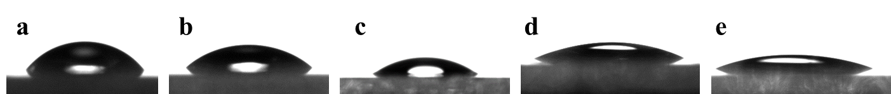
Figure S2. The contact angle of the glass surface after different hydroxylation treatments. a, No treatment; b, Sonication treatment; c, Acid treatment; d, Base treatment with 25 wt% aqueous NaOH; e, Base treatment with 10 wt% aqueous NaOH.

6.3 General procedure for covalently linking organic units and glasses via 1c.
A 10 mL round bottom flask was charged with 1c (0.3 mmol, 1 equiv.), 13 (0.3 mmol, 1 equiv.) in anhydrous MeCN (1 mL), then added BTMG (0.0103 g, 0.06 mmol). The reaction mixture was stirred at room temperature for 2 h. When the reaction was completed, 100 μL of reaction mixture was added to the hydrolysate (EtOH/H₂O, 10:1 v/v, 10 mL), and the pH was adjusted to 4.0 by acetic acid. Subsequently, the hydroxylated glass substrates were immersed to the solution and incubated for 24 h at room temperature. The treated cover slides were sonicated for 10 min in deionized water and then in acetone, ethanol and dried under the Ar flow⁹.

6.4 Assessment of the functionalized glass surface
The cover glasses were functionalized with triclosan (TC), fluorescein (FR), 1H,1H,2H,2H-perfluoro-1-decanol (PD) or nonylphenol (NP), respectively. Contact angle measurements was performed using an contact angle goniometer. Atomic force microscope (AFM) characterization is performed using a Bruker Dimension XR FastScan microscope. Green fluorescence was visualized with a 488-nm laser using a Leica DMi8 fluorescence microscope. The antimicrobial property of the functionalized slides was determined using the International Standard (ISO 22196:2011) Protocol, with minor modifications¹⁰⁻¹². Each cover glass (24 × 24 mm) was placed into a separate sterile Petri dish. 100 μL of test Staphylococcus aureus (CMCC 26003) at 10⁶ CFU/mL prepared in 1/500 diluted nutrient broth (NB) medium were placed onto the glass surface with cover film (22 × 22 mm) on the cell suspension. The disk was incubated at 35 °C for 24 h with a relative humidity ≥90%. Each material was tested in triplicate. Non-treated cover slides were used as controls for determination of bacterial viability. Samples were analyzed at 0 h and 24 h. After incubation, disks were washed with 10 mL of soya casein digest lecithin polysorbate (SCDLP) broth. The number of viable bacteria was determined using the plate counting method. The recovered bacteria liquid was performed 10-fold serial dilutions of the SCDLP in phosphate-buffered saline, pH 7.2 (PBS). 1 mL of each dilution, as well as 1 mL of the SCDLP recovery solution, was mixed with 15 mL of plate count agar (PCA). For each concentration gradient, there were two replicates, and the plates were incubated at 35 °C for 40–48 h. Antibacterial activity was evaluated by computing the viable microbe indicative of colony forming units (CFU/mL).
Result: Organic functional molecules were covalently linked to the slide surfaces, and endowed the surfaces with specific functions.
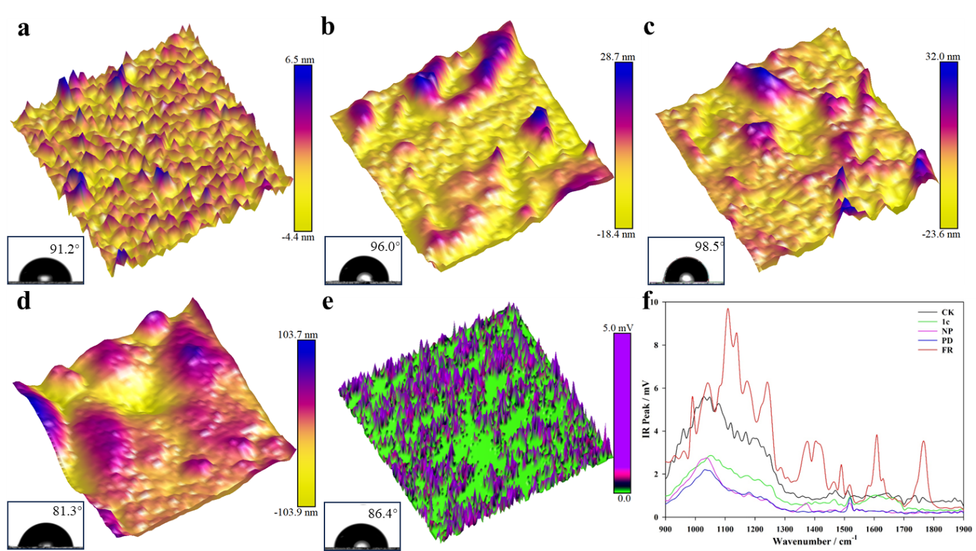
Figure S3. AFM-IR and contact angle measurements of functionalized cover slides. AFM topographic height images and contact angle of the cover slides surface functionalized with 1c (a) and nonylphenol (NP, b), 1H,1H,2H,2H-perfluoro-1-decanol (PD, c), fluorescein (FR, d) via the S-SuFEx hub 1c. e, AFM-IR image obtained at 1379 cm⁻¹ of triclosan-functionalized glass surface. f, AFM-IR spectra of the functionalized cover slides.
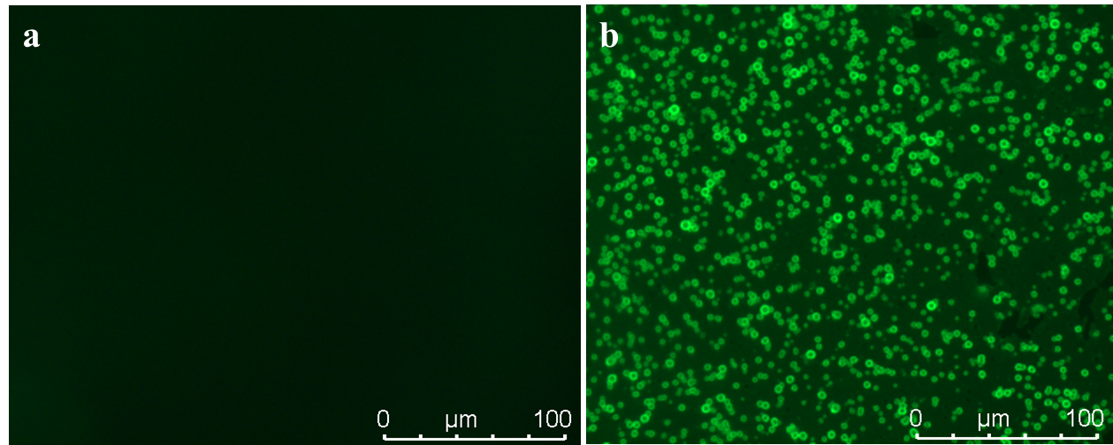
Figure S4. Surface fluorescence observations for the functionalized cover slides. a, the pristine glass surface. b, The surface of the fluorescein-functionalized slide (FR).
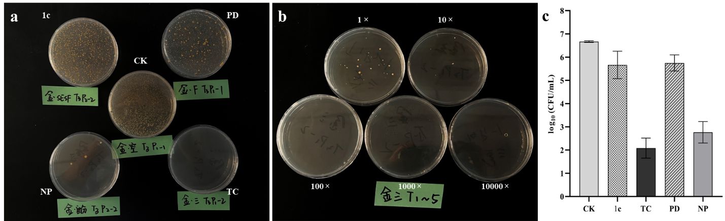
Figure S5. Surface antimicrobial assay for the functionalized cover slides. a, Efficacy of antimicrobial activity of the cover slides surface functionalized with nonylphenol (NP), 1H,1H,2H,2H-perfluoro-1-decanol (PD) and triclosan (TC) via the S-SuFEx hub 1c. b, Colony forming units of the bacteria liquid recovered from the surface of the triclosan-functionalized slide (TC) at different dilution fold. c, Measurement of antibacterial activity of the functionalized cover slides.

7 Mechanistic investigations

7.1 The reaction between 1b and phenol without BTMG
A 10 mL round bottom flask was charged with 1b (0.0775 g, 0.3 mmol) and 4a (0.0282 g, 0.3 mmol) in MeCN-d₃ (1 mL). The reaction mixture was stirred at room temperature for 2 h. The reaction mixture was directly analyzed by ¹H-NMR, and the yields was calculated by ¹H-NMR by adding 1,1,2,2- tetrachloroethane as internal standard.
Result: No reaction occurred without BTMG.
Figure S6. ¹H NMR spectra for the SuFEx reaction between 1b and 4a with or without BTMG (500 MHz, MeCN-d₃).

7.2 Different amounts of BTMG to sulfonyl fluoride 1b monitored by ¹H NMR
A 10 mL round bottom flask was charged with 1b (0.0775 g, 0.3 mmol) and BTMG (0.2, 0.4, 0.5 or 1.0 equiv.) in MeCN-d₃ (1 mL). The reaction mixture was stirred at room temperature for 2 h, and was directly analyzed by ¹H-NMR.
Result: BTMG addition resulted in the α-H deprotonation of alkyl sulfonyl fluoride 1b, rather than the formation of BTMG-sulfonyl fluoride active intermediate.
Figure S7. ¹H NMR spectra for different amounts of BTMG to sulfonyl fluoride 1b (500 MHz, MeCN-d₃).

7.3 Different amounts of BTMG to phenol 4a monitored by ¹H NMR
A 10 mL round bottom flask was charged with 4a (0.0775 g, 0.3 mmol) and BTMG (0.2, 0.5, 1.0 or 1.2 equiv.) in MeCN-d₃ (1 mL). The reaction mixture was stirred at room temperature for 2 h, and was directly analyzed by ¹H-NMR.
Result: As the addition amount of BTMG increased, hydrogen protons on the benzene ring showed relatively gradual reductions in chemical shifts. The chemical shifts gradually stabilized as 1 molar equivalent BTMG added, which is consistent with the formation of the phenoxide guanidinium complex. Particularly, the chemical shift of the para-H with respect to the phenolic hydroxyl moiety was significantly less, which suggested the accumulation of electron density by oxygen. Notably, full activation of phenol could be achieved even in the presence of 0.2 equivalent of BTMG.
Figure S8. ¹H NMR spectra for different amounts of BTMG to phenol 4a (500 MHz, MeCN-d₃).

7.4 Reaction courses
A 10 mL round bottom flask was charged with 4a (0.0282 g, 0.3 mmol) and BTMG (0.0257 g, 0.15 mmol) in MeCN-d₃ (1 mL). The reaction mixture was stirred at room temperature for 2 h, and 1b (0.0775 g, 0.3 mmol) was added. The reaction was continued with stirring for another 2 h. The reaction mixture was directly analyzed by ¹H-NMR, and the yields was calculated by ¹H-NMR by adding 1,1,2,2- tetrachloroethane as internal standard.
A 10 mL round bottom flask was charged with 1b (0.0775 g, 0.3 mmol) and BTMG (0.0257 g, 0.15 mmol) in MeCN-d₃ (1 mL). The reaction mixture was stirred at room temperature for 2 h, and 4a (0.0282 g, 0.3 mmol) was added. The reaction was continued with stirring for another 2 h. The reaction mixture was directly analyzed by ¹H-NMR, and the yields was calculated by ¹H-NMR by adding 1,1,2,2- tetrachloroethane as internal standard.
Result: Compound 4a reacted with BTMG to form active intermediate, followed by reaction with 1b to give the desired product 5b. However, the intermediate formed by 1b with BTMG could not continue the SuFEx reaction.

8 References
- Dong, J., Krasnova, L., Finn, M. G. & Sharpless, K. B. Sulfur(VI) fluoride exchange (SuFEx): another good reaction for click chemistry. Angew. Chem. Int. Ed. 53, 9430-48 (2014).
- Hechenbichler, M., Laschewsky, A. & Gradzielski, M. Poly(N, N-bis(2-methoxyethyl)acrylamide), a thermoresponsive non-ionic polymer combining the amide and the ethyleneglycolether motifs. Colloid. Polym. Sci. 299, 205-219 (2021).
- Nair, D. P. et al. The thiol-Michael addition click reaction: a powerful and widely used tool in materials chemistry. Chem. Mater. 26, 724-744 (2014).
- Thomson, B. J. et al. Facile synthesis of sulfonyl fluorides from sulfonic acids. Chem. Commun. 59, 555-558 (2023).
- Lee, S. B., Park, J. H. & Bae, H. Y. Hydrophobic amplification enabled high-turnover phosphazene superbase catalysis. ChemSusChem 15, e202200634 (2022).
- Pang, R. et al. Degradation of sulfonamide antibiotics and a structurally related compound by chlorine dioxide: Efficiency, kinetics, potential products and pathways. Chem. Eng. J. 451, 138502 (2023).
- Arnold, R. M., Sheppard, G. R. & Locklin, J. Comparative aminolysis kinetics of different active ester polymer brush platforms in postpolymerization modification with primary and aromatic amines. Macromolecules 45, 5444-5450 (2012).
- Song, D., Jo, Y., Choi, J. M. & Jung, Y. Client proximity enhancement inside cellular membrane-less compartments governed by client-compartment interactions. Nat. Commun. 11, 5642 (2020).
- Zhang, L., Zhou, A. G., Sun, B. R., Chen, K. S. & Yu, H. Z. Functional and versatile superhydrophobic coatings via stoichiometric silanization. Nat. Commun. 12, 982 (2021).
- ISO 22196. Measurement of Antibacterial Activity on Plastics and Other Non-Porous Surfaces; International Standard Organization: Geneva, Switzerland, 2011.
- Dinjaski, N. et al. PHACOS, a functionalized bacterial polyester with bactericidal activity against methicillin-resistant Staphylococcus aureus. Biomaterials 35, 14-24 (2014).
- Armugam. A. et al. Broad spectrum antimicrobial PDMS-based biomaterial for catheter fabrication. Biomater. Res. 25, 33 (2021).

9 NMR spectra
¹H NMR spectrum for compound 1a (500 MHz, CDCl₃)
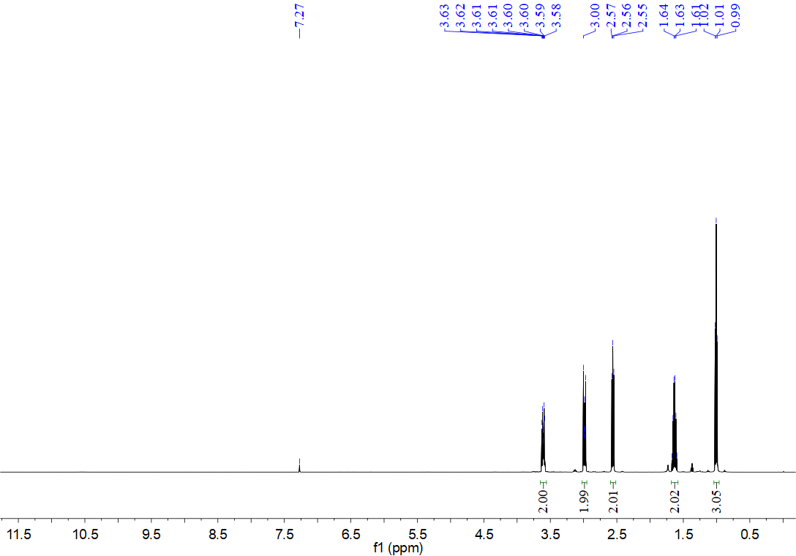
¹³C NMR spectrum for compound 1a (126 MHz, CDCl₃)
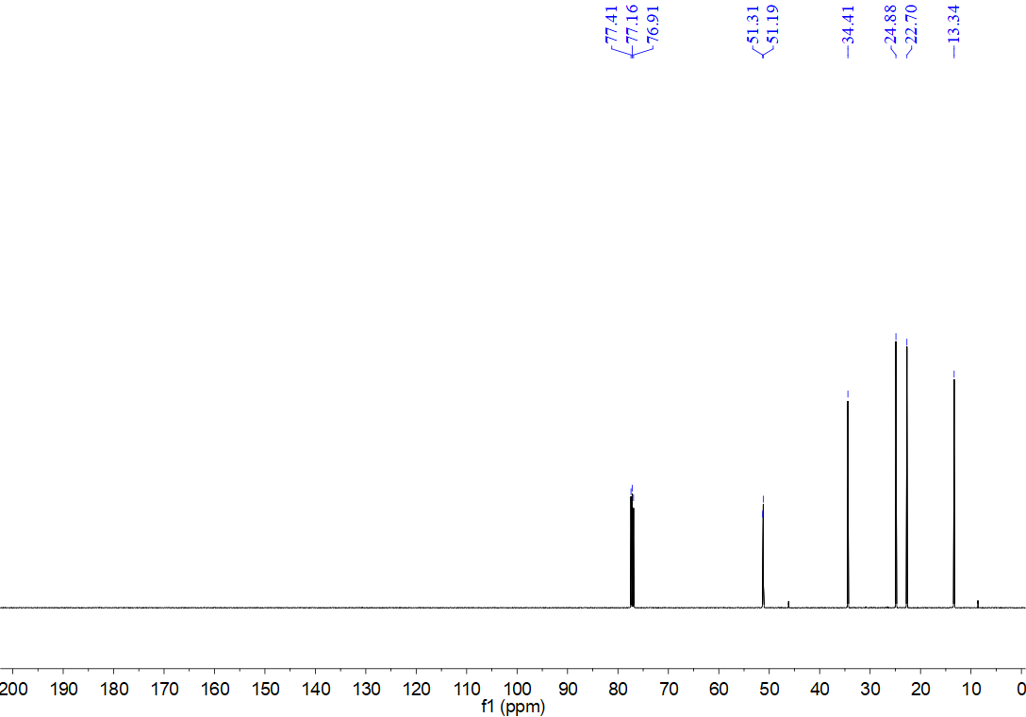
¹⁹F NMR spectrum for compound 1a (471 MHz, CDCl₃)
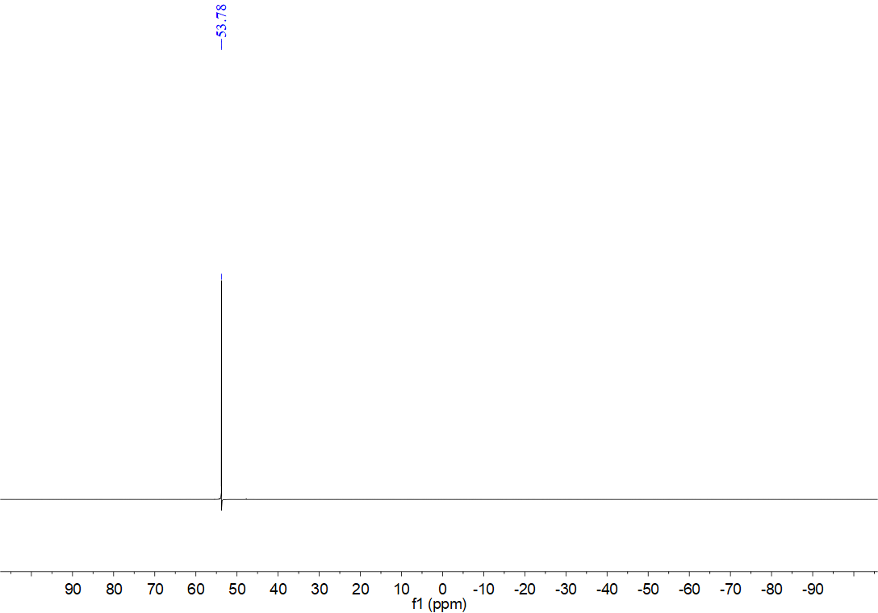
¹H NMR spectrum for compound 1b (500 MHz, CDCl₃)
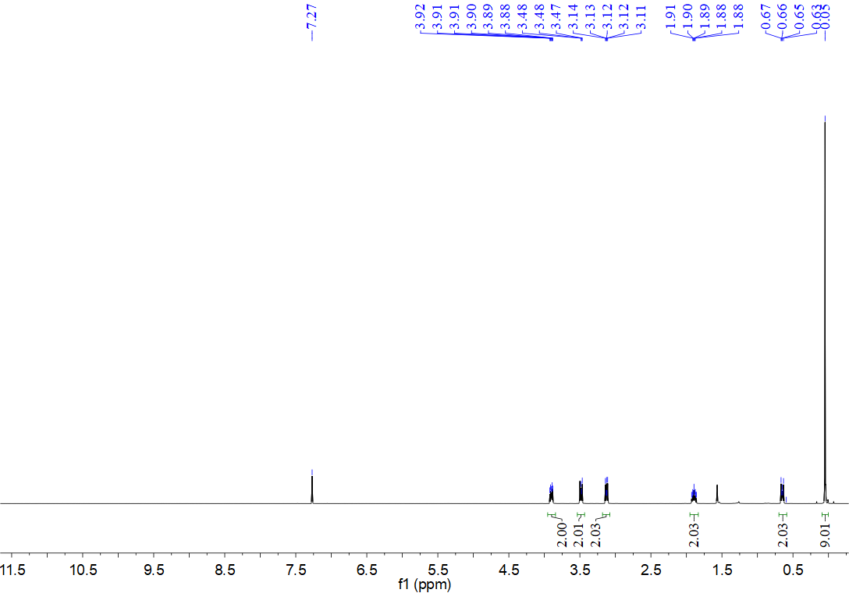
¹³C NMR spectrum for compound 1b (126 MHz, CDCl₃)
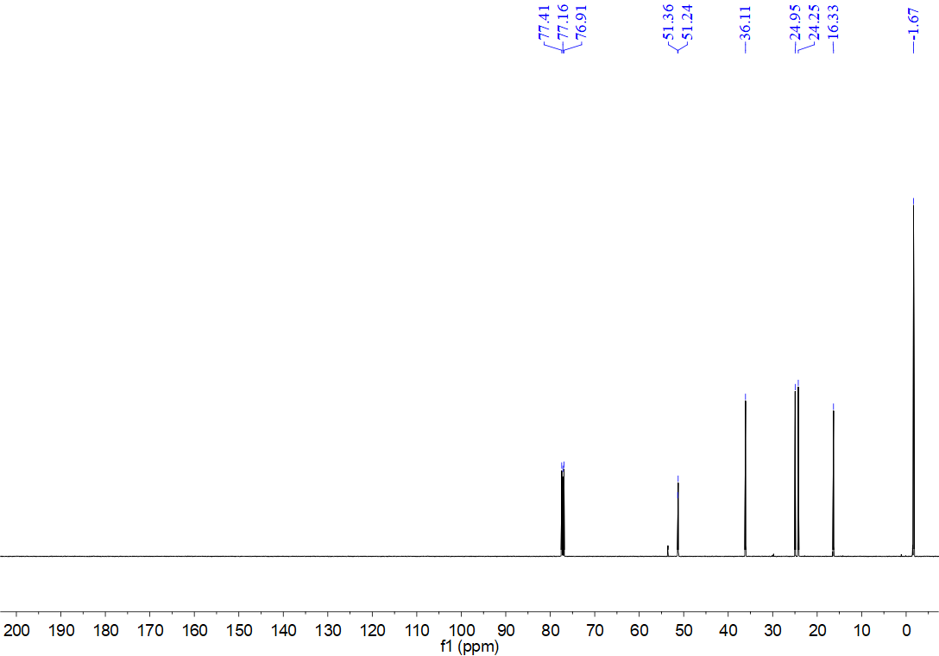
¹⁹F NMR spectrum for compound 1b (471 MHz, CDCl₃)
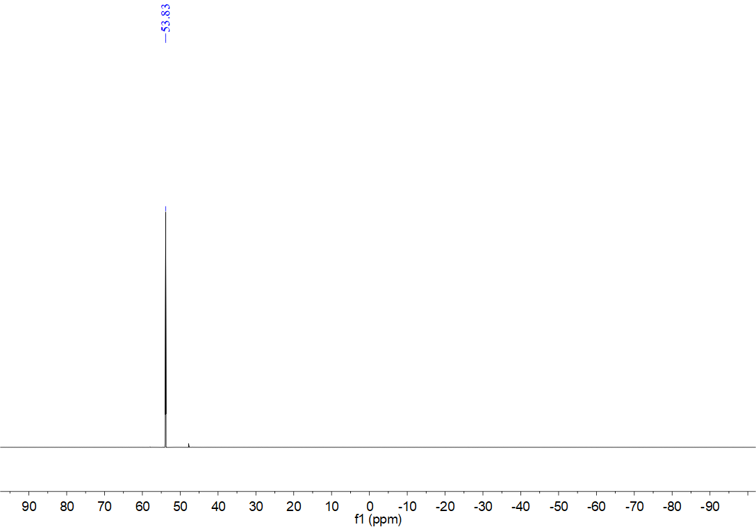
¹H NMR spectrum for compound 1c (500 MHz, CDCl₃)
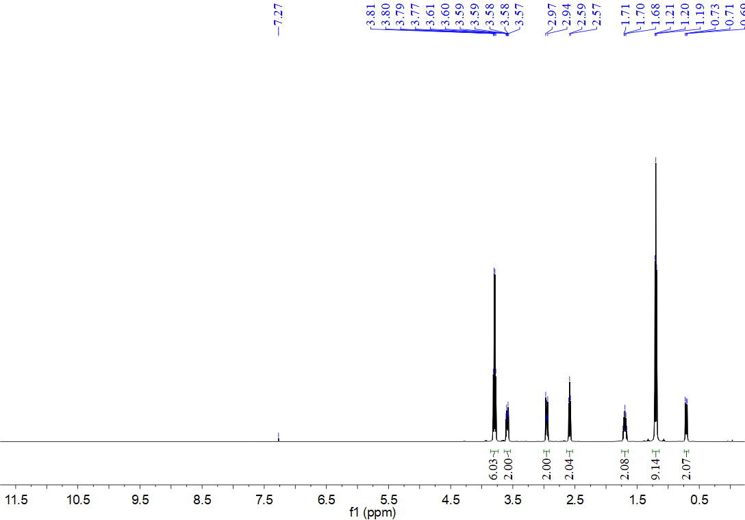
¹³C NMR spectrum for compound 1c (126 MHz, CDCl₃)
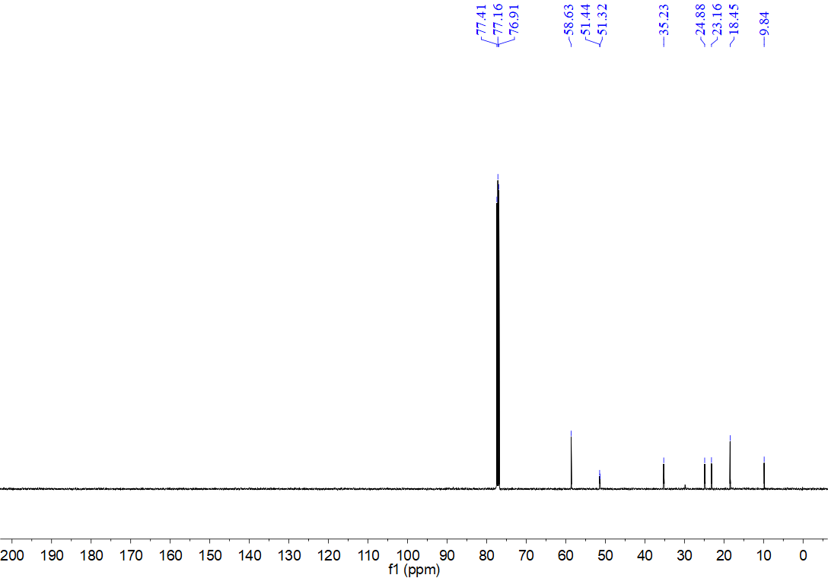
¹⁹F NMR spectrum for compound 1c (471 MHz, CDCl₃)
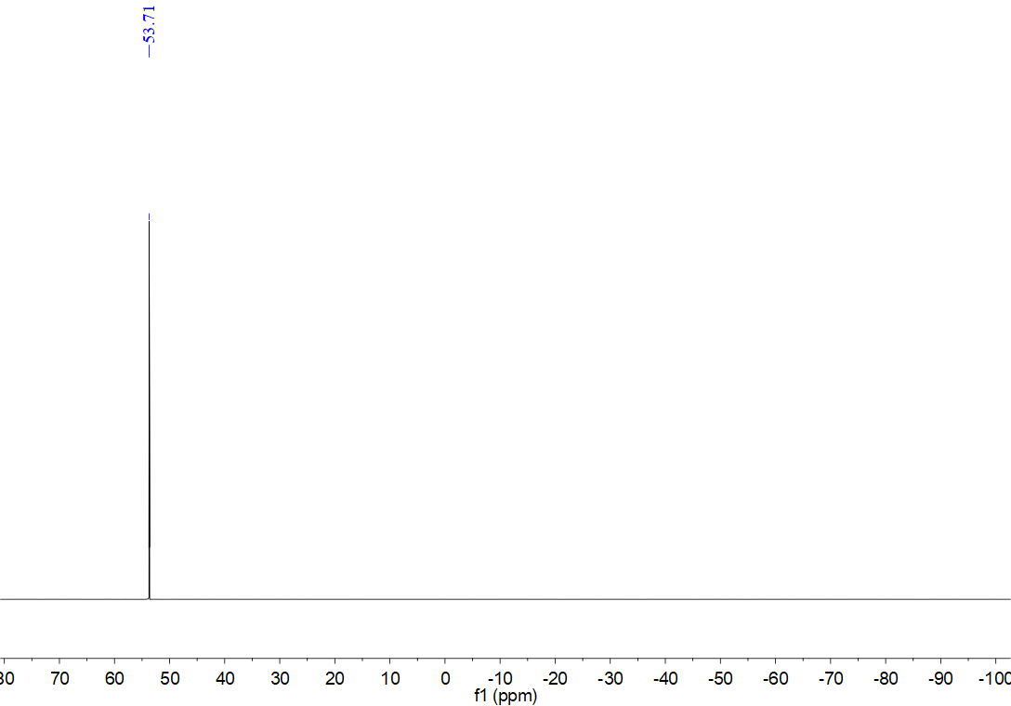
¹H NMR spectrum for compound 3a (500 MHz, CDCl₃)
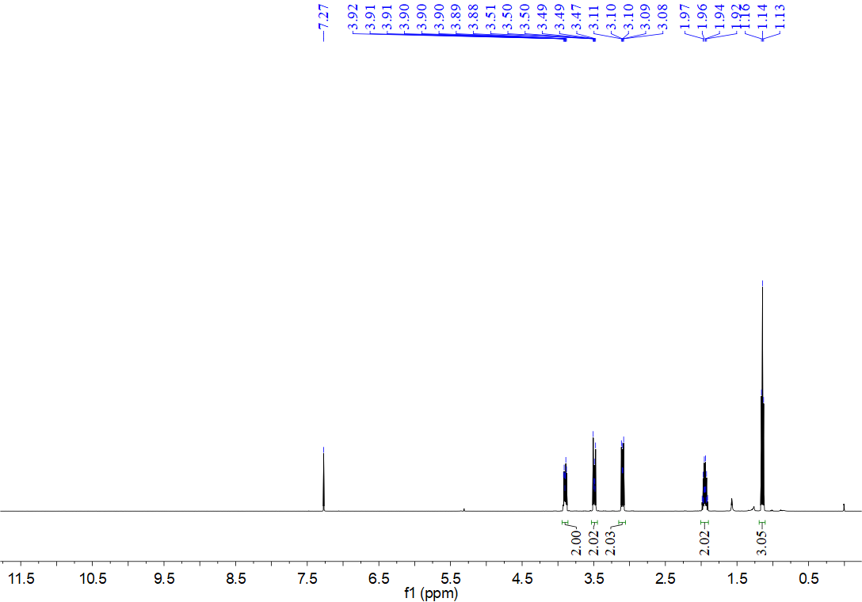
¹³C NMR spectrum for compound 3a (126 MHz, CDCl₃)
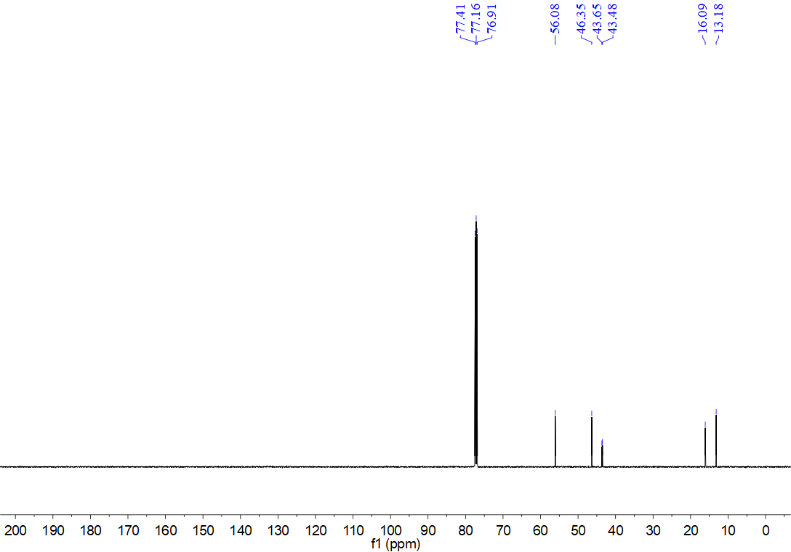
¹H NMR spectrum for compound 3b (500 MHz, CDCl₃)
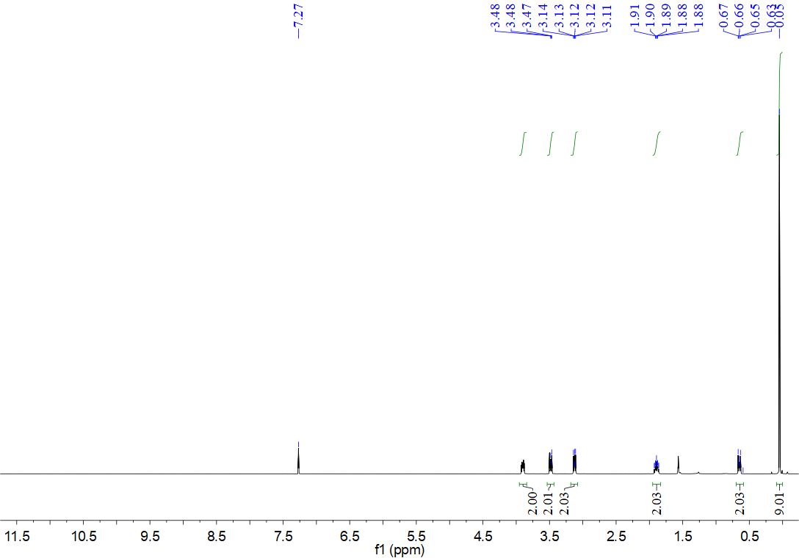
¹³C NMR spectrum for compound 3b (126 MHz, CDCl₃)
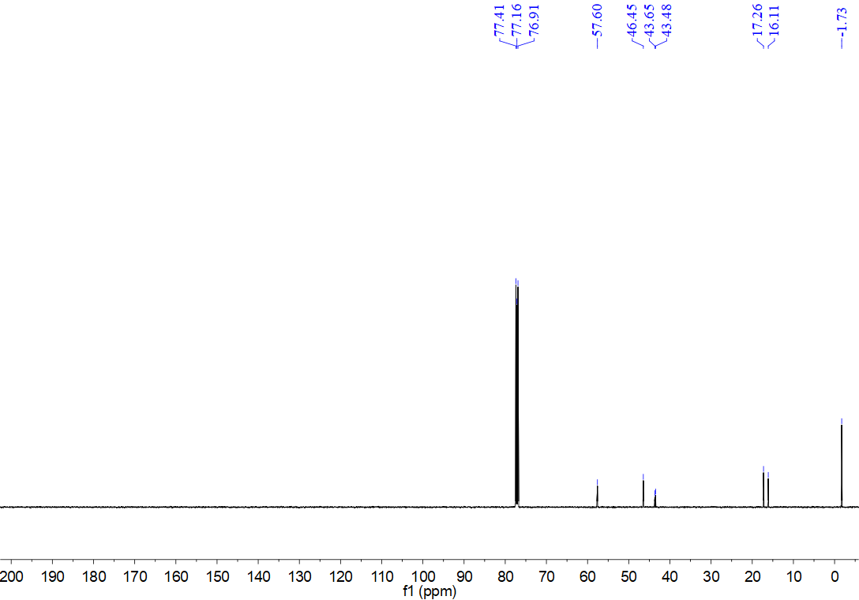
¹H NMR spectrum for compound 5a (500 MHz, CDCl₃)
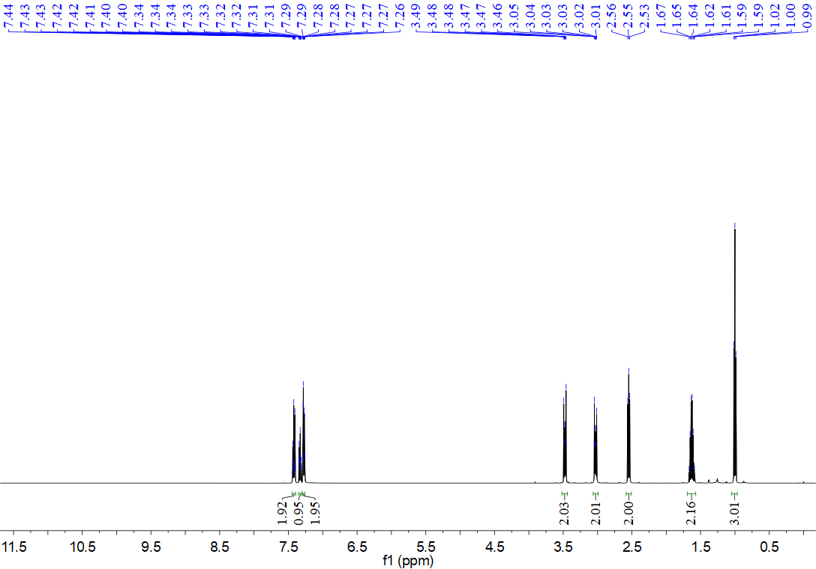
¹³C NMR spectrum for compound 5a (126 MHz, CDCl₃)
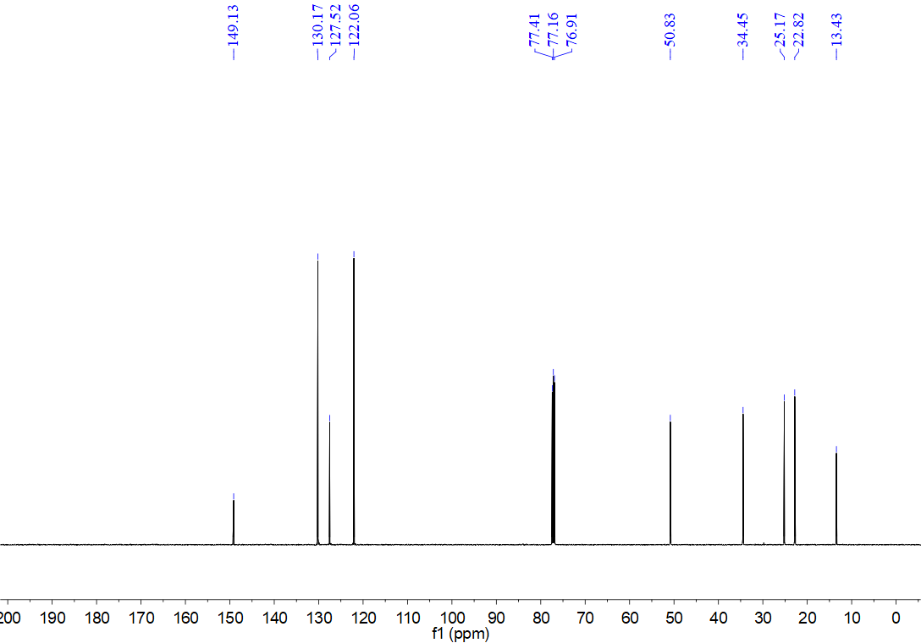
¹H NMR spectrum for compound 5z (500 MHz, CDCl₃)
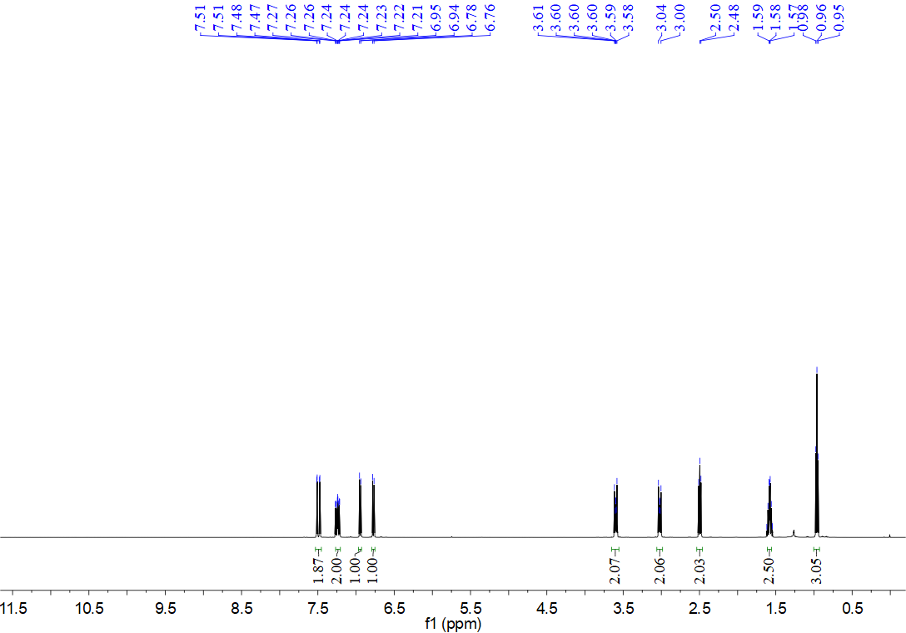
¹³C NMR spectrum for compound 5z (126 MHz, CDCl₃)
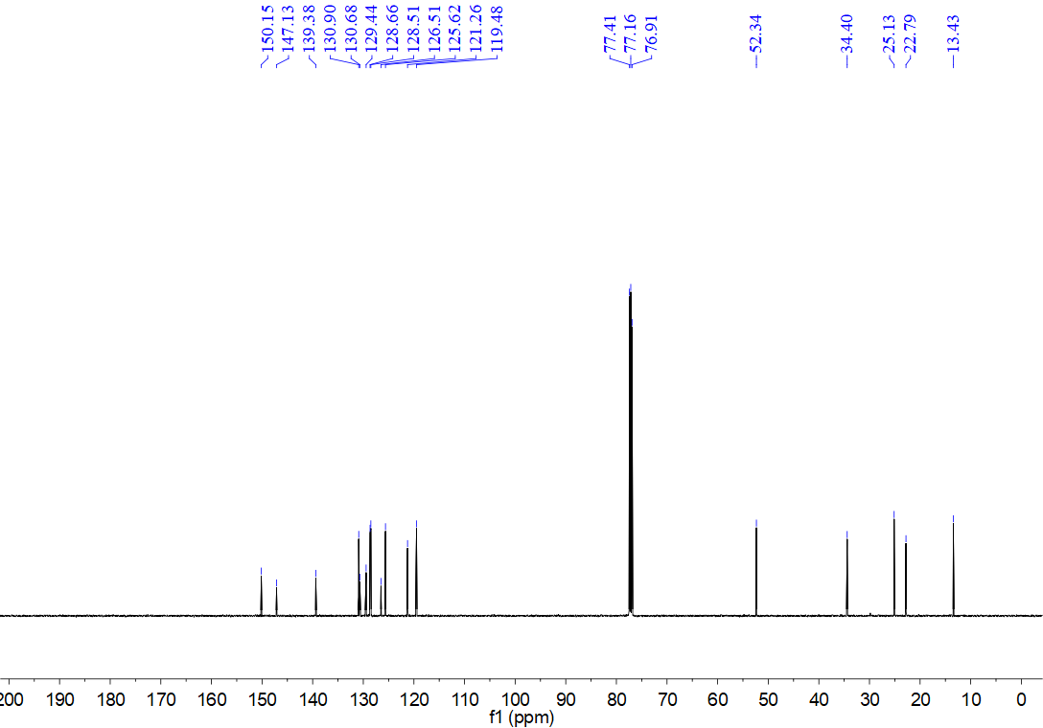
¹H NMR spectrum for compound 8a (500 MHz, CDCl₃)
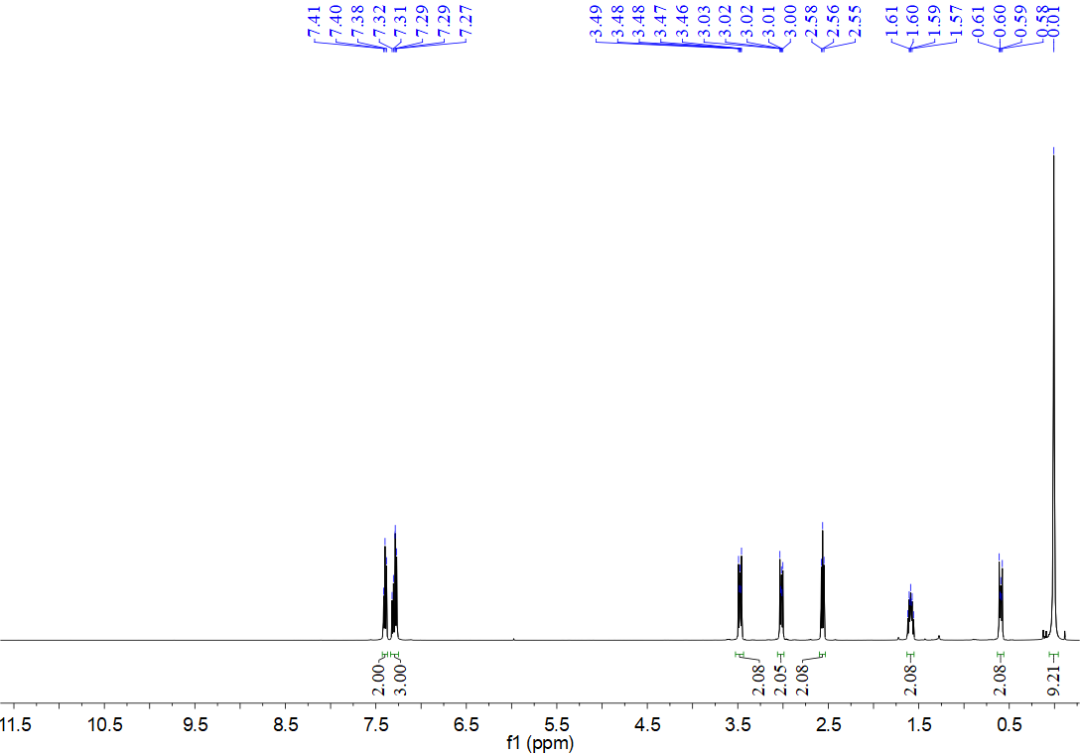
¹³C NMR spectrum for compound 8a (126 MHz, CDCl₃)
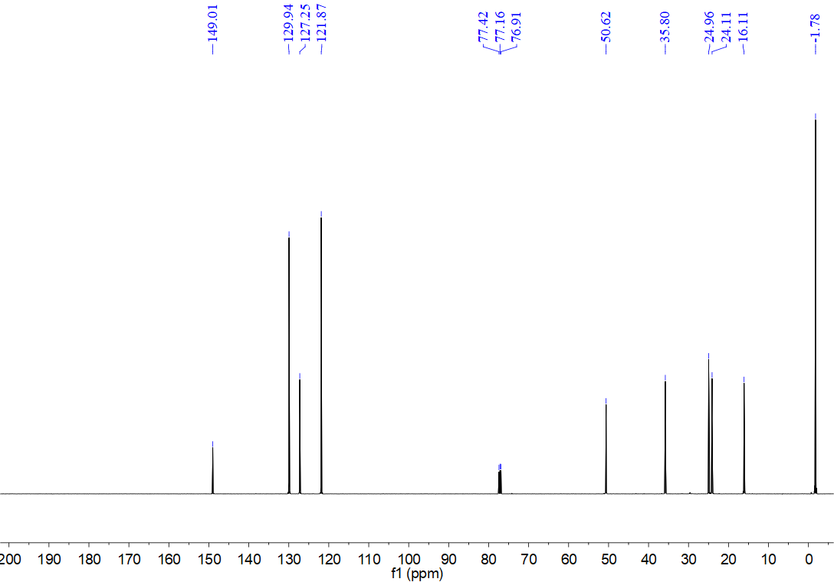
¹H NMR spectrum for compound 8b (500 MHz, CDCl₃)
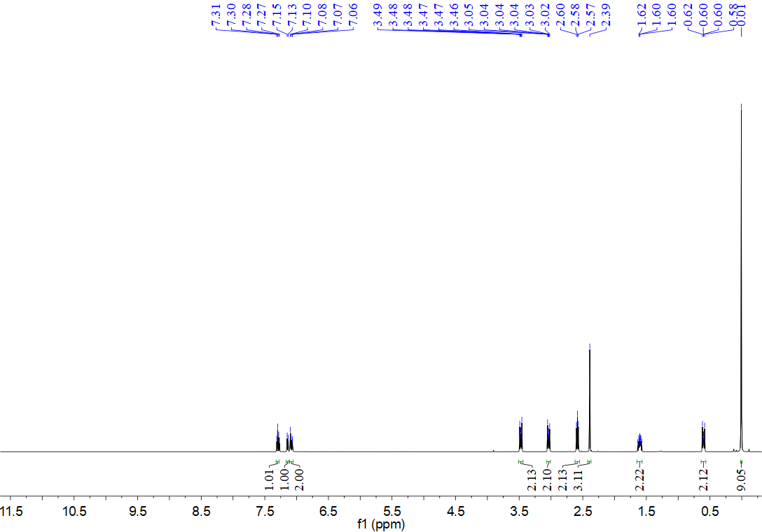
¹³C NMR spectrum for compound 8b (126 MHz, CDCl₃)
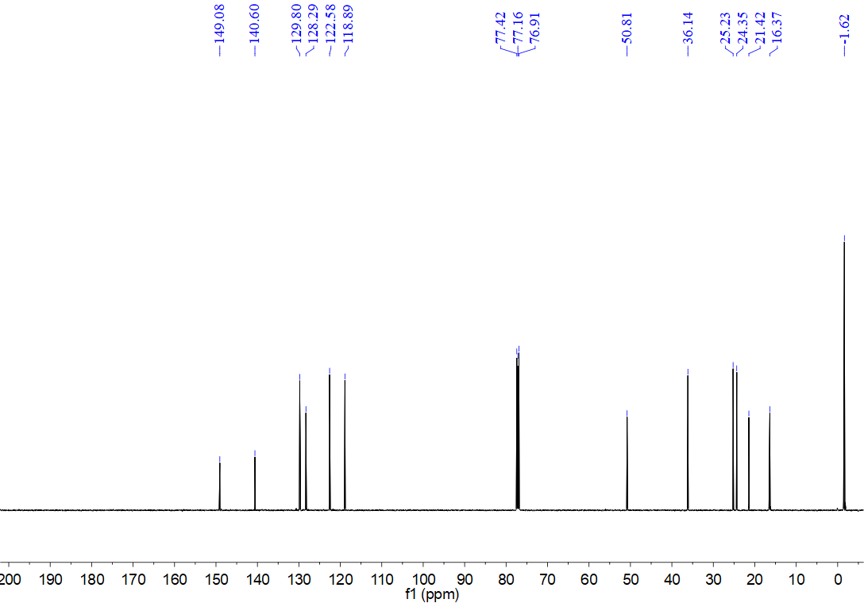
¹H NMR spectrum for compound 8c (500 MHz, CDCl₃)
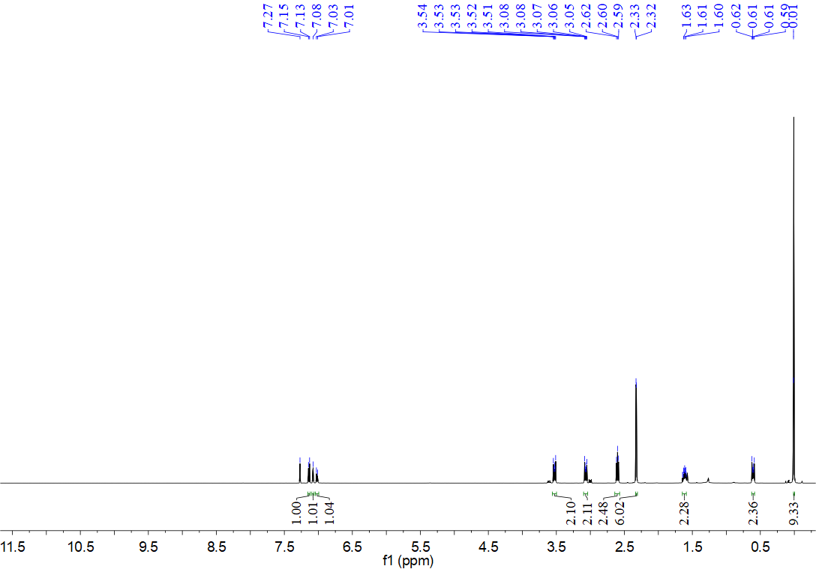
¹³C NMR spectrum for compound 8c (126 MHz, CDCl₃)
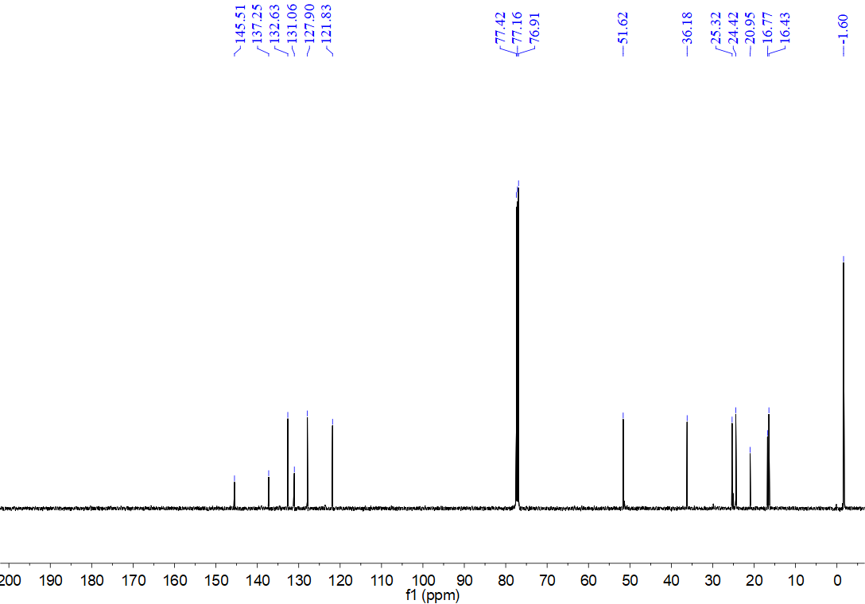
¹H NMR spectrum for compound 8d (500 MHz, CDCl₃)
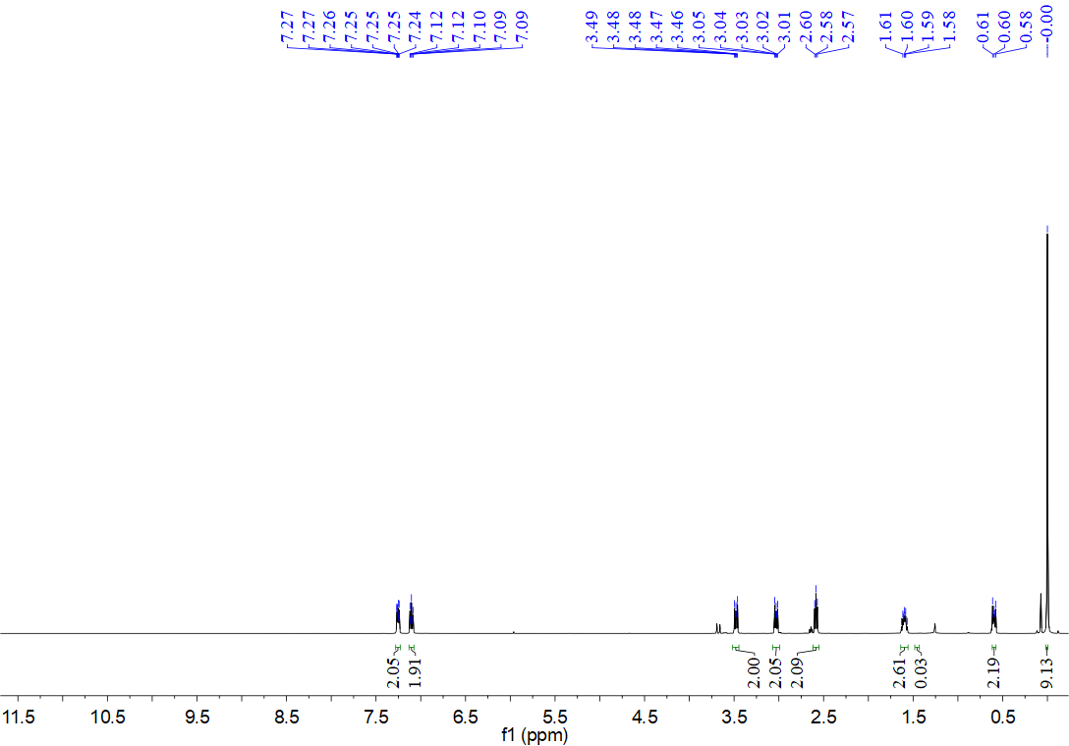
¹³C NMR spectrum for compound 8d (126 MHz, CDCl₃)
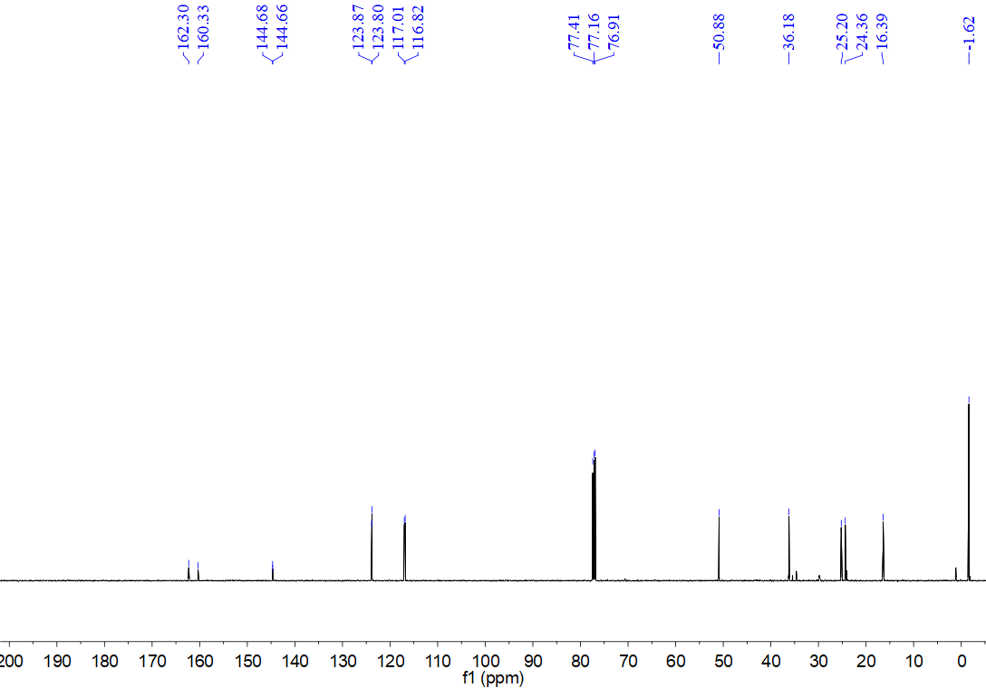
¹H NMR spectrum for compound 8e (500 MHz, CDCl₃)
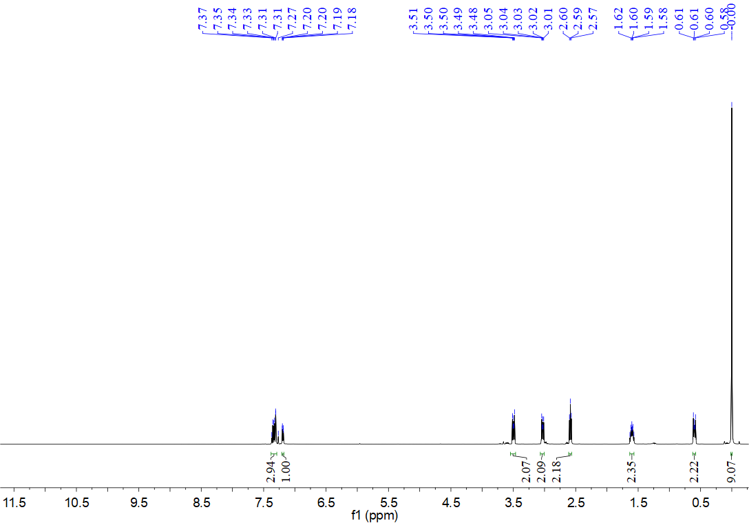
¹³C NMR spectrum for compound 8e (126 MHz, CDCl₃)
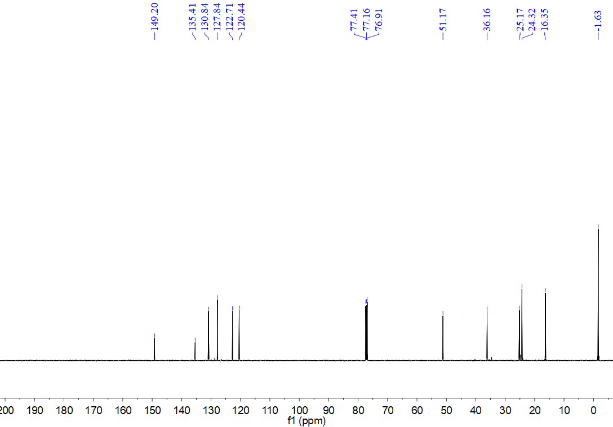
¹H NMR spectrum for compound 8f (500 MHz, CDCl₃)
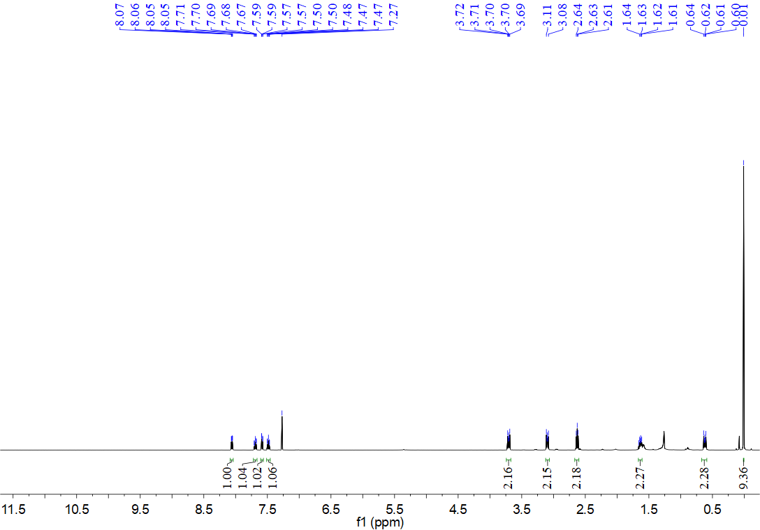
¹³C NMR spectrum for compound 8f (126 MHz, CDCl₃)
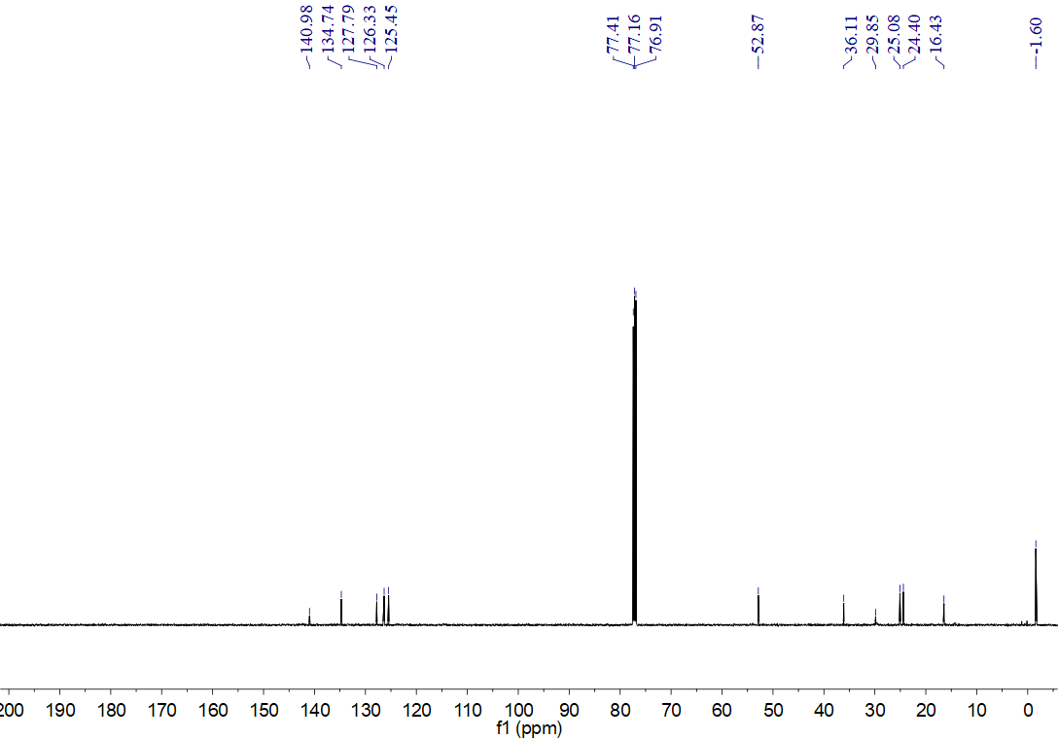
¹H NMR spectrum for compound 8g (500 MHz, CDCl₃)
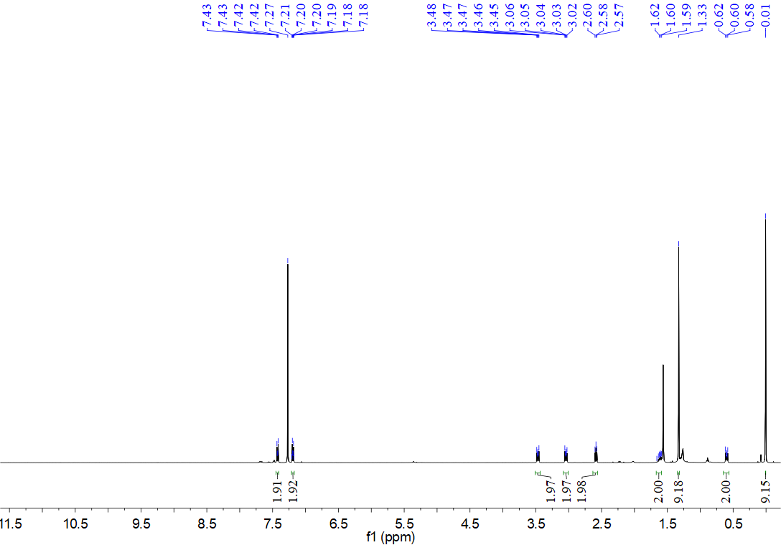
¹³C NMR spectrum for compound 8g (126 MHz, CDCl₃)
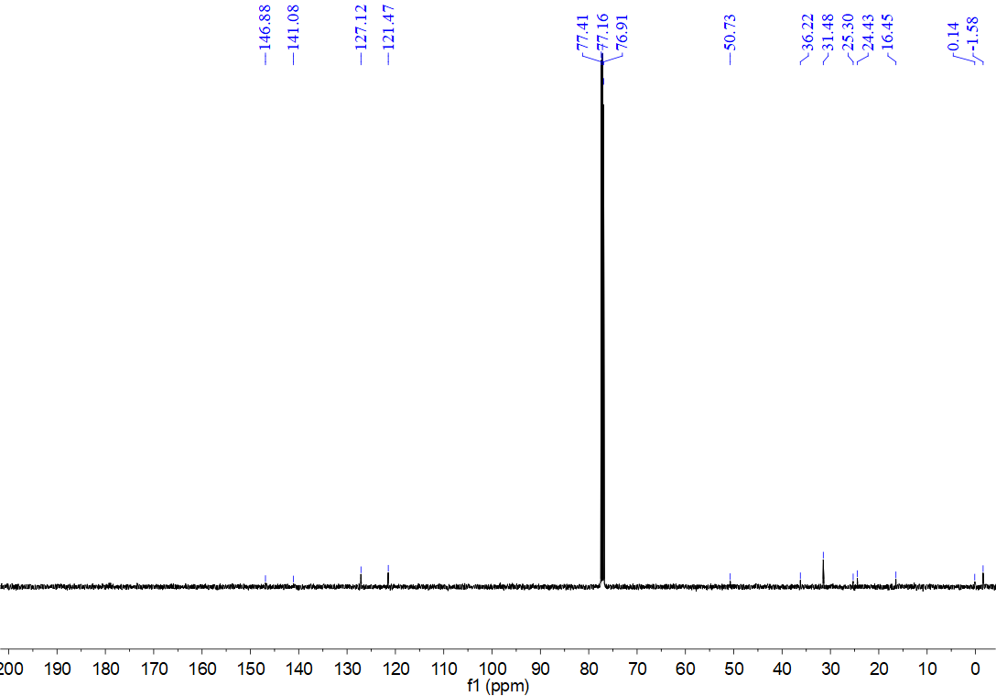
¹H NMR spectrum for compound 8h(500 MHz, CDCl₃)
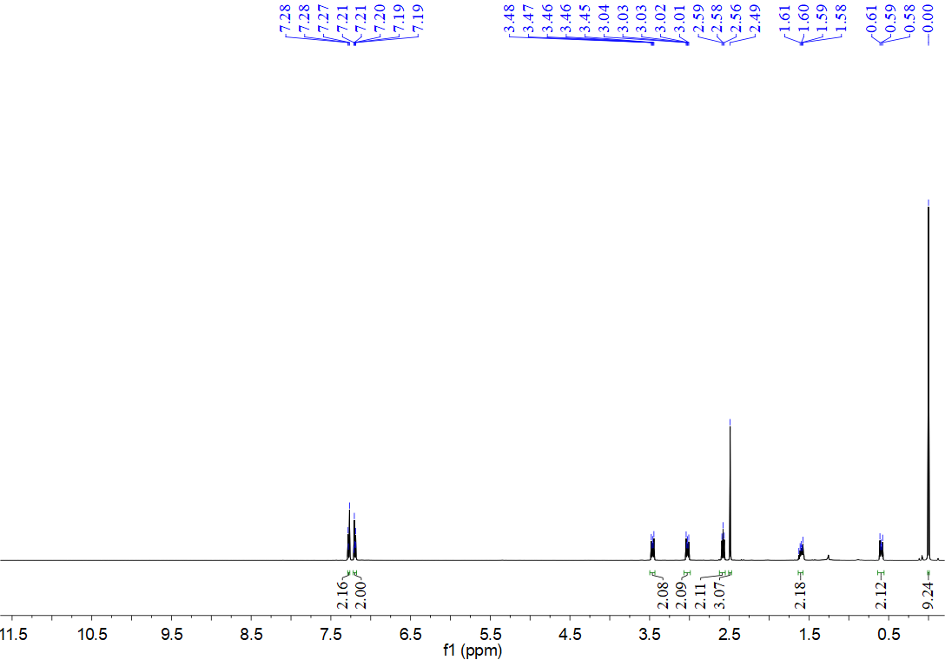
¹³C NMR spectrum for compound 8h (126 MHz, CDCl₃)
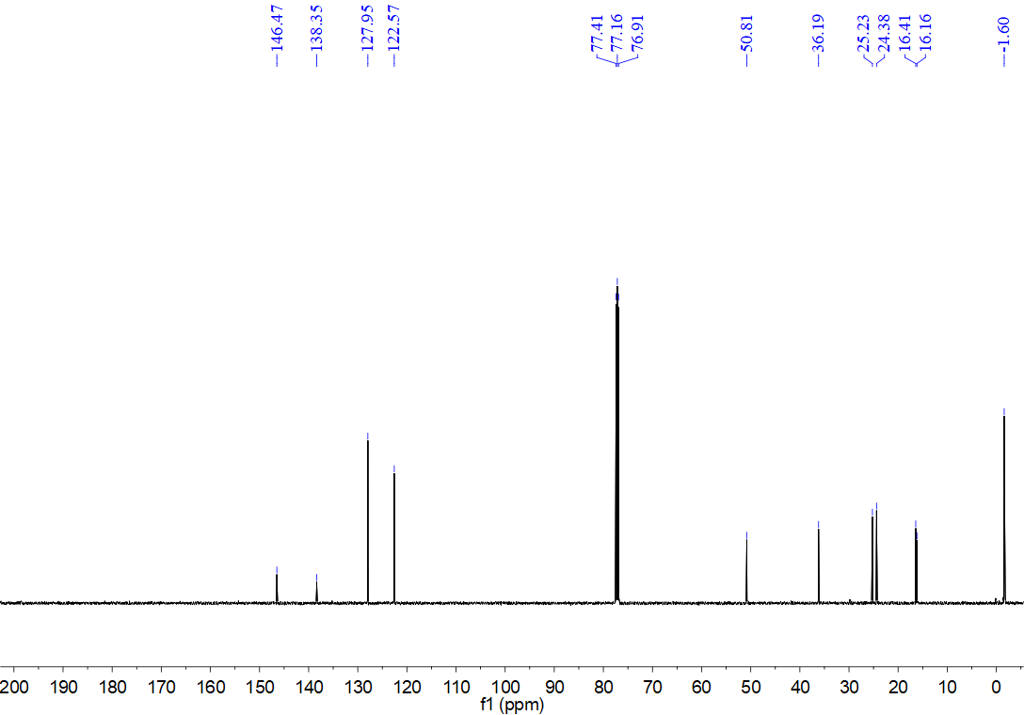
¹H NMR spectrum for compound 8i (500 MHz, CDCl₃)
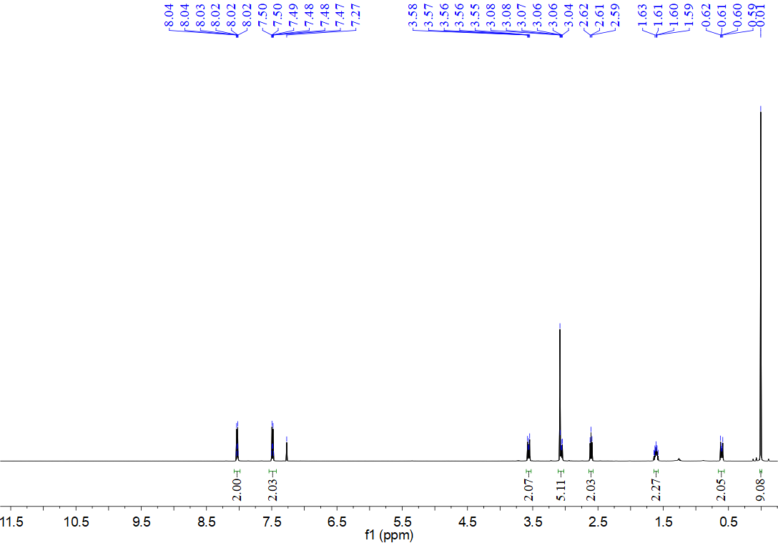
¹³C NMR spectrum for compound 8i (126 MHz, CDCl₃)
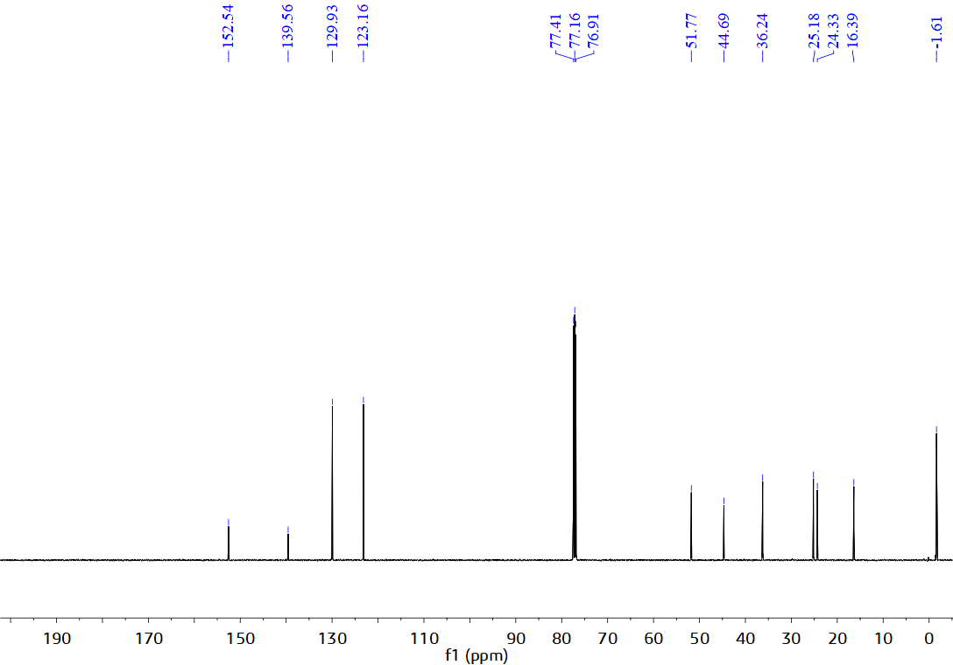
¹H NMR spectrum for compound 8j (500 MHz, CDCl₃)
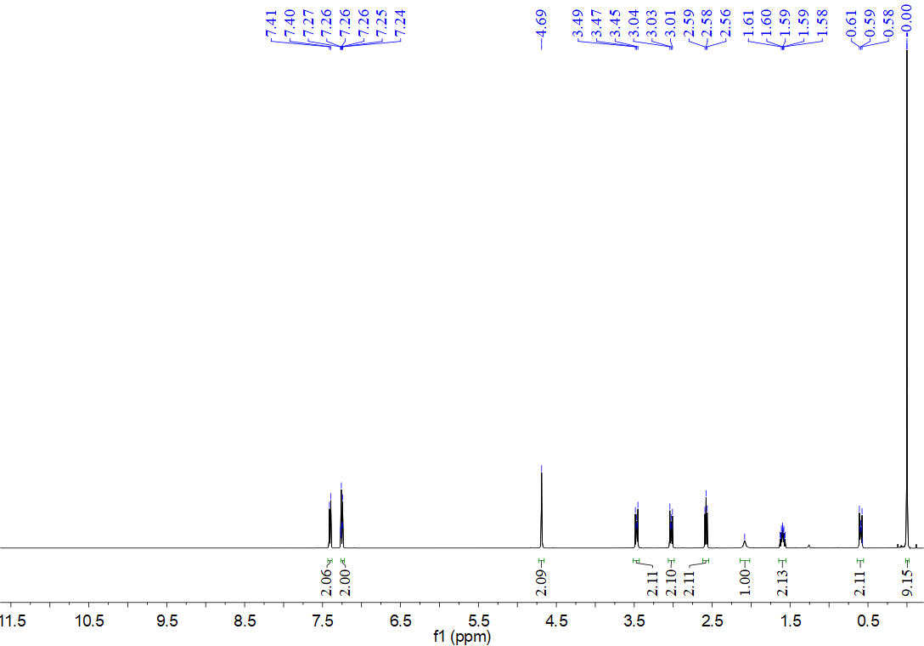
¹³C NMR spectrum for compound 8j (126 MHz, CDCl₃)
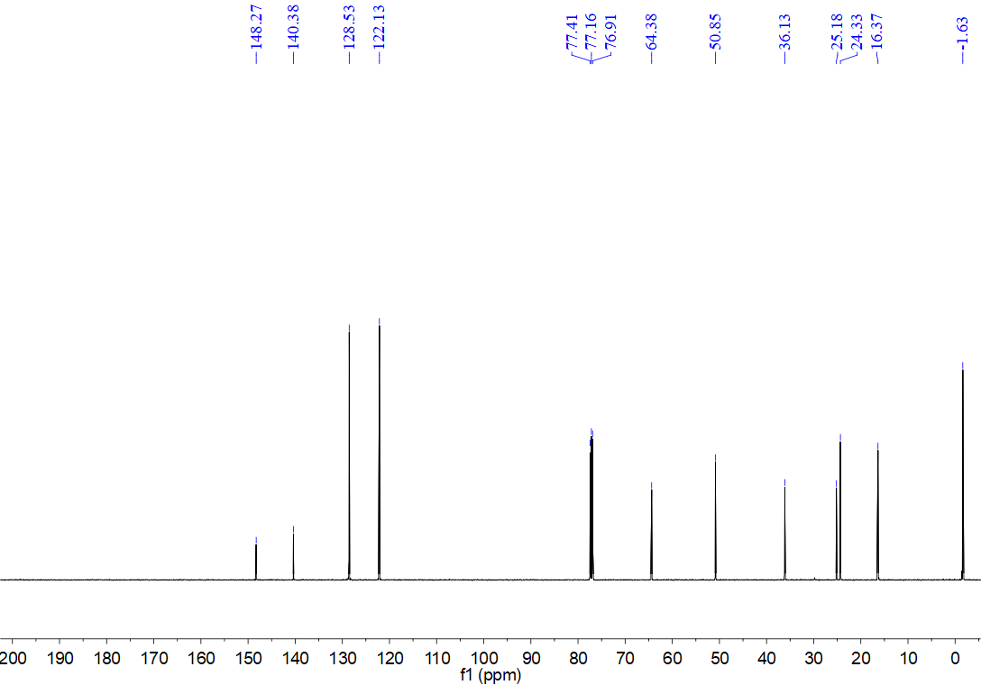
¹H NMR spectrum for compound 8k (500 MHz, CDCl₃)
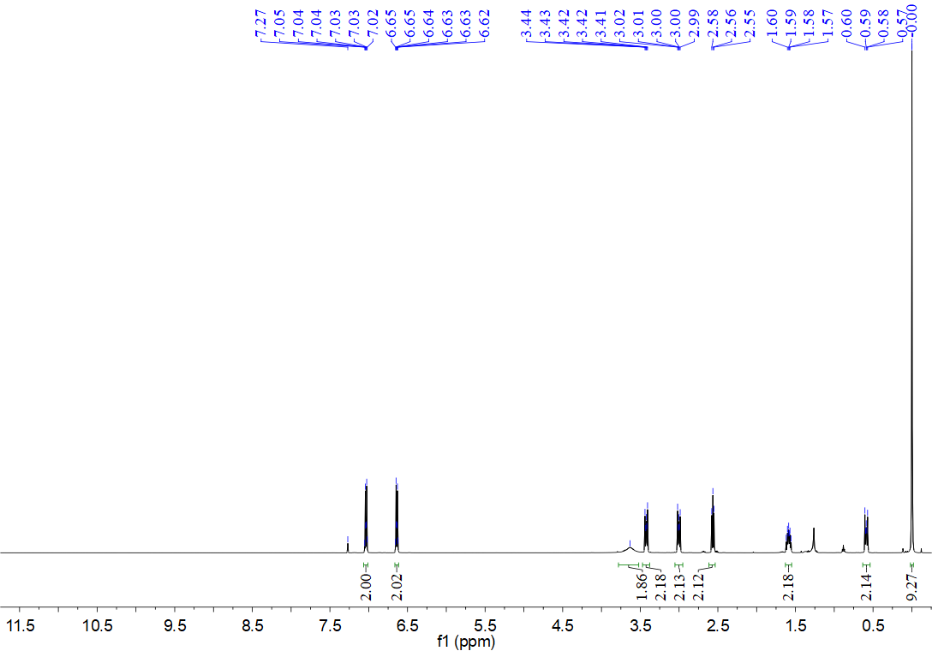
¹³C NMR spectrum for compound 8k (126 MHz, CDCl₃)
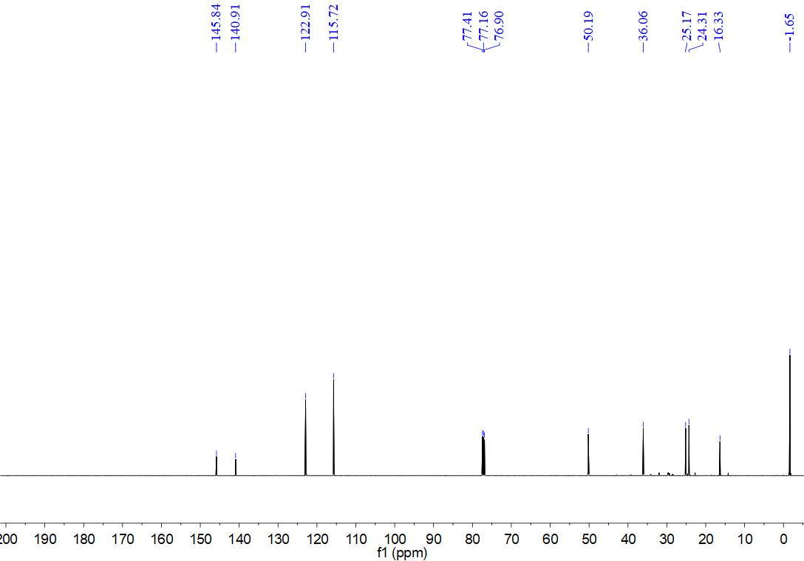
¹H NMR spectrum for compound 8l (500 MHz, CDCl₃)
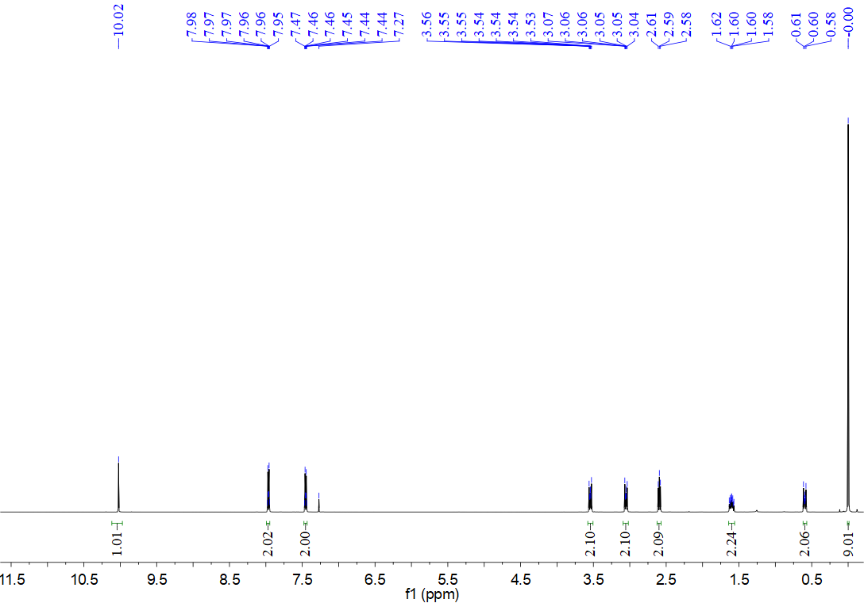
¹³C NMR spectrum for compound 8l (126 MHz, CDCl₃)
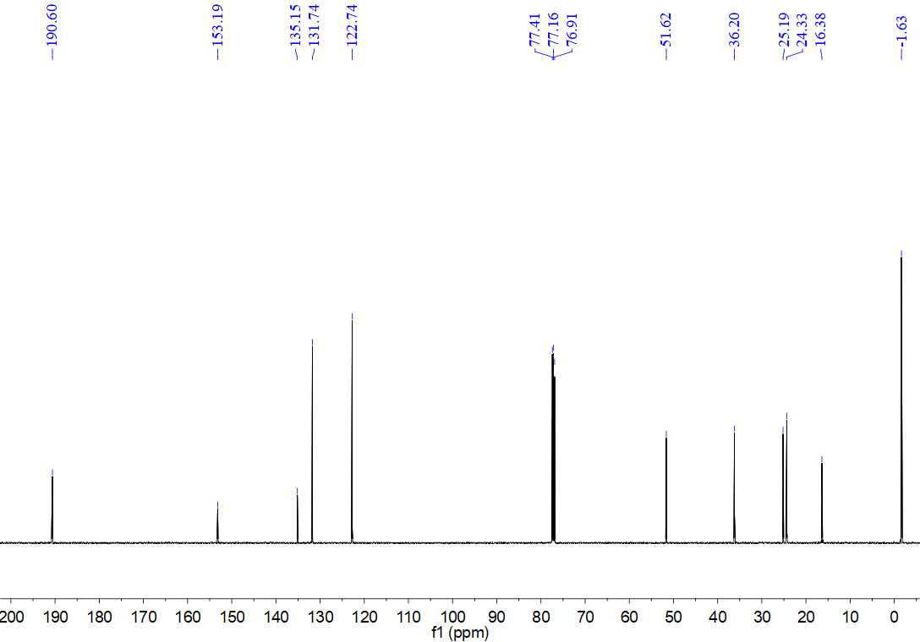
¹H NMR spectrum for compound 8m (500 MHz, CDCl₃)
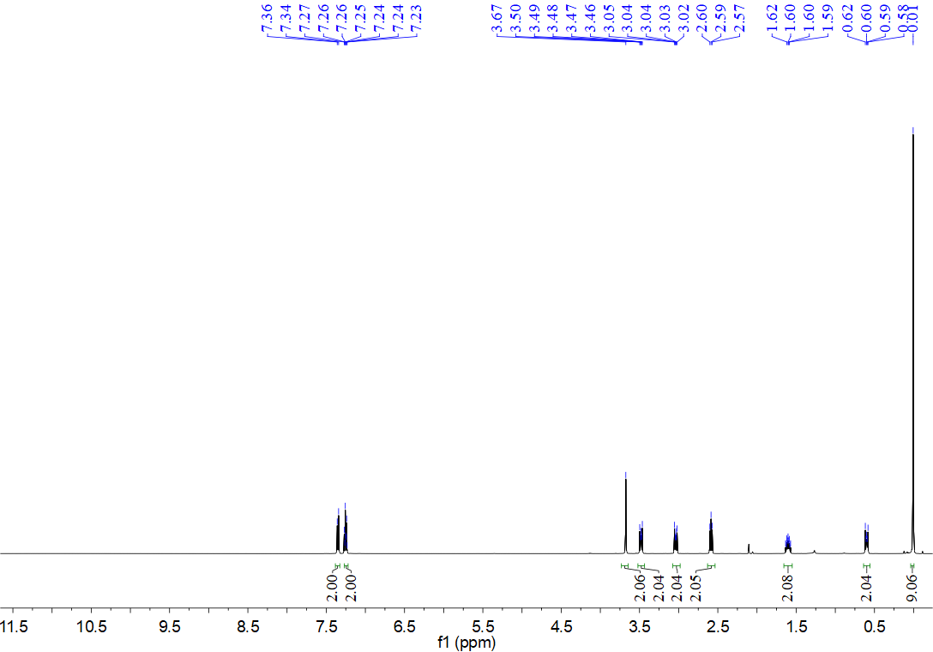
¹³C NMR spectrum for compound 8m (126 MHz, CDCl₃)
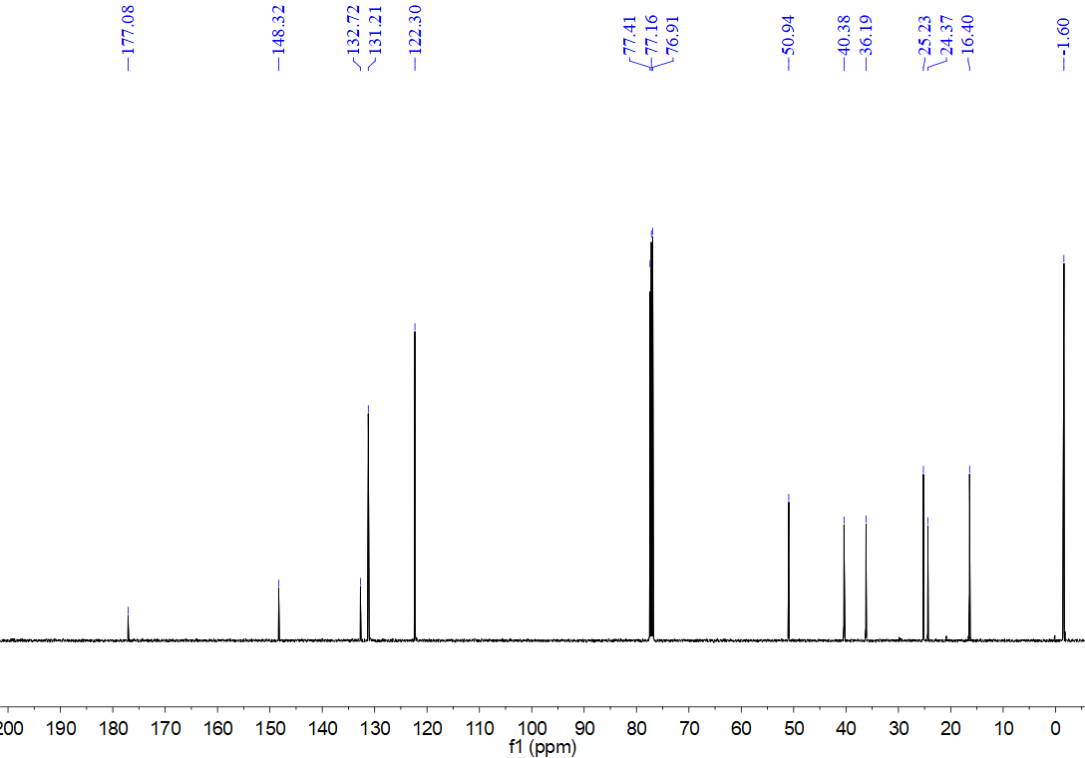
¹H NMR spectrum for compound 8n (500 MHz, CDCl₃)
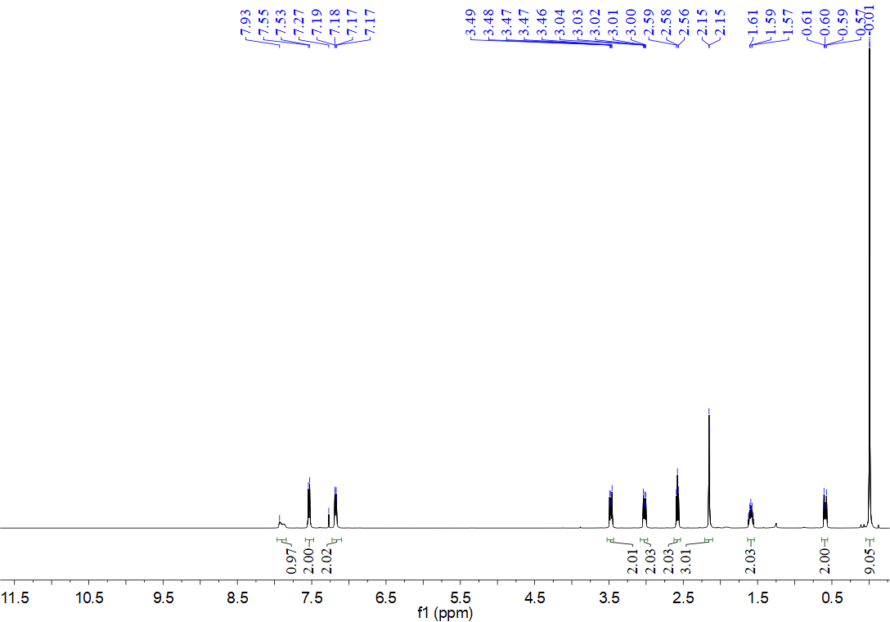
¹³C NMR spectrum for compound 8n (126 MHz, CDCl₃)
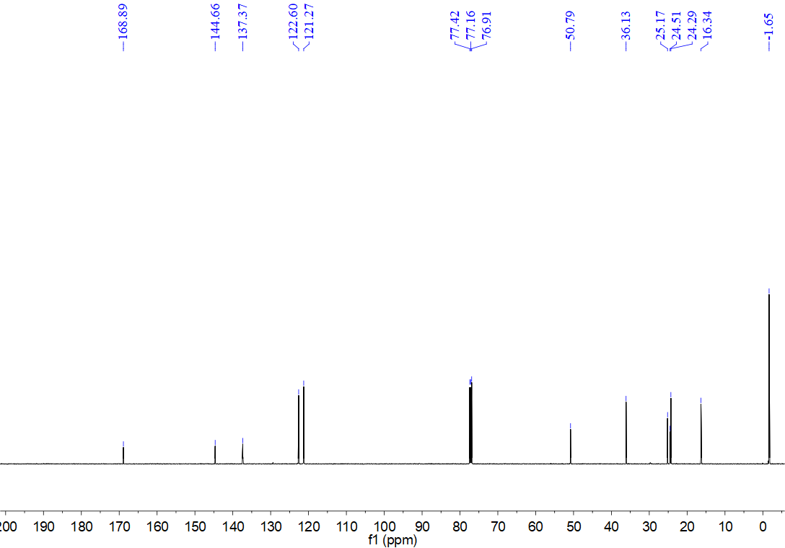
¹H NMR spectrum for compound 8o (500 MHz, CDCl₃)
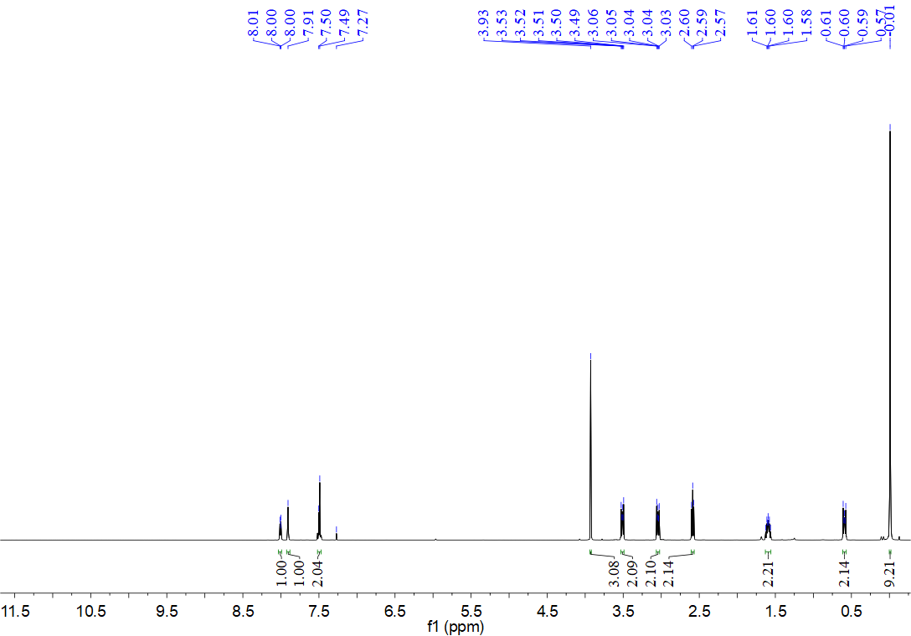
¹³C NMR spectrum for compound 8o (126 MHz, CDCl₃)
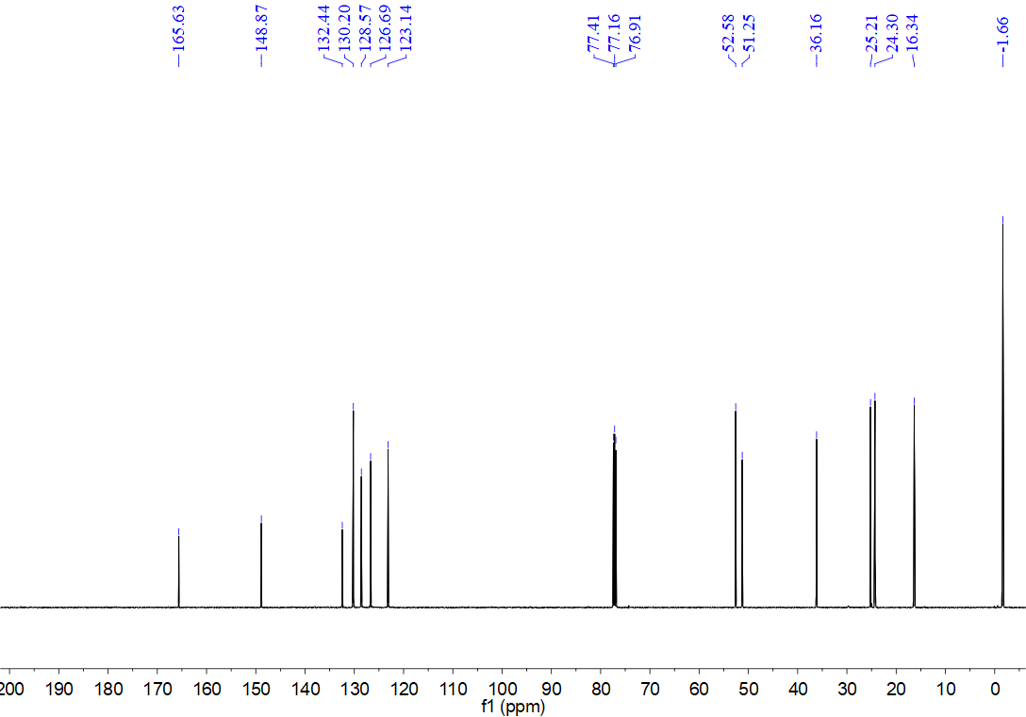
¹H NMR spectrum for compound 8p (500 MHz, CDCl₃)
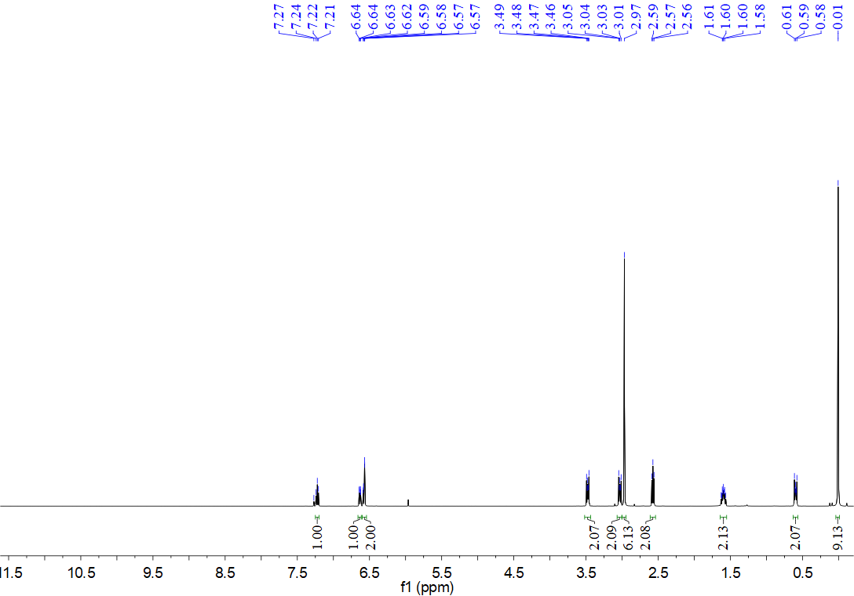
¹³C NMR spectrum for compound 8p (126 MHz, CDCl₃)
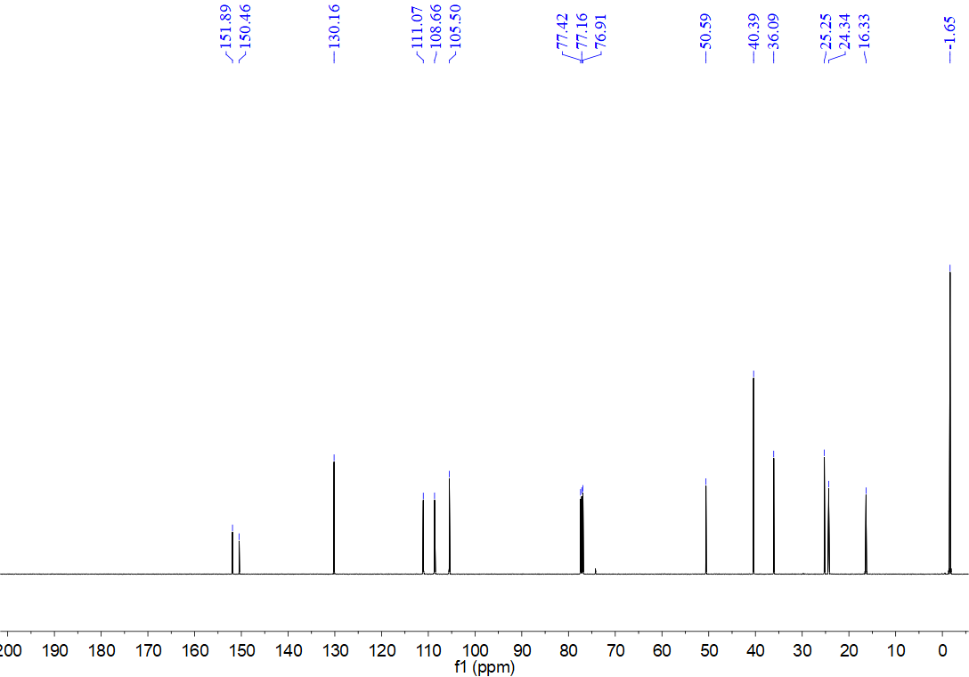
¹H NMR spectrum for compound 8q (500 MHz, CDCl₃)
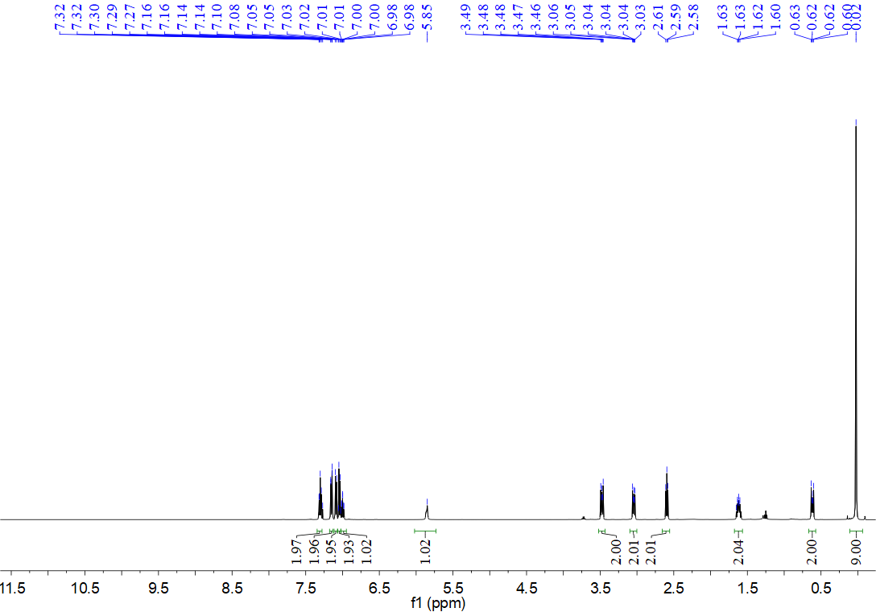
¹³C NMR spectrum for compound 8q (126 MHz, CDCl₃)
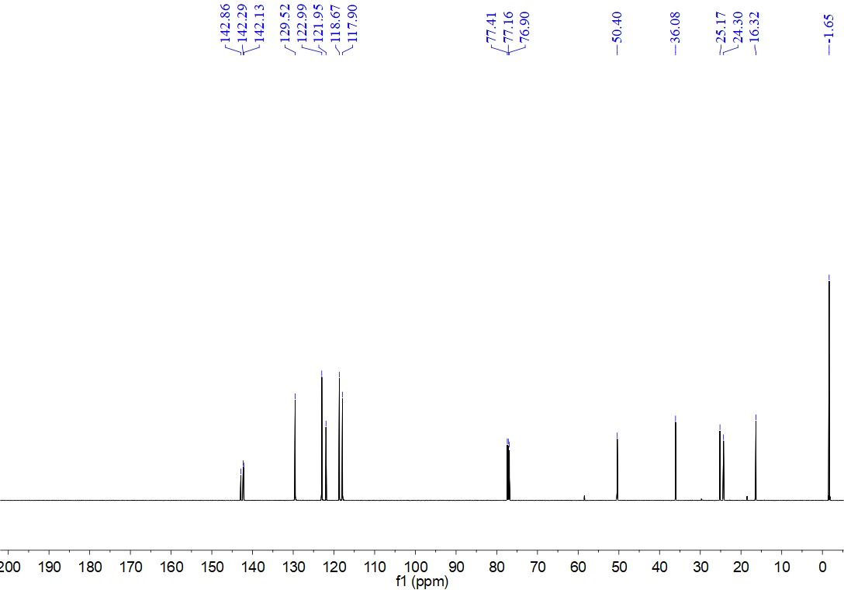
¹H NMR spectrum for compound 8r (500 MHz, CDCl₃)
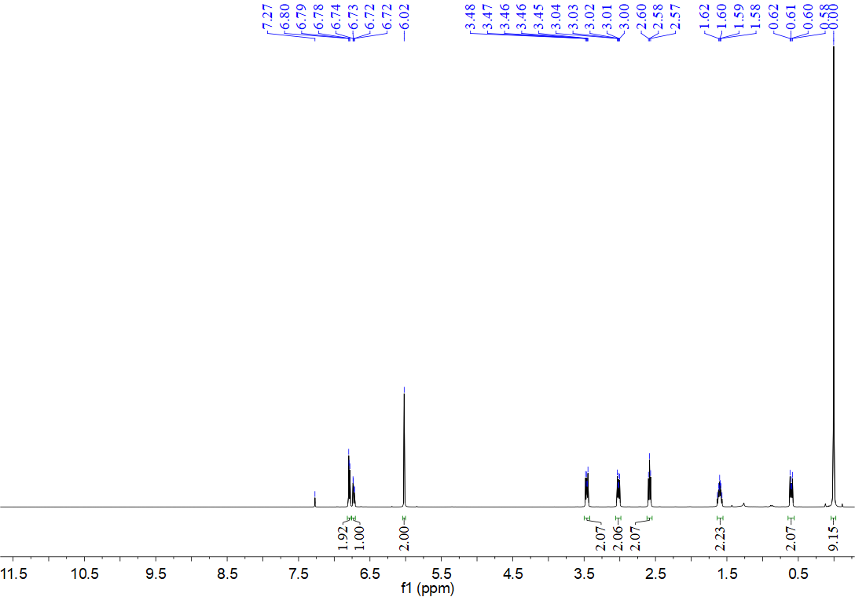
¹³C NMR spectrum for compound 8r (126 MHz, CDCl₃)
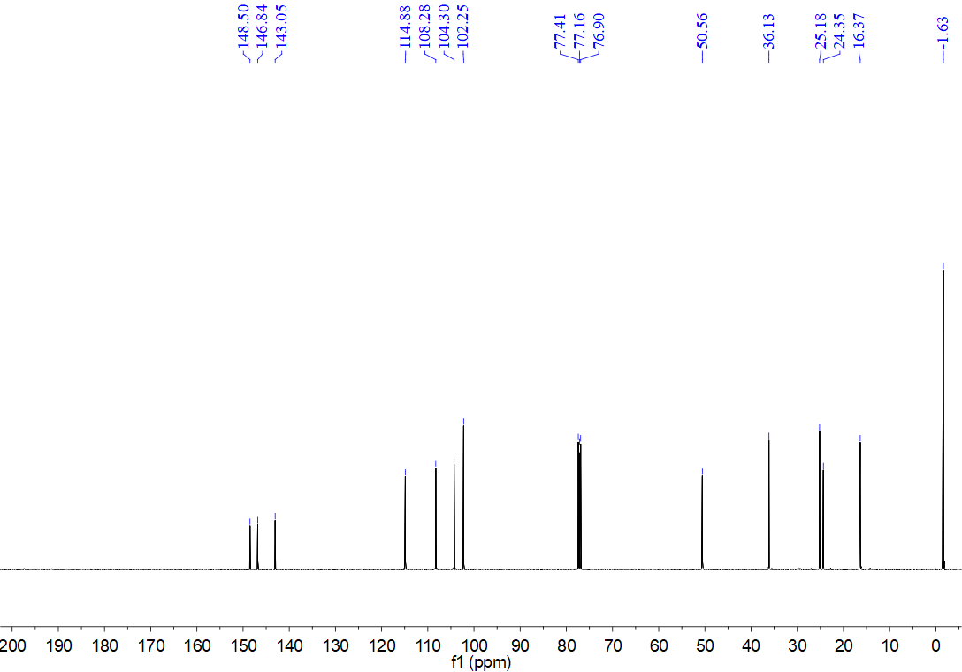
¹H NMR spectrum for compound 8s (500 MHz, CDCl₃)
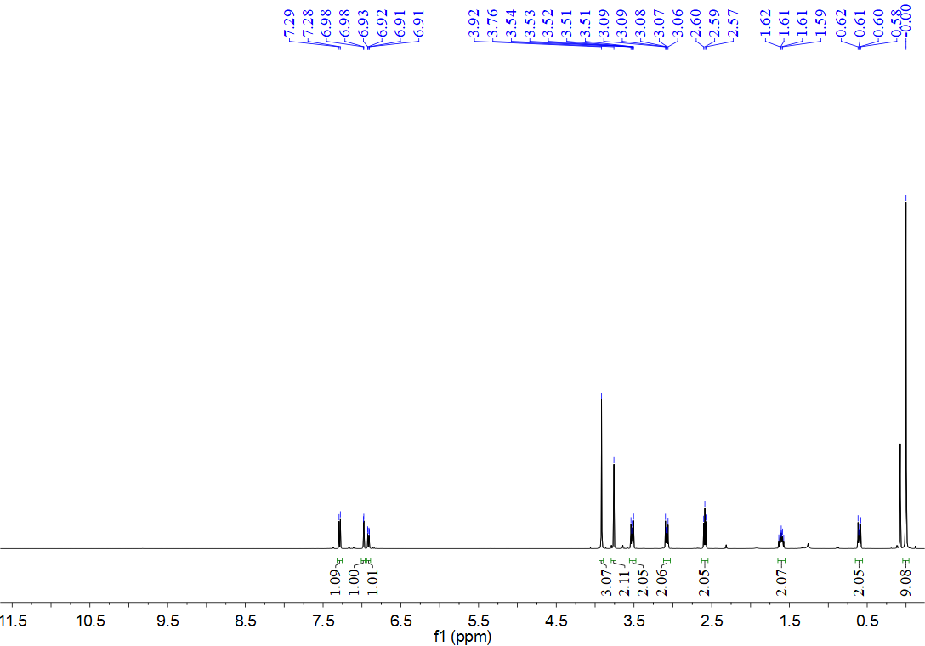
¹³C NMR spectrum for compound 8s (126 MHz, CDCl₃)
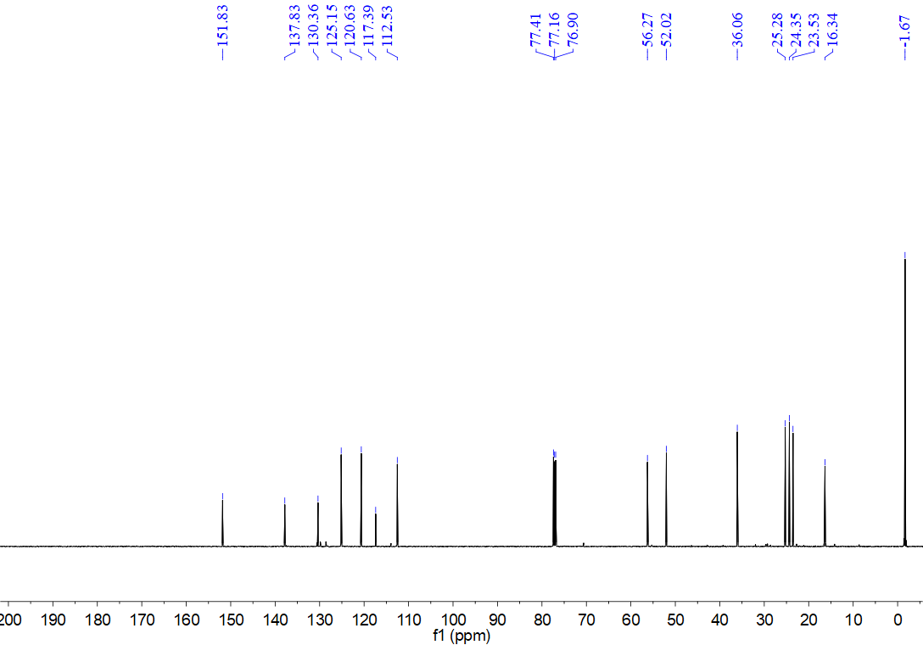
¹H NMR spectrum for compound 8t (500 MHz, CDCl₃)
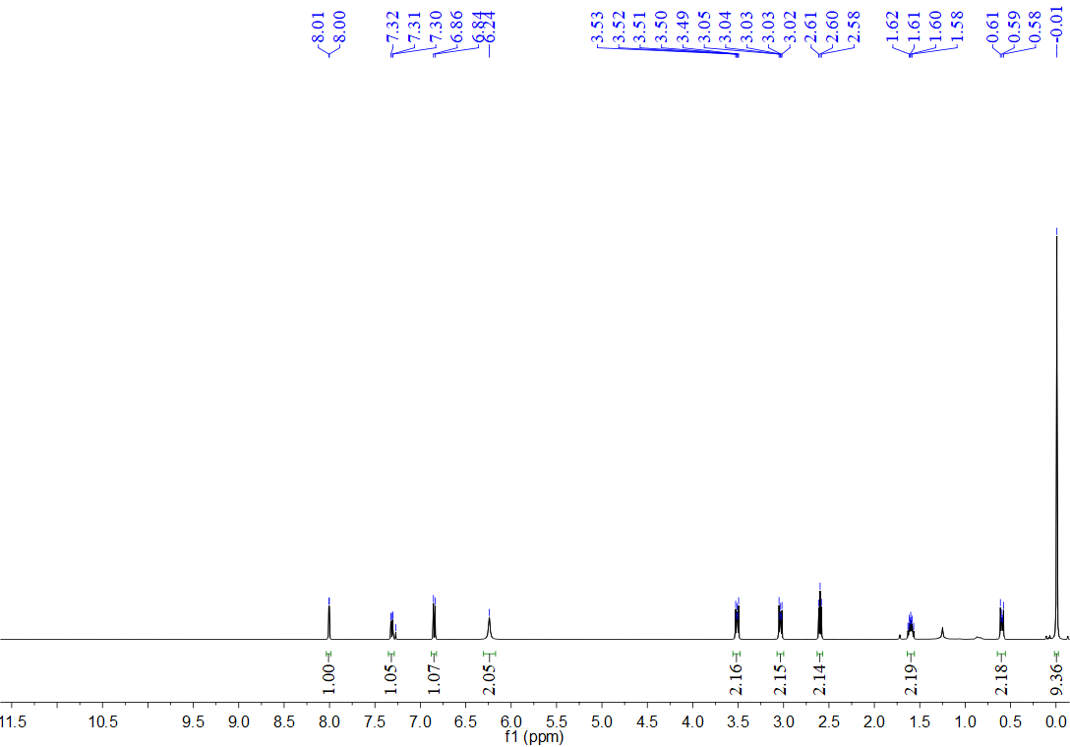
¹³C NMR spectrum for compound 8t (126 MHz, CDCl₃)
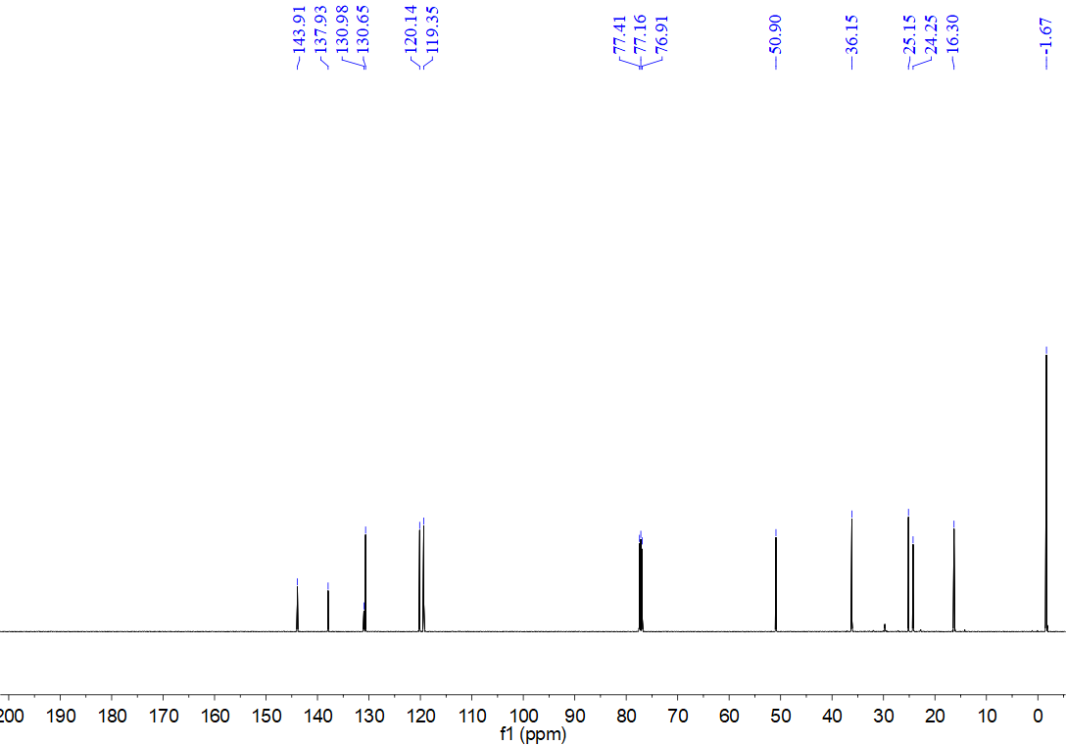
¹H NMR spectrum for compound 8u (500 MHz, CDCl₃)
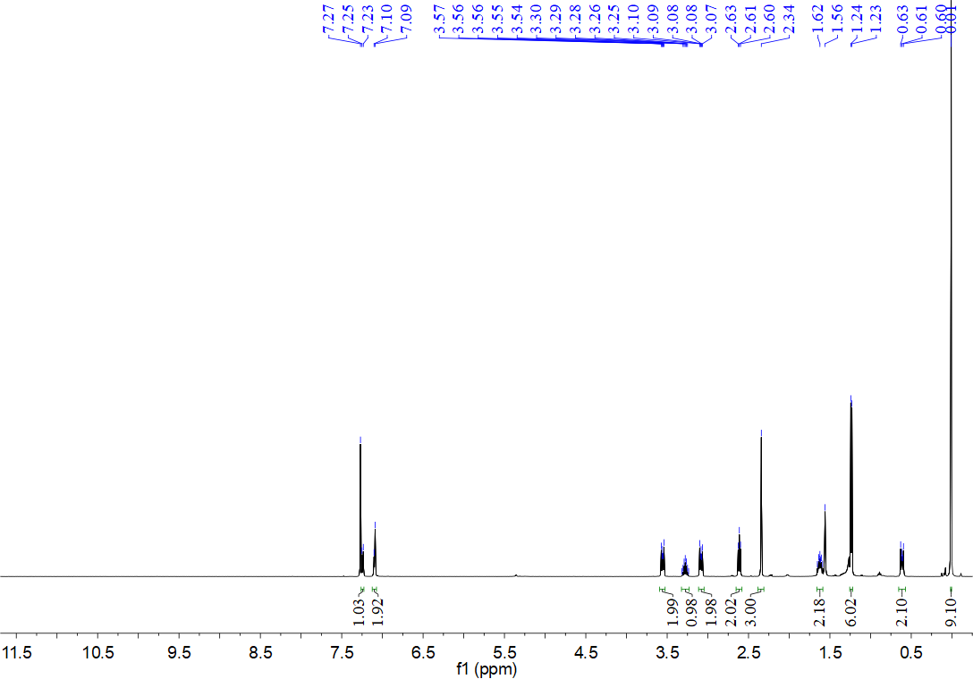
¹³C NMR spectrum for compound 8u (126 MHz, CDCl₃)
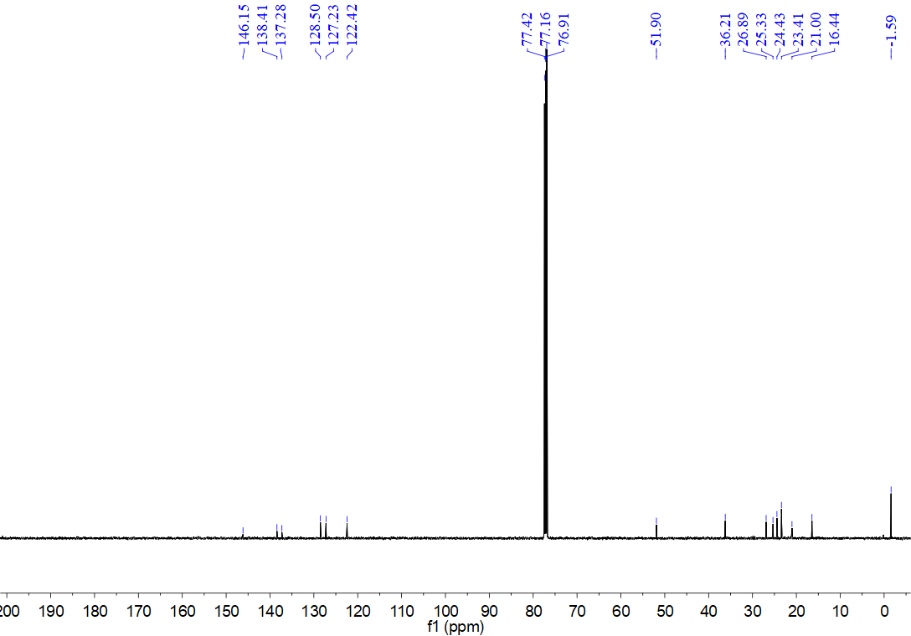
¹H NMR spectrum for compound 8v (500 MHz, CDCl₃)
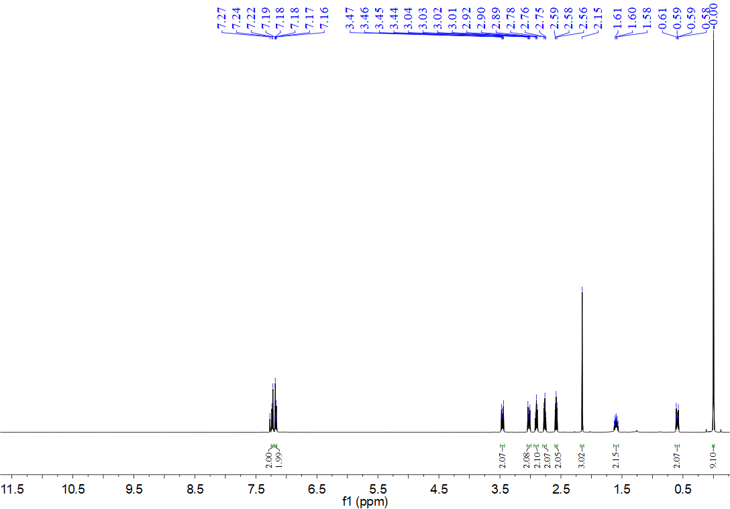
¹³C NMR spectrum for compound 8v (126 MHz, CDCl₃)
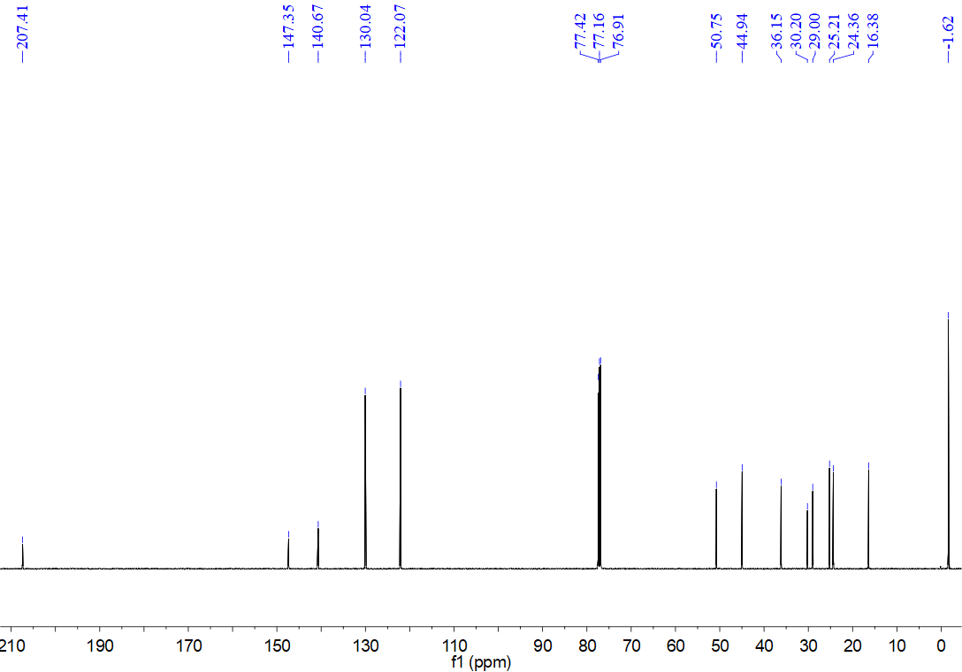
¹H NMR spectrum for compound 8w (500 MHz, CDCl₃)
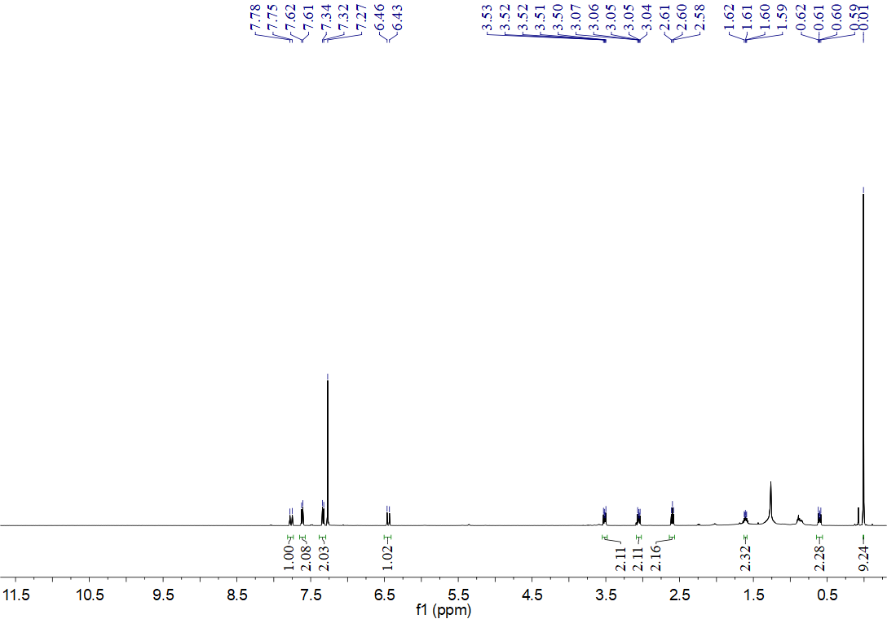
¹³C NMR spectrum for compound 8w (126 MHz, CDCl₃)
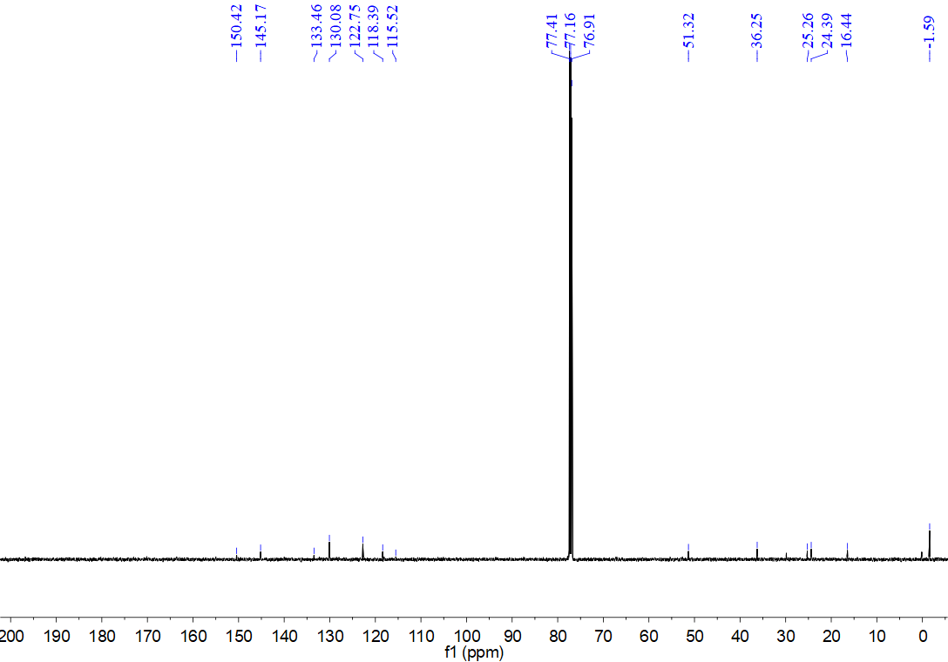
¹H NMR spectrum for compound 8x (500 MHz, CDCl₃)
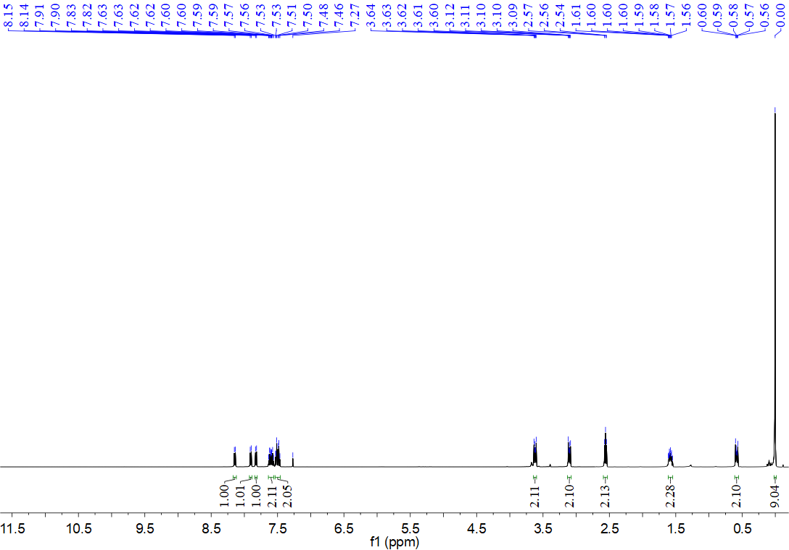
¹³C NMR spectrum for compound 8x (126 MHz, CDCl₃)
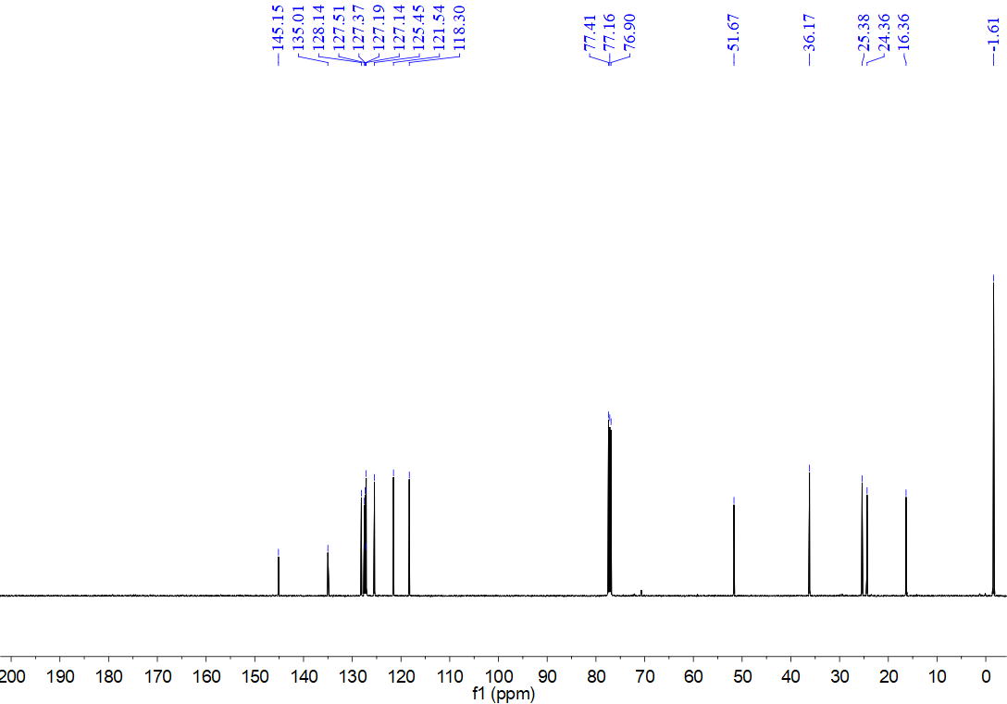
¹H NMR spectrum for compound 8y (500 MHz, CDCl₃)
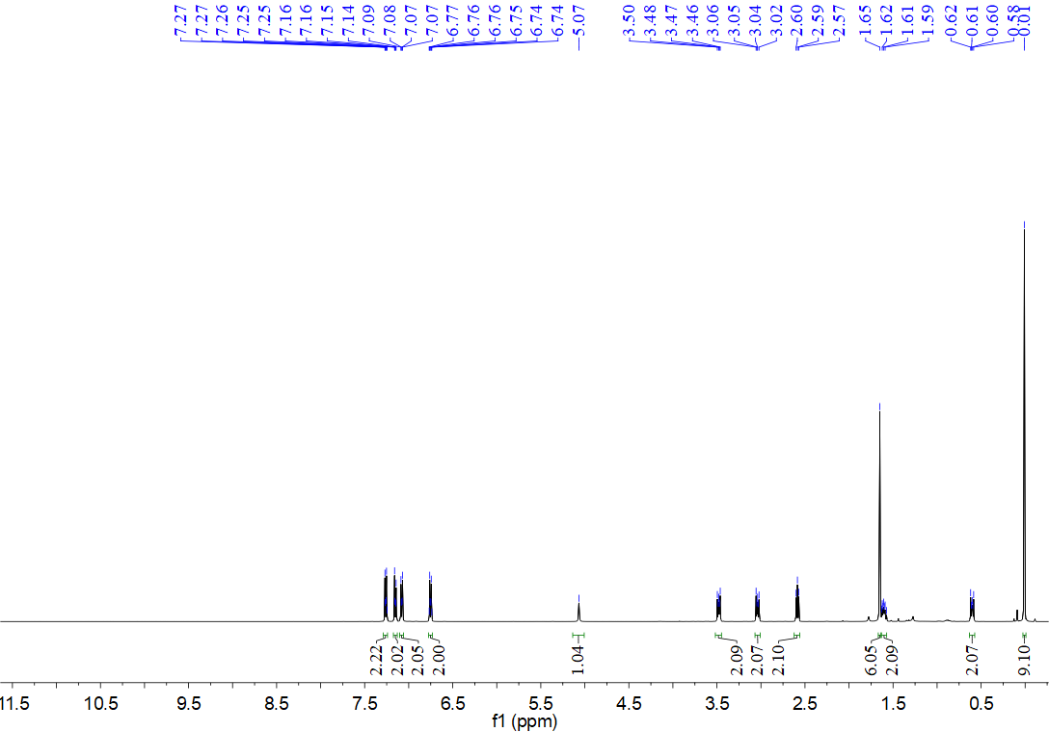
¹³C NMR spectrum for compound 8y (126 MHz, CDCl₃)
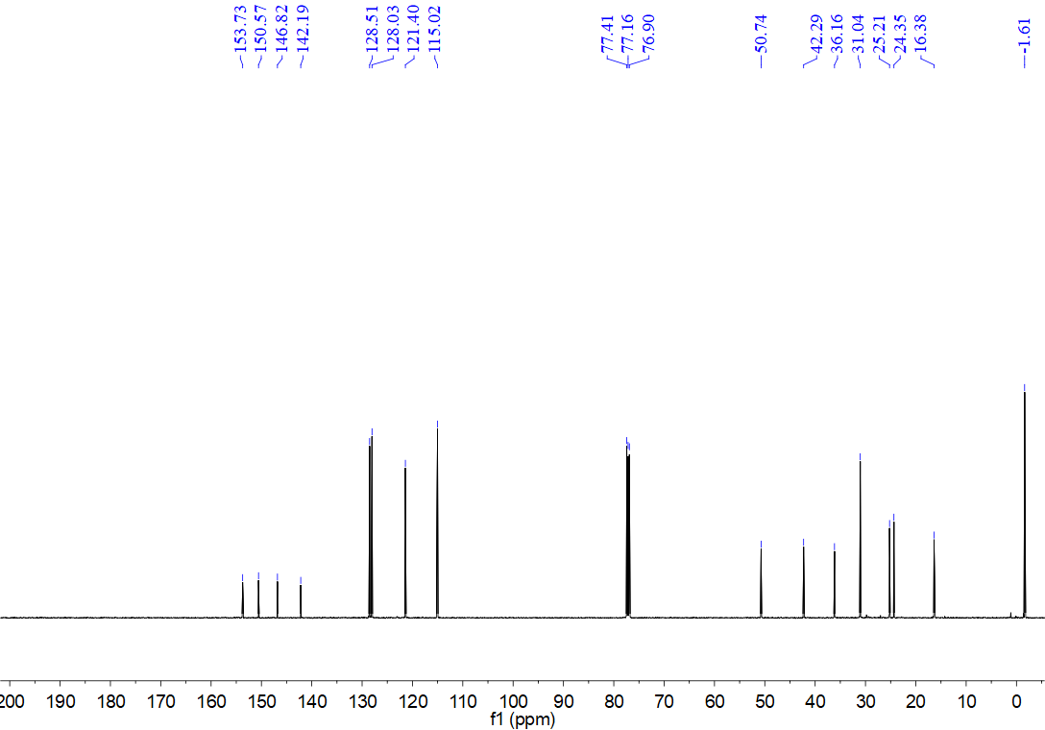
¹H NMR spectrum for compound 8z (500 MHz, CDCl₃)
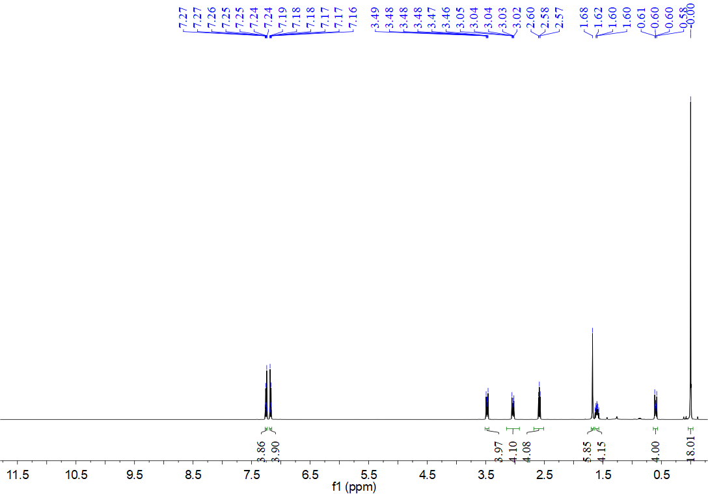
¹³C NMR spectrum for compound 8z (126 MHz, CDCl₃)
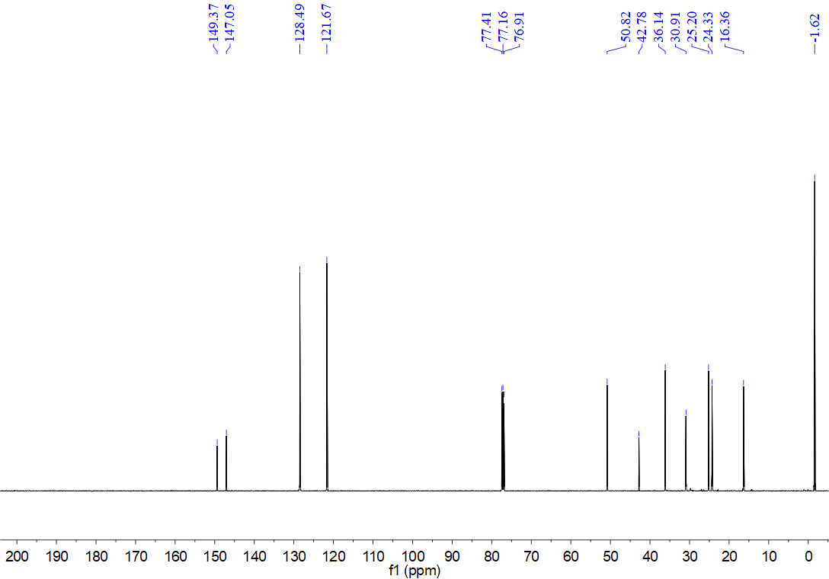
¹H NMR spectrum for compound 8aa (500 MHz, CDCl₃)
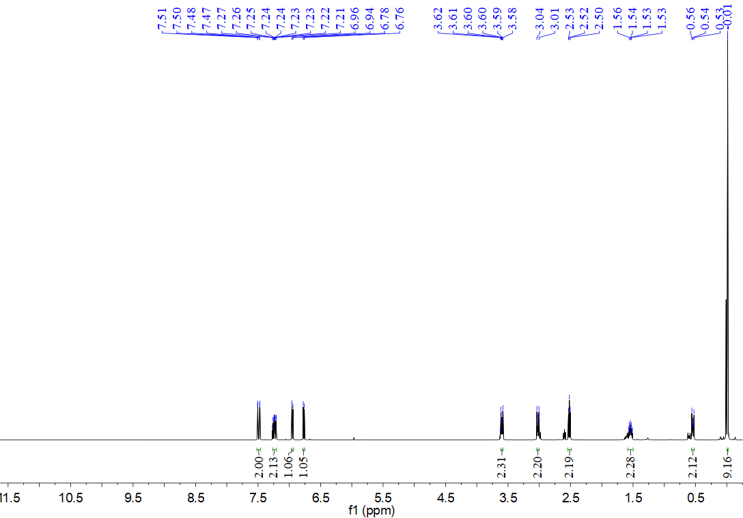
¹³C NMR spectrum for compound 8aa (126 MHz, CDCl₃)
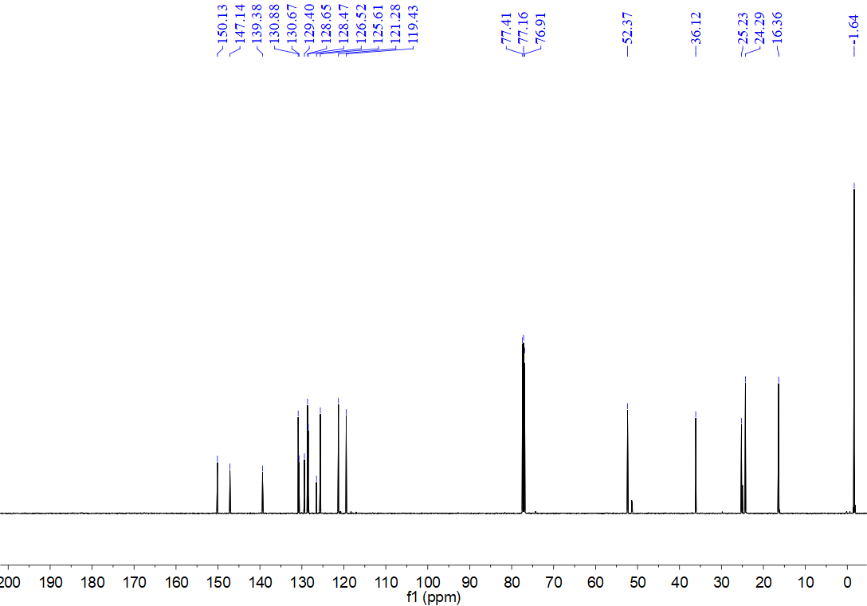
¹H NMR spectrum for compound 8ab (500 MHz, CDCl₃)
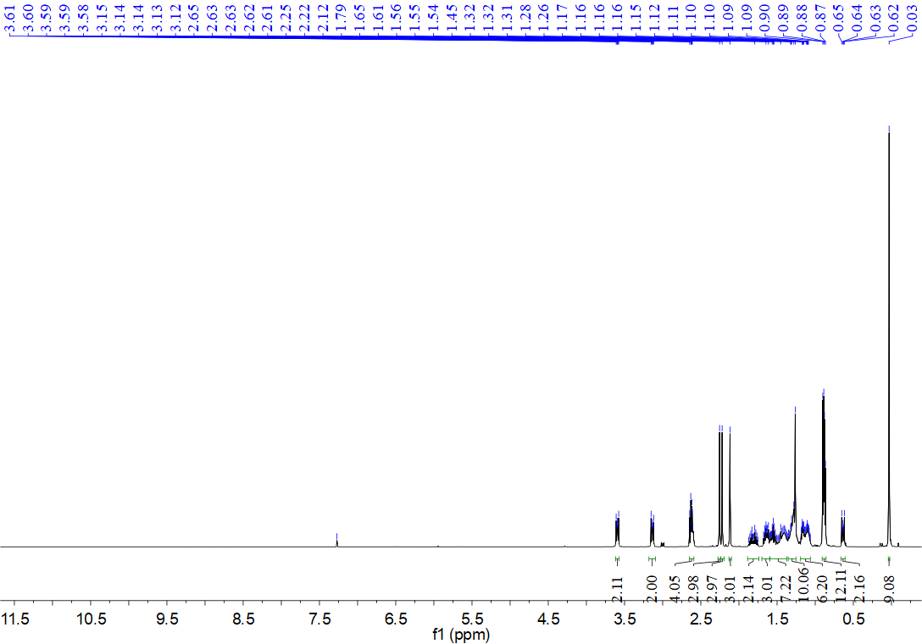
¹³C NMR spectrum for compound 8ab (126 MHz, CDCl₃)
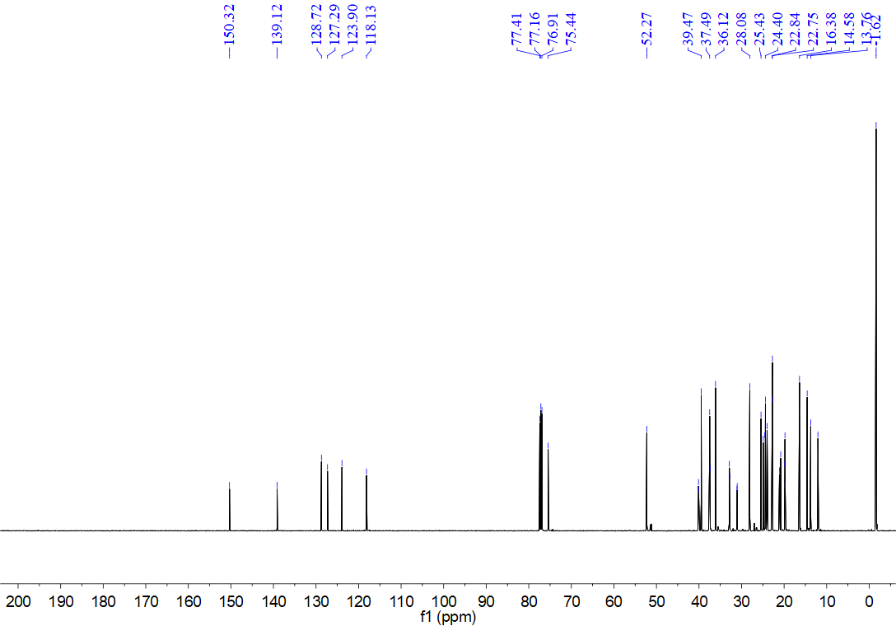
¹H NMR spectrum for compound 8ac (500 MHz, CDCl₃)
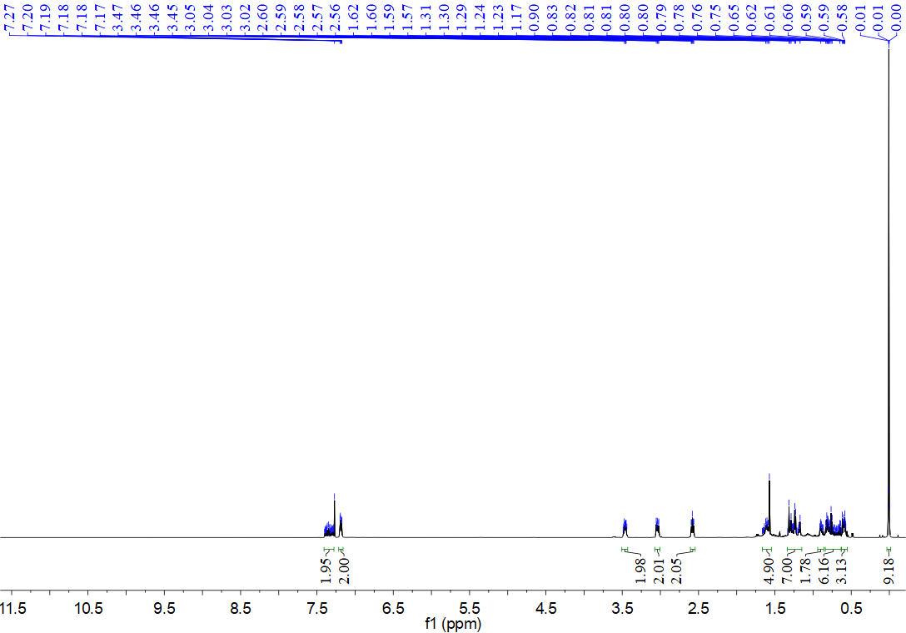
¹³C NMR spectrum for compound 8ac (126 MHz, CDCl₃)
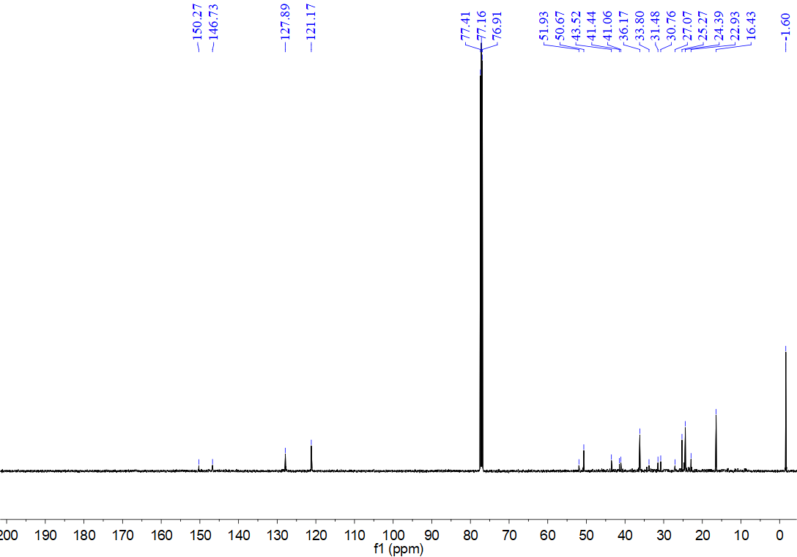
¹H NMR spectrum for compound 8ad (500 MHz, CDCl₃)
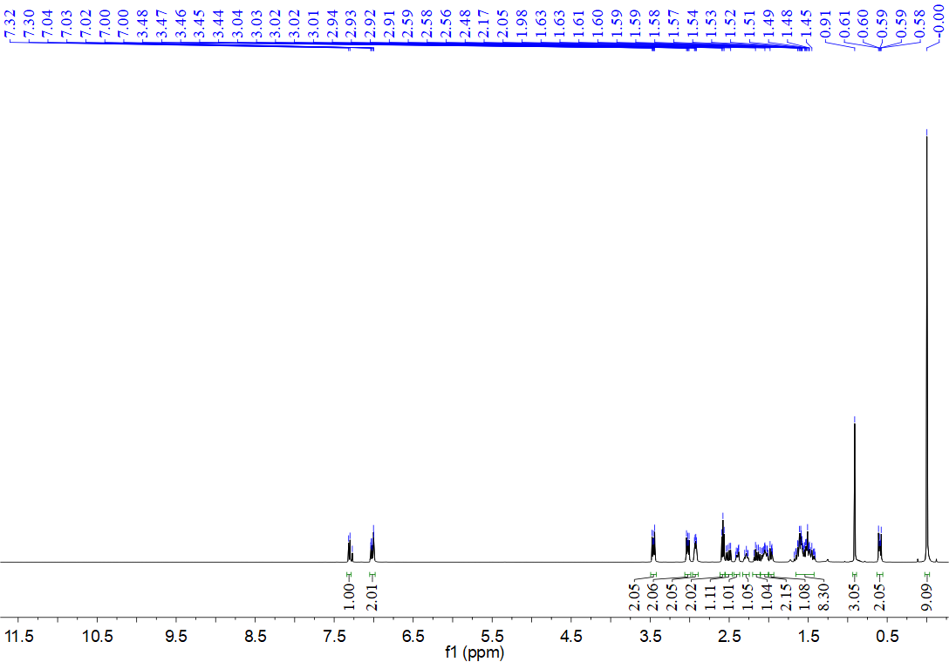
¹³C NMR spectrum for compound 8ad (126 MHz, CDCl₃)
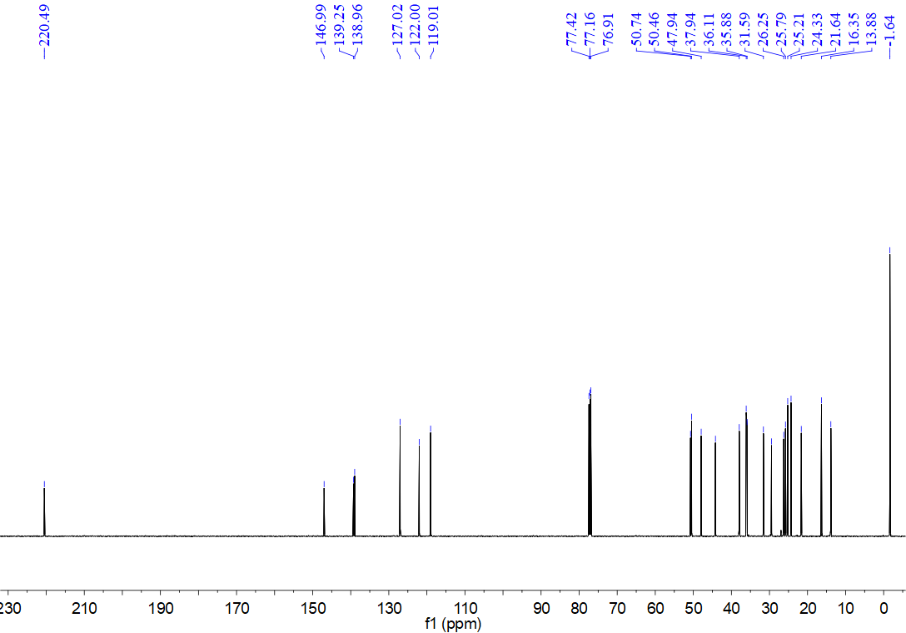
¹H NMR spectrum for compound 8ae (500 MHz, CDCl₃)
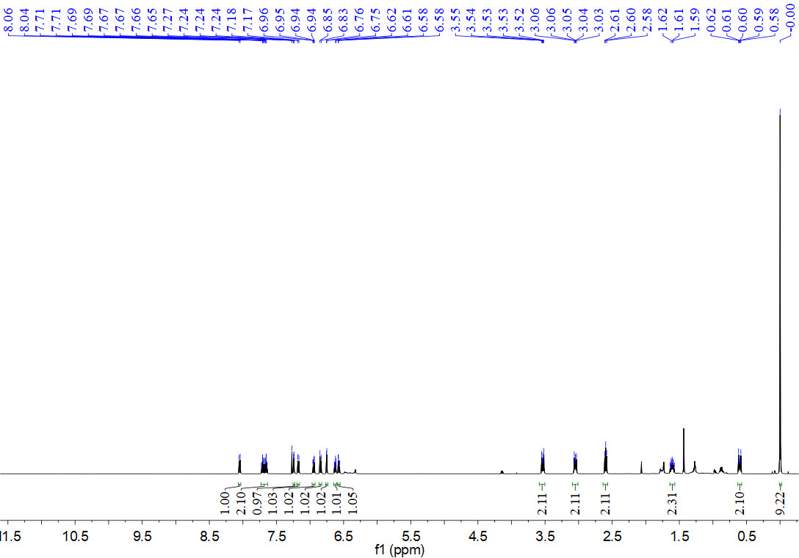
¹³C NMR spectrum for compound 8ae (126 MHz, CDCl₃)
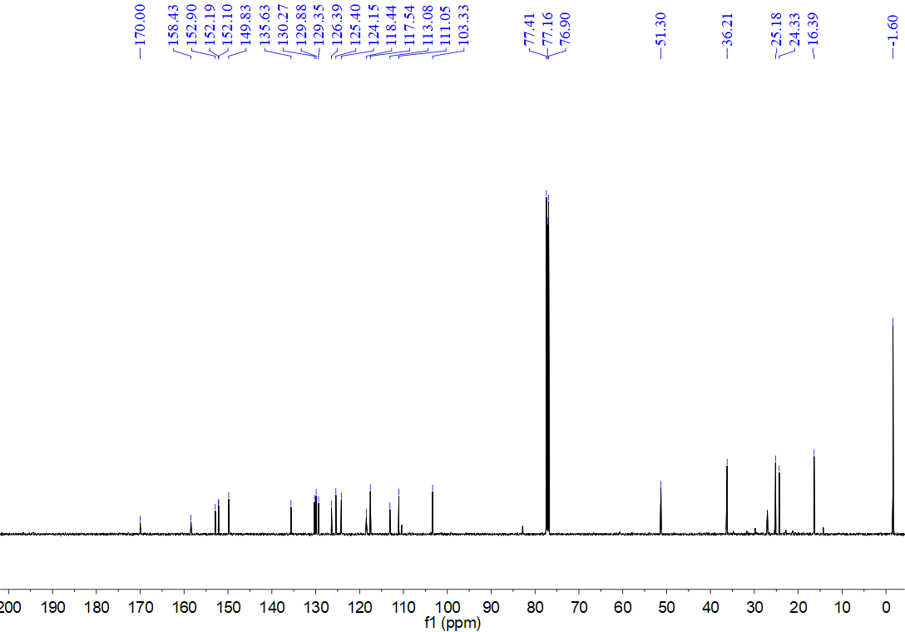
¹H NMR spectrum for compound 8af (500 MHz, CDCl₃)
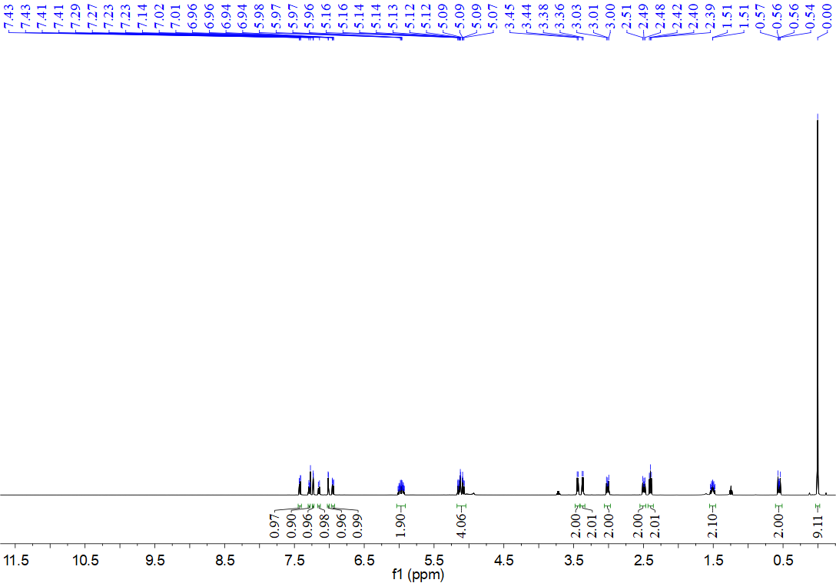
¹³C NMR spectrum for compound 8af (126 MHz, CDCl₃)
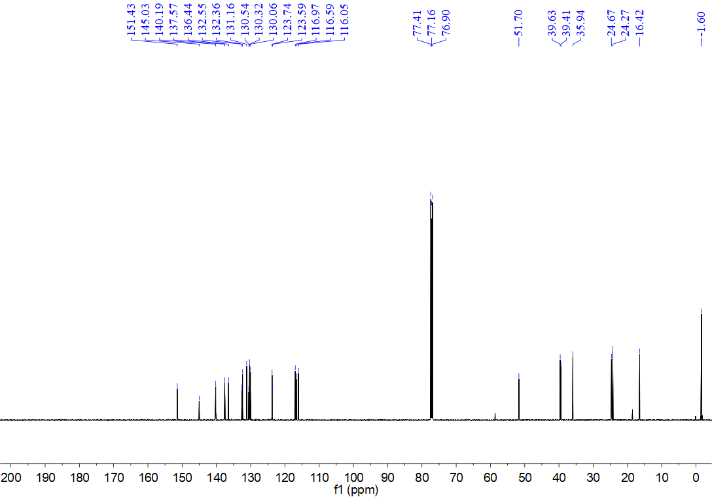
¹H NMR spectrum for compound 8ag (500 MHz, CDCl₃)
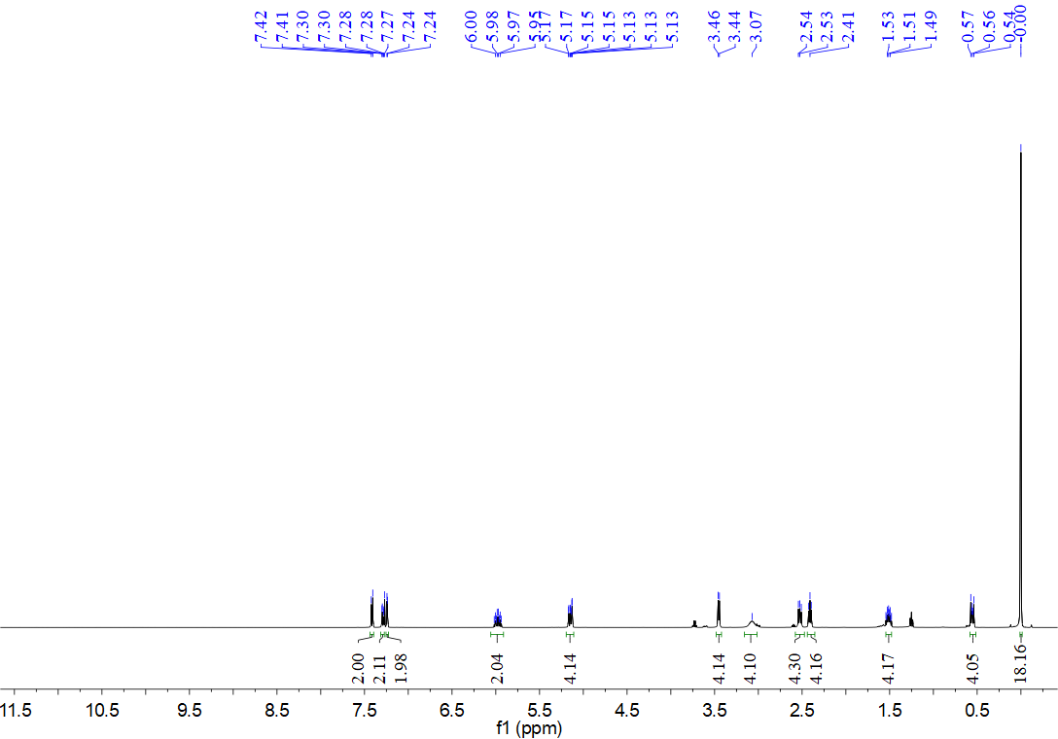
¹³C NMR spectrum for compound 8ag (126 MHz, CDCl₃)
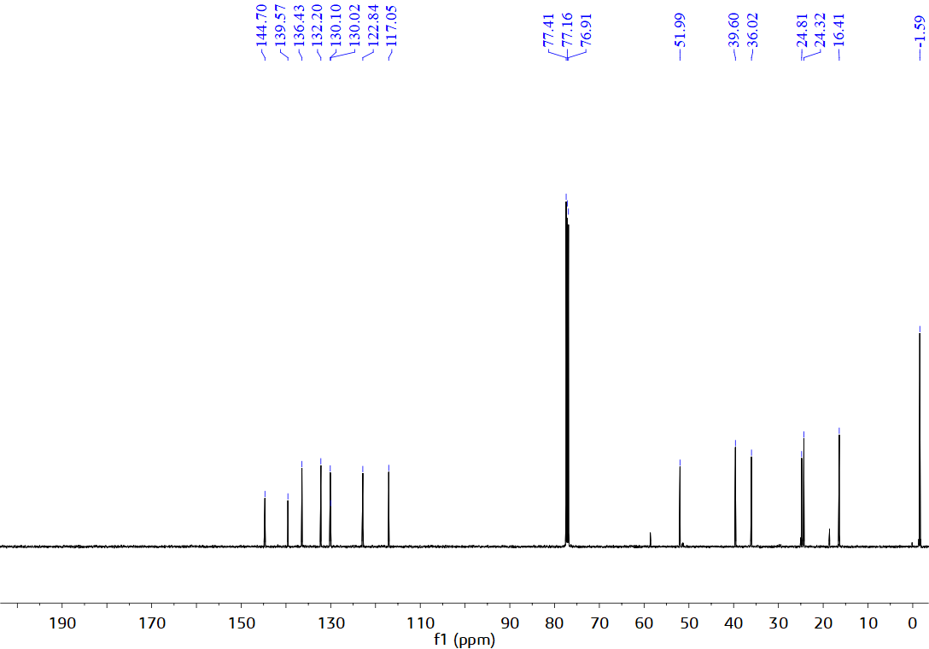
¹H NMR spectrum for compound 10a (500 MHz, CDCl₃)
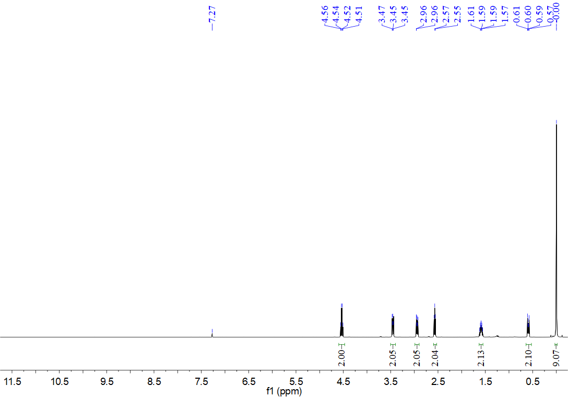
¹³C NMR spectrum for compound 10a (126 MHz, CDCl₃)
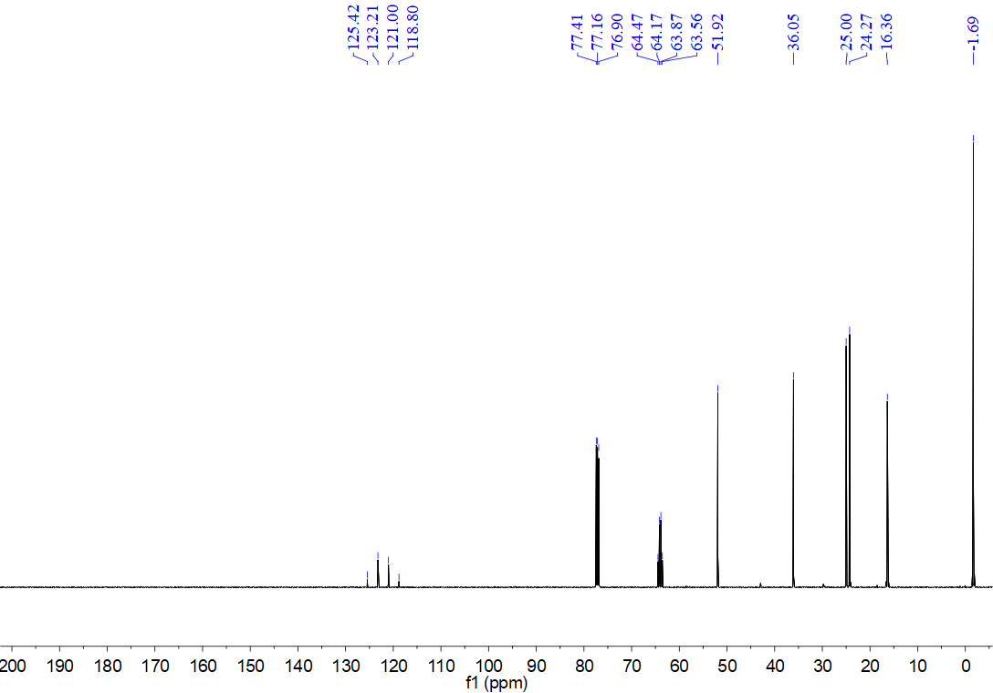
¹H NMR spectrum for compound 10b (500 MHz, CDCl₃)
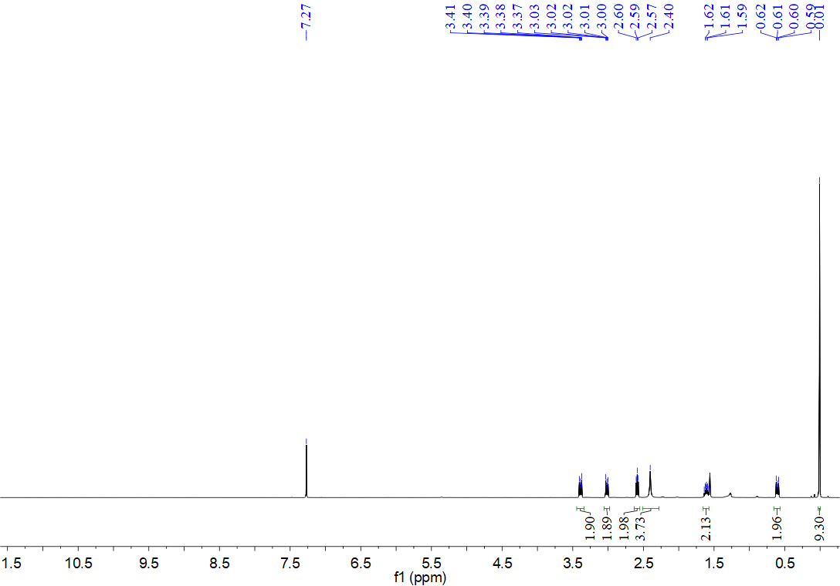
¹³C NMR spectrum for compound 10b (126 MHz, CDCl₃)
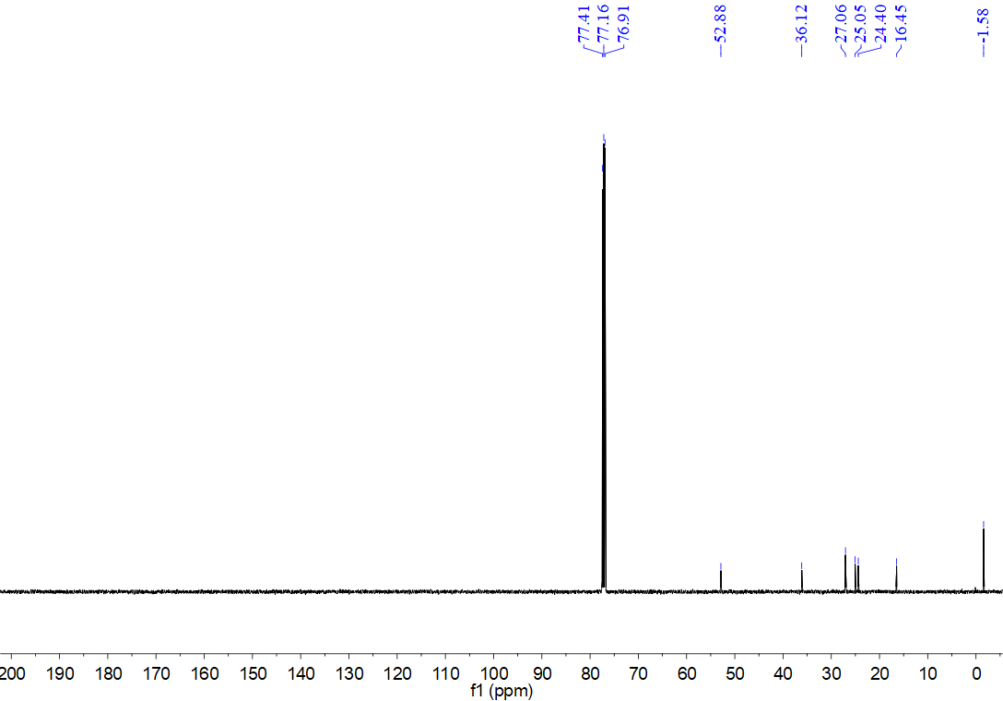
¹H NMR spectrum for compound 10c (500 MHz, CDCl₃)
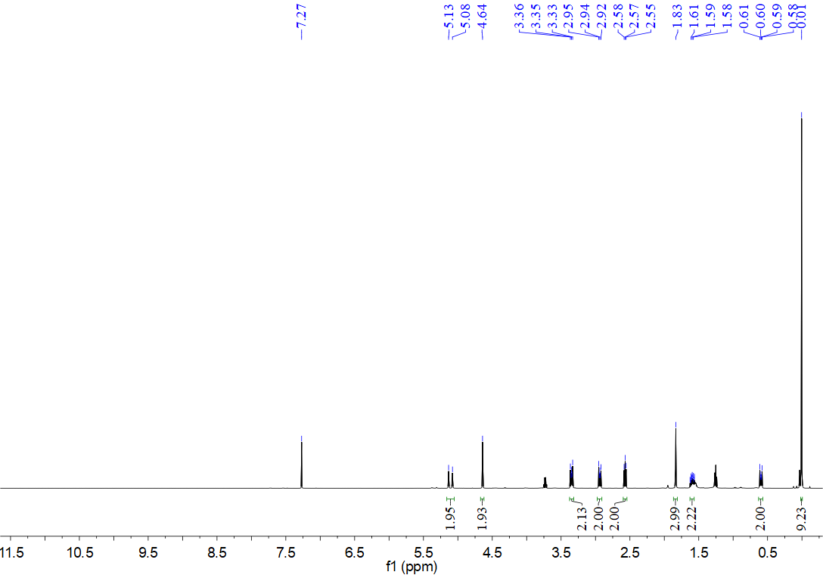
¹³C NMR spectrum for compound 10c (126 MHz, CDCl₃)
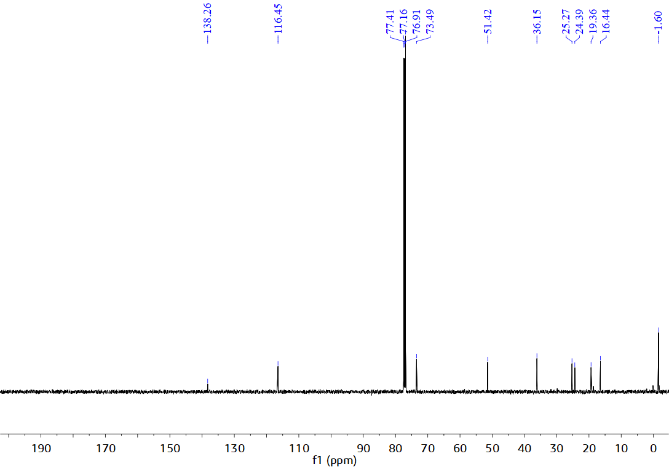
¹H NMR spectrum for compound 10d (500 MHz, CDCl₃)
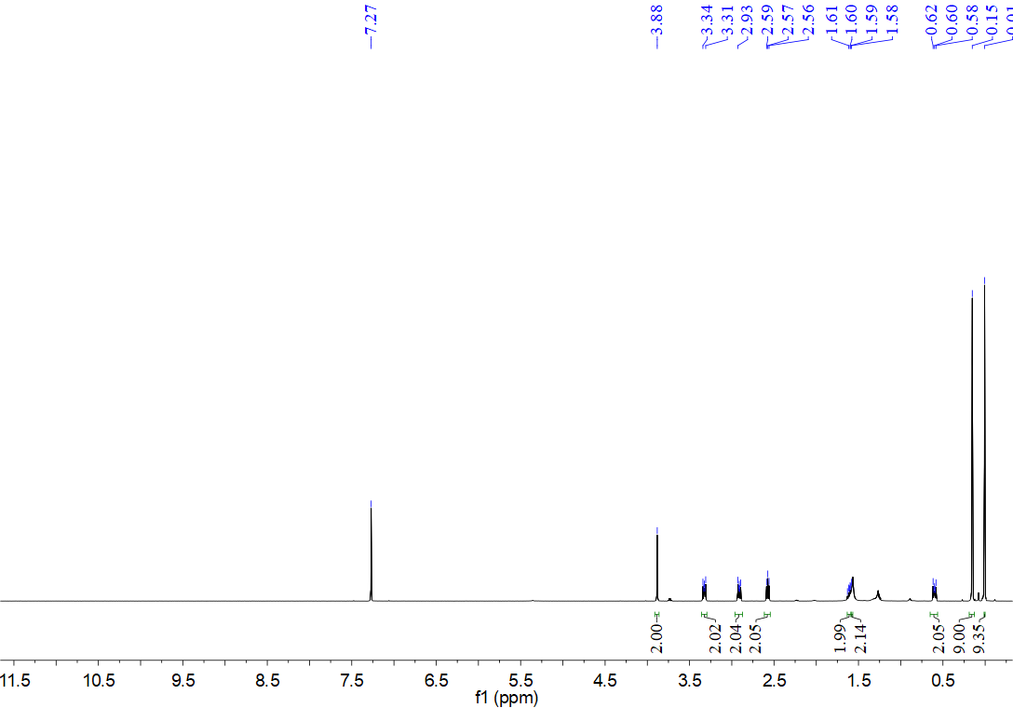
¹³C NMR spectrum for compound 10d (126 MHz, CDCl₃)
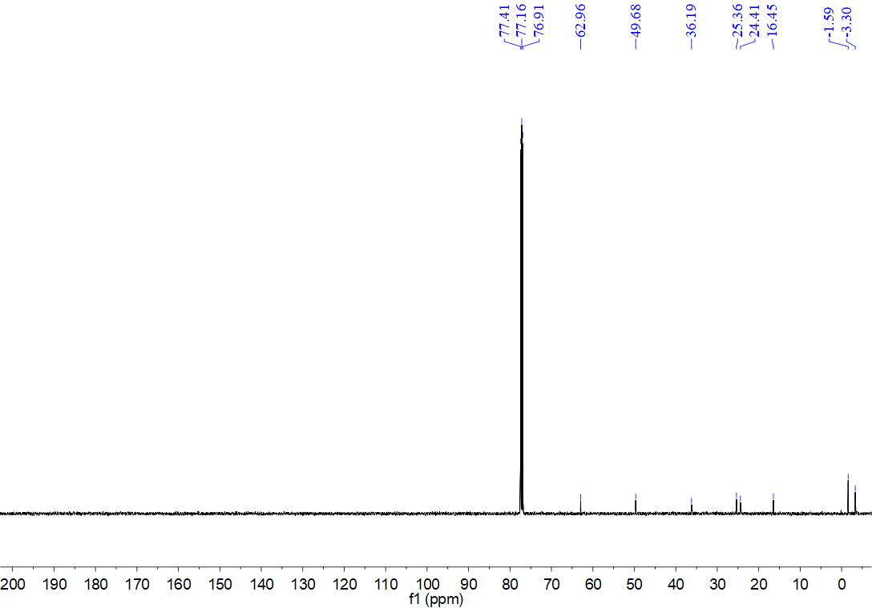
¹H NMR spectrum for compound 10e (500 MHz, CDCl₃)
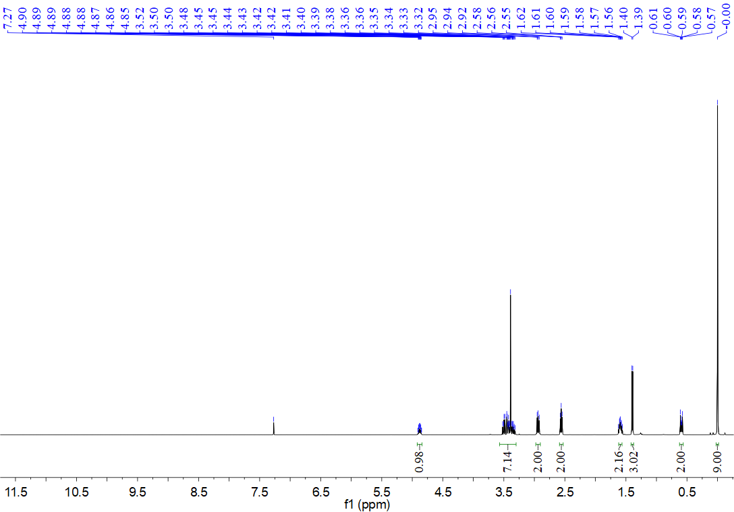
¹³C NMR spectrum for compound 10e (126 MHz, CDCl₃)
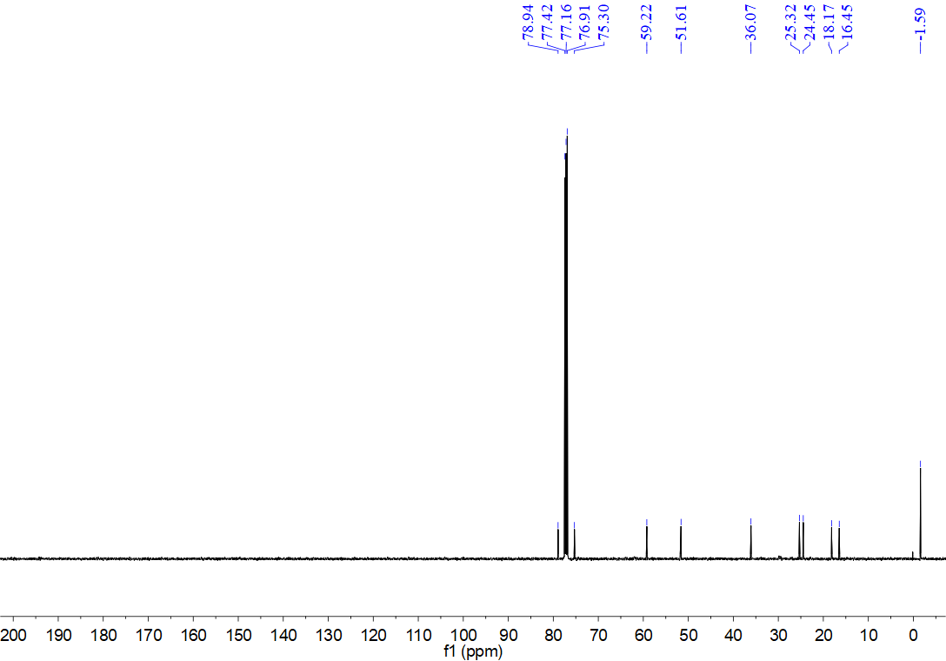
¹H NMR spectrum for compound 10f (500 MHz, CDCl₃)
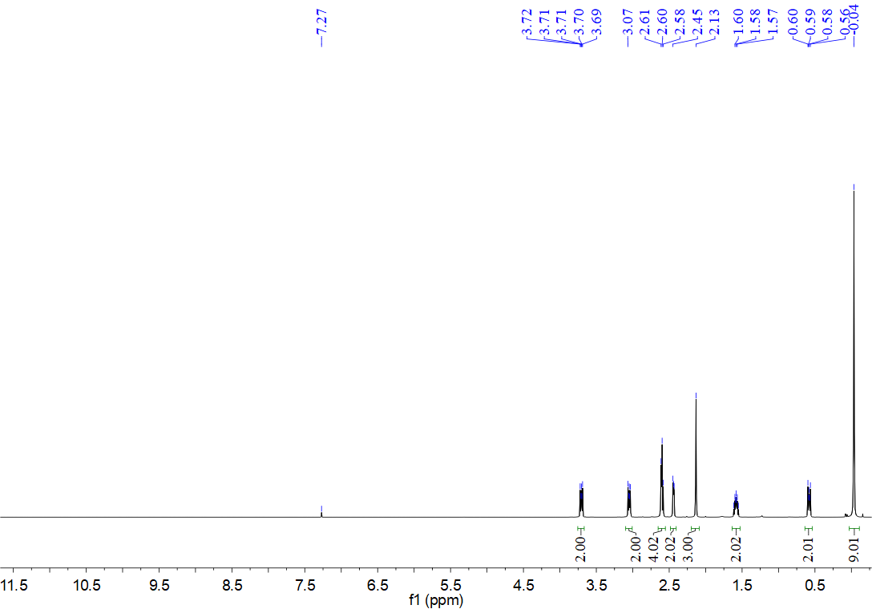
¹³C NMR spectrum for compound 10f (126 MHz, CDCl₃)
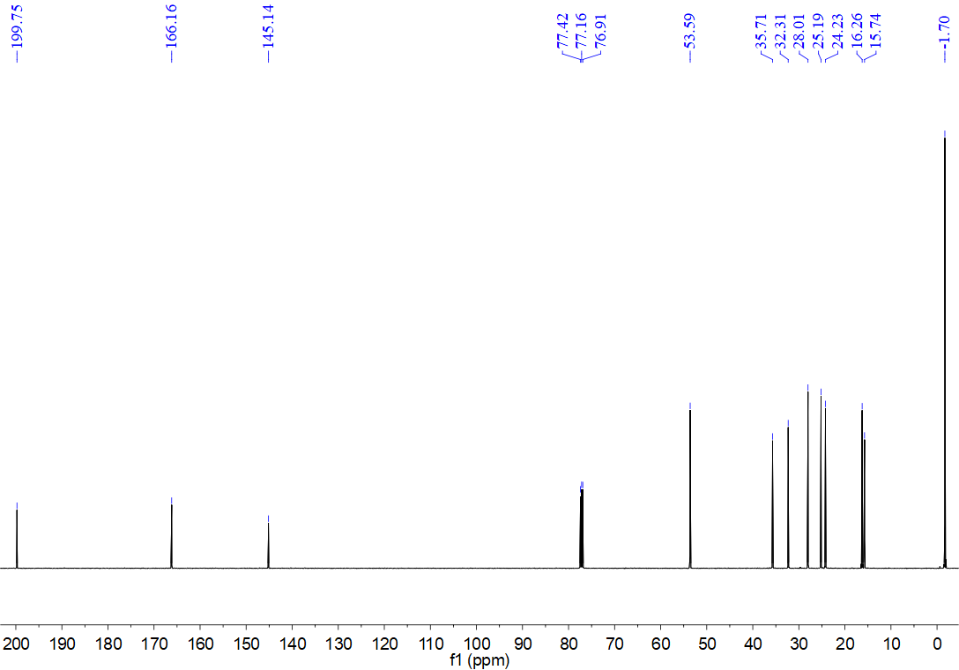
¹H NMR spectrum for compound 10g (500 MHz, CDCl₃)
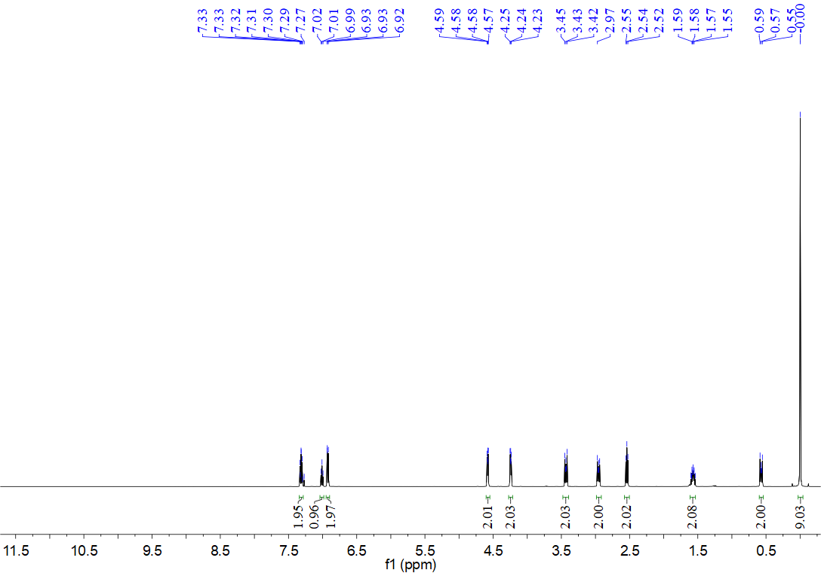
¹³C NMR spectrum for compound 10g (126 MHz, CDCl₃)
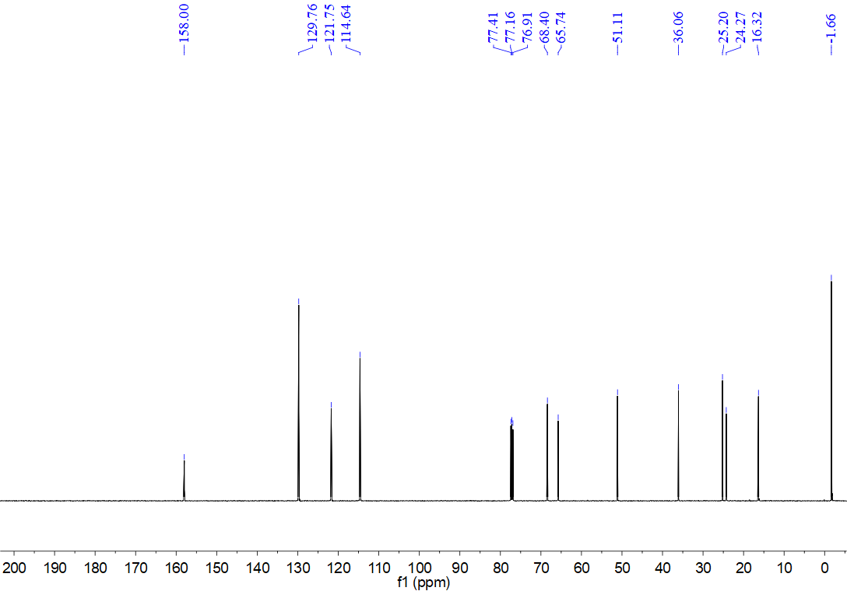
¹H NMR spectrum for compound 10h (500 MHz, CDCl₃)
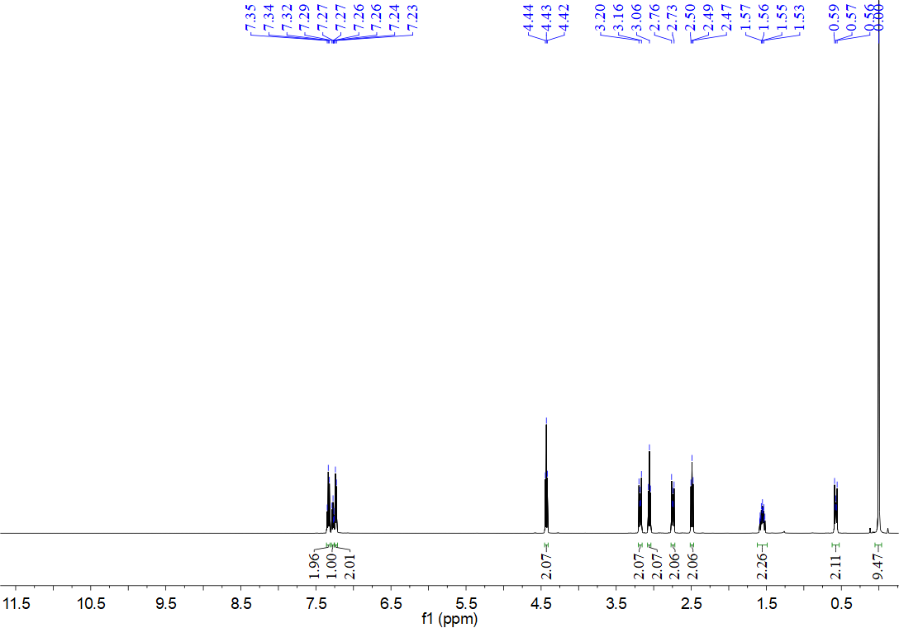
¹³C NMR spectrum for compound 10h (126 MHz, CDCl₃)
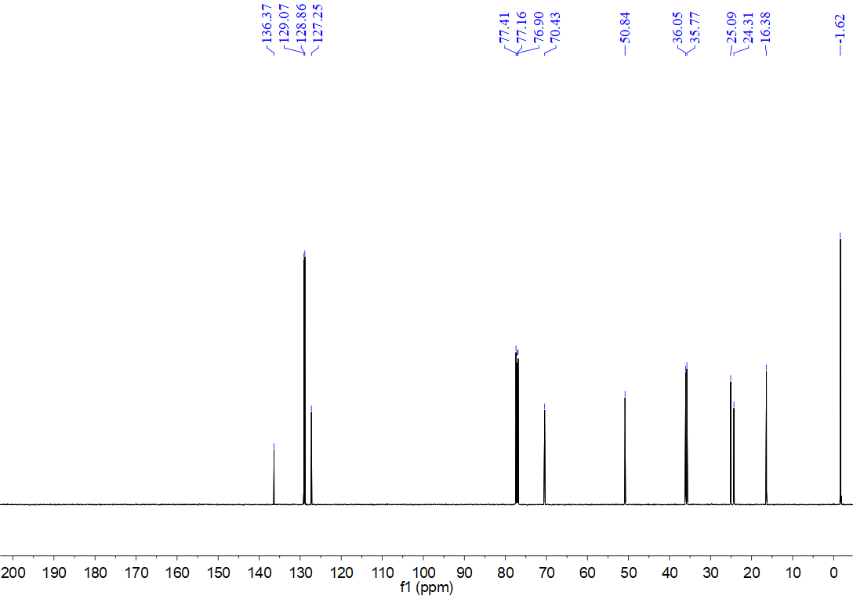
¹H NMR spectrum for compound 10i (500 MHz, CDCl₃)
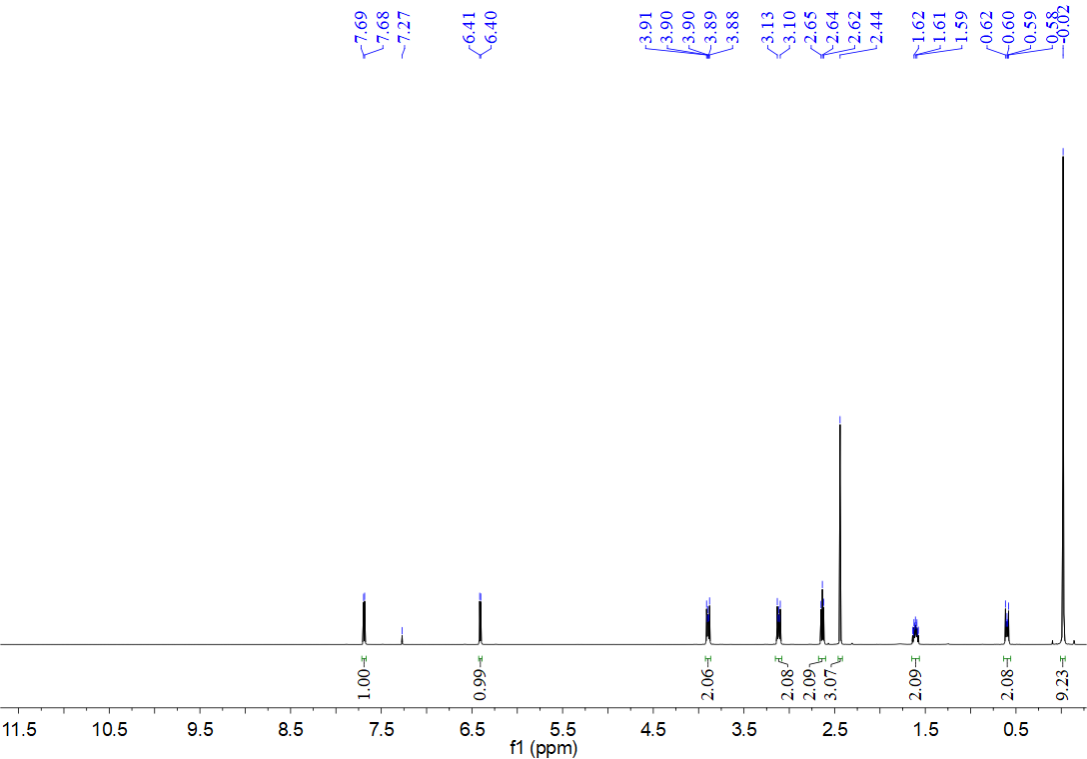
¹³C NMR spectrum for compound 10i (126 MHz, CDCl₃)
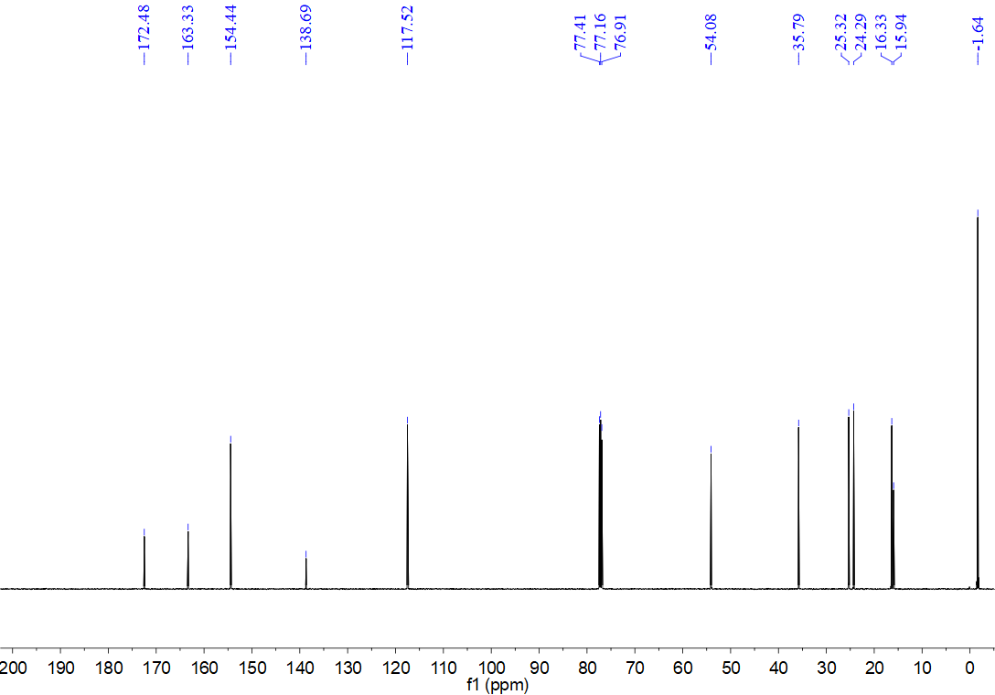
¹H NMR spectrum for compound 10j (500 MHz, CDCl₃)
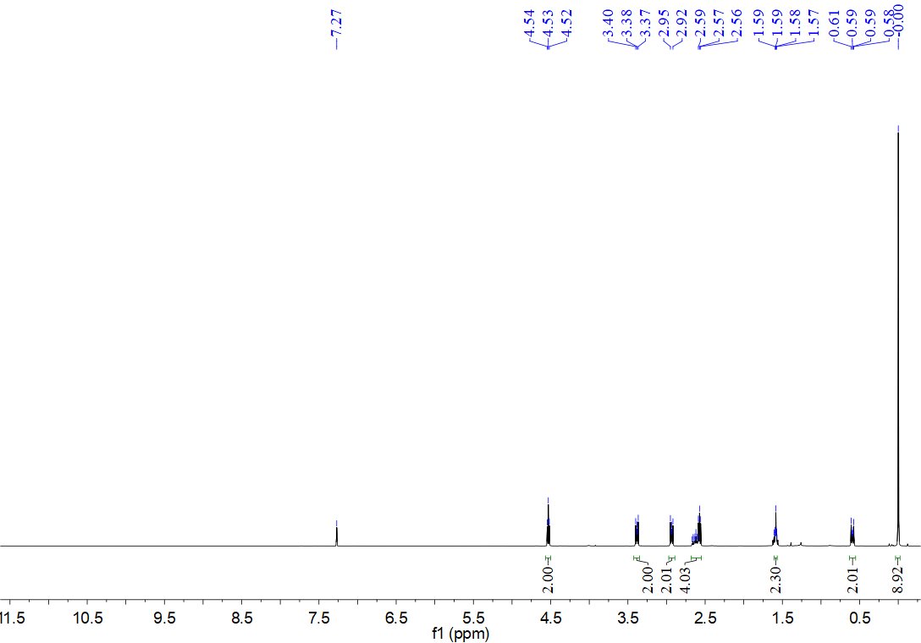
¹³C NMR spectrum for compound 10j (126 MHz, CDCl₃)
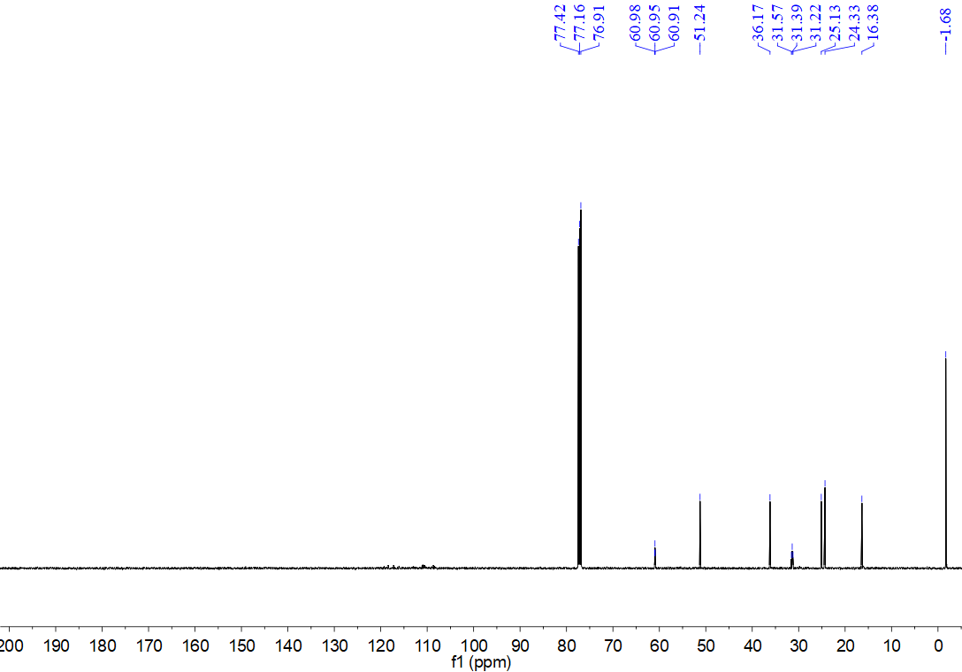
¹H NMR spectrum for compound 12a (500 MHz, CDCl₃)
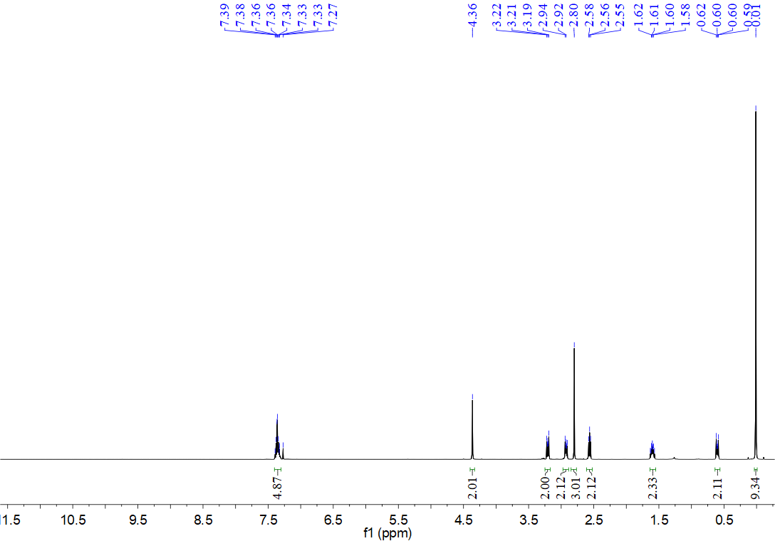
¹³C NMR spectrum for compound 12a (126 MHz, CDCl₃)
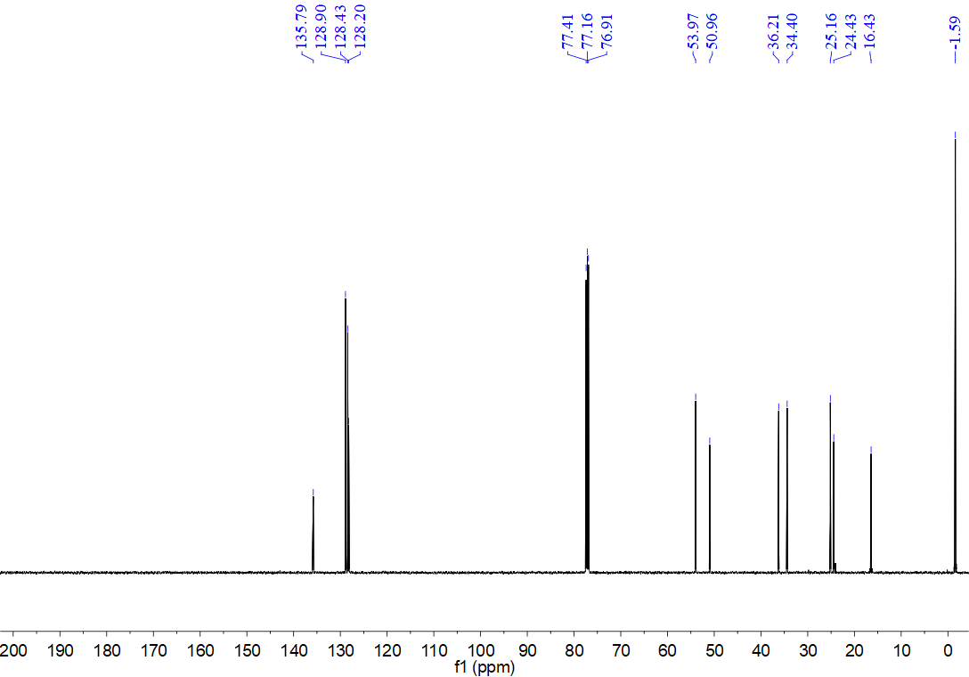
¹H NMR spectrum for compound 12b (500 MHz, CDCl₃)
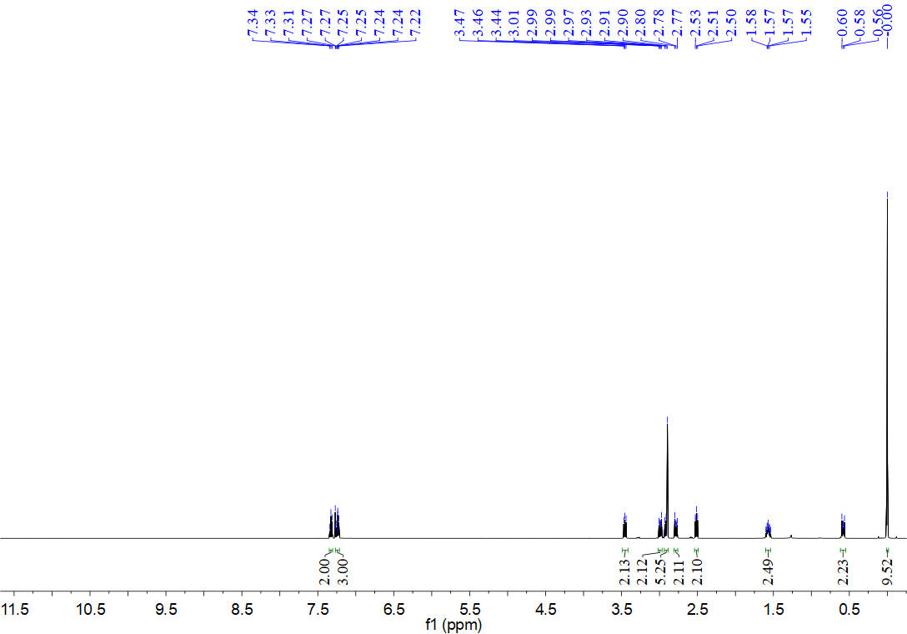
¹³C NMR spectrum for compound 12b (126 MHz, CDCl₃)
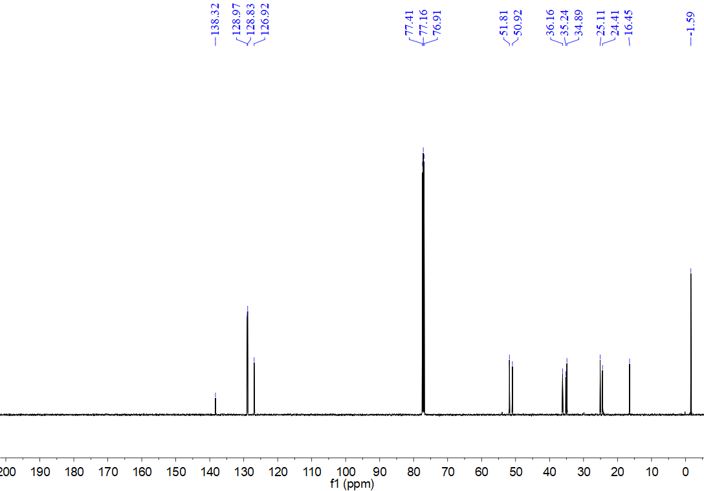
¹H NMR spectrum for compound 12c (500 MHz, CDCl₃)
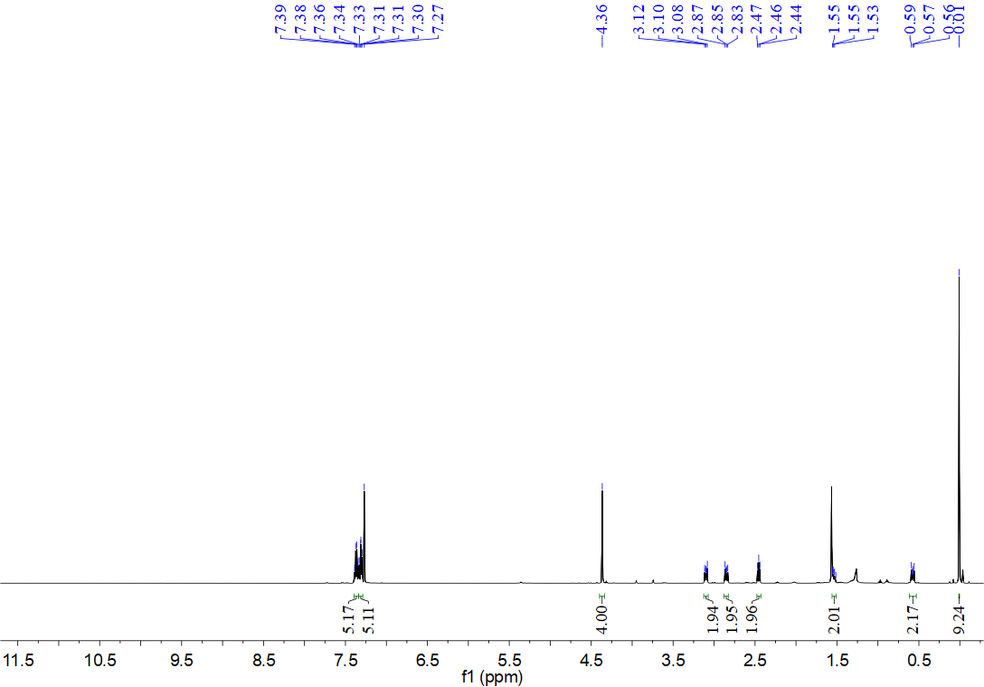
¹³C NMR spectrum for compound 12c (126 MHz, CDCl₃)
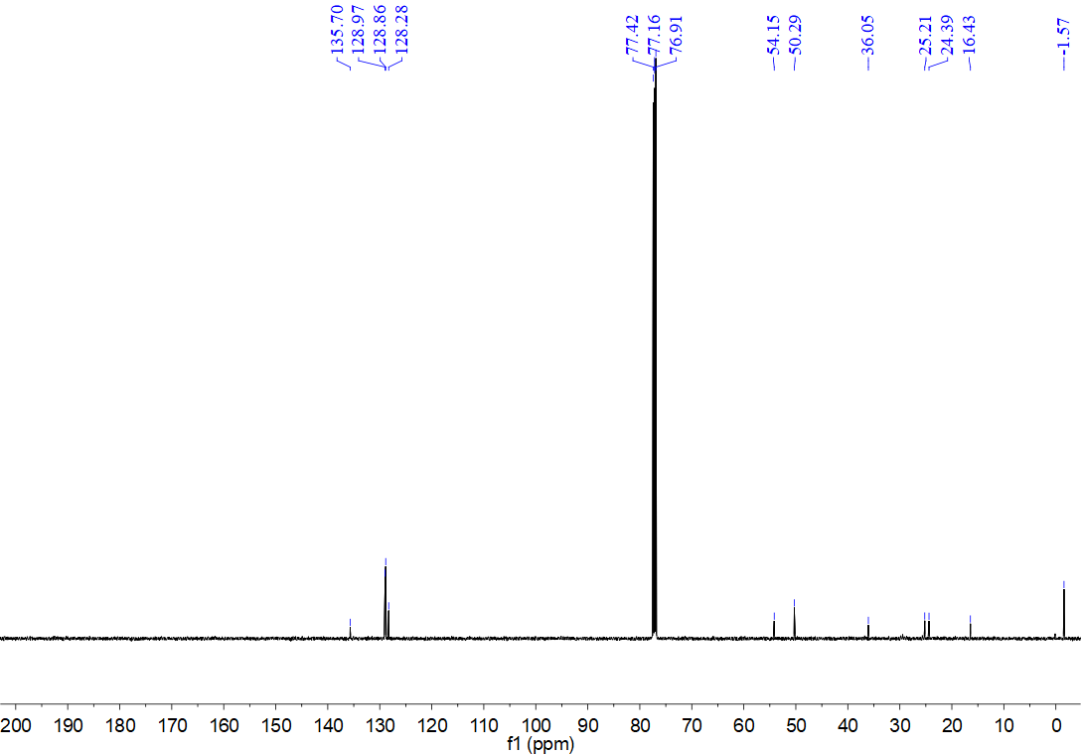
¹H NMR spectrum for compound 12d (500 MHz, CDCl₃)
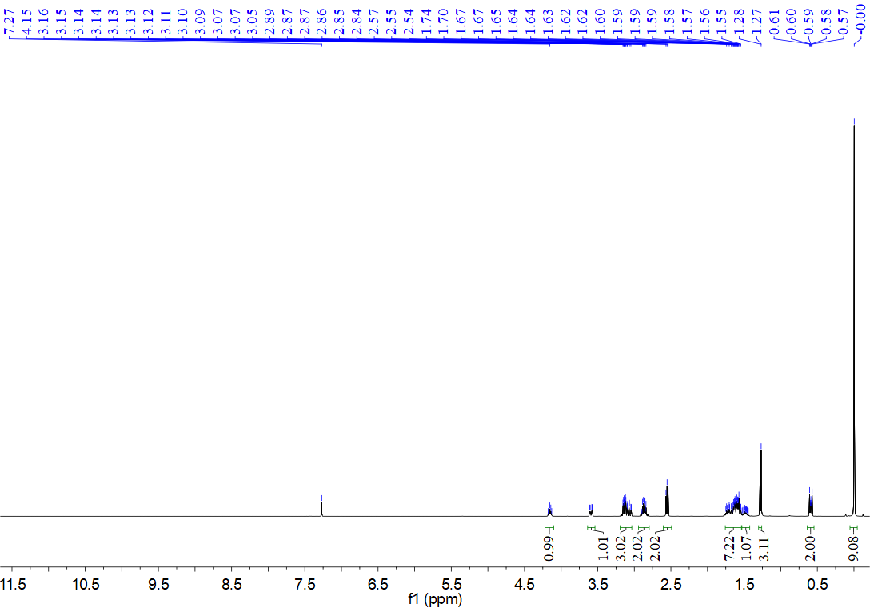
¹³C NMR spectrum for compound 12d (126 MHz, CDCl₃)
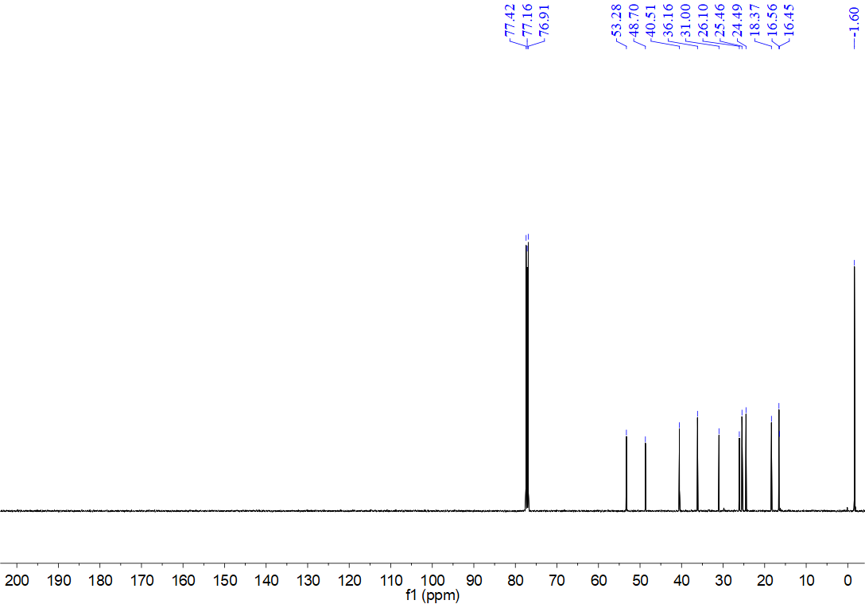
¹H NMR spectrum for compound 12e (500 MHz, CDCl₃)
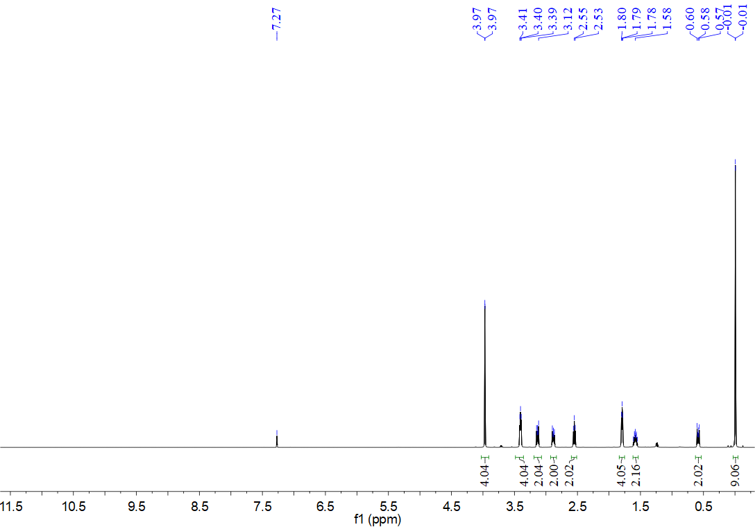
¹³C NMR spectrum for compound 12e (126 MHz, CDCl₃)
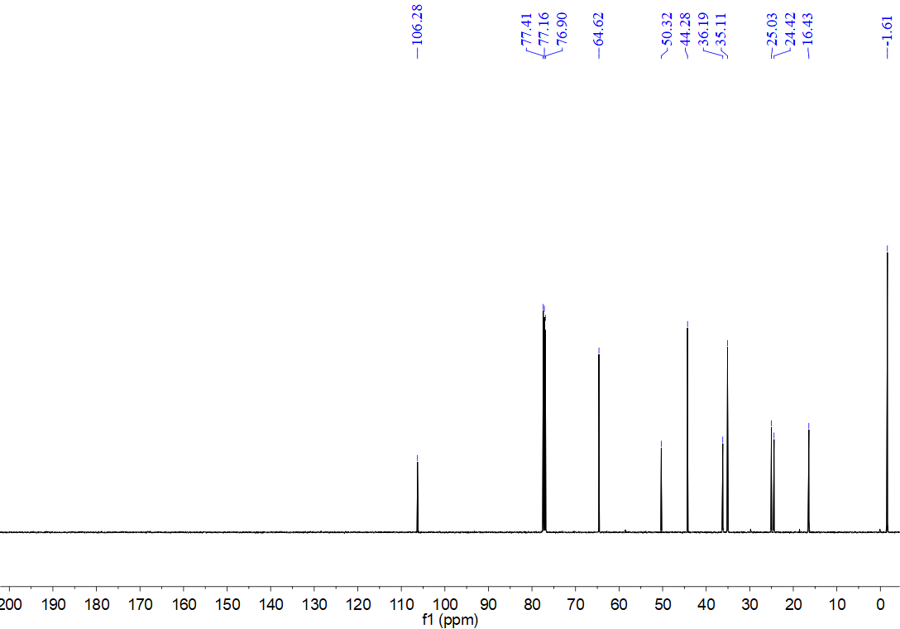
¹H NMR spectrum for compound 12f (500 MHz, CDCl₃)
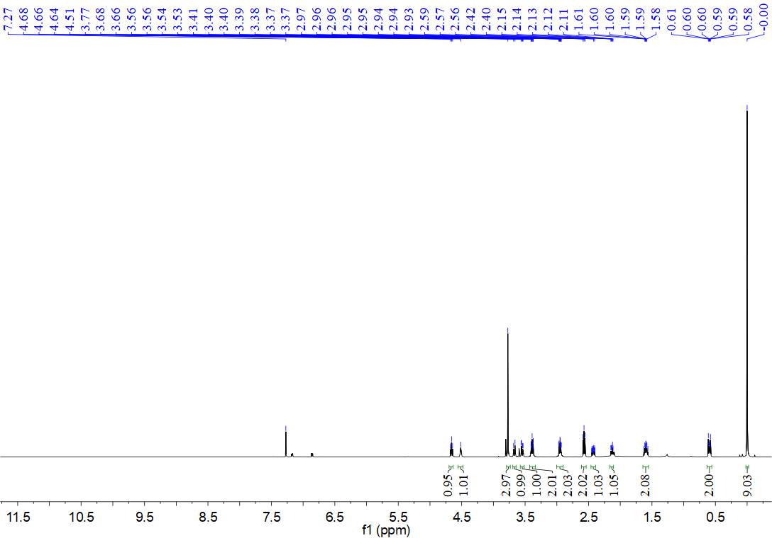
¹³C NMR spectrum for compound 12f (126 MHz, CDCl₃)
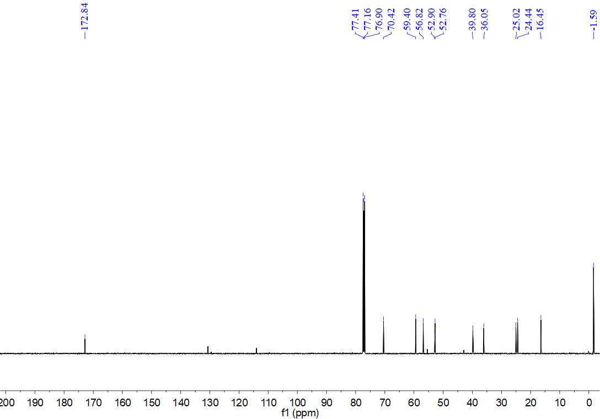
¹H NMR spectrum for compound 12g (500 MHz, CDCl₃)
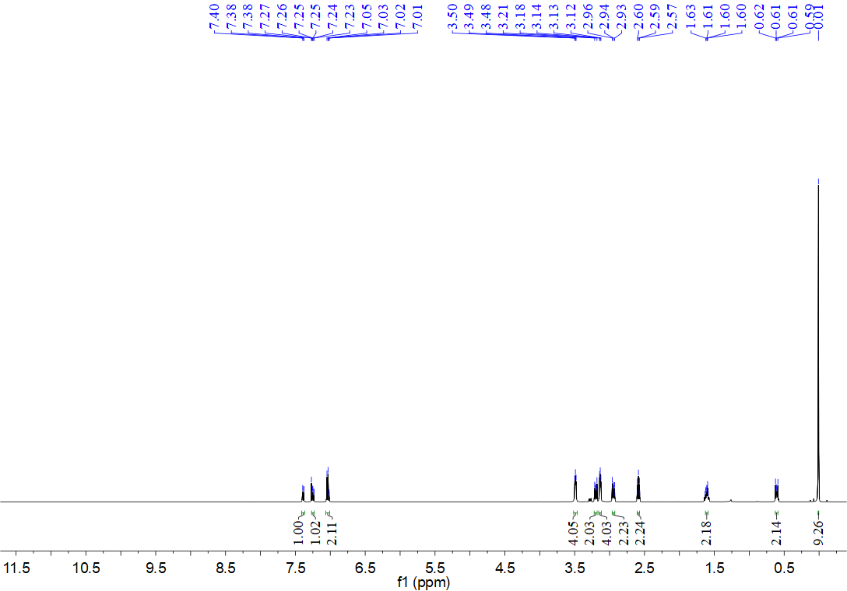
¹³C NMR spectrum for compound 12g (126 MHz, CDCl₃)
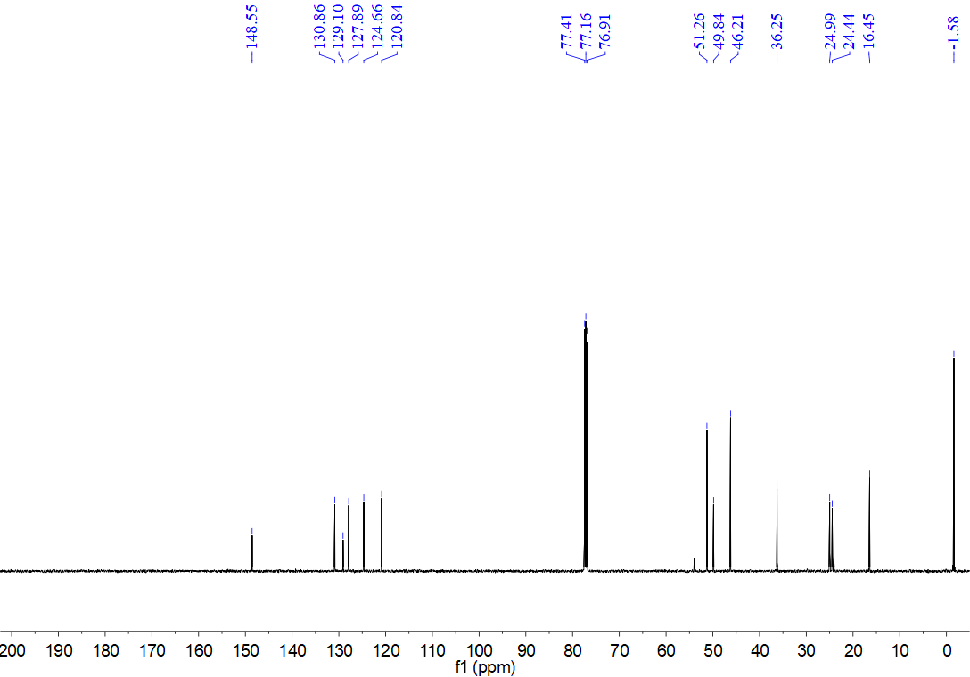
¹H NMR spectrum for compound 12h (500 MHz, CDCl₃)
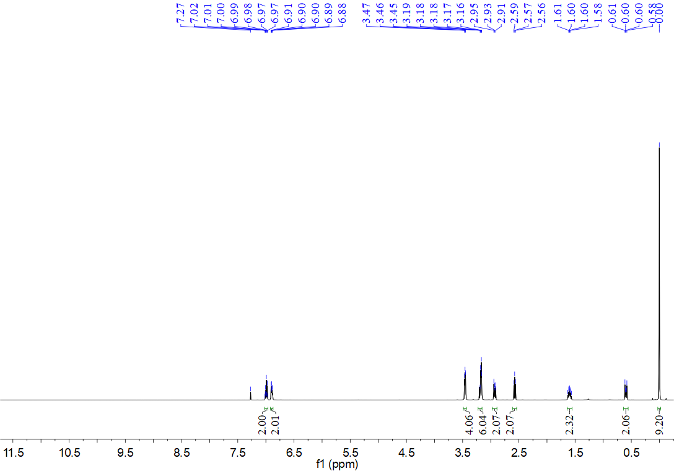
¹³C NMR spectrum for compound 12h (126 MHz, CDCl₃)
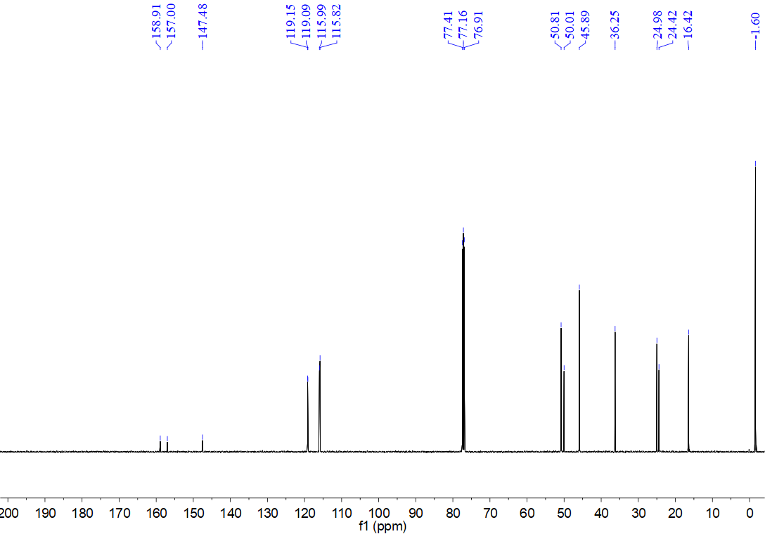
¹H NMR spectrum for compound 12i (500 MHz, CDCl₃)
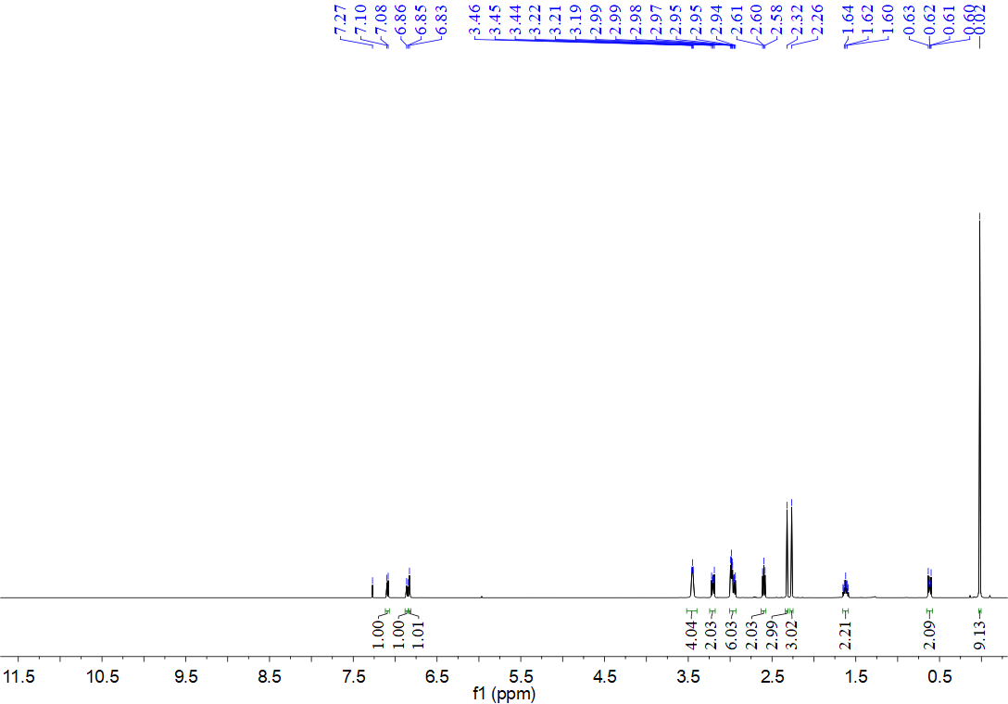
¹³C NMR spectrum for compound 12i (126 MHz, CDCl₃)
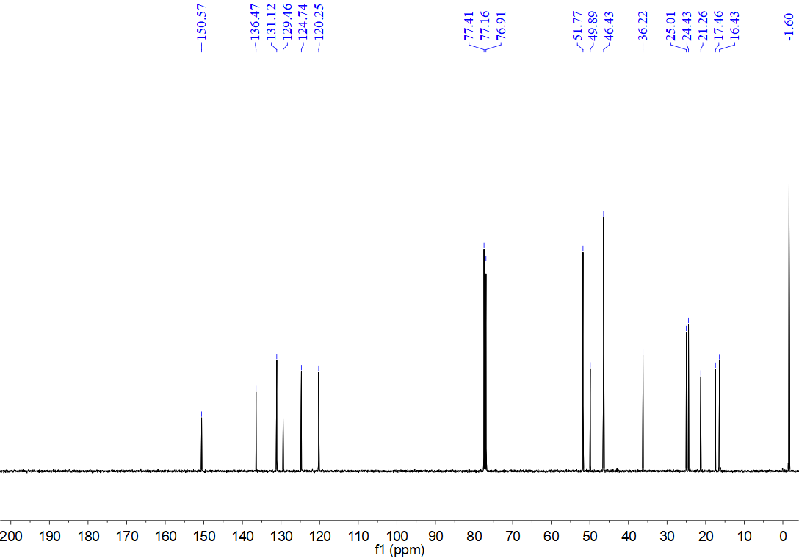
¹H NMR spectrum for compound 12j (500 MHz, CDCl₃)
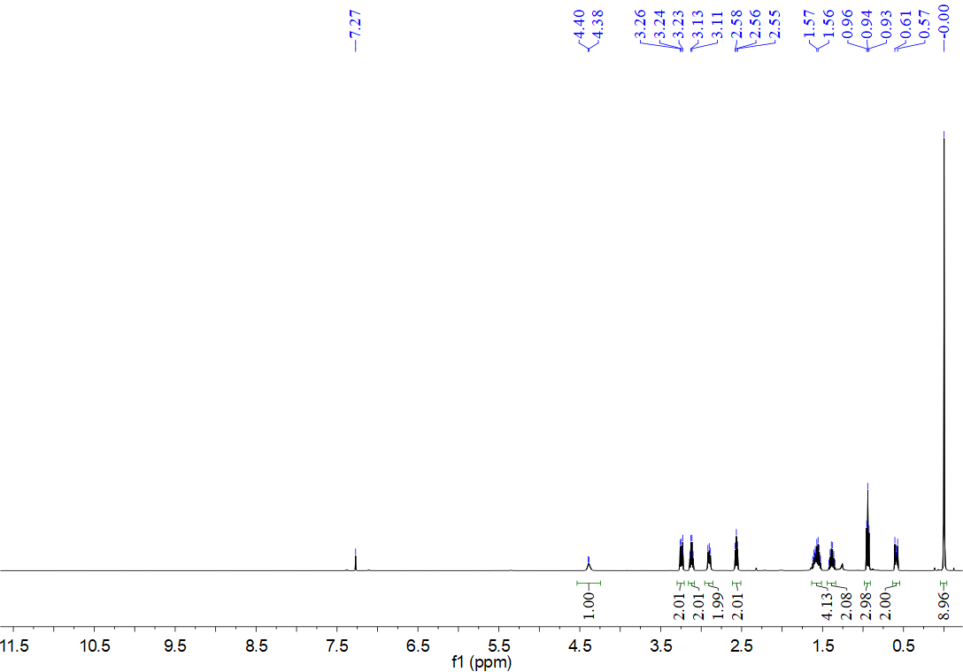
¹³C NMR spectrum for compound 12j (126 MHz, CDCl₃)
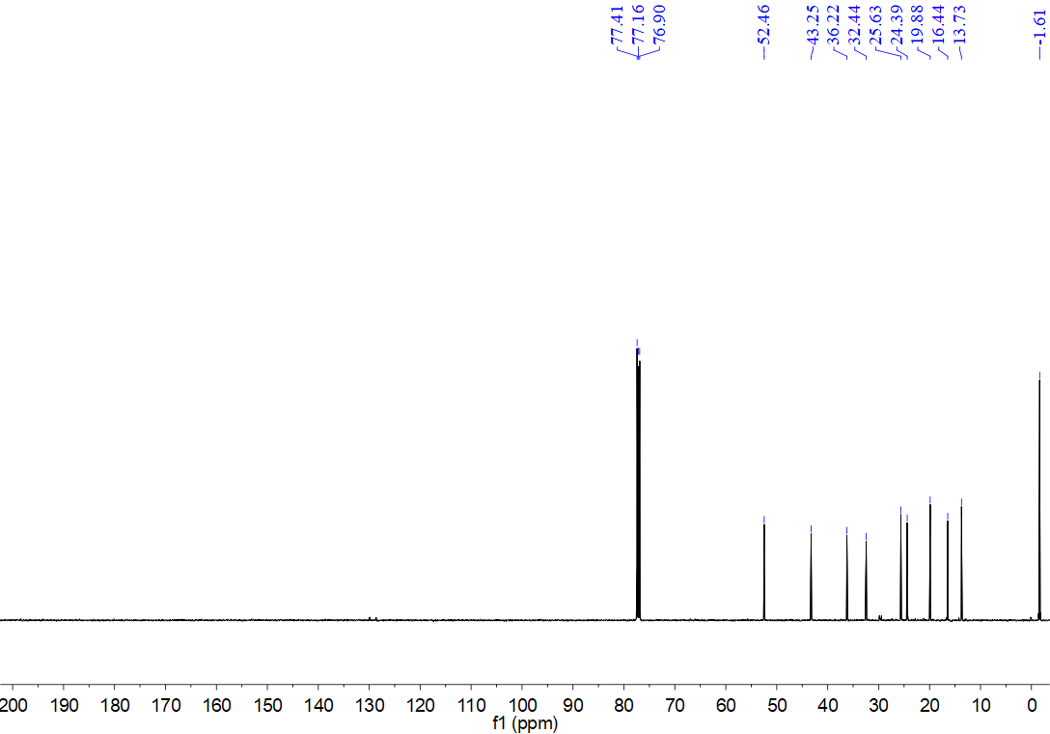
¹H NMR spectrum for compound 12k (500 MHz, CDCl₃)
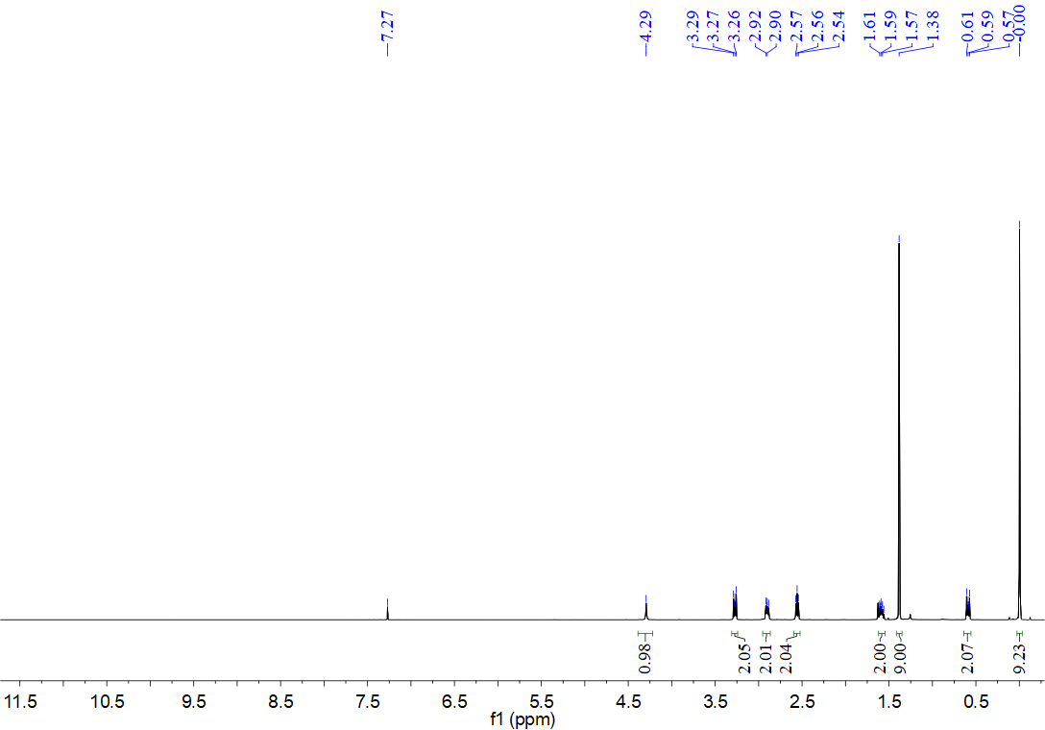
¹³C NMR spectrum for compound 12k (126 MHz, CDCl₃)
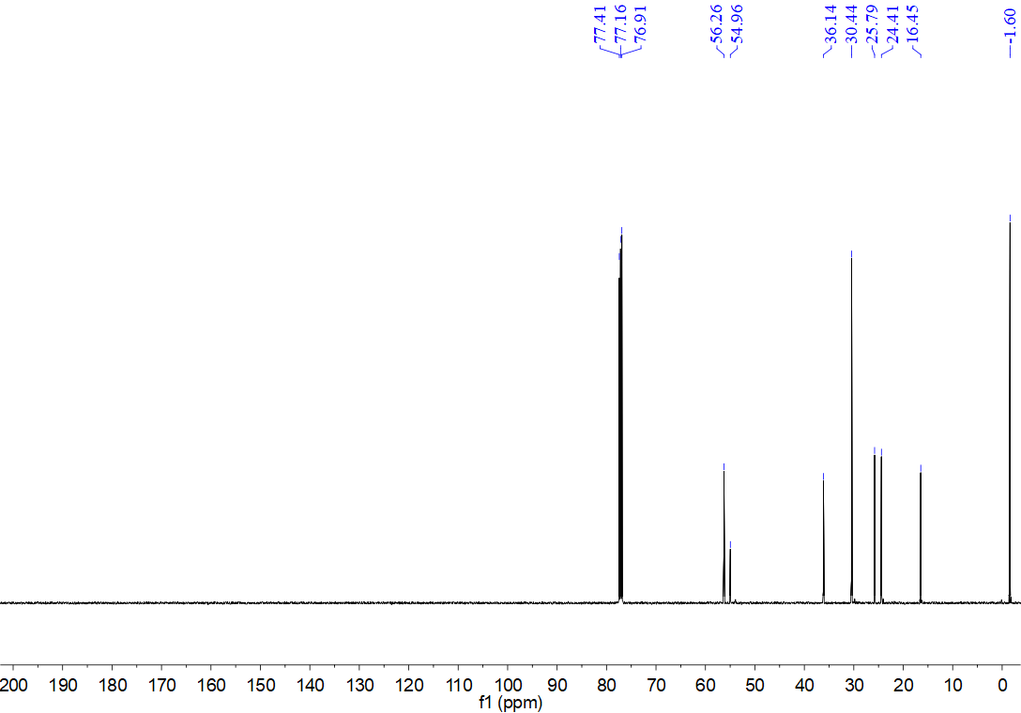
¹H NMR spectrum for compound 12l (500 MHz, CDCl₃)
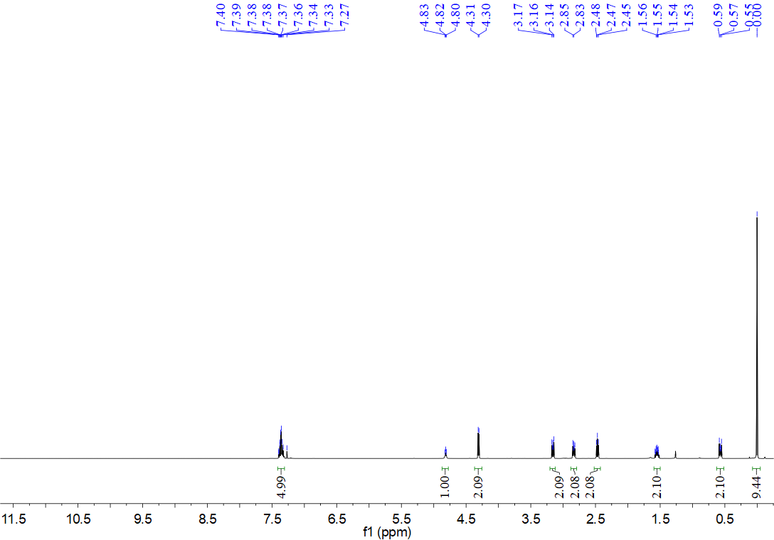
¹³C NMR spectrum for compound 12l (126 MHz, CDCl₃)
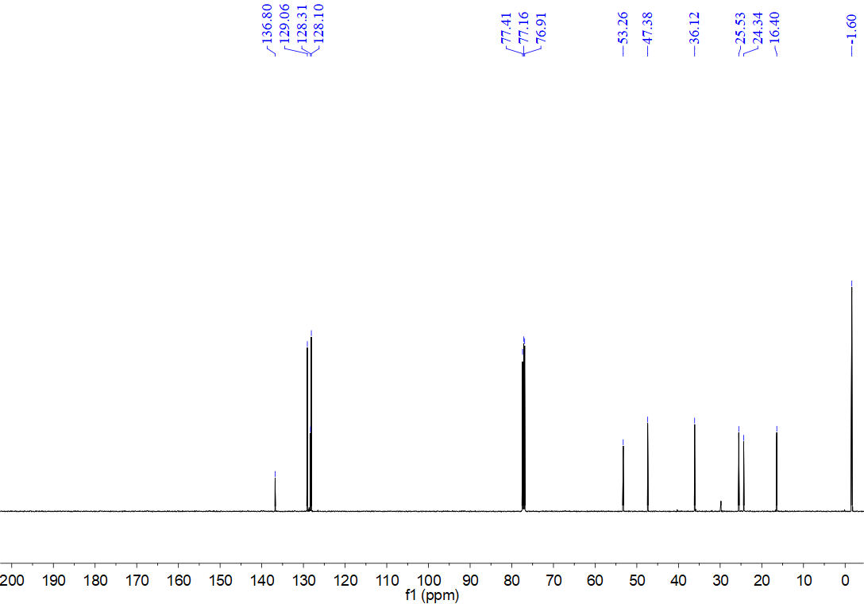
¹H NMR spectrum for compound 12m (500 MHz, CDCl₃)
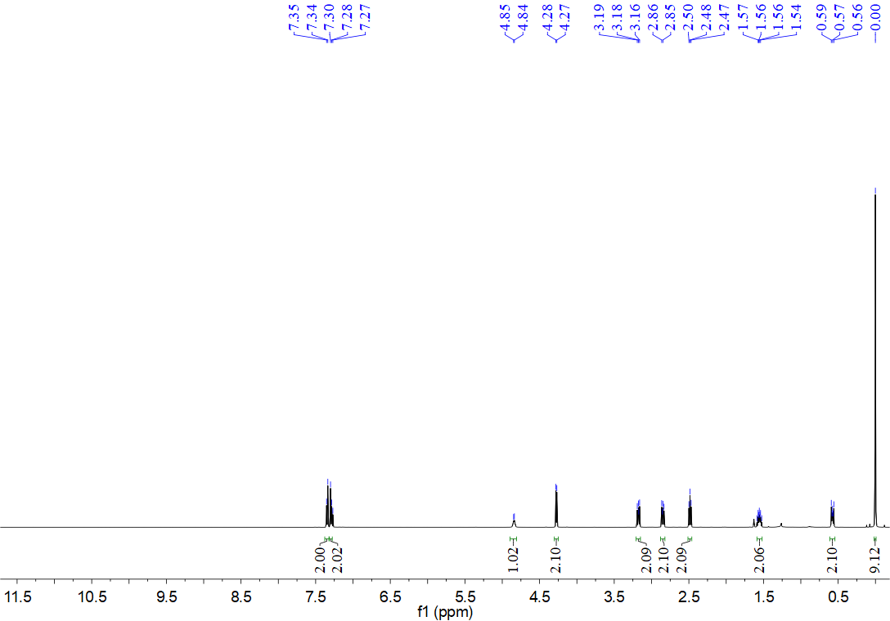
¹³C NMR spectrum for compound 12m (126 MHz, CDCl₃)
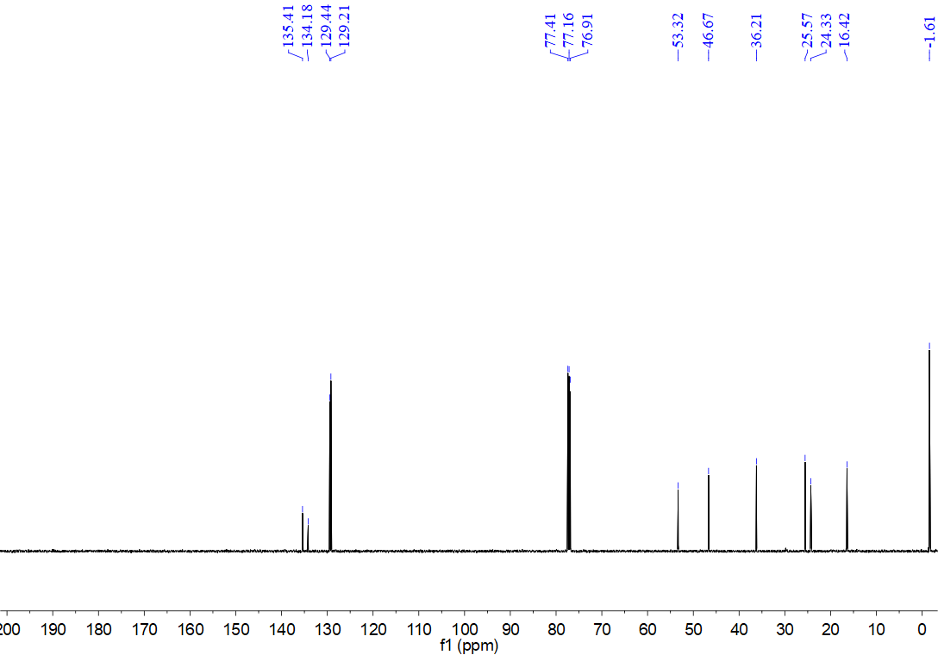
¹H NMR spectrum for compound 12n (500 MHz, CDCl₃)
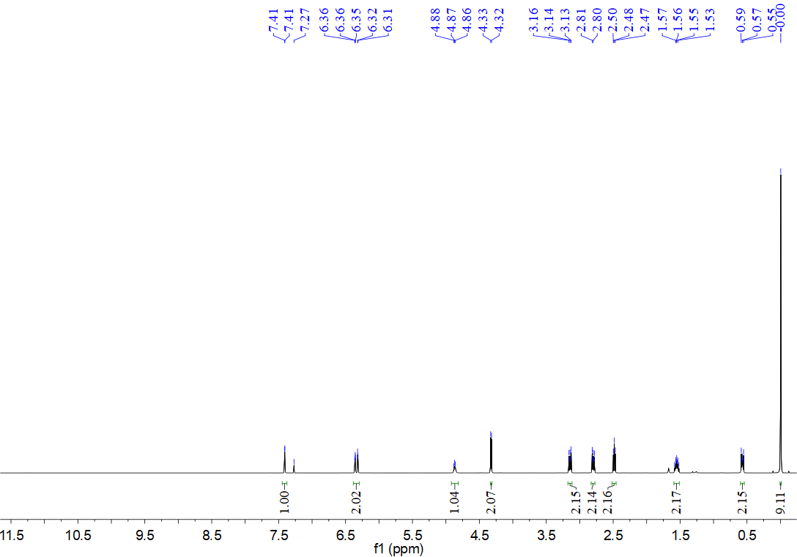
¹³C NMR spectrum for compound 12n (126 MHz, CDCl₃)
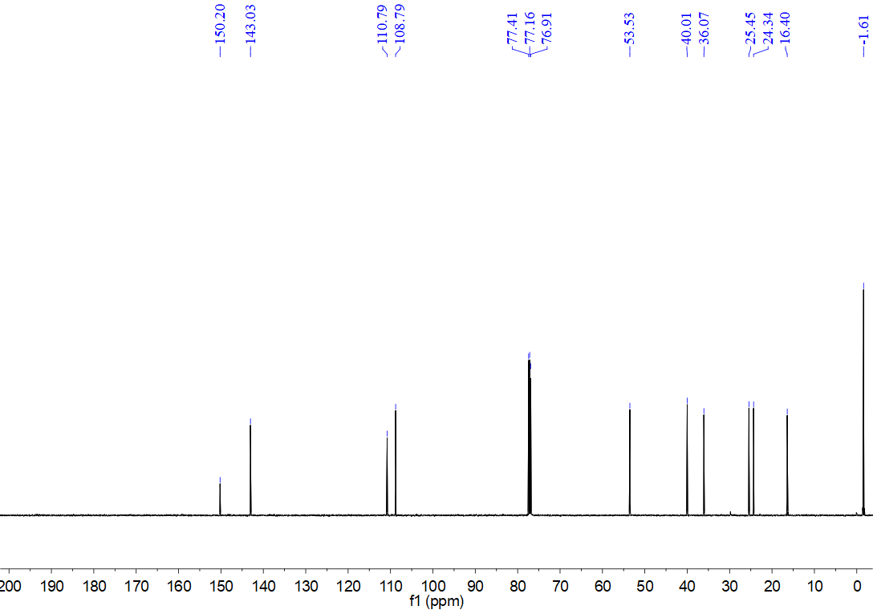
¹H NMR spectrum for compound 12o (500 MHz, CDCl₃)
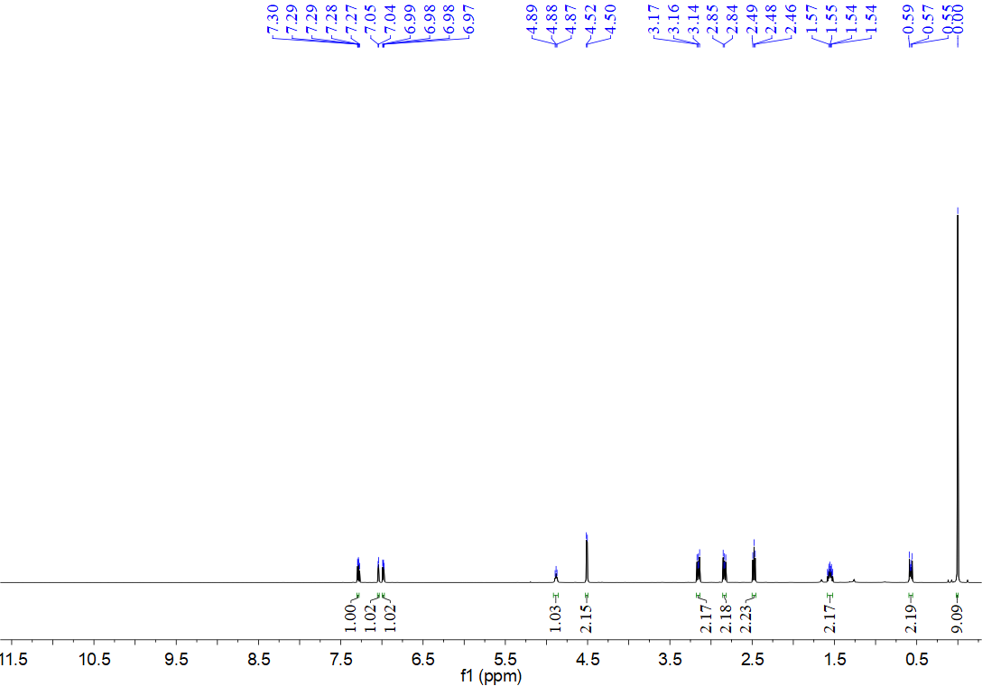
¹³C NMR spectrum for compound 12o (126 MHz, CDCl₃)
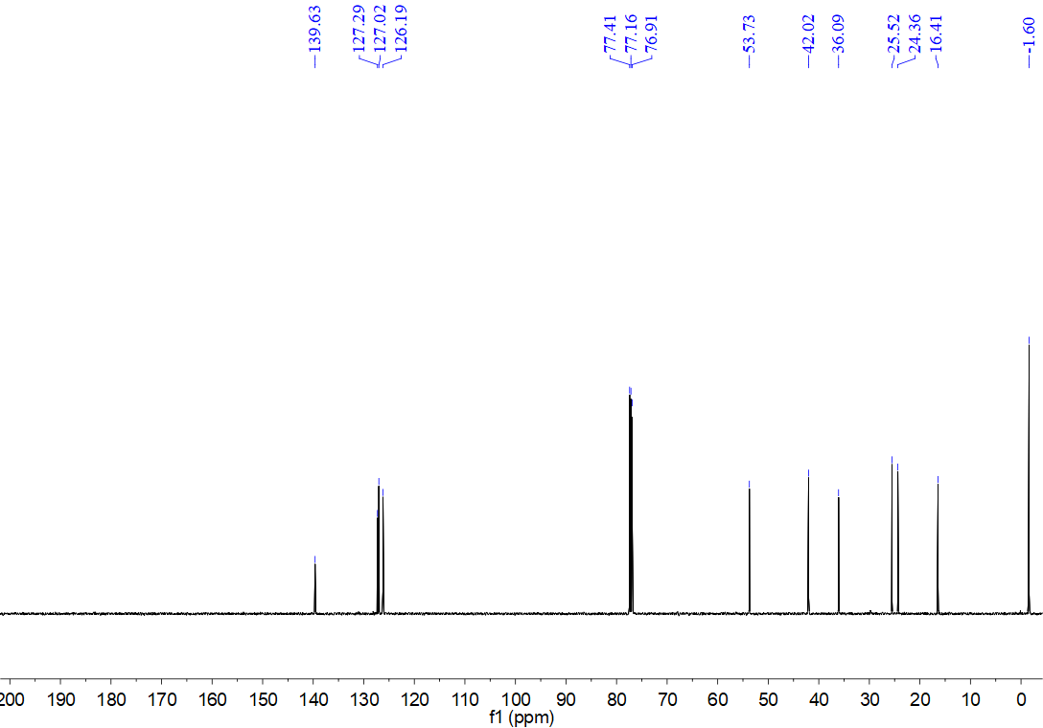
¹H NMR spectrum for compound 12p (500 MHz, CDCl₃)
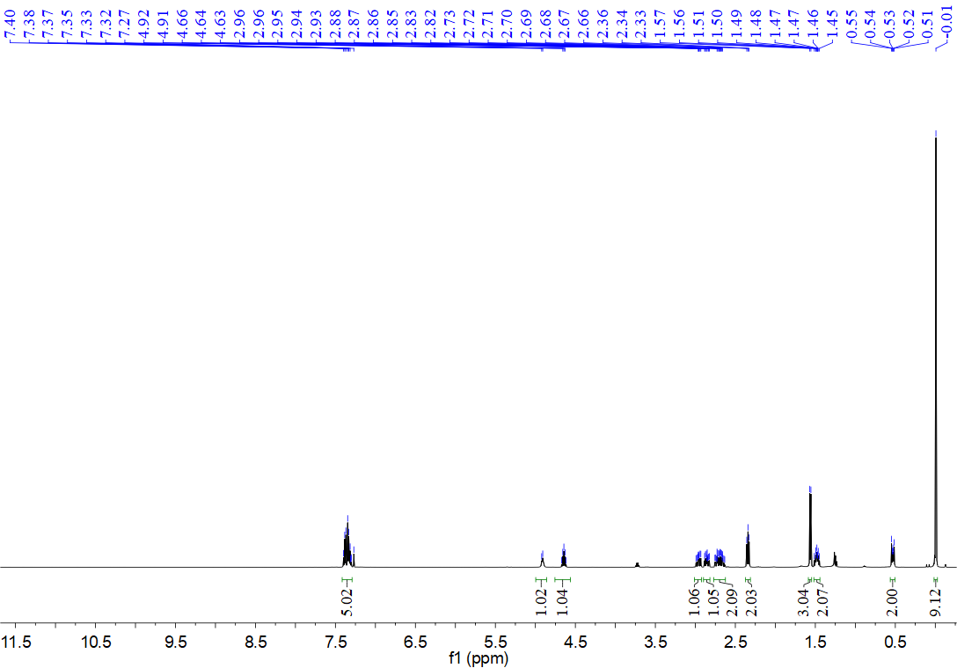
¹³C NMR spectrum for compound 12p (126 MHz, CDCl₃)
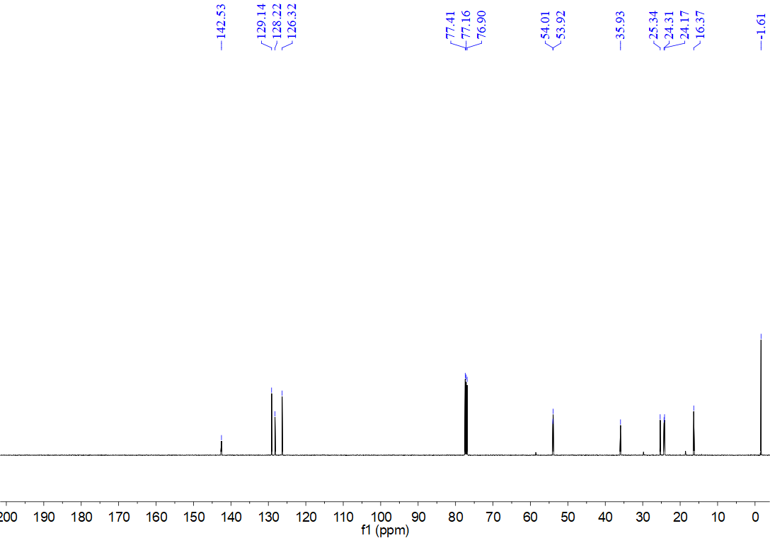
¹H NMR spectrum for compound 12q (500 MHz, CDCl₃)
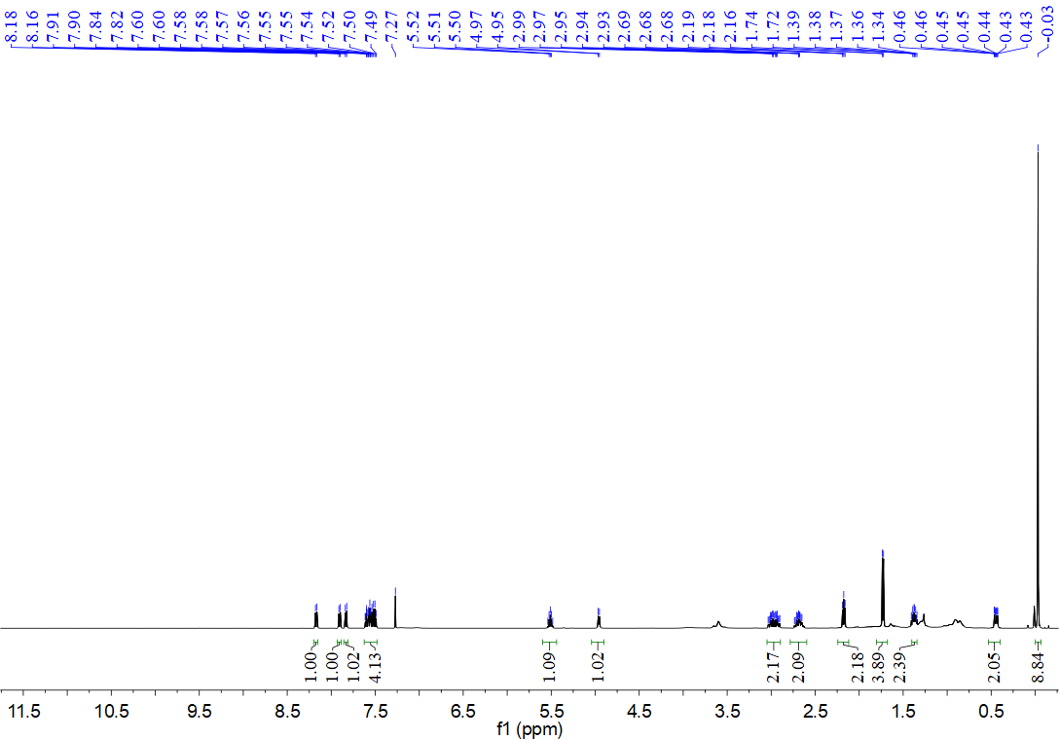
¹³C NMR spectrum for compound 12q (126 MHz, CDCl₃)
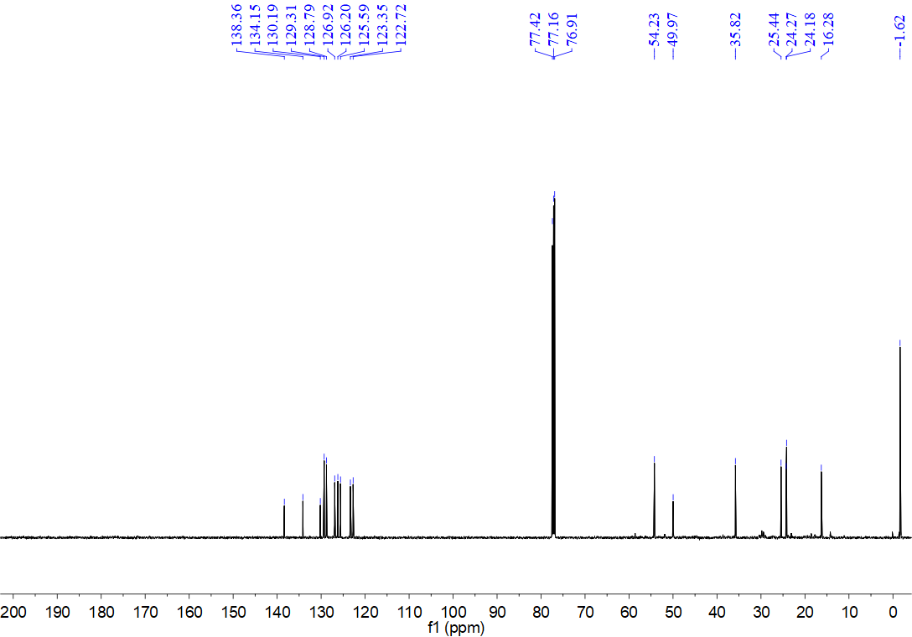
¹H NMR spectrum for compound 12r (500 MHz, CDCl₃)
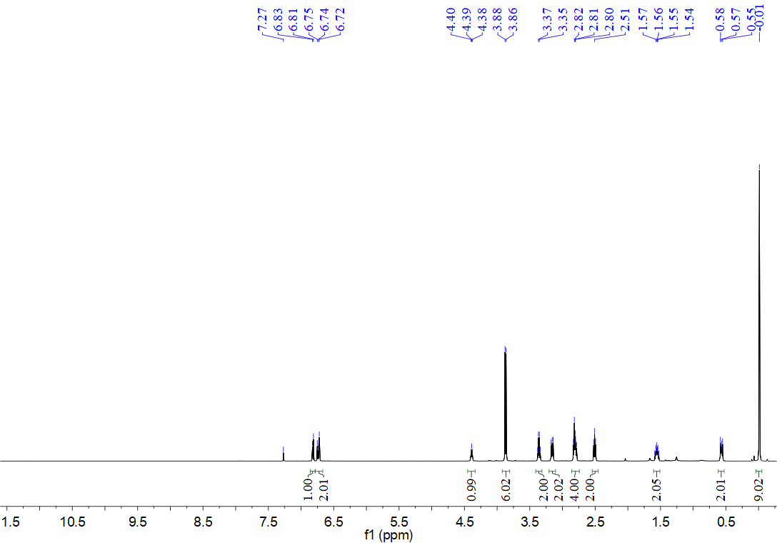
¹³C NMR spectrum for compound 12r (126 MHz, CDCl₃)
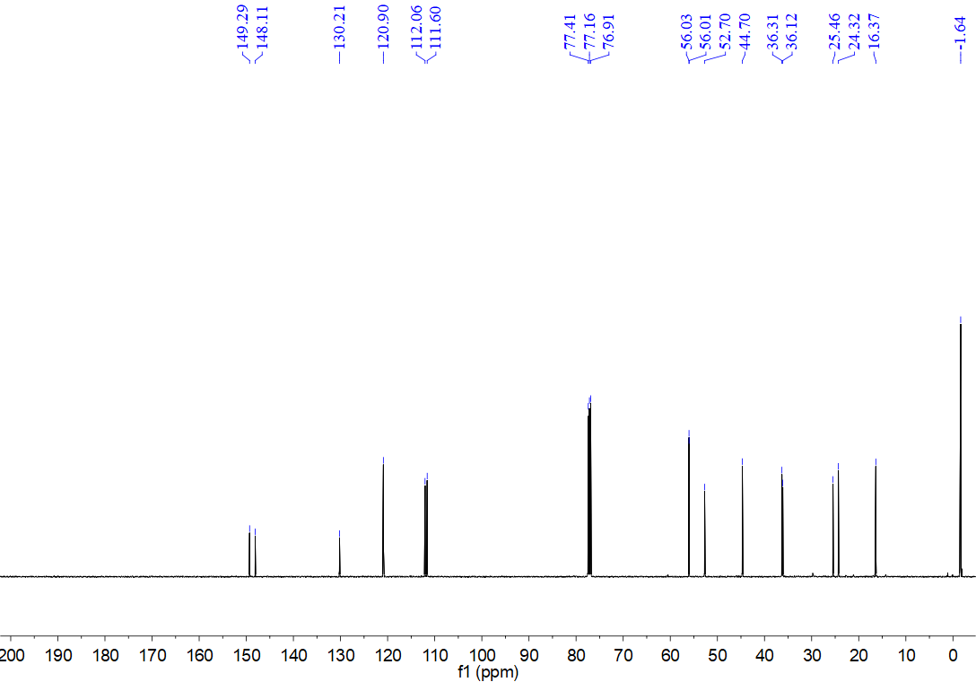
¹H NMR spectrum for compound 12s (500 MHz, CDCl₃)
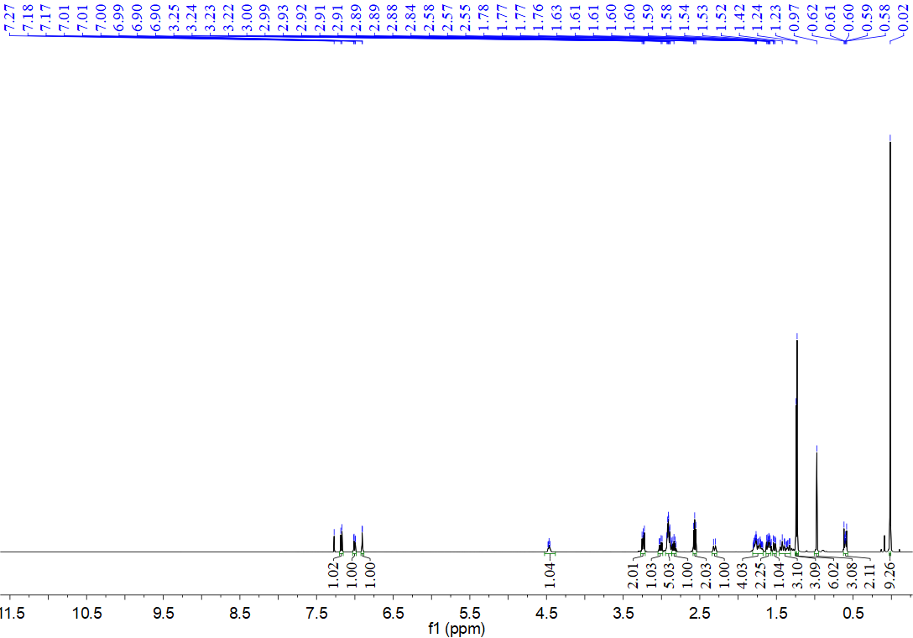
¹³C NMR spectrum for compound 12s (126 MHz, CDCl₃)
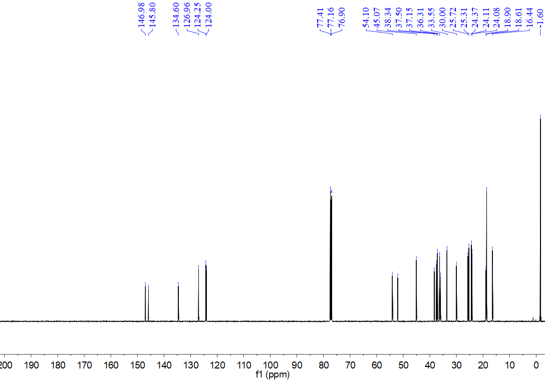
¹H NMR spectrum for compound 12t (500 MHz, CDCl₃)
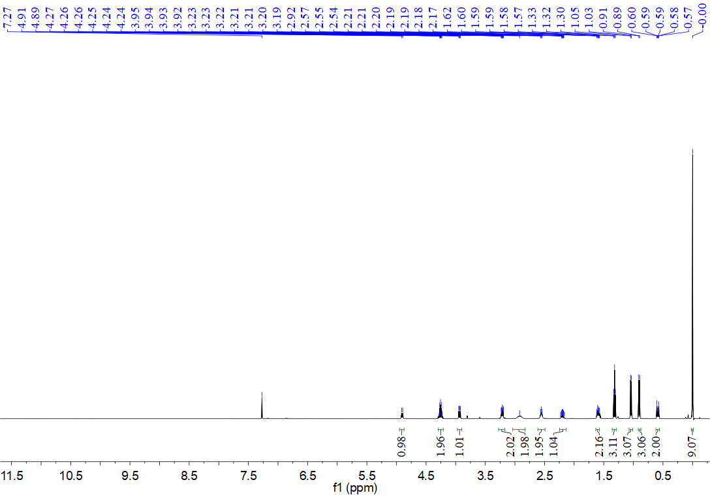
¹³C NMR spectrum for compound 12t (126 MHz, CDCl₃)
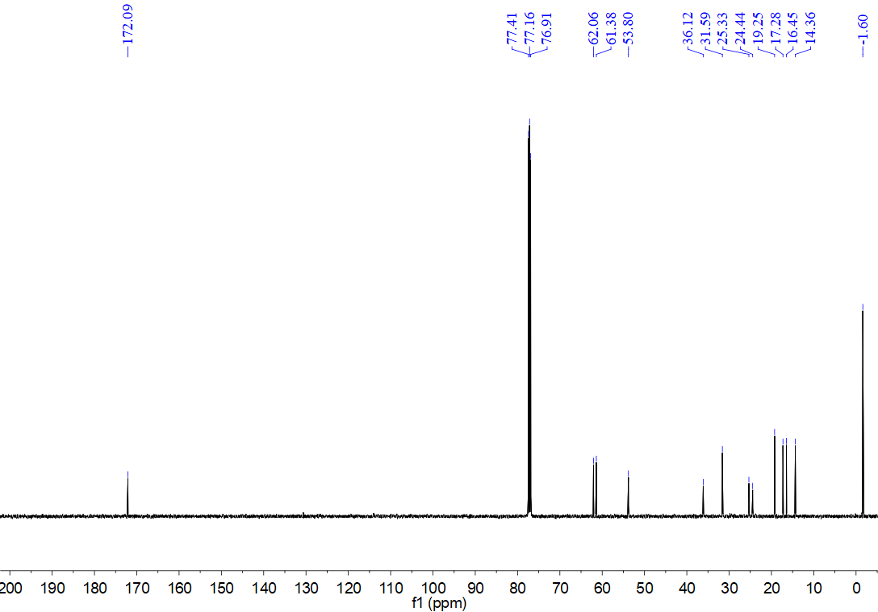
¹H NMR spectrum for compound 12u (500 MHz, CDCl₃)
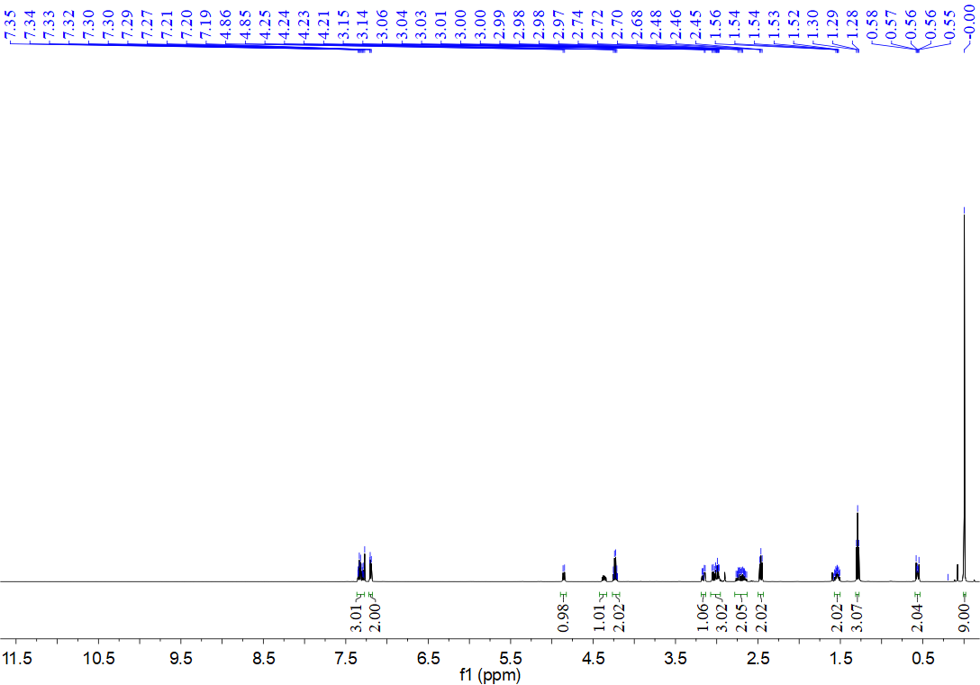
¹³C NMR spectrum for compound 12u (126 MHz, CDCl₃)
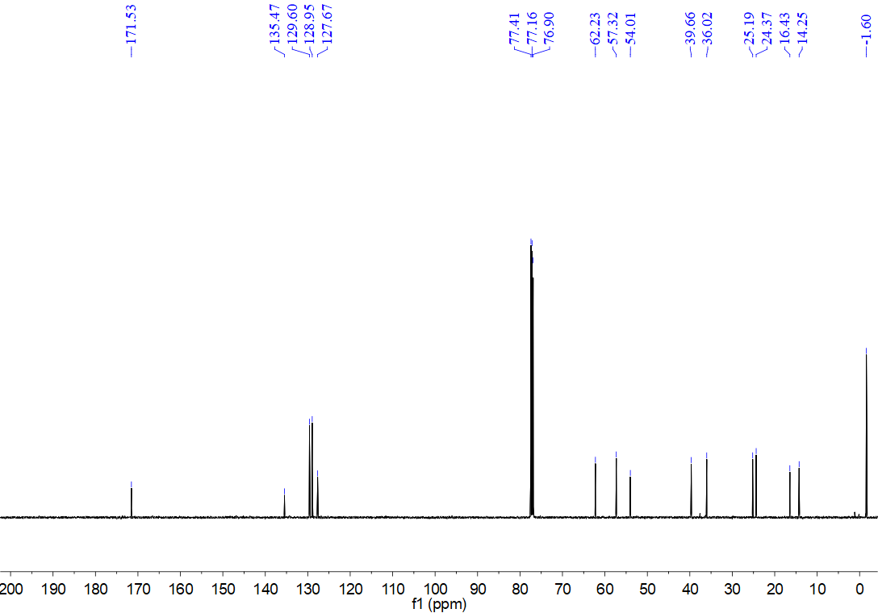
¹H NMR spectrum for compound 12v (500 MHz, CDCl₃)
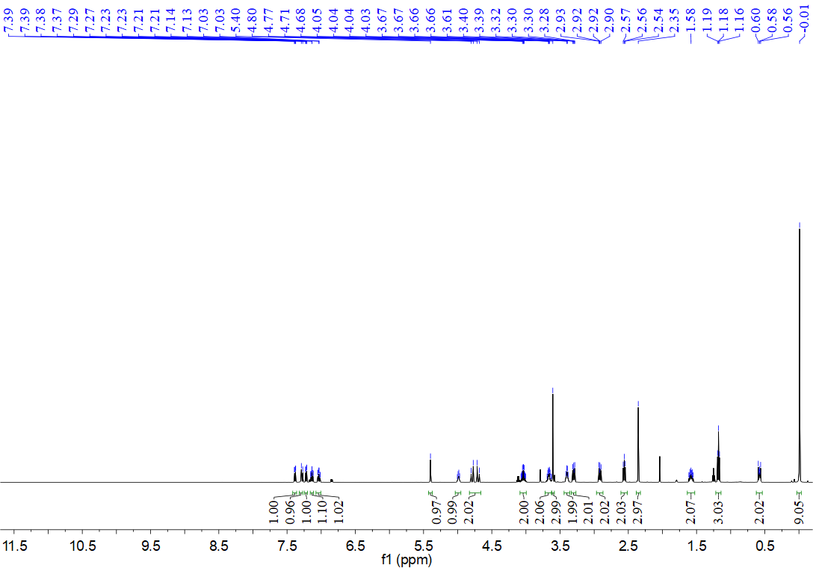
¹³C NMR spectrum for compound 12v (126 MHz, CDCl₃)
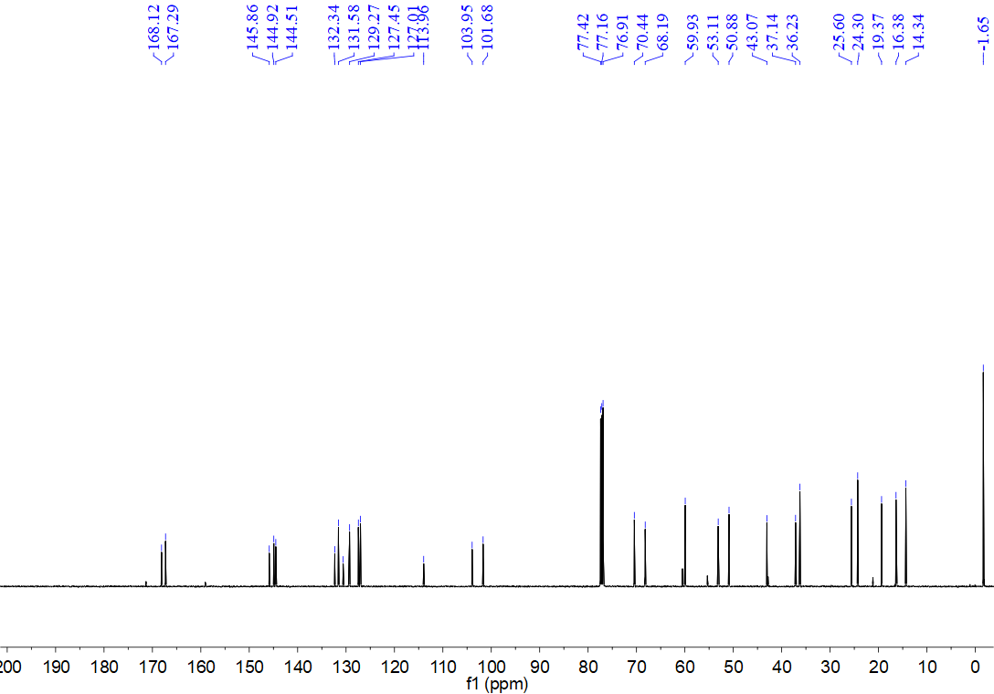
¹H NMR spectrum for compound 12w (500 MHz, CDCl₃)
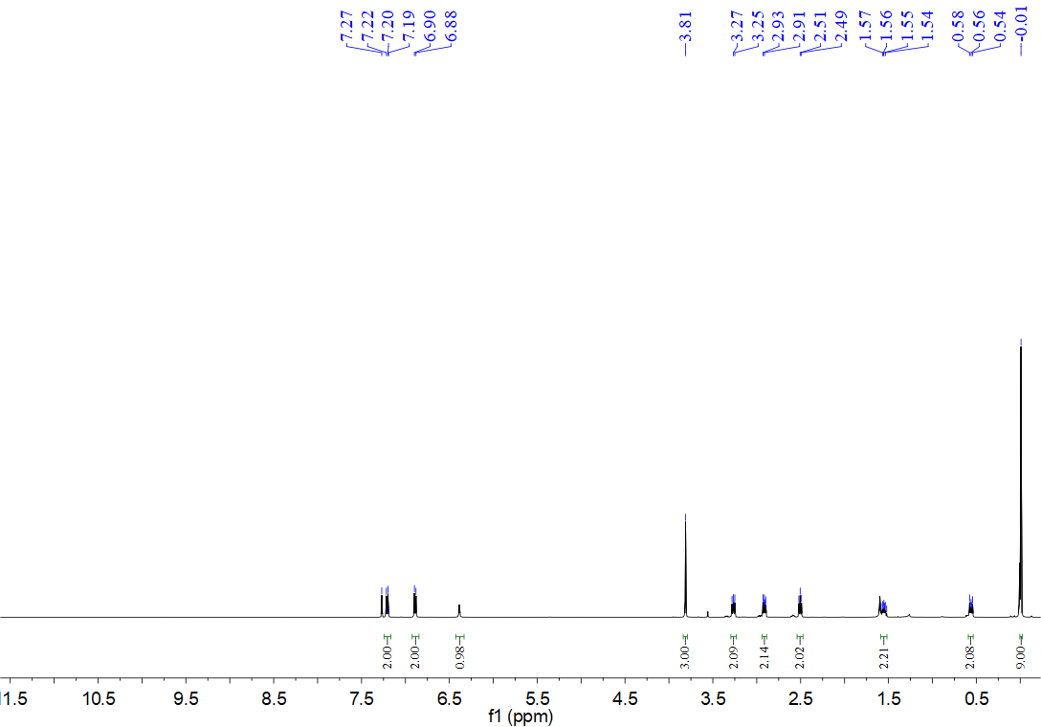
¹³C NMR spectrum for compound 12w (126 MHz, CDCl₃)
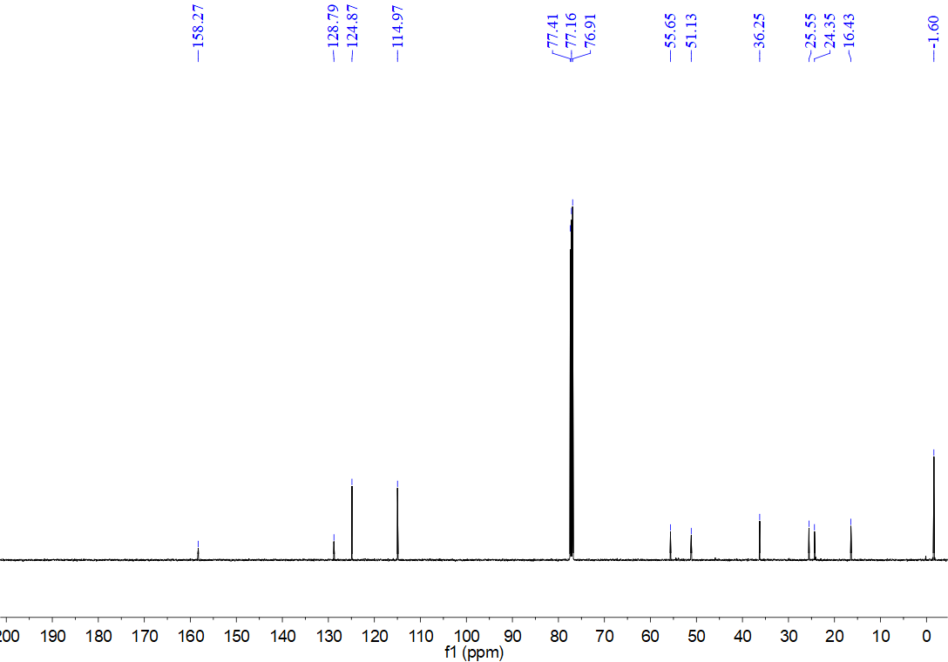
¹H NMR spectrum for compound 12x (500 MHz, CDCl₃)
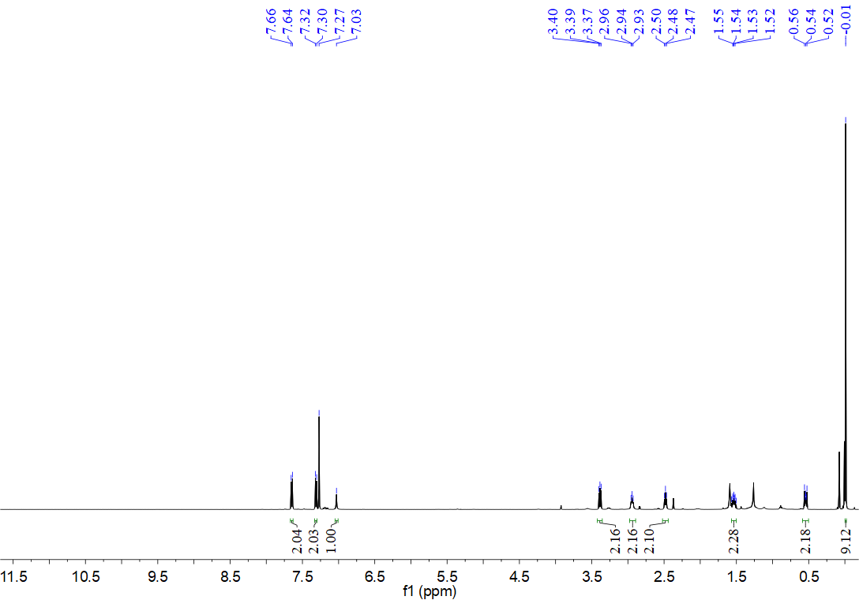
¹³C NMR spectrum for compound 12x (126 MHz, CDCl₃)
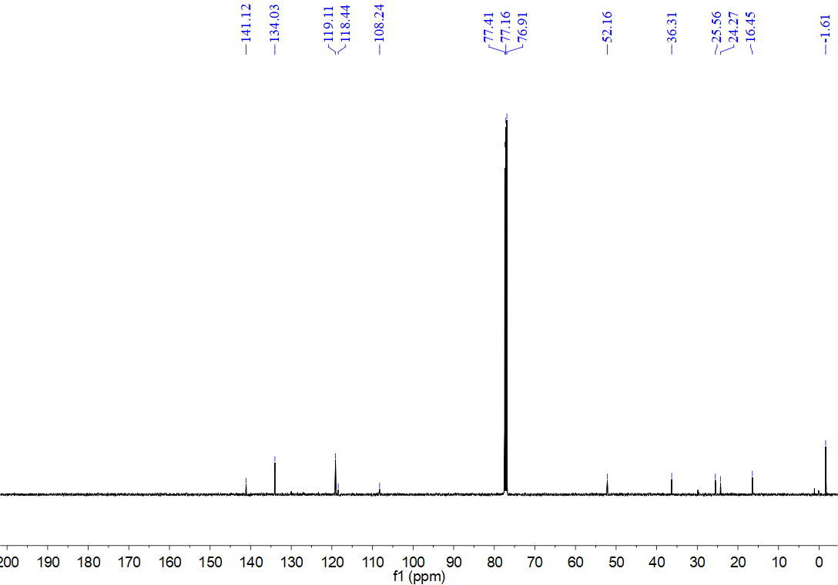
¹H NMR spectrum for compound 12y (500 MHz, CDCl₃)
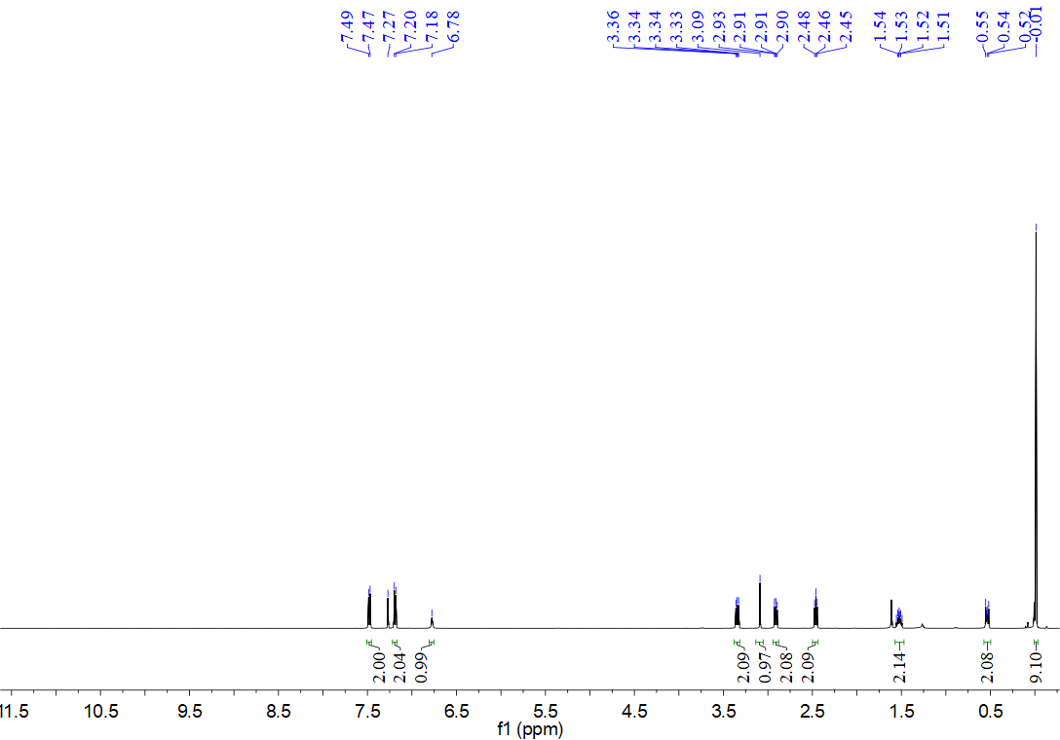
¹³C NMR spectrum for compound 12y (126 MHz, CDCl₃)
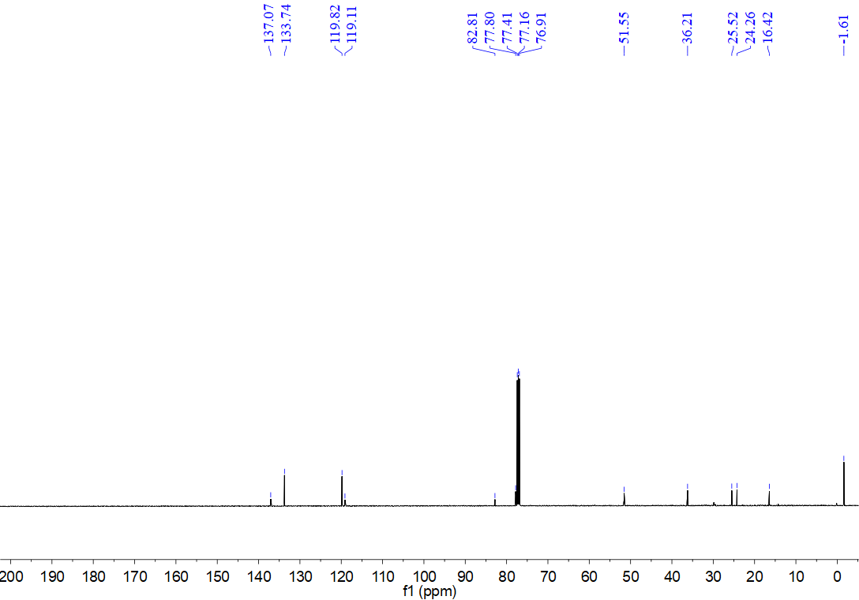
¹H NMR spectrum for compound 12z (500 MHz, CDCl₃)
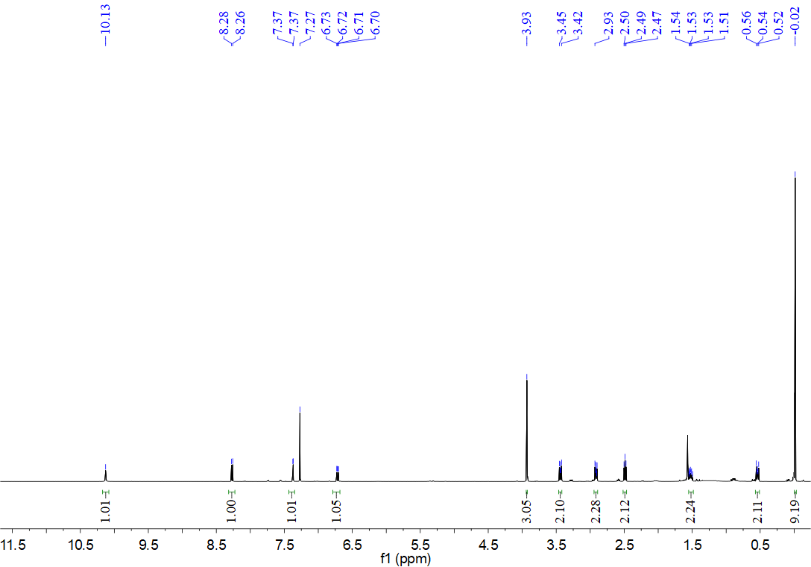
¹³C NMR spectrum for compound 12z (126 MHz, CDCl₃)
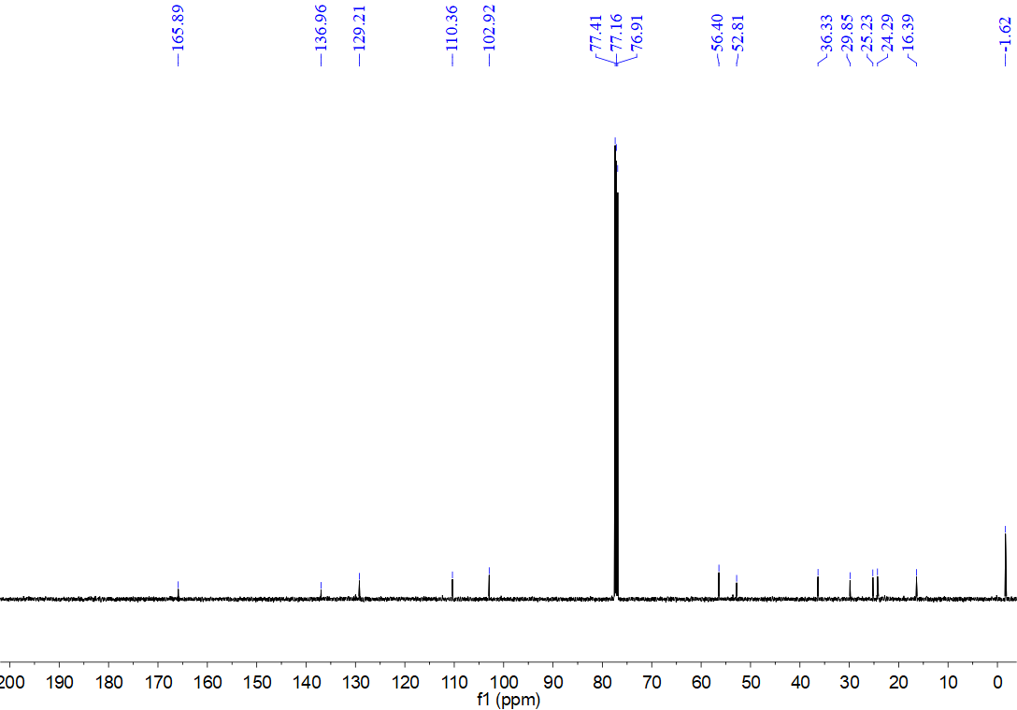
¹H NMR spectrum for compound 12aa (500 MHz, CDCl₃)
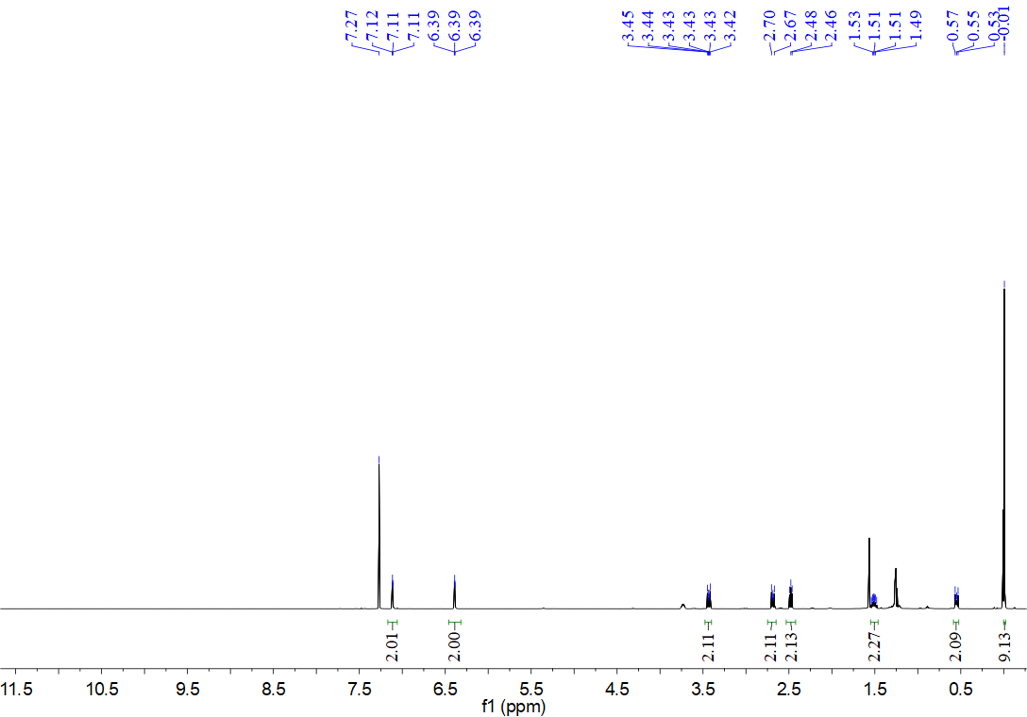
¹³C NMR spectrum for compound 12aa (126 MHz, CDCl₃)
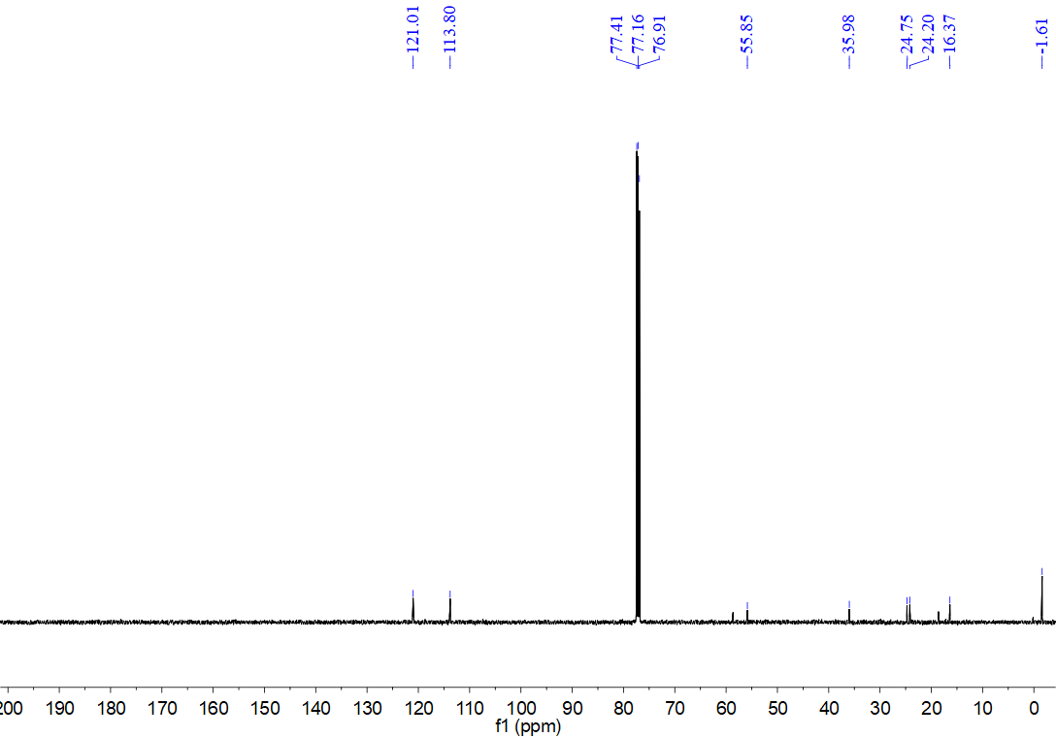
¹H NMR spectrum for compound 12ab (500 MHz, CDCl₃)
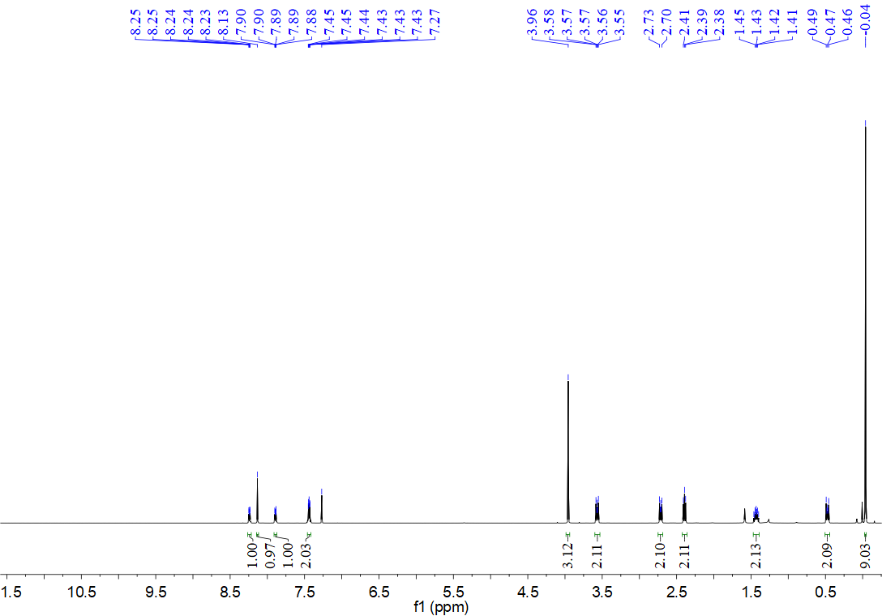
¹³C NMR spectrum for compound 12ab (126 MHz, CDCl₃)
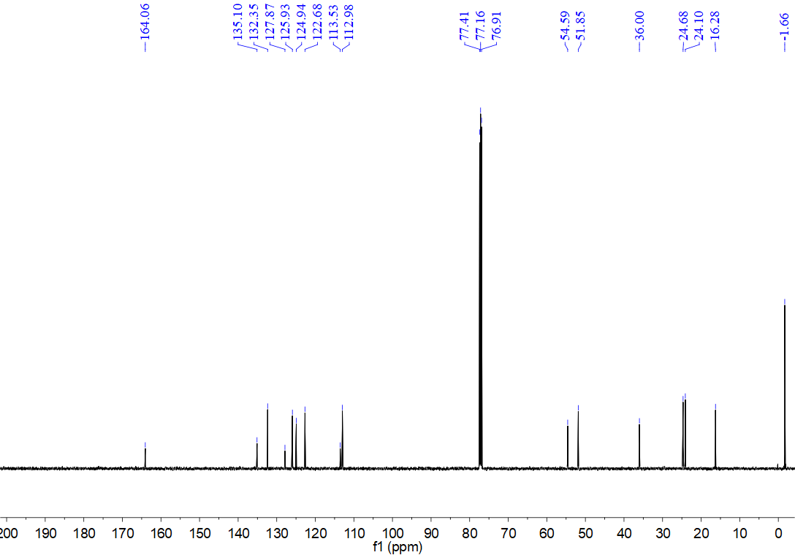
¹H NMR spectrum for compound 12ac (500 MHz, CDCl₃)
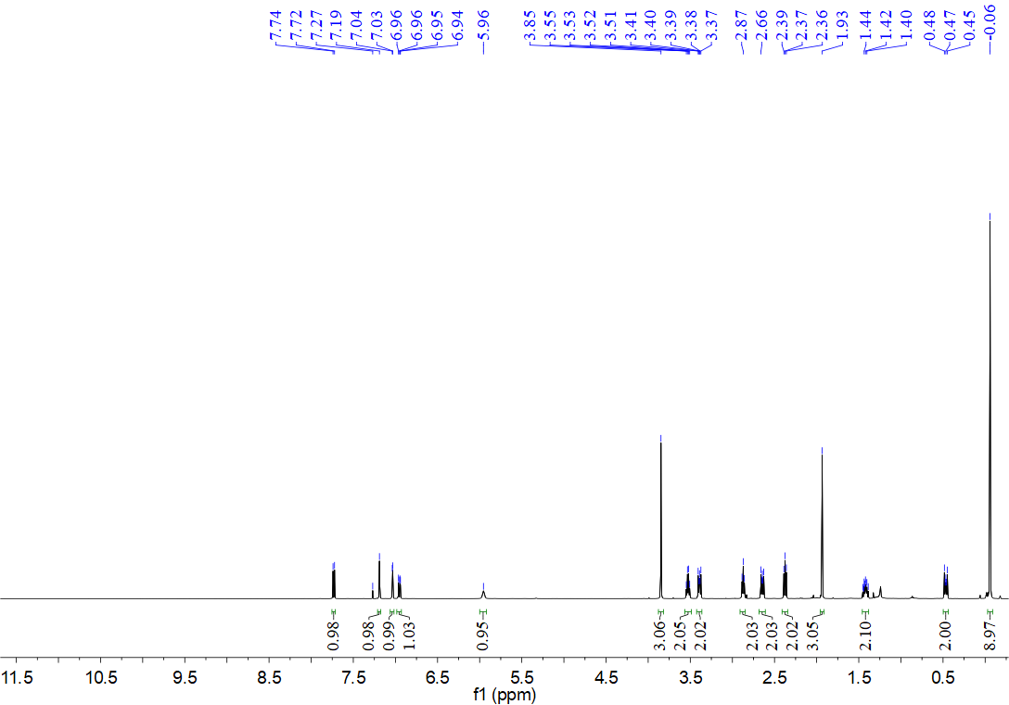
¹³C NMR spectrum for compound 12ac (126 MHz, CDCl₃)
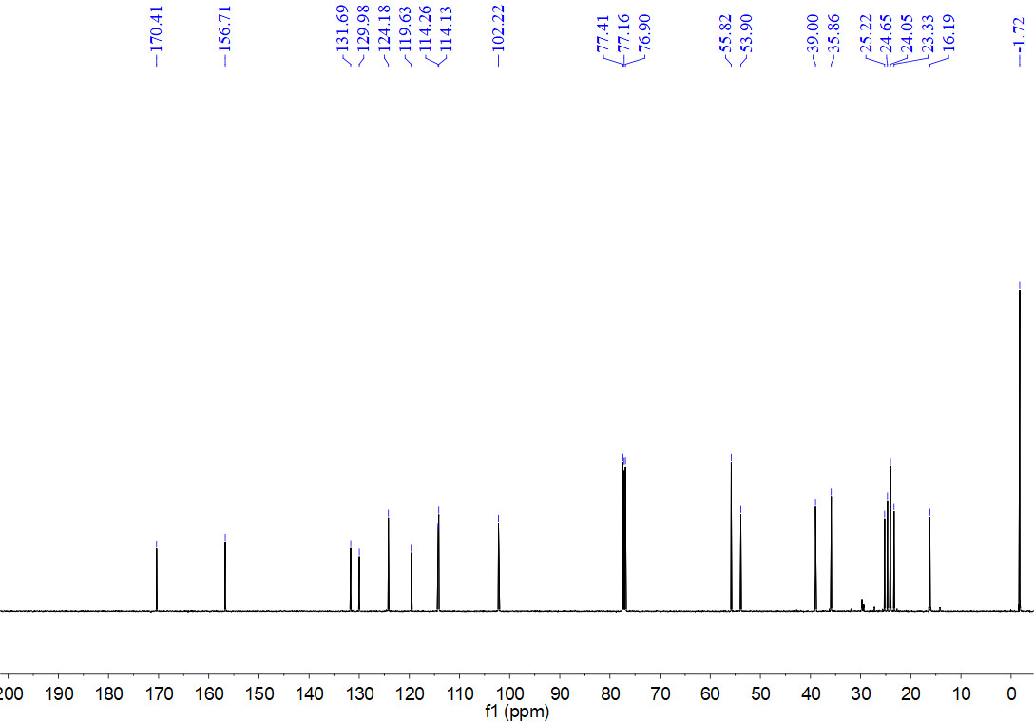
¹H NMR spectrum for compound 12ad (500 MHz, CDCl₃)
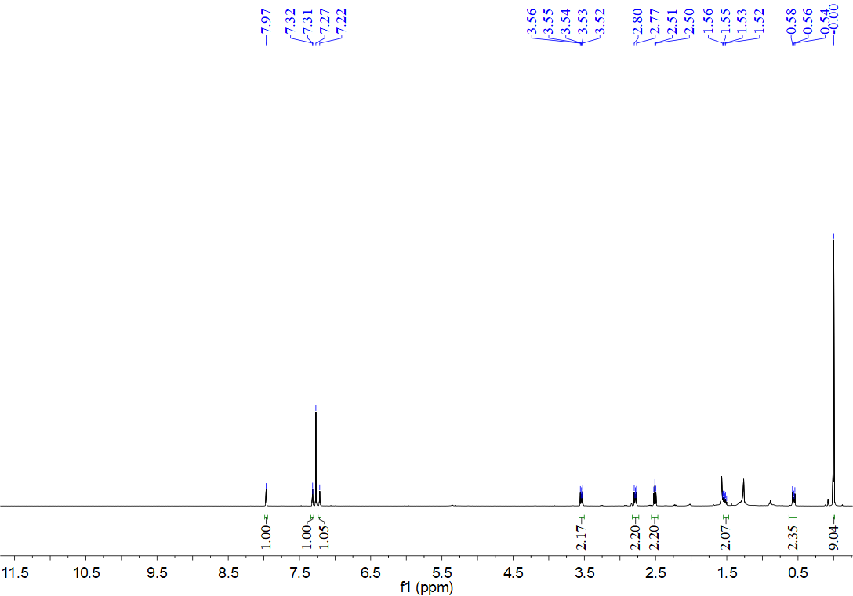
¹³C NMR spectrum for compound 12ad (126 MHz, CDCl₃)
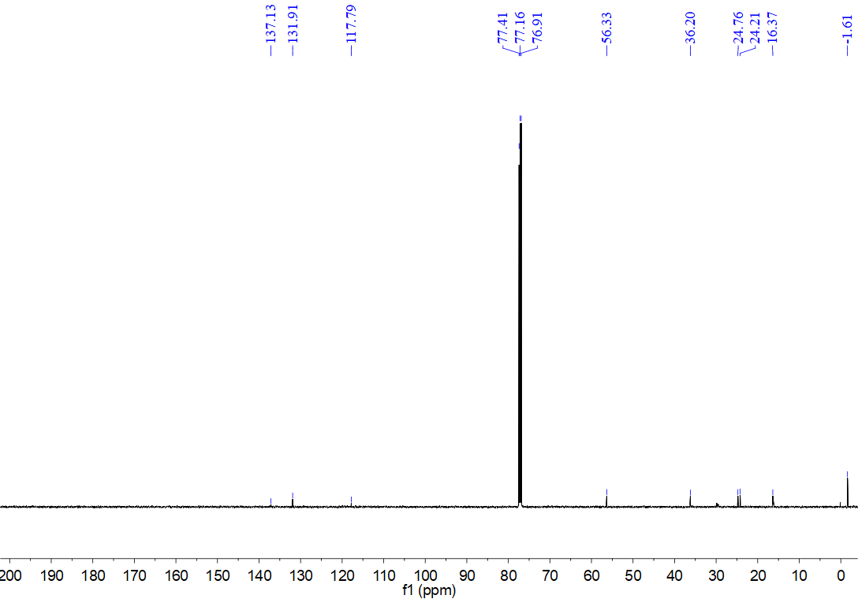
¹H NMR spectrum for compound 12ae (500 MHz, DMSO)
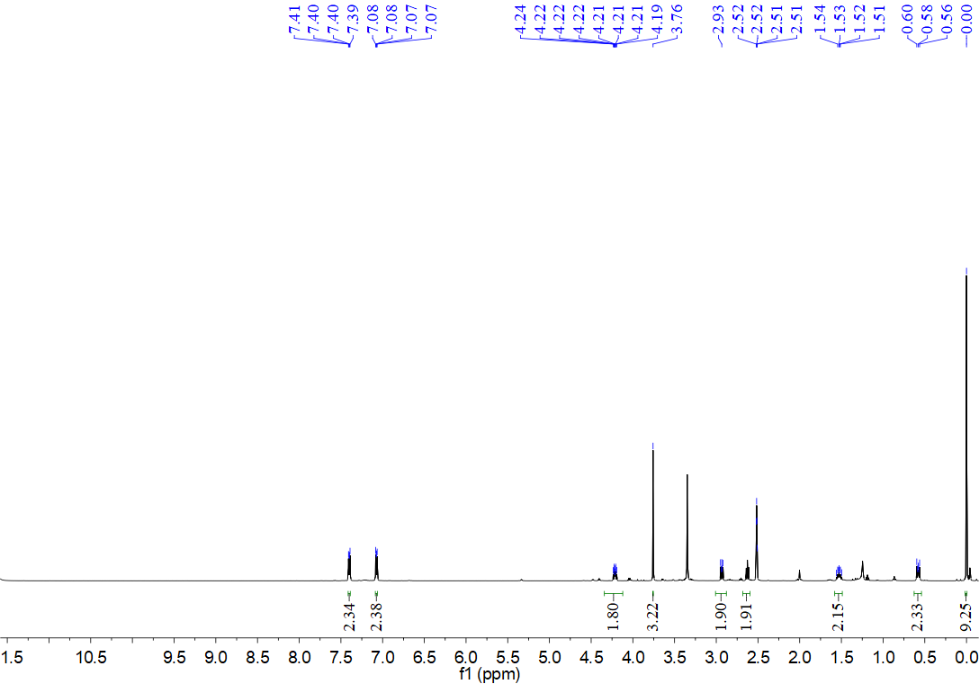
¹³C NMR spectrum for compound 12ae (126 MHz, DMSO)
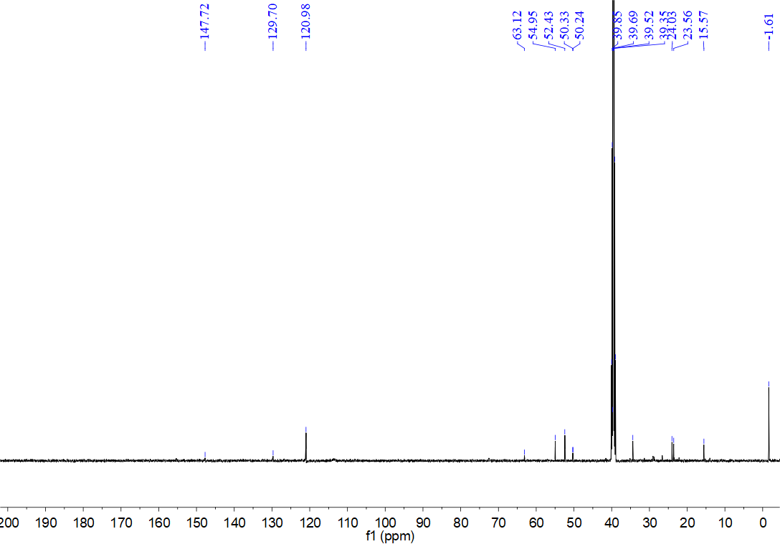
¹H NMR spectrum for compound 14a (500 MHz, CDCl₃)
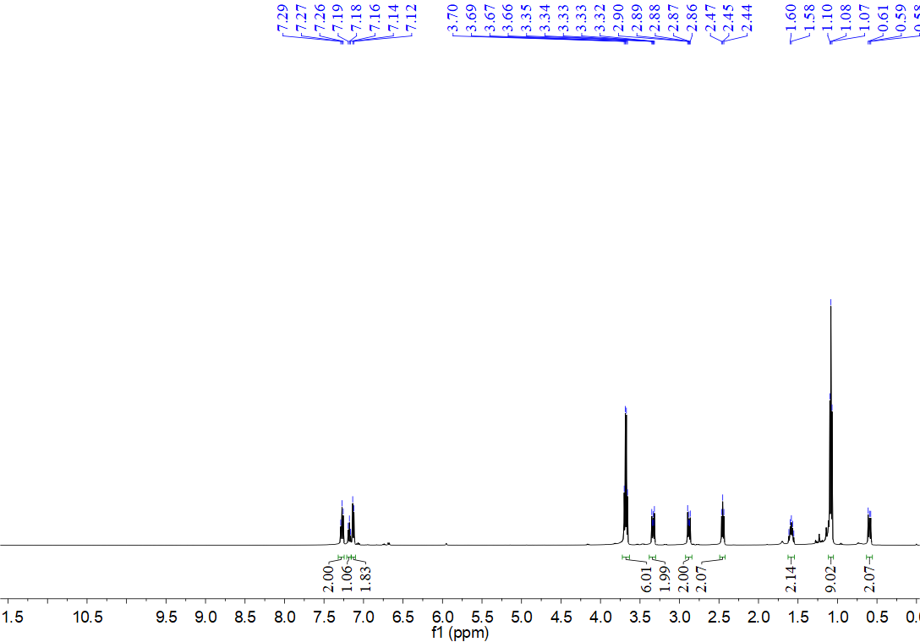
¹³C NMR spectrum for compound 14a (126 MHz, CDCl₃)
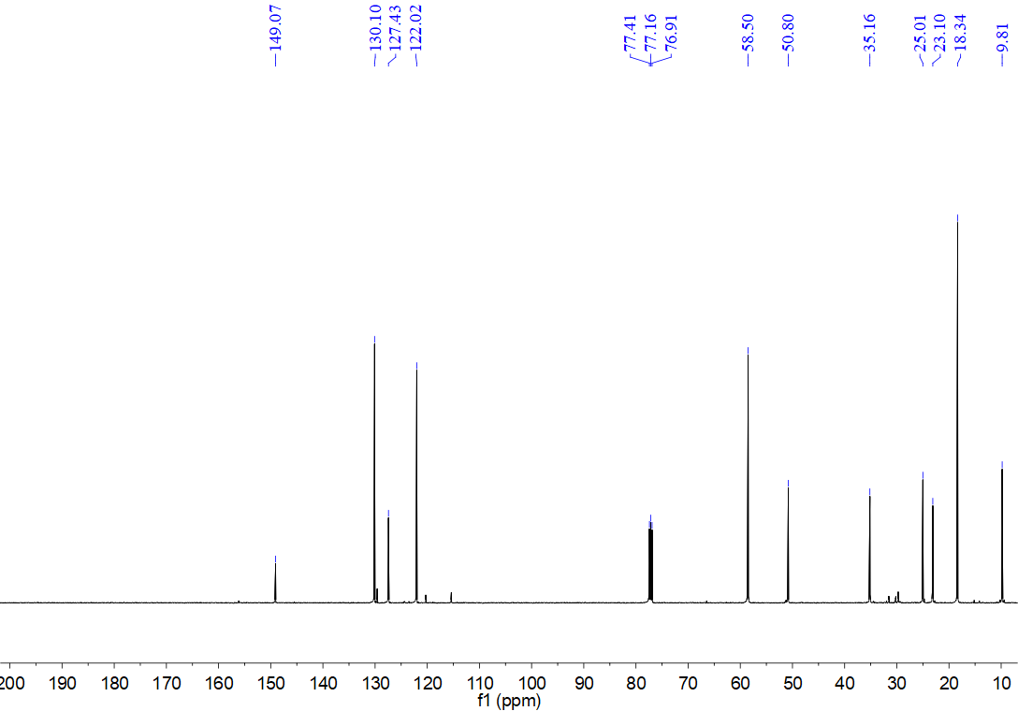
¹H NMR spectrum for compound 14b (500 MHz, CDCl₃)
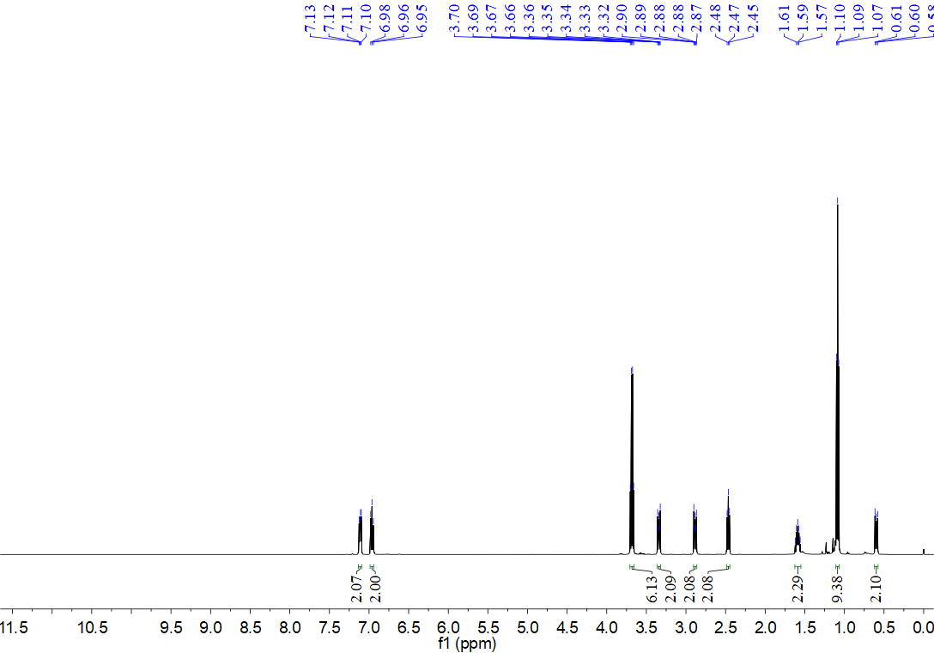
¹³C NMR spectrum for compound 14b (126 MHz, CDCl₃)
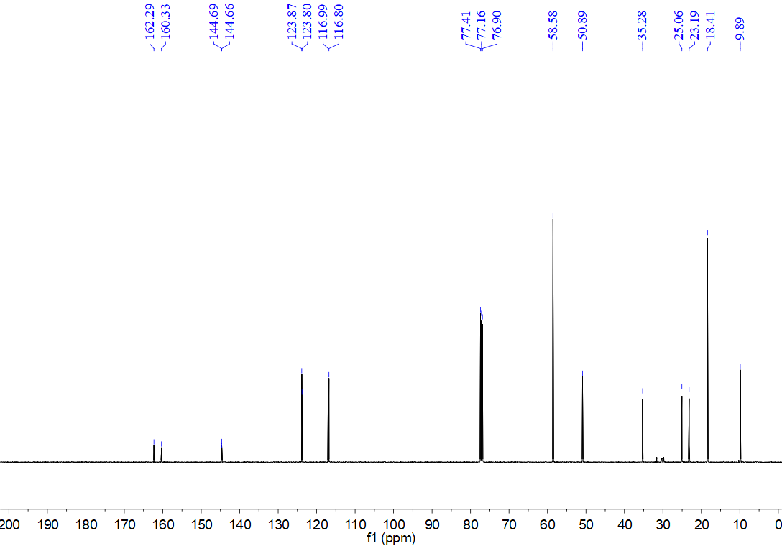
¹H NMR spectrum for compound 14c (500 MHz, CDCl₃)
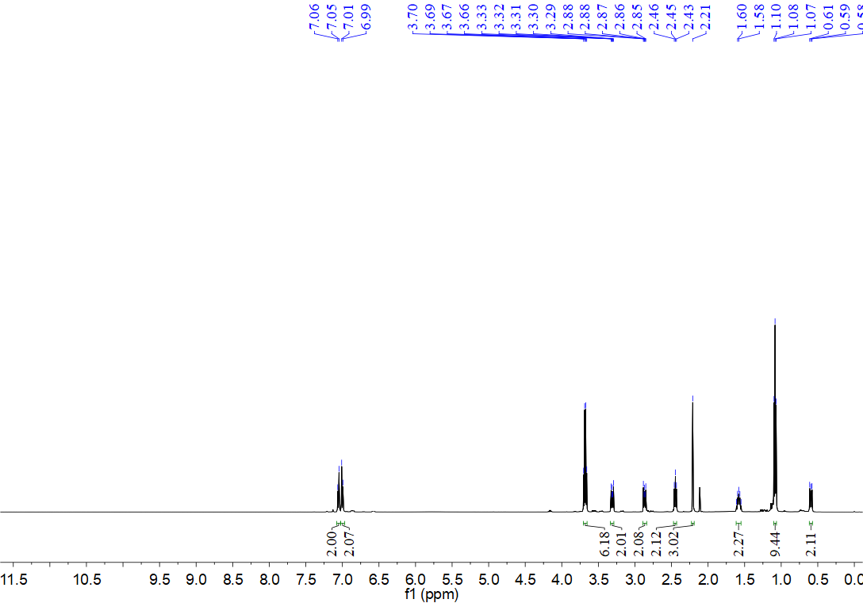
¹³C NMR spectrum for compound 14c (126 MHz, CDCl₃)
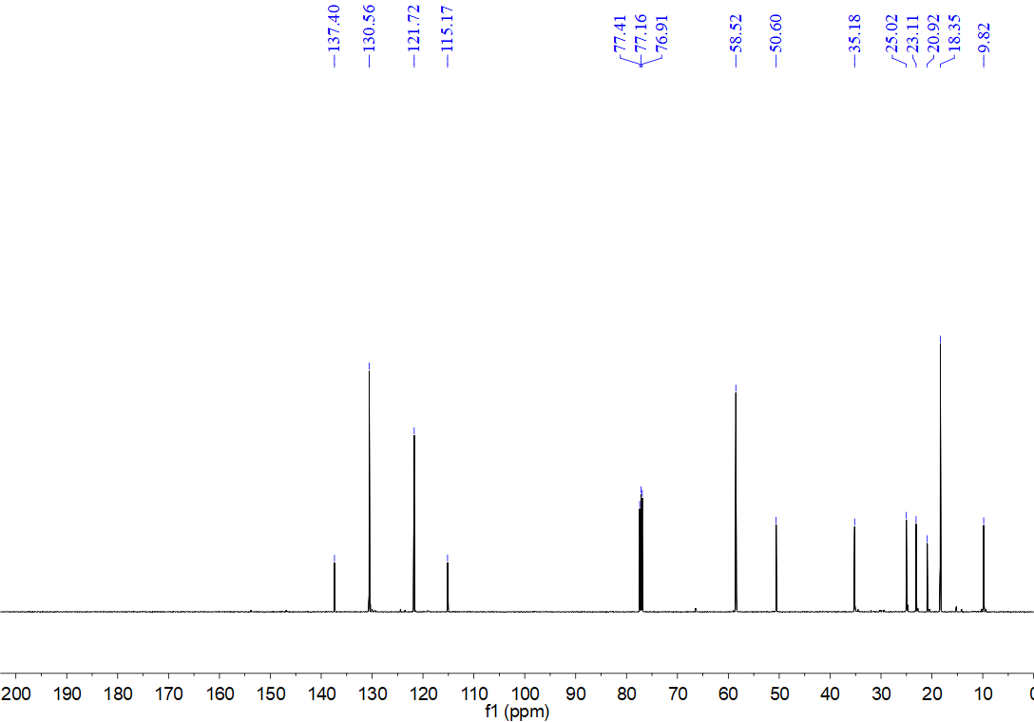
¹H NMR spectrum for compound 14d (500 MHz, CDCl₃)
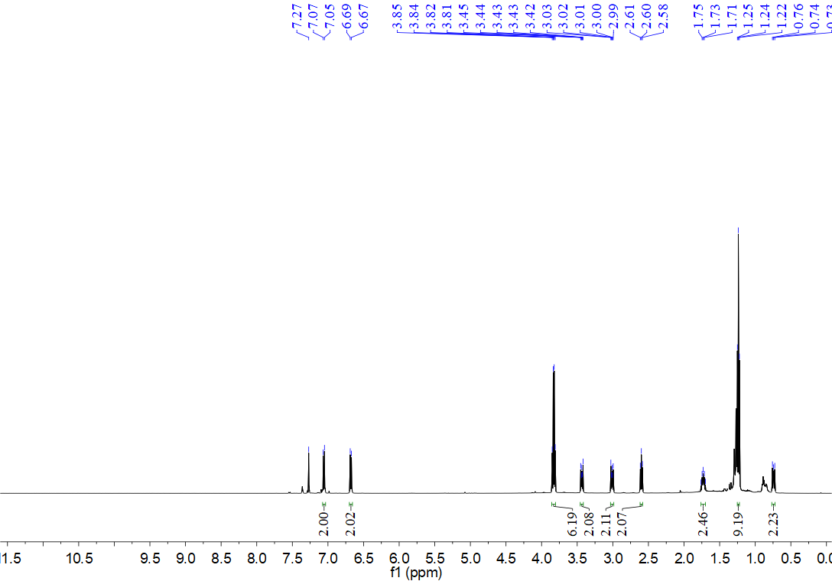
¹³C NMR spectrum for compound 14d (126 MHz, CDCl₃)
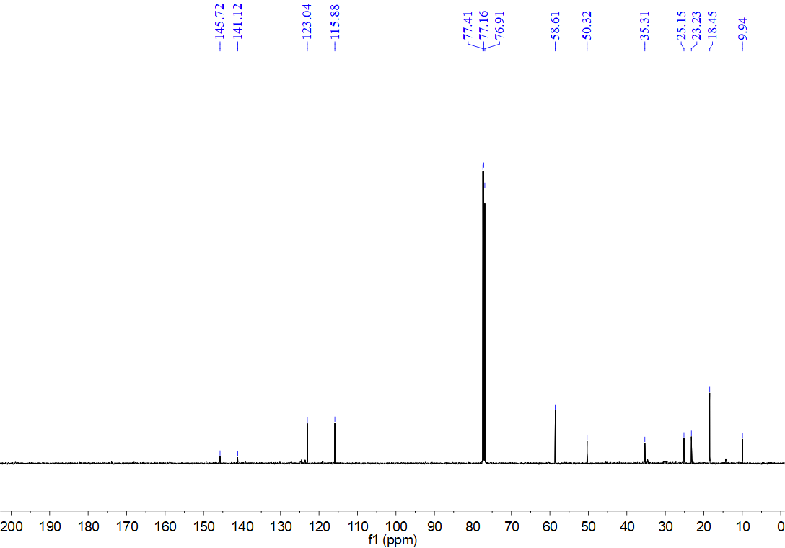
¹H NMR spectrum for compound 14e (500 MHz, CDCl₃)
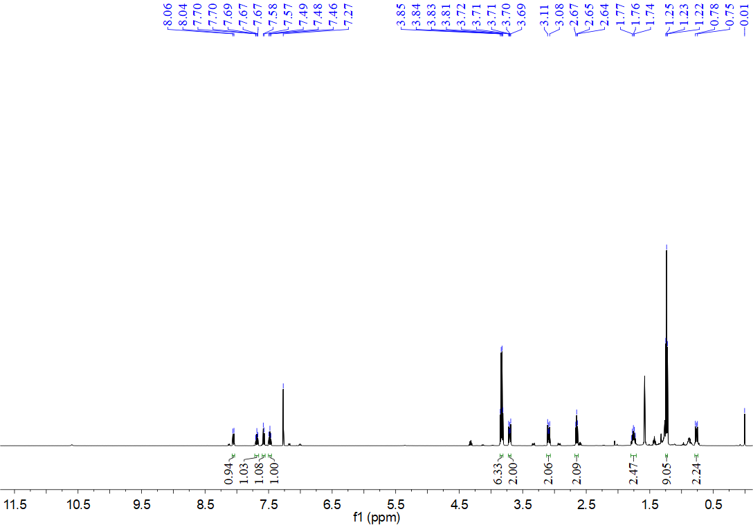
¹³C NMR spectrum for compound 14e (126 MHz, CDCl₃)
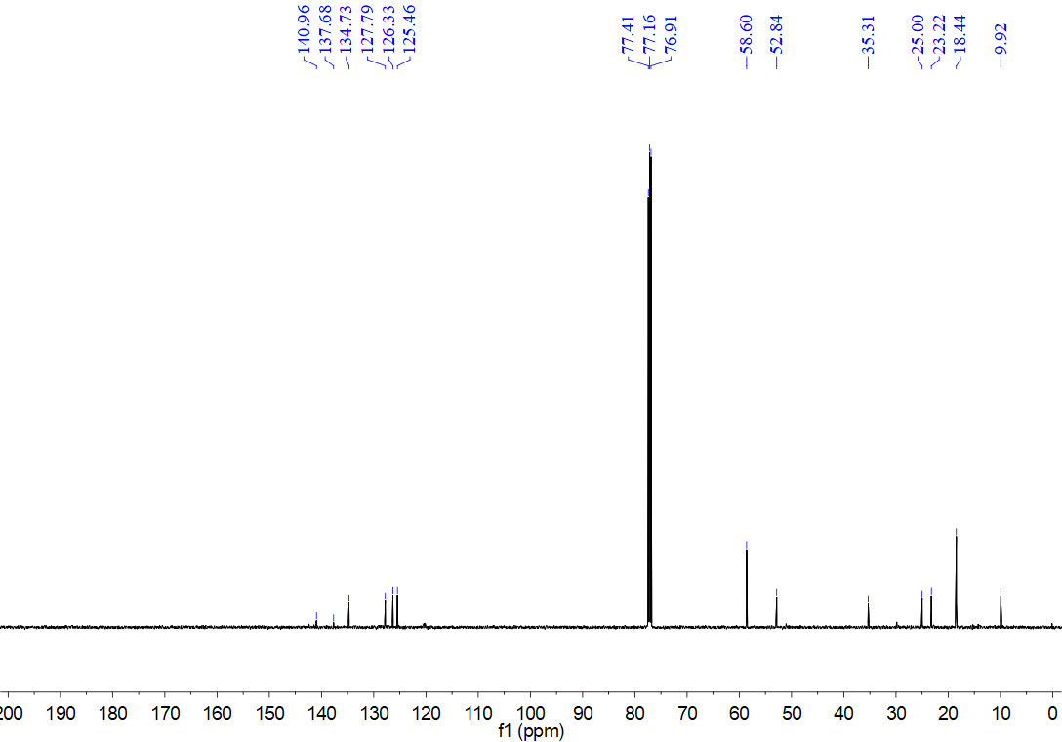
¹H NMR spectrum for compound 14f (500 MHz, CDCl₃)
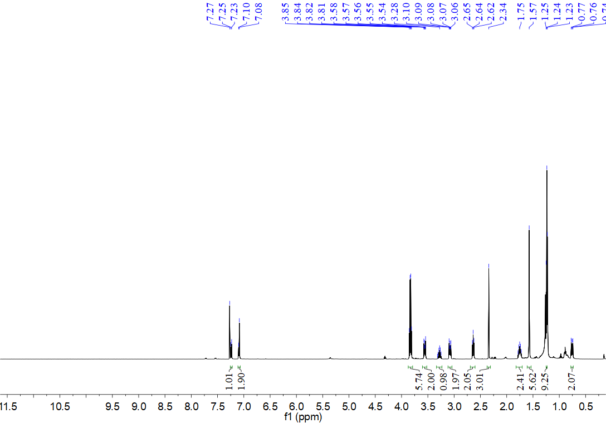
¹³C NMR spectrum for compound 14f (126 MHz, CDCl₃)
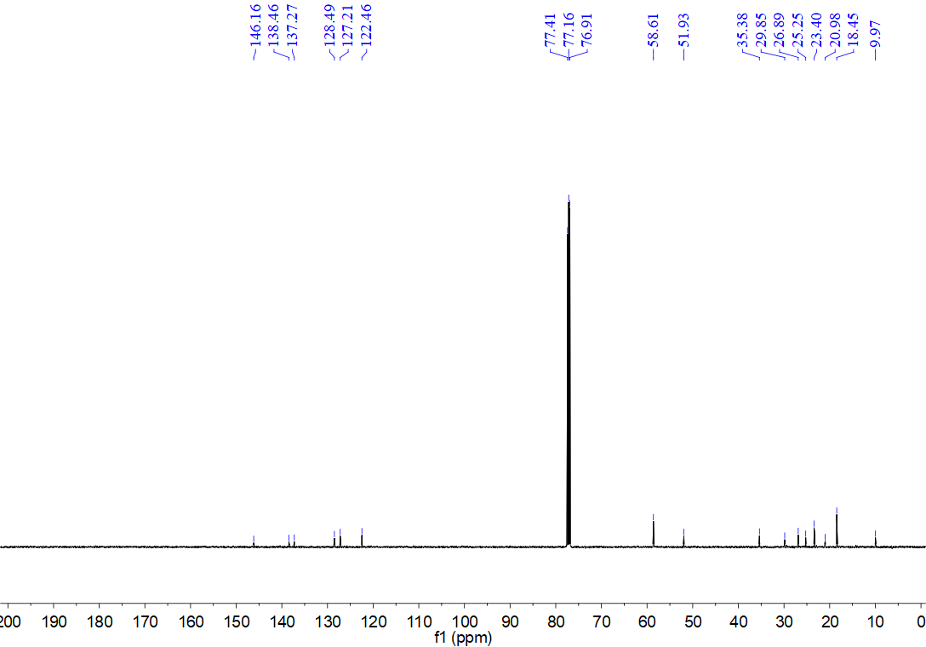
¹H NMR spectrum for compound 14g (500 MHz, CDCl₃)
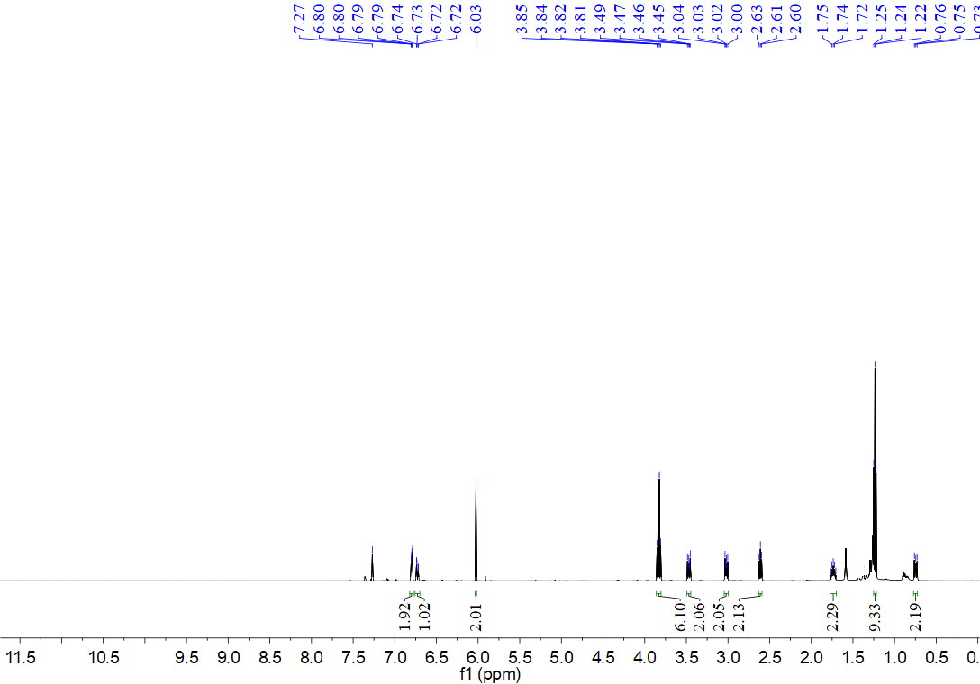
¹³C NMR spectrum for compound 14g (126 MHz, CDCl₃)
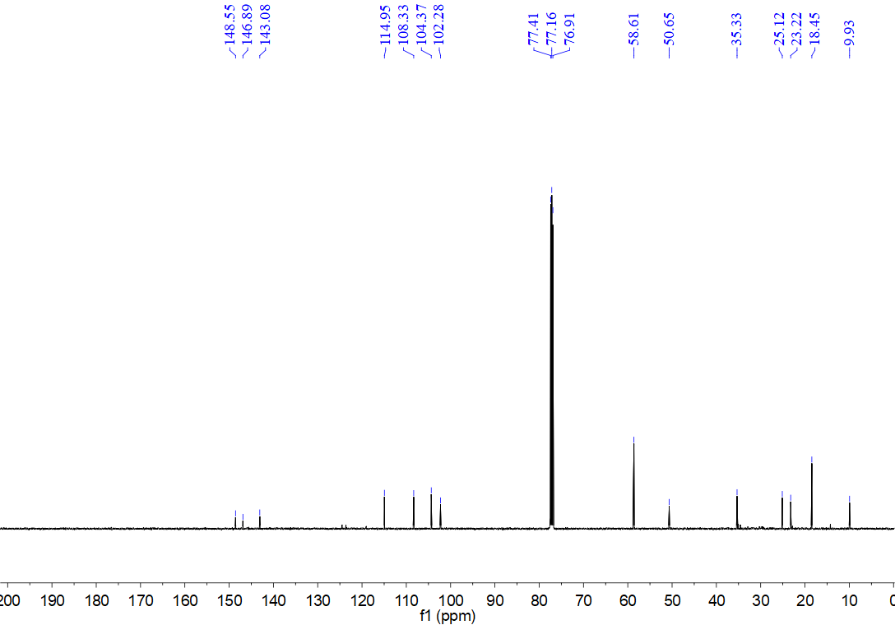
¹H NMR spectrum for compound 14h (500 MHz, CDCl₃)
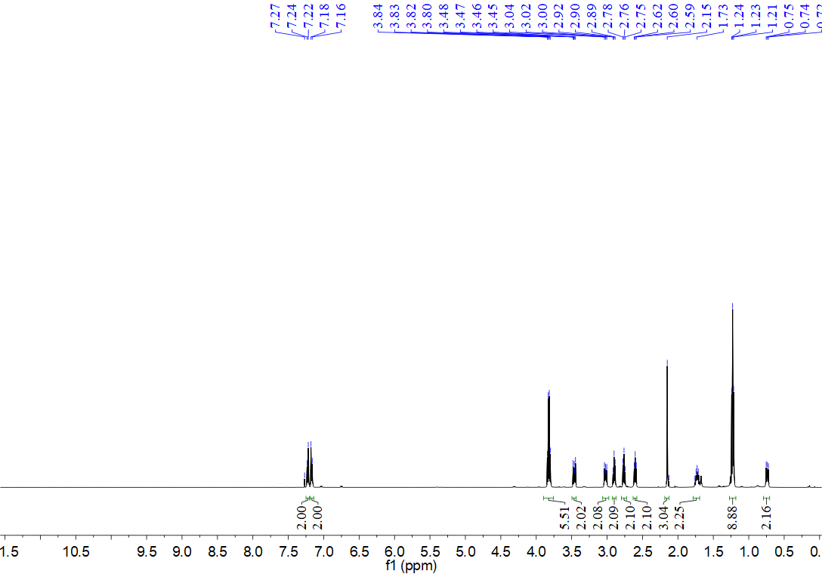
¹³C NMR spectrum for compound 14h (126 MHz, CDCl₃)
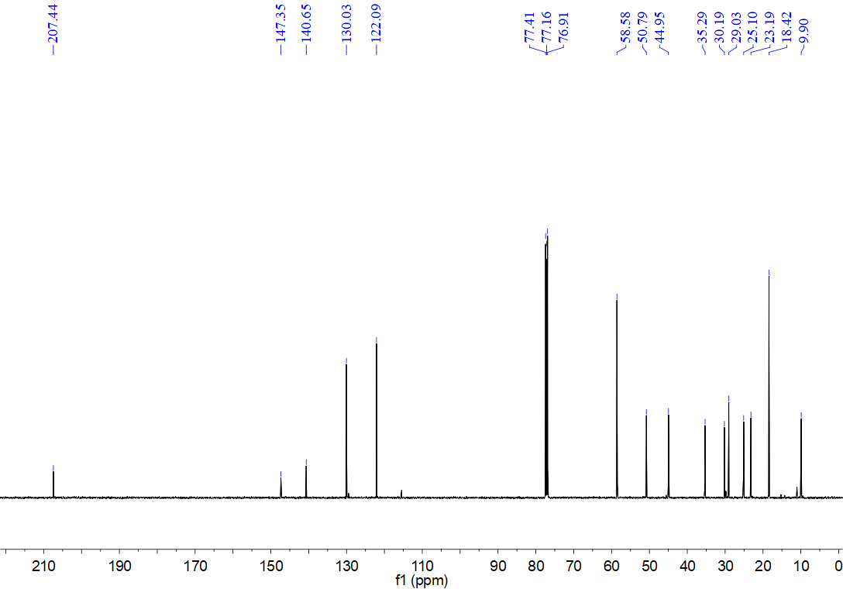
¹H NMR spectrum for compound 14i (500 MHz, CDCl₃)
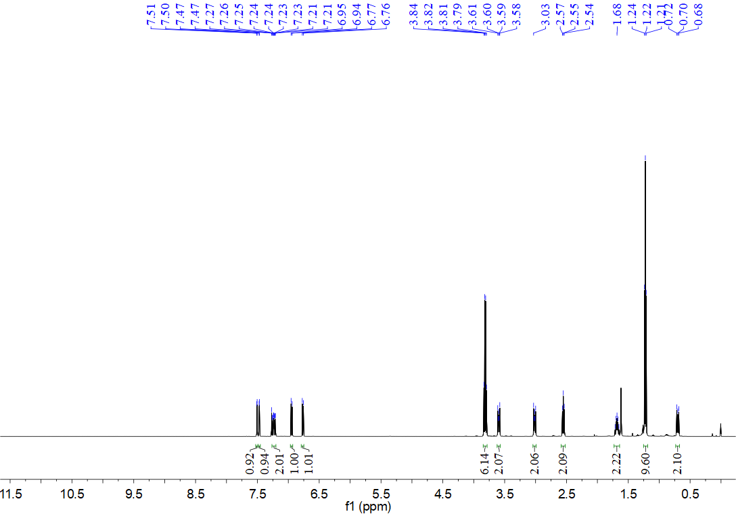
¹³C NMR spectrum for compound 14i (126 MHz, CDCl₃)
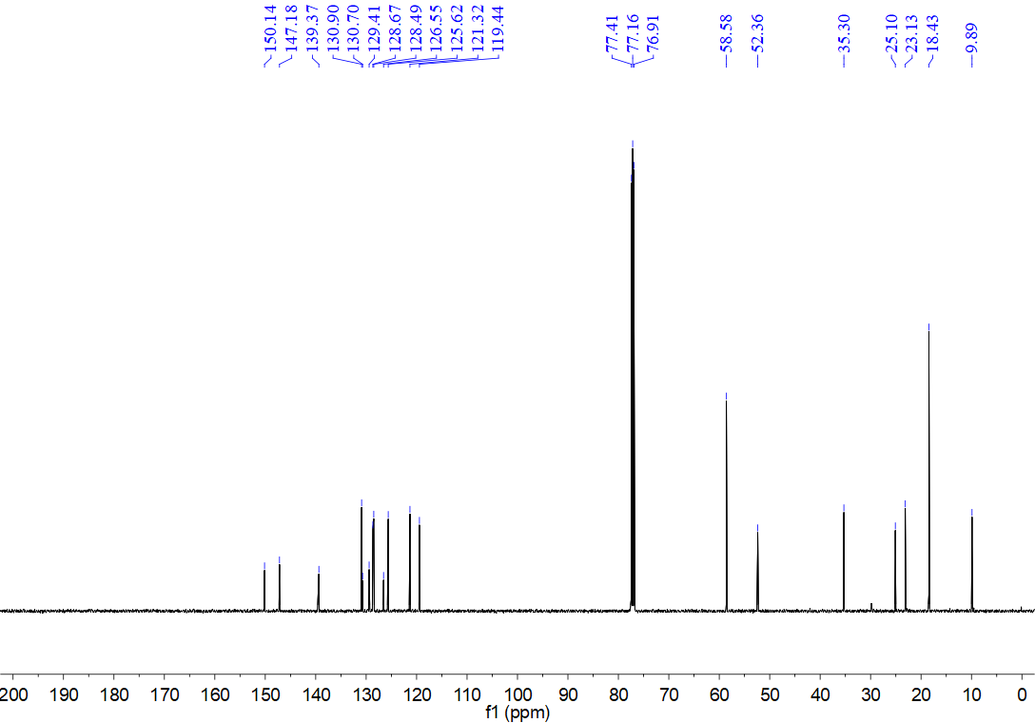
¹H NMR spectrum for compound 14j (500 MHz, CDCl₃)
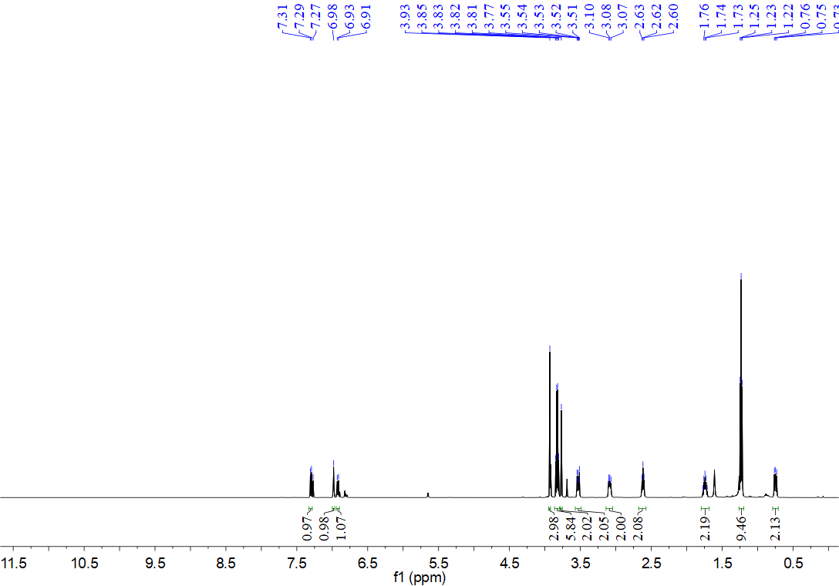
¹³C NMR spectrum for compound 14j (126 MHz, CDCl₃)
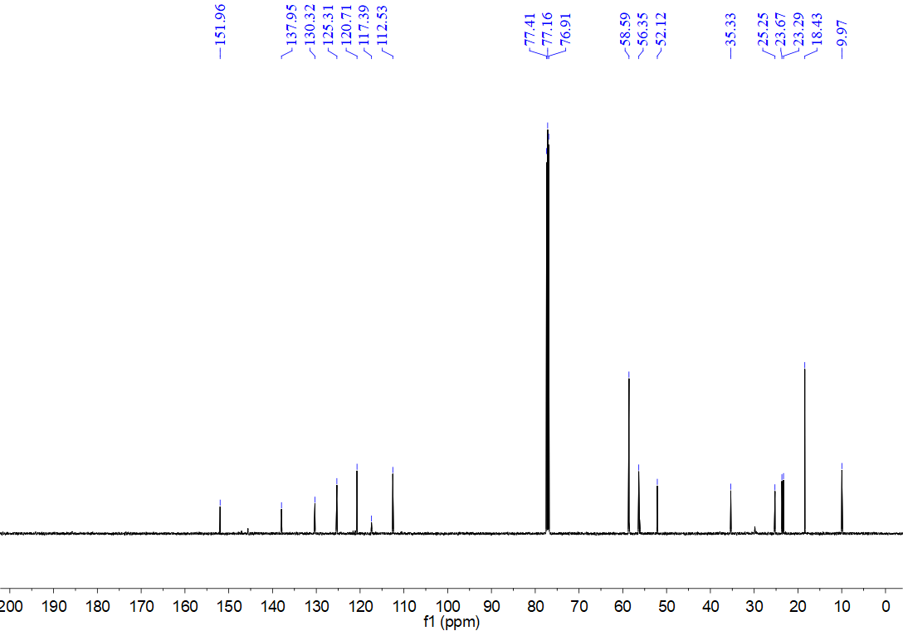
¹H NMR spectrum for compound 14k (500 MHz, CDCl₃)
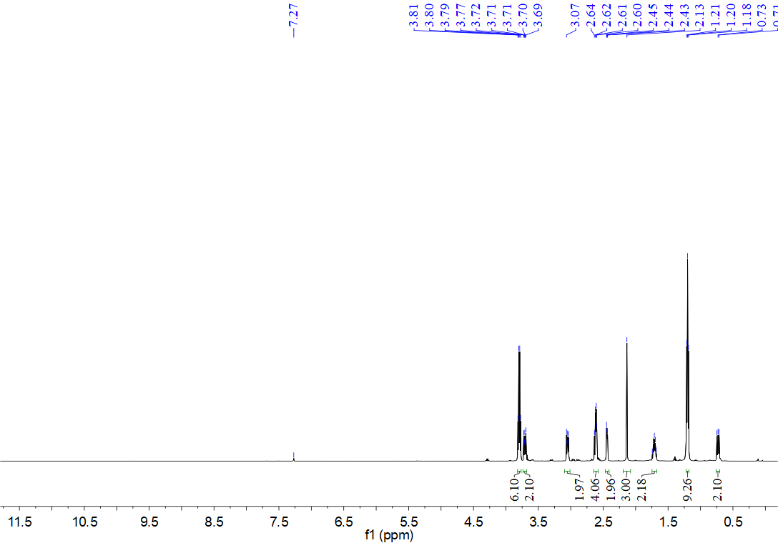
¹³C NMR spectrum for compound 14k (126 MHz, CDCl₃)
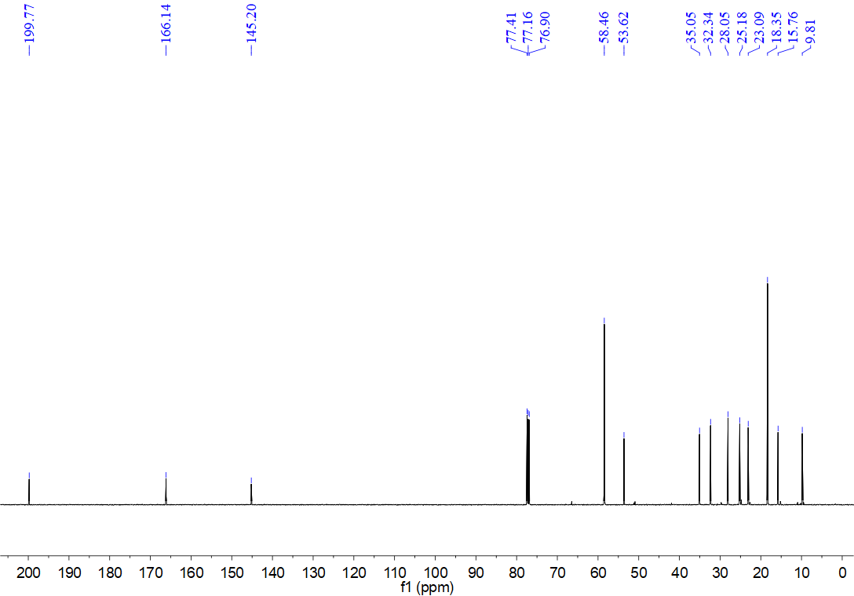
¹H NMR spectrum for compound 14l (500 MHz, CDCl₃)
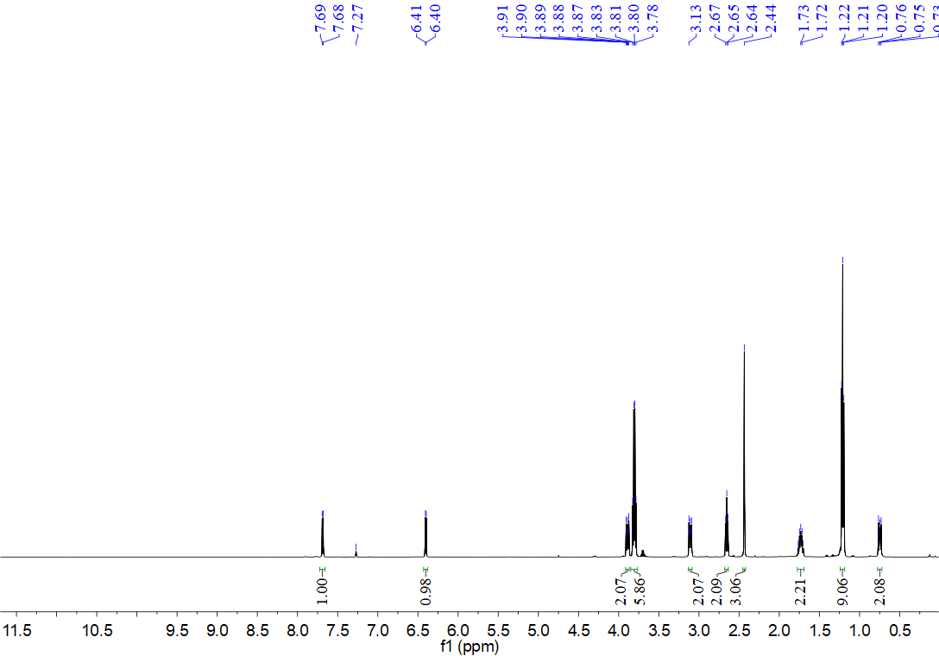
¹³C NMR spectrum for compound 14l (126 MHz, CDCl₃)
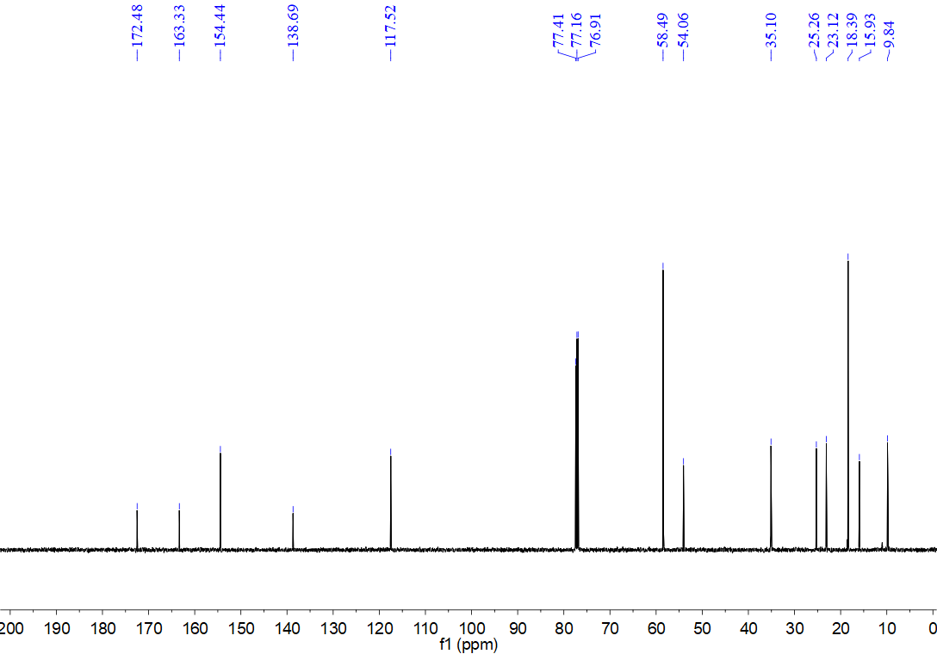
¹H NMR spectrum for compound 14m (500 MHz, CDCl₃)
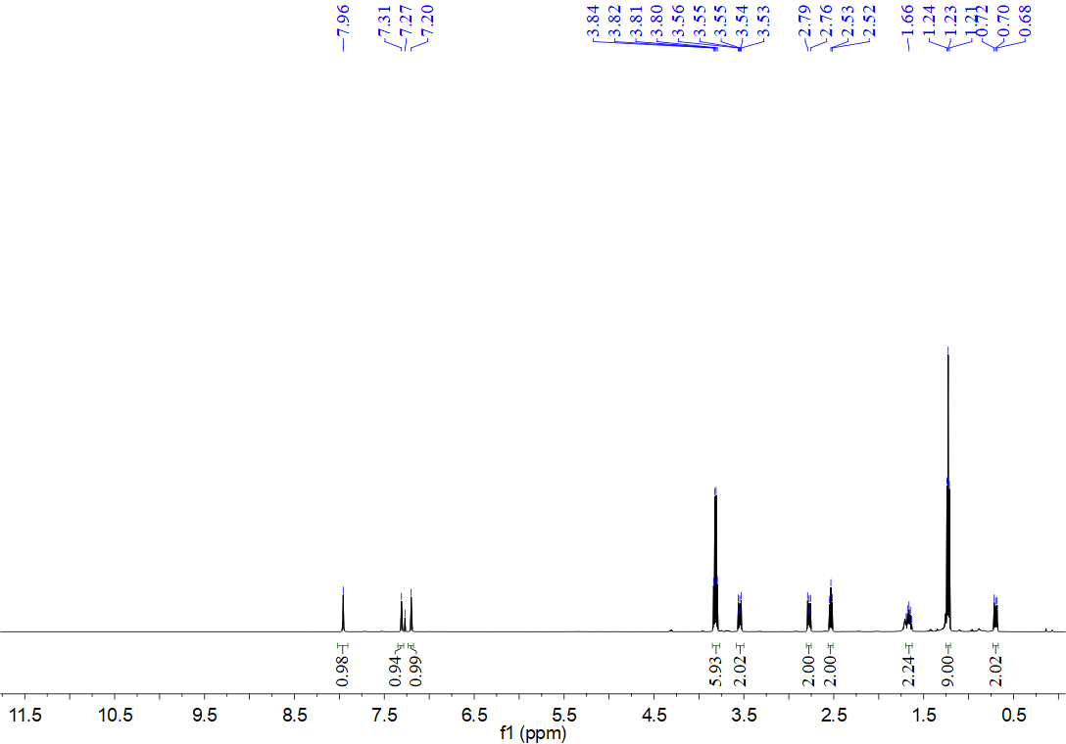
¹³C NMR spectrum for compound 14m (126 MHz, CDCl₃)
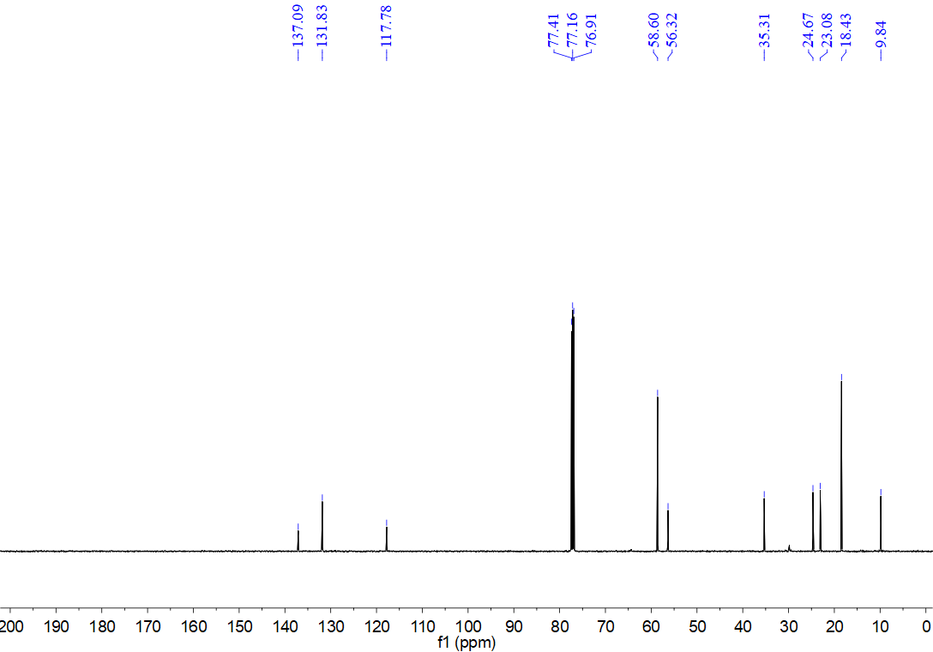
¹H NMR spectrum for compound 14n (500 MHz, CDCl₃)
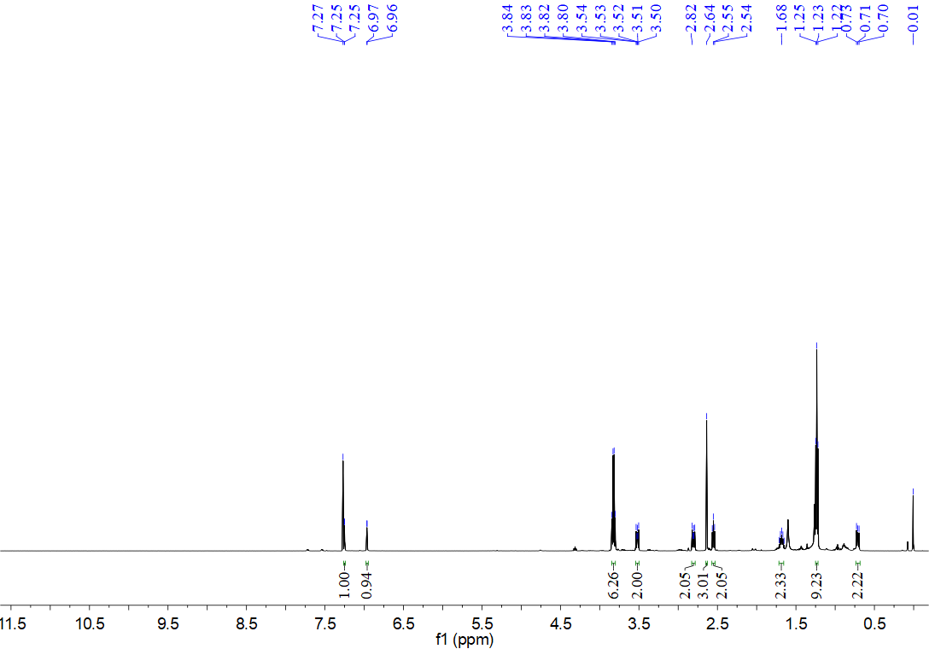
¹³C NMR spectrum for compound 14n (126 MHz, CDCl₃)
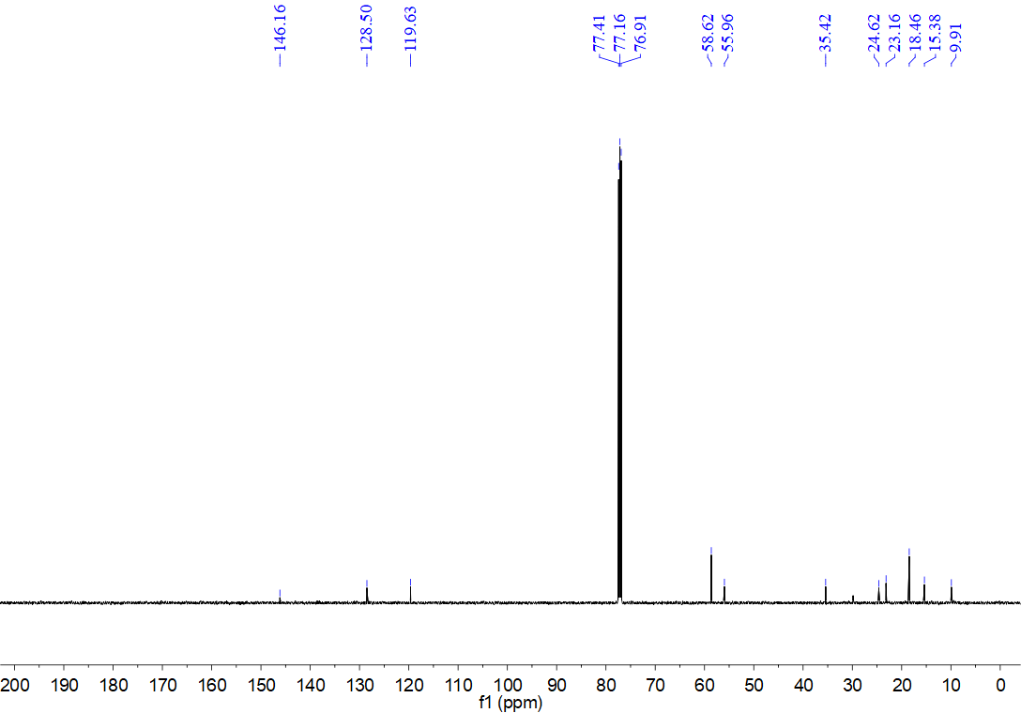
¹H NMR spectrum for compound 14o (500 MHz, CDCl₃)
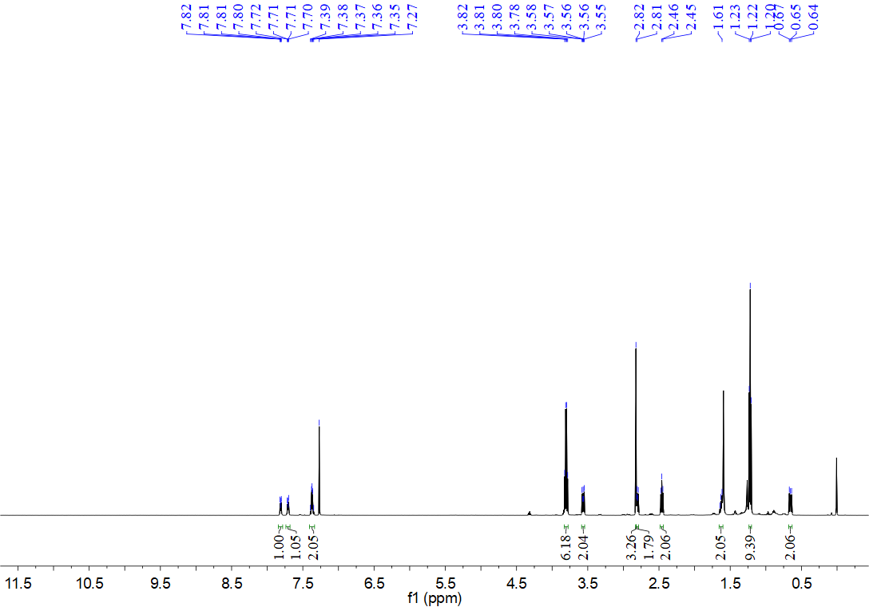
¹³C NMR spectrum for compound 14o (126 MHz, CDCl₃)
