Supplementary materials
Supplementary table 1: List of the 151 targeted genes of the AIO solid-tumor panel
ABL1 | AKAP13 | AKT1 | ALK | APC | ARID1A | ATM | BCL2 | BCR | BRAF
BRCA1 | BRCA2 | CAMTA1 | CAV1 | CCND1 | CCND2 | CCNE1 | CD274 | CDC25A | CDC73
CDH1 | CDK12 | CDK4 | CDK6 | CDKN2A | CDKN2B | CIC | CREBBP | CSF1R | CSMD1
CTNNB1 | CYP27B1 | CYP2E1 | DACH1 | DDR2 | DNMT3A | DPYD | EGFR | EPCAM | ERBB2
ERBB3 | ERBB4 | ESR1 | ETV1 | ETV4 | ETV6 | EZH2 | FBXO11 | FBXW7 | FGF19
FGF3 | FGF4 | FGFR1 | FGFR2 | FGFR3 | FGFR4 | FHIT | FOXL2 | FOXN3 | GNA11
GNAQ | GNAS | GOPC | HNF1A | HRAS | IDH1 | IDH2 | JAK2 | JAK3 | KDR
KIT | KLLN | KMT2A | KRAS | KTN1 | LRP1B | MAP2K1 | MAP2K2 | MAP2K4 | MAP3K8
MAPK8 | MDM2 | MET | MLH1 | MSH2 | MSH6 | MSI2 | MSR1 | MTAP | MTOR
MTSS1 | MYC | MYCN | MYD88 | NAV1 | NF1 | NF2 | NFE2L2 | NOTCH1 | NRAS
NRG1 | NTRK1 | OCA2 | PAX3 | PDCD1LG2 | PDCD2 | PDGFRA | PDGFRB | PIK3CA | PIK3CB
PIK3R1 | PKD1 | PRCC | PTCH1 | PTEN | PTPN11 | PTPRT | PVT1 | RAF1 | RARB
RASSF10 | RB1 | RET | ROCK2 | ROS1 | RPS19 | RUNX2 | SLCO1B3 | SMAD4 | SMARCB1
SMO | SRC | ST7 | STK11 | SUZ12 | TACC3 | TCF4 | TERT | TMPRSS2 | TP53
TP63 | TP73 | TRIM24 | TSC1 | TSC2 | TSHR | TSPAN31 | UGT1A1 | VEGFA | VHL
WT1

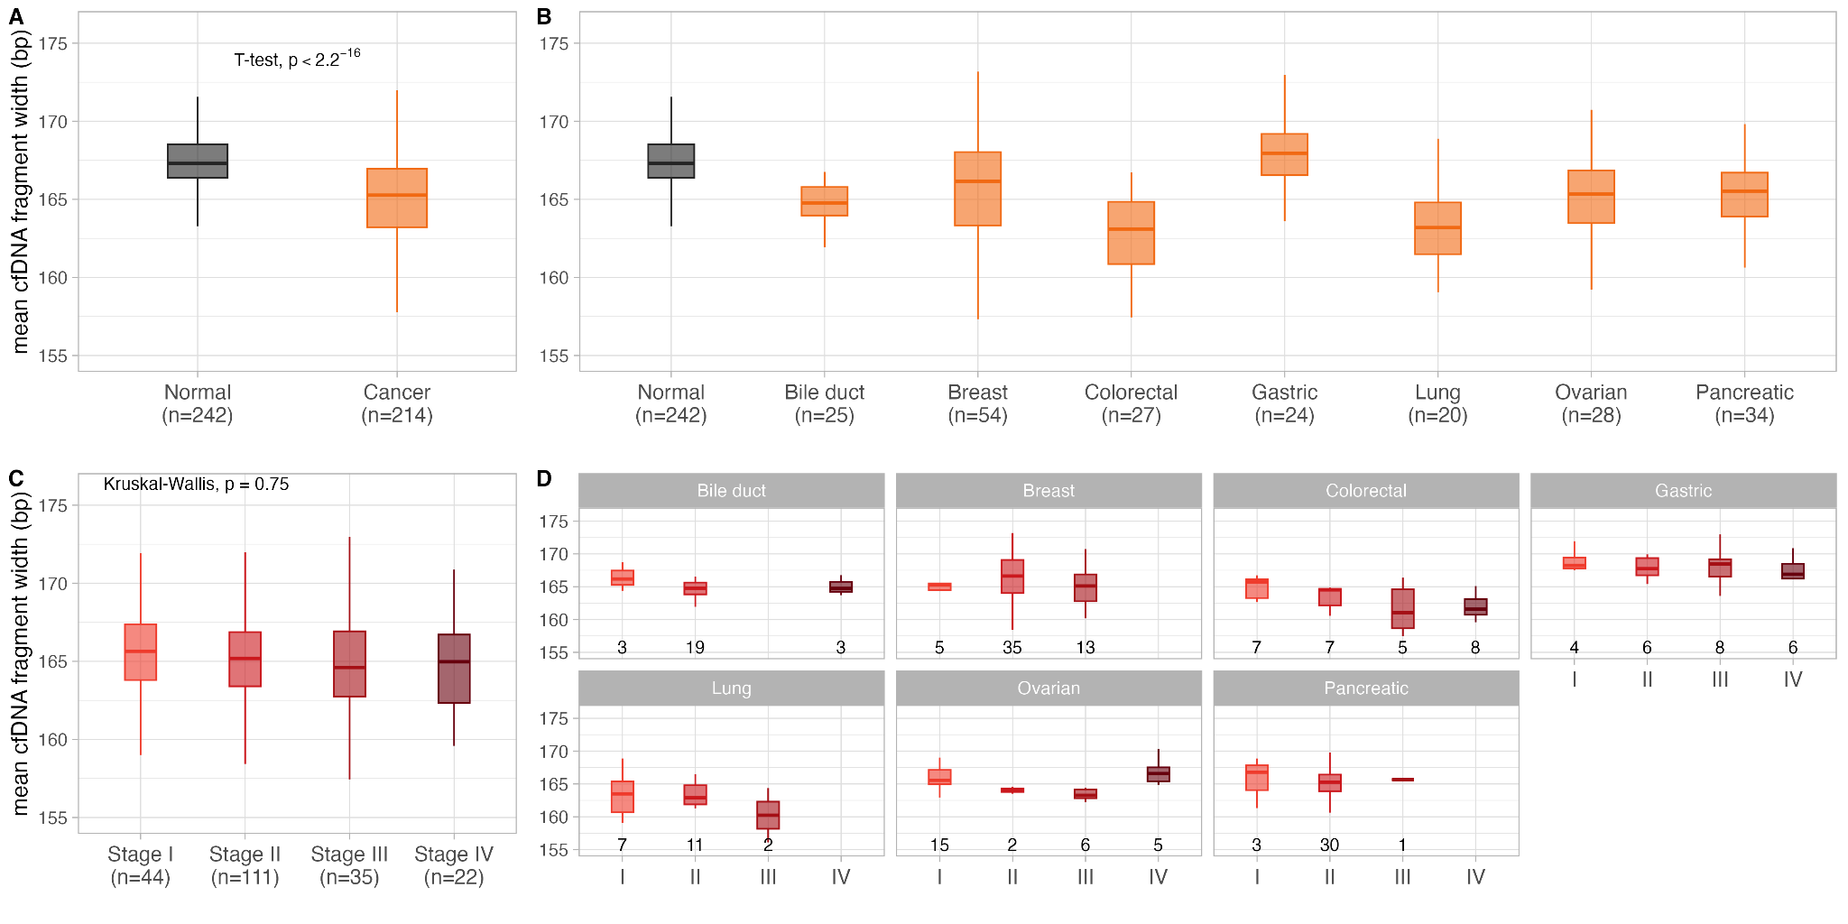
Figure S1. Analyses of mean cfDNA fragment width. (A) Comparison of mean cfDNA fragment widths between healthy individuals (n=242) and cancer patients (n=214). (B) Comparison of mean cfDNA fragment widths of healthy individuals and seven cancer types. (C) Comparison of mean cfDNA fragment widths across cancer stages. (D) For each cancer type, comparison of mean cfDNA fragment widths across cancer stages.

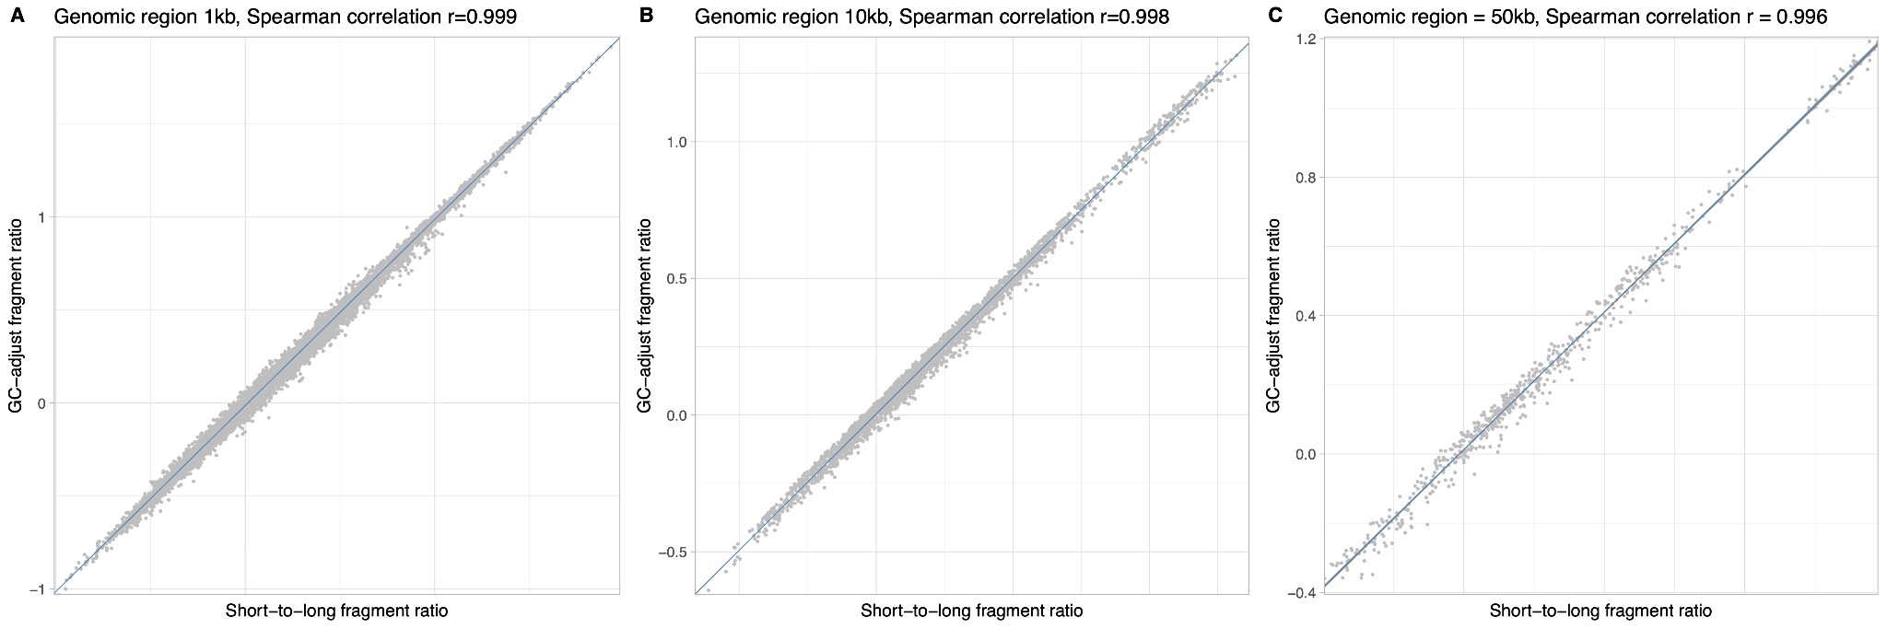
Figure S2. Consistent correlation of cfDNA short-to-long fragment ratios pre- and post-GC content adjustment. (A-C) The correlation at genomic bin sizes of 1 kb, 10 kb, and 50 kb, respectively. Each point on the plots denotes a specific data entry in a cfDNA fragmentation profile. The x-axis represents the short-to-long fragment ratio prior to GC content adjustment, while the y-axis represents the ratio post-adjustment.

