Engineering a pH-responsive polymeric micelle co-loaded with paclitaxel and tretinoin for breast cancer therapy

Mengmeng Zhang ^{a, d, 1}, Na Ying ^{a, d, 1}, Jie Chen^{b}，Liwen Wuª, Huajie Liu^{b,*}, Shihua Luo^{c, *}, Dongdong Zeng ^{a, **}
ª Shanghai University of Medicine & Health Sciences, Shanghai 201318, China
^{b} Tongji University, Shanghai 200092, China
^{c} Department of Traumatology, Rui Jin Hospital, School of Medicine, Shanghai Jiao Tong University, Shanghai 200025, China
^{d} Shanghai University of Traditional Chinese Medicine, Shanghai 201203, China

¹ Co-first authors
* Co-corresponding authors
** Corresponding author at: Shanghai University of Medicine & Health Sciences, Shanghai 201318, China
E-mail address: zengdd@sumhs.edu.cn (D. Zeng), jqab@163.com (S. Luo), liuhuajie@tongji.edu.cn (H. Liu)

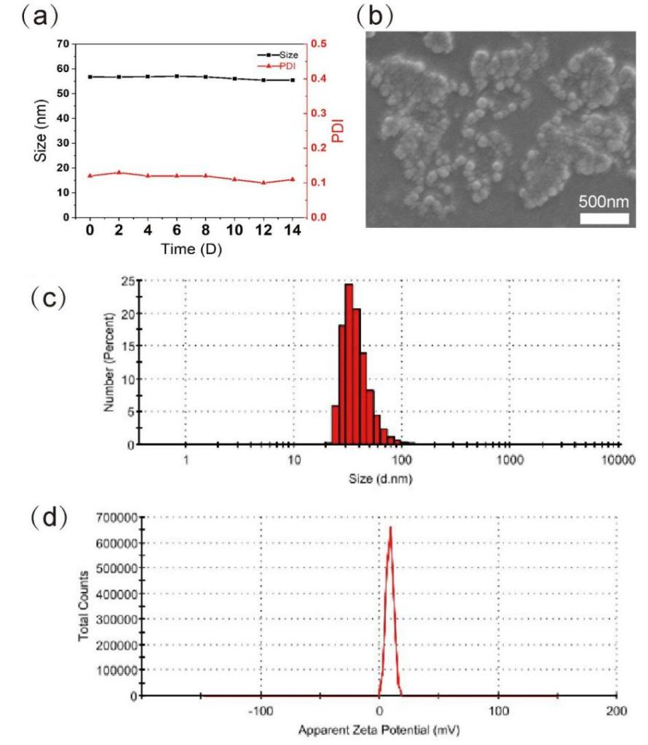

Figure S1.Characterization and biocompatibility of PPMs. (a) The particle size and PDI of PPMs in 14 days.
(b) SEM images, (c) Particle size distribution and (d) zeta potential of TPL/PTX-PPMs.

Table S1 Linear regression equations, correlation coefficients and IC₅₀ values for different dosing groups
Group | Linear regression equation | Correlation coefficient (r) |  | IC₅₀
TPL | Y=0.9208X-1.6025 |  | 0.9919 | 55
PTX | Y=0.8341X-1.047 |  | 0.9733 | 18
TPL: PTX (1:2) | Y=0.988X-0.8225 |  | 0.9679 | 6.8
TPL: PTX (1:4) | Y=0.9904X-0.3583 |  | 0.9289 | 2.3
TPL: PTX (1:6) | Y=0.82X-0.3263 |  | 0.9284 | 2.5

Table S2. Combination index (CI) of different ratios of TPL and PTX combined on MDA-MB-231 cells at different affect fractions (fa).
fa |  | 0.1 | 0.2 | 0.3 | 0.4 | 0.5 | 0.6 | 0.7 | 0.8 | 0.9
CI | TPL: PTX  (1:2) | 2.054 | 1.785 | 1.627 | 1.509 | 1.408 | 1.315 | 1.22 | 1.114 | 0.973
CI | TPL: PTX  (1:4) | 1.347 | 1.162 | 1.054 | 0.973 | 0.905 | 0.841 | 0.777 | 0.705 | 0.61
CI | TPL: PTX  (1:6) | 1.348 | 1.376 | 1.396 | 1.412 | 1.427 | 1.443 | 1.46 | 1.482 | 1.516

Table S3. Results of statistical analysis of C6 uptake in MDA-MB-231 cells (n=3).
Time（h） |  | 0.5 | 2 | 6
Fluorescence mean intensity | Free-C6 | 21.8 ± 0.95 | 37.4 ± 0.13 | 49.7 ± 0.56
Fluorescence mean intensity | C6-PPMs | 88.3 ± 0.82 | 118.3 ± 0.64 | 169.6 ± 0.74

