Supplementary Information
Biotransformation of docosahexaenoic acid into 10R,17S-dihydroxydocosahexaenoic acid as protectin Dx 10-epimer by serial reactions of arachidonate 8R- and 15S-lipoxygenases

Tae-Eui Lee¹· Yoon-Joo Ko²· Kyung-Chul Shin^{3*}· Deok-Kun Oh^{1,3*}

¹Department of Bioscience and Biotechnology, Konkuk University, Seoul 05029, Republic of Korea
²National Center for Inter-University Research facilities (NCIRF), Seoul National University, Seoul 08826, Republic of Korea
³Department of Integrative Bioscience and Biotechnology, Konkuk University, Seoul 05029, Republic of Korea

Tae-Eui Lee, legals1@naver.com
Yoon-Joo Ko, yjko@snu.ac.kr
*Corresponding author: Kyung-Chul Shin, hidex2@konkuk.ac.kr;
*Corresponding author: Deok-Kun Oh, deokkun@konkuk.ac.kr

ORCID
Tae-Eui Lee: 0000-0001-8629-1125
Kyung-Chul Shin: 0000-0002-1527-0164
Deok-Kun Oh: 0000-0002-6886-7589

Table S1: ¹H and ¹³C NMR data of 10-epi PDX and PDX (850 MHz, MeOD)
 | 10R,17S-DiHDHA (10-epi PDX) |  |  |  | 10S,17S-DiHDHA (PDX)  (Shin et al., 2022)
C No. | ¹H (δ) | ¹³C (δ) |  |  | ¹H (δ) | ¹³C (δ)
1 |  | 177 |  |  |  | 177
2 | 2.31−2.26 (m, 2H) | 35.1 |  | 2.31−2.26 (m, 2H) |  | 35.3
3 | 2.36−2.31 (m, 2H) | 24.0 |  | 2.36−2.31 (m, 2H) |  | 24.1
4 | 5.38−5.30 (m, 1H) | 129 |  | 5.37−5.30 (m, 1H) |  | 129
5 | 5.38−5.30 (m, 1H) | 130 |  | 5.37−5.30 (m, 1H) |  | 130
6 | 2.80 (m, 2H) | 26.8 |  | 2.80 (m, 2H) |  | 26.8
7 | 5.46−5.38 (m, 1H) | 131 |  | 5.46−5.37 (m, 1H) |  | 131
8 | 5.46−5.38 (m, 1H) | 127 |  | 5.46−5.37 (m, 1H) |  | 127
9 | 2.36−2.26 (m, 2H) | 36.5 |  | 2.36−2.26 (m, 2H) |  | 36.5
10 | 4.14 (td, J = 6.56, 6.42, 1H) | 73.1 |  | 4.14 (td, J = 6.53, 6.12, 1H) |  | 73.2
11 | 5.70 (dd, J = 15.1, 6.42, 1H) | 138 |  | 5.70 (dd, J = 15.1, 6.12, 1H) |  | 138
12 | 6.69 (dd, J = 15.1, 1H) | 127 |  | 6.69 (dd, J = 15.1, 1H) |  | 127
13 | 5.93 (d, J = 10.0, 1H) | 130 |  | 5.93 (d, J = 9.83, 1H) |  | 130
14 | 5.93 (d, J = 10.0, 1H) | 130 |  | 5.93 (d, J = 9.83, 1H) |  | 130
15 | 6.68 (dd, J = 15.1, 1H) | 127 |  | 6.68 (d, J = 15.1, 1H) |  | 127
16 | 5.68 (dd, J = 15.1, 6.46, 1H) | 138 |  | 5.68 (dd, J = 15.1, 6.54, 1H) |  | 138
17 | 4.12 (td, J = 6.50, 6.46, 1H) | 73.2 |  | 4.12 (td, 6.58, 6.54) |  | 73.3
18 | 2.36−2.21 (m, 2H) | 36.3 |  | 2.36−2.21 (m, 2H) |  | 36.3
19 | 5.38−5.30 (m, 1H) | 126 |  | 5.37−5.30 (m, 1H) |  | 126
20 | 5.46−5.38 (m, 1H) | 135 |  | 5.46−5.37 (m, 1H) |  | 135
21 | 2.02 (td, J = 7.54, 7.11, 2H) | 21.8 |  | 2.02 (td, J = 7.50, 7.15, 2H) |  | 21.8
22 | 0.92 (t, J = 7.54, 3H) | 14.7 |  | 0.92 (t, J = 7.50, 3H) |  | 14.7

A
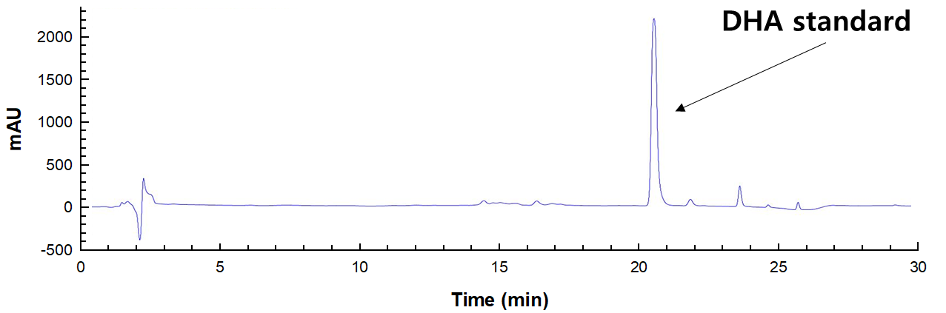
B
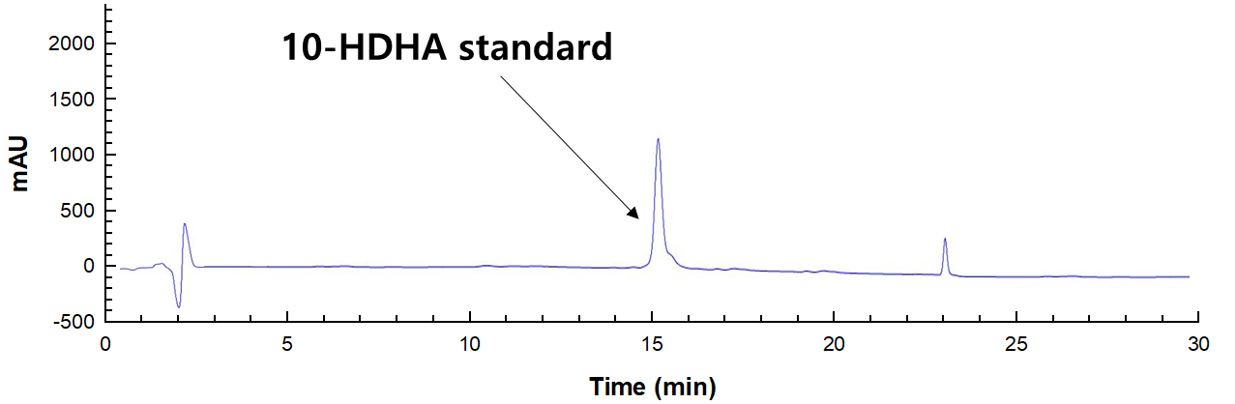
C
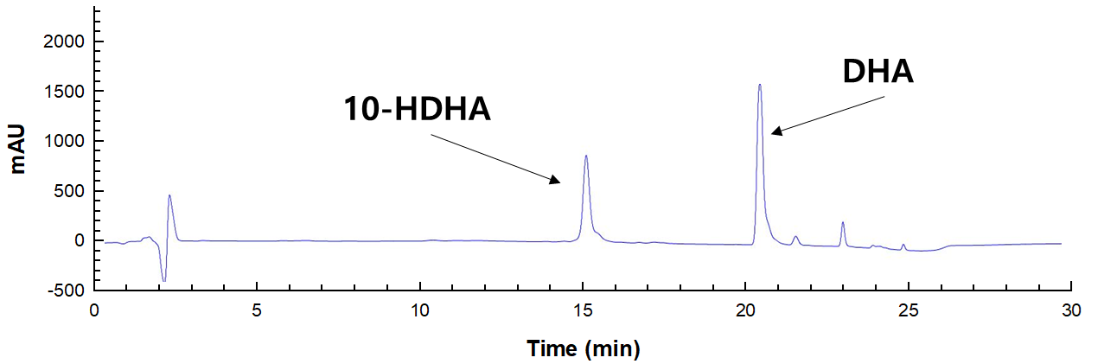
Figure S1: High-performance liquid chromatography (HPLC) chromatograms with reversed-phase column of DHA and 10-hydroxydocosahexaenoic acid (10-HDHA) standards and the product obtained from the conversion of DHA by Plexaura homomalla 8R-LOX. A HPLC chromatogram of DHA standard. B HPLC chromatogram of 10-HDHA standard. C HPLC chromatogram of the product obtained from the conversion of DHA in the presence of cysteine by P. homomalla 8R-LOX. The product obtained from the conversion of DHA by P. homomalla 8R-LOX was identified as 10-HDHA.

A
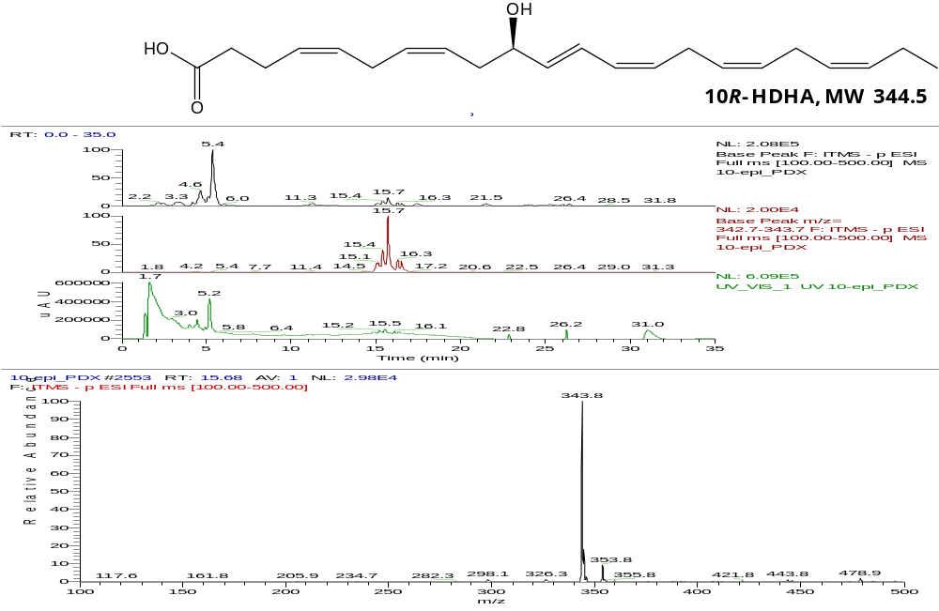
B
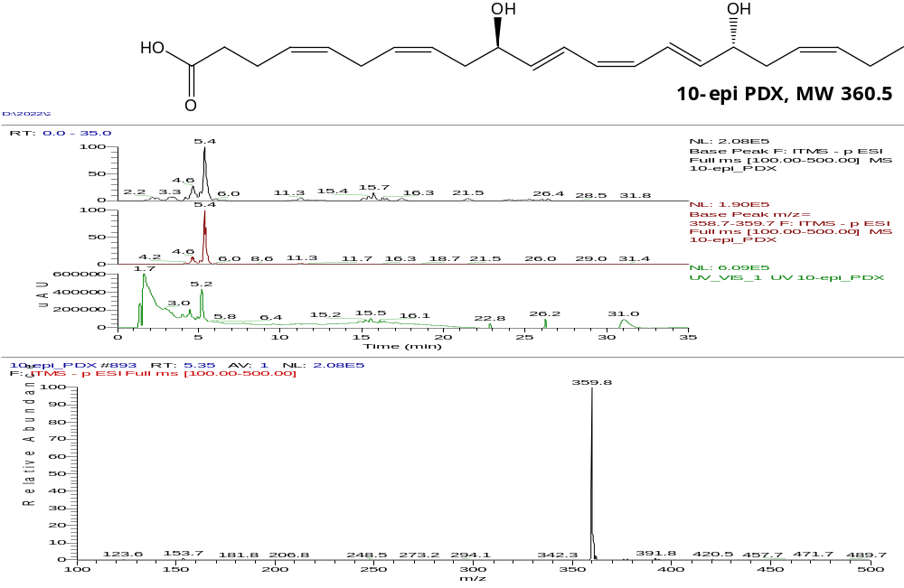
Figure S2: Liquid chromatography-mass spectrometry (LC-MS) spectra of A 10R-HDHA and B 10-epi PDX (10R,17S-dihydroxydocosahexaenoic acid, 10R,17S-DiHDHA). 10R-HDHA and 10-epi PDX were obtained from the conversion of DHA and 10R-HDHA by P. homomalla 8R-LOX and Archangium violaceum 15S-LOX, respectively.

A
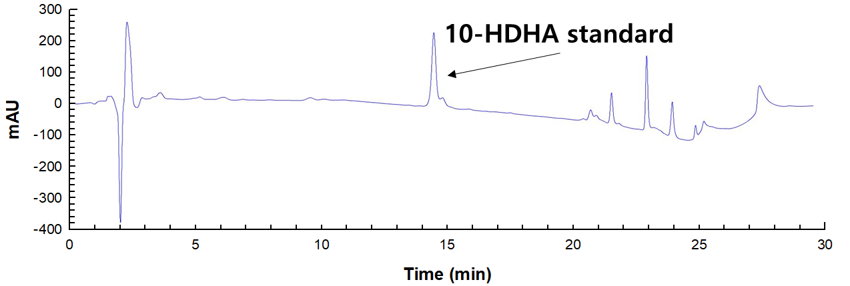
B
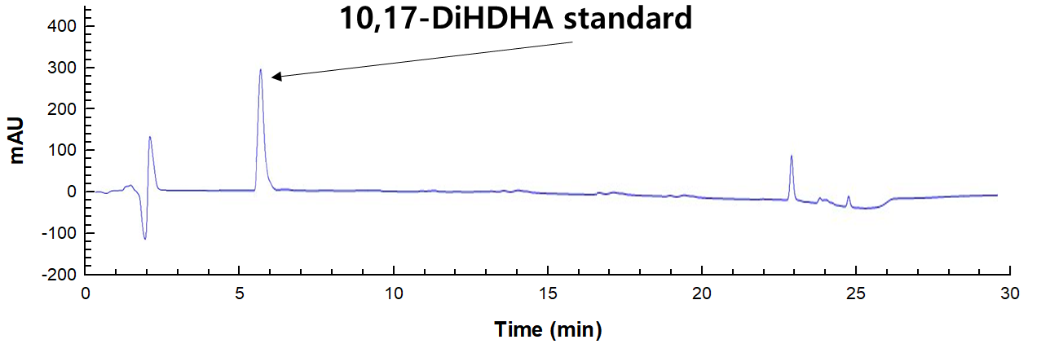
C
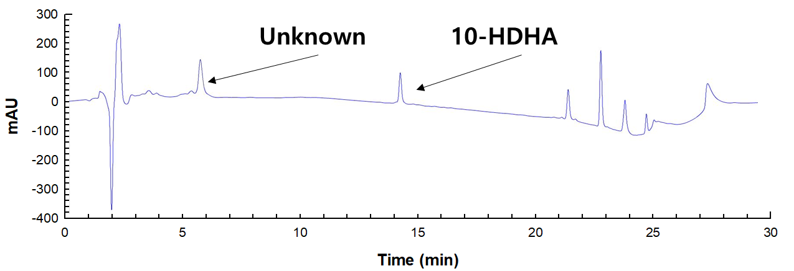
Figure S3: HPLC chromatograms with reverse-phase column of 10-HDHA and 10,17-DiHDHA standards and the unknown product obtained from the conversion of 10R-HDHA by A. violaceum 15S-LOX. A HPLC chromatogram of 10-HDHA standard. B HPLC chromatogram of 10,17-DiHDHA standard. C HPLC chromatogram of the unknown product obtained from the conversion of DHA in the presence of cysteine by A. violaceum 15S-LOX. The reactions were performed at 30 °C in 50 mM CHES buffer (pH 8.5) containing 0.5 mM 10R-HDHA, 0.5 g/L cells, 200 mM cysteine, and 5% (v/v) ethanol for 5 min.

A
B
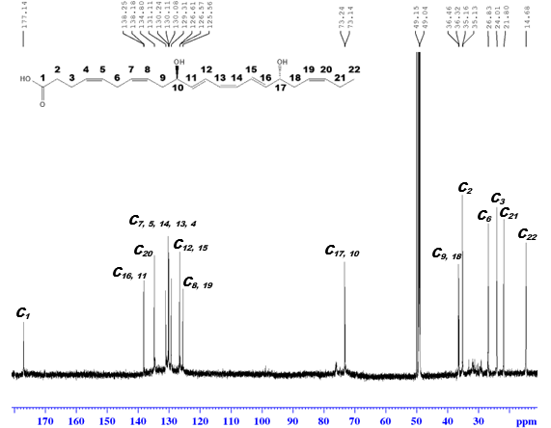
C
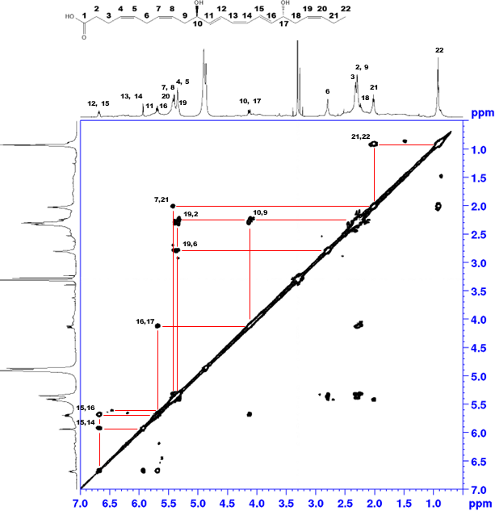
D
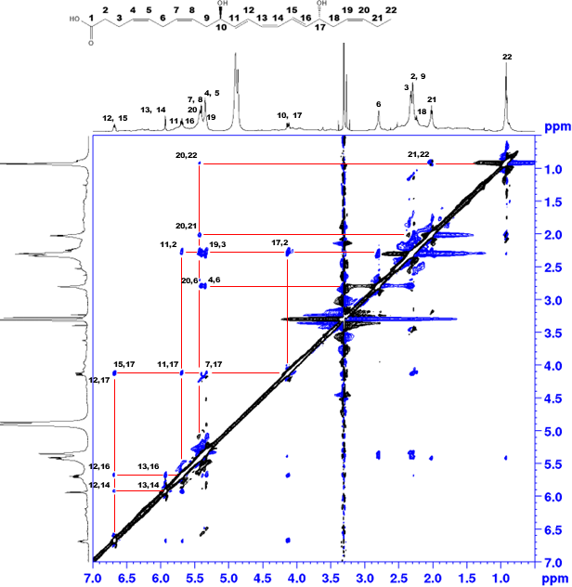
E
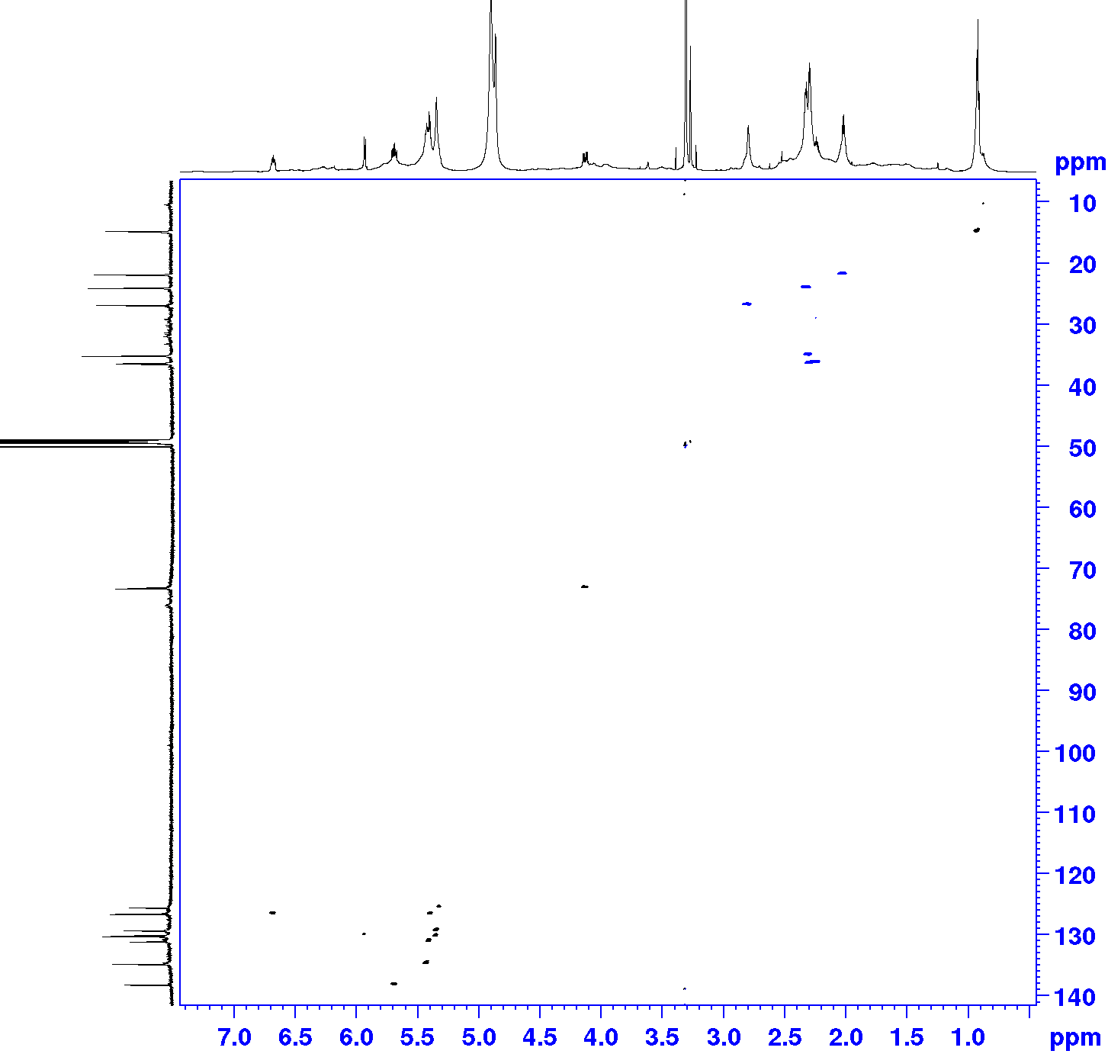
F
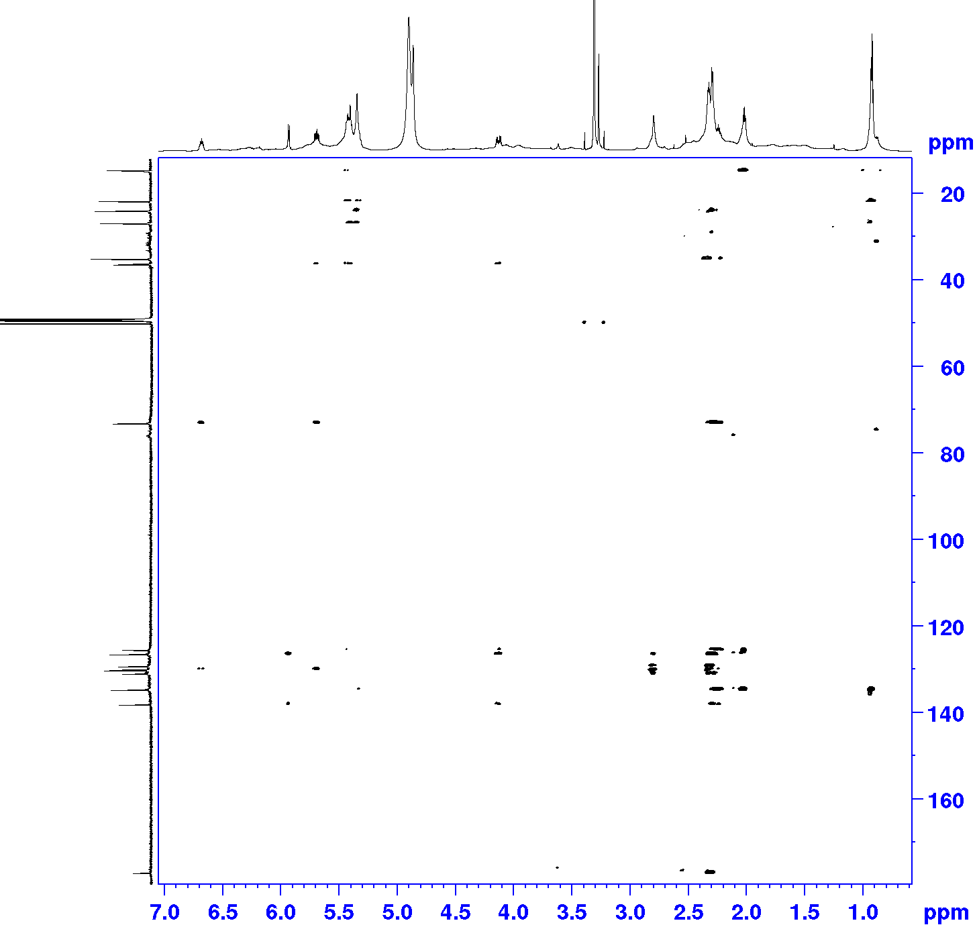
Figure S4: 1D and 2D nuclear magnetic resonance (NMR, 850 MHz) spectra of 10-epi PDX using deuterated methanol (MeOD). 1D NMR includes ¹H and ¹³C, and 2D NMR includes correlation spectroscopy (COSY), rotating frame overhauser enhancement spectroscopy (ROSEY), heteronuclear single quantum coherence (HSQC), and heteronuclear multiple bond coherence (HMBC). A ¹H NMR spectrum of 10-epi PDX. B ¹³C NMR spectrum of 10-epi PDX. C COSY spectrum of 10-epi PDX. D ROSEY spectrum of 10-epi PDX. E HSQC spectrum of 10-epi PDX. F HMBC spectrum of 10-epi PDX.

A
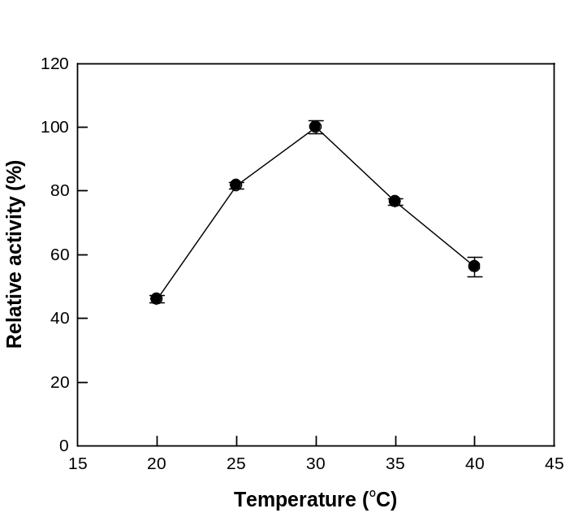
B
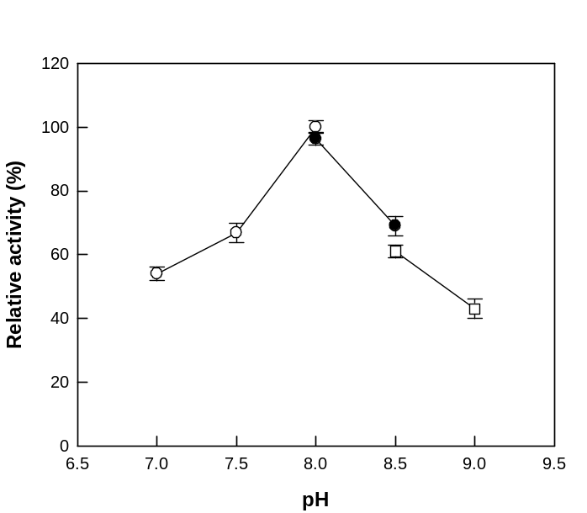
Figure S5: Effects of temperature and pH on 10R-HDHA production from DHA by Escherichia coli expressing P. homomalla 8R-LOX. A Effect of temperature. The reactions were performed at a constant pH of 8.0 in 50 mM HEPES buffer containing 2.0 g/L cells, 0.5 mM DHA, 200 mM cysteine, and 5% (v/v) ethanol by varying the temperature from 20 to 40 ℃ for 5 min. B Effect of pH. The reactions were performed at a constant temperature of 30 ℃ by ranging the pH from of 7.0 to 9.0 using 50 mM HEPES (open circle, pH 7.0−8.0), 50 mM HEPPS (filled circle, pH 8.0−8.5), and 50 mM CHES buffers (open square, pH 8.5−9.0) containing 0.5 mM DHA, 2.0 g/L cells, 200 mM cysteine, and 5 % (v/v) ethanol for 5 min. Error bars and data indicate the standard deviation and means of three experiments, respectively.

A
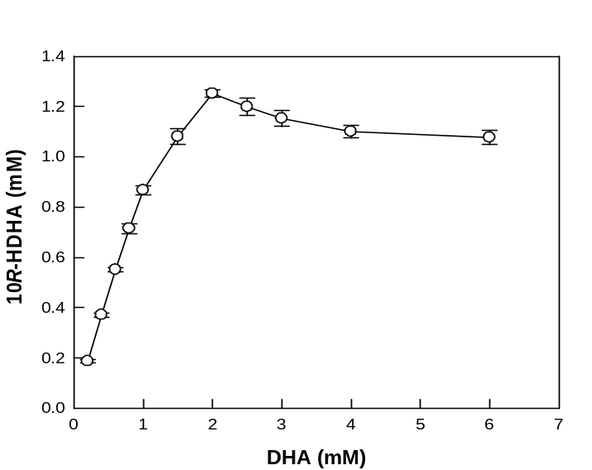
B
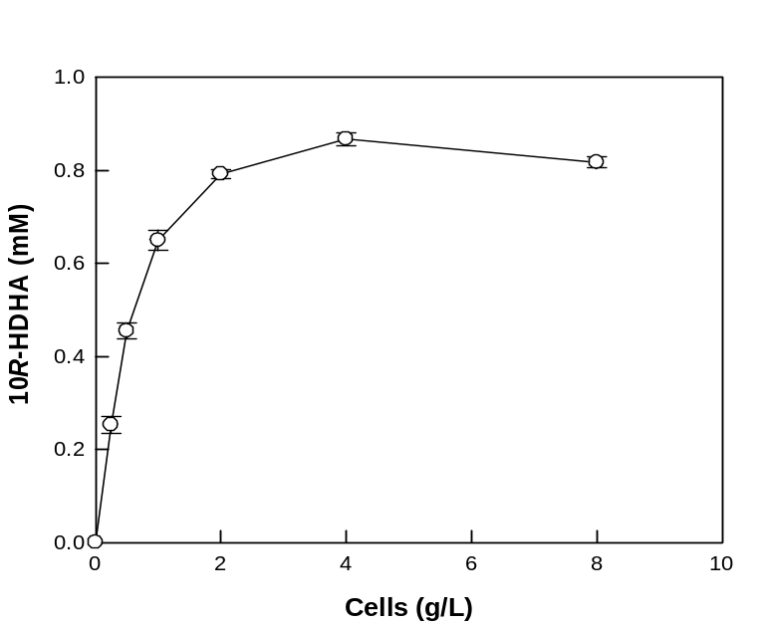
Figure S6: Effects of substrate and cell concentrations on 10R-HDHA production by E. coli expressing P. homomalla 8R-LOX. A Effect of substrate concentration. B Effect of cell concentration. The reactions were performed at 30 ℃ in 50 mM HEPES (pH 8.0) containing 1.0 g/L cells, 200 mM cysteine, and 5% (v/v) ethanol by varying the concentration of DHA from 0.2 to 6.0 mM or the cell concentration of 0.25 to 8 g/L for 40 min. Error bars and data indicate the standard deviation and means of three experiments, respectively.

A
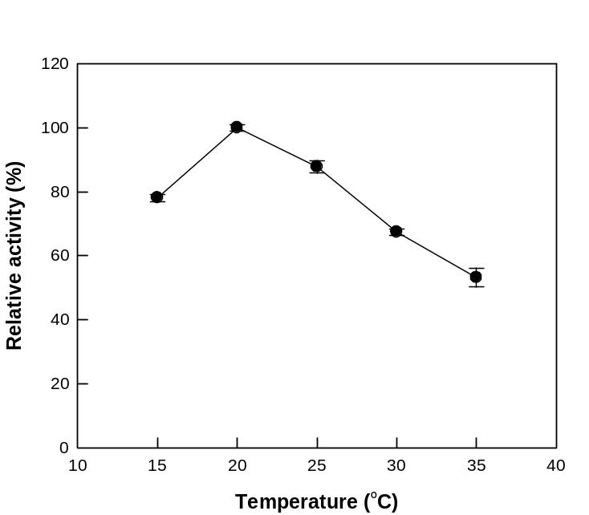
B
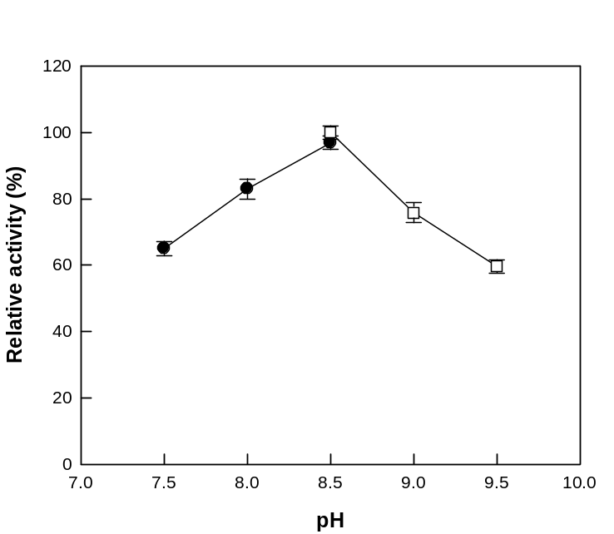

Figure S7: Effects of temperature and pH on 10-epi PDX production from 10R-HDHA by E. coli expressing A. violaceum 15S-LOX. A Effect of temperature. The reactions were performed at a constant pH of 8.5 in 50 mM CHES buffer containing 1.0 g/L cells, 0.5 mM 10R-HDHA, 200 mM cysteine, and 5% (v/v) ethanol by varying the temperature from 15 to 35 ℃ for 5 min. B Effect of pH. The reactions were performed at a constant temperature of 20 ℃ in 50 mM HEPPS (filled circle, pH 7.5−8.5) and 50 mM CHES buffers (open square, pH 8.5−9.5) containing 1.0 g/L cells, 0.5 mM 10R-HDHA, 200 mM cysteine, and 5 % (v/v) ethanol by ranging the pH from 7.5 to 9.5 for 5 min. The purified 10R-HDHA obtained from the conversion of DHA by E. coli expressing P. homomalla 8R-LOX was used as a substrate to biosynthesize 10-epi PDX. Error bars and data indicate the standard deviation and means of three experiments, respectively.

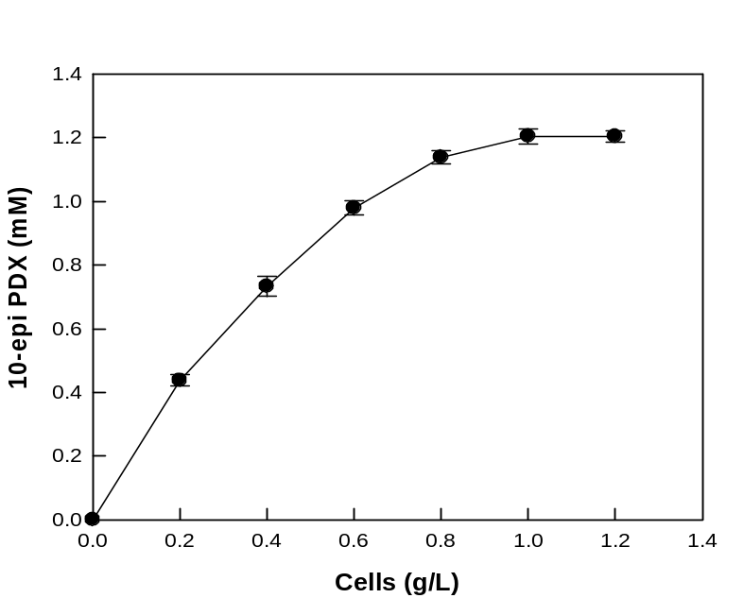
Figure S8: Effect of cell concentration on 10-epi PDX production from 10R-HDHA by E. coli expressing A. violaceum 15S-LOX. The reactions were performed at 20 ℃ in 50 mM CHES buffer (pH 8.5) containing 1.4 mM 10R-HDHA, 200 mM cysteine, and 5% (v/v) ethanol by ranging the cell concentration from 0.2 to 1.2 g/L for 40 min.

A
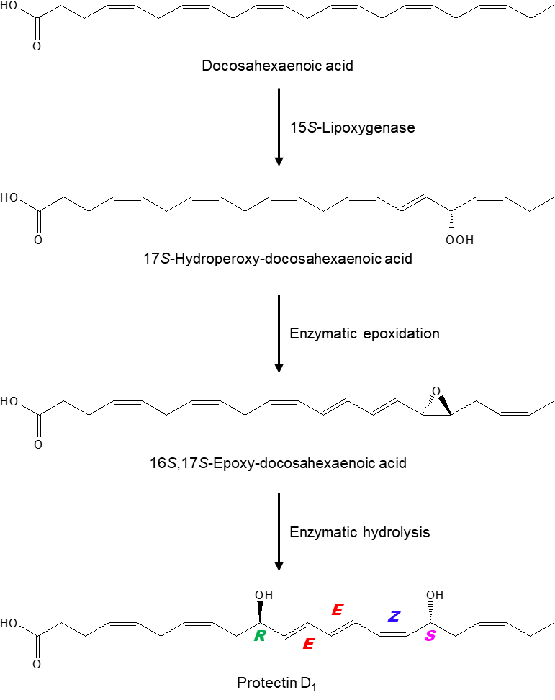

B
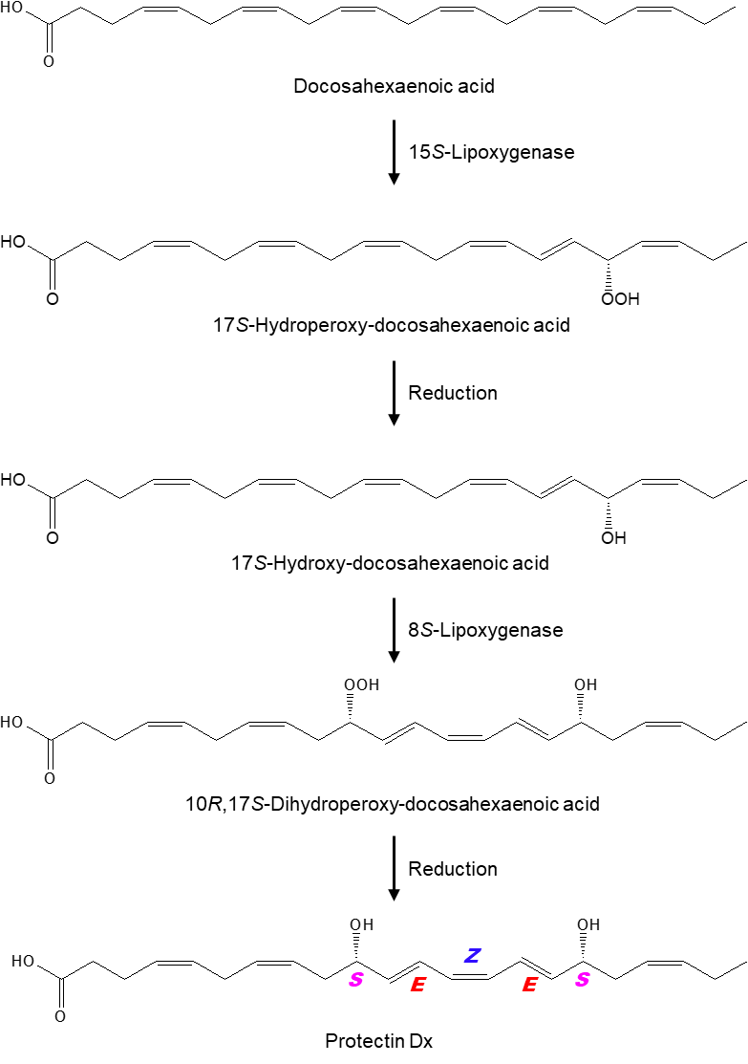
Figure S9: Biosynthetic pathways of DHA (docosahexaenoic acid) to protectin D₁ (PD1, 10R,17S-dihydroxy-4Z,7Z,11E,13E,15Z,19Z-docosahexaenoic acid) and protectin Dx (PDX, 10S,17S-dihydroxy-4Z,7Z,11E,13Z,15E,19Z-docosahexaenoic acid) by lipoxygenases (LOXs). A Biosynthetic pathway from DHA to PD1. B Biosynthetic pathway from DHA to PDX in the presence of a reducing agent.

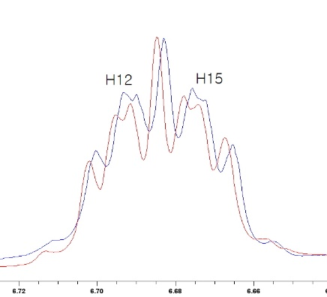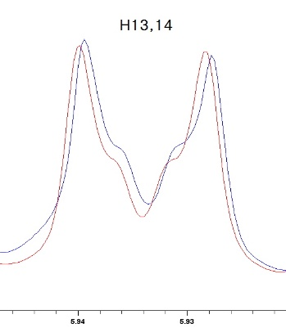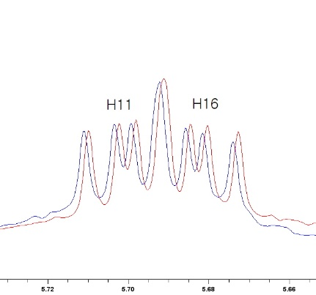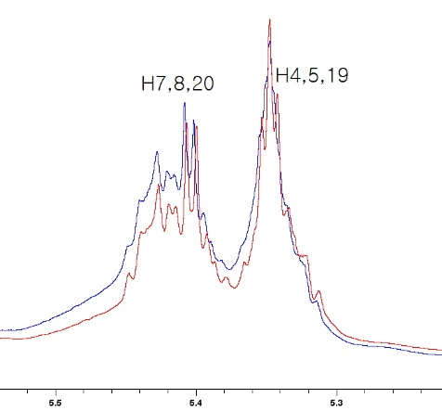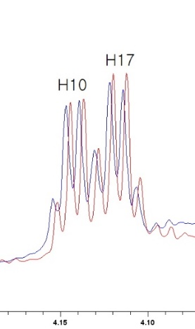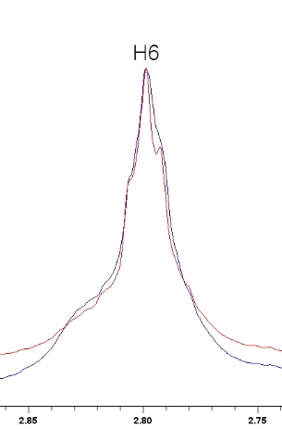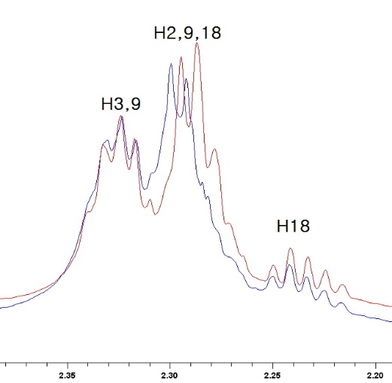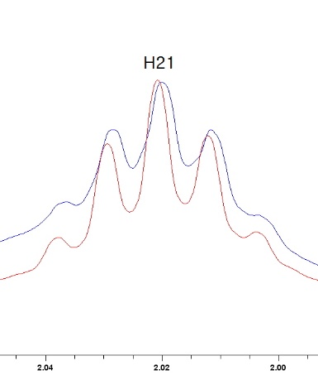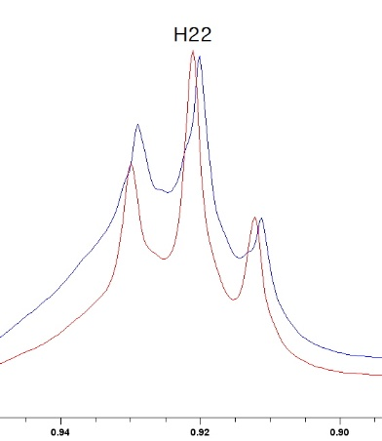
Figure S10: ¹H NMR spectra of 10-epi PDX (10R,17S-DiHDHA, blue) and PDX (10S,17S-DiHDHA, red) (Shin et al. 2022). H12,13,14,15,21, and 22 of 10-epi PDX were shielding (0.001 ppm) compared to those of PDX, whereas H2,10,11,16, and 17 were deshielding (0.001~0.005 ppm) compared to those of PDX. MeOD was used as the solvent and internal standard.

