Environmental risk score of multiple pollutants for kidney damage among residents in vulnerable areas by occupational chemical exposure in Korea: The FROM study

Supplementary Materials

Table A1. List of R packages used for assessing environmental risk score
Model | Package name
Elastic net | cv.glmnet and caret
Adaptive elastic net | cv.gcdnet
Weighted quantile sum regression | gWQS
Bayesian kernel machine regression | Bkmr
Bayesian additive regression tree | Bayes Tree
Super learner | E1071  bartMachineCV  CV.SuperLearner  Gam  Ipred  missForest  itertools  iterators  xgboost

Fig A1 Correlation plot of urinary concentrations of metabolites for environmental hazard materials. PAHs, polycyclic aromatic hydrocarbons; 2-naph, 2-naphthol; 1-ohp, 1-hydroxypyrene; 2-ohf, 2-hydroxyfluorene; 1-ohph, 1-hydroxyphenanthrene; VOCs, volatile organic compounds; PGA, phosphoglyceric acid, tt-MA, trans, trans-muconic acid, MHA, methylhippuric acid; BMA, benzylmercapturic acid; β2-MG, beta-2-microglobulin; NAG, N-acetylglucosaminidase; eGFR, estimate glomerular filtration rate
Table A2. General characteristics for original and test datasets
 | Original data | Test data | p valueª
 | N (%) | N (%) | p valueª
All | 256 (100) | 199 (100)
Gender |  |  | > 0.999
Male | 99 (38.67) | 77 (38.69)
Female | 157 (61.33) | 122 (61.31)
Age (years) |  |  | 0.996
< 65 | 69 (26.95) | 53 (26.63)
65–74 | 94 (36.72) | 73 (36.68)
75+ | 93 (36.33) | 73 (36.68)
Co-morbidity (Hypertension or Diabetes) |  |  | 0.446
No | 117 (45.70) | 99 (49.75)
Yes | 139 (54.30) | 100 (50.25)
Medication for any disease |  |  | 0.870
No | 49 (19.14) | 36 (18.09)
Yes | 207 (80.86) | 163 (81.91)
Area^{b} |  |  | > 0.999
Gimhae | 32 (12.50) | 25 (12.56)
Goseong | 68 (26.56) | 53 (26.63)
Sangchon | 63 (24.61) | 49 (24.62)
Janghang | 93 (36.33) | 72 (36.18)
Period of residence (years) |  |  | 0.933
T1 (<12.92) | 85 (33.20) | 68 (34.17)
T2 (12.92–< 50.00) | 80 (31.25) | 59 (29.65)
T3 (50.00–93.00) | 91 (35.55) | 72 (36.18)
Urinary cotinine level (μg/g Crea.)
T1 (< 2.09) | 85 (33.20) | 61 (30.65)
T2 (2.09–< 6.97) | 85 (33.20) | 68 (34.17)
T3 (6.97-3851.99) | 86 (33.59) | 70 (35.18)
History of occupational chemical exposure |  |  | 0.844
No | 224 (87.50) | 174 (87.44)
Yes | 32 (12.50) | 25 (12.56)
Period of occupational chemical exposure (years) |  |  | > 0.999
None | 224 (87.50) | 174 (87.44)
<4.5 | 16 (6.3) | 9 (4.52)
4.5–≤60 | 16 (6.3) | 16 (8.04)
Metabolites in urine (μg/g Crea.), GM (95% CI)
Metals
Hg | 0.65 (0.58, 0.72) | 0.67 (0.59, 0.76) | 0.741
V | 0.34 (0.31, 0.36) | 0.34 (0.32, 0.37) | 0.708
Cr | 0.32 (0.29, 0.36) | 0.32 (0.28, 0.36) | 0.884
Mn | 0.26 (0.23, 0.29) | 0.26 (0.23, 0.30) | 0.980
Ni | 3.66 (3.36, 4.00) | 3.58 (3.24, 3.96) | 0.730
Mo | 96.39 (89.23, 104.11) | 90.75 (83.41, 98.73) | 0.301
Cd | 1.73 (1.58, 1.89) | 1.77 (1.60, 1.97) | 0.716
Sb | 0.10 (0.09, 0.11) | 0.10 (0.09, 0.11) | 0.840
Pb | 0.80 (0.72, 0.90) | 0.79 (0.69, 0.89) | 0.799
Polycyclic Aromatic Hydrocarbons
2-naphthol | 3.68 (3.17, 4.27) | 3.87 (3.25, 4.60) | 0.667
1-Hydroxypyrene | 0.13 (0.11, 0.15) | 0.13 (0.11, 0.15) | 0.818
2-Hydroxyfluorene | 0.16 (0.14, 0.18) | 0.16 (0.14, 0.19) | 0.862
1-Hydroxyphenanthrene | 0.08 (0.07, 0.09) | 0.08 (0.07, 0.09) | 0.900
Volatile Organic Compounds
Phosphoglyceric acid | 109.54 (96.15, 124.79) | 114.33 (98.95, 132.10) | 0.666
Trans, trans-muconic acid | 65.44 (59.01, 72.57) | 64.48 (57.39, 72.44) | 0.851
Methylhippuric acid | 70.59 (60.70, 82.11) | 75.81 (63.61, 90.35) | 0.543
Benzylmercapturic | 11.74 (10.43, 13.22) | 11.63 (10.17, 13.30) | 0.915
Testing dataset was sampled data from the original dataset using systematic sampling.
GM, geometric mean; CI, confidence interval
ªp value estimated using chi-squared test or t-test
^{b}The pollution source of Goseong and Sangchon are abandoned metal mines, and that of Janghang is smelter. The participants in Goseong, Sangchon, and Janghang lived within distances of 1.18 to 3.76 km, 4.09 to 5.63 km, and 1.33 to 23.60 km from the source of pollution
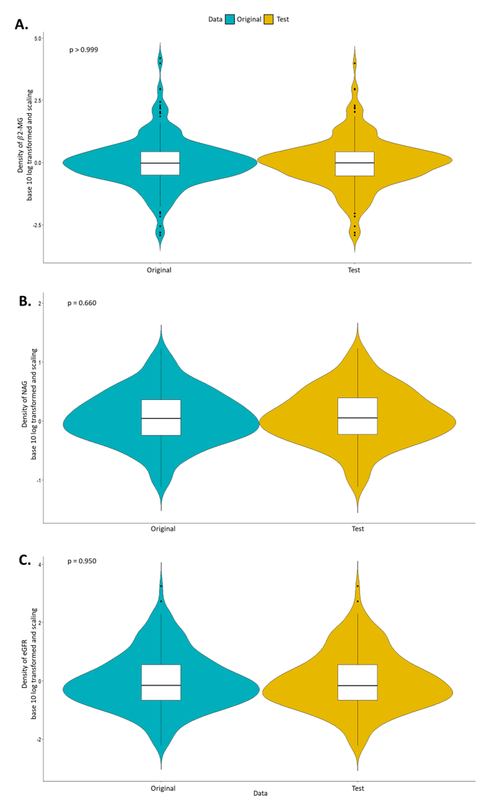
Fig. A2 Density of kidney damage marker according to the data on β2-microglobulin (A), N-acetyl glucosaminidase (B), and estimated glomerular filtration rate (eGFR) (C). eGFR = 141 × min (S_{cr} /κ, 1)^{α} × max(S_{cr} /κ, 1)^{-1.209} × 0.993^{Age} × 1.018 [if female], where S_{cr} is serum creatinine in mg/dL, κ is 0.7 for females and 0.9 for males, α is −0.329 for females and −0.411 for males. Original was total population dataset (n = 256), and test was sampled using stratified sampling from the original dataset, with consideration of all covariates and a sampling ratio of 80% (n = 199). p value was estimated using t-test.
Table A3. Comparison of the distribution and performance of environmental risk score (ERS) of urinary metabolites for biomarkers by kidney damage markers (Crude model for Table 2)
 | Model
 | Base |  | ENET |  | AENET |  | WQS |  | BKMR |  | BART |  | SL
Data | Original | Test | Original | Test | Original | Test | Original | Test | Original | Test | Original | Test | Original | Test
 | β2-Microglobulin (μg/dL)
Distribution of ERS
Mean (SD) | 0.01 (0.83) | −0.02 (0.92) | 0.01 (0.21) | −0.02 (0.14) | 0.01 (0.18) | −0.02 (0.17) | 0.01 (0.34) | −0.02 (0.38) | −0.01 (0.64) | −0.02 (0.62) | 0.01 (0.45) | −0.01 (0.31) | 0.00 (0.44) | −0.01 (0.49)
Range (Min, Max) | (−2.46, 3.05) | (−2.76, 3.34) | (−0.53, 0.80) | (−0.38, 0.39) | (−0.45, 0.77) | (−0.43, 0.75) | (−0.72, 0.75) | (−0.79, 0.80) | (−1.78, 2.67) | (−1.74, 1.93) | (−0.97, 1.53) | (−0.70, 0.75) | (−1.21, 1.14) | (−1.50, 1.26)
Risk prediction performance
R² | 0.71 | 0.83 | 0.22 | 0.14 | 0.16 | 0.15 | 0.11 | 0.14 | 0.91 | 0.83 | 0.56 | 0.41 | 0.09 | 0.13
MSPE | 0.28 | 0.18 | 0.83 | 0.93 | 0.87 | 0.92 | 0.87 | 0.88 | 0.19 | 0.27 | 0.52 | 0.71 | 0.91 | 0.91
RMSE | 0.53 | 0.42 | 0.91 | 0.97 | 0.93 | 0.96 | 0.93 | 0.94 | 0.43 | 0.52 | 0.72 | 0.84 | 0.95 | 0.95
MAE | 0.42 | 0.33 | 0.65 | 0.69 | 0.66 | 0.69 | 0.68 | 0.70 | 0.31 | 0.38 | 0.52 | 0.60 | 0.70 | 0.70
 | N-acetylglucosaminidase (IU/L)
Distribution of ERS
Mean (SD) | 0.06 (0.37) | 0.08 (0.41) | 0.06 (0.08) | 0.08 (0.07) | 0.06 (0.05) | 0.08 (0.09) | 0.06 (0.19) | 0.08 (0.21) | 0.06 (0.40) | 0.07 (0.34) | 0.06 (0.12) | 0.08 (0.18) | 0.04 (0.26) | 0.06 (0.30)
Range (Min, Max) | (−1.06, 1.15) | (−1.23, 1.09) | (−0.14, 0.38) | (−0.10, 0.33) | (−0.08, 0.27) | (−0.10, 0.44) | (−0.41, 0.55) | (−0.44, 0.68) | (−1.00, 1.10) | (−0.80, 0.90) | (−0.22, 0.37) | (−0.33, 0.56) | (−0.64, 0.80) | (−0.67, 1.08)
Risk prediction performance
R² | 0.68 | 0.80 | 0.19 | 0.19 | 0.14 | 0.20 | 0.17 | 0.20 | 1.00 | 0.97 | 0.30 | 0.46 | 0.07 | 0.13
MSPE | 0.06 | 0.04 | 0.18 | 0.19 | 0.19 | 0.18 | 0.17 | 0.17 | 0.00 | 0.02 | 0.16 | 0.13 | 0.21 | 0.20
RMSE | 0.25 | 0.20 | 0.42 | 0.43 | 0.43 | 0.43 | 0.41 | 0.41 | 0.05 | 0.14 | 0.40 | 0.36 | 0.45 | 0.45
MAE | 0.20 | 0.16 | 0.33 | 0.34 | 0.34 | 0.33 | 0.32 | 0.32 | 0.04 | 0.11 | 0.31 | 0.28 | 0.35 | 0.35
 | Estimated glomerular filtration rate (eGFR)
Distribution of ERS
Mean (SD) | −0.02 (0.76) | −0.01 (0.87) | −0.02 (0.16) | −0.01 (0.20) | −0.02 (0.19) | −0.01 (0.12) | −0.02 (0.19) | −0.01 (0.22) | −0.02 (0.75) | −0.02 (0.42) | −0.02 (0.36) | 0.00 (0.21) | −0.02 (0.40) | −0.03 (0.35)
Range (Min, Max) | (−2.20, 2.49) | (−2.13, 2.79) | (−0.58, 0.91) | (−0.72, 1.06) | (−0.73, 1.16) | (−0.50, 0.96) | (−0.49, 0.51) | (−0.51, 0.57) | (−1.73, 2.58) | (−0.93, 1.21) | (−0.88, 0.97) | (−0.49, 0.53) | (−1.08, 1.38) | (−0.88, 1.14)
Risk prediction performance
R² | 0.62 | 0.77 | 0.17 | 0.25 | 0.17 | 0.09 | 0.04 | 0.05 | 0.98 | 0.87 | 0.50 | 0.36 | 0.03 | 0.01
MSPE | 0.36 | 0.22 | 0.83 | 0.82 | 0.82 | 0.92 | 0.89 | 0.93 | 0.06 | 0.38 | 0.57 | 0.77 | 0.95 | 1.02
RMSE | 0.60 | 0.47 | 0.91 | 0.91 | 0.91 | 0.96 | 0.95 | 0.96 | 0.25 | 0.62 | 0.75 | 0.88 | 0.98 | 1.01
MAE | 0.46 | 0.35 | 0.71 | 0.71 | 0.70 | 0.75 | 0.73 | 0.75 | 0.20 | 0.49 | 0.59 | 0.69 | 0.77 | 0.78
SD, standard deviation; CI, confidence interval; Base model is multiple linear regression model; ENET, elastic net; AENET, adaptive elastic net; WQS, weighted quantile sum regression; BKMR, Bayesian kernel machine regression; BART, Bayesian additive regression tree; SL, super learner; MSPE, mean-square-prediction error; RMSE, root-mean-square error; MAE, mean absolute error.
Original was total population dataset (n=256), and test was sampled using stratified sampling from the original dataset, with consideration of all covariates and a sampling ratio of 80% (n=199)
Kidney damage markers were base-10 log transformed and scaled, and metabolites were scale.
eGFR = 141 × min (S_{cr} /κ, 1)^{α} × max (S_{cr} /κ, 1)^{−1.209} × 0.993^{Age} × 1.018 [if female], where S_{cr} is serum creatinine in mg/dL, κ is 0.7 for females and 0.9 for males, α is −0.329 for females and −0.411 for males.

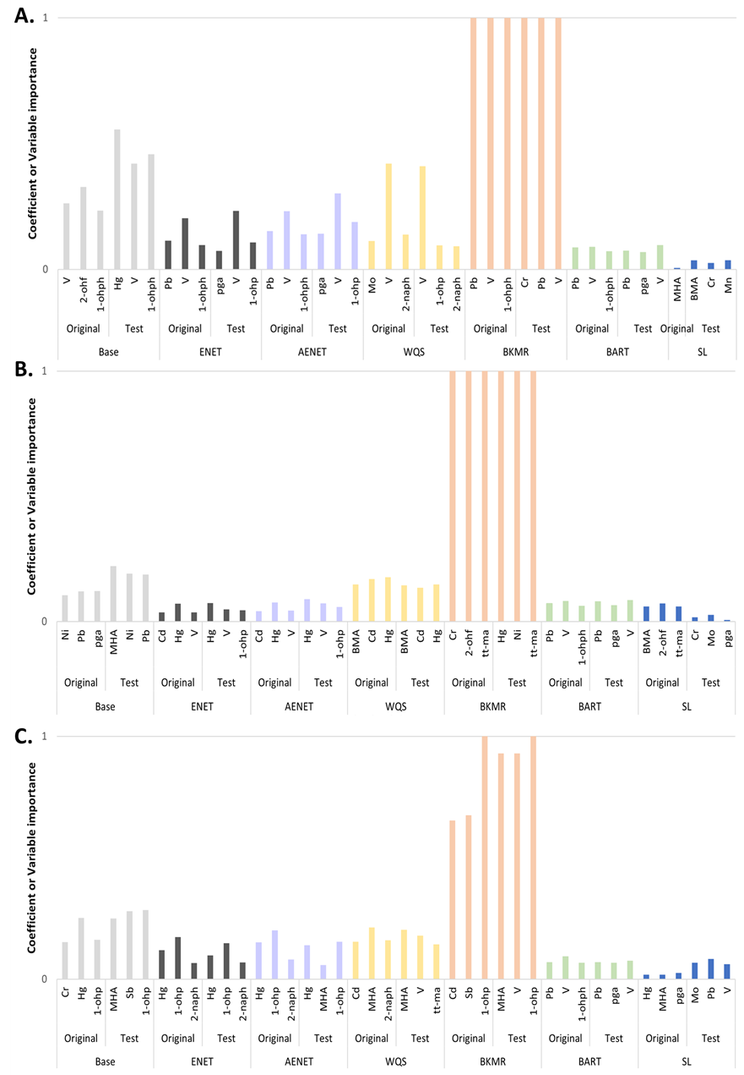
Fig. A3 Most effective metabolites according to ERS model and data types for each model: β2-microglobulin (A), N-acetyl glucosaminidase (B), and estimated glomerular filtration rate (eGFR) (C). Base model is multiple linear regression model; ENET, elastic net; AENET, adaptive elastic net; WQS, weighted quantile sum regression; BKMR, Bayesian kernel machine regression; BART, Bayesian additive regression tree; SL, super learner. Kidney damage markers were base-10 log transformed and scaled, and metabolites were scale. eGFR = 141 × min (S_{cr} /κ, 1)^{α} × max (S_{cr} /κ, 1)^{−1.209} × 0.993^{Age} × 1.018 [if female], where S_{cr} is serum creatinine in mg/dL, κ is 0.7 for females and 0.9 for males, α is −0.329 for females and −0.411 for males
Table A4. Distribution of concentration of urinary metabolites for environmental hazard materials.
Concentration of urinary metabolites (μg/g Crea.) | All | History of occupational chemical exposure (OCE)
Concentration of urinary metabolites (μg/g Crea.) | All | Non-OCE (n=224) | OCE (n=32)
Concentration of urinary metabolites (μg/g Crea.) | GM (95% CI) | GM (95% CI) | GM (95% CI)
Metals
Hg | 0.65 (0.58, 0.72) | 0.68 (0.61, 0.77) | 0.45 (0.34, 0.61)
V | 0.34 (0.31, 0.36) | 0.33 (0.31, 0.36) | 0.36 (0.30, 0.44)
Cr | 0.32 (0.29, 0.36) | 0.31 (0.28, 0.35) | 0.41 (0.28, 0.61)
Mn | 0.26 (0.23, 0.29) | 0.27 (0.24, 0.30) | 0.21 (0.15, 0.28)
Ni | 3.66 (3.36, 4.00) | 3.57 (3.24, 3.94) | 4.38 (3.59, 5.32)
Mo | 96.39 (89.23, 104.11) | 97.64 (90.36, 105.50) | 88.06 (64.70, 119.85)
Cd | 1.73 (1.58, 1.89) | 1.76 (1.60, 1.94) | 1.51 (1.12, 2.05)
Sb | 0.10 (0.09, 0.11) | 0.10 (0.09, 0.11) | 0.09 (0.07, 0.12)
Pb | 0.80 (0.72, 0.90) | 0.79 (0.70, 0.90) | 0.87 (0.61, 1.24)
Polycyclic Aromatic Hydrocarbons
2-naphthol | 3.68 (3.17, 4.27) | 3.60 (3.08, 4.22) | 4.26 (2.61, 6.94)
1-Hydroxypyrene | 0.13 (0.11, 0.15) | 0.12 (0.11, 0.14) | 0.14 (0.09, 0.21)
2-Hydroxyfluorene | 0.16 (0.14, 0.18) | 0.15 (0.13, 0.17) | 0.22 (0.14, 0.34)
1-Hydroxyphenanthrene | 0.08 (0.07, 0.09) | 0.08 (0.07, 0.09) | 0.10 (0.08, 0.13)
Volatile Organic Compounds
Phosphoglyceric acid | 109.54 (96.15, 124.79) | 109.29 (95.11, 125.59) | 111.27 (74.82, 165.48)
Trans, trans-muconic acid | 65.44 (59.01, 72.57) | 64.43 (57.71, 71.93) | 73.01 (53.33, 99.96)
Methylhippuric acid | 70.59 (60.70, 82.11) | 66.48 (56.79, 77.83) | 107.48 (65.56, 176.18)
Benzylmercapturic | 11.74 (10.43, 13.22) | 11.66 (10.32, 13.17) | 12.39 (8.04, 19.09)
GM, Geometric mean; CI, Confidence interval

Table A5. Posterior inclusion probability (PIP) of environmental risk score (ERS) for kidney damage markers stratified with the history of occupational chemical exposure
Urinary metabolites | Kidney damage markers
Urinary metabolites | β2-Microglobulin |  | N-acetylglucosaminidase |  | eGFR
Urinary metabolites | History of occupational chemical exposure |  | History of occupational chemical exposure |  | History of occupational chemical exposure
Urinary metabolites | No | Yes | No | Yes | No | Yes
Urinary metabolites | PIPª | PIPª | PIPª | PIPª | PIPª | PIPª
Metals
Hg | 0.51 | 0.79 | 0.16 | 0.52 | 0.50 | 0.91
V | 1.00 | 0.78 | 0.01 | 0.56 | 0.39 | 0.76
Cr | 0.72 | 0.70 | 0.00 | 0.56 | 0.34 | 0.83
Mn | 0.55 | 0.60 | 0.00 | 0.40 | 0.35 | 0.79
Ni | 0.54 | 0.84 | 0.00 | 0.52 | 0.36 | 0.96
Mo | 0.53 | 0.69 | 0.01 | 0.51 | 0.53 | 0.72
Cd | 0.56 | 0.68 | 0.06 | 0.61 | 0.50 | 0.82
Sb | 0.61 | 0.74 | 0.09 | 0.47 | 0.56 | 0.67
Pb | 0.89 | 0.74 | 0.00 | 0.47 | 0.50 | 0.70
Polycyclic Aromatic Hydrocarbons
2-naphthol | 0.50 | 0.92 | 0.00 | 0.51 | 0.29 | 0.79
1-Hydroxypyrene | 0.42 | 0.72 | 0.00 | 0.58 | 0.99 | 0.79
2-Hydroxyfluorene | 0.68 | 0.69 | 0.02 | 0.39 | 0.47 | 0.73
1-Hydroxyphenanthrene | 0.94 | 0.82 | 1.00 | 0.35 | 0.55 | 0.77
Volatile Organic Compounds
Phosphoglyceric acid | 0.80 | 0.73 | 0.00 | 0.54 | 0.40 | 0.77
Trans, trans-muconic acid | 0.72 | 0.70 | 1.00 | 0.49 | 0.26 | 0.75
Methylhippuric acid | 0.65 | 0.73 | 0.11 | 0.42 | 0.52 | 0.80
Benzylmercapturic | 0.78 | 0.81 | 0.00 | 0.50 | 0.36 | 0.60
ªPosterior inclusion probability estimated using Bayesian kernel machine regression (BKMR)
GFR = 141 × min (S_{cr} /κ, 1)^{α} × max (S_{cr} /κ, 1)^{−1.209} × 0.993^{Age} × 1.018 [if female], where S_{cr} is serum creatinine in mg/dL, κ is 0.7 for females and 0.9 for males, α is −0.329 for females and −0.411 for males

