Figure S1. Flowchart of literature search.

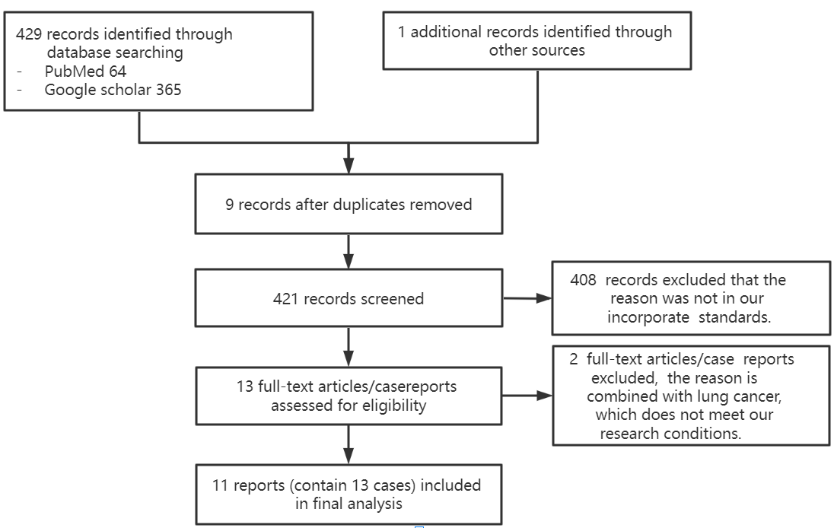
Table S1： Epidemiology, clinical features, imaging manifestations and treatment of 19 patients of pulmonary melioidosis(n=19)
Case  No | Ref | Age/  sex | Exposure history（occupation） | Risk factors | Clinical symptoms | Chest CT shows  the location and/or size | Other findings of chest | Other findings of  Position | Main inspection methods | Main blood count results | Antibiotics (duration（day）) | Outcome
1 | Ching-Yi Chen et al. | 64/M | Taiwan Province（fish vendor） | DM | Fever  Cough phlegm,  weight loss | Periphery | Right Pleural effusions | Skin rash | CT-guided biopsy;  sputum  and blood culture | WBC9180/ul;  80.6% neutrophils;  platelet  85，000/ul;  CRP 179.8mg/L | Imipenem/  cilastatin/ meropenem  cotrimoxazol (92） | Improved
2 | Bree-Anna Gadsby1 et al. | 66/F | Australia | DM  COPD,  smoke  hyperlipi-daemia | Malaise, weight loss， non-productive cough  with a single episode of haemopt-ysis. | Central type | Innumerable bilateral pulmonary  nodules；extensive hilar and mediastinal lymphadenopathy | ND | CT; PET  bronchoscopy;  bronchial washings. | ND | Intravenous  and oral antibiotic therapy as per local guidelines. （120） | Cured
3 | Bree-Anna Gadsby1 et al. | 25/F | Australia | DM and a recent mild COVID infection which  had fully resolved | Fevers, headaches  sore throat, productive cough and small volume haemopty-sis, stachypno-eic | Central type | Right  hilar lymphadenop-athy | ND | CTPA;  EBUS;  AFB;  blood cultures | CRP 184 mg/L | Local guidelines（30） | Cured
4 | Bree-Anna Gadsby1 et al. | 36/F | Australia | DM，active smoker with a Long history | Fevers,  non-productive cough，malaise, anorexia, weight loss, tachypnoeic | Central type | Left hilar lymphaden-opathy and subcarinal lymphaden-opathy | ND | Sputum and blood culture;  CT; EBUS; bronchoscopy | CRP 114 mg/L. | Local guidelines（30） | Cured
5 | Kimberly K. Truong et al. | 70/F | Mexico (no tourism，lives in an adobe mud house.) | Smoke | Fevers, chills, and  weight loss | Central type  2.5×3.0 cm | Prominent regional lymphaden-opathy | A left supraclavicular abscess | EBUS；Automated VITEK 2 instrument;  CT; blood culture | WBC 8800 Cells/mm^3、 | Meropenem  trimethoprim  /sulfamethoxazole  Polycycline（194） | Improved
6 | B. Merrick et al. | 52/F | Britain (Thailand travel） | ND | Septic shock | Central type | Multiple bilateral cavitating lung nodules and Prominent regional lymphaden-opathy | ND | Blood culture;  VATS | Neutrophilia 22.6×10^6/L  CRP 330mg/L | Meropenem and  cotrimoxazole（109） | Cured
7 | Kyi Kyi Zawa et al. | 41/F | Australia（avid gardener） | Smoke | Intermittent  Non-specific chest pain，progressive exertional dyspnea | Periphery  3.6×2.2 cm | ND | ND | EBUS; bronchial brushings  X-ray;CT;  PET-CT | WBC 11.5×109/L  neutrophilia 7.9×109/L  CRP 15mg/L | Ceftazidime  sulfamethoxa-zole  /trimethoprim, folic acid（120） | Improved
8 | Joseph Zhao et al. | 57/M | Singapore (joined the Thailand military 28 years ago) | Hypertension and hyperlipidemia, both well control-led with medica-tions | Chilling fever and dry cough  associated with pleutic chest pain | Central type  3.3×2.7cm | There are  low density masses in the left hilar  region,  pleural effusion,  mediastinal adenopathy and pericardial effusion | ND | X-ray;  CT;PET;  biochemical analysis of the pleural aspiration；  blood and sputum culture; Percutaneous lung biopsy | 87.6％neutrophils,  CRP 93.4mg/L | Meropenem  Moxifloxacin、cotrimoxazole and Polycycline  （63） | Improved
9 | Sze Shyang Kho et al. | 63/M | Central Sarawak, Malaysia（farmer） | DM，hypertension and dyslipidemia | Fever,chills, non-productive cough, weight loss and septic shock | Central type  2.5×4.1×2.5cm | Prominent regional lymphaden-opathy | ND | X-ray;CT;  bronchoscopy; blood cultures, biochemical  testing and mass spectrometry | Haemoglobin12·6g/dL, platelet 399×10^9 /L  WBC  11.4×10⁹/L | Amoxicillin and clavulanic acid Meropenem  ,Temofloxacin（231） | Cured
10 | Wipa Reechaipichitkul et al. | 62/M | Thailand（gover-nment employee） | DM，heavy smoking and drinking | Fever,cough, His sputum was  scanty, mucoid, and free of blood. weight loss | Central type  3.9 x 4.8 cm | Prominent regional lymphaden-opathy | ND | X-ray; CT  blood cultures  bronchoscopy; bronchoalveolar lavage fluid; | ND | Ceftazidime  cotrimoxazole  vibramycin（167） | Improved
11 | Malcolm Wilson et al. | 59/M | Les Channel Island (Australia) | DM and with a Long history of smoking | Reduced exercise tolerance, night sweats,weight loss and Blood pressure drop | Central type | Prominent regional lymphaden-opathy | ND | CT;  blood cultures | ND | Meropenem  Ceftazidime  trimethoprim  /Sulfamethox-azole, folic acid（126） | Improved
12 | Chew Lip Ng et al. | 42/M | Malaysia（an outdoor project  Coordin-ator frequently in contact with soil during  field surveys in gardens） | DM，smoke pulmo-nary TB in 1994 for which treatment was  Complete | Cough  productive of yellowish sputum, hoarseness and  intermittent daily fever associated with chills | Central type | Extensive mediastinal lymphaden-opathy | Laryng-eal infective ulcers | CT;  blood, sputum and  urine for bacterial cultures; bronchoalveolar lavage; Endoscopy | 72.2% neutrophils | Ceftazidime、cotrimoxazole  （224） | Cured
13 | Wipa Reechaipichitkul et al. | 39/M | Thailand（  furniture builder） | Smoke | Dry cough, fever | Central type  3×3.4×4cm | Left pleural effusion(postoperautive) and prominent regional lymphaden-opathy | ND | X-ray; CT ;  bronchoscopy; bronchoalveolar lavage fluid; Pathological examination of lung mass resection | Platelet339,000Cells/mm^3 | Ceftazidime,  cotrimoxazole  polycycline  (180) | Cured
14 | / | 51/F | Wenchan-g City, Hainan Province, (farmer) | DM, hyperlipi-daemia | Fever, cough, weight loss | Central type | Prominent mediastinal and right hilar lymphadenopathy | ND | EBUS;CT | WBC 10.04×10^9/L,  neutrophils  7.01×10^9/L,  Platelet  420×10^9/L | Ceftazidime  cotrimoxazole  (21) | Improved
15 | / | 56/M | Dongfang City, Hainan Province, (farmer) | DM，long-term smoking and drinking | High fever, cough,chill | Central type | Prominent mediastinal and right hilar lymphadenopathy  right pleural effusions | ND | CT;  bronchoalveolar lavage fluid | WBC  12.57×10^9/L,  82.8% neutrophils,  CRP 234.30mg/L | Cefodizime sodium  (21) | Improved
16 | / | 69/F | Danzhou City, Hainan Province, (farmer) | Cerebral Infarct-ion | Cough white mucinous-like sputum, occasional blood in sputum, chest tightness and shortness of breath，Headache during fever | Central type | Multiple pulmonary  nodules；mediastinal and right hilar lymphadenopathy | Soft tissue infection of right thigh and left forearm | CT;  blood cultures | CRP 41.04mg/L  platelet 348×10^9/L | Latamoxef,  levofloxacin,  ceftazidime  (12) | Ask for discharge
17 | / | 53/M | Sanya City, Hainan Province, (farmer) | DM，hepatitis B, liver cirrhosis | Fever, occasional cough, right chest pain and shortness of breath | Periphery | Multiple pulmonary  nodules | ND | CT;  blood cultures | WBC  12.05×10^9/L  92%neutrophils  CRP257mg/L | Imipenem cilastatin、piperacillin-tazobactam  (36) | Improved
18 | / | 50/M | Dongfang City, Hainan Province, (farmer) | Smoke | fever, cough,chill | Central type | There is a  small nodules in the right lower lobe；mediastinal and right hilar lymphaden-opathy；right pleural effusions | ND | CT;  blood cultures;  bronchoalveolar lavage fluid; | WBC  13.37×10^9/L  80.8%  neutrophils  platelet  450×10^9/L | Ceftriaxone sodium,  piperacillin-tazobactam  levofloxacin  (25) | Improved
19 | / | 41/M | Qionghai City, Hainan Province, (farmer) | DM,  smoke | Fever，fatigue | Central type | Prominent mediastinal and right hilar lymphaden-opathy | ND | CT;EBUS | WBC  11.09×10^9/L  neutrophils  7.52×10^9/L  platelet  384×10^9/L  CRP85.57mg/L | Lacoxacef sodium,  Imipenem  sulfanilamide；piperacillin-tazobactam，  doxycycline  amikacin  (26) | Improved
Cases 1-13 are literature population, and cases 14-19 are local population.F, female; M, male; DM, diabetes mellitus；ref, references；WBC,white blood cell; CRP, C-reactive protein;Sulfamethoxazole(trimethoprim-sulfamethoxazole);COPD,chronic obstructive pulmonary disease;CT,computerized x-ray tomography technology; PET,positron emission tomography;CTPA,computed tomography pulmonary angiography;EBUS,endobronchial ultrasound;AFB,acid fast bacilli;ND,not determined.

