Supplementary Figures for

Sequencing-guided re-estimation and promotion of cultivability for environmental bacteria

Minjia Zheng^{1,#}, Linran Wen^{1,#}, Cailing He^{1,#}, Xinlan Chen¹, Laiting Si¹, Hao Li¹, Yiting Liang¹, Wei Zheng¹, Feng Guo^{1，2*}

Author information
Authors and Affiliations
- State Key Laboratory of Cellular Stress Biology, School of Life Sciences, Xiamen University, Xiamen, China
- Key Laboratory of Fujian Provincial University for Microorganism Resource, Fujian Province, China
#These authors contributed equally: Minjia Zheng, Linran Wen and Cailing He.
*Correspondence: fguo.bio@xmu.edu.cn

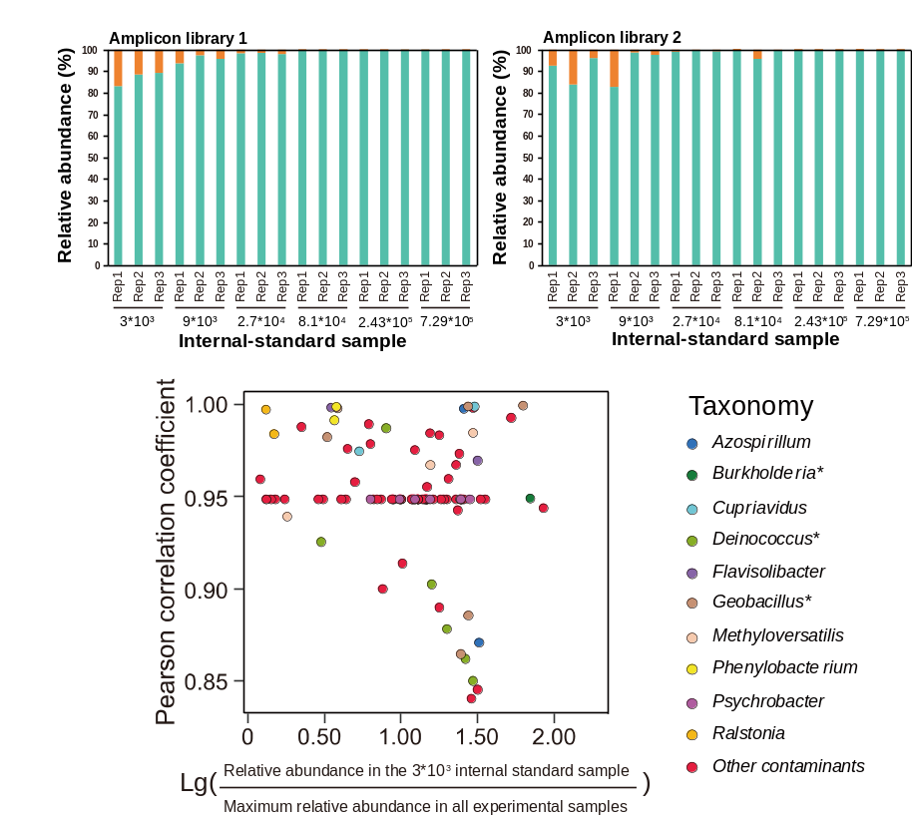
Figure S1 Determination of contaminant ASVs in the amplicon sequencing data by using the Decontam strategy (Karstens et al., 2019) with modification. The internal standards of NS6-2 of various dilution were used to determine the level of contamination in our experiment systems. Two libraries were constructed and the percentage of non-NS6-2 sequences showed an increasing trend with dilution (in A and B). However, in the internal standards >10⁵ per PCR reaction, the percentage is very low (<0.5%), indicating the low impact of the contamination on our samples (usually using 5-20 ng DNA template). Contaminant ASVs were shown in (C), They were screened based on a Pearson correlation coefficient >0.8 between their relative abundances and the dilution rates in the internal standards. For each ASV, if its relative abundance in the 3×10³ internal standard sample (the average value of triplicates) exceeded the maximum relative abundance observed in all experimental samples from the same library, it was considered as contamination. The genera labeled with * have been mentioned as contaminant taxa in references (Glassing et al., 2016; de Goffau et al., 2019).
Figure S2 A significant proportion of culturomics ASVs cannot be detected in the inoculum samples of soil (A) and AS (B). However, when increasing sequencing depth from 10,000 to 20,000, the ratio decreased. Comparison analysis was performed using paired one-tailed t-test (*P<0.05, **P<0.01 and ***P<0.001).

Figure S3 More emerging ASVs in the culturomic amplicon datasets than in the inoculum when increasing sequencing depth from 10,000 to 20,000. Comparison analysis was performed using paired one-tailed t-test (*P<0.05, **P<0.01 and ***P<0.001).

Figure S4 Number of microcolonies (<300 µm) and macrocolonies on selected agar plates.
Figure S5 Phylogenomic tree of 140 Burkholderiales genomes with uncultivable and cultivable phenotypes. The phylogenetic tree was reconstructed based on the bacterial 120 universal genes (Parks et al., 2022) by using FastTree software (Price et al., 2011).
Figure S6 Evidence supporting the vitamin B₁₂-dependence of nearly all (139 of 140) Burkholderiales MAGs. According to Shelton et al. (2019), there are 15 known cobamide-dependent enzyme families. We detected eight for the 140 genomes. Only one MAG (marked as the red star) have no cobamide-dependent enzyme families.

