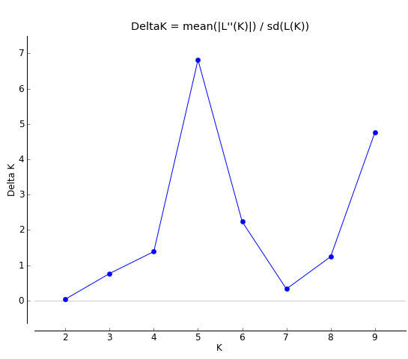
Fig. S1 The ΔK method of STRUCTURE analysis plots the change of K values

Fig. S2 UPGMA clustering results of 65 samples

