Turning Waste into Wealth: An Efficient Platform for Capturing, Recycling and Reusing Perfluorinated Compounds
Zhuojing Yang,†‡ Yutong Zhu,†‡ Xiao Tan,†‡ Samruddhi Jayendra Gunjal,†‡ Yiqing Wang,†‡ Ruijing Xin,† Changkui Fu,† Katie Macintosh,# Lee G. Sprague,∇ Lam Leung,∇ Timothy E. Hopkins,∇ Andrew K. Whittaker,†% and Cheng Zhang*†‡
†Australian Institute for Bioengineering and Nanotechnology, The University of Queensland, Brisbane, QLD 4072, Australia
‡The Centre for Advanced Imaging (CAI), The University of Queensland, Brisbane, QLD 4072, Australia
#City of Gold Coast, 833 Southport Nerang Rd, Nerang QLD 4211, Australia
∇The Chemours Company, Chemours Discovery Hub, 201 Discovery Boulevard, Newark, DE 19713 USA
%Australian Research Council Centre of Excellence for Green Electrochemical Transformation of Carbon Dioxide, The University of Queensland, Australia
Email: c.zhang3@uq.edu.au

Characterization Methods
Materials
The hydroxy-terminated perfluorinated poly(propylene ether) (PFPE AL-2, M_{n} ∼ 2000 g/mol, CAS Number: 126066-30-6) was obtained from The Chemours Company. The polymerization initiator 2,2’-azobis(2-methylpropionitrile) (AIBN) was purified and recrystallized using methanol forming thin flakes before use. Inhibitor 4-tert-butylcatechol was purchased from Fluka Chemicals. Milli-Q water with a resistivity of 18.4 MΩ·cm was used for the sorption experiments. All other chemicals such as PFAS compounds, 4-vinyl benzene chloride (VBC), divinyl benzene (DVB) and solvents were purchased from Sigma-Aldrich and used as received. The empty cartridges used in this study were ordered from Hawach Scientific Co., Ltd.
Synthesis of sPFPE monomer¹
PFPE-OH (30 g, 15 mmol), trifluorotoluene (TFT, 40 ml) and tetrabutylammonium hydrogen sulphate (THS, 2.85 g, 8.4 mmol) were added to a 250 ml round-bottom flask. Potassium hydroxide (KOH, 2.88 g, 51.3 mmol) was dissolved in 30 ml Milli-Q water and then added into the TFT solution. This KOH solution is prepared in ice bath and added under stirring. Finally, VBC (5.14 mL, 32.9 mmol) was added into the mixture and the reaction was conducted in an oil bath under continuous stirring at 45 ℃ for 48 hours. After completion of the reaction, a viscous transparent liquid product was obtained by precipitation against methanol for three times and dry under vacuum at 40 ℃. The product was dissolved in certain amount of TFT solvent with the addition of trace amount of 4-tert-butylcatechol inhibitor and stored in refrigerator at -4 ℃ for future use.
Synthesis of PFPE-IEX+ resins
A series of PFPE-IEX resins with different weight percentages of crosslinker were prepared through thermally initiated free radical polymerization. According to the proportions provided in Supplementary Table 1, sPFPE, VBC, and DVB were dissolved in 4 mL of TFT solvent, with AIBN used as the initiator. The mixture was sealed with a rubber stopper and deoxygenated with nitrogen gas for 20 minutes. The reaction mixture, composed of the above components, was placed in a round-bottom flask and continuously stirred in a 70°C oil bath for 24 hours. After the reaction was completed, a gray-white gel was formed, which was washed three times with methanol and centrifuged. Then, it was dried at approximately 60°C for about 4 hours. Subsequently, a mortar and pestle were used to grind the dried, dense block into a fine and uniform powder. Quaternization was performed using trimethylamine at 40°C for 48 hours, followed by screening to select particles of size 80-100 micrometers.
Stability
PFPE-IEX+ was weighted and placed in 20 individual Eppendorf tubes (50 mg each). The total weight of each sample, including the Eppendorf tube, was recorded as m₁. Ten of the samples were individually suspended in 1 mL of alkaline solution with a pH = 10, while the other ten were suspended in 1 mL of acidic solution with a pH = 2. These suspensions were incubated on a shaker at 60 degrees Celsius and 120 rpm. Sampling was conducted after incubation of one and three days, and then every week until week eight. The separation of PFPE-IEX+ resin and the solution were achieved through centrifugation (12000 rpm for 15 minutes). The solution was then extracted from Eppendorf tubes, washed once with deionized water, aggregated, and dried. The total weight of each dried sample, including the Eppendorf tube, was recorded as m₂. Each experiment was carried out in duplicate.
$$\%Mass Remaining =\frac{m_{2}}{m_{1}}$$
Swelling ratio test
One of the important properties of hydrogels is their swelling property. Hydrogels are material that retain a significant portion of water within their structure without getting solubilized in the water². This property is also demonstrated by the synthesized PFPE-IEX+ resin. Free absorbance capacity measurements are performed by checking the water retention of the hydrogel w.r.t. the time interval ². But in the case PFPE-IEX+ resins, despite studying the swelling kinetics the difference between the initial and final weight of the resin plays an important role since this resin is designed for PFAS sorption through the cartridge column. Three samples of each of the PFPE-IEX+ resins measuring 200 mg are taken in the measured falcon tube. Then 5 ml of water was added to the resin ensuring the complete immersion of resins in the water. In this manner, the swelling ratio optimization was performed, by varying the weight percent of the 4-vinyl benzyl chloride (VBC) and divinyl benzene (DVB).
$$Swelling Ratio= \frac{Weight of wet resin (mg)}{Weight of dry resin (mg)}$$
Small angle x-ray scattering
SAXS measurements of bulk sample was conducted using a custom-built SAXS diffractometer at the Centre for Microscopy and Microanalysis (CMM) X-ray facility (University Queensland). For these experiments, 1.54 Ǻ Cu Kα X-rays were generated using a Genix 50 W X-ray microsource (50 μm micro-focus) equipped with FOX2D collimating multilayer optics (Xenocs, France) and high efficiency scatterless single crystal/metal hybrid slits.
NMR spectroscopy
The monomer sPFPE synthesis is confirmed by ¹H NMR of the sPFPE dispersed and thoroughly mixed with CDCl₃. The characterization is done using Bruker Advance 400 MHz (9.4 T) spectrometer at 25 ℃, other parameters maintained were a 90° pulse width of 14 µs, relaxation delay of 1 s, the acquisition time of 4.1 s, and 64 scans. The ¹⁹F NMR spectra were utilized to analyze the absorption capacity of the PFPE-IEX resins as compared to the commercially available resins such as Granular activated carbon and Ion exchange resin. The ¹⁹F NMR spectra were obtained using a coaxial insert filled with D₂O for the measurement of the sample dissolved in H₂O in a 4:1 ratio of H₂O: D₂O. The ¹⁹F NMR spectra were measured applying the conditions as follows: 90° pulse width 15 µs, 2 s relaxation delay, 0.73 s acquisition time, and 128 scans.
Solid-state NMR spectroscopy
The degree of the quaternization of the PFPE-IEX resin was analyzed using the solid-state NMR at the Centre for Advanced Imaging (CAI), University of Queensland. The specification of the system is as follows: it is a 300Mhz system, with a 4 mm rotor, 5kHz spinning, CPMAS used in this case is 1ms cross-polarization time with 3ms recycling delay, and 100 kHzh ppm decoupling.
Fourier transform infrared spectroscopy (FT-IR)
The FT-IR was employed here to understand the quaternization of the PFPE-IEX resin. The analysis was conducted using the Nicolet 5700 FT-IR spectrometer from Thermo-Fisher, the set of conditions applied while collecting the spectra are as follows: DTGS-TEC detector, autogain, IR turbo, smart orbit accessory, diamond window material, a velocity of 0.6329, aperture of 100, range from 4000 to 500 cm⁻¹. The background collection of 128 scans was done before polymer spectra collection for which as well same scan rate is applied. The increased scan rate ensures the accuracy of the spectra and reduces the noise.
LC-MS/MS
The LC-MS Analysis was utilized for the isothermal study using HFPO-DA absorption of PFAS from leachate using cartridge column, and multiple PFAS absorption studies. A Sciex X500R QTOF system from Sciex Applied Biosystems, MA, USA was coupled to an Exion LC AC liquid C 18 chromatograph whose specifications are as follows: 50 × 2.1 mm, 2.6 µm particle size from Phenomenex, USA. The temperature was maintained at 40 ℃ throughout the analysis. The other specifications include the mass spectrometer operated at m/z 413.0 in a negative ion scan mode of the precursor. The quantification of the absorption analysis was done using the fragment at m/z 169.002 ± 0.025. The flow rate was set to 0.3 ml/min and a 7 µl injection volume was used. The composition of the mobile phase includes 0.5 mM of aqueous ammonium acetate acid (A) and 0.5 mM aqueous ammonium acetate acid/90 % methanol (v/v) (B). The conditions set for the gradient are as follows: 40 % of the solvent B for 0.7 min, which is increased from 40 to 70 % within 0.1 min, further increased to 100 % at 2 min, and then held for 2.5 min. After that solvent B was returned to 40 % in 0.1 min. Since the QTOF system was operated in the negative electrospray ionization mode, the spray voltage was set to -4500 V. The temperature of the ionization chamber was maintained at 420 ℃ and curtain gas pressure was set to 30 psi, the ion source gases 1 and 2 were maintained at 50 psi at the same time. The declustering potential (DP) was - 60 eV and the collision energy was -10 eV for the TOF-MS.
Inductively-coupled plasma optical emission spectrometer (ICP-OES)
Potable and landfill leachate water samples were collected and prepared for analysis of metal ion concentration. The collected samples were digested using a 1 mL solution of 20% nitric acid (HNO₃). This digestion step is to solubilize and stabilize the elements of interest for subsequent analysis. Following digestion, the sample solution was carefully diluted to a final concentration of 2% nitric acid (HNO₃) with a total volume of 10 mL. This dilution step ensures that the sample is in an optimal state for analysis while minimizing interference from excessive acid content. Subsequently, the prepared sample was subjected to analysis using the Perkin Elmer Optima 8300DV inductively-coupled plasma optical emission spectrometer (ICP-OES).

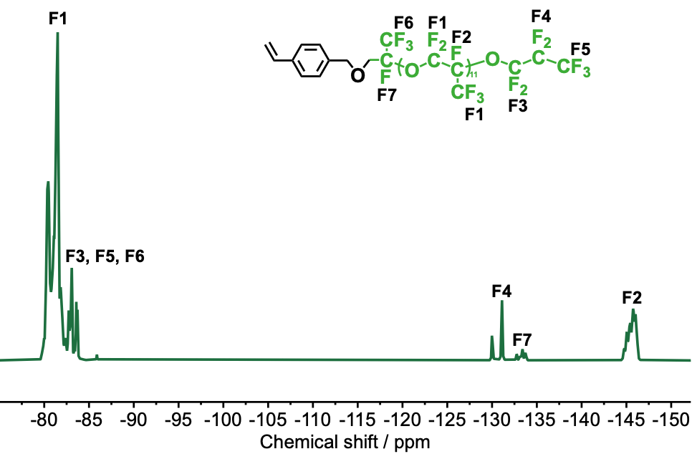
Supplementary Figure 1. ¹⁹F NMR spectrum and corresponding assignment of sPFPE in CDCl₃.

Supplementary Table 1. The preparation of PFPE-IEX resins.
Sorbents | sPFPE (mg) | VBC (mg) | DVB (mg) | AIBN (mg) | TFT (mL)
PFPE-IEX-4 | 2000 | 2500 | 191 | 164 | 4
PFPE-IEX-10 | 2000 | 2200 | 478 | 164 | 4
PFPE-IEX-20 | 2000 | 1700 | 960 | 164 | 4

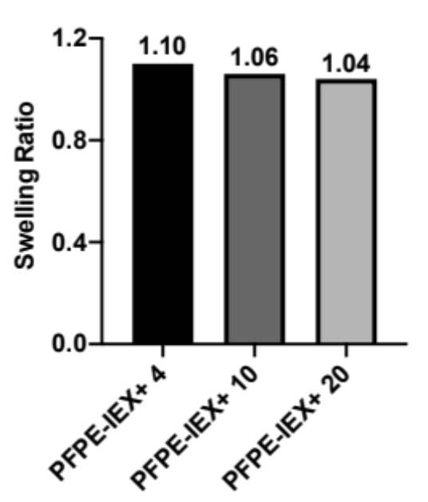
Supplementary Figure 2. Swelling ratio test of PFPE-IEX+ having different cross-linking densities at 4, 10 and 20%.

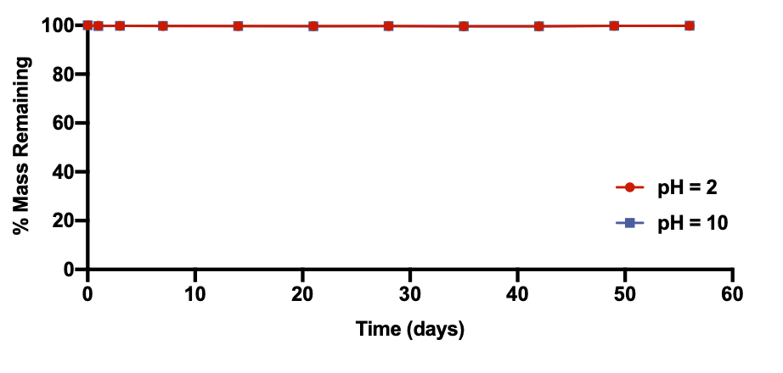
Supplementary Figure 3. Mass loss of PFPE-IEX+ over 56 days in pH = 2.0 and 10.0 water solution at 60 °C. Error bars: standard deviation of two experiments.

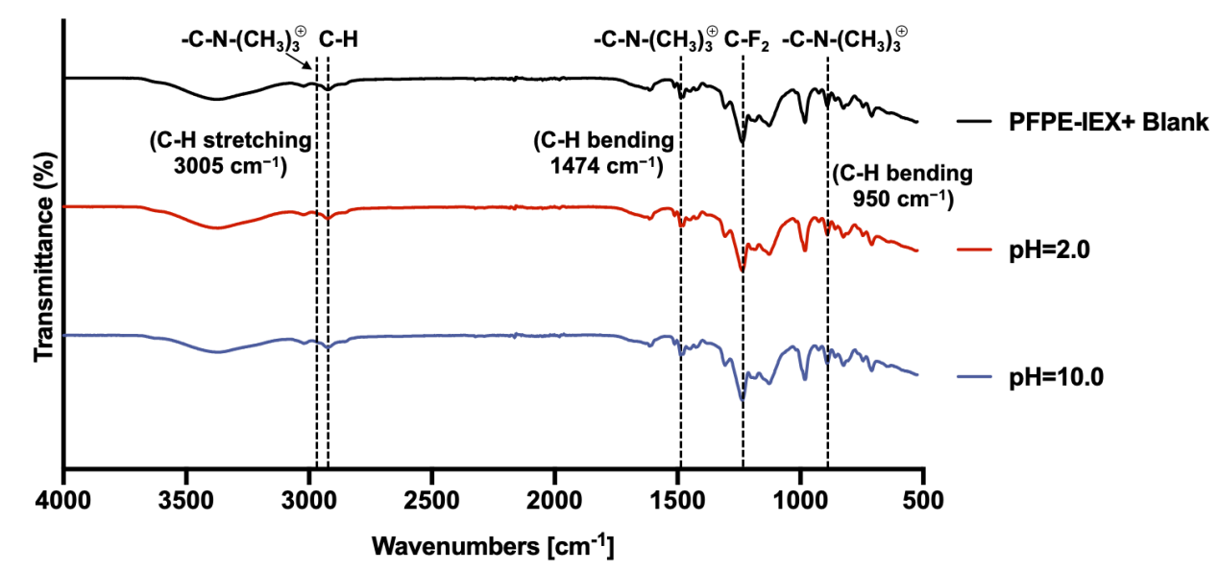
Supplementary Figure 4. FT-IR spectra of PFPE-IEX+ after 56 days of incubation at pH = 2.0 and 10.0 at 60 °C.

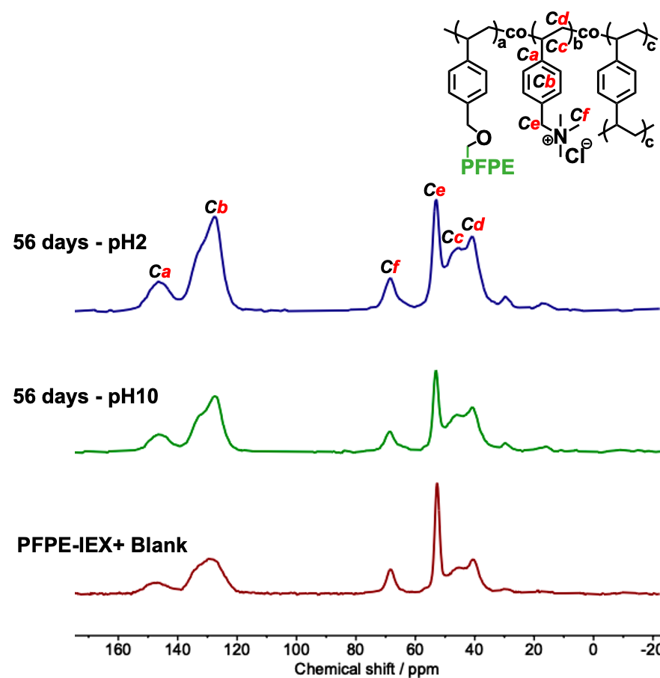
Supplementary Figure 5. Solid-state ¹³C NMR spectra of PFPE-IEX+ after 56 days of incubation at pH = 2.0 and 10.0 at 60 °C.
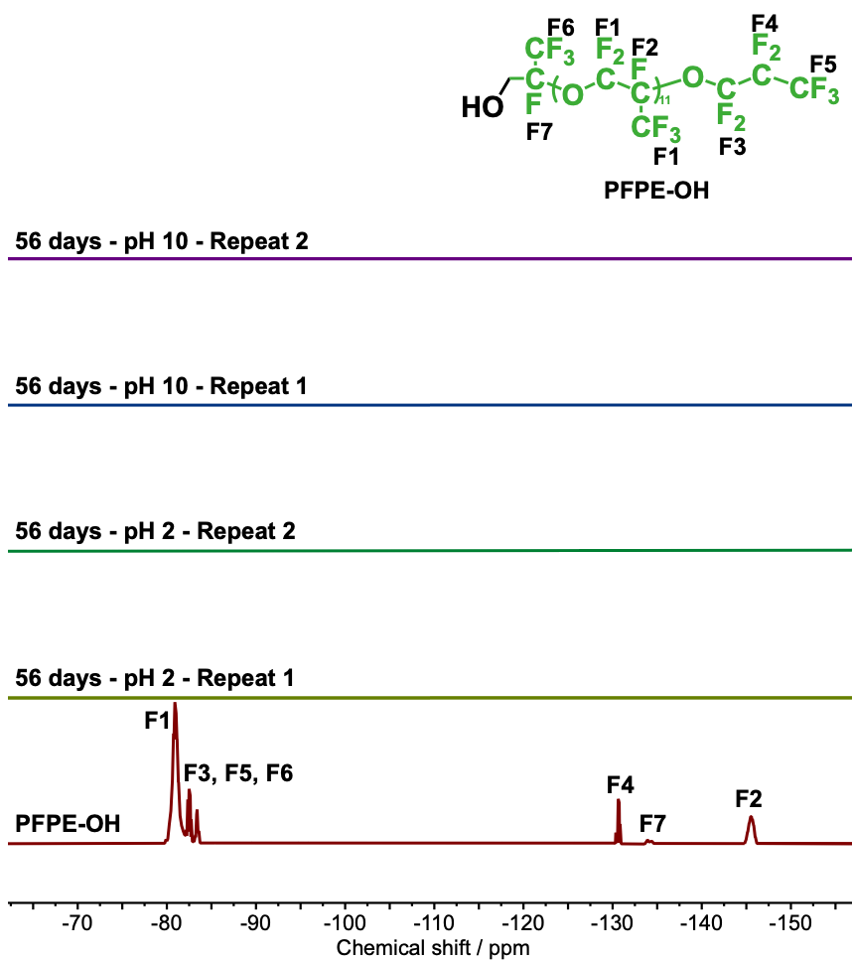
Supplementary Figure 6. ¹⁹F NMR spectra of the supernatant after 56 days of incubation at 60 ºC at pH = 2.0 and 10.0. No fluorine signal can be detected after incubation, indicating good hydrolytic stability of PFPE-IEX+.

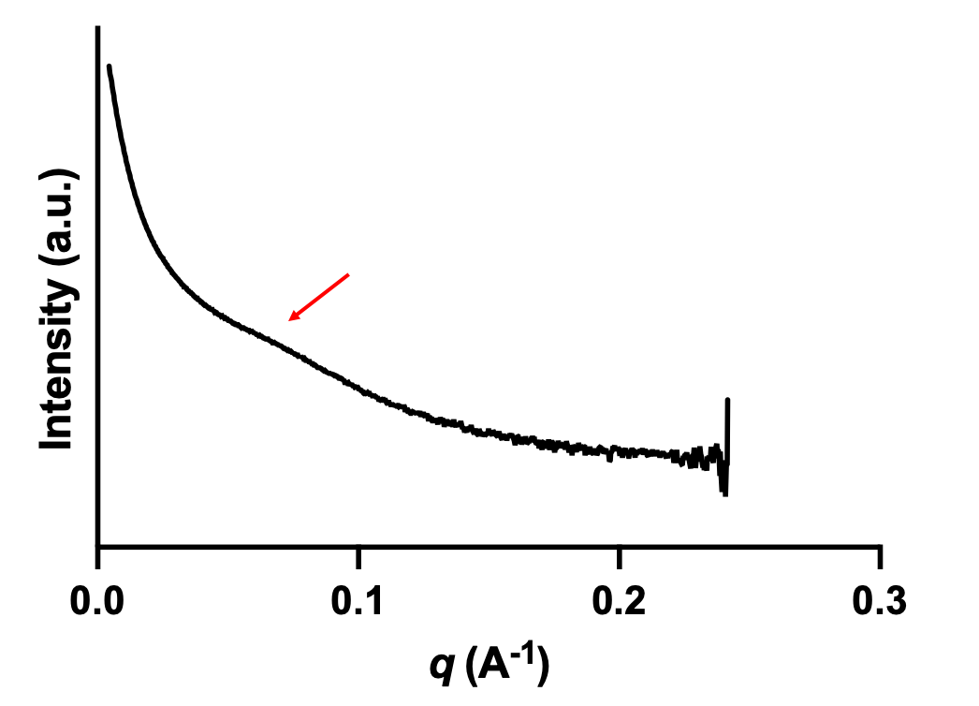
Supplementary Figure 7. Small-angle X-ray scattering (SAXS) spectrum of the swollen PFPE-IEX+.

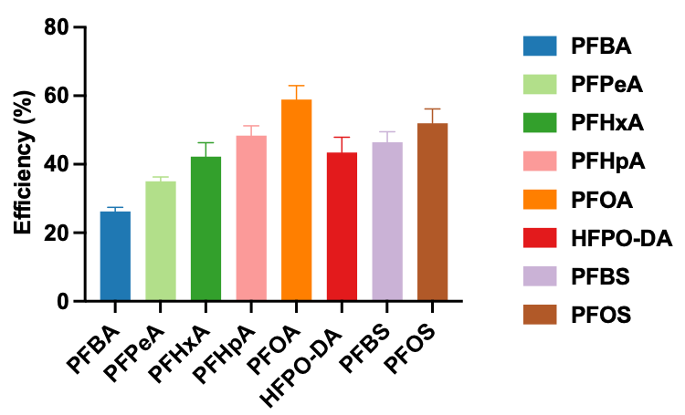
Supplementary Figure 8. Removal efficiency of eight different PFAS using PFPE-IEX+ determined by ¹⁹F NMR. Sorbent concentration, 0.2 mg/mL; PFAS concentration, 0.4 mg/mL each in Milli-Q water; sorption duration, 24 h.

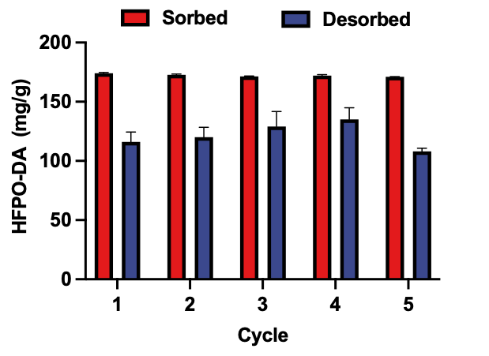
Supplementary Figure 9. Regeneration ability of PFPE-IEX+ determined by LC-MS/MS. Sorbent concentration, 5 mg/mL; HFPO-DA concentration, 0.88 mg/mL; sorption and desorption duration, 30 mins. The results are the average of duplicate, and standard deviation is shown.

Supplementary Table 2. Metal ion concentrations for potable water and landfill leachate determined by ICP-OES.
Sample | Al | B | As | Ba | Ca | Co | Cr | Cu | Fe | K
 | mg/L | mg/L | mg/L | mg/L | mg/L | mg/L | mg/L | mg/L | mg/L | mg/L
Potable water | 0.001 | 0.137 | 0.025 | 0.068 | 33.2 | 0.001 | 0.006 | 0.192 | 0.005 | 3.6
Landfill leachate | 0.422 | 3.809 | 3.474 | 0.377 | 59.3 | 0.569 | 6.600 | 0.048 | 3.653 | 994.9
Sample | Mg | Mn | Na | Ni | P | Si | S | Sr | Zn
 | mg/L | mg/L | mg/L | mg/L | mg/L | mg/L | mg/L | mg/L | mg/L
Potable water | 13.9 | 0.003 | 32.7 | 0.009 | 0.005 | 4.191 | 11.8 | 0.194 | 0.058
Landfill leachate | 53.6 | 0.230 | 2288.7 | 1.693 | 14.3 | 30.9 | 38.1 | 0.609 | 0.221

References
(1) Zhou, Z.; Dominey, R. N.; Rolland, J. P.; Maynor, B. W.; Pandya, A. A.; DeSimone, J. M. Molded, high surface area polymer electrolyte membranes from cured liquid precursors. J. Am. Chem. Soc. 2006, 128 (39), 12963-12972.
(2) Zhang, K.; Feng, W.; Jin, C. Protocol efficiently measuring the swelling rate of hydrogels. MethodsX 2020, 7, 100779. DOI: 10.1016/j.mex.2019.100779.

