Additional file 2: Community training pictures
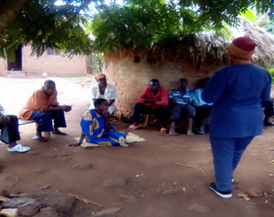
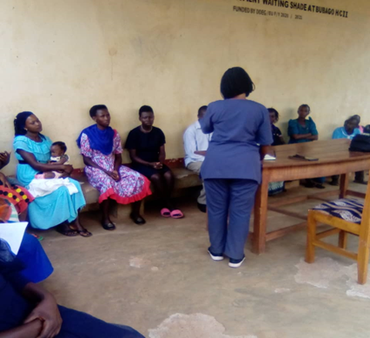
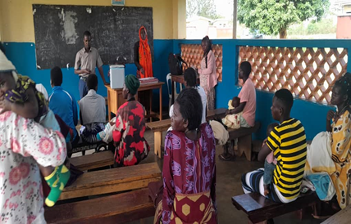
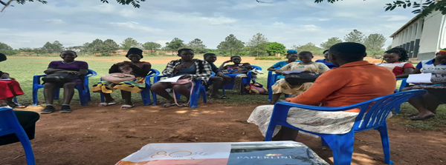
Bunabugo community: Men keep home in morning as women go for garden work
OPD community training at Bubago HC II
Butansi HC III OPD training
Participants at Kamuli Youth centre - doing pre-test assessment
Kitafani TC community found on their day of village Parish Development Model Meeting
Kamuli Prisons community training

