Table 2 The numbers of patients with the various combinations of branching patterns of the pulmonary arteries and veins according to Yamashita’s classification [18].

 | Pulmonary vein type
 | Apical vein  dominant type | Intermediate  type | Central vein  dominant type
Pulmonary arteries | 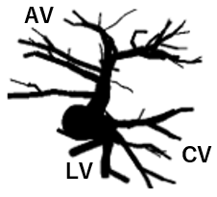 | 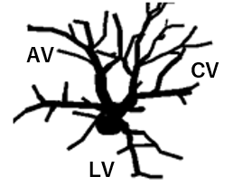 | 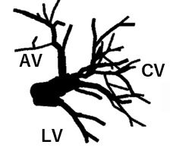 | Total
IL-type | 51 (49.5%) ^{a,}* | 15 (14.6%) ^{b,}* | 0 ^{b,}* | 66 (64.1%)
M-type | 18 (17.5%) ^{b,}* | 16 (15.5%) ^{a,}* | 3 (2.9%) ^{a,}* | 37 (35.9%)
Total | 69 (67.0%) | 31 (30.1%) | 3 (2.9%) | 103 (100%)

The veinous branching patterns were sorted three type; apical vein dominant, intermediate, and central vein dominant types. The letter “AV” means apical vein, “CV” central vein and “LV” lingular vein. M- and IL-types indicate LUL having lingular pulmonary artery all or partly from pars mediastinalis, and lingular pulmonary artery all from pars inter lobaris, respectively. The numbers having superscripts ^{“a”} and ^{“b”} are significantly higher and lower than the theoretical numbers, respectively. *, p < 0.05 (Chi-square test)

