Table 1 The numbers of patients with the various combinations of branching patterns of the pulmonary arteries and the bronchi according to Yamashita’s classification [18] in the left upper lobes (LUL).

 | Bronchial type
 | Apico- | Subapico- | Anterior
 | anterior | anterior | extension type
 | extension type | extension type
Pulmonary  arteries | 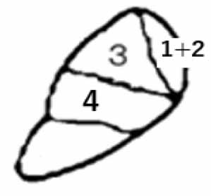 | 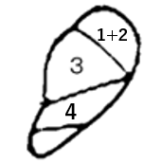 | 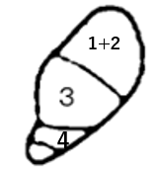 | Total
IL-type | 17 (16.5%) | 31 (30.1%) | 18 (17.5%) ^{a,}* | 66 (64.1%)
M-type | 16 (15.5%) | 18 (17.5%) | 3 (2.9%) ^{b,}* | 37 (35.9%)
Total | 33 (32.0%) | 49 (47.6%) | 21 (20.4%) | 103

The bronchial branching patterns were sorted three types; apico-anterior extension, subapico-anterior extension, and anterior extension types. The letter “1+2” in the illustrations means the apicoposterior segment, the letter “3” anterior segment and the letter “4” upper lingual segment of LUL. M- and IL-types indicate LUL having lingular pulmonary artery all or partly from pars mediastinalis, and lingular pulmonary artery all from pars inter lobaris, respectively. The numbers having superscripts ^{“a”} and ^{“b”} are significantly higher and lower than the theoretical numbers, respectively. *, p < 0.05 (Chi-square test)

