Supplementary Figure 1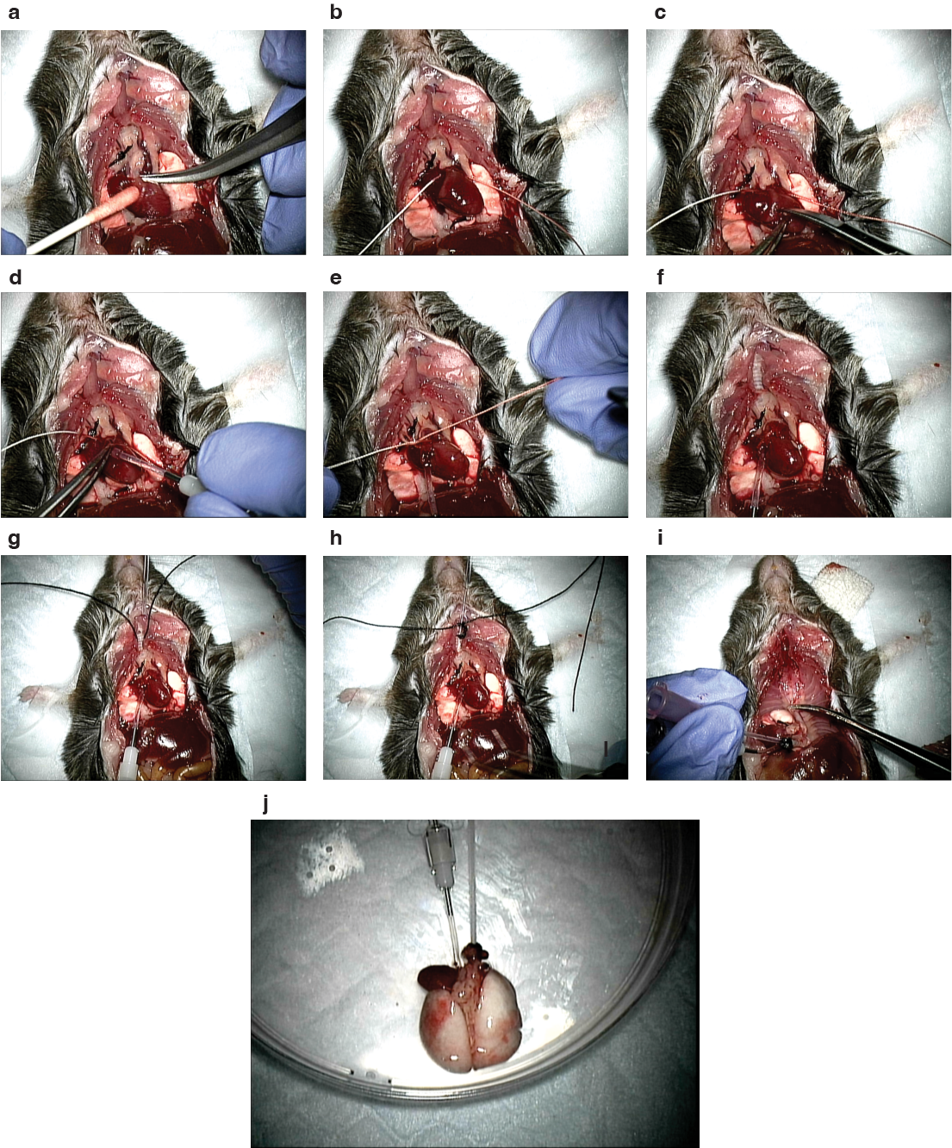
Supplementary figure 1. Mouse surgery
The thoracic cavity of the mouse was opened, and the pulmonary artery was ligated by a silk suture (a and b). The access window for the PA was cut on the right ventricle wall immediately below the pulmonary artery (c). The PA catheter was inserted (d). The PA catheter was fixed by ligating the silk suture (e). The trachea was exposed (f). The trachea was taped by a silk suture, and the tracheostomy was performed (g). The tracheal catheter was inserted and fixed (h). The heart-lung block was removed from the thoracic cavity (i). The isolated heart-lung block was transferred to the next procedure, such as decellularization (j).

Supplementary Figure 2

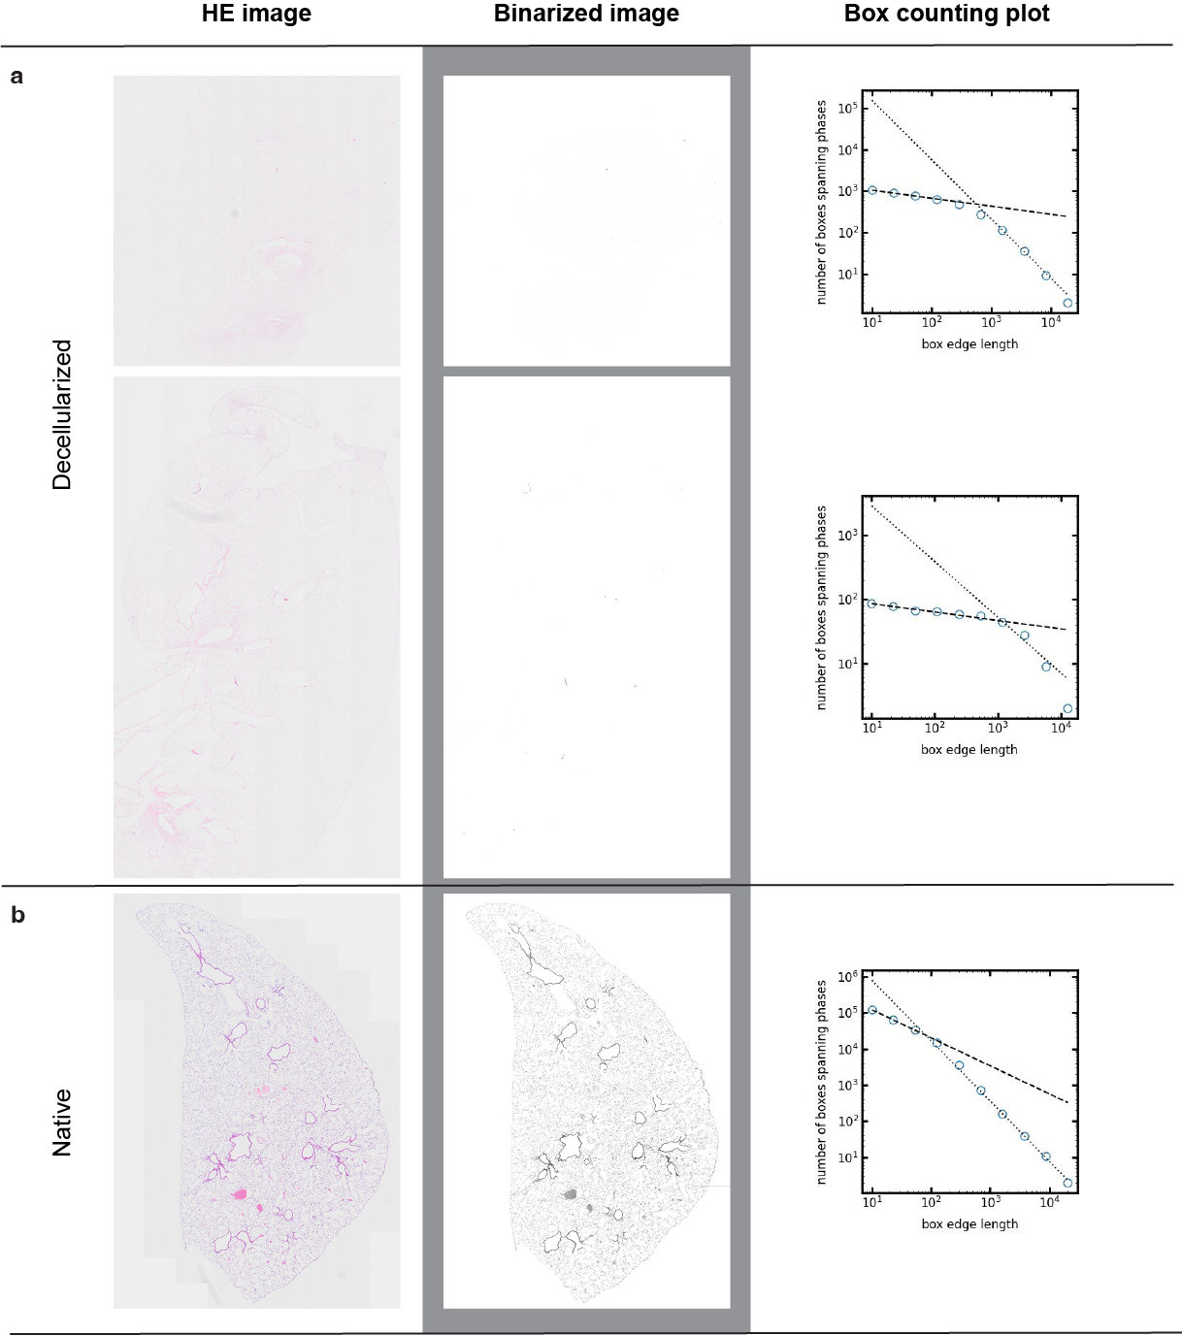
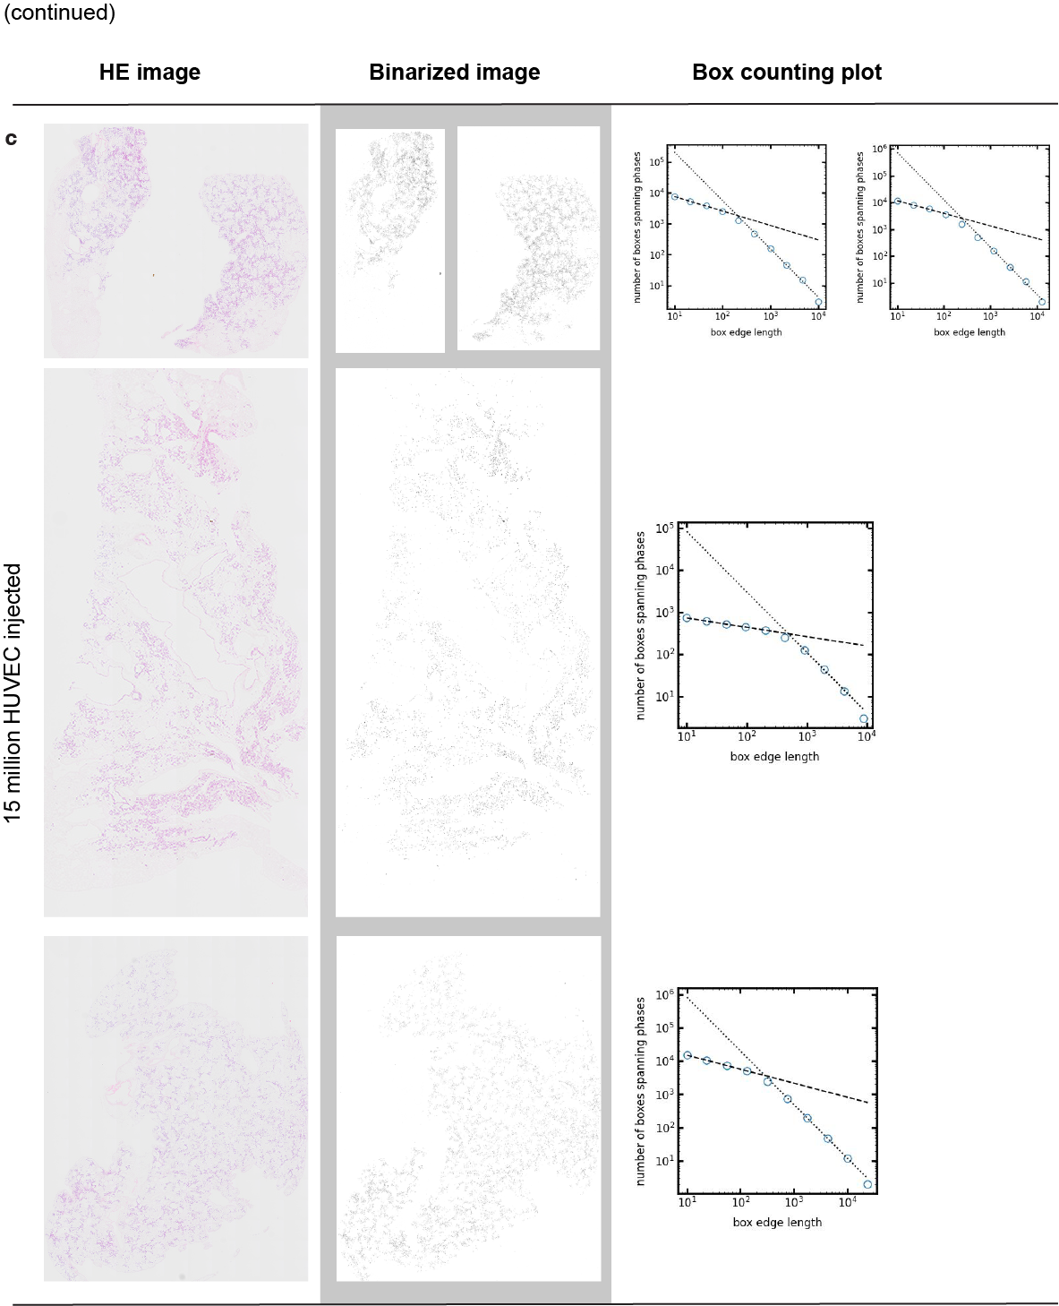
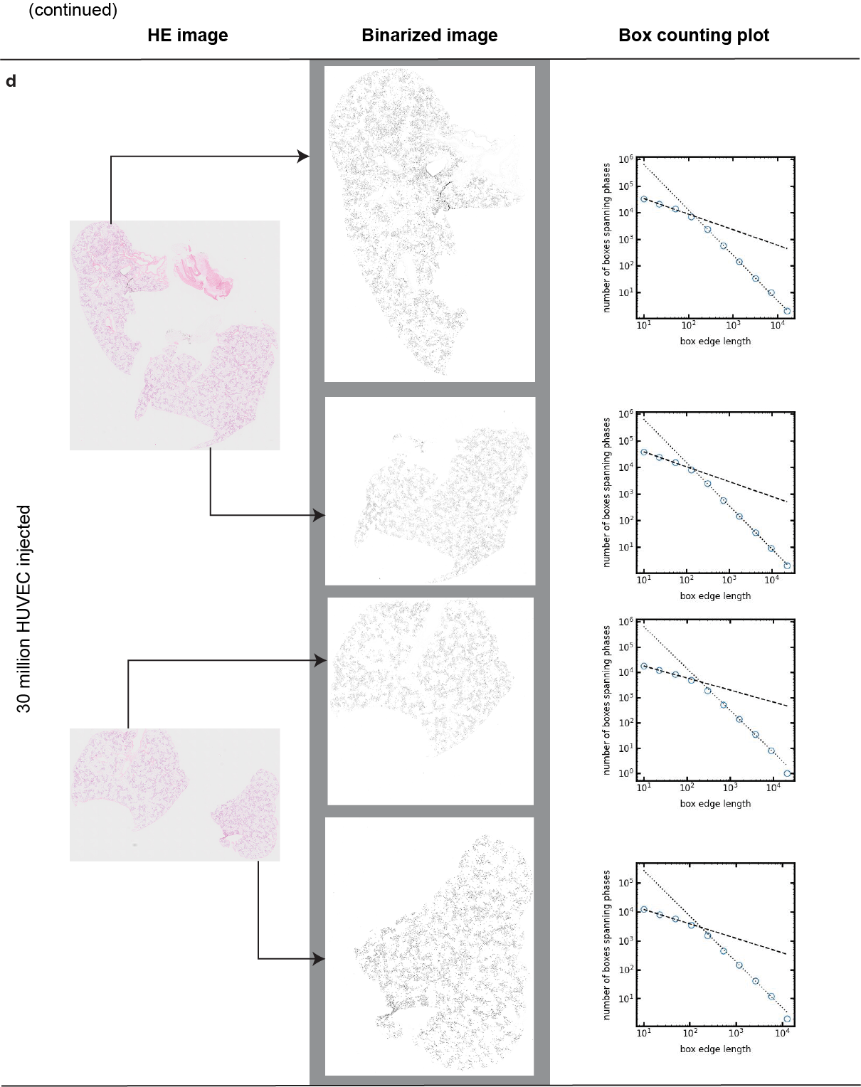

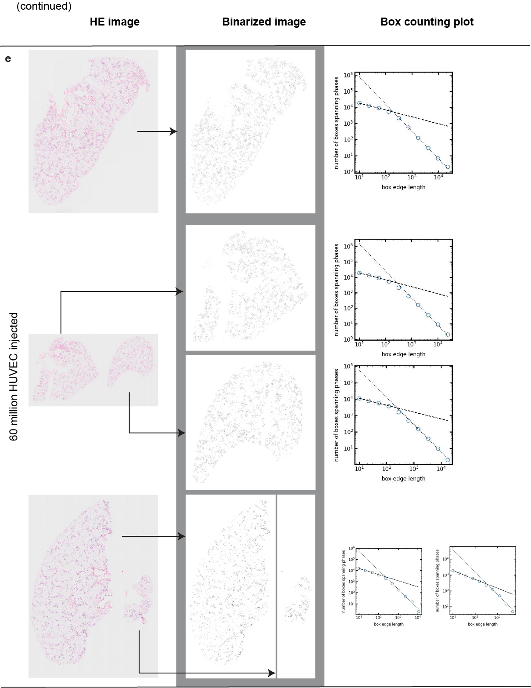
Supplementary figure 2 Box counting of native, decellularized, and recellularized lungs.
The left column represents the H and E staining of the samples. The middle column represents the binarized image of the corresponding HE images. The right colum represents the log-log plots using the box-counting methods.

